SUPPLEMENTARY METHODS

Participants and Setting
We recruited individuals who self-identified as having IBS registered with three UK organizations. These were the IBS network, the registered charity for people living with the condition, TalkHealth, an online social health community providing information about various medical conditions, and ContactMe-IBS, a dedicated register allowing individuals with IBS not receiving specialist care currently to participate in research. This cohort has been described elsewhere. ¹ ² There were no exclusion criteria, other than an inability to understand written English. We approached all individuals registered with these organizations, via a postal and electronic mailshot, between December 2017 and December 2018. This correspondence directed them to a website, where they were able to access further information about the study. Those interested could complete a web-based questionnaire, with their responses stored in a secure online database. We received approval for the study from the University of Leeds research ethics committee in November 2017.

Data Collection and Synthesis
Demographic and Symptom Data
We collected basic demographic data, and asked respondents to state whether they had seen a primary care physician or a gastroenterologist about their IBS symptoms. We captured lower gastrointestinal symptom data using the Rome III and Rome IV questionnaires, ³ ⁴ assigning presence or absence of either Rome III or Rome IV-defined IBS among all individuals according to the scoring algorithms proposed for their use. ⁵ ⁶ We assessed severity of IBS symptoms using the IBS severity scoring system (IBS-SSS). ⁷ This measures presence, severity, and frequency of abdominal pain, presence and severity of abdominal distension, satisfaction with bowel habit, and degree to which IBS symptoms are affecting, or interfering with, the person’s life. The maximum score is 500 points: <75 points indicates remission of symptoms; 75-174 points mild symptoms; 175-299 points moderate symptoms; and 300-500 points severe symptoms.

Assessment of Mood and Extra-Intestinal Symptoms
We collected anxiety and depression data using the hospital anxiety and depression scale (HADS). ⁸ The total HADS score ranges from a minimum of 0 to a maximum of 21 for either anxiety or depression. We collected extra-intestinal symptom data using the patient health questionnaire-12 (PHQ-12), ⁹ derived from the validated PHQ-15. ¹⁰ The total PHQ-12 score ranges from a minimum of 0 to a maximum of 24.

Assessment of Gastrointestinal Symptom-specific Anxiety and Perceived Stress
We used the 15-item visceral sensitivity index (VSI), ¹¹ which measures gastrointestinal symptom-specific anxiety. Replies to each item are provided on a six-point scale from “strongly disagree” (scored as 0) to “strongly agree” (scored as 5). There are no validated cut offs to define low, medium, or high levels of gastrointestinal symptom-specific anxiety, so we divided these data into equally sized tertiles. We utilized the 10-item version of the Cohen perceived stress scale (CPSS) to assess perceived stress, which is derived from the original 14-item instrument. ¹² It is considered to be psychometrically reliable and comparable with its predecessor, ¹³ and measures the degree to which the individual feels they have experienced stress in the previous month. Again, there are no validated cut offs to define low, medium, or high levels of perceived stress, so again we divided these data into equally sized tertiles.
SUPPLEMENTARY RESULTS

Latent Class Analysis in the Rome III Cohort
In this cohort, as with the Rome IV cohort, the best LCA solution was achieved with seven clusters, as indicated by the lowest value of the BIC(LL) (Supplementary Figure 2). An overview of the seven-cluster result is provided in Supplementary Figure 3, and more detail is presented in Supplementary Figure 4, with radar plots depicting the specific symptom profile for each cluster. The characteristics of the seven clusters were almost identical to those identified in the Rome IV cohort analysis.

Cluster Assignment Among Those Individuals Not Meeting Rome III or IV Criteria for IBS
There were 271 individuals who, although they identified as having IBS, met neither the Rome III nor Rome IV criteria for IBS. In the case of Rome IV, this was because, in 235 people (86.7%), their GI symptoms were mild, although 89 (37.9%) of these reported psychological symptoms. When we applied the Rome IV-derived model to these 271 people, 146 (53.9%) were assigned to cluster 3, with low overall gastrointestinal symptoms and low psychological burden, and 89 (32.8%) to cluster 2, with low overall gastrointestinal symptoms and high psychological burden. The findings for the Rome III criteria, and applying the Rome III-derived model, were similar.

10-fold Cross-validation for the Rome IV and Rome III Latent Class Analyses
The misclassification statistic for the Rome IV cohort seven-cluster LCA was 12.2%, compared with 14.8% when 10-fold cross-validation was carried out. This suggests we could expect the model to perform similarly, if applied to a different dataset containing the same variables. When we undertook the cross-validation process manually and drew radar plots to characterize the clusters resulting from each iteration, seven clusters of very similar appearance occurred each time, matching the characteristics of the seven clusters described in our original analysis. The results from 10-fold cross-validation in the Rome III cohort were broadly similar; the misclassification statistic for the Rome III cohort seven-cluster LCA was 14.4%, compared with 16.4% when 10-fold cross-validation was carried out.

Supplementary Figure 1. Values of BIC(LL) Plotted for Each Specification of the Number of Clusters in the Rome IV Cohort.

Lowest value of BIC(LL) indicates the optimum number of clusters. The model converges on a 7-cluster solution being the best fit for the model.
BIC(LL): Bayesian information criterion of the log-likelihood.
Supplementary Figure 2. Values of BIC(LL) Plotted for Each Specification of the Number of Clusters in the Rome III Cohort.

Lowest value of BIC indicates the optimum number of clusters. The model converges on a 7-cluster solution being the best fit for the model.
BIC(LL): Bayesian information criterion of the log-likelihood.
Supplementary Figure 3. Latent Class Analysis in a Cohort of 1080 People with Rome III IBS.
Cluster 1 (22%):
Diarrhea and urgency with
low psychological burden

Cluster 2 (21%):
Low overall gastrointestinal symptom severity with high psychological burden

Latent
class analysis
1080 people with Rome III IBS

Cluster 3 (20%):
Low overall gastrointestinal symptom severity with low psychological burden

Cluster 4 (17%):
Diarrhea, abdominal pain, and urgency with high psychological burden

Cluster 5 (7%):
Constipation, abdominal pain, and bloating with high psychological burden

Cluster 6 (7%):
High overall gastrointestinal symptom severity with high psychological burden

Cluster 7 (6%):
Constipation and bloating with
low psychological burden

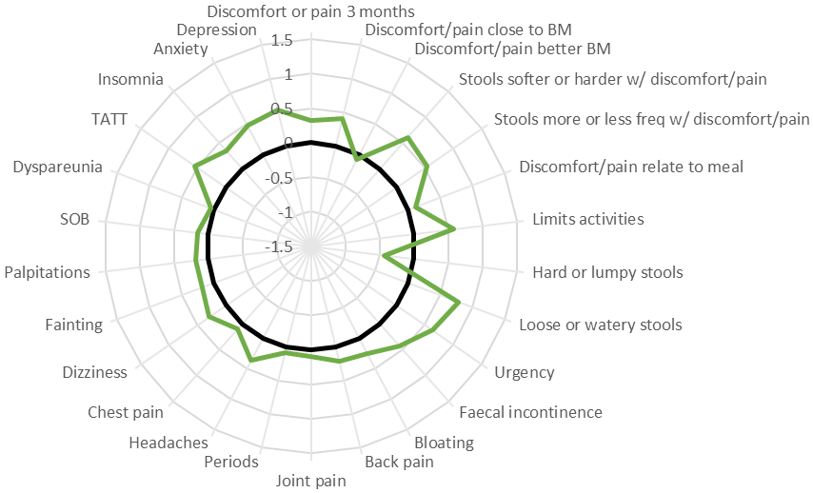
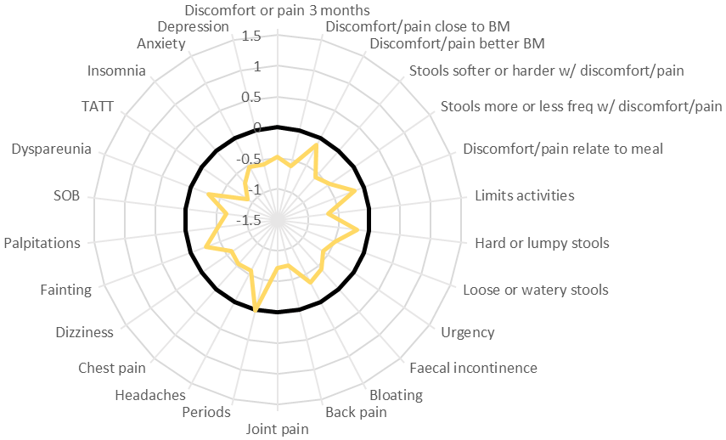
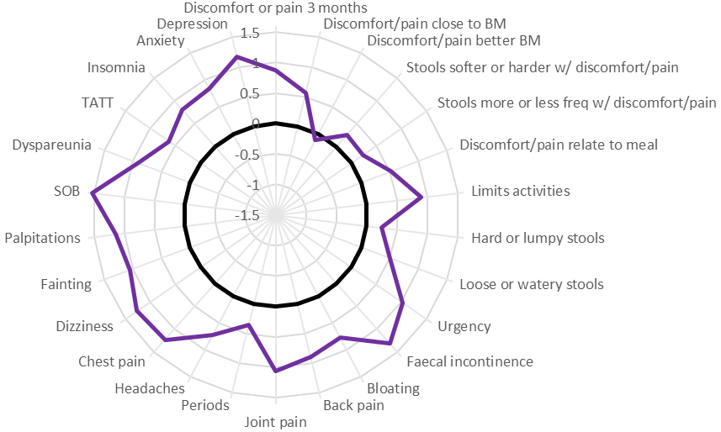
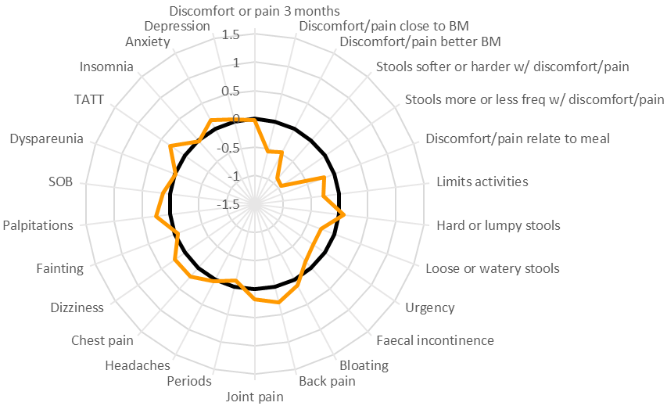
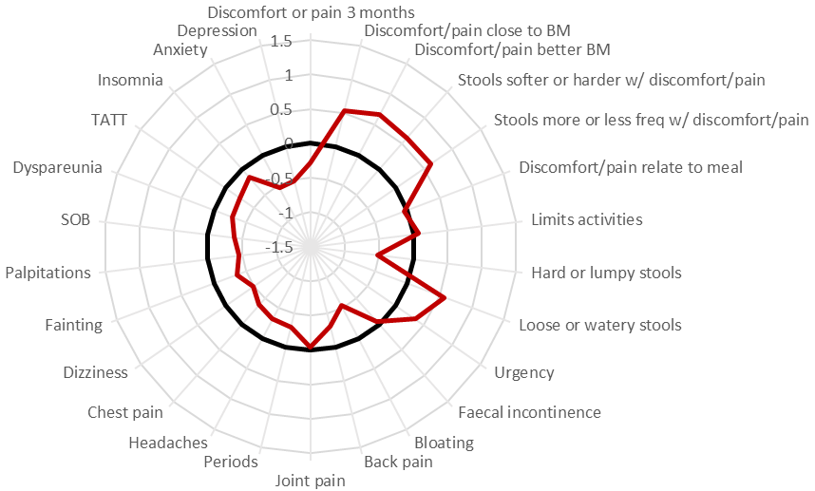
Supplementary Figure 4. Profiles of the Seven Latent Class Clusters Identified in the Rome III Cohort.
D
C
F
B
A
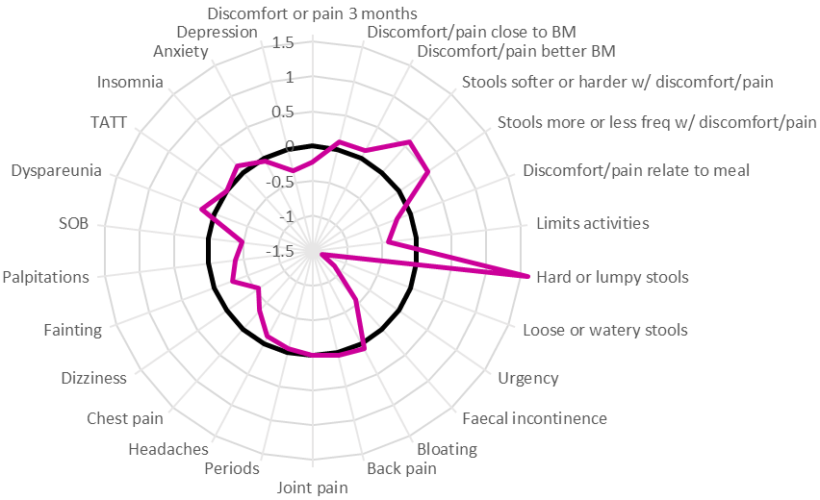
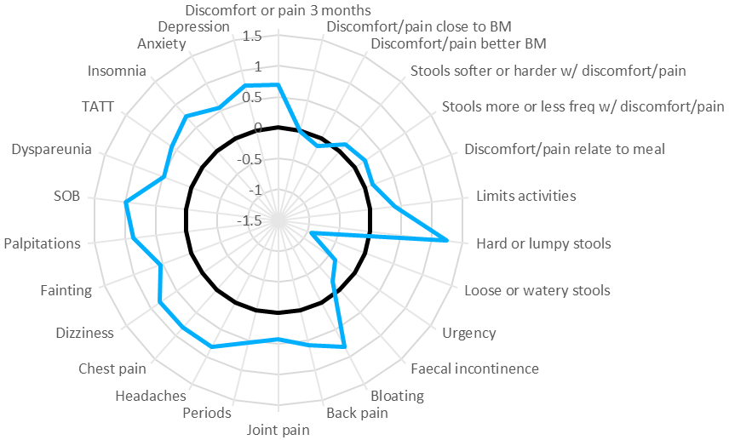
G
E

= adjusted cohort mean

- Cluster 1: Diarrhea and urgency with low psychological burden.
- Cluster 2: Low overall gastrointestinal symptom severity with high psychological burden.
- Cluster 3: Low overall gastrointestinal symptom severity with low psychological burden.
- Cluster 4: Diarrhea, abdominal pain, and urgency with high psychological burden.
- Cluster 5: Constipation, abdominal pain, and bloating with high psychological burden.
- Cluster 6: High overall gastrointestinal symptom severity with high psychological burden.
- Cluster 7: Constipation and bloating with low psychological burden.

BM: bowel movement; SOB: shortness of breath; TATT: tired all the time

Supplementary Table 1. Variables Used in the Latent Class Analysis
 | Variable | Type of variable | Scale of Measurement | Reason for including in the model
Gastrointestinal Symptoms | Frequency of abdominal pain (or discomfort*) anywhere in the abdomen in past 3 months | Ordinal | 9-point scale from “Never” (0) to “Multiple times per day or all the time” (8) | All of these variables for quantifying gastrointestinal symptoms were taken from Rome Foundation questionnaires. These are the recognized “gold standard” for diagnosing IBS, and are widely used.
Gastrointestinal Symptoms | Frequency of abdominal pain being closely related to a bowel movement | Ordinal | 11-point scale from “0%” (never) to “100%” (always)
Gastrointestinal Symptoms | Frequency with which abdominal pain improved or resolved following a bowel movement | Ordinal | 11-point scale from “0%” (never) to “100%” (always)
Gastrointestinal Symptoms | Frequency with which stools became softer or harder than usual in association with abdominal pain | Ordinal | 11-point scale from “0%” (never) to “100%” (always)
Gastrointestinal Symptoms | Frequency with which stools became more or less frequent than usual in association with abdominal pain | Ordinal | 11-point scale from “0%” (never) to “100%” (always)
Gastrointestinal Symptoms | Frequency with which abdominal pain started or got worse after a meal | Ordinal | 11-point scale from “0%” (never) to “100%” (always)
Gastrointestinal Symptoms | Frequency with which abdominal pain restricted usual activities | Ordinal | 11-point scale from “0%” (never) to “100%” (always)
Gastrointestinal Symptoms | Frequency of hard or lumpy stools in last 3 months | Ordinal | 5-point scale from “0%” (never or rarely) to “100%” (always)
Gastrointestinal Symptoms | Frequency of loose, mushy, or watery stools in the last 3 months | Ordinal | 5-point scale from “0%” (never o rarely) to “100%” (always)
Gastrointestinal Symptoms | Frequency of fecal urgency over last 3 months | Ordinal | 9-point scale from “Never” (0) to “Multiple times per day or all the time” (8)
Gastrointestinal Symptoms | Frequency of fecal incontinence over last 3 months | Ordinal | 9-point scale from “Never” (0) to “Multiple times per day or all the time” (8)
Gastrointestinal Symptoms | Frequency of abdominal bloating or distension over last 3 months | Ordinal | 9-point scale from “Never” (0) to “Multiple times per day or all the time” (8)
Extraintestinal Symptoms | All individual items of the PHQ-12 and the frequency experienced in the last 4 weeks:  Back pain  Arm, leg, joint pain  Period pain/period problems  Headaches  Chest pain  Dizziness  Fainting spells  Heart pounding/racing  Shortness of breath  Pain/problems during sex  Feeling tired or low in energy  Trouble sleeping | Ordinal | 3-point scale: “Never” (0), “A little” (1), or “A lot” (2) | Reporting symptoms referable to multiple body systems, also referred to as somatization, is recognized as being associated with IBS and other functional GI disorders. The PHQ-12 questionnaire is a widely used and validated method for measuring this.
Mood | Presence of anxiety, as measured by the total score of the HADS-Anxiety questionnaire | Ordinal | 3-point scale: normal (0), borderline (1), or abnormal (2) | Abnormal mood is well-recognized as being an important factor in IBS. The HADS questionnaire for quantifying the presence of anxiety and/or depression are widely used and validated for this purpose.
Mood | Presence of depression, as measured by the total score of HADS-Depression questionnaire | Ordinal | 3-point scale: normal (0), borderline (1), or abnormal (2)
HADS: hospital anxiety and depression scale; IBS: irritable bowel syndrome; PHQ-12: patient health questionnaire-12
* Discomfort was included, in addition to pain, for the Rome III definition of IBS, as per Rome III criteria.

Supplementary Table 2. Characteristics of Latent Class Clusters in the Rome III Cohort.
 | Cluster 1  Diarrhea and urgency with low psychological burden  (n = 236) | Cluster 2  Low overall GI symptom severity with high psychological burden  (n = 225) | Cluster 3  Low overall GI symptom severity with low psychological burden  (n = 212) | Cluster 4  Diarrhea, abdominal pain, and urgency with high psychological burden  (n = 185) | Cluster 5  Constipation, abdominal pain, and bloating with high psychological burden  (n = 81) | Cluster 6  High overall GI symptom severity with high psychological burden  (n = 80) | Cluster 7  Constipation and bloating with low psychological burden  (n = 61) | P value*
Mean age (SD) | 53.3 (15.4) | 48.6 (15.2) | 48.3 (16.4) | 46.8 (14.1) | 40.0 (13.5) | 46.4 (13.6) | 47.66 (13.6) | <0.001
Female (%) | 202 (85.6) | 181 (80.4) | 167 (78.8) | 161 (87.0) | 78 (96.3) | 70 (87.5) | 56 (91.8) | 0.002
Seen a gastroenterologist with IBS (%) | 132 (55.9) | 136 (60.4) | 104 (49.1) | 119 (64.3) | 40 (49.4) | 53 (67.1) | 62 (59.0) | 0.014
High VSI scores (%) | 53 (22.5) | 73 (32.6) | 27 (12.7) | 97 (52.4) | 47 (58.8) | 60 (75.9) | 15 (24.6) | <0.001
High CPSS scores (%) | 31 (13.1) | 72 (32.0) | 21 (9.9) | 92 (50.0) | 43 (53.1) | 66 (82.5) | 14 (23.0) | <0.001
Severe symptoms on IBS-SSS (%) | 59 (25.2) | 73 (32.4) | 23 (10.8) | 100 (54.3) | 55 (67.9) | 69 (86.3) | 17 (27.9) | <0.001
Subtype on BSFS
IBS-C (%) | 10 (4.2) | 38 (17.0) | 49 (23.1) | 4 (2.2) | 46 (56.8) | 3 (3.8) | 45 (73.8)
IBS-D (%) | 149 (63.1) | 61 (27.2) | 70 (33.0) | 105 (56.8) | 2 (2.5) | 26 (32.5) | 5 (8.2)
IBS-M (%) | 65 (27.5) | 116 (51.8) | 81 (38.2) | 74 (40.0) | 32 (39.5) | 47 (58.8) | 10 (16.4)
IBS-U (%) | 12 (5.1) | 9 (4.0) | 12 (5.7) | 2 (1.1) | 1 (1.2) | 4 (5.0) | 1 (1.6) | <0.001
IBS after acute enteric infection (%) | 34 (14.4) | 28 (12.5) | 37 (17.5) | 24 (13.0) | 9 (11.1) | 12 (15.2) | 3 (4.9) | 0.269

BSFS: Bristol stool form scale; GI: gastrointestinal; IBS-SSS: irritable bowel syndrome symptom severity score; CPSS: Cohen perceived stress scale; VSI: visceral sensitivity index.
* P value for Pearson χ² for comparison of categorical data and one-way ANOVA for comparison of means.

REFERENCES

1. Black CJ, Yiannakou Y, Houghton LA, et al. Epidemiological, clinical, and psychological characteristics of individuals with self-reported irritable bowel syndrome based on the Rome IV vs Rome III criteria. Clin Gastroenterol Hepatol 2019; doi: 10.1016/j.cgh.2019.05.037 doi: 10.1016/j.cgh.2019.05.037

2. Black CJ, Yiannakou Y, Houghton LA, et al. Anxiety-related factors associated with symptom severity in irritable bowel syndrome. Neurogastroenterol Motil 2020:e13872. doi: 10.1111/nmo.13872

3. Whitehead WE, and the Validation Working Team Committee in association with the Rome Questionnaire C. Development and validation of the Rome III diagnostic questionnaire. In: Drossman DA, editorRome III: The functional gastrointestinal disorders, 3rd editionVirginia: Degnon Associates Inc 2006:835-53.

4. Palsson OS, Whitehead WE, van Tilburg MA, et al. Rome IV diagnostic questionnaires and tables for investigators and clinicians. Gastroenterology 2016;150:1481-91.

5. Longstreth GF, Thompson WG, Chey WD, et al. Functional bowel disorders. Gastroenterology 2006;130:1480-91.

6. Mearin F, Lacy BE, Chang L, et al. Bowel disorders. Gastroenterology 2016;150:1393-407.

7. Francis CY, Morris J, Whorwell PJ. The irritable bowel severity scoring system: A simple method of monitoring irritable bowel syndrome and its progress. Aliment Pharmacol Ther 1997;11:395-402.

8. Zigmond AS, Snaith RP. The hospital anxiety and depression scale. Acta Psychiatr Scand 1983;67:361-70.

9. Spiller RC, Humes DJ, Campbell E, et al. The Patient Health Questionnaire 12 Somatic Symptom scale as a predictor of symptom severity and consulting behaviour in patients with irritable bowel syndrome and symptomatic diverticular disease. Aliment Pharmacol Ther 2010;32:811-20.

10. Kroenke K, Spitzer RL, Williams JBW. The PHQ-15: Validity of a new measure for evaluating the severity of somatic symptoms. Psychosom Med 2002;64:258-66.

11. Labus JS, Bolus R, Chang L, et al. The Visceral Sensitivity Index: Development and validation of a gastrointestinal symptom-specific anxiety scale. Aliment Pharmacol Ther 2004;20:89-97.

12. Cohen S, Kamarck T, Mermelstein R. A global measure of perceived stress. Journal of health and social behavior 1983;24:385-96.

13. Cohen S, Williamson GM. Perceived stress in a probability sample in the United States. In: Oskamp SSS, ed. The social psychology of health. Oxford: Newbury Park, CA 1988:31-67.

