Supplementary Digital Content 3

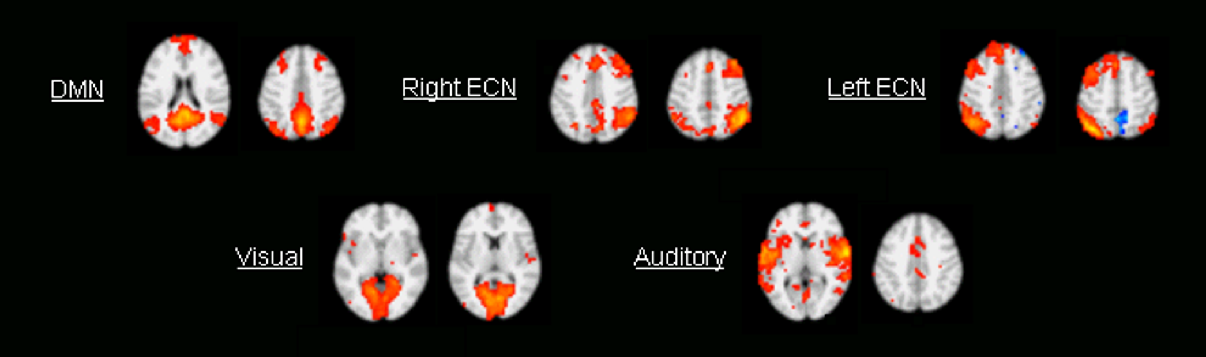

Template images used for automated goodness-of-fit independent components selection approach. These templates were obtained from an independent component analysis (ICA) group analysis performed on data acquired during normal wakefulness in a separate group of 12 subjects, using a concatenation group analysis approach as implemented in MELODIC, part of Functional Functional Magnetic Resonance (MRI) Laboratory Software Library.* Each network map was visually selected and thresholded at p > 0.6 using alternative hypothesis mixture model testing, before further use as a template in goodness-of-fit based components selection.

* http://www.fmrib.ox.ac.uk/fsl. Last accessed June 16, 2010.

