S1. Search terms and engines
Search engine | Query | Items found
Pubmed | ((ect OR electroconvulsive therapy [MeSH] OR (electroconvulsive AND (therapy or therapeut*))) AND ((((pulmonary AND ?edema) OR „pulmonary edema“ [mesh] OR  (myocard* AND (infarc* or damage)) OR „myocardial infarction“ [Mesh] OR ((heart OR cardiac) AND (failure OR death OR arrest)) OR „heart failure“ [Mesh] OR death OR  asystol* OR cardiac arrest [Mesh] OR arrhythmi* OR cardia* OR heart OR “heart“ [Mesh] OR  arrhythmia* OR "arrhythmias, cardiac"[MeSH])))) NOT animal | 996
Ovid (Medline, PsycInfo, Cochrane CENTRAL, The Cochrane Database of Systematic Reviews) | (((ect OR (electroconvulsive AND (therapy or therapeut*))) AND ((cardiac AND adverse AND effects) OR (pulmonary AND ?edema) OR (myocard* AND (infarc* or damage)) OR ((heart OR cardiac) AND (failure OR death OR arrest)) OR death OR asystol* OR arrhythmi* OR cardia* OR heart OR arrhythmia*)) NOT animal) | 1606
Scopus | ( TITLE-ABS-KEY ( ( ect OR ( electroconvulsive AND ( therapy OR therapeut* ) ) ) ) AND PUBYEAR > 1979 ) AND ( ( TITLE-ABS-KEY ( ( cardiac AND adverse AND effects ) ) OR TITLE-ABS-KEY ( ( pulmonary AND ?edema ) ) OR TITLE-ABS-KEY ( ( myocard* AND ( infarc* OR damage ) ) ) OR TITLE-ABS-KEY ( ( ( heart OR cardiac ) AND ( failure OR death OR arrest ) ) ) OR TITLE-ABS-KEY ( death OR asystol* OR arrhythmi* OR cardia* OR heart OR arrhythmia* ) ) AND PUBYEAR > 1979 ) | 1974
Current Content | (((ect OR (electroconvulsive AND (therapy or therapeut*))) AND ((cardiac AND adverse AND effects) OR (pulmonary AND ?edema) OR (myocard* AND (infarc* or damage)) OR ((heart OR cardiac) AND (failure OR death OR arrest)) OR death OR asystol* OR arrhythmi* OR cardia* OR heart OR arrhythmia*)) NOT animal) | 468
S2. Items extracted and risk of bias assessment at study-level
Extracted variables | Categories | Definition | RoB
Population | General population | No exclusion or inclusion criteria regarding cardiovascular health status | low
Population | Cardiac disease | Inclusion of patients with significant cardiovascular disease and exclusion of patients without significant cardiovascular disease | high
Population | No cardiac disease | Inclusion of patients without significant cardiovascular disease and exclusion of patients with significant cardiovascular disease | high
Study design | Retrospective observational study | cohort studies and registries | moderate
Study design | Prospective observational study | cohort studies and registries | low
Study design | Interventional study | randomized, not randomized, blinded, and open studies | low
Study design | Survey | Surveys targeting healthcare providers | high
Quality of harm assessment and reporting | Occurrence of MACE or death reported | Occurrence of one or more components of MACE or death | low
Quality of harm assessment and reporting | Absence of MACE or death reported | Absence of any adverse event reported | moderate
Quality of harm assessment and reporting | No information of MACE or death | No evidence of surveillance | critical
Duration of Follow-up | > 24h | Patient was included for multiple Sessions or followed for more than 24 hours | low
Duration of Follow-up | < 24h | Patient was observed for less than 24 hours | moderate
Duration of Follow-up | Unkown | No information about follow up | unclear
MACE = major adverse cardiac events, RoB = Risk of Bias
S3. Definition of Major Adverse Cardiac Events and Death
Extracted Adverse Events | Definition
Components of MACE
Myocardial infarction | Clinical diagnosis of myocardial infarction
Pulmonary embolism | Clinical diagnosis of pulmonary embolism
Pulmonary edema | Clinical diagnosis of pulmonary edema
Acute heart failure | Clinical diagnosis of an congestive heart failure or ejection fraction <40%
Cardiac arrest | Absence of circulation including pharmaceutical or mechanical resuscitation
Arrhythmia | Potentially life-threatening arrhythmia, arrhythmia with hemodynamic instability such as asystole >5 seconds, ventricular tachycardia, 2nd or 3rd degree atrioventricular block, atrial fibrillation, atrial flutter, or arrhythmia noted as adverse event in patient record
Death, cardiac | death of cardiac origin
All-cause mortality | death

S4. List of studies included in the meta-analysis
MACE
Study | Design (RoB) | Cardiovascular Health Status (RoB) | Duration of Follow-up (RoB) | Reported MACE (RoB) | N Patients/ N ECT
Alexopoulos¹, 1984 | Retrospective observational (moderate) | General population (low) | > 24h (low) | Acute heart failure; arrhythmia; pulmonary edema; myocardial infarction, clinical (low) | Y/Y
Acharya², 2015 | Prospective observational (low) | General population (low) | > 24h (low) | Arrhythmia (low) | Y/Y
Azuma³, 2007 | Interventional (low) | General population (low) | < 24h (moderate) | Myocardial infarction, clinical (low) | Y/Y
Bjolseth⁴, 2015 | Interventional (low) | Major cardiac disease (high) | > 24h (low) | Arrhythmia (low) | Y/Y
Boey ⁵, 1990 | Interventional (low) | General population (low) | > 24h (low) | Arrhythmia (low) | Y/Y
Burd⁶, 1998 | Retrospective observational (moderate) | General population (low) | < 24h (moderate) | Arrhythmia (low) | Y/Y
Canbek⁷, 2015 | Interventional (low) | No or minor cardiac disease (high) | < 24h (moderate) | Arrhythmia (low) | Y/Y
Damm⁸, 2010 | Retrospective observational (moderate) | General population (low) | > 24h (low) | Arrhythmia (low) | Y/Y
Dolenc⁹, 2004 | Retrospective observational (moderate) | Major cardiac disease (high) | < 24h (moderate) | Arrhythmia (low) | Y/Y
Figiel¹⁰, 1993 | Interventional (low) | Major cardiac disease (high) | > 24h (low) | Cardiac arrest, arrhythmia, pulmonary edema, pulmonary embolism (low) | Y/Y
Gerring¹¹, 1982 | Retrospective observational (moderate) | General population (low) | > 24h (low) | Acute heart failure; myocardial infarction, clinical; cardiac arrest (low) | Y/Y
Gonzalez-Pinto¹², 2002 | Retrospective observational (moderate) | No or minor cardiac disease (high) | > 24h (low) | Cardiac arrest (low) | Y/Y
Huuhka¹³, 2003 | Retrospective observational (moderate) | General population (low) | > 24h (low) | Arrhythmia (low) | Y/Y
Ito¹⁴, 2012 | Prospective observational (low) | General population (low) | > 24h (low) | Arrhythmia; pulmonary edema (low) | Y/Y
Janouschek¹⁵, 2013 | Interventional (low) | General population (low) | > 24h (low) | Arrhythmia (low) | Y/Y
Kayhan ¹⁶, 2012 | Interventional (low) | No or minor cardiac disease (high) | < 24h (moderate) | Arrhythmia (low) | Y/Y
Kemp¹⁷, 2015 | Retrospective observational (moderate) | General population (low) | < 24h (moderate) | Cardiac arrest (low) | Y/Y
Kitamura¹⁸, 1984 | Prospective observational (low) | General population (low) | < 24h (moderate) | Arrhythmia (low) | Y/Y
Krahn¹⁹, 2001 | Retrospective observational (moderate) | General population (low) | < 24h (moderate) | Arrhythmia (low) | Y/Y
Kramer²⁰, 1985 | Retrospective observational (moderate) | General population (low) | no information (unclear) | Cardiac arrest (low) | Y/Y
Kramer²¹, 1999 | Retrospective observational (moderate) | General population (low) | < 24h (moderate) | Cardiac arrest (low) | Y/Y
Loh²², 2013 | Survey (high) | General population (low) | unkown (unclear) | Cardiac arrest; arrhythmia; myocardial infarction, clinical (low) | Y/Y
MacPherson²³, 2006 | Retrospective observational (moderate) | Major cardiac disease (high) | unkown (unclear) | Arrhythmia (low) | Y/Y
Mayur²⁴, 1998 | Interventional (low) | No or minor cardiac disease (high) | < 24h (moderate) | Arrhythmia (low) | Y/Y
Mehta²⁵, 2004 | Retrospective observational (moderate) | General population (low) | < 24h (moderate) | Arrhythmia (low) | Y/Y
Miller²⁶, 1987 | Interventional (low) | General population (low) | < 24h (moderate) | Arrhythmia (low) | Y/Y
Mizen²⁷, 2015 | Retrospective observational (moderate) | General population (low) | unkown (unclear) | Arrhythmia (low) | Y/Y
Mokriski²⁸, 1992 | Interventional (low) | General population (low) | unknown (unclear) | Arrhythmia (low) | Y/Y
Mulsant²⁹, 1991 | Retrospective observational (moderate) | General population (low) | > 24h (low) | Arrhythmia (low) | Y/Y
Murray³⁰, 1986 | Retrospective observational (moderate) | General population (low) | > 24h (low) | Arrhythmia (low) | Y/Y
Nagler³¹, 2010 | Interventional (low) | General population (low) | < 24h (moderate) | Arrhythmia (low) | N/Y
Navarro³², 2008 | Interventional (low) | General population (low) | > 24h (low) | Myocardial infarction, clinical (low) | Y/Y
Nuttall³³, 2004 | Retrospective observational (moderate) | General population (low) | > 24h (low) | Arrhythmia; cardiac arrest (low) | Y/Y
O'Flaherty³⁴, 1992 | Interventional (low) | No or minor cardiac disease (high) | < 24h (moderate) | Arrhythmia (low) | Y/Y
Pekel³⁵, 2016 | Interventional (low) | No or minor cardiac disease (high) | > 24h (low) | Arrhythmia (low) | Y/Y
Pullen³⁶, 2011 | Retrospective observational (moderate) | General population (low) | > 24h (low) | Arrhythmia, myocardial infarction, clinical, pulmonary edema, pulmonary embolism (low) | Y/Y
Rasanen³⁷, 1988 | Interventional (low) | General population (low) | > 24h (low) | Arrhythmia (low) | Y/N
Rasmussen³⁸, 2008 | Retrospective observational (moderate) | General population (low) | > 24h (low) | Arrhythmia (low) | Y/Y
Rice³⁹, 1994 | Retrospective observational (moderate) | Major cardiac disease (high) | unknown (unclear) | Arrhythmia; myocardial infarction, clinical (low) | Y/Y
Rivera⁴⁰, 2011 | Retrospective observational (moderate) | Major cardiac disease (high) | < 24h (moderate) | Arrhythmia; myocardial infarction, clinical (low) | Y/Y
Santos Jr⁴¹, 2013 | Retrospective observational (moderate) | General population (low) | > 24h (low) | Arrhythmia (low) | Y/Y
Schott⁴², 1992 | Retrospective observational (moderate) | General population (low) | > 24h (low) | Arrhythmia (low) | Y/Y
Shettar⁴³, 1989 | Interventional (low) | General population (low) | < 24h (moderate) | Arrhythmia (low) | Y/Y
Stewart⁴⁴, 2011 | Retrospective observational (moderate) | General population (low) | > 24h (low) | Arrhythmia (low) | N/Y
Takada⁴⁵, 2005 | Retrospective observational (moderate) | No or minor cardiac disease (high) | < 24h (moderate) | Arrhythmia (low) | Y/Y
Tecoult⁴⁶, 2001 | Retrospective observational (moderate) | General population (low) | > 24h (low) | Arrhythmia (low) | Y/Y
Van Den Broek⁴⁷, 1999 | Interventional (low) | No or minor cardiac disease (high) | < 24h (moderate) | Arrhythmia (low) | Y/Y
Watts⁴⁸, 2011 | Retrospective observational (moderate) | General population (low) | < 24h (moderate) | Arrhythmia (low) | N/Y
Zielinski⁴⁹, 1993 | Prospective observational (low) | Major cardiac disease (high) | < 24h (moderate) | Acute heart failure; arrhythmia; myocardial infarction, clinical (low) | Y/Y
Mortality
Study | Design | Cardiovascular Health Status | Duration of Follow-up | Reported MACE | N Patients/ N ECT
Alexopoulos¹, 1984 | Retrospective observational (moderate) | General population (low) | > 24h (low) | Death, cardiac (low) | Y/Y
Alpak⁵⁰, 2014 | Prospective observational (low) | No or minor cardiac disease (high) | > 24h (low) | No adverse event (moderate) | Y/Y
Aydin⁵¹, 2012 | Prospective observational (low) | No or minor cardiac disease (high) | > 24h (low) | No adverse event (moderate) | Y/Y
Aydogan⁵², 2013 | Retrospective observational (moderate) | General population (low) | > 24h (low) | No adverse event (moderate) | Y/Y
Blanch⁵³, 2001 | Interventional (low) | General population (low) | > 24h (low) | No adverse event (moderate) | Y/Y
Bueno⁵⁴, 2011 | Prospective observational (low) | No or minor cardiac disease (high) | > 24h (low) | No adverse event (moderate) | Y/Y
Chanpattana⁵⁵, 2007 | Survey (high) | General population (low) | unknown (unclear) | No adverse event (moderate) | Y/Y
Chanpattana⁵⁶, 2004 | Survey (high) | General population (low) | unknown (unclear) | No adverse event (moderate) | Y/Y
Chung⁵⁷, 2003 | Retrospective observational (moderate) | General population (low) | unknown (unclear) | No adverse event (moderate) | Y/Y
Dennis⁵⁸, 2016 | Retrospective observational (moderate) | General population (low) | unknown (unclear) | Death, cardiac; death, unknown; death, noncardiac (low) | N/Y
Dilbaz⁵⁹, 2005 | Retrospective observational (moderate) | No or minor cardiac disease (high) | > 24h (low) | No adverse event (moderate) | Y/Y
Figiel¹⁰, 1993 | Interventional (low) | Major cardiac disease (high) | > 24h (low) | No adverse event | Y/Y
Fu⁶⁰, 1999 | Interventional (low) | General population (low) | > 24h (low) | No adverse event (moderate) | Y/Y
Fu⁶¹, 1998 | Interventional (low) | No or minor cardiac disease (high) | > 24h (low) | No adverse event (moderate) | Y/Y
Fuenmayor⁶², 1997 | Prospective observational (low) | No or minor cardiac disease (high) | < 24h (moderate) | No adverse event (moderate) | Y/Y
Geersing⁶³, 2011 | Prospective observational (low) | General population (low) | unknown (unclear) | No adverse event (moderate) | Y/Y
Geretsegger⁶⁴, 1998 | Interventional (low) | General population (low) | > 24h (low) | No adverse event (moderate) | Y/Y
Gerring¹¹, 1982 | Retrospective observational (moderate) | General population (low) | > 24h (low) | Death, cardiac (low)
Guttmacher⁶⁵, 1990 | Retrospective observational (moderate) | General population (low) | > 24h (low) | No adverse event (moderate) | Y/Y
Hodgson⁶⁶, 2004 | Interventional (low) | General population (low) | < 24h (moderate) | No adverse event (moderate) | Y/Y
Howie⁶⁷, 1992 | Interventional (low) | No or minor cardiac disease (high) | < 24h (moderate) | No adverse event (moderate) | Y/Y
Howie⁶⁸, 1990 | Interventional (low) | No or minor cardiac disease (high) | > 24h (low) | No adverse event (moderate) | Y/Y
Kadoi⁶⁹, 2014 | Interventional (low) | No or minor cardiac disease (high) | > 24h (low) | No adverse event (moderate) | Y/Y
Kadoi⁷⁰, 2014 | Interventional (low) | No or minor cardiac disease (high) | > 24h (low) | No adverse event (moderate) | Y/Y
Kovac⁷¹, 1990 | Interventional (low) | General population (low) | > 24h (low) | No adverse event (moderate) | Y/Y
Kovac⁷², 1991 | Interventional (low) | General population (low) | > 24h (low) | No adverse event (moderate) | Y/Y
Kramer²⁰, 1985 | Retrospective observational (moderate) | General population (low) | unknown (unclear) | Death, cardiac; death, unknown; death, noncardiac (low) | Y/Y
Kramer²¹, 1999 | Retrospective observational (moderate) | General population (low) | < 24h (moderate) | Death, unknown (low) | Y/Y
Lee⁷³, 1985 | Interventional (low) | General population (low) | < 24h (moderate) | No adverse event (moderate) | Y/Y
Lui⁷⁴, 1993 | Interventional (low) | General population (low) | < 24h (moderate) | No adverse event (moderate) | Y/Y
Martin⁷⁵, 1992 | Survey (high) | General population (low) | > 24h (low) | No adverse event (moderate) | Y/Y
Martinez⁷⁶, 2011 | Retrospective observational (moderate) | General population (low) | < 24h (moderate) | Death, unknown (low)
Masdrakis⁷⁷, 2011 | Retrospective observational (moderate) | General population (low) | < 24h (moderate) | No adverse event (moderate) | Y/Y
Mayur²⁴, 1998 | Interventional (low) | No or minor cardiac disease (high) | < 24h (moderate) | Death, cardiac; death, unknown; death, noncardiac (low) | Y/Y
Oulis⁷⁸, 2011 | Prospective observational (low) | No or minor cardiac disease (high) | < 24h (moderate) | No adverse event (moderate) | Y/Y
Petrides⁷⁹, 1996 | Interventional (low) | No or minor cardiac disease (high) | < 24h (moderate) | No adverse event (moderate) | Y/Y
Pullen³⁶, 2011 | Retrospective observational (moderate) | General population (low) | > 24h (low) | Death, other (low) | Y/Y
Reid⁸⁰, 1998 | Retrospective observational (moderate) | General population (low) | > 24h (low) | Death, cardiac; death, noncardiac (low) | Y/Y
Rivera⁴⁰, 2011 | Retrospective observational (moderate) | Major cardiac disease (high) | < 24h (moderate) | Death, cardiac; death, unknown; death, noncardiac (low) | Y/Y
Shiwach⁸¹, 2001 | Retrospective observational (moderate) | General population (low) | > 24h (low) | Death, cardiac; death, unknown; death, noncardiac (low) | Y/Y
Tecoult⁴⁶, 2001 | Retrospective observational (moderate) | General population (low) | >24h (low) | Death, noncardiac (low) | Y/Y
Watts⁴⁸, 2011 | Retrospective observational (moderate) | General population (low) | < 24h (moderate) | Death, noncardiac (low) | N/Y

S5. Estimated incidence of MACE after ECT per patients
A. Myocardial Infarction
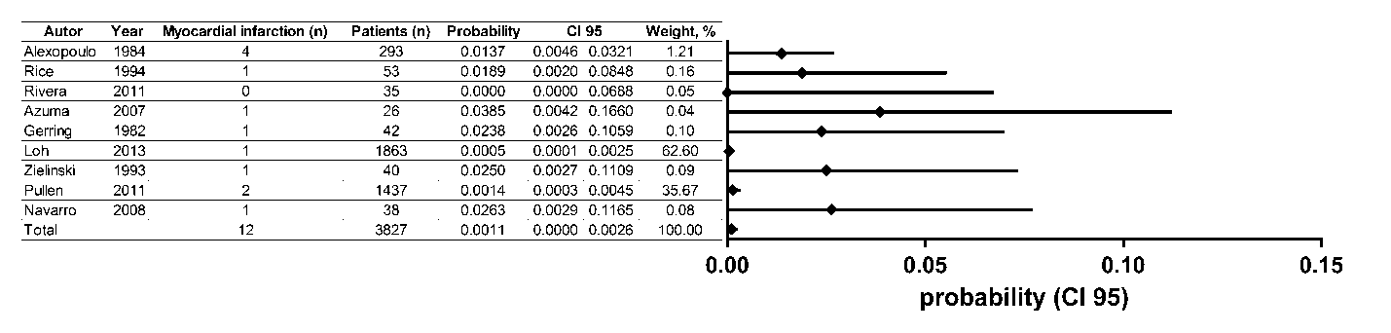
Heterogeneity: χ² = 9.01 (d.f. = 8) p = .342, I² = 11.2%, τ² = .0061
Test of probability=0: z=1.48, p = .138
B. Arrhythmia
Heterogeneity: χ² = 201.73 (d.f. = 38) p = .000, I² = 81.2%, τ² = .7212
Test of probability=0: z=4.69, p = .000

C. Acute Pulmonary Edema
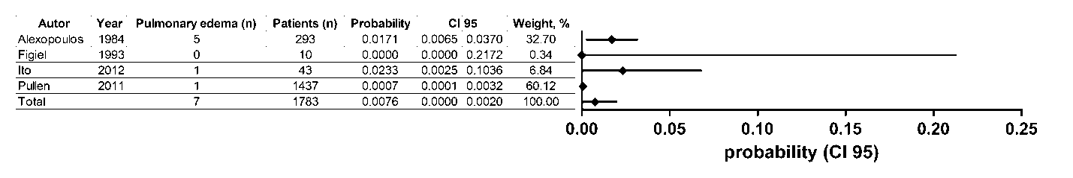
Heterogeneity: χ² = 5.59 (d.f. = 3) p = .133, I² = 46.4%, τ² = .6722
Test of probability=0: z=1.19, p = .234
D. Pulmonary Embolism
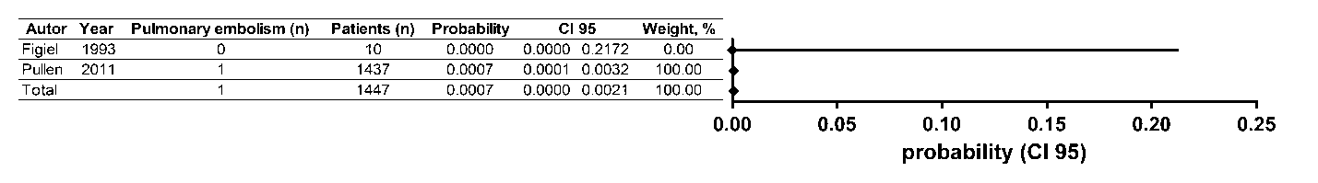
Heterogeneity: χ² = .00 (d.f. =1) p = .995, I² = 0.0%, τ² = .0000
Test of probability=0: z=1.00, p = .317
E. Acute Heart Failure
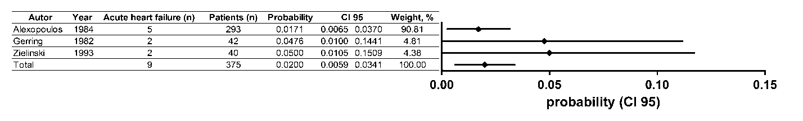
Heterogeneity: χ² = 1.61 (d.f. = 2) p = .446, I² = 0%, τ² = .0000
Test of probability=0: z=2.77, p = .006
F. Cardiac Arrest
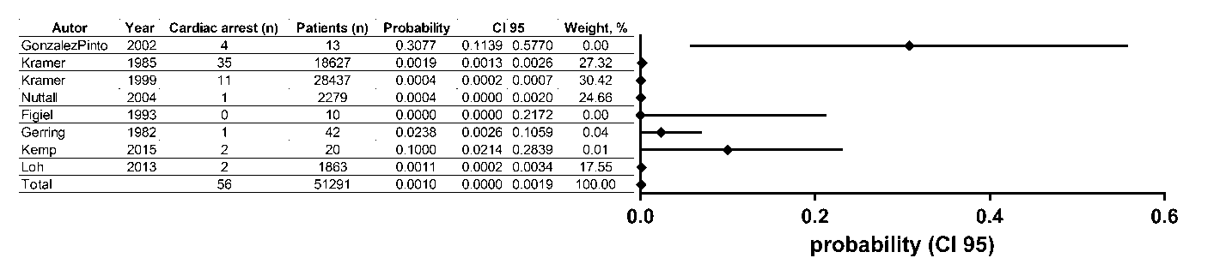
Heterogeneity: χ² = 28.95 (d.f. = 7) p = .000, I² = 75.8%, τ² = .0075
Test of probability=0: z=1.96, p = .050
S6. Estimated incidence of MACE after ECT per ECT treatments
A. Myocardial Infarction
Heterogeneity: χ² = 10.34 (d.f. = 8) p = .242, I² = 22.7%, τ² = .0031
Test of probability=0: z=1.86, p = .063
B. Arrhythmia
Heterogeneity: χ² = 356.93 (d.f. = 40) p = .000, I² = 88.8%, τ² = .0042
Test of probability=0: z=3.47, p = .001

C. Acute Pulmonary Edema
Heterogeneity: χ² = 1.32 (d.f. = 3) p = .725, I² = 0%, τ² = .0000
Test of probability=0: z=2.39, p = .017
D. Pulmonary Embolism
Heterogeneity: χ² = 0.00 (d.f. = 1) p = .990, I² = 0%, τ² = .0000
Test of probability=0: z=1.00, p = .317

E. Acute Heart Failure
Heterogeneity: χ² = 1.33 (d.f. = 2) p = .514, I² = .0%, τ² = .0000
Test of probability=0: z=2.77, p = .006
F. Cardiac Arrest
Heterogeneity: χ² = 27.79 (d.f. = 7) p = .000, I² = 74.8%, τ² = .0002
Test of probability=0: z=2.11, p = .035
S7. Estimated incidence of mortality after ECT per patients
A. All-cause mortality (sensitivity analysis)
Heterogeneity: χ² = 42.29 (d.f. =12) p = .000, I² = 71.6%, τ² = .0010
Test of probability=0: z=2.05, p = .041
B. Cardiac Death (sensitivity analysis)
Heterogeneity: χ² = 14.63 (d.f. = 8) p = .067, I² = 45.3%, τ² = .0005
Test of probability=0: z=1.25, p = .211

C. All-cause mortality
Heterogeneity: χ² = 42.29 (d.f. =40) p = .372, I² = 5.4%, τ² = .0001
Test of probability=0: z=2.02, p = .044

D. Cardiac Death
Heterogeneity: χ² = 14.63 (d.f. = 36) p = .999, I² = .0%, τ² = .0000
Test of probability=0: z=0.64, p = .519

S8. Estimated incidence of mortality after ECT per 1,000 ECT treatments
A. All-cause mortality (sensitivity analysis)
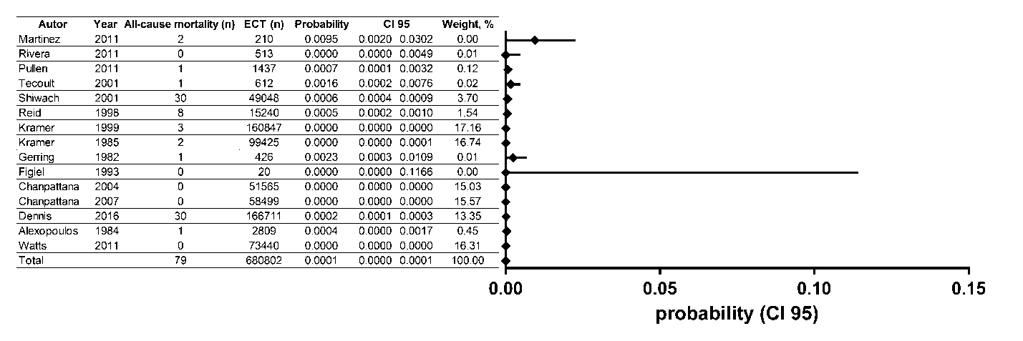
Heterogeneity: χ² = 67.73 (d.f. = 14) p = .000, I² = 79.3%, τ² = .0000
Test of probability=0: z=2.67, p = .0008
B. Cardiac Death (sensitivity analysis)
Heterogeneity: χ² = 19.81 (d.f. = 10) p = .031, I² = 49.5%, τ² = .0000
Test of probability=0: z=1.51, p = .131

C. All-cause mortality
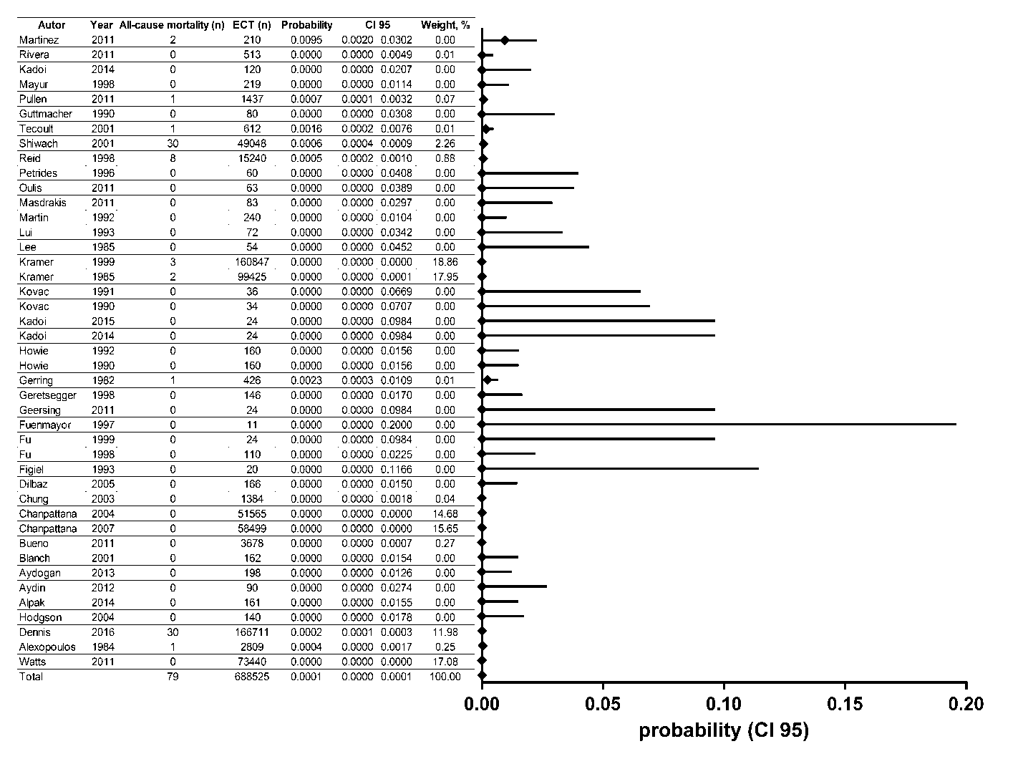
Heterogeneity: χ² = 67.73 (d.f. =42) p = .007, I² = 38.0%, τ² = .0000
Test of probability=0: z=2.75, p = .006

D. Cardiac Death
Heterogeneity: χ² = 19.81 (d.f. = 38) p = .993, I² = .0%, τ² = .0000
Test of probability=0: z=1.78, p = .075

References:
1. Alexopoulos GS, Shamoian CJ, Lucas J, Weiser N, Berger H: Medical problems of geriatric psychiatric patients and younger controls during electroconvulsive therapy. J Am Geriatr Soc 1984; 32: 651-4
2. Acharya D, Harper DG, Achtyes ED, Seiner SJ, Mahdasian JA, Nykamp LJ, Adkison L, White LV, McClintock SM, Ujkaj M, Davidoff DA, Forester BP: Safety and utility of acute electroconvulsive therapy for agitation and aggression in dementia. Int J Geriatr Psychiatry 2015; 30: 265-273
3. Azuma H, Fujita A, Sato K, Arahata K, Otsuki K, Hori M, Mochida Y, Uchida M, Yamada T, Akechi T, Furukawa TA: Postictal cardiovascular response predicts therapeutic efficacy of electroconvulsive therapy for depression. Psychiatry Clin Neurosci 2007; 61: 290-4
4. Bjolseth TM, Engedal K, Benth JS, Dybedal GS, Gaarden TL, Tanum L: Clinical efficacy of formula-based bifrontal versus right unilateral electroconvulsive therapy (ECT) in the treatment of major depression among elderly patients: A pragmatic, randomized, assessor-blinded, controlled trial. J Affect Disord 2015; 175: 8-17
5. Boey WK, Lai FO: Comparison of propofol and thiopentone as anaesthetic agents for electroconvulsive therapy. Anaesthesia 1990; 45: 623-8
6. Burd J, Kettl P: Incidence of asystole in electroconvulsive therapy in elderly patients. Am J Geriatr Psychiatry 1998; 6: 203-11
7. Canbek O, Ipekcioglu D, Menges OO, Atagun MI, Karamustafalioglu N, Cetinkaya OZ, Ilnem MC: Comparison of Propofol, Etomidate, and Thiopental in Anesthesia for Electroconvulsive Therapy: A Randomized, Double-blind Clinical Trial. J ECT 2015; 31: 91-7
8. Damm J, Eser D, Schule C, Obermeier M, Moeller HJ, Rupprecht R, Baghai TC: Influence of age on effectiveness and tolerability of electroconvulsive therapy. J ECT 2010; 26: 282-288
9. Dolenc TJ, Barnes RD, Hayes DL, Rasmussen KG: Electroconvulsive therapy in patients with cardiac pacemakers and implantable cardioverter defibrillators. Pacing Clin Electrophysiol 2004; 27: 1257-63
10. Figiel GS, DeLeo B, Zorumski CF, Baker K, Goewert A, Jarvis M, Smith D, Mattingly G, Ruwitch J: Combined use of labetalol and nifedipine in controlling the cardiovascular response from ECT. J Geriatr Psychiatry Neurol 1993; 6: 20-24
11. Gerring JP, Shields HM: The identification and management of patients with a high risk for cardiac arrhythmias during modified ECT. J Clin Psychiatry 1982; 43: 140-3
12. Gonzalez-Pinto A, Gutierrez M, Gonzalez N, Elizagarate E, Perez de Heredia JL, Mico JA: Efficacy and safety of venlafaxine-ECT combination in treatment-resistant depression. J Neuropsychiatry Clin Neurosci 2002; 14: 206-9
13. Huuhka MJ, Seinelä L, Reinikainen P, Leinonen EVJ: Cardiac arrhythmias induced by ECT in elderly psychiatric patients: Experience with 48-hour Holter monitoring. J ECT 2003; 19: 22-25
14. Ito M, Hatta K, Usui C, Arai H: Urine catecholamine levels are not influenced by electroconvulsive therapy in depression or schizophrenia over the long term. Psychiatry Clin Neurosci 2012; 66: 602-10
15. Janouschek H, Nickl-Jockschat T, Haeck M, Gillmann B, Grozinger M: Comparison of methohexital and etomidate as anesthetic agents for electroconvulsive therapy in affective and psychotic disorders. J Psychiatr Res 2013; 47: 686-693
16. Kayhan GE, Yucel A, Colak YZ, Ozgul U, Yologlu S, Karlidag R, Ersoy MO: Ketofol (mixture of ketamine and propofol) administration in electroconvulsive therapy. Anaesth Intensive Care 2012; 40: 305-310
17. Kemp MF, Allard J, Paquet M, Marcotte P: Impact of an oral theophylline loading dose pre-electroconvulsive therapy. J ECT 2015; 31: 37-42
18. Kitamura T, Page AJF: Electrocardiographic changes following electroconvulsive therapy. Eur Arch Psychiatry Neurol Sci 1984; 234: 147-148
19. Krahn LE, Hanson CA, Pileggi TS, Rummans TA: Electroconvulsive therapy and cardiovascular complications in patients taking trazodone for insomnia. J Clin Psychiatry 2001; 62: 108-10
20. Kramer BA: Use of ECT in California, 1977-1983. Am J Geriatr Psychiatry 1985; 142: 1190-1192
21. Kramer BA: Use of ECT in California, revisited: 1984-1994. J ECT 1999; 15: 245-251
22. Loh N, Nickl-Jockschat T, Sheldrick AJ, Grözinger M: Accessibility, standards and challenges of electroconvulsive therapy in Western industrialized countries: A German example. World J Biol Psychiatry 2013; 14: 432-440
23. MacPherson RD, Loo CK, Barrett N: Electroconvulsive therapy in patients with cardiac pacemakers. Anaesth Intensive Care 2006; 34: 470-4
24. Mayur PM, Gangadhar BN, Girish K, Prasad KM, Subbakrishna DK, Janakiramiah N: Acute post-ECT cardiovascular response: a comparison of threshold right unilateral and bilateral ECT. J ECT 1998; 14: 94-8
25. Mehta V, Mueller PS, Gonzalez-Arriaza HL, Pankratz VS, Rummans TA: Safety of electroconvulsive therapy in patients receiving long-term warfarin therapy. Mayo Clin Proc 2004; 79: 1396-1401
26. Miller ME, Gabriel A, Herman G: Atropine sulfate premedication and cardiac arrhythmia in electroconvulsive therapy (ECT). Convuls Ther 1987; 3: 10-17
27. Mizen L, Morton C, Scott A: The cardiovascular safety of the empirical measurement of the seizure threshold in electroconvulsive therapy. Psychiatr Bull 2015; 39: 14-18
28. Mokriski BK, Nagle SE, Papuchis GC, Cohen SM, Waxman GJ: Electroconvulsive therapy-induced cardiac arrhythmias during anesthesia with methohexital, thiamylal, or thiopental sodium. J Clin Anesth 1992; 4: 208-12
29. Mulsant BH, Rosen J, Thornton JE, Zubenko GS: A prospective naturalistic study of electroconvulsive therapy in late-life depression. J Geriatr Psychiatry Neurol 1991; 4: 3-13
30. Murray GB, Shea V, Conn DK: Electroconvulsive therapy for poststroke depression. J Clin Psychiatry 1986; 47: 258-60
31. Nagler J: Absence of asystole during bifrontal stimulation in electroconvulsive therapy. J ECT 2010; 26: 100-3
32. Navarro V, Gastobal C, Torres X, Masana G, Penades R, Guarch J, Vazquez M, Serra M, Pujol N, Pintor L, Catalan R: Continuation/maintenance treatment with nortriptyline versus combined nortriptyline and ect in late-life psychotic depression: A two-year randomized study. Am J Geriatr Psychiatry 2008; 16: 498-505
33. Nuttall GA, Bowersox MR, Douglass SB, McDonald J, Rasmussen LJ, Decker PA, Oliver WC, Jr., Rasmussen KG: Morbidity and mortality in the use of electroconvulsive therapy. J ECT 2004; 20: 237-41
34. O'Flaherty D, Husain MM, Moore M, Wolff TR, Sills S, Giesecke AH: Circulatory responses during electroconvulsive therapy. The comparative effects of placebo, esmolol and nitroglycerin. Anaesthesia 1992; 47: 563-7
35. Pekel M, Postaci NA, Aytaç İ, Karasu D, Keleş H, Şen Ö, Dıkmen B, Göka E: Sevoflurane versus propofol for electroconvulsive therapy: Effects on seizure parameters, anesthesia recovery, and the bispectral index. Turk J Med Sci 2016; 46: 756-763
36. Pullen SJ, Rasmussen KG, Angstman ER, Rivera F, Mueller PS: The safety of electroconvulsive therapy in patients with prolonged QTc intervals on the electrocardiogram. J ECT 2011; 27: 192-200
37. Rasanen J, Martin DJ, Downs JB, Hodges MR: Oxygen supplementation during electroconvulsive therapy. Br J Anaesth 1988; 61: 593-7
38. Rasmussen KG, Albin SM, Mueller PS, Abel MD: Electroconvulsive therapy in patients taking steroid medication: Should supplemental doses be given on the days of treatment? J ECT 2008; 24: 128-130
39. Rice EH, Sombrotto LB, Markowitz JC, Leon AC: Cardiovascular morbidity in high-risk patients during ECT. Am J Psychiatry 1994; 151: 1637-41
40. Rivera FA, Lapid MI, Sampson S, Mueller PS: Safety of electroconvulsive therapy in patients with a history of heart failure and decreased left ventricular systolic heart function. J ECT 2011; 27: 207-13
41. Santos Jr AD, Oliveira MC, Andrade TDS, de Freitas RR, Banzato CEM, de Azevedo RCS, Botega NJ: Twenty years of electroconvulsive therapy in a psychiatric unit at a university general hospital. Trends Psychiatry Psychother 2013; 35: 229-233
42. Schott K, Bartels M, Heimann H, Buchkremer G: [Results of electroconvulsive therapy in restrictive indications. A retrospective study of 15 years]. Nervenarzt 1992; 63: 422-5
43. Shettar SM, Grunhaus L, Pande AC, Tandon RC, Kronfol ZA, Haskett RF: Protective Effects of Intramuscular Glycopyrrolate on Cardiac Conduction During ECT. Convuls Ther 1989; 5: 349-352
44. Stewart PT, Loo CK, MacPherson R, Hadzi-Pavlovic D: The effect of electrode placement and pulsewidth on asystole and bradycardia during the electroconvulsive therapy stimulus. Int J Neuropsychopharmacol 2011; 14: 585-94
45. Takada JY, Solimene MC, da Luz PL, Grupi CJ, Giorgi DM, Rigonatti SP, Rumi DO, Gowdak LH, Ramires JA: Assessment of the cardiovascular effects of electroconvulsive therapy in individuals older than 50 years. Braz J Med Biol Res 2005; 38: 1349-57
46. Tecoult E, Nathan N: Morbidity in electroconvulsive therapy. Eur J Anaesthesiol 2001; 18: 511-518
47. Van Den Broek WW, Leentjens AFG, Mulder PGH, Kusuma A, Bruijn JA: Low-dose esmolol bolus reduces seizure duration during electroconvulsive therapy: A double-blind, placebo-controlled study. Br J Anaesth 1999; 83: 271-274
48. Watts BV, Groft A, Bagian JP, Mills PD: An examination of mortality and other adverse events related to electroconvulsive therapy using a national adverse event report system. J ECT 2011; 27: 105-8
49. Zielinski RJ, Roose SP, Devanand D, Woodring S, Sackeim HA: Cardiovascular complications of ECT in depressed patients with cardiac disease. Am J Psychiatry 1993; 150: 904-909
50. Alpak G, Ercan S, Alici H, Bulbul F, Altunbas G, Alici D, Saricicek V, Davutoglu V: Influence of recurrent electroconvulsive therapy on cardiac function. Med Princ Pract 2014; 23: 225-8
51. Aydin A, Gumrukcuoglu HA, Selvi Y, Besiroglu L, Ozdemir PG, Ozdemir O, Akdag S, Cegin B: Alterations in P wave duration and dispersion in depressive patients following electroconvulsive therapy. Gen Hosp Psychiatry 2012; 34: 201-5
52. Aydogan MS, Yücel A, Begec Z, Colak YZ, Durmus M: The hemodynamic effects of dexmedetomidine and esmolol in electroconvulsive therapy: A retrospective comparison. J ECT 2013; 29: 308-311
53. Blanch J, Martínez-Pallí G, Navinés R, Arcega JM, Imaz ML, Santos P, Faulí A, Bernardo M, Gomar C: Comparative hemodynamic effects of urapidil and labetalol after electroconvulsive therapy. J ECT 2001; 17: 275-279
54. Bueno CR, Rosa MO, Rumi DO, Ribeiro RB, Rosa MA: Cardiovascular safety of the method of limits titration procedure for electroconvulsive therapy dosing: a retrospective study. Brain Stimul 2011; 4: 43-5
55. Chanpattana W: A questionnaire survey of ECT practice in Australia. J ECT 2007; 23: 89-92
56. Chanpattana W, Kramer BA: Electroconvulsive therapy practice in Thailand. J ECT 2004; 20: 94-8
57. Chung KF: Electroconvulsive therapy in Hong Kong: Rates of use, indications, and outcome. J ECT 2003; 19: 98-102
58. Dennis NM, Dennis PA, Shafer A, Weiner RD, Husain MM: Electroconvulsive Therapy and All-Cause Mortality in Texas, 1998–2013. J ECT 2016
59. Dilbaz N, Şengül C, Okay T, Bayam G, Türkoglu A: The combined treatment of venlafaxine and ECT in treatment-resistant depressive patients. Int J Psychiatry Clin Pract 2005; 9: 55-59
60. Fu W, White PF: Dexmedetomidine failed to block the acute hyperdynamic response to electroconvulsive therapy. Anesthesiology 1999; 90: 422-4
61. Fu W, Stool LA, White PF, Husain MM: Is oral clonidine effective in modifying the acute hemodynamic response during electroconvulsive therapy? Anesth Analg 1998; 86: 1127-30
62. Fuenmayor AJ, el Fakih Y, Moreno J, Fuenmayor AM: Effects of electroconvulsive therapy on cardiac function in patients without heart disease. Cardiology 1997; 88: 254-7
63. Geersing PGKB, Bulte CSE, Viersen VA, Stek ML, Bouwman RA, Boer C, Loer SA: Beat-to-beat hemodynamic monitoring during electroconvulsive therapy. J ECT 2011; 27: 189-191
64. Geretsegger C, Rochowanski E, Kartnig C, Unterrainer AF: Propofol and methohexital as anesthetic agents for electroconvulsive therapy (ECT): a comparison of seizure-quality measures and vital signs. J ECT 1998; 14: 28-35
65. Guttmacher LB, Greenland P: Effects of Electroconvulsive Therapy on the Electrocardiogram in Geriatric Patients with Stable Cardiovascular Diseases. Convuls Ther 1990; 6: 5-12
66. Hodgson RE, Dawson P, Hold AR, Rout CC, Zuma K: Anaesthesia for electroconvulsive therapy: a comparison of sevoflurane with propofol. Anaesth Intensive Care 2004; 32: 241-5
67. Howie MB, Hiestand DC, Svara DA, Kim PY, McSweeney TD, Coffman JA: Defining the dose range for esmolol used in electroconvulsive therapy hemodynamic attenuation. Anesth Analg 1992; 75: 805-810
68. Howie MB, Black HA, Zvara D, McSweeney TD, Martin DJ, Coffman JA: Esmolol reduces autonomic hypersensitivity and length of seizures induced by electroconvulsive therapy. Anesth Analg 1990; 71: 384-8
69. Kadoi Y, Saito S: Effects of Adding Remifentanil to Propofol Anesthesia on Systemic Hemodynamics, Cardiac Output, and Middle Cerebral Artery Flow Velocity During Electroconvulsive Therapy: A Pilot Study. J ECT 2014
70. Kadoi Y, Saito S: Optimal dose of landiolol for preventing abrupt changes in both cardiac output and middle cerebral artery flow velocity after electroconvulsive therapy. J ECT 2014; 30: 224-6
71. Kovac AL, Goto H, Arakawa K, Pardo MP: Esmolol bolus and infusion attenuates increases in blood pressure and heart rate during electroconvulsive therapy. Can J Anaesth 1990; 37: 58-62
72. Kovac AL, Goto H, Pardo MP, Arakawa K: Comparison of two esmolol bolus doses on the haemodynamic response and seizure duration during electroconvulsive therapy. Can J Anaesth 1991; 38: 204-9
73. Lee JT, Erbguth PH, Stevens WC, Sack RL: Modification of electroconvulsive therapy induced hypertension with nitroglycerin ointment. Anesthesiology 1985; 62: 793-6
74. Lui PW, Ma JY, Chan KK: Modification of tonic-clonic convulsions by atracurium in multiple-monitored electroconvulsive therapy. J Clin Anesth 1993; 5: 16-21
75. Martin M, Figiel G, Mattingly G, Zorumski CF, Jarvis M: ECT-induced interictal delirium in patients with a history of a CVA. J Geriatr Psychiatry Neurol 1992; 5: 149-155
76. Martinez MW, Rasmussen KG, Mueller PS, Jaffe AS: Troponin elevations after electroconvulsive therapy: the need for caution. Am J Med 2011; 124: 229-34
77. Masdrakis VG, Tzanoulinos G, Markatou M, Oulis P: Cardiac safety of the electroconvulsive therapy-paliperidone combination: a preliminary study. Gen Hosp Psychiatry 2011; 33: 83.e9-10
78. Oulis P, Florakis A, Markatou M, Tzanoulinos G, Masdrakis VG: Corrected QT interval changes during electroconvulsive therapy-antidepressants-atypical antipsychotics coadministration: safety issues. J ECT 2011; 27: e4-6
79. Petrides G, Maneksha F, Zervas I, Carasiti I, Francis A: Trimethaphan (Arfonad) control of hypertension and tachycardia during electroconvulsive therapy: a double-blind study. J Clin Anesth 1996; 8: 104-9
80. Reid WH, Keller S, Leatherman M, Mark Mason MS: ECT in Texas: 19 months of mandatory reporting. J Clin Psychiatry 1998; 59: 8-13
81. Shiwach RS, Reid WH, Carmody TJ: An analysis of reported deaths following electroconvulsive therapy in Texas, 1993-1998. Psychiatr Serv 2001; 52: 1095-7

