Supplemental Tables

Supplemental Table 1. Risk of bias assessment for clinical outcomes reported in randomized controlled trials.
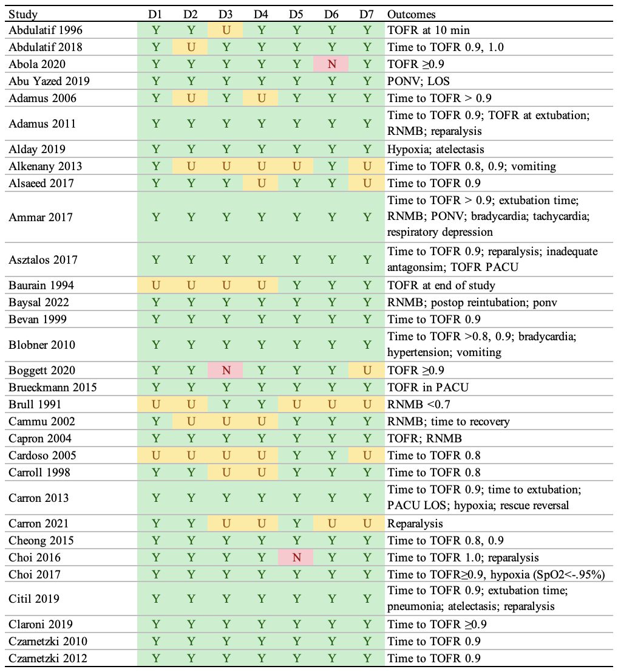
RNMB: residual neuromuscular blockade; LOS: length of stay; TOFR: train-of-four ratio; PACU: postanesthesia care unit
Y: yes; N: no; U: unclear; L: low risk of bias; H: high risk of bias.
D1: Randomization: Was the allocation sequence adequately generated?
D2: Was randomization sequence adequately concealed before group assignment?
D3: Was study group allocation adequately hidden from patients and study personnel?
D4: Was study group allocation adequately hidden from outcome assessors?
D5: Were incomplete outcome data addressed (e.g., attrition and exclusions reported, and reasons explained)?
D6: Selective outcome reporting: Is study free of suggestion of selective outcome reporting? Were all pre-specified outcomes reported?
D7: Other sources of bias: Was study free of other potential problems that could put it at high risk of bias?

Supplemental Table 1 (continued). Risk of bias assessment for clinical outcomes reported in randomized controlled trials.
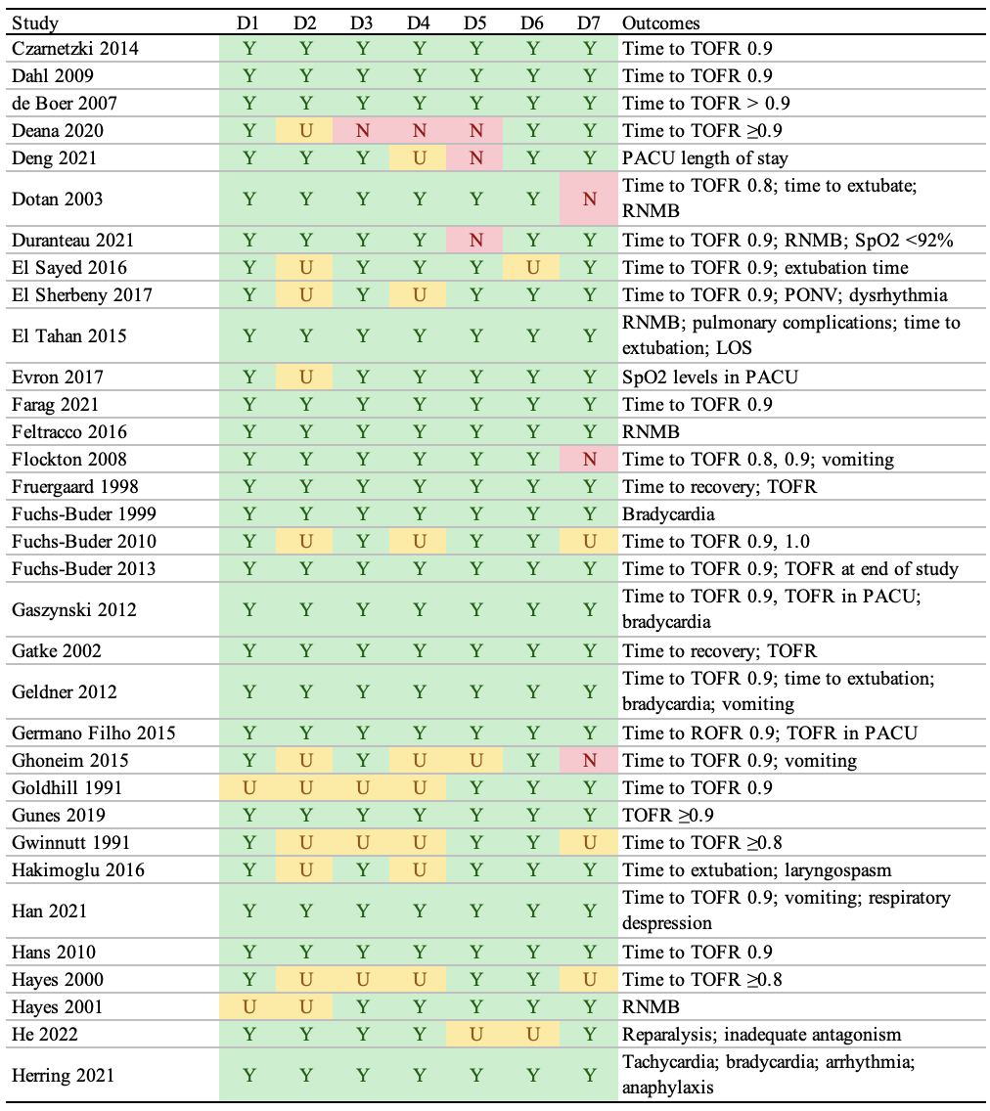
RNMB: residual neuromuscular blockade; LOS: length of stay; TOFR: train-of-four ratio; PACU: postanesthesia care unit
Y: yes; N: no; U: unclear; L: low risk of bias; H: high risk of bias.
D1: Randomization: Was the allocation sequence adequately generated?
D2: Was randomization sequence adequately concealed before group assignment?
D3: Was study group allocation adequately hidden from patients and study personnel?
D4: Was study group allocation adequately hidden from outcome assessors?
D5: Were incomplete outcome data addressed (e.g., attrition and exclusions reported, and reasons explained)?
D6: Selective outcome reporting: Is study free of suggestion of selective outcome reporting? Were all pre-specified outcomes reported?
D7: Other sources of bias: Was study free of other potential problems that could put it at high risk of bias?

Supplemental Table 1 (continued). Risk of bias assessment for clinical outcomes reported in randomized controlled trials.
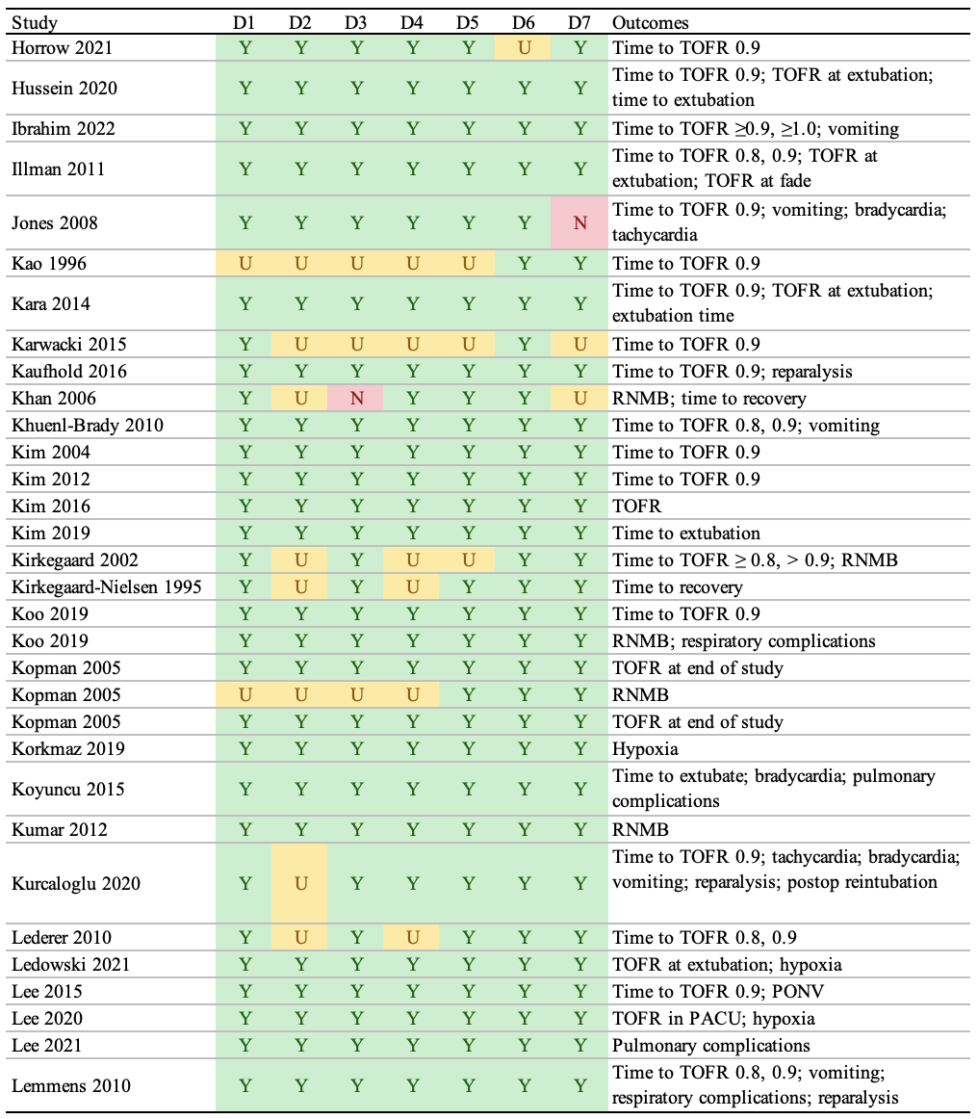
RNMB: residual neuromuscular blockade; LOS: length of stay; TOFR: train-of-four ratio; PACU: postanesthesia care unit
Y: yes; N: no; U: unclear; L: low risk of bias; H: high risk of bias.
D1: Randomization: Was the allocation sequence adequately generated?
D2: Was randomization sequence adequately concealed before group assignment?
D3: Was study group allocation adequately hidden from patients and study personnel?
D4: Was study group allocation adequately hidden from outcome assessors?
D5: Were incomplete outcome data addressed (e.g., attrition and exclusions reported, and reasons explained)?
D6: Selective outcome reporting: Is study free of suggestion of selective outcome reporting? Were all pre-specified outcomes reported?
D7: Other sources of bias: Was study free of other potential problems that could put it at high risk of bias?

Supplemental Table 1 (continued). Risk of bias assessment for clinical outcomes reported in randomized controlled trials. 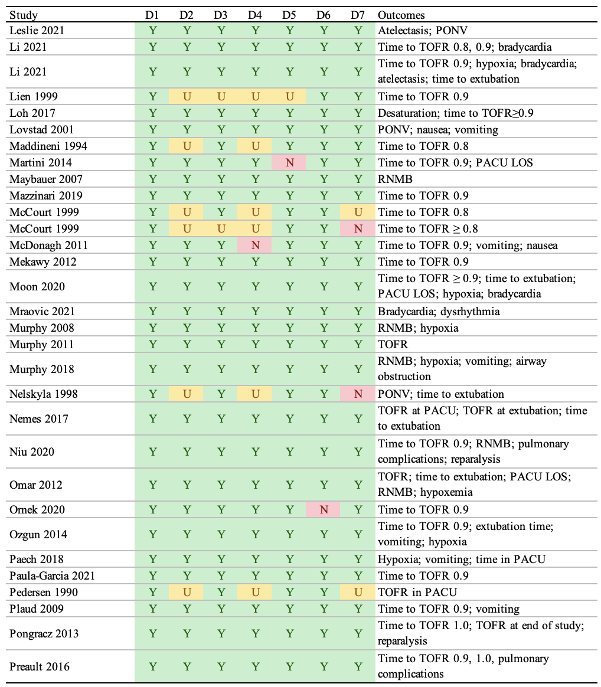
RNMB: residual neuromuscular blockade; LOS: length of stay; TOFR: train-of-four ratio; PACU: postanesthesia care unit
Y: yes; N: no; U: unclear; L: low risk of bias; H: high risk of bias.
D1: Randomization: Was the allocation sequence adequately generated?
D2: Was randomization sequence adequately concealed before group assignment?
D3: Was study group allocation adequately hidden from patients and study personnel?
D4: Was study group allocation adequately hidden from outcome assessors?
D5: Were incomplete outcome data addressed (e.g., attrition and exclusions reported, and reasons explained)?
D6: Selective outcome reporting: Is study free of suggestion of selective outcome reporting? Were all pre-specified outcomes reported?
D7: Other sources of bias: Was study free of other potential problems that could put it at high risk of bias?

Supplemental Table 1 (continued). Risk of bias assessment for clinical outcomes reported in randomized controlled trials.
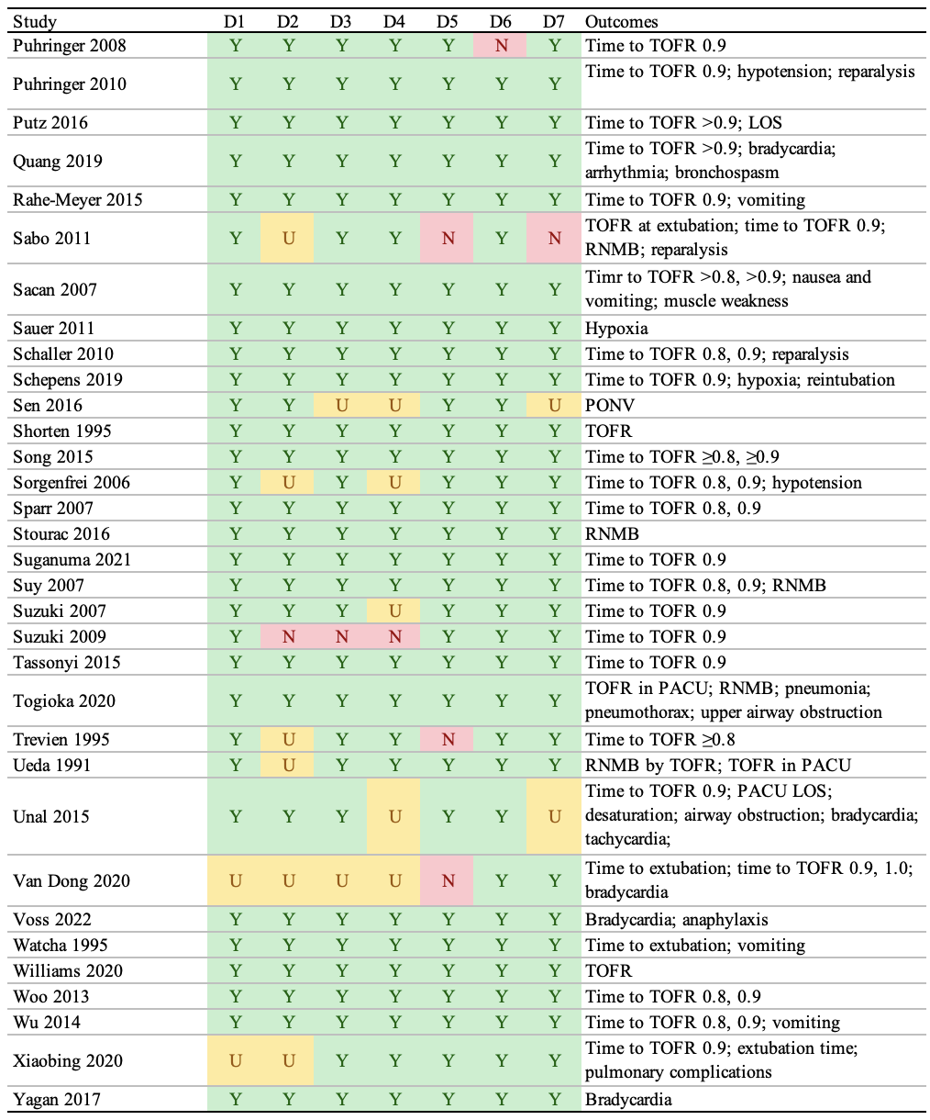
RNMB: residual neuromuscular blockade; LOS: length of stay; TOFR: train-of-four ratio; PACU: postanesthesia care unit; PONV: postoperative nausea and vomiting
Y: yes; N: no; U: unclear; L: low risk of bias; H: high risk of bias.
D1: Randomization: Was the allocation sequence adequately generated?
D2: Was randomization sequence adequately concealed before group assignment?
D3: Was study group allocation adequately hidden from patients and study personnel?
D4: Was study group allocation adequately hidden from outcome assessors?
D5: Were incomplete outcome data addressed (e.g., attrition and exclusions reported, and reasons explained)?
D6: Selective outcome reporting: Is study free of suggestion of selective outcome reporting? Were all pre-specified outcomes reported?
D7: Other sources of bias: Was study free of other potential problems that could put it at high risk of bias?

Supplemental Table 2. Risk of bias assessment for clinician-assessed outcomes reported in randomized controlled trials.
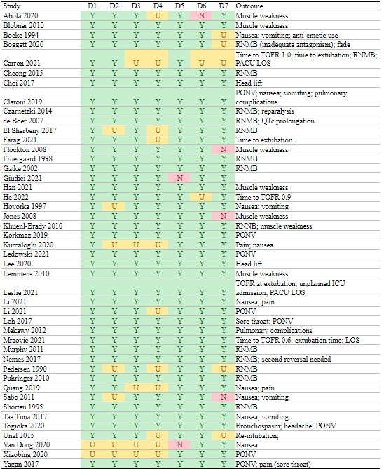
RNMB: residual neuromuscular blockade; LOS: length of stay; TOFR: train-of-four ratio; PACU: postanesthesia care unit; PONV: postoperative nausea and vomiting
Y: yes; N: no; U: unclear; L: low risk of bias; H: high risk of bias.
D1: Randomization: Was the allocation sequence adequately generated?
D2: Was randomization sequence adequately concealed before group assignment?
D3: Was study group allocation adequately hidden from patients and study personnel?
D4: Was study group allocation adequately hidden from outcome assessors?
D5: Were incomplete outcome data addressed (e.g., attrition and exclusions reported, and reasons explained)?
D6: Selective outcome reporting: Is study free of suggestion of selective outcome reporting? Were all pre-specified outcomes reported?
D7: Other sources of bias: Was study free of other potential problems that could put it at high risk of bias?

Supplemental Table 3. ROBINS-I (“Risk Of Bias In Non-randomised Studies - of Interventions”) ratings for observational studies.
D1 to D8 ratings — L: Low (clear evidence that all results correspond to intended outcomes, analyses, subgroups); M: Moderate (outcomes consistent with a priori plan and no indication of reporting based on results) S: Serious (high risk among multiple analyses or only subgroup reported); C: Critical (strong suspicion and unreported results substantially different); NI: No information; NA: Not applicable.
Overall risk of bias ratings — L: Low (comparable to well-performed RCT; M: Moderate (sound evidence but cannot be compared to well-performed RCT); S: Serious (has important problems); C: Critical (too problematic to provide useful evidence); NI: No information; NA: Not applicable.
D1: Bias due to confounding.
D2: Bias in selection of participants into the study.
D3: Bias in classification of interventions.
D4: Bias due to deviations from intended interventions.
D5: Bias due to missing data.
D6: Bias in measurement of outcomes.
D7: Bias in selection of reported results.

Supplemental Table 4. CLARITY (Clinical Advances through Research and Information Technology) risk of bias ratings for TOFR ≥ 0.9 confirmation at extubation.
Y: yes; Prob: probably; U: uncertain.
D1: Was selection of exposed and non-exposed cohorts drawn from the same population?
D2: Can we be confident in the assessment of exposure?
D3: Can we be confident that the outcome of interest was not present at start of study?
D4: Did the study match exposed and unexposed for all variables that are associated with the outcome of interest or did the statistical analysis adjust for these prognostic variables?
D5: Can we be confident in the assessment of the presence or absence of prognostic factors?
D6: Can we be confident in the assessment of outcome?
D7: Was the follow up of cohorts adequate?
D8: Were co-interventions similar between groups?
Ratings for domains: definitely yes (low risk of bias); probably yes; probably no; definitely no.
Rating for assessment of bias: low risk of bias for all key domains; unclear risk of bias for one or more key domains; high risk of bias for one or more key domains.

Supplemental Table 5. QUADAS-II (Quality Assessment of Diagnostic Accuracy Studies) for studies of diagnostic performance.
D1: Patient selection.
D2: Index test.
D3: Reference standard.
D4: Flow and timing.

Supplemental Table 6. Strength of evidence for outcomes following neuromuscular monitoring (evidence obtained from randomized controlled trials unless noted).
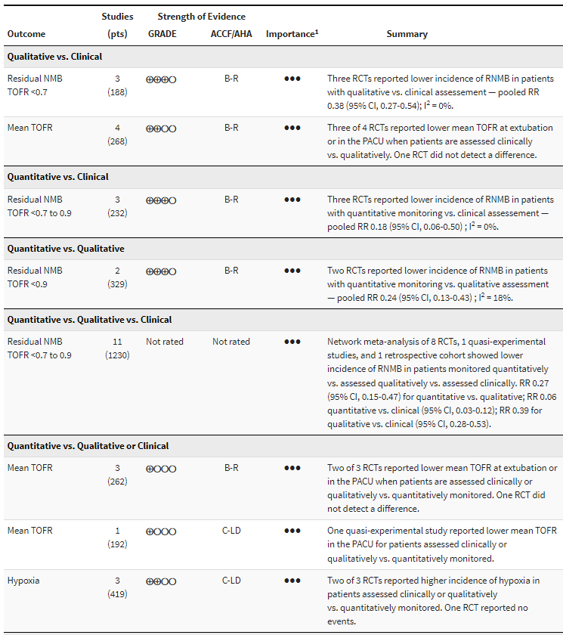
2
2
RNMB: residual neuromuscular blockade; RCT: randomized controlled trial; TOFR: train-of-four ratio; RR: risk ratio;
GRADE: Grading of Recommendations Assessment, Development and Evaluation; ACCF/AHA: American College of Cardiology Foundation/American Heart Association.
GRADE strength of evidence: ⨁⨁⨁⨁ high, ⨁⨁⨁◯ moderate, ⨁⨁◯◯ low, ⨁◯◯◯ very low.
ACCF/AHA ratings: A: high-quality evidence from more than 1 RCT; B-R: moderate-quality evidence from more than 1 RCT; B-NR: moderate-quality evidence from more than one observational study; C-LD: randomized or non-randomized observational or registry studies with limited data; C-EO: consensus of expert opinion.
¹ ● Limited, ●● Important, ●●● Critical.
² Not rated as obtained from network meta-analysis agnostic of study design. However, consistency of effects with that from the randomized designs alone could argue for rating up the strength of evidence.

Supplemental Table 6 (continued). Strength of evidence for outcomes following neuromuscular monitoring (evidence obtained from randomized controlled trials unless noted).
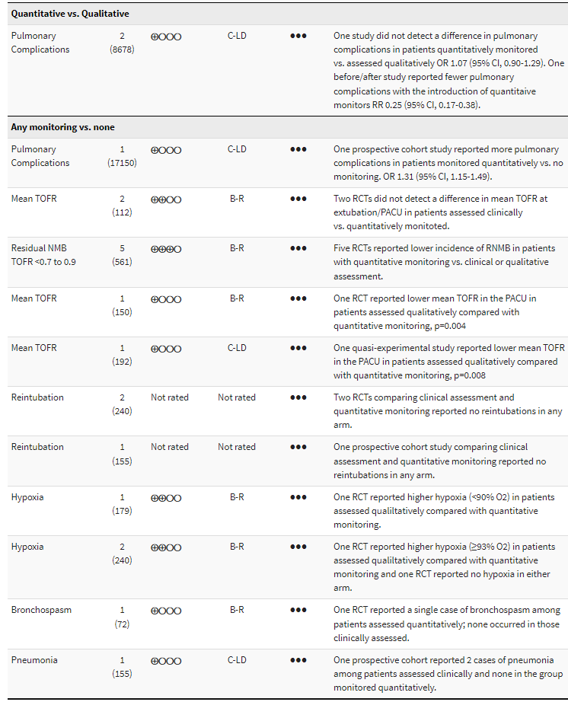
RNMB: residual neuromuscular blockade; RCT: randomized controlled trial; TOFR: train-of-four ratio; RR: risk ratio;
GRADE: Grading of Recommendations Assessment, Development and Evaluation; ACCF/AHA: American College of Cardiology Foundation/American Heart Association.
GRADE strength of evidence: ⨁⨁⨁⨁ high, ⨁⨁⨁◯ moderate, ⨁⨁◯◯ low, ⨁◯◯◯ very low.
ACCF/AHA ratings: A: high-quality evidence from more than 1 RCT; B-R: moderate-quality evidence from more than 1 RCT; B-NR: moderate-quality evidence from more than one observational study; C-LD: randomized or non-randomized observational or registry studies with limited data; C-EO: consensus of expert opinion.
¹ ● Limited, ●● Important, ●●● Critical.

Supplemental Table 7. GRADE domains for strength of evidence ratings relevant to outcomes with neuromuscular monitoring.
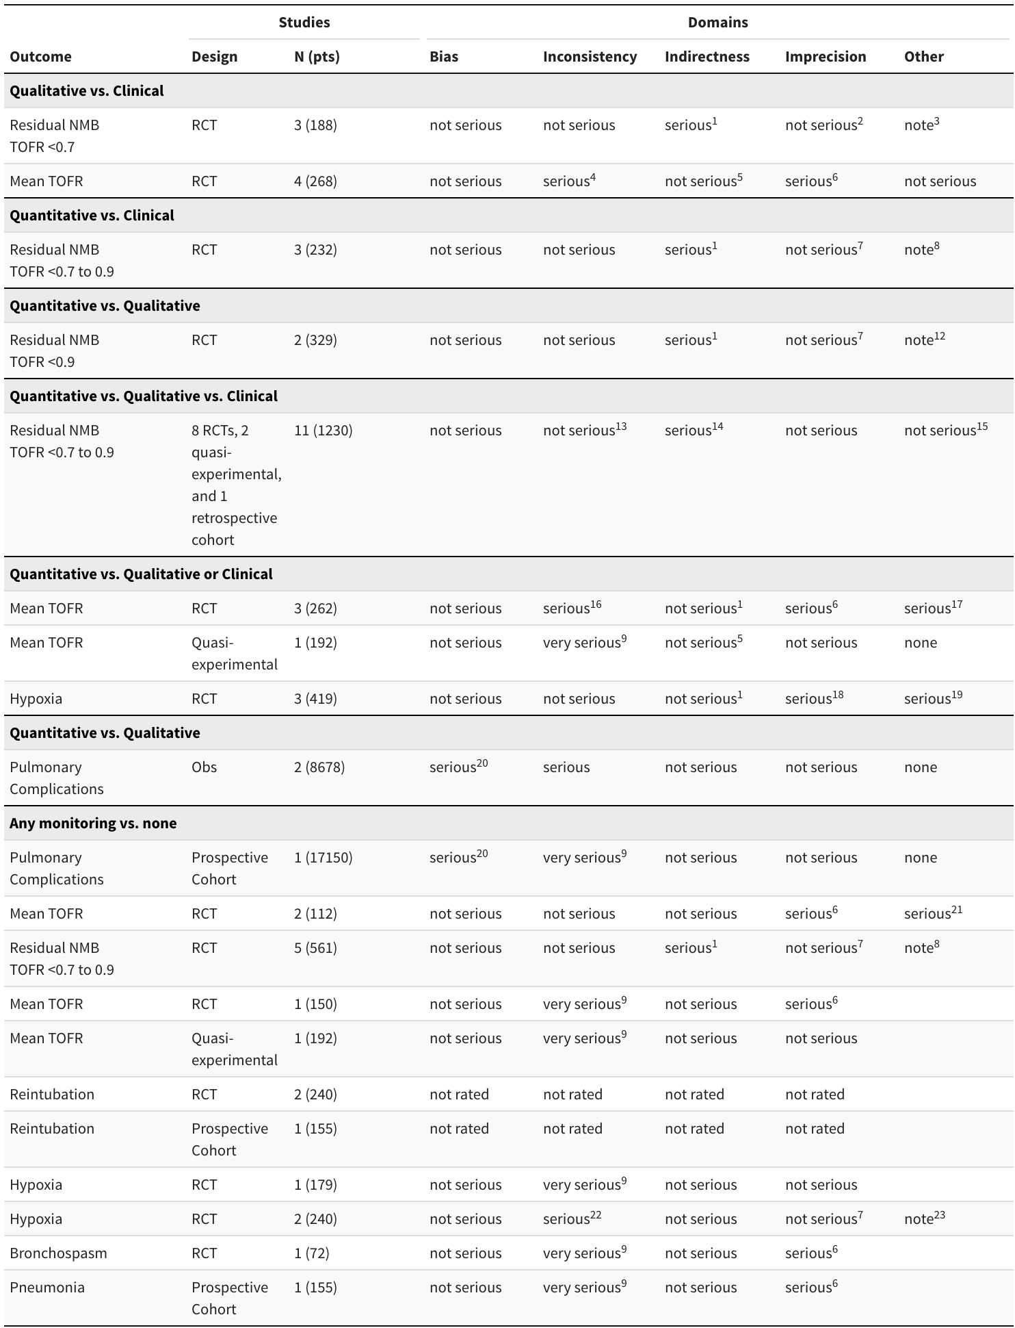
¹ Intermediate outcome; sugammadex not used in any trial.
² Sufficient events given effect size and control incidence.
³ Large effect, but wide prediction interval; too few studies to assess potential publication bias.
⁴ Three of 4 RCTs report lower mean TOFR in patients monitored clinically vs. qualitatively. One did not detect a difference.
⁵ Intermediate outcome; sugammadex not used.
⁶ Estimates have wide confidence intervals.
⁷ Wide confidence interval but not crossing the decision treatment threshold.
⁸ Large effect, but wide confidence and prediction intervals; too few studies to assess potential publication bias.
⁹ Single study cannot assess consistency.
¹⁰ Intermediate outcome.
¹¹ Limited number of events.
¹² Large effect but based on 2 trials from same investigators; too few studies to assess potential publication bias.
¹³ Low heterogeneity (I ² = 25%).
¹⁴ Intermediate outcome; sugammadex used in one observational study.
¹⁵ Large effects but methodological heterogeneity related to different study designs and TOFR thresholds.
¹⁶ Two of 3 RCTs report lower mean TOFR in patients assessed either clinically or qualitatively vs. quantitatively monitoring. One did not detect a difference.
¹⁷ Methodological heterogeneity.
¹⁸ Limited number of events.
¹⁹ Methodological heterogeneity: different thresholds for hypoxia.
²⁰ Deviations from intended interventions.
²¹ Methodological heterogeneity (one measured at extubation, one in PACU).
²² One study reports higher incidence with clinical assessment; one reported none in either arm.
²³ One study defined hypoxia as ≤93% O2; other study did not provide threshold.

Supplemental Table 8. Results from studies reporting residual neuromuscular blockade for the highest train-of-four ratio threshold reported for train-of-four ratio. Risk ratio (RR) compares the lowest incidence (last monitoring arm) to the prior arm(s).
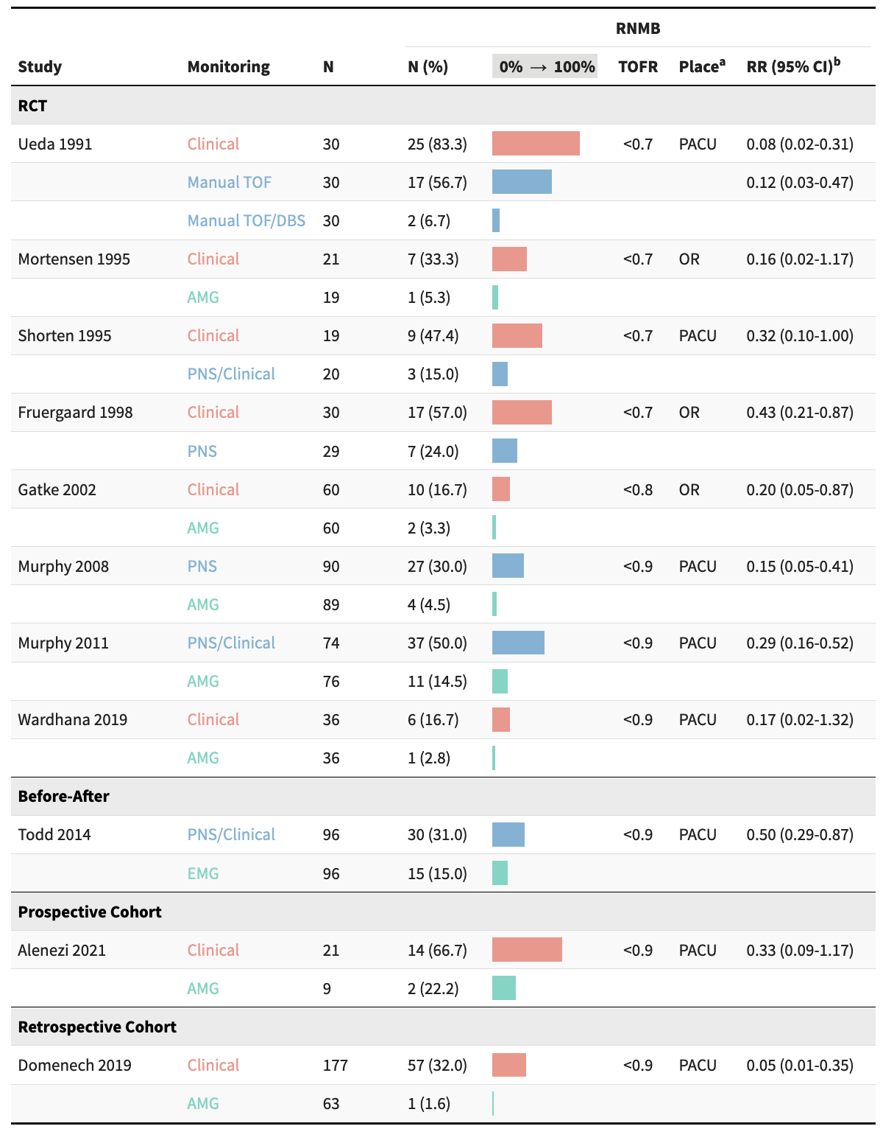
AMG: acceleromyography; DBS: double-burst stimulation; EMG: electromyography; OR: operating room; PACU: postanesthesia care unit; PNS: peripheral nerve stimulator; RCT: randomized controlled trial; RNMB: residual neuromuscular blockade; RR: risk ratio.
ª PACU if designated as PACU or recovery, OR if designated as such or as postextubation.
^{b} Risk ratio comparing the last monitoring arm (lowest incidence) to the prior arm. For studies reporting results for >1 threshold, only those for the highest threshold are shown.

Supplemental Table 9. Anesthetics and antagonist drugs in quantitative monitoring studies.
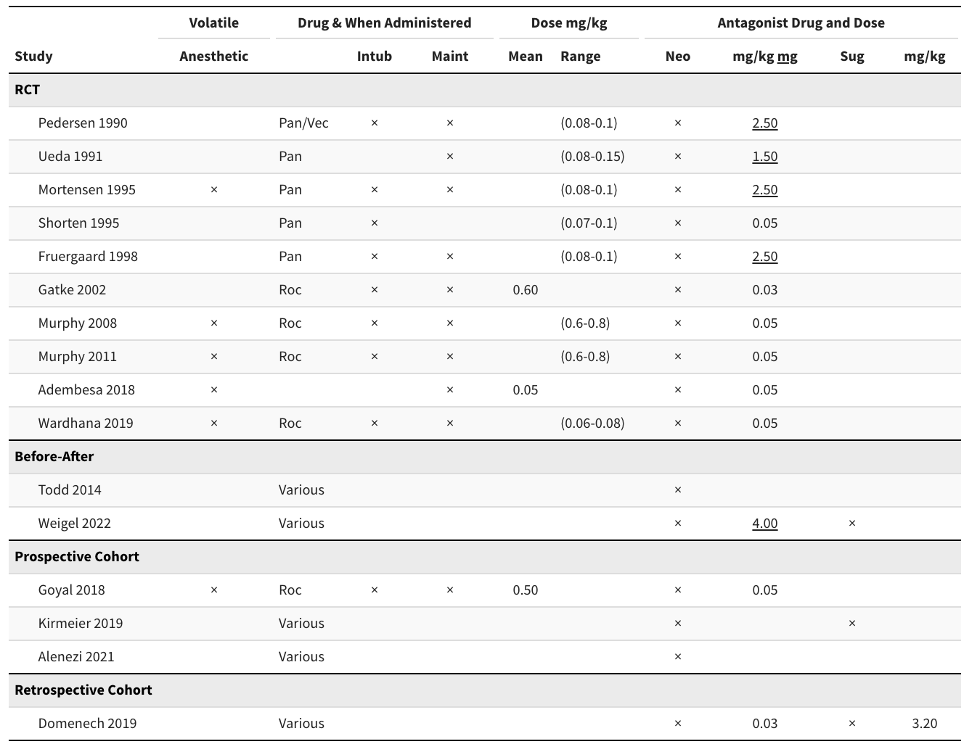
Intub: intubation; Maint: maintenance; Neo: neostigmine; Pan: pancuronium; Roc: rocuronium; RCT: randomized controlled trial; Sug: sugammadex; Vec: vecuronium.

Supplemental Table 10. League table for risk ratios comparing upper left to lower right for residual neuromuscular blockade. Network comparisons in lower left triangle and direct comparisons in upper right. Naive synthesis of randomized and nonrandomized designs.
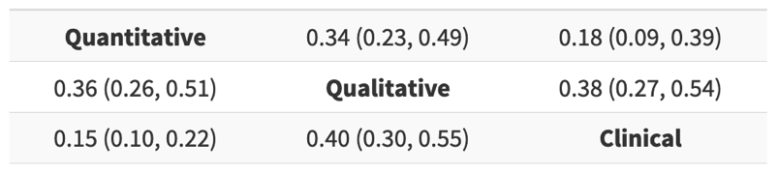

Supplemental Table 11. Strength of evidence for train-of-four ratio confirmation prior to extubation.
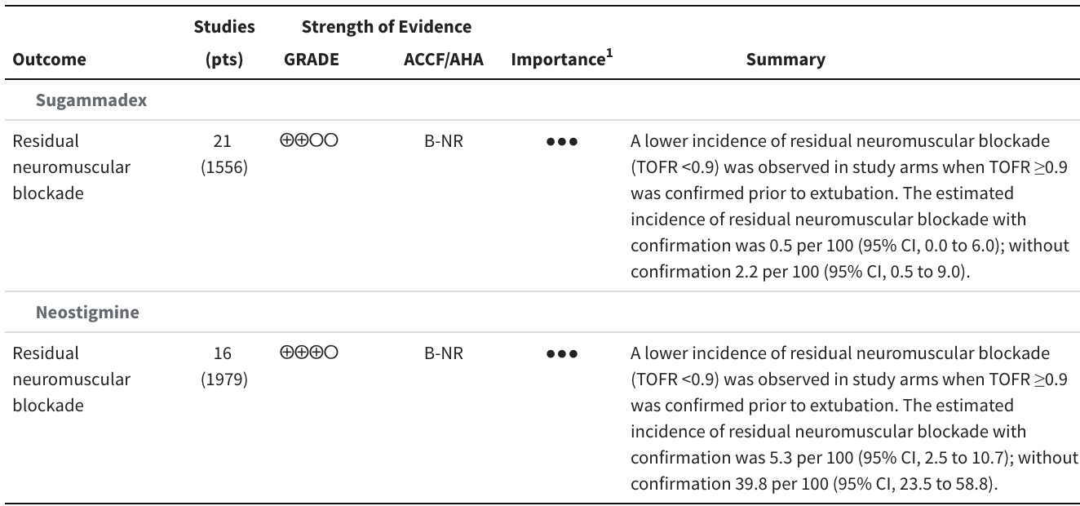
GRADE: Grading of Recommendations Assessment, Development and Evaluation; ACCF/AHA: American College of Cardiology Foundation/American Heart Association; TOFR: train-of-four ratio.
GRADE strength of evidence: ⨁⨁⨁⨁ high, ⨁⨁⨁◯ moderate, ⨁⨁◯◯ low, ⨁◯◯◯ very low.
ACCF/AHA ratings: A: high-quality evidence from more than 1 RCT; B-R: moderate-quality evidence from more than 1 RCT; B-NR: moderate-quality evidence from more than one observational study; C-LD: randomized or non-randomized observational or registry studies with limited data; C-EO: consensus of expert opinion.
¹ ● Limited, ●● Important, ●●● Critical.

Supplemental Table 12. GRADE domains for strength of evidence ratings for train-of-four ratio confirmation prior to extubation.
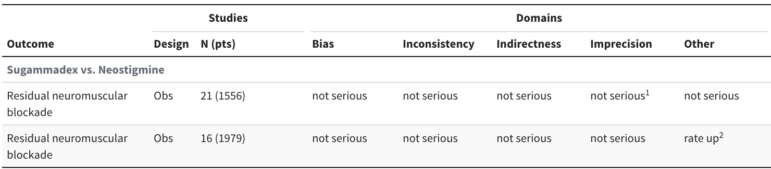
¹ Similar confidence intervals for confirmation or not.
² Strong effect.

Supplemental Table 13. Study arms included in analyses of train-of-four ratio ≥ 0.9 confirmed prior to extubation (sugammadex).
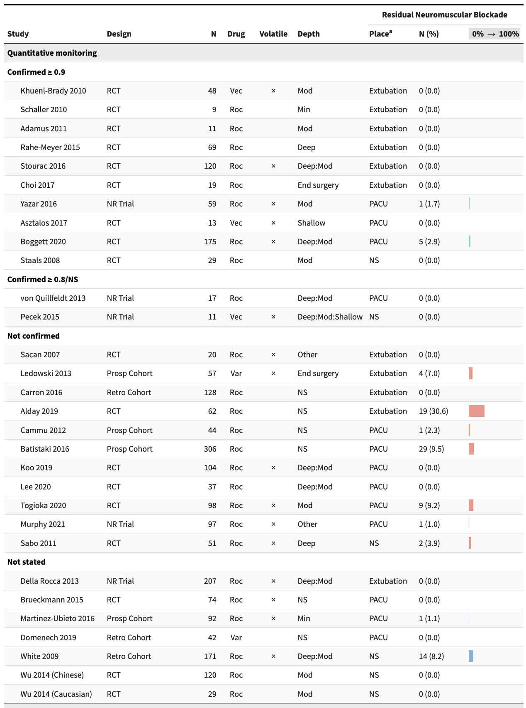
Min: minimal; Mod: moderate; NR Trial: nonrandomized trial; NS: not stated; PACU: postanesthesia care unit; Prosp Cohort: prospective cohort; RCT: randomized controlled trial; Retro Cohort: retrospective cohort; Roc: rocuronium; TOFR: train-of-four ratio; Var: various; Vec: vecuronium.
ª Extubation includes designated in operating room.

Supplemental Table 13 (continued). Study arms included in analyses of train-of-four ratio ≥ 0.9 confirmed prior to extubation (sugammadex).
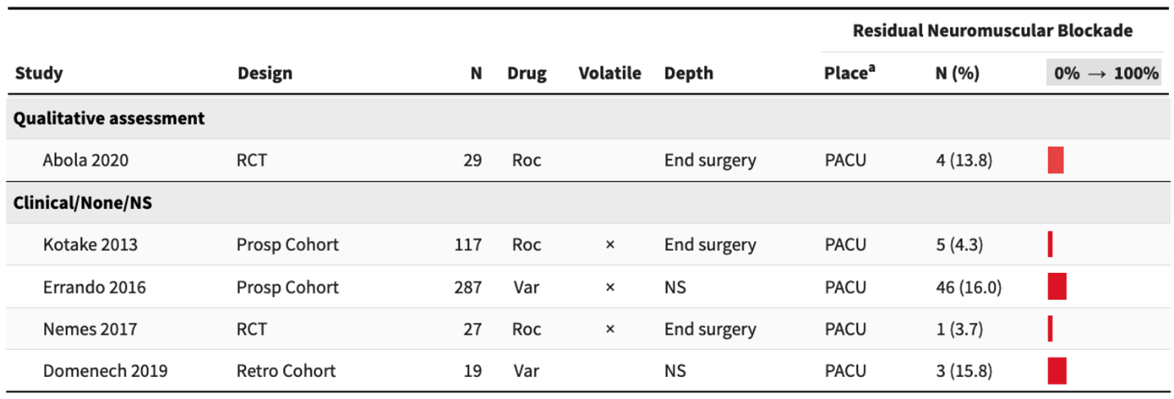
Min: minimal; Mod: moderate; NR Trial: nonrandomized trial; NS: not stated; PACU: postanesthesia care unit; Prosp Cohort: prospective cohort; RCT: randomized controlled trial; Retro Cohort: retrospective cohort; Roc: rocuronium; TOFR: train-of-four ratio; Var: various.
ª Extubation includes designated in operating room.

Supplemental Table 14. Study arms included in analyses of train-of-four ratio ≥ 0.9 confirmed prior to extubation (neostigmine).
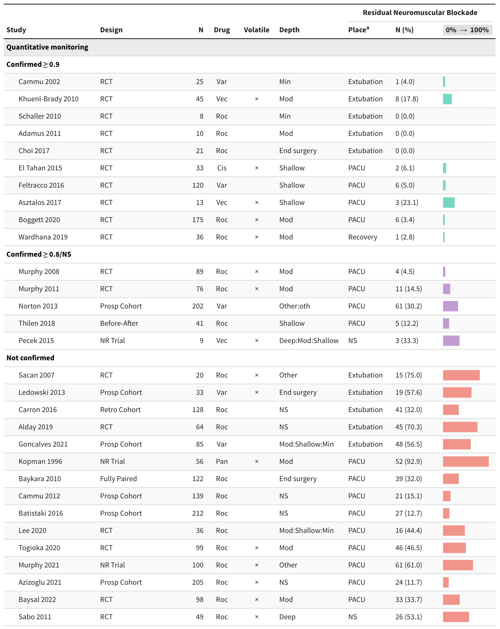
Atr: atracurium; Cis: cisatracurium; Min: minimal; Mod: moderate; NR Trial: nonrandomized trial; NS: not stated; PACU: postanesthesia care unit; Pan; pancuronium; Prosp Cohort: prospective cohort; RCT: randomized controlled trial; Retro Cohort: retrospective cohort; Roc: rocuronium; TOFR: train-of-four ratio; Var: various; Vec: vecuronium.
ª Extubation includes designated in operating room.

Supplemental Table 14 (continued). Study arms included in analyses of train-of-four ratio ≥ 0.9 confirmed prior to extubation (neostigmine).
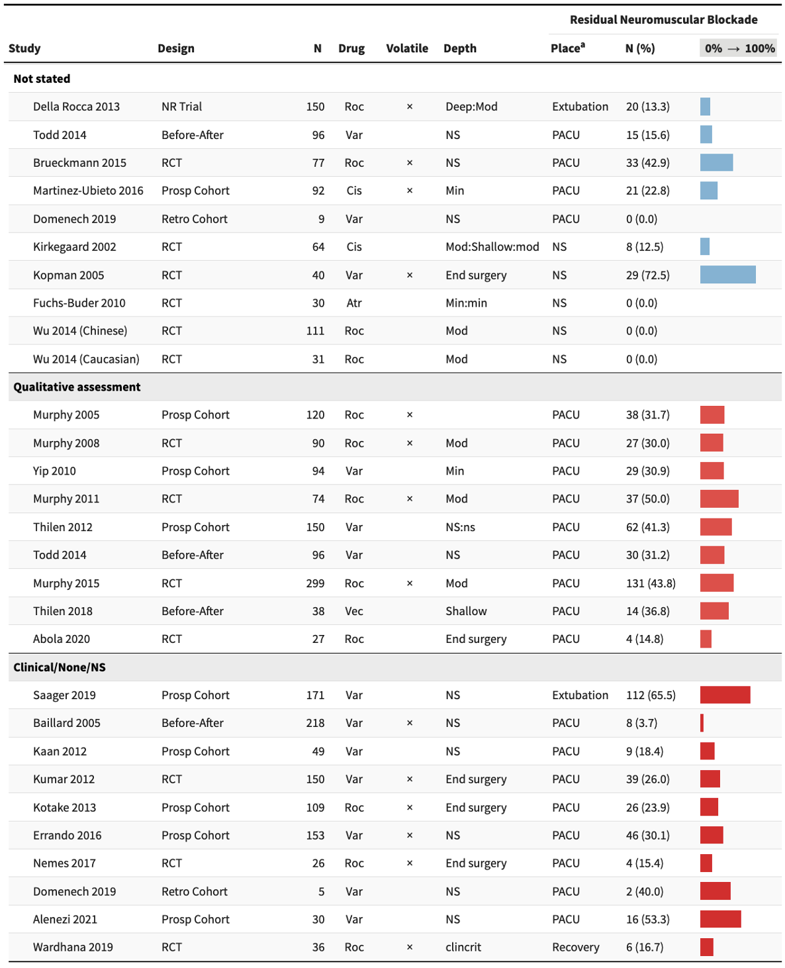
Atr: atracurium; Cis: cisatracurium; Min: minimal; Mod: moderate; NR Trial: nonrandomized trial; NS: not stated; PACU: postanesthesia care unit; Pan; pancuronium; Prosp Cohort: prospective cohort; RCT: randomized controlled trial; Retro Cohort: retrospective cohort; Roc: rocuronium; TOFR: train-of-four ratio; Var: various; Vec: vecuronium.
ª Extubation includes designated in operating room.

Supplemental Table 15. Characteristics of studies comparing different muscles to adductor pollicis for monitoring.
Study | N | Age  Mean (SD) | Agent | Antagonist drug | TOFR threshold | Start time
Fully paired
Adductor pollicis vs. corrugator supercilii
Plaud 2001 | 12 | 36 (15) | Roc | Spon | ≥0.9 | T1 25%
Yamamoto 2015 | 20 | 20-60ª | Roc | Sug, 2 mg/kg | ≥1.0 | Antagonism
 | 20 | 20-60ª |  | Sug, 4 mg/kg
 | 19 | ≥70ª |  | Sug, 2 mg/kg
 | 19 | ≥70ª |  | Sug, 4 mg/kg
Thudium 2020 | 20 | 63.8 (13.4) | Roc | Spon (85%); Sug (15%) | ≥0.9 | Not stated
Adductor pollicis vs. orbicularis oculi
Abdulatif 1997 | 30 | 36.7 | Miv | Spon | ≥0.9 | Block
Larsen 2002 | 16 | 45.5^{b} | Vec | Neo | ≥0.8 | T1 25%
Adductor pollicis vs. masseter
Vega 2016 | 10 | 30^{b} | Roc | Spon | ≥0.9 | Block
Adductor pollicis vs. flexor hallucis brevis
Le Merrer 2020 | 41 | 45 (17) | Atr | Spon (79%); Neo (29%) | ≥0.9 | Block
RCT
Adductor pollicis vs. corrugator supercilii
Suzuki 2009 | 30 | 44 | Roc | Spon | ≥0.9 | Block
Atr: atracurium; Miv: mivacurium; Neo: neostigmine; RCT: randomized controlled trial; Roc: rocuronium; Spon: spontaneous; Sug: sugammadex; TOFR: train-of-four ratio; Vec: vecuronium.
ª Range
^{b} Median

Supplemental Table 16. Time to train-of-four ratio from different muscle groups.

Study | Muscle | N | Age  Mean (SD) | Time (minutes)  Mean (SD) | P value
Fully paired
Plaud 2001 | Adductor pollicis | 12 | 36 (15) | 20 (9) | NS
 | Corrugator supercilii |  |  | 22 (10)
Yamamoto 2015 | Adductor pollicis | 20 | 44.6 (10.4) | 5.5 (2.4) | <0.0001
 | Corrugator supercilii |  |  | 2.7 (0.4)
 | Adductor pollicis | 20 | 43.1 (10.0) | 2.0 (0.16) | <0.0001
 | Corrugator supercilii |  |  | 1.4 (0.21)
 | Adductor pollicis | 19 | 76.6 (5.5) | 6.1 (3.0) | <0.0001
 | Corrugator supercilii |  |  | 3.0 (1.8)
 | Adductor pollicis | 19 | 78.4 (6.0) | 3.0 (0.7) | <0.0001
 | Corrugator supercilii |  |  | 1.5 (0.3)
Thudium 2020 | Adductor pollicis | 20 | 63.8 (13.4) | 49.3 | <0.001
 | Corrugator supercilii |  |  | 29.3
Abdulatif 1997 | Adductor pollicis | 30 | 36.7 | 30.8 (7.4) | <0.001
 | Orbicularis oculi |  |  | 20.2 (4.3)
Larsen 2002 | Adductor pollicis | 16 | 45.5ª | 12.7 (10.7-14.1)^{b} | 0.01
 | Orbicularis oculi |  |  | 10.6 (8.3-13.3)^{b}
Vega 2016 | Adductor pollicis | 10 | 30ª | 29.9 (6.7) | 0.77
 | Masseter |  |  | 29.3 (8.1)
Le Merrer 2020 | Adductor pollicis | 41 | 45 (17) | 67.3 (8.3) | <0.0001
 | Flexor hallucis brevis |  |  | 61.3 (8.6)
 | Adductor pollicis | 11 | 45 (17) | 54.0 (12.4) | 0.28
 | Flexor hallucis brevis |  |  | 53.0 (12.2)
RCT
Suzuki 2009 | Adductor pollicis | 15 | 46.8 (10.2) | 16.2 (6.0) | 0.016
 | Corrugator supercilii | 15 | 42.3 (5.1) | 11.4 (3.8)
RCT: randomized controlled trial; TOFR: train-of-four ratio; NS: not significant.
ª Median
^{b} Median (interquartile range)

Supplemental Table 17. Strength of evidence for outcomes relevant to neuromuscular monitor technical performance.
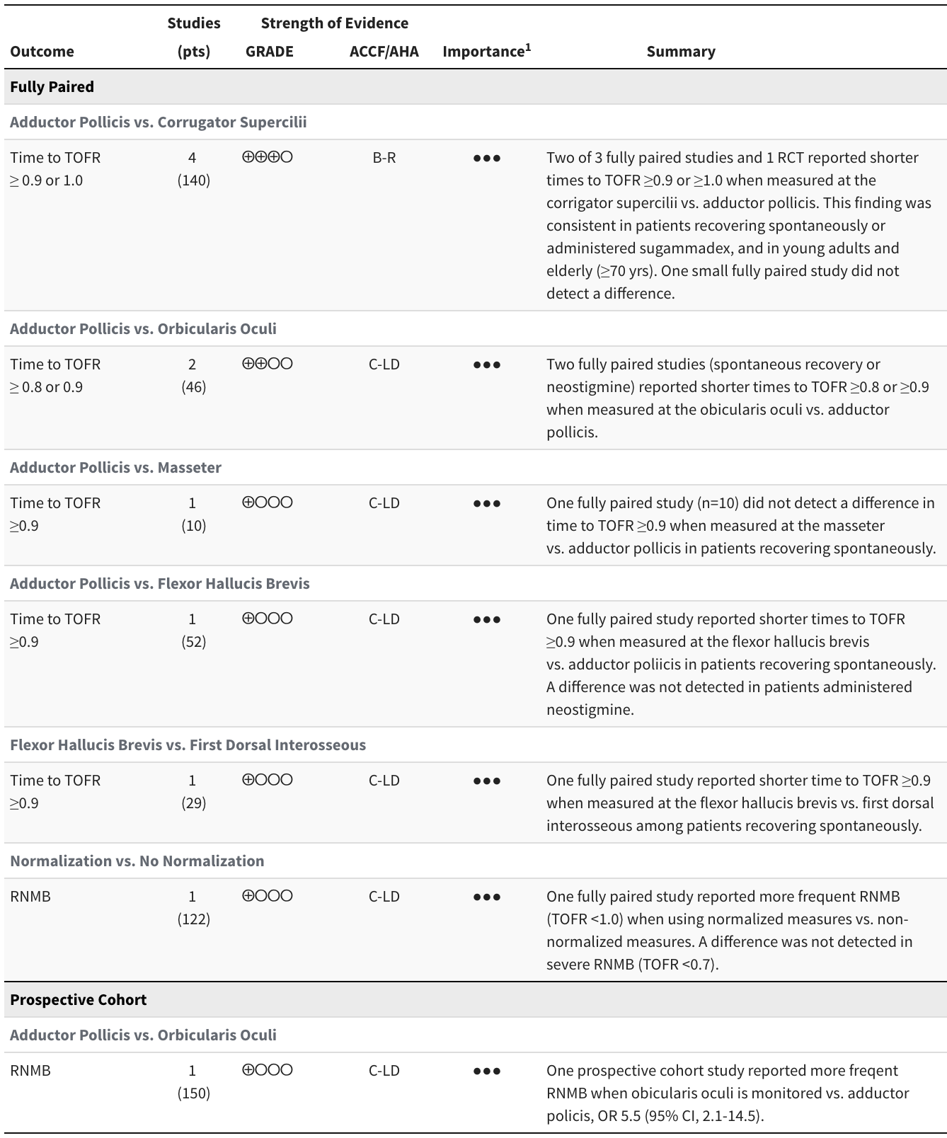
RNMB: residual neuromuscular blockade; TOFR: train-of-four ratio; OR: odds ratio; RCT: randomized controlled trial
GRADE: Grading of Recommendations Assessment, Development and Evaluation
ACCF/AHA; American College of Cardiology Foundation/American Heart Association
GRADE strength of evidence: ⨁⨁⨁⨁ high, ⨁⨁⨁◯ moderate, ⨁⨁◯◯ low, ⨁◯◯◯ very low.
ACCF/AHA ratings: A: high-quality evidence from more than 1 RCT; B-R: moderate-quality evidence from more than 1 RCT; B-NR: moderate-quality evidence from more than one observational study; C-LD: randomized or non-randomized observational or registry studies with limited data; C-EO: consensus of expert opinion.
¹ ● Limited, ●● Important, ●●● Critical.

Supplemental Table 18. GRADE domains for strength of evidence rating for outcomes relevant to neuromuscular monitor technical performance.
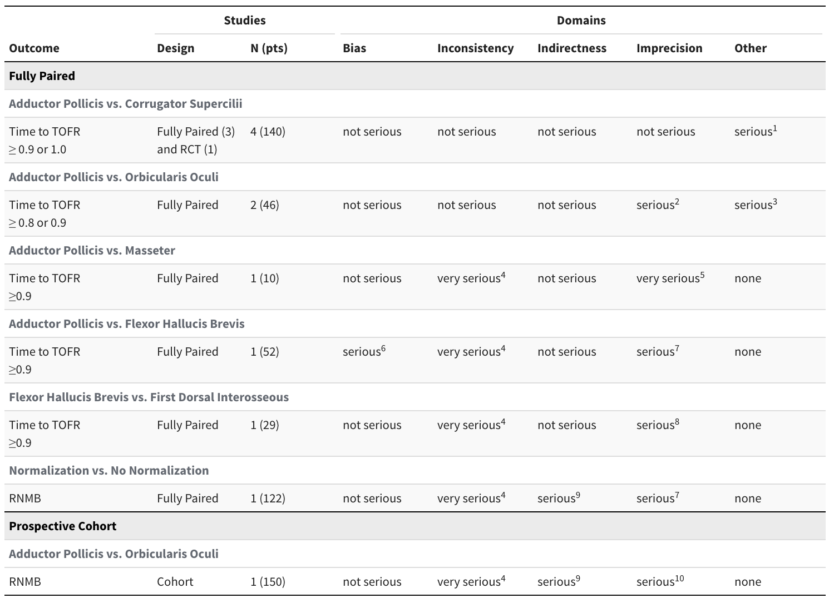
RNMB: residual neuromuscular blockade; TOFR: train-of-four ratio: RCT: randomized controlled trial.
¹ Methodological heterogeneity: spontaneous/sugammadex; TOFR threshold.
² Overlapping distributions in one of the two studies.
³ Methodological heterogeneity.
⁴ Single study cannot assess consistency.
⁵ Estimate has large standard deviation, small sample size (n=10).
⁶ 13% excluded from analysis due to missing data and protocol deviation.
⁷ Estimates have large standard deviations.
⁸ Estimate has large standard deviation.
⁹ Intermediate outcome.
¹⁰ Estimate has wide confidence interval.

Supplemental Table 19. Strength of evidence for outcomes comparing sugammadex with neostigmine.
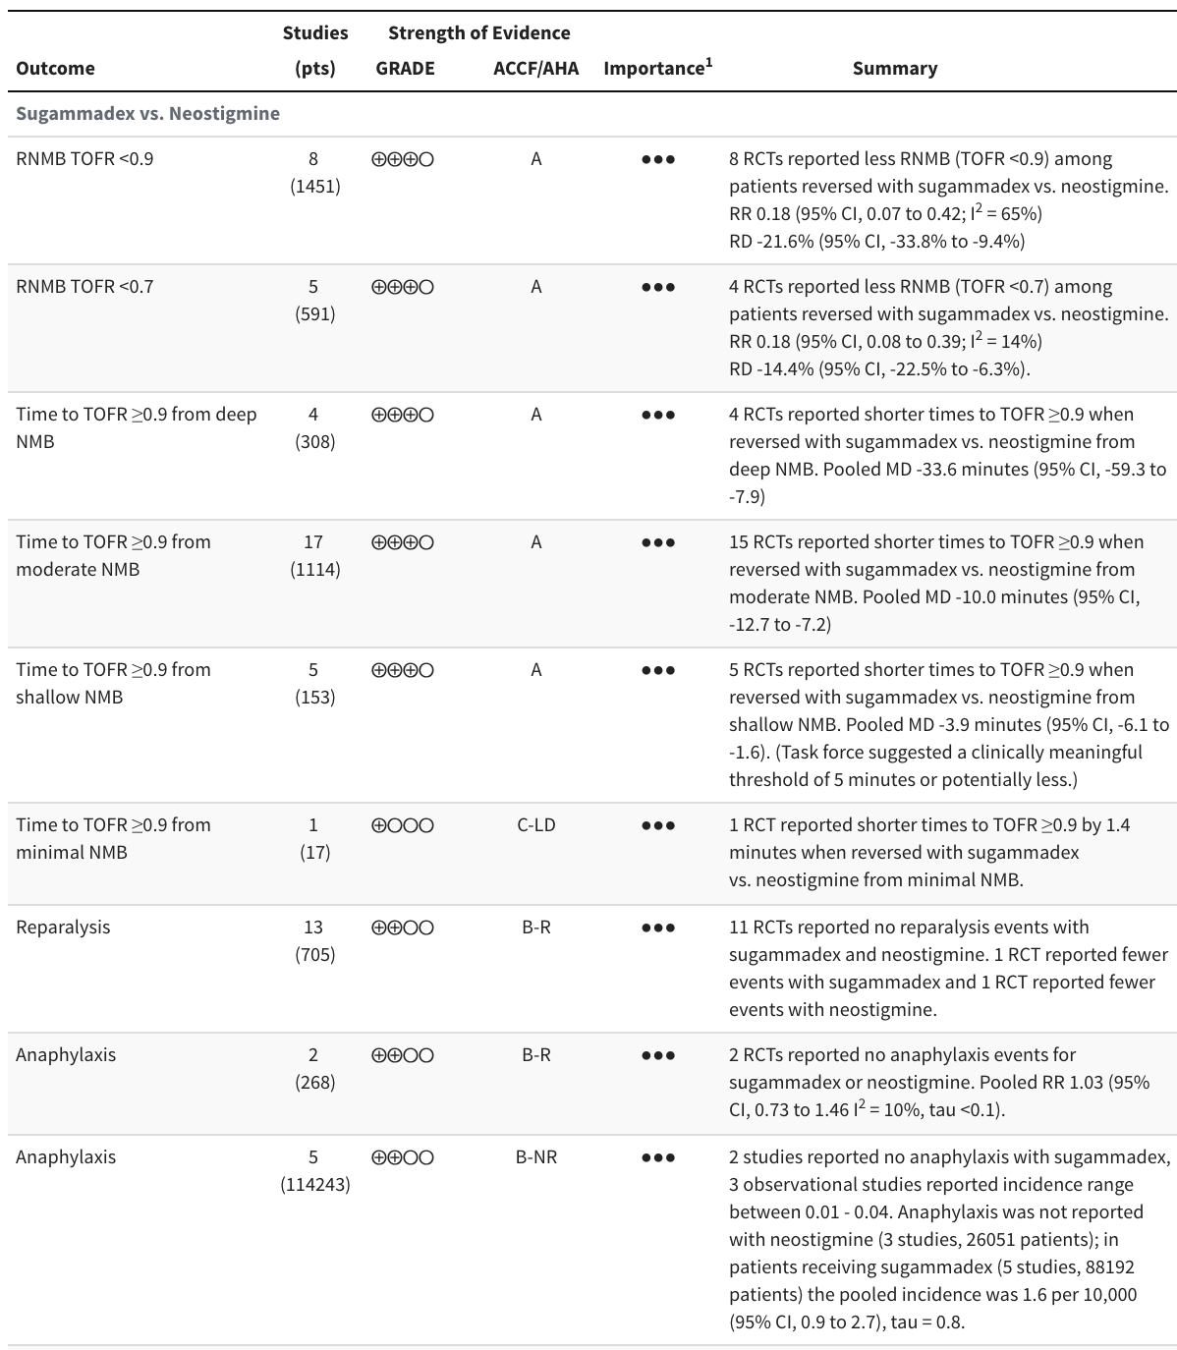
RNMB: residual neuromuscular blockade; RR: risk ratio; RD: risk difference; OR: odds ratio; MD: mean difference; RCT: randomized controlled trial; NRSI: nonrandomized study of interventions.
GRADE: Grading of Recommendations Assessment, Development and Evaluation
ACCF/AHA; American College of Cardiology Foundation/American Heart Association
GRADE strength of evidence: ⨁⨁⨁⨁ high, ⨁⨁⨁◯ moderate, ⨁⨁◯◯ low, ⨁◯◯◯ very low.
ACCF/AHA ratings: A: high-quality evidence from more than 1 RCT; B-R: moderate-quality evidence from more than 1 RCT; B-NR: moderate-quality evidence from more than one observational study; C-LD: randomized or non-randomized observational or registry studies with limited data; C-EO: consensus of expert opinion.
¹ ● Limited, ●● Important, ●●● Critical.

Supplemental Table 19. Strength of evidence for outcomes comparing sugammadex with neostigmine (continued).
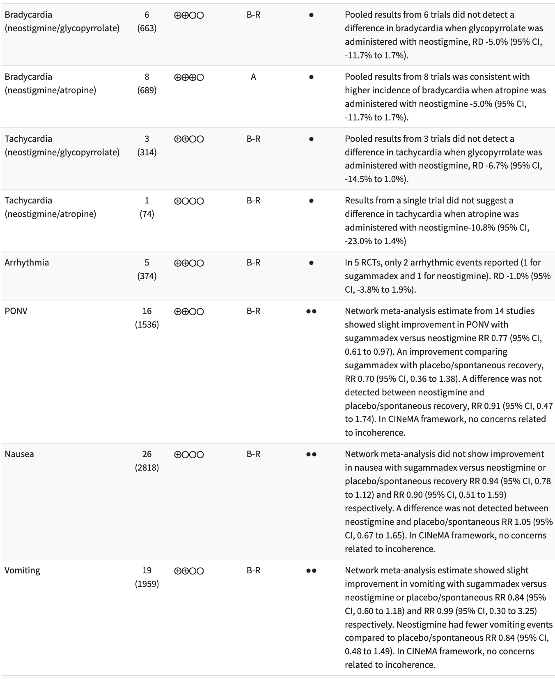
RNMB: residual neuromuscular blockade; RR: risk ratio; RD: risk difference; OR: odds ratio; MD: mean difference; RCT: randomized controlled trial; NRSI: nonrandomized study of interventions; GRADE: Grading of Recommendations Assessment, Development and Evaluation; ACCF/AHA; American College of Cardiology Foundation/American Heart Association
GRADE strength of evidence: ⨁⨁⨁⨁ high, ⨁⨁⨁◯ moderate, ⨁⨁◯◯ low, ⨁◯◯◯ very low.
ACCF/AHA ratings: A: high-quality evidence from more than 1 RCT; B-R: moderate-quality evidence from more than 1 RCT; B-NR: moderate-quality evidence from more than one observational study; C-LD: randomized or non-randomized observational or registry studies with limited data; C-EO: consensus of expert opinion.
¹ ● Limited, ●● Important, ●●● Critical.

Supplemental Table 19. Strength of evidence for outcomes comparing sugammadex with neostigmine (continued).
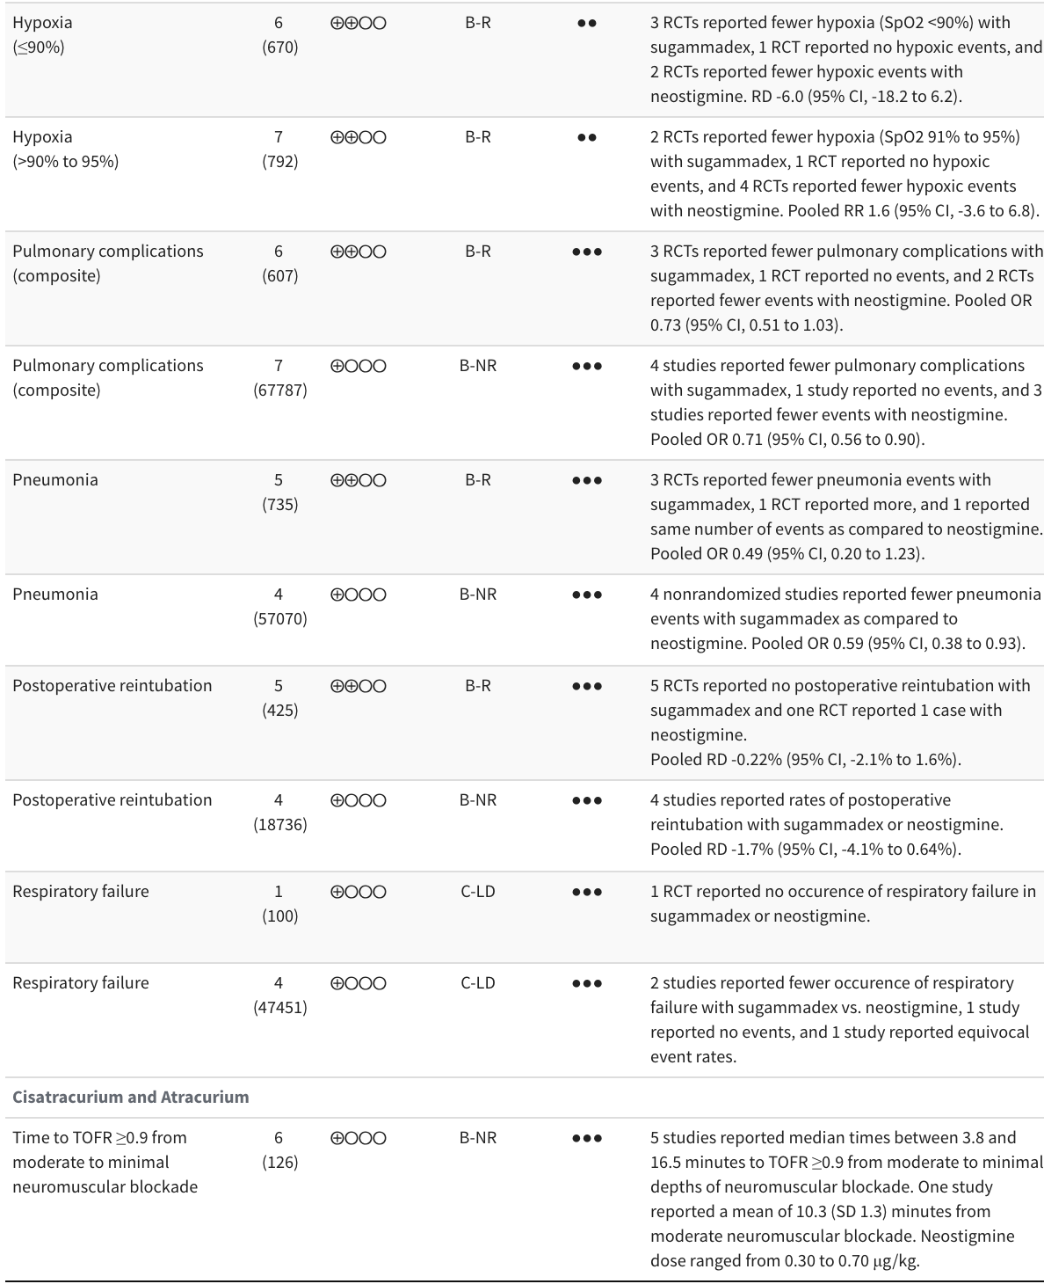
RNMB: residual neuromuscular blockade; RR: risk ratio; RD: risk difference; OR: odds ratio; MD: mean difference; RCT: randomized controlled trial; NRSI: nonrandomized study of interventions; GRADE: Grading of Recommendations Assessment, Development and Evaluatio; ACCF/AHA; American College of Cardiology Foundation/American Heart Association.
GRADE strength of evidence: ⨁⨁⨁⨁ high, ⨁⨁⨁◯ moderate, ⨁⨁◯◯ low, ⨁◯◯◯ very low.
ACCF/AHA ratings: A: high-quality evidence from more than 1 RCT; B-R: moderate-quality evidence from more than 1 RCT; B-NR: moderate-quality evidence from more than one observational study; C-LD: randomized or non-randomized observational or registry studies with limited data; C-EO: consensus of expert opinion.
¹ ● Limited, ●● Important, ●●● Critical.

Supplemental Table 20. GRADE domains for strength of evidence ratings for outcomes comparing sugammadex with neostigmine.
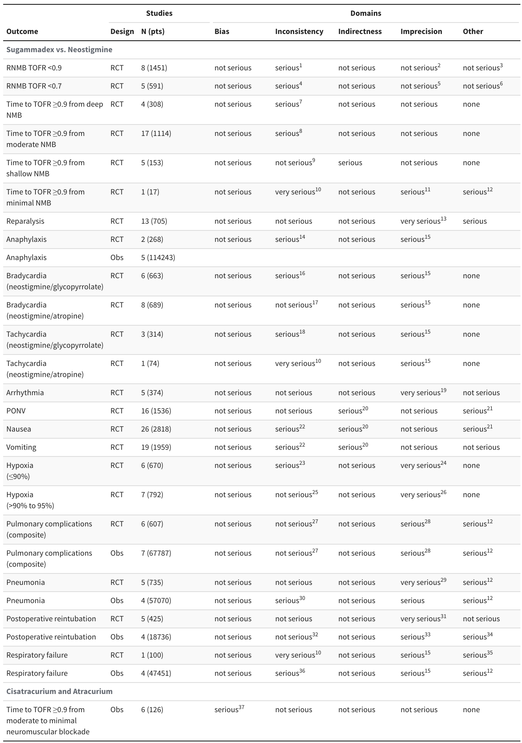
RCT: randomized controlled trial; Obs: observational (nonrandomized).
¹Wide prediction interval (I ² = 65% for pooled RR).
² Wide confidence interval, but upper bound (0.42) would not alter decision.
³ Methodological heterogeneity, but 3 trials did not report depth of block. Large effect ≥≥not rated up owing to consideration of precision.
⁴ Wide 95% prediction interval (0.02–1.48).
⁵ Wide confidence interval, but upper bound (0.39) would not alter decision.
⁶ Methodological heterogeneity, but 2 trials did not report depth of block. Large effect not rated up owing to consideration of precision.
⁷ Considerable heterogeneity (I ² = 96%).
⁸ Considerable heterogeneity (I ² = 97%).
⁹ Considerable heterogeneity (I ² = 88%).
¹⁰ Single study cannot assess consistency.
¹¹ Small sample size.
¹² Methodological heterogeneity (downgraded two levels in combination with inconsistency and precision).
¹³ Low event rate, confidence interval for the risk difference crosses the null (-8.5 to 2.7).
¹⁴ Two studies cannot assess consistency.
¹⁵ Low event rate.
¹⁶ Wide 95% prediction interval (-21.4% to 11.5%).
¹⁷ Based on examination of relative effects.
¹⁸ Discrepant risk differences in the 3 trials.
¹⁹ Only 2 events in the 5 trials.
²⁰ Potential confounding related to use of anti-emetics; 5 studies reported administering antiemetics prophylactically (some concerns CINeMA).
²¹ Asymmetry of comparison-adjusted funnel plot.
²² Wide prediction interval.
²³ Moderate heterogeneity (I ² = 60%).
²⁴ Wide confidence interval consistent with thresholds leading to different decisions. (Imprecision in combination with inconsistency downgraded two levels.).
²⁵ No heterogeneity (I ² = 0%).
²⁶ Wide confidence interval consistent with thresholds leading to different decisions.
²⁷ Low heterogeneity.
²⁸ Confidence interval crossing the null.
²⁹ Confidence interval crossing the null. Wide confidence interval, low event rate.
³⁰ Substantial heterogeneity (I ² = 71%).
³¹ Confidence interval crossing the null. Low event rate.
³² High heterogeneity, but to one small study.
³³ Wide confidence interval.
³⁴ Methodological heterogeneity (downgraded in combination with inconsistency).
³⁵ Methodological heterogeneity.
³⁶ Variable results (not pooled).
³⁷ Unclear on outcome assessor blinding in 2 studies and 1 study reported technical issues with device

Supplemental Table 21. Anaphylaxis in studies comparing sugammadex with neostigmine enrolling adult patients.
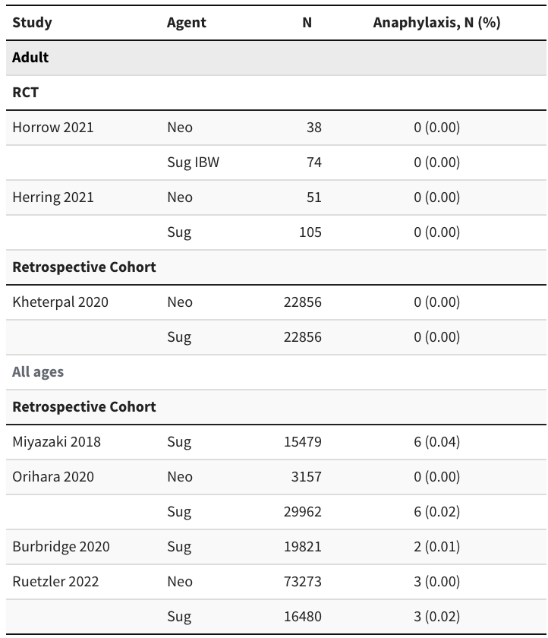
IBW: ideal body weight; Neo: neostigmine; Sug: sugammadex.
Anaphylaxis was unreported with neostigmine (3 studies, 26,051 patients); in patients receiving sugammadex (5 studies, 88,192 patients), the pooled incidence was 1.6 per 10,000 (95% CI, 0.9, 2.7), 𝜏 = 0.8 (identical to the exact confidence interval for 8 events in a sample of 88,192).

Supplemental Table 22. Incidence of arrhythmias in studies comparing sugammadex with neostigmine enrolling adult patients.
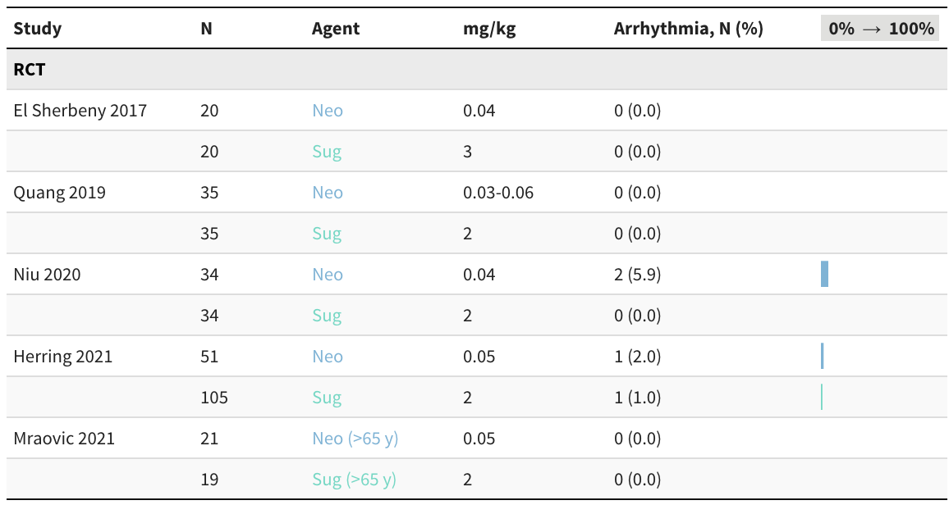
Risk difference for sugammadex vs. neostigmine -1.1% (95% CI, -4.1% to 1.9%).
Neo: neostigmine; Sug: sugammadex.

Supplemental Table 23. Characteristics of monitors in studies reporting agreement (Bland-Altman) at specific train-of-four ratios.
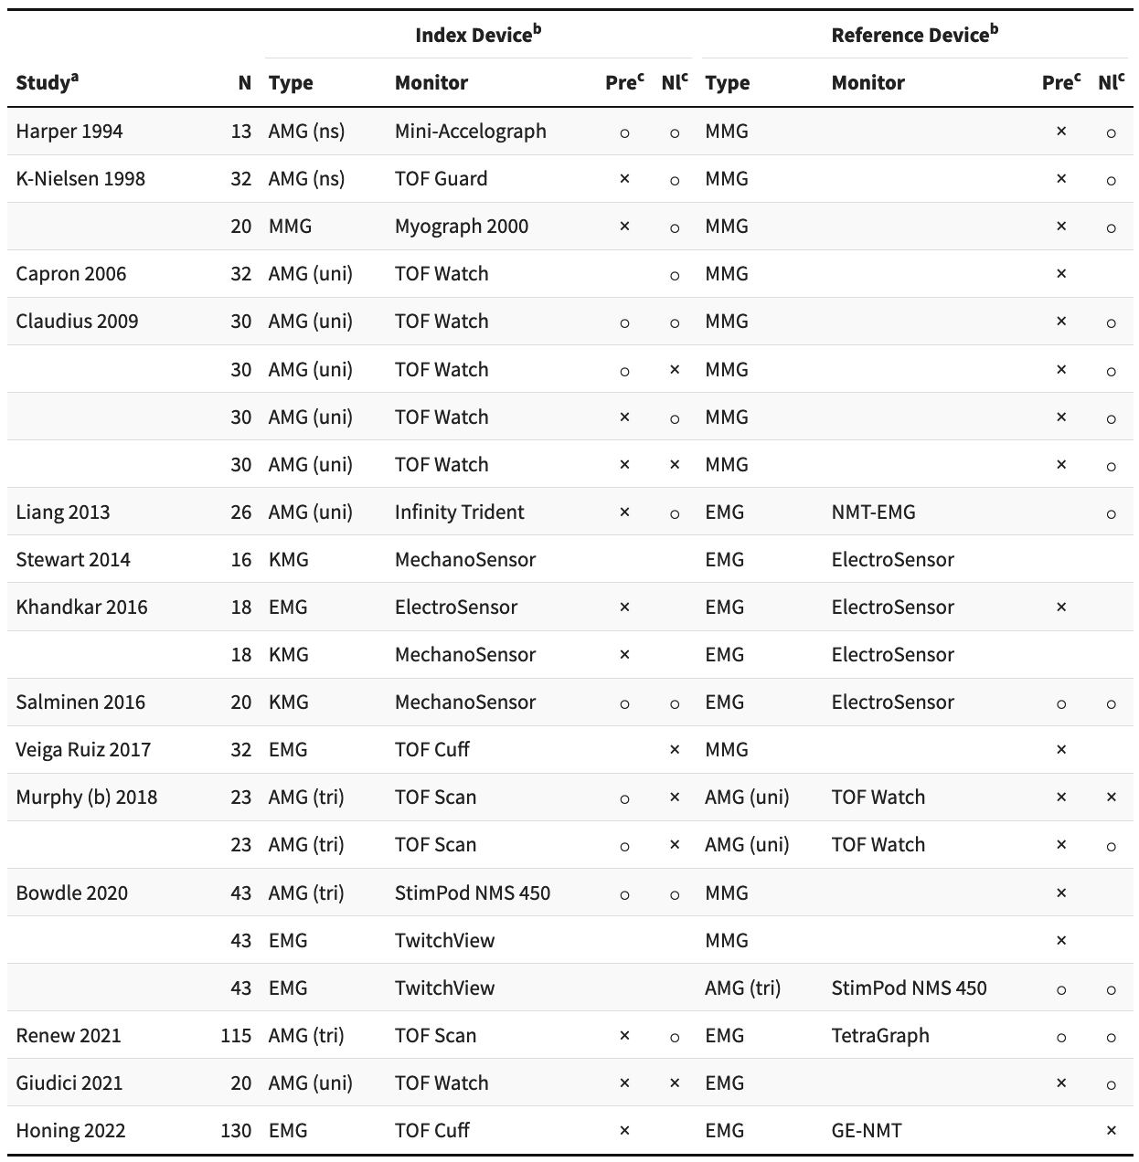
AMG: acceleromyography; EMG: electromyography; KMG: kinemyography; MMG: mechanomyography; NA: not applicable; Nl: normalized; ns: not specified; Pre: preload; TOF, train-of-four; tri: triaxial; uni: uniaxial; ×: yes; ￮: no.
ª Fully paired designs.
^{b} Ulnar nerve except cuff which applies stimulus to the brachial plexus at the humeral level.
^{c} No designation if not reported in publication or not applicable.

Supplemental Table 24. Reported agreement (Bland-Altman) at specific train-of-four ratios.
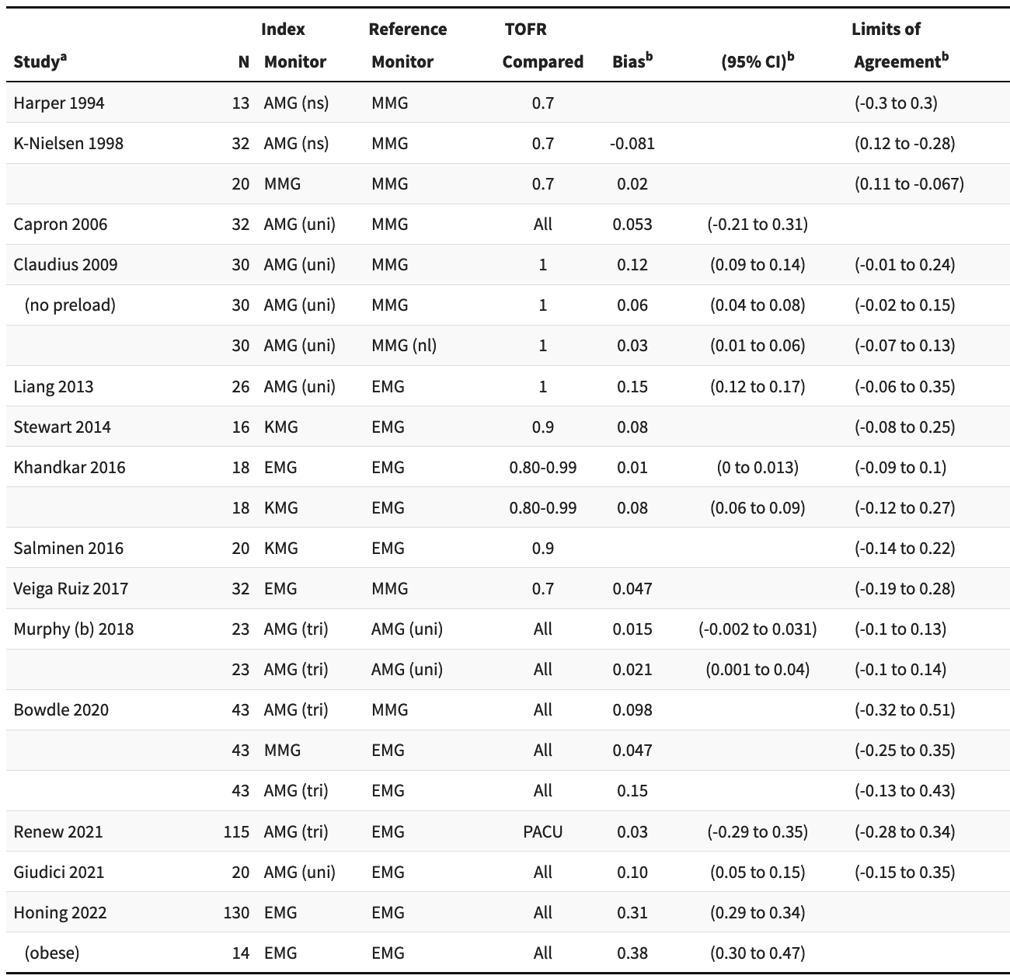
AMG: acceleromyography; EMG: electromyography; KMG: kinemyography; MMG: mechanomyography; PACU: postanesthesia care unit; TOFR: train-of-four ratio; tri: triaxial; uni: uniaxial.
ª Fully paired designs.
^{b} Formatted as proportions if reported as percentages.

Supplemental Table 25. Characteristics of monitors in studies reporting agreement (Bland-Altman) for time to a train-of-four ratio.
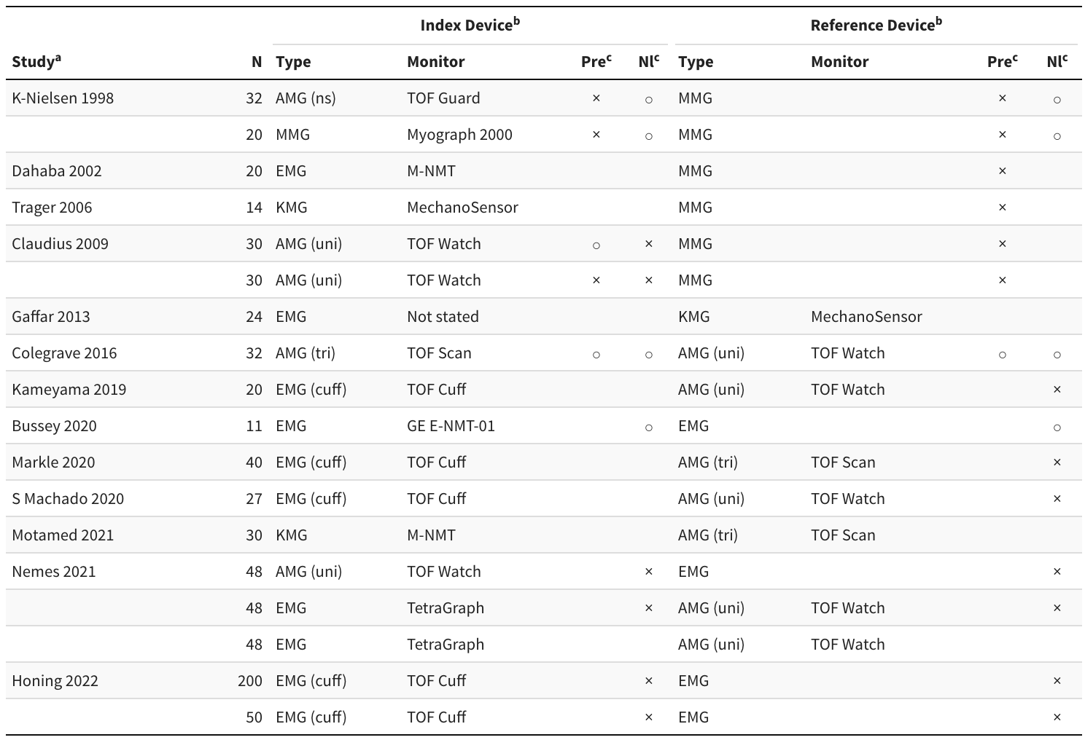
AMG: acceleromyography; EMG: electromyography; KMG: kinemyography; MMG: mechanomyography; Nl: normalized; ns: not specified; Pre: preload; TOF: train-of-four; tri: triaxial; uni: uniaxial; ×: yes; ￮: no.
ª Fully paired designs.
^{b} Ulnar nerve except cuff, which applies stimulus to the brachial plexus at the humeral level.
^{c} No designation if not reported in publication or not applicable.

Supplemental Table 26. Reported agreement (Bland-Altman) for time to a train-of-four ratio.
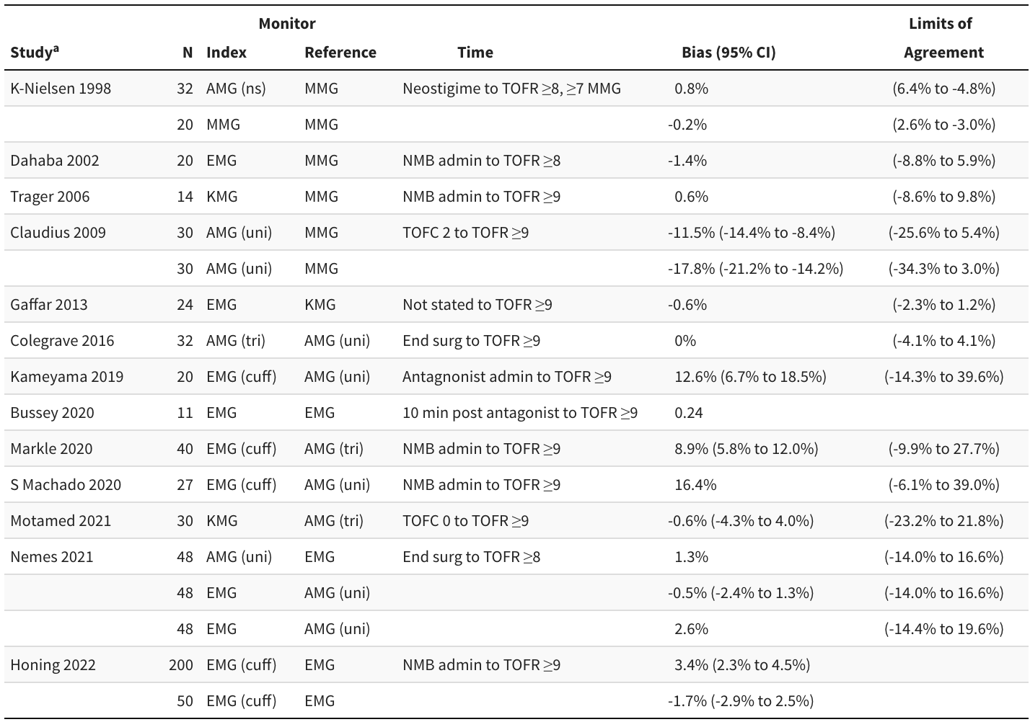
AMG: acceleromyography; EMG: electromyography; KMG: kinemyography; MMG: mechanomyography; NMB: neuromuscular blockade; TOFC: train-of-four count; TOFR: train-of-four ratio; tri: triaxial; uni: uniaxial.
ª Fully paired designs.

