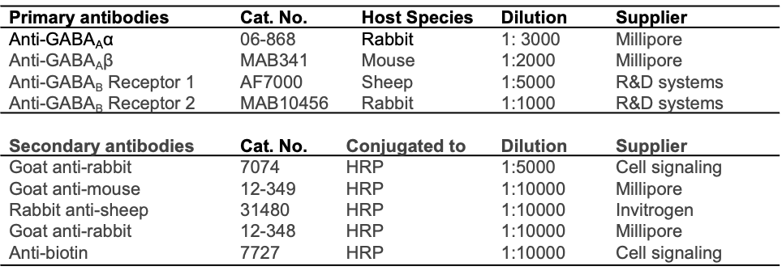
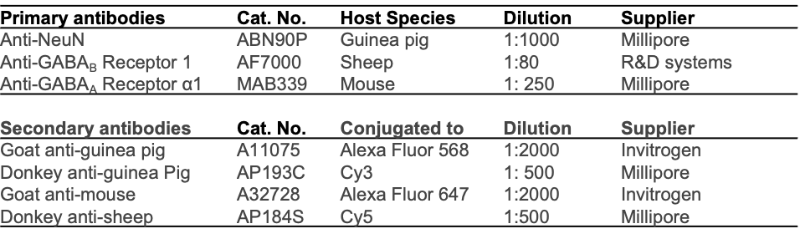
Supplemental Table
IHC
Western blot

