Table S1: TREND Statement Checklist

Paper Section/Topic | Item No | Description | Reported?
Paper Section/Topic | Item No | Description | ✓ | Page #
Title and Abstract
Title and abstract | 1 |  Information on how unit were allocated to interventions | ✓ | 1
Title and abstract | 1 | Structured abstract recommended | ✓ | 4
Title and abstract | 1 | Information on target population or study sample | ✓ | 4
Introduction
Background | 2 | Scientific background and explanation of rationale | ✓ | 6
Background | 2 | Theories used in designing behavioral interventions | NA
Methods
Participants | 3 | Eligibility criteria for participants, including criteria at different levels in recruitment/sampling plan (e.g., cities, clinics, subjects) | ✓ | 7
Participants | 3 | Method of recruitment (e.g., referral, self-selection), including the sampling method if a systematic sampling plan was implemented | ✓ | 7
Participants | 3 | Recruitment setting | ✓ | 7
Participants | 3 | Settings and locations where the data were collected | ✓ | 7
Interventions | 4 | Details of the interventions intended for each study condition and how and when they were actually administered, specifically including: | ✓ | 7-8
Interventions | 4 | - Content: what was given? | ✓ | 7-8
Interventions | 4 | - Delivery method: how was the content given? | ✓ | 7-8
Interventions | 4 | - Unit of delivery: how were the subjects grouped during delivery? | NA
Interventions | 4 | - Deliverer: who delivered the intervention? | ✓ | 7-8
Interventions | 4 | - Setting: where was the intervention delivered? | ✓ | 7-8
Interventions | 4 | - Exposure quantity and duration: how many sessions or episodes or events were intended to be delivered? How long were they  intended to last? | ✓ | 7-8
Interventions | 4 | - Time span: how long was it intended to take to deliver the  intervention to each unit? | NA
Interventions | 4 | - Activities to increase compliance or adherence (e.g., incentives) | NA
Objectives | 5 | Specific objectives and hypotheses | ✓ | 6
Outcomes | 6 | Clearly defined primary and secondary outcome measures | ✓ | 8
Outcomes | 6 | Methods used to collect data and any methods used to enhance the quality of measurements | ✓ | 8
Outcomes | 6 | Information on validated instruments such as psychometric and biometric properties | NA
Sample Size | 7 | How sample size was determined and, when applicable, explanation of any interim analyses and stopping rules | ✓ | 10
Assignment Method | 8 | Unit of assignment (the unit being assigned to study condition, e.g., individual, group, community) | ✓ | 7
Assignment Method | 8 | Method used to assign units to study conditions, including details of any restriction (e.g., blocking, stratification, minimization) | NA
Assignment Method | 8 | Inclusion of aspects employed to help minimize potential bias induced due to non-randomization (e.g., matching) | NA
Blinding (masking) | 9 | Whether or not participants, those administering the interventions, and those assessing the outcomes were blinded to study condition assignment; if so, statement regarding how the blinding was accomplished and how it was assessed. | ✓ | 7
Unit of Analysis | 10 | Description of the smallest unit that is being analyzed to assess intervention effects (e.g., individual, group, or community) | ✓ | 7
 |  | If the unit of analysis differs from the unit of assignment, the analytical method used to account for this (e.g., adjusting the standard error estimates by the design effect or using multilevel analysis) | NA
Statistical Methods | 11 | Statistical methods used to compare study groups for primary methods outcome(s), including complex methods of correlated data | NA
 |  | Statistical methods used for additional analyses, such as a subgroup analyses and adjusted analysis | ✓ | 10
 |  | Methods for imputing missing data, if used | NA
 |  | Statistical software or programs used | ✓ | 10
Results
Participant flow | 12 | Flow of participants through each stage of the study: enrollment, assignment, allocation, and intervention exposure, follow-up, analysis (a diagram is strongly recommended) | ✓ | 11
 |  | - Enrollment: the numbers of participants screened for eligibility, found to be eligible or not eligible, declined to be enrolled, and  enrolled in the study | ✓ | 11
 |  | - Assignment: the numbers of participants assigned to a study  condition | ✓ | 11
 |  | - Allocation and intervention exposure: the number of participants assigned to each study condition and the number of participants  who received each intervention | ✓ | 11
 |  | - Follow-up: the number of participants who completed the follow- up or did not complete the follow-up (i.e., lost to follow-up), by  study condition | ✓ | 11
 |  | - Analysis: the number of participants included in or excluded from  the main analysis, by study condition | ✓ | 11
 |  | Description of protocol deviations from study as planned, along with reasons | ✓ | 11
Recruitment | 13 | Dates defining the periods of recruitment and follow-up | ✓ | 11
Baseline Data | 14 | Baseline demographic and clinical characteristics of participants in each study condition | ✓ | 11
 |  | Baseline characteristics for each study condition relevant to specific disease prevention research | NA
 |  | Baseline comparisons of those lost to follow-up and those retained, overall and by study condition | NA
 |  | Comparison between study population at baseline and target population of interest | NA
Baseline equivalence | 15 | Data on study group equivalence at baseline and statistical methods used to control for baseline differences | NA
Numbers analyzed | 16 | Number of participants (denominator) included in each analysis for each study condition, particularly when the denominators change for different  outcomes; statement of the results in absolute numbers when feasible | ✓ | 11
 |  | Indication of whether the analysis strategy was “intention to treat” or, if not, description of how non-compliers were treated in the analyses | ✓ | 11
Outcomes and estimation | 17 | For each primary and secondary outcome, a summary of results for each estimation study condition, and the estimated effect size and a confidence interval to indicate the precision | ✓ | 11-12
 |  | Inclusion of null and negative findings | ✓ | 11-13
 |  | Inclusion of results from testing pre-specified causal pathways through which the intervention was intended to operate, if any | NA
Ancillary analyses | 18 | Summary of other analyses performed, including subgroup or restricted analyses, indicating which are pre-specified or exploratory | ✓ | 12
Adverse events | 19 | Summary of all important adverse events or unintended effects in each  study condition (including summary measures, effect size estimates, and confidence intervals) | ✓ | 13
Discussion
Interpretation | 20 | Interpretation of the results, taking into account study hypotheses, sources of potential bias, imprecision of measures, multiplicative analyses,  and other limitations or weaknesses of the study | ✓ | 14-15
 |  | Discussion of results taking into account the mechanism by which the intervention was intended to work (causal pathways) or alternative mechanisms or explanations | ✓ | 14-15
 |  | Discussion of the success of and barriers to implementing the intervention, fidelity of implementation | NA
 |  | Discussion of research, programmatic, or policy implications | ✓ | 16
Generalizability | 21 | Generalizability (external validity) of the trial findings, taking into account the study population, the characteristics of the intervention, length of follow-up, incentives, compliance rates, specific sites/settings involved in  the study, and other contextual issues | ✓ | 14-15
Overall evidence | 22 | General interpretation of the results in the context of current evidence and current theory | ✓ | 17

Characteristics | Cycle 1  (n = 50) | Cycle 2  (n = 48) | Cycle 3  (n = 34) | Cycle 4  (n = 18) | Cycle 5  (n = 9)
Red blood cell recovery - % | 82.6 (77.2 - 91.4) | 88.7 (83.3 - 93.6) | 89.9 (80.5 - 95.1) | 89.1 (80.0 - 95.5) | 89.3 (72.1 - 98.6)
Hematocrit Post-treatment - % | 41.2 (37.7 - 44.6) | 42.2 (38.7 - 45.7) | 43.9 (39.0 - 45.9) | 40.8 (36.2 - 43.4) | 39.3 (36.6 - 44.0)
Platelet recovery - % | 45.1 (38.6 - 59.6) | 49.8 (39.1 - 62.6) | 54.1 (40.0 - 58.3) | 49.6 (41.2 - 61.2) | 44.4 (33.1 - 56.7)
Leukocyte recovery - % | 93.4 (83.4 - 100.5) | 89.4 (81.5 - 95.7) | 91.0 (78.6 - 101.1) | 92.0 (78.8 - 101.7) | 81.9 (69.9 - 107.1)
Heparin removal ratio - % | 98.5 (96.0 - 99.7) | 99.4 (98.5 - 99.8) | 99.6 (99.0 - 99.7) | 99.6 (98.4 - 99.8) | 99.6 (99.2 - 99.7)
Free hemoglobin removal ratio - % | 96.0 (93.6 - 97.6) | 94.5 (91.9 - 96.1) | 94.0 (92.0 - 96.6) | 92.7 (88.3 - 95.3) | 93.1 (87.1 - 95.6)
Total proteins removal ratio - % | 94.4 (91.7 - 95.6) | 94.5 (93.4 - 95.4) | 94.3 (92.6 - 95.8) | 94.2 (93.0 - 95.7) | 94.8 (93.2 - 95.8)
Potassium removal ratio - % | 89.6 (85.8 - 92.6) | 89.1 (86.6 - 92.7) | 88.8 (87.2 - 90.7) | 88.9 (84.8 - 90.2) | 89.3 (87.8 - 91.0)
Triglycerides removal ratio - % | 94.2 (91.1 - 95.9) | 94.4 (92.3 - 96.0) | 94.6 (92.5 - 96.0) | 94.7 (92.7 - 96.4) | 95.2 (94.7 - 97.2)

Table S2: Cell recovery and washing performance according to successive treatment cycles

---
Only the first 5 cycles are reported (4 patients underwent 6 cycles and 1 patient 9 cycles).

Table S3: Perioperative evolution of complete blood count in the 50 patients included

Visit Interval | RBC Count  (10¹²/L) | Hemoglobin  (g/dL) | Hematocrit  (%) | WBC Count  (10⁹/L) | Platelet count  (10⁹/L)
Anesthesia induction | 4.3 (4.0 - 4.5) | 13.1 (12.3 - 13.9) | 38.8 (36.0 - 40.4) | 5.5 (4.5 - 6.6) | 195 (169 - 231)
ICU admission (H0) | 3.8 (3.4 - 4.0) | 11.6 (10.6 - 12.3) | 34.1 (31.5 - 36.9) | 12.6 (10.4 - 15.8) | 158 (136 - 199)
Day 1 | 3.8 (3.5 - 4.1) | 11.6 (10.8 - 12.4) | 34.0 (31.5 - 37.0) | 13.8 (11.0 - 16.5) | 182 (143 - 207)
Day 2 | 3.4 (3.0 - 3.7) | 10.6 (9.3 - 11.5) | 31.0 (27.5 - 34.1) | 12.2 (10.6 - 15.0) | 149 (131 - 176)

Table S4: Perioperative adverse events

Adverse events | Number of events
Adverse Events | 245
Not related to procedure or device | 99
Related to cardiac procedure | 146
possibly related | 45
probably related | 56
definitely related | 45
Related to device (Adverse Device Effects) | 0
Severity
Mild | 28
Moderate | 198
Severe | 19
Outcome
Recovered | 218
Ongoing / Not recovered | 24
Fatal | 3
Serious Adverse Events | 16

Table S5: Perioperative serious adverse events

Events | Day 0 to day 7 | Day 7 to day 30 | All SAE
Reintervention for bleeding
Pericardial effusion | 3ª | 3 | 6
Pericardial tamponade | 0 | 1 | 1
Surgical bleeding | 1^{b} | 0 | 1
Cardiogenic shock | 2 | 0 | 2
Stroke | 0 | 1 | 1
Arrhythmia | 0 | 1 | 1
Pneumothorax | 1 | 0 | 1
Infection
Mediastinitis | 1 | 0 | 1
Sternal wound infection | 1 | 0 | 1
Metastatic cancer (diagnosed after surgery) | 1 | 0 | 1
ª no reintervention within 48 hours after surgery
^{b} left internal mammary artery bleeding

Figure S1: sameTM by i-SEP autotransfusion device.
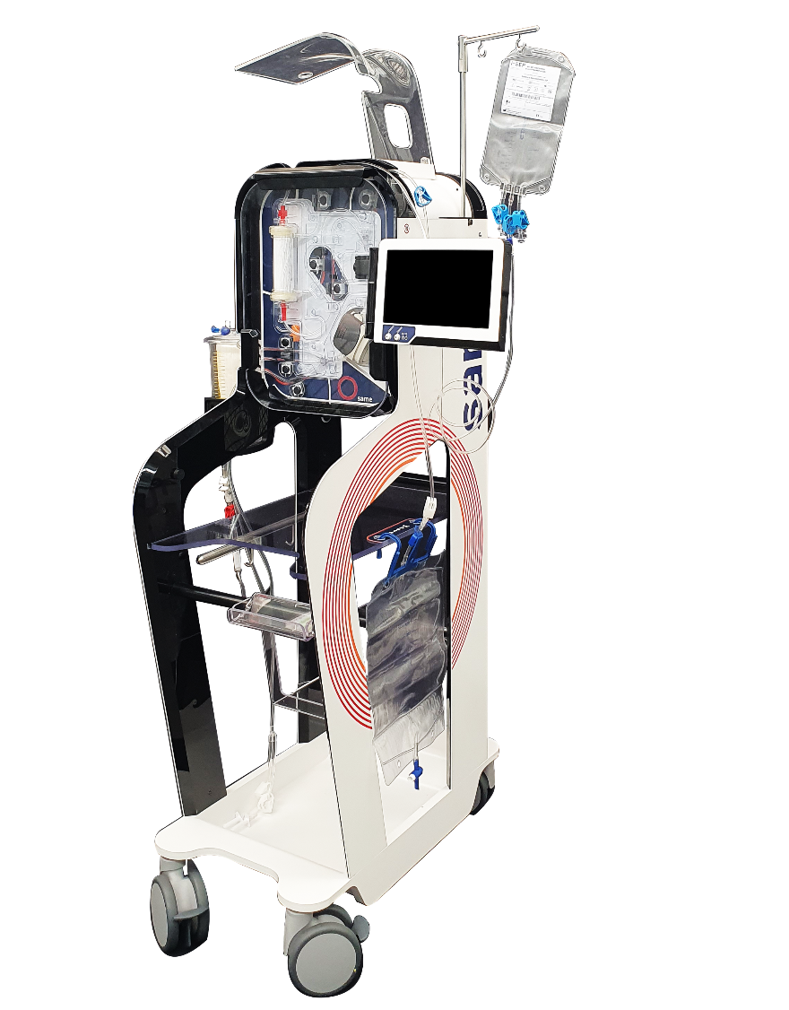

Figure S2: Effect of i-SEP device processing on active GpIIbIIIa platelet expression and evaluation of platelet activation potential by thrombin receptor pathway stimulation using thrombin receptor-activating peptide 6 (TRAP6)
Active GpIIbIIIa expression reported as the number of receptors per platelet, measured between pre-treatment and post-treatment blood for the first and second cycles. This analysis was performed in one center for 17 patients. **P < 0.01, ***P < 0.001. +, platelet stimulation by thrombin receptor-activating peptide 6 (TRAP6); −, absence of platelet stimulation by TRAP6.

