Appendix A: Burnout survey sent to anesthesiologists

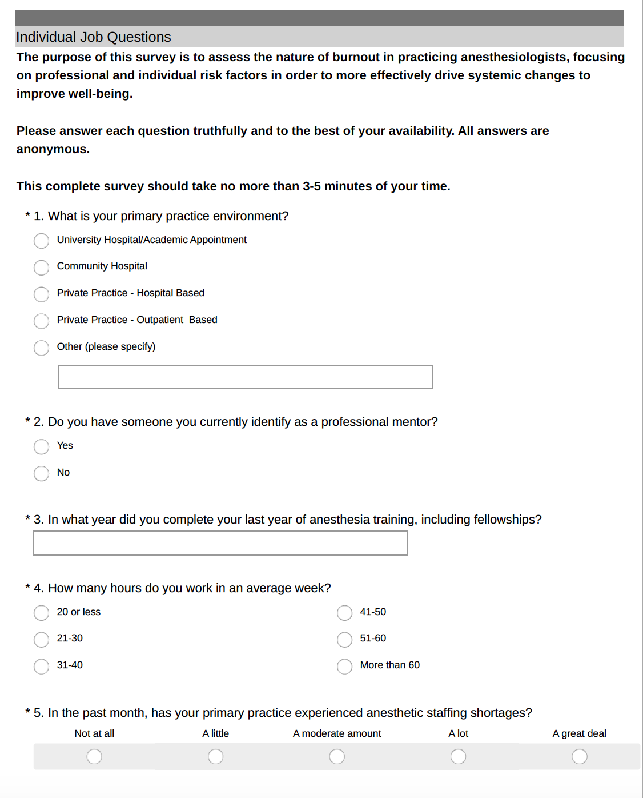

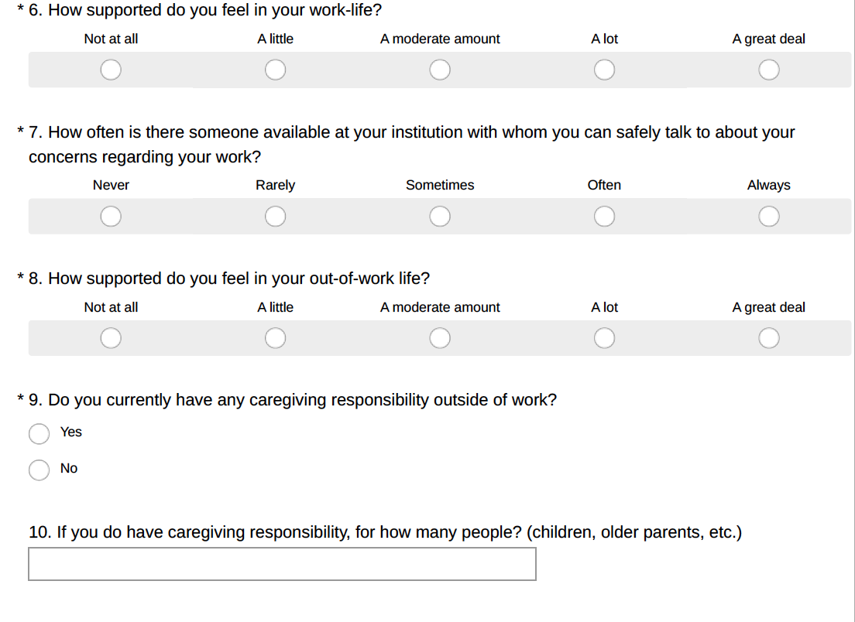

** MBI-HSS Questionnaire (#11-32) **
