Supplemental Digital Content
Contents
Search Strategy 2
Additional information about data extraction and analysis 16
Excluded publications after screening of full text versions and conference abstracts 18
Identification of duplicate publications 81
Excluded duplicate publications 83
Analysis of included publications 85
Effectiveness outcomes in the included studies (mixed indication) 88
Meta-analysis of effectiveness and safety outcomes 90
Table 7. Meta-analysis of effectiveness outcomes, survival (random-effect model) 90
Table 8. Meta-analysis of effectiveness outcomes, weaning from support or bridging to repeat heart transplant or VAD (random-effect model) 91
Table 10. Meta-analysis of effectiveness outcomes with exclusion of studies, which contribute to heterogeneity (random-effect model) 93
Table 11. Meta-analysis of effectiveness outcomes with exclusion of studies, which contribute to heterogeneity (fixed-effect model) 94
Table 12. Meta-analysis of adverse events (proportion of patients experienced adverse event) (random-effect model) 95
Table 13. Meta-analysis of adverse events (proportion of patients experienced adverse event) (fixed-effect model) 96
Technical data. VAD support in pre-cardiotomy cardiogenic shock indication 99
Technical data. VAD support in post-cardiac surgery cardiogenic shock indication 103
Technical data. VAD support in post-transplant graft rejection or failure indication 106
Technical data. Post-LVAD placement right ventricular failure indication 108
Technical data. Adverse events 112
Technical data. Analysis of adverse events in adult and paediatric populations 119
Additional references 127
R-code for meta-analysis of effectiveness and safety outcomes 129

Search Strategy

The Ovid interface was used for Medline and Medline (R) In-Process, the EMBASE interface for the EMBASE database, and The Cochrane Library interface for the CENTRAL and NHS EED databases. The manufacturer of CentriMag (Thoratec Corporation, Pleasanton, CA, USA) and authors provided information about unpublished studies, if available.
Study Selection
The following inclusion criteria were used:
- Population: no restrictions;
- Interventions: magnetically levitated centrifugal pump; CentriMag or PediVAS (manufactured by Levitronix or Thoratec), for extracorporeal membrane oxygenation or ventricular assistance;
- Study design: multiple patient studies including patient registries and audits, case-series studies, cohort studies, observational studies and case-control studies (case studies were accepted for reports of adverse events);
- Language: no restrictions;
- Search dates: from 2003 – present.
Animal and benchtop laboratory studies were excluded. If device name was not stated in the abstract, full text was acquired. As CentriMag entered the market in late 2003, searches were conducted from this date.
During screening of abstracts and evaluation of full text versions, relevance of non-English publications was assessed by native speakers at Synergus AB. To enable review, included non-English publications were professionally translated.
The search strategy for clinical evidence, economic evidence and adverse events in Medline and Medline (R) In-Process databases via OVID, is presented below. The approach recommended in current versions of the Cochrane Handbook for Systematic Reviews of Interventions⁶ and CRD’s Guidance for Undertaking Reviews in Healthcare⁶⁴, was used to construct the search strategy. The search strategy consists of a disease and outcomes domain (terms #1-20), a device domain (terms #22-38), an adverse events domain (terms #40-55) and an economics domain (terms #57-71). Boolean operators were used to combine the search terms. Modifications to the medical devices adverse events search filter, recommended by the InterTASC Information Specialists’ Sub-Group, were incorporated into the search strategy⁶⁴. Search filters for economic evaluations, recommended by the InterTASC Information Specialists’ Sub-Group, were used in the search strategy⁶⁴. Search strategy was not limited to the brand-name CentriMag, but was designed to identify publications in which ventricular assist devices or ECMO systems were used in patients with acute cardiac or cardiac-pulmonary failure.
Search strategy in Medline and Medline (R) In-Process databases via OVID
# | Search terms
1 | Heart Failure/ or Heart Failure, Diastolic/ or Heart Failure, Systolic/
2 | exp Myocardial Infarction/
3 | Respiratory Distress Syndrome, Adult/
4 | Respiratory Distress Syndrome, Newborn/
5 | Respiratory Insufficiency/
5 | cardiogenic shock$.ti,ab.
6 | (respirat$ adj3 (failure$ or insuffi$)).ti,ab.
7 | Hyaline Membrane Disease/
8 | (respirat$ distress syndrom$ or RDS).ti,ab.
9 | heart transplant$.ti,ab. or heart transplantation/ or exp Lung Transplantation/ or lung transplant$.ti,ab. or heart-lung transplant$.ti,ab.
10 | Myocarditis/
11 | Cardiomyopathies/ or Cardiomyopathies, Dilated/
12 | heart failure$.ti,ab.
13 | fulminant myocarditis.ti,ab.
14 | myocardial infarction$.ti,ab.
15 | cardiac failure$.ti,ab.
16 | Hernia, Diaphragmatic/ or congenital diaphragmatic hernia$.ti,ab.
17 | Meconium Aspiration Syndrome/ or meconium aspiration syndrom$.ti,ab.
18 | Persistent Fetal Circulation Syndrome/ or persistent fetal circulation syndrom$.ti,ab.
19 | (cardio-respiratory failure$ or cardiorespiratory failure$):ti,ab
20 | Exp Treatment Outcome/ or treatment outcome$.ti,ab. or Critical Illness/ or critical illness$.ti,ab.
21 | Or/1-20
22 | Heart, Artificial/
23 | Assisted Circulation/
24 | Heart-Lung Machine/
25 | (centrimag or centri-mag or centri mag or pedivas or pedi vas or pedi-vas or pedimag or pedi-mag or pedi mag or levitronix or thoratec).tw.
26 | Heart-Assist Devices/
27 | Extracorporeal Membrane Oxygenation/
28 | ((extracorporeal or extra corporeal or extra-corporeal) adj3 membrane oxygenation).ti,ab.
29 | Cardiopulmonary Bypass/
30 | Heart Bypass, Left/ or Heart Bypass, Right/
31 | mechanical circulatory support$.ti,ab.
32 | ((ventricular or biventricular or bi-ventricular) adj3 assist$).ti,ab.
33 | ECMO.ti,ab.
34 | (VAD$ or LVAD$ or L-VAD$ or RVAD$ or R-VAD$ or Bi-VAD$ or BiVAD$).ti,ab.
35 | (cardiac surgical procedures/ or cardiac surgical procedure$.ti,ab.) and (heart failure/ or heart failure$.ti,ab.)
36 | (magnetically and levitated and pump$).tw.
37 | (exp Magnetics/ or magnetic$.ti,ab.) and (22 or 24 or 26 or 27 or 28 or 33 or 34)
38 | (Centrifugation/ or centrifugation$.ti,ab.) and (22 or 24 or 26 or 27 or 28 or 33 or 34)
39 | Or/22-38
40 | Thrombosis/ or Thromboembolism/ or Embolism/
41 | thromb$.ti,ab.
42 | Disseminated Intravascular Coagulation/
43 | (intravascular clotting or blood clotting).ti,ab.
44 | Hemorrhage/ or Blood Loss Surgical/ or Postoperative Hemorrhage/
45 | (hemorrhage$ or haemorrhage$ or bleed$).ti,ab.
46 | Equipment Failure/ or Product Surveillance, Postmarketing/ or Clinical Trials, Phase IV as Topic/
47 | ((mechanical or device or equipment) adj3 failure$).tw.
48 | (safe or safety).ti,ab.
49 | side effect$.ti,ab.
50 | ((adverse or undesirable or harm$ or serious) adj3 (effect$ or reaction$ or event$ or outcome$)).ti,ab.
51 | pump failure$.ti,ab.
52 | (cannul$ adj3 (infect$ or bleed$ or hemorrhage$ or haemorrhage$)).ti,ab.
53 | wound infection/ or infection/ or Catheter-Related Infections/
54 | Hemolysis/ or hemolys$.ti,ab. or haemolys$.ti,ab.
55 | Treatment Outcome/ or treatment outcome$.ti,ab. or Critical Illness/ or critical illness$.ti,ab.
56 | Or/40-55
57 | economics/
58 | exp "costs and cost analysis"/
59 | economics, dental/
60 | exp "economics, hospital"/
61 | economics, medical/
62 | economics, nursing/
63 | economics, pharmaceutical/
64 | (economic$ or cost or costs or costly or costing or price or prices or pricing or pharmacoeconomic$).ti,ab.
65 | (expenditure$ not energy).ti,ab.
66 | value for money.ti,ab.
67 | budget$.ti,ab.
68 | Or/57-67
69 | ((energy or oxygen) adj cost).ti,ab.
70 | (metabolic adj cost).ti,ab.
71 | ((energy or oxygen) adj expenditure).ti,ab.
72 | Or/69-71
73 | 68 not 72
74 | letter.pt.
75 | editorial.pt.
76 | historical article.pt.
77 | Or/74-76
78 | 73 not 77
79 | Animals/
80 | Humans/
81 | 79 not (79 and 80)
82 | 78 not 81
83 | (21 and 39) or (39 and (46 or 47 or 51)) or (21 and 39 and 56) or (21 and 39 and 82)) or 25
84 | limit 83 to yr="2003 -Current"
85 | 84 not 81
The search strategy for clinical evidence, economic evidence and adverse events in the EMBASE database via the EMBASE interface, is presented below. The approach recommended in current versions of the Cochrane Handbook for Systematic Reviews of Interventions⁶ and CRD’s Guidance for Undertaking Reviews in Healthcare⁶⁴, was used to construct the search strategy. The search strategy consists of a disease and outcomes domain (terms #1-15), a device domain (terms #17-35), an adverse events domain (terms #37-51) and economics domain (terms #53-64). Boolean operators were used to combine the search terms. Modifications to the medical devices adverse events search filter, recommended by the InterTASC Information Specialists’ Sub-Group, were incorporated into the search strategy⁶⁵. Search filters for economic evaluations, recommended by the InterTASC Information Specialists’ Sub-Group, were used in the search strategy⁶⁵. Search strategy was not limited to the brand-name CentriMag, but was designed to identify publications in which ventricular assist devices or ECMO systems were used in patients with acute cardiac or cardiac-pulmonary failure.
Search strategy in EMBASE database via EMBASE interface
# | Search Term
1 | 'heart failure'/de OR 'acute heart failure'/de OR 'cardiogenic shock'/de OR 'cardiopulmonary insufficiency'/de OR 'congestive heart failure'/de OR 'systolic dysfunction'/de
2 | 'heart infarction'/de OR 'acute heart infarction'/de OR 'anterior myocardial infarction'/de OR 'dressler syndrome'/de OR 'heart reinfarction'/de OR 'heart ventricle infarction'/de OR 'inferior myocardial infarction'/de OR 'posterior myocardial infarction'/de OR 'st segment elevation myocardial infarction'/de
3 | 'adult respiratory distress syndrome'/de OR 'neonatal respiratory distress syndrome'/de
4 | 'respiratory failure'/de OR 'acute respiratory failure'/de OR 'cardiopulmonary arrest'/de OR 'cardiopulmonary insufficiency'/de OR 'chronic respiratory failure'/de OR 'lung insufficiency'
5 | 'hyaline membrane disease'/de
5 | 'cardiogenic shock':ab,ti OR 'cardiogenic shocks':ab,ti
6 | (respirat* NEAR/3 (failure OR insuffi*)):ab,ti
7 | (respirat* NEAR/5 ('distress syndrom' OR 'distress syndrome' OR 'distress syndromes')):ab,ti OR rds:ab,ti
8 | 'heart transplantation'/de OR 'lung transplantation'/exp OR ((lung OR heart OR 'heart lung') NEAR/3 transplant*):ab,ti
9 | 'myocarditis'/de or (dilated NEAR/3 cardiomyopath*):ab,ti
10 | 'cardiomyopathy'/de OR 'cardiomyopathies, dilated'
11 | 'heart failure':ab,ti OR 'heart failures':ab,ti
12 | 'fulminant myocarditis':ab,ti OR 'myocardial infarction':ab,ti OR 'myocardial infarctions':ab,ti OR 'cardiac failure':ab,ti OR 'cardiac failures':ab,ti
13 | 'hernia, diaphragmatic'/de OR 'congenital diaphragmatic hernia':ab,ti OR 'congenital diaphragmatic hernias':ab,ti
14 | 'meconium aspiration syndrome'/de OR 'meconium aspiration syndrome':ab,ti OR 'meconium aspiration syndromes':ab,ti
15 | 'persistent fetal circulation syndrome'/de OR 'persistent fetal circulation syndrome':ab,ti OR 'persistent fetal circulation syndromes':ab,ti
16 | OR/1-15
17 | 'artificial heart'/de
18 | 'assisted circulation'/de
19 | 'heart-lung machine'/de
20 | centrimag:ab,ti OR 'centri mag':ab,ti OR 'centri-mag':ab,ti OR levitronix:ab,ti OR pedivas:ab,ti OR 'pedi vas':ab,ti OR 'pedi-vas':ab,ti OR pedimag:ab,ti OR 'pedi mag':ab,ti OR 'pedi-mag':ab,ti OR thoratec:ab,ti
21 | 'heart assist device'/exp
22 | 'extracorporeal oxygenation'/de
23 | ((extracorporeal OR 'extra corporeal' OR 'extra corporeal') NEAR/3 'membrane oxygenation'):ab,ti
24 | 'cardiopulmonary bypass'/de
25 | 'heart left ventricle bypass'/de OR 'cardiopulmonary bypass'/de
26 | 'mechanical circulatory support':ab,ti OR 'mechanical circulatory supports':ab,ti
27 | ((ventricular or biventricular or bi-ventricular) NEAR/3 assist*):ab,ti
28 | ecmo:ab,ti
29 | vad:ab,ti OR vads:ab,ti OR lvad:ab,ti OR lvads:ab,ti OR 'l vad':ab,ti OR 'l vads':ab,ti OR rvad:ab,ti OR rvads:ab,ti OR 'r vad':ab,ti OR 'r vads':ab,ti OR bivad:ab,ti OR bivads:ab,ti OR 'bi vad':ab,ti OR 'bi vads':ab,ti
30 | 'heart surgery'/de OR 'cardiac surgical procedure':ab,ti OR 'cardiac surgical procedures':ab,ti AND ('heart failure'/de OR 'heart failure':ab,ti OR 'heart failures':ab,ti)
31 | magnetically AND levitated AND pump*
32 | 'centrifugation'/de OR centrifugation*:ab,ti
33 | 'magnetism'/exp OR magnet*:ab,ti
34 | 32 and (17 or 19 or 20 or 22 or 23 or 28 or 29)
35 | 33 and (17 or 19 or 20 or 22 or 23 or 28 or 29)
36 | OR/17-30 OR/35-35
37 | 'thrombosis'/de OR 'thromboembolism'/de OR 'embolism'/de
38 | thromb*:ab,ti
39 | 'disseminated intravascular clotting'/de
40 | 'intravascular clotting':ab,ti OR 'blood clotting':ab,ti
41 | 'bleeding'/de
42 | hemorrhage*:ab,ti OR haemorrhage*:ab,ti OR bleed*:ab,ti
43 | 'equipment'/de ‘postmarketing surveillance’/de or ‘phase 4 clinical trial (topic)’/de
44 | ((mechanical OR device OR equipment) NEAR/3 failure*):ab,ti
45 | safe:ab,ti OR safety:ab,ti
46 | 'side effect':ab,ti OR 'side effects':ab,ti
47 | ((adverse OR undesirable OR harms* OR serious) NEAR/3 (effect* OR reaction* OR event* OR outcome*)):ab,ti
48 | 'pump failure':ab,ti OR 'pump failures':ab,ti
49 | (cannul* NEAR/3 (infect* OR bleed* OR hemorrhage* OR haemorrhage*)):ab,ti
50 | 'wound infection'/de OR 'infection'/de OR 'catheter infection'/de OR 'treatment outcome'/exp OR 'treatment outcome':ab,ti OR 'treatment outcomes':ab,ti OR 'critical illness'/de OR 'critical illness':ab,ti OR 'critical illnesses':ab,ti
51 | 'hemolysis'/de OR hemolysis*:ab,ti OR haemolys*:ab,ti
52 | OR/37-51
53 | 'health economic' OR 'economic evaluation'/exp OR 'health care cost'/exp OR 'pharmacoeconomics'/exp
54 | econom*:ab,ti OR cost:ab,ti OR costs:ab,ti OR costly:ab,ti OR costing:ab,ti OR price:ab,ti OR prices:ab,ti OR pricing:ab,ti OR pharmacoeconomic*:ab,ti
55 | expenditure*:ab,ti NOT energy:ab,ti OR (value NEAR/2 money):ab,ti OR budget*:ab,ti
56 | 54 OR 55
57 | 53 OR 56
58 | letter:it
59 | editorial:it
60 | note:it
61 | OR/58-60
62 | (56 OR 57) NOT 61
63 | (metabolic NEAR/5 cost):ab,ti OR ((energy OR oxygen) NEAR/5 cost):ab,ti OR ((energy OR oxygen) NEAR/5 expenditure):ab,ti
64 | 62 NOT 63
65 | 'animal'/exp
66 | 'animal experiment'/exp
67 | 'nonhuman'/de
68 | rat:lnk,ab,ti OR rats:lnk,ab,ti OR mouce:lnk,ab,ti OR mice:lnk,ab,ti OR hamster:lnk,ab,ti OR hamsters:lnk,ab,ti OR animal:lnk,ab,ti OR animals:lnk,ab,ti OR dog:lnk,ab,ti OR dogs:lnk,ab,ti OR cat:lnk,ab,ti OR cats:lnk,ab,ti OR bovine:lnk,ab,ti OR sheep:lnk,ab,ti
69 | OR/65-68
70 | 'human'/exp
71 | 'human experiment'/exp
72 | 70 OR 71
73 | 69 NOT (69 AND 72)
74 | 64 NOT 73
75 | (16 AND 36) OR (36 AND (43 OR 44 OR 48)) OR (36 AND 16 AND 74) OR (36 AND 16 AND 52) OR 20
76 | 75 NOT 73
77 | 76 AND (2003-2012)/py
78 | 77 AND (embase)/lim NOT (medline)/lim
The search strategy for clinical evidence, economic evidence and adverse events in the CENTRAL and NHS EED databases via the Cochrane Library interface, is presented below. The approach recommended in current versions of the Cochrane Handbook for Systematic Reviews of Interventions⁶ and CRD’s Guidance for Undertaking Reviews in Healthcare⁶⁴, was used to construct the search strategy. The search strategy consists of a disease and outcomes domain (terms #1-27) and a device domain (terms #29-47). Boolean operators were used to combine the search terms. Adverse events and economic search terms were not added to the search strategy to increase its sensitivity.
Search strategy in CENTRAL and NHS EED databases via Cochrane Library interface
# | Search Term
1 | MeSH descriptor Heart Failure, this term only
2 | MeSH descriptor Heart Failure, Diastolic, this term only
3 | MeSH descriptor Heart Failure, Systolic, this term only
4 | MeSH descriptor Myocardial Infarction explode all trees
5 | MeSH descriptor Respiratory Distress Syndrome, Adult, this term only
5 | MeSH descriptor Respiratory Insufficiency, this term only
6 | (cardiogenic shock*):ti,ab,kw
7 | (respirat* NEAR/3 (failure* or insuffi*)):ti,ab,kw
8 | MeSH descriptor Hyaline Membrane Disease, this term only
9 | (respirat* distress syndrom* or RDS):ti,ab,kw
10 | (heart transplant* or lung transplant* or heart-lung transplant*):ti,ab,kw
11 | MeSH descriptor Heart Transplantation, this term only
12 | MeSH descriptor Lung Transplantation explode all trees
13 | MeSH descriptor Myocarditis, this term only
14 | MeSH descriptor Cardiomyopathies, this term only
15 | MeSH descriptor Cardiomyopathy, Dilated, this term only
16 | (heart failure* or fulminant myocarditis or myocardial infarction* or cardiac failure*):ti,ab,kw
17 | MeSH descriptor Hernia, Diaphragmatic, this term only
18 | (congenital diaphragmatic hernia*):ti,ab,kw
19 | MeSH descriptor Meconium Aspiration Syndrome, this term only
20 | (meconium aspiration syndrom*):ti,ab,kw
21 | MeSH descriptor Persistent Fetal Circulation Syndrome, this term only
22 | (persistent fetal circulation syndrom*):ti,ab,kw
23 | MeSH descriptor Respiratory Distress Syndrome, Newborn, this term only
24 | MeSH descriptor Treatment Outcome explode all trees
25 | MeSH descriptor Critical Illness, this term only
26 | (treatment outcome* OR critical illness*):ti,ab,kw
27 | (cardio-respiratory failure* OR cardiorespiratory failure*):ti,ab,kw
28 | OR/1-27
29 | MeSH descriptor Heart, Artificial, this term only
30 | MeSH descriptor Assisted Circulation, this term only
31 | MeSH descriptor Heart-Lung Machine, this term only
32 | (centrimag or centri-mag or centri mag or pedivas or pedi-vas or pedi vas or pedimag or pedi-mag or pedi mag or levitronix or thoratec)
33 | MeSH descriptor Extracorporeal Membrane Oxygenation, this term only
34 | ((extracorporeal or extra corporeal or extra-corporeal) NEAR/3 membrane oxygenation):ti,ab,kw
35 | MeSH descriptor Cardiopulmonary Bypass, this term only
36 | MeSH descriptor Heart Bypass, Left, this term only
37 | MeSH descriptor Heart Bypass, Right, this term only
38 | (mechanical circulatory support*):ti,ab,kw
39 | (ventricular assist*):ti,ab,kw
40 | (ECMO):ti,ab,kw
41 | (VAD* or LVAD* or L-VAD* or RVAD* or R-VAD* or BiVAD* or Bi-VAD*):ti,ab,kw
42 | (magnetically and levitated and pump*)
43 | MeSH descriptor Heart-Assist Devices, this term only
44 | MeSH descriptor Magnetics, this term only
45 | (magnetic*):ti,ab,kw
46 | MeSH descriptor Centrifugation, this term only
47 | (centrifugation*):ti,ab,kw
48 | (( #44 OR #45 ) AND ( #29 OR #31 OR #33 OR #34 OR #40 OR #41 OR #43))
49 | (( #46 OR #47 ) AND (#29 OR #31 OR #33 OR #34 OR #40 OR #41 OR #43))
50 | OR/29-43 OR OR/48-49
51 | (28 AND 50) OR 32
52 | 51, from 2003 to 2012 (NHS EED and ClinicalTrial Database)

Additional information about data extraction and analysis

The following data were extracted for this review:
Study Details: study acronym, author’s name, intervention, comparator, population; Methodology: location, design, duration of study, duration of follow-up, recruitment procedure, intervention and comparator details, primary outcomes, secondary outcomes, inclusion and exclusion criteria; Patient Characteristics: age (mean age, standard deviation and range), primary disease and disease which lead to VAD or ECMO support; Treatment Details: number of patients who received treatment, number of patients who received treatment with different modes of support, information about switching from one type of support to another (e.g. from ECMO to VAD support, etc.); Outcomes Measures for: survival on support, survival at discharge, 30-day, 60-day, 90-day, 6-month and 1-year survival (if available); survival after 1 year, number of patients weaned from support, number of patients bridged to transplant, number of patients bridged to a long-term ventricular assist device, duration of support, length of intensive care unit stay, length of hospital stay, bleeding (including bleeding requiring re-operation or blood transfusion), haemolysis, thrombosis and thromboembolism, neurological complications, renal failure, infections, device failure; Details of Statistical Analysis: statistical analysis used, significance level; Quality Assessment for Observational Studies: Was the cohort recruited in an acceptable way? Was the exposure accurately measured to minimise bias? Was the outcome accurately measured to minimise bias? Have the authors identified all important confounding factors? Have the authors taken account of the confounding factors in the design and/or analysis? Was the follow-up of patients complete? How precise are the results?
An algorithm for classification of study’s designs, recommended by NICE, was used⁶⁶. If control group was present in the study, but comparison with CentriMag group was not performed, these studies were classified as case-series studies. Data were extracted as absolute numbers. When absolute numbers were not available, they were calculated from proportions, reported in the study. In the extraction of safety data a zero was extracted only when there was a statement to the effect that a particular event did not occur. No assumptions were made if outcome was not reported and it was not included in analyses.
Survival rates and rate of adverse events were analysed as dichotomous (binary) data. An initial attempt was made to quantify rate of adverse events as continuous data by dividing number of adverse events reported in the group per number of patients in the group. Although as majority of the studies report number of patients, who experienced events, rate of adverse events was analysed as dichotomous outcome.

Excluded publications after screening of full text versions and conference abstracts

Table 4. Excluded publications after screening of full text versions and conference abstracts
Study reference | Reason for exclusion
Agar NJ, Berkowitz RG.Airway complications of pediatric extracorporeal membrane oxygenation.Ann Otol Rhinol Laryngol. 2011 Jun;120(6):353-7 | Device name is not reported
Aggarwal S, Stockmann P, Klein MD, Natarajan G.Echocardiographic measures of ventricular function and pulmonary artery size: prognostic markers of congenital diaphragmatic hernia?.J Perinatol. 2011 Aug;31(8):561-6 | Device name is not reported Impact of VAD/ECMO on outcomes is not assessed
Ahmad T, Mentz RJ, Felker GM, Milano CA, Rogers JG, Patel CB.Recurrence of heart failure symptoms after LVAD placement due to bradycardia-induced inflow obstruction.J Heart Lung Transplant. 2012 Jan;31(1):111-3 | Device used is not magnetically levitated centrifugal pump CentriMag or PediVAS/PediMag, manufactured by Levitronix or Thoratec. Case study
Aigner C, Wisser W, Taghavi S, Lang G, Jaksch P, Czyzewski D, Klepetko W.Institutional experience with extracorporeal membrane oxygenation in lung transplantation.Eur J Cardiothorac Surg. 2007 Mar;31(3):468-73 | Device used is not magnetically levitated centrifugal pump CentriMag or PediVAS/PediMag, manufactured by Levitronix or Thoratec
Al-Hertani W, Kantor PF, Halliday W, Robinson BH, Siriwardena K. Case report: Variable histochemical findings in two siblings with sengers syndrome. J Inherit. Metab. Dis. 2011;34(S3):S162 | Not relevant to research questions
Alsara OO, Terzic CM, Park SJ, Squires RW, Thomas RJ. Cardiac rehabilitation in patients receiving LVAD therapy: The Mayo Clinic experience. J Cardiopulm Rehabil Prev. 2011;31(4):E9 | Device name is not reported.
Alshehri SS, Shetty R, Caldarone CA, Gruenwald C, Manlhiot C, McCrindle BW, Schwartz SM, Van Arsdell GS, Sivarajan VB. Neurological and cardiac functional status after extracorporeal membrane oxygenation in children with heart disease. Circulation 2011;124(21) | Device name is not reported
Anastasiadis K, Papaconstantinou C. Mechanical support of patients with dilated cardiomyopathy. Epitheorese Klin Farmakol Farmakokinet. 2010;28(2):197-202 | Review
Anastasiadis K, Antonitsis P, Chalvatzoulis O, Papakonstantinou C. Use of a novel short-term mechanical circulatory support device for cardiac recovery. J Heart Lung Transplant. 2011 Jun;30(6):732-3 | Device used is not magnetically levitated centrifugal pump CentriMag or PediVAS/PediMag, manufactured by Levitronix or Thoratec
Anderson E, Jaroszewski D, Pierce C, DeValeria P, Arabia F. Parallel application of extracorporeal membrane oxygenation and the Cardiowest total artificial heart as a bridge to transplant. Ann Thorac Surg. 2009 Nov;88(5):1676-8 | Case report of CentriMag (assessment of clinical effectiveness)
Askegard-Giesmann JR, Besner GE, Fabia R, Caniano DA, Preston T, Kenney BD. Extracorporeal membrane oxygenation as a lifesaving modality in the treatment of pediatric patients with burns and respiratory failure. J Pediatr Surg. 2010 Jun;45(6):1330-5 | Device name is not reported
Aubert S, Leprince P, Bonnet N, Barreda T, Ouattara A, Varnous S, Pavie A, Gandjbakhch I. Limited mechanical circulatory support following orthotopic heart transplantation. Interact Cardiovasc Thorac Surg. 2006 Apr;5(2):88-9 | Device name is not reported
Backer CL. Re: Outcome of extracorporeal membrane oxygenation for early primary graft failure after pediatric heart transplantation. J Am Coll Cardiol. 2009 Aug 18;54(8):738-9 | Editorial
Bakhtiary F, Keller H, Dogan S, Dzemali O, Oezaslan F, Meininger D, Ackermann H, Zwissler B, Kleine P, Moritz A. Venoarterial extracorporeal membrane oxygenation for treatment of cardiogenic shock: clinical experiences in 45 adult patients. J Thorac Cardiovasc Surg. 2008 Feb;135(2):382-8 | Device used is not magnetically levitated centrifugal pump CentriMag or PediVAS/PediMag, manufactured by Levitronix or Thoratec
Balasubramanian SK, Tiruvoipati R, Amin M, Aabideen KK, Peek GJ, Sosnowski AW, Firmin RK. Factors influencing the outcome of paediatric cardiac surgical patients during extracorporeal circulatory support. J Cardiothorac Surg. 2007 Jan 11;2:4 | Device used is not magnetically levitated centrifugal pump CentriMag or PediVAS/PediMag, manufactured by Levitronix or Thoratec
Barbanti C, Vedovati S, Pellicioli I, Bonanomi E, Corno M, Lucianetti A, Codazzi D. Veno-venous extracorporeal membrane oxygenation in a pediatric nonintubated patient as a bridge to redo lung transplantation.Intensive Care Med. 2011; 37(S2):S418-S419 | Device name is not reported. Case study
Barge-Caballero E, Paniagua-Martin MJ, Marzoa-Rivas R, Campo-Perez R, Rodriguez-Fernandez JA, Perez-Perez A, Garcia-Bueno L, Blanco-Canosa P, Cancela ZG, Solla-Buceta M, Juffe-Stein A, Herrera-Norena JM, Cuenca-Castillo JJ, Muniz J, Castro-Beiras A, Crespo-Leiro MG. Usefulness of the INTERMACS Scale for predicting outcomes after urgent heart transplantation. Rev Esp Cardiol. 2011 Mar;64(3):193-200 | Device name is not reported
Barnewolt CE, Kunisaki SM, Fauza DO, Nemes LP, Estroff JA, Jennings RW. Percent predicted lung volumes as measured on fetal magnetic resonance imaging: a useful biometric parameter for risk stratification in congenital diaphragmatic hernia. J Pediatr Surg. 2007 Jan;42(1):193-7 | Device used is not magnetically levitated centrifugal pump CentriMag or PediVAS/PediMag, manufactured by Levitronix or Thoratec. Impact of VAD/ECMO on outcomes is not assessed
BarZiv SM, McCrindle BW, West LJ, Edgell D, Coles JG, VanArsdell GS, Bohn D, Perez R, Campbell A, Dipchand AI. Outcomes of pediatric patients bridged to heart transplantation from extracorporeal membrane oxygenation support.ASAIO J 2007 Jan-Feb;53(1):97-102 | Device used is not magnetically levitated centrifugal pump CentriMag or PediVAS/PediMag, manufactured by Levitronix or Thoratec
Bastero P, Goldsworthy M, Best D, Butt W, Shekerdemian L. Ecmo comes of age: 21 year of extracorporeal membrane oxygenation for respiratory failure beyond the neonatal period at the royal children's hospital, Melbourne. Pediatr Crit Care Med. 2011;12(3):A59-A60 | Device name is not reported
Busch T, Laudi S, Kaisers U. Ventilatory support versus ECMO for severe adult respiratory failure. Lancet 2010 Feb 13;375(9714):549 | Letter
Bedossa M, Flecher E, Guillaume L, Bertheuil N, Fouquet O, Bellouin A, Verhoye JP. Acute myocardial infarction and refractory shock: Is there a way with ECMO? Analysis of the results of a French center. Catheterization and Cardiovascular Interventions 2010; 75 Suppl. 2 (S62-S63) | Device name is not reported
Beiderlinden M, Eikermann M, Boes T, Breitfeld C, Peters J. Treatment of severe acute respiratory distress syndrome: role of extracorporeal gas exchange. Intensive Care Med. 2006 Oct;32(10):1627-31 | Device used is not magnetically levitated centrifugal pump CentriMag or PediVAS/PediMag, manufactured by Levitronix or Thoratec
Bein T, Graf B, Weber-Carstens S. Ventilatory support versus ECMO for severe adult respiratory failure. Lancet 2010 Feb 13;375(9714):549-50 | Letter
Beitzke D, Wieselthaler G, Schima H, Loewe C. Pulmonary embolism in a patient with a biventricular assist device--imaging with multislice computed tomography. Eur J Cardiothorac Surg. 2011 Mar;39(3):415 | Device used is not magnetically levitated centrifugal pump CentriMag or PediVAS/PediMag, manufactured by Levitronix or Thoratec
Belle L, Mangin L, Bonnet H, Fol S, Santre C, Bougon D, Vialle E, Dompnier A, Desjoyaux E, Blin D. Emergency extra-corporeal membrane oxygenation in cardiac shock and cardiac arrest in hospital without on-site cardiac surgical facilities. Eur. Heart J. 2011;32(S1):80-81 | Device name is not reported
Belohlavek J, Rohn V, Kunstyr J, Lips M, Semrad M, Horak J, Mlejnsky F, Tosovsky J, Linhart A, Lindner J. Extracorporeal membrane oxygenation in acute cardiology. Eur Heart J Suppl. 2010;12:F93 | Device name is not reported
Belohlávek J, Rohn V, Tosovsky J, Kunstyr J, Semrád M, Horák J, Lips M, Mlejnsky F, Vykydal I, Balík M, Strítesky M, Mrázek V, Klein A, Linhart A, Lindner J. A review of a newly established ECMO program in a university affiliated cardiac center. J Cardiovasc Surg (Torino). 2011 Jun;52(3):445-51 | Device used is not magnetically levitated centrifugal pump CentriMag or PediVAS/PediMag, manufactured by Levitronix or Thoratec
Belohlavek J, Rohn V, Jansa P, Tosovsky J, Kunstyr J, Semrad M, Horak J, Lips M, Mlejnsky F, Balik M, Klein A, Linhart A, Lindner J. Veno-arterial ECMO in severe acute right ventricular failure with pulmonary obstructive hemodynamic pattern. J Invasive Cardiol. 2010 Aug;22(8):365-9 | Device used is not magnetically levitated centrifugal pump CentriMag or PediVAS/PediMag, manufactured by Levitronix or Thoratec
Bembea MM, Savage W, Strouse JJ, Schwartz JM, Graham E, Thompson CB, Everett A. Glial fibrillary acidic protein as a brain injury biomarker in children undergoing extracorporeal membrane oxygenation. Pediatr Crit Care Med. 2011 Sep;12(5):572-9 | Device used is not magnetically levitated centrifugal pump CentriMag or PediVAS/PediMag, manufactured by Levitronix or Thoratec
Ben Gal T, Iakobishvili Z, Abuhazira M, Yaari V, Hasdai D, Battler A, Porath E, Medalion B. Axial flow pump left ventricular assist device (LVAD) as destination therapy:a single center experience. European Journal of Heart Failure 2010; 9 Suppl. 1 (S277-S278) | Device used is not magnetically levitated centrifugal pump CentriMag or PediVAS/PediMag, manufactured by Levitronix or Thoratec.
Bermudez C, Toyoda Y, Avila F, Mulukutla S, Marroquin O, Teuteberg J, Kormos R. Use of extracorporeal membrane oxygenation ( ECMO) in patients with chronic cardiomyopathy: A word of caution. Journal of Heart and Lung Transplantation 2010; 29:2 Suppl. 1 (S179-S180) | Device name is not reported
Bermudez CA, Rocha RV, Toyoda Y, Zaldonis D, Sappington PL, Mulukutla S, Marroquin OC, Toma C, Bhama JK, Kormos RL. Extracorporeal membrane oxygenation for advanced refractory shock in acute and chronic cardiomyopathy. Ann Thorac Surg. 2011 Dec;92(6):2125-31 | Device name is not reported
Bermudez CA, Abarca A, Zaldonis D, Toyoda Y, Bhama JK, Bonde P, Teuteberg JJ, McNamara D, Alvarez RJ, Kormos R. Midterm outcomes of patients undergoing durable VAD support for acute myocardial infarction complicated with cardiogenic shock. J Heart Lung Transplant 2011;30(4):S216 | Device name is not reported
Bermudez CA, Rocha RV, Zaldonis D, Bhama JK, Crespo MM, Shigemura N, Pilewski JM, Sappington PL, Boujoukos AJ, Toyoda Y. Extracorporeal membrane oxygenation as a bridge to lung transplant: midterm outcomes. Ann Thorac Surg. 2011 Oct;92(4):1226-31 | Outcomes are not reported separately for CentriMag, BP-80 pump and Rota Flow Jostra pump
Bibro C, Lasich C, Rickman F Jr, Foley NE, Kunugiyama SK, Moore E, O'Brien A, Sherman N, Schulman CS. Critically ill patients with H1N1 influenza A undergoing extracorporeal membrane oxygenation. Crit Care Nurse. 2011 Oct;31(5):e8-e24 | Device name is not reported. Case study
Bilen O, Loftis L, Teruya J. Severe thrombotic and bleeding complications in a baby with heterozygous factor V Leiden and acquired von Willebrand disease on ECMO. J Extra Corpor Technol. 2011 Jun;43(2):64-9 | Device name is not reported
Birks EJ, Tansley PD, Hardy J, George RS, Bowles CT, Burke M, Banner NR, Khaghani A, Yacoub MH. Left ventricular assist device and drug therapy for the reversal of heart failure. N Engl J Med. 2006 Nov 2;355(18):1873-84 | Device used is not magnetically levitated centrifugal pump CentriMag or PediVAS/PediMag, manufactured by Levitronix or Thoratec
Bittner HB, Binner C, Lehmann S, Kuntze T, Rastan A, Mohr FW. Replacing cardiopulmonary bypass with extracorporeal membrane oxygenation in lung transplantation operations. Eur J Cardiothorac Surg. 2007 Mar;31(3):462-7 | Device used is not magnetically levitated centrifugal pump CentriMag or PediVAS/PediMag, manufactured by Levitronix or Thoratec
Bonacchi M, Harmelin G, Peris A, Sani G. A novel strategy to improve systemic oxygenation in venovenous extracorporeal membrane oxygenation: the "χ-configuration". J Thorac Cardiovasc Surg. 2011 Nov;142(5):1197-204 | Device name is not reported.
Bostic RR. Heart transplant and left ventricular assist device costs. J Heart Lung Transplant 2005 Nov;24(11):1997-8 | Letter
Boyle AJ, Savitt MA, Sulemanjee NZ, Hastings TE, Crouch JD, Warren GV, Wallach JD, Nagendran K, Anigbogu ME, Downey FX. Mechanical circulatory support in dialysis patients. J Heart Lung Transplant 2011;30(4):S213-S214 | Device name is not reported
Brenyo A, Rao M, Koneru S, Hallinan W, Shah S, Massey HT, Chen L, Polonsky B, McNitt S, Huang DT, Goldenberg I, Aktas M. Risk of Mortality for Ventricular Arrhythmia in Ambulatory LVAD Patients. J Cardiovasc Electrophysiol. 2011 Nov 14. doi: 10.1111/j.1540-8167 | Device used is not magnetically levitated centrifugal pump CentriMag or PediVAS/PediMag, manufactured by Levitronix or Thoratec
Brewer RJ, Morgan JA, Nemeh H, Williams C, Czerska B, Tita C, Drost C, Smith C, Chernich J, Lanfear D. Persistent right ventricular failure after LVAD implantation for bridge-to-transplant does not reduce survival to transplantation. J Card Fail. 2009;15(6)(S1):S47 | Device name is not reported
Brindley PG, Cave D, Lequier L. Extracorporeal membrane oxygenation (ECMO) in severe adult respiratory distress syndrome. Canadian Journal of Anesthesia 2010; 57:3 (273-275) | Review
Brogan TV, Thiagarajan RR, Rycus PT, Bartlett RH, Bratton SL. Extracorporeal membrane oxygenation in adults with severe respiratory failure: a multi-center database. Intensive Care Med. 2009 Dec;35(12):2105-14 | Device name is not reported
Brothers M, Kreeger J, Mahle WT. Examination of hyperlucent foci and clinical outcomes in pediatric cardiac patients on extracorporeal membrane oxygenation. Echocardiography. 2011 Mar;28(3):358-62 | Device name is not reported
Brown KL, Wray J, Wood TL, Mc Mahon AM, Burch M, Cairns J. Cost utility evaluation of extracorporeal membrane oxygenation as a bridge to transplant for children with end-stage heart failure due to dilated cardiomyopathy. J Heart Lung Transplant. 2009 Jan;28(1):32-8 | Device name is not reported
Brown KL, Walker G, Grant DJ, Tanner K, Ridout DA, Shekerdemian LS, Smith JH, Davis C, Firmin RK, Goldman AP. Predicting outcome in ex-premature infants supported with extracorporeal membrane oxygenation for acute hypoxic respiratory failure. Arch Dis Child Fetal Neonatal Ed. 2004 Sep;89(5):F423-7 | Device name is not reported
Bruckner BA, DiBardino DJ, Ning Q, Adeboygeun A, Mahmoud K, Valdes J, Eze J, Allison PM, Cooley DA, Gregoric ID, Frazier OH. High incidence of thromboembolic events in left ventricular assist device patients treated with recombinant activated factor VII. J Heart Lung Transplant 2009 Aug;28(8):785-90 | Outcomes are not reported separately for CentriMag
Brunet D, Eltchaninoff H, Kerkeni M, Tron C, Baala B, Litzler PY, Bessou JP, Cribier A. Mechanical circulatory assistance in myocardial infarction with refractory cardiogenic shock: clinical experience in 10 patients at a teaching hospital in Rouen. Arch Cardiovasc Dis. 2008 Jan;101(1):30-4 | Device used is not magnetically levitated centrifugal pump CentriMag or PediVAS/PediMag, manufactured by Levitronix or Thoratec
Bryner BS, Kim AC, Khouri JS, Drongowski RA, Bruch SW, Hirschl RB, Mychaliska GB. Right-sided congenital diaphragmatic hernia: high utilization of extracorporeal membrane oxygenation and high survival. J Pediatr Surg. 2009 May;44(5):883-7 | Device name is not reported
Cabrera AG, Prodhan P, Cleves MA, Fiser RT, Schmitz M, Fontenot E, McKamie W, Chipman C, Jaquiss RD, Imamura M.Interhospital transport of children requiring extracorporeal membrane oxygenation support for cardiac dysfunction. Congenit Heart Dis. 2011 May-Jun;6(3):202-8 | Device name is not reported
Camboni D, Philipp A, Lubnow M, Bein T, Haneya A, Diez C, Schmid C, Müller T. Support time-dependent outcome analysis for veno-venous extracorporeal membrane oxygenation. Eur J Cardiothorac Surg. 2011 Dec;40(6):1341-6;discussion 1346-7 | Device used is not magnetically levitated centrifugal pump CentriMag or PediVAS/PediMag, manufactured by Levitronix or Thoratec
Camboni D, Philipp A, Foltan M, Ruprecht L, Müller T, Lubnow M, Arlt M, Hilker M, Schmid C. Institutional experience with veno-venous extracorporeal membrane oxygenation in 89 adult patients suffering from acute lung failure. Thoracic and Cardiovascular Surgeon 2011; 58 Suppl. 1 | Device name is not reported
Cardarelli MG, Young AJ, Griffith B. Use of extracorporeal membrane oxygenation for adults in cardiac arrest (E-CPR): a meta-analysis of observational studies. ASAIO J 2009 Nov-Dec;55(6):581-6 | Device name is not reported. Systematic review
Casida JM, Parker J. A preliminary investigation of symptom pattern and prevalence before and up to 6 months after implantation of a left ventricular assist device. J Artif Organs. 2011 Nov 26 | Device name is not reported
Chan KK, Lee KL, Lam PK, Law KI, Joynt GM, Yan WW.Hong Kong's experience on the use of extracorporeal membrane oxygenation for the treatment of influenza A (H1N1). Hong Kong Med J. 2010 Dec;16(6):447-54 | Device name is not reported
Chen YS, Yu HY, Huang SC, Chiu KM, Lin TY, Lai LP, Lin FY, Wang SS, Chu SH, Ko WJ. Experience and result of extracorporeal membrane oxygenation in treating fulminant myocarditis with shock: what mechanical support should be considered first?. J Heart Lung Transplant 2005 Jan;24(1):81-7 | Device name is not reported
Chenaitia H, Massa H, Toesca R, Michelet P, Auffray JP, Gariboldi V. Mobile cardio-respiratory support in prehospital emergency medicine. Eur J Emerg Med. 2011 Apr;18(2):99-101 | Device name is not reported
Cheng RK, Tseng CH, Shemin R, MacLellan WR. Prognostic scoring in patients requiring BIVAD as a bridge to cardiac transplantation.J. Card. Fail. 2011;17(8);S1:S83-S84 | Device name is not reported
Chestovich PJ, Kwon MH, Cryer HG, Tillou A, Hiatt JR. Surgical procedures for patients receiving mechanical cardiac support. Am Surg. 2011 Oct;77(10):1314-7 | Device name is not reported
Chou NK, Chi NH, Wu IW, Huang SC, Chen YS, Yu HY, Tsao CI, Ko WJ, Chu SH, Wang SS. Extracoporeal membrane oxygenation hybrid with Thoratec ventricular-assist devices as double bridge to heart transplantation. Transplant Proc. 2010 Apr;42(3):920-2 | Device used is not magnetically levitated centrifugal pump CentriMag or PediVAS/PediMag, manufactured by Levitronix or Thoratec
Chou NK, Chi NH, Ko WJ, Yu HY, Huang SC, Wang SS, Lin FY, Chu SH, Chen YS. Extracorporeal membrane oxygenation for perioperative cardiac allograft failure ASAIO J 2006 Jan-Feb;52(1):100-3 | Device used is not magnetically levitated centrifugal pump CentriMag or PediVAS/PediMag, manufactured by Levitronix or Thoratec
Chung JC, Tsai PR, Chou NK, Chi NH, Wang SS, Ko WJ. Extracorporeal membrane oxygenation bridge to adult heart transplantation.Clin Transplant 2010 May-Jun;24(3):375-80. | Device name is not reported.
Chung SY, Chua S, Tsai TH, Chen YL, Yip HK. Outcome of profound cardiogenic shock patients undergoing cardiopulmonary resuscitation and quickly extracorporeal membrane oxygenation support: A single-center of clinical observational study. Eur Heart J.2011;32(S1):1047 | Device name is not reported
Cianchi G, Bonizzoli M, Pasquini A, Bonacchi M, Zagli G, Ciapetti M, Sani G, Batacchi S, Biondi S, Bernardo P, Lazzeri C, Giovannini V, Azzi A, Abbate R, Gensini G, Peris A. Ventilatory and ECMO treatment of H1N1-induced severe respiratory failure: results of an Italian referral ECMO center. BMC Pulm Med. 2011 Jan 11;11:2 | Device used is not magnetically levitated centrifugal pump CentriMag or PediVAS/PediMag, manufactured by Levitronix or Thoratec
Ciapetti M, Cianchi G, Zagli G, Greco C, Pasquini A, Spina R, Batacchi S, Bonizzoli M, Bonacchi M, Lazzeri C, Bernardo P, Peris A. Feasibility of inter-hospital transportation using extra-corporeal membrane oxygenation (ECMO) support of patients affected by severe swine-flu(H1N1)-related ARDS.Scand J Trauma Resusc Emerg Med. 2011 May 27;19:32 | Device used is not magnetically levitated centrifugal pump CentriMag or PediVAS/PediMag, manufactured by Levitronix or Thoratec
Cleveland JC Jr, Naftel DC, Reece TB, Murray M, Antaki J, Pagani FD, Kirklin JK. Survival after biventricular assist device implantation: an analysis of the Interagency Registry for Mechanically Assisted Circulatory Support database.J Heart Lung Transplant 2011 Aug;30(8):862-9 | Device used is not magnetically levitated centrifugal pump CentriMag or PediVAS/PediMag, manufactured by Levitronix or Thoratec
Cohn WE, Gregoric ID, La Francesca S, Frazier OH. Bedside right ventricular assist device removal in the conscious patient. Ann Thorac Surg 2007; 83:1556-1557 | Case report of CentriMag (assessment of clinical effectiveness)
Cordell-Smith JA, Roberts N, Peek GJ, Firmin RK.Traumatic lung injury treated by extracorporeal membrane oxygenation (ECMO).Injury. 2006 Jan;37(1):29-32 | Device name is not reported
Cortina G, Jungraithmayr T, Schönlaub J, Schermer E, Neu N, Frühwirth M, Zimmerhackl LB.  Extracorporeal membrane oxygenation (ECMO) with or without renal replacement therapy (RRT) in a pediatric intensive care unit. Pediatric Nephrology 2010 25:8 (1589) | Device name is not reported
Cortina G, Schonlaub J, Geiger R, Schweigmann U, Schermer E, Neu N, Fruhwith M. Extracorporal membrane oxygenation ( ECMO) with or without renal replacment therapy ( RRT) in a pediatric intensive care unit. Pediatr Crit Care Med.2011;12(3):A71 | Device name is not reported
D'Alessandro C, Golmard JL, Barreda E, Laali M, Makris R, Luyt CE, Leprince P, Pavie A. Predictive risk factors for primary graft failure requiring temporary extra-corporeal membrane oxygenation support after cardiac transplantation in adults. Eur J Cardiothorac Surg. 2011 Oct;40(4):962-9 | Device name is not reported
D'Alessandro C, Aubert S, Golmard JL, Praschker BL, Luyt CE, Pavie A, Gandjbakhch I, Leprince P. Extra-corporeal membrane oxygenation temporary support for early graft failure after cardiac transplantation. Eur J Cardiothorac Surg. 2010 Feb;37(2):343-9 | Device used is not magnetically levitated centrifugal pump CentriMag or PediVAS/PediMag, manufactured by Levitronix or Thoratec
Daly A, Sobajima H, Olia S, Takatani S, Kameneva M. Application of drag-reducing polymer solutions as test fluids for in vitro evaluation of potential blood damage in blood pumps. ASAIO J 2010 Jan-Feb;56(1):6-11 | Technical study of CentriMag pump
D'Ancona G, Capitanio G, Chiaramonte G, Serretta R, Turrisi M, Pilato M, Arcadipane A. Extracorporeal membrane oxygenator rescue and airborne transportation of patients with influenza A (H1N1) acute respiratory distress syndrome in a Mediterranean underserved area. Interact Cardiovasc Thorac Surg. 2011 Jun;12(6):935-7 | Device used is not magnetically levitated centrifugal pump CentriMag or PediVAS/PediMag, manufactured by Levitronix or Thoratec
Dasse K, Gellman B, Kameneva M, Wooley J, Johnson C, Gempp T, Marks J, Kent S, Koert A, Richardson S, Franklin S, Snyder T, Wearden P, Wagner W, Gilbert R, Borovetz H. Assessment of hydraulic performance and biocompatibility of a maglev centrifugal pump system designed for pediatric cardiac or cardiopulmonary support. ASAIO J 2007;52:771-777 | Technical study of CentriMag pump
Dassinger MS, Copeland DR, Gossett J, Little DC, Jackson RJ, Smith SD. Congenital Diaphragmatic Hernia Study Group. Early repair of congenital diaphragmatic hernia on extracorporeal membrane oxygenation. J Pediatr Surg. 2010 Apr;45(4):693-7 | Device name is not reported
Davies RR, Russo MJ, Yang J, Quaegebeur JM, Mosca RS, Chen JM. Listing and transplanting adults with congenital heart disease. Circulation. 2011 Feb 22;123(7):759-67 | Device name is not reported
Davies RR, Russo MJ, Hong KN, O'Byrne ML, Cork DP, Moskowitz AJ, Gelijns AC, Mital S, Mosca RS, Chen JM. The use of mechanical circulatory support as a bridge to transplantation in pediatric patients: an analysis of the United Network for Organ Sharing database. J Thorac Cardiovasc Surg. 2008 Feb;135(2):421-7 | Device name is not reported
Davis MK, Higgins J, Kaan A, Ignaszewski A, Cheung A. Outcomes of patients with acute right ventricular failure in the era of mechanical circulatory support. J. Card. Fail. 2011;17(8):S46 | Device used is not magnetically levitated centrifugal pump CentriMag or PediVAS/PediMag, manufactured by Levitronix or Thoratec
Deckert Z, Stoiber M, Reindl C, Germann P, Wieselthaler G, Schima H. Compact ECMO System with a Magnetically Levitated Blood Pump. ISRBP Tokyo 2005 Sep. (Abstract) | No clinical outcomes are reported for patients receiving support with CentriMag
Dellgren G, Schersten H, Kjellman U, Gilljam M, Swärd K, Thylén A, Silverborn M, Riise GC. ECMO can be a bridge to lung transplantation. New method saves life in acute pulmonary failure according to a retrospective study. Lakartidningen 2011 Aug 10-23;108(32-33):1493-7 | Device name is not reported
Delmo Walter EM, Alexi-Meskishvili V, Huebler M, Loforte A, Stiller B, Weng Y, Berger F, Hetzer R. Extracorporeal membrane oxygenation for intraoperative cardiac support in children with congenital heart disease.Interact Cardiovasc Thorac Surg. 2010 May;10(5):753-8 | Device used is not magnetically levitated centrifugal pump CentriMag or PediVAS/PediMag, manufactured by Levitronix or Thoratec
Delmo Walter EM, Alexi-Meskishvili V, Huebler M, Redlin M, Boettcher W, Weng Y, Berger F, Hetzer R. Rescue extracorporeal membrane oxygenation in children with refractory cardiac arrest. Interact Cardiovasc Thorac Surg. 2011 Jun;12(6):929-34 | Device name is not reported
Demirozu ZT, Ho J, Bogaev RC, Lemaire SA, Coselli JS, Frazier OH. Thrombotic occlusion of an aortic-root xenograft during left ventricular assistance. Tex Heart Inst J. 2011;38(1):66-7 | Case report of CentriMag (assessment of clinical effectiveness)
Di Chiara L, Morelli S, Ricci Z, Genuardi R, Favia I, Cetrano E, Leibovich S, Amodeo A. Pediatric extracorporeal life support ( ECLS): A 6 year experience of a single institution. Intensive Care Med.2011;37(S2):S341 | Device name is not reported
Dohner ML, Wiedmeier SE, Stoddard RA, Null D Jr, Lambert DK, Burnett J, Baer VL, Hunt JC, Henry E, Christensen RD. Very high users of platelet transfusions in the neonatal intensive care unit. Transfusion. 2009 May;49(5):869-72 | Device name is not reported. Impact of VAD/ECMO on outcomes is not assessed
Donker DW, Pragt E, Weerwind PW, Holtkamp JW, Vainer J, Mochtar B, Maessen JG. Rescue extracorporeal life support as a bridge to reflection in fulminant stress-induced cardiomyopathy. Int J Cardiol. 2012 Feb 9;154(3):e54-6 | Device name is not reported. Case report
Drakos SG, Terrovitis JV, Nanas JN, Charitos EI, Ntalianis AS, Malliaras KG, Diakos N, Koudoumas D, Theodoropoulos S, Yacoub MH, Anastasiou-Nana MI. Reverse electrophysiologic remodeling after cardiac mechanical unloading for end-stage nonischemic cardiomyopathy. Ann Thorac Surg. 2011 Mar;91(3):764-9 | Device used is not magnetically levitated centrifugal pump CentriMag or PediVAS/PediMag, manufactured by Levitronix or Thoratec
Drews T, Dandel M, Krabatsch T, Potapov E, Stepanenko A, Hennig E, Lehmkuhl HB, Pasic M, Weng Y, Hetzer R.Long-term mechanical circulatory support in 198 patients: largest single-center experience worldwide.ASAIO J 2011 Jan-Feb;57(1):9-16 | Device used is not magnetically levitated centrifugal pump CentriMag or PediVAS/PediMag, manufactured by Levitronix or Thoratec
Dyamenahalli U, Morris M, Bhutta AT, Rycus P, Prodhan P. Outcomes for neonates and infants on ECMO support with congenital diaphragmatic hernia and major congenital heart disease. Pediatr. Crit. Care Med.2011;12(4):S97 | Device name is not reported
Eckhauser A, O'Connor MJ, Ravishankar C, Montenegro LM, Nicolson SC, Gruber PJ, Spray TL, Gaynor JW, Kaufman BD, Fuller S. Ventricular assist device use: A single pediatric center experience. Artif Organs.2011;35(4):A7 | Device name is not reported
El-Banayosy A, Kizner L, Morshuis M, Arusoglu L, Roefe D, Koerfer R. CentriMag as Bridge to Bridge in Cardiogenic Shock Patients - A Last Chance? ASAIO CARDIAC (Abstract) | Study provides information about patients, who were successfully bridged to long-term VAD with CentriMag pump. Outcomes of interest are not reported (survival, mortality, comparative characteristics of bridged and died on support patients)
El-Banayosy A,Oezpeker C, Arusoglu L, Kizner L, Morshuis M. Use of Novel MagLev Centrifugal Pump in Cardiogenic Shock Patients requiring ECMO Support. ASAIO CARDIAC 2010 March-April; 52(2): (Abstract) | Excluded because of inconsistent reporting of outcomes
El-Banayosy A, Cobaugh D, Zittermann A, Kitzner L, Arusoglu L, Morshuis M, Milting H, Tenderich G, Koerfer R. A multidisciplinary network to save the lives of severe, persistent cardiogenic shock patients. Ann Thorac Surg. 2005 Aug;80(2):543-7 | Device used is not magnetically levitated centrifugal pump CentriMag or PediVAS/PediMag, manufactured by Levitronix or Thoratec
El-Khuffash A, Kieran E, Palmer K, Molloy E. Neonatal respiratory extracorporeal membrane oxygenation (ECMO) referrals. Ir Med J. 2011 Mar;104(3):78-81 | Device name is not reported
Elmunzer BJ, Padhya KT, Lewis JJ, Rangnekar AS, Saini SD, Eswaran SL, Scheiman JM, Pagani FD, Haft JW, Waljee AK. Endoscopic findings and clinical outcomes in ventricular assist device recipients with gastrointestinal bleeding. Dig Dis Sci. 2011 Nov;56(11):3241-6 | Device used is not magnetically levitated centrifugal pump CentriMag or PediVAS/PediMag, manufactured by Levitronix or Thoratec
Elsharkawy HA, Li L, Esa WA, Sessler DI, Bashour CA. Outcome in patients who require venoarterial extracorporeal membrane oxygenation support after cardiac surgery. J Cardiothorac Vasc Anesth. 2010 Dec;24(6):946-51 | Device name is not reported
Emin A, Rogers CA, Thomas HL, Tsui S, Schueler S, MacGowan G, Simon A, Bonser RS, Parameshwar J, Banner NR. Management of advanced heart failure in the UK: Trends in heart transplantation and mechanical circulatory support. Heart 2011;97:A48-A49 | Device name is not reported
Factora FN, Bustamante S, Spiotta A, Avitsian R. Intracranial hemorrhage surgery on patients on mechanical circulatory support: a case series. J Neurosurg Anesthesiol. 2011 Jan;23(1):30-4 | Device name is not reported
Ferrari M, Hekmat K, Jung C, Ferrari-Kuehne K, Pfeifer R, Schlosser MH, Werner GS, Figulla HR. Better outcome after cardiopulmonary resuscitation using percutaneous emergency circulatory support in non-coronary patients compared to those with myocardial infarction. Acute Card Care. 2011 Mar;13(1):30-4 | Device used is not magnetically levitated centrifugal pump CentriMag or PediVAS/PediMag, manufactured by Levitronix or Thoratec
Field D, Elbourne D, Hardy P, Fenton AC, Ahluwalia J, Halliday HL, Subhedar N, Heinonen K, Aikio O, Grieve R, Truesdale A, Tomlin K, Normand C, Stocks J. INNOVO Trial Collaborating Group. Neonatal ventilation with inhaled nitric oxide vs. ventilatory support without inhaled nitric oxide for infants with severe respiratory failure born at or near term: the INNOVO multicentre randomised controlled trial. Neonatology 2007;91(2):73-82 | Device name is not reported. Impact of VAD/ECMO on outcomes is not assessed
Field DJ, Firmin R, Azzopardi DV, Cowan F, Juszczak E, Brocklehurst P; NEST Study Group. Neonatal ECMO Study of Temperature (NEST)--a randomised controlled trial.BMC Pediatr. 2010 Apr 19;10:24 | Description of the NEST study methodology
Fitzgerald D, Ging A, Burton N, Desai S, Elliott T, Edwards L. The use of percutaneous ECMO support as a 'bridge to bridge' in heart failure patients: a case report. Perfusion 2010 Sep;25(5):321-5, 327 | Case report of CentriMag (assessment of clinical effectiveness)
Fitzpatrick JR, Frederick JR, Hiesinger W, Hsu VM, McCormick RC, Kozin ED, Laporte CM, O'Hara ML, Howell E, Dougherty D, Cohen JE, Southerland KW, Howard JL, Paulson EC, Acker MA, Morris RJ, Woo YJ. Early planned institution of biventricular mechanical circulatory support results in improved outcomes compared with delayed conversion of a left ventricular assist device to a biventricular assist device. J Thorac Cardiovasc Surg. 2009 Apr;137(4):971-7 | Device used is not magnetically levitated centrifugal pump CentriMag or PediVAS/PediMag, manufactured by Levitronix or Thoratec
Formica F, Avalli L, Colagrande L, Ferro O, Greco G, Maggioni E, Paolini G. Extracorporeal membrane oxygenation to support adult patients with cardiac failure: predictive factors of 30-day mortality. Interact Cardiovasc Thorac Surg. 2010 May;10(5):721-6 | Device used is not magnetically levitated centrifugal pump CentriMag or PediVAS/PediMag, manufactured by Levitronix or Thoratec
Formica P, Murthy S, Edwards P, Goldstein D, Maybaum S. A structured 3-step approach to evaluate cardiac recovery with continuous flow circulatory support. J Heart Lung Transplant. 2010 Dec;29(12):1440-2 | Device used is not magnetically levitated centrifugal pump CentriMag or PediVAS/PediMag, manufactured by Levitronix or Thoratec
Formica F, Avalli L, Redaelli G, Paolini G. Interhospital stabilization of adult patients with refractory cardiogenic shock by veno-arterial extracorporeal membrane oxygenation. Int J Cardiol. 2011 Feb 17;147(1):164-5 | Device used is not magnetically levitated centrifugal pump CentriMag or PediVAS/PediMag, manufactured by Levitronix or Thoratec
Forrest P, Ratchford J, Burns B, Herkes R, Jackson A, Plunkett B, Torzillo P, Nair P, Granger E, Wilson M, Pye R. Retrieval of critically ill adults using extracorporeal membrane oxygenation: an Australian experience. Intensive Care Med. 2011 May;37(5):824-30 | Device used is not magnetically levitated centrifugal pump CentriMag or PediVAS/PediMag, manufactured by Levitronix or Thoratec
Forrest P, Cheong JY, Vallely MP, Torzillo PJ, Hendel PN, Wilson MK, Bannontt PG, Bayfield MS, Herkes R, Walker SW. International retrieval of adults on extracorporeal membrane oxygenation support. Anaesth Intensive Care. 2011 Nov;39(6):1082-5 | Device used is not magnetically levitated centrifugal pump CentriMag or PediVAS/PediMag, manufactured by Levitronix or Thoratec
Fraser KH, Zhang T, Sorensen EN, Hu J, Williams K, Feller ED, Garcia J, Griffith BP, Wu ZJ. Mechanical blood damage in an axial VAD compared to a centrifugal VAD. J Heart Lung Transplant.2011;30(4):S209 | Modeling study
Freilich M, Stub D, Esmore D, Negri J, Salamonsen R, Bergin P, Leet A, Richardson M, Taylor A, Woodard J, Kaye D, Rosenfeldt F. Recovery from anthracycline cardiomyopathy after long-term support with a continuous flow left ventricular assist device. J Heart Lung Transplant 2009 Jan;28(1):101-3 | Device used is not magnetically levitated centrifugal pump CentriMag or PediVAS/PediMag, manufactured by Levitronix or Thoratec. Case study
Fux T, Van Der Linden J, Grinnemo KH, Svenarud P, Hultman J, Gabrielsen A, Lund LH. Long-term outcome after short-term mechanical circulatory support for cardiogenic shock. Eur Heart J.2010;31:65-66 | Device name is not reported
Gandhi R, Almond C, Singh TP, Gauvreau K, Piercey G, Thiagarajan RR. Factors associated with in-hospital mortality in infants undergoing heart transplantation in the United States. J Thorac Cardiovasc Surg. 2011 Feb;141(2):531-6 | Device name is not reported. Impact of VAD/ECMO on outcomes is not assessed
Ganslmeier P, Philipp A, Rupprecht L, Diez C, Arlt M, Mueller T, Pfister K, Hilker  M, Schmid C. Percutaneous cannulation for extracorporeal life support. Thorac Cardiovasc Surg. 2011 Mar;59(2):103-7 | Device name is not reported
Garatti A, Russo C, Lanfranconi M, Columbo T, Bruschi G, Trunfio S, Milazzo F, Catena E, Columbo P, Maria F, Vitali E. Mechanical circulatory support for cardiogenic shock complicating acute myocardial infarction: an experimental and clinical review. ASAIO J 2007 May-Jun;53(3):278-87 | Review
Garbade J, Langenstroth EM, Barten MJ, Bittner HB, Rastan A, Lehmann S, Borger MA, Mohr FW. Advanced heart failure managed with new generation of non-pulsatile ventricular assist device. Eur J Heart Fail Suppl. 2011;10:S37-S38 | Device name is not reported
Garcia JP, Iacono A, Kon ZN, Griffith BP. Ambulatory extracorporeal membrane oxygenation: a new approach for bridge-to-lung transplantation. J Thorac Cardiovasc Surg. 2010 Jun;139(6):e137-9. Epub 2010 Mar 9 | Case report of CentriMag (assessment of clinical effectiveness)
Gerrah R, Charette K, Chen JM. The first successful use of the Levitronix PediMag ventricular support device as a biventricular bridge to transplant in an infant. J Thorac Cardiovasc Surg. 2011 Nov;142(5):1282-3 | Case report of CentriMag (assessment of clinical effectiveness)
Ghez O, Feier H, Ughetto F, Fraisse A, Kreitmann B, Metras D.Postoperative extracorporeal life support in pediatric cardiac surgery: recent results. ASAIO J. 2005 Sep-Oct;51(5):513-6 | Device used is not magnetically levitated centrifugal pump CentriMag or PediVAS/PediMag, manufactured by Levitronix or Thoratec
Ghosh PS, Indulkar S. Horner's syndrome as complication of extracorporeal membrane oxygenation in a neonate. J Pediatr. 2012 Feb;160(2):349-349.e1 | Device name is not reported
Gilmore L, Beddows K, Richmond M, Addonizio L, Singh R, Williams M, Smerling A, Vincent J. Use of percutaneous bi-ventricular assist devices in an adolescent patient with fulminant myocarditis. Critical Care Medicine 2009; 37:12 Suppl. (A525) | Case report of CentriMag (assessment of clinical effectiveness)
Gimeno R, Fuset M, Pérez F, Torregrosa S, Bonastre J,Botella J. The extracorporeal membrane oxygenator ( ECMO) as a bridge to cardiac transplantation in dilated cardiomyopathy. Intensive Care Med. 2010;36:S124 | Device name is not reported
Goda A, Takayama H, Pak SW, Uriel N, Mancini D, Naka Y, Jorde UP. Aortic valve procedures at the time of ventricular assist device placement. Ann Thorac Surg. 2011 Mar;91(3):750-4 | Device used is not magnetically levitated centrifugal pump CentriMag or PediVAS/PediMag, manufactured by Levitronix or Thoratec
González-Costello J, Yang J, Sims DB, Kossar AP, Murray LK, Colombo PC, Takayama H, Mancini D, Naka Y, Jorde UP, Uriel N. Bridging cardiogenic shock patients with short-term ventricular support at a community hospital to long-term ventricular support at a tertiary hospital. J Heart Lung Transplant. 2012; Available online 9 February 2012. doi:10.1016/j.healun.2012.01.863 | Outcomes are not reported separately for CentriMag
Goto T, Suzuki Y, Suzuki Y, Osanai A, Aoki K, Yamazaki A, Daitoku K, Fukuda I. The impact of extracorporeal membrane oxygenation on survival in pediatric patients with respiratory and heart failure: review of our experience. Artif Organs. 2011 Nov;35(11):1002-9 | Device used is not magnetically levitated centrifugal pump CentriMag or PediVAS/PediMag, manufactured by Levitronix or Thoratec
Gow KW, Heiss KF, Wulkan ML, Katzenstein HM, Rosenberg ES, Heard ML, Rycus PT, Fortenberry JD. Extracorporeal life support for support of children with malignancy and respiratory or cardiac failure: The extracorporeal life support experience. Crit Care Med. 2009 Apr;37(4):1308-16 | Device name is not reported
Grasselli G, Bombino M, Patroniti N, Foti G, Benini A, Abbruzzese C, Fumagalli R, Pesenti A. Management of acute respiratory complications from influenza A (H1N1) infection: experience of a tertiarylevel Intensive Care Unit. Minerva Anestesiol. 2011 Sep;77(9):884-91 | Device name is not reported
Gregoric ID, Cohn WE, Akay MH, La Francesca S, Myers T, Frazier OH. CentriMag left ventricular assist system: cannulation through a right minithoracotomy. Tex Heart Inst J. 2008;35(2):184-5 | Case report of CentriMag (assessment of clinical effectiveness)
Griffith KE, Jenkins E, Stulak J, Paugh T, Pagani FD. Long-term use of the CentriMag® Ventricular Assist System as a right ventricular assist device: a case report. Perfusion 2012 Jan;27(1):65-70 | Case report of CentriMag (assessment of clinical effectiveness)
Griffith K, Jenkins E, Haft T. Treatment of massive pulmonary embolism utilizing a multidisciplinary approach: a case study. Perfusion 2009 May;24(3):169-72 | Case report of CentriMag (assessment of clinical effectiveness)
Griffith K. Commentary on: Long-term use of the Centrimag(R) ventricular assist system as a right ventricular assist system: a case report. Perfusion 2012 Jan;27(1):71 | Commentary
Yulong Guan, Xiaowei Su, McCoach R, Kunselman A, El-Banayosy A, Undar A. Mechanical performance comparison between RotaFlow and CentriMag centrifugal blood pumps in an adult ECLS model. Perfusion. 2010 Mar;25(2):71-6. Epub 2010 Mar 8 | Modeling study
Gude D. Heart and ECMO: are we ready?. Ann Card Anaesth. 2011 May-Aug;14(2):161-2 | Device name is not reported
Gurbanov E, Meng X, Cui Y, Jia Y, Zeng W, Han J, Shi J.Evaluation ECMO in adult cardiac transplantation: can outcomes of marginal donor hearts be improved?. J Cardiovasc Surg (Torino) 2011 Jun;52(3):419-27 | Device used is not magnetically levitated centrifugal pump CentriMag or PediVAS/PediMag, manufactured by Levitronix or Thoratec
Hall JL, Fermin DR, Birks EJ, Barton PJ, Slaughter M, Eckman P, Baba HA, Wohlschlaeger J, Miller LW. Clinical, molecular, and genomic changes in response to a left ventricular assist device. J Am Coll Cardiol. 2011 Feb 8;57(6):641-52 | Review
Hämmäinen P, Schersten H, Lemström K, Riise GC, Kukkonen S, Swärd K, Sipponen J, Silverborn M, Dellgren G. Usefulness of extracorporeal membrane oxygenation as a bridge to lung transplantation: a descriptive study. J Heart Lung Transplant 2011 Jan;30(1):103-7 | Device used is not magnetically levitated centrifugal pump CentriMag or PediVAS/PediMag, manufactured by Levitronix or Thoratec
Haneya A, Camboni D, Philipp A, Mueller T, Lubnow M, Hilker M, Arlt M, Zink W, Schmid C, Hirt S. Extracorporeal circulatory systems as a bridge to lung transplantation at remote transplant centers. Thorac Cardiovasc Surg. 2011 Jan;91(1):250-5. | Device name is not reported.
Haneya A, Philipp A, Diez C, Metterlein T, Puehler T, Hilker M, Rupprecht L, Zausig Y, Schmid C, Hirt SW. Successful use of temporary right ventricular support to avoid implantation of biventricular long-term assist device: a transcutaneous approach. ASAIO J. 2011 Jul-Aug;57(4):274-7 | Device used is not magnetically levitated centrifugal pump CentriMag or PediVAS/PediMag, manufactured by Levitronix or Thoratec
Haneya A, Philipp A, Puehler T, Rupprecht L, Kobuch R, Hilker M, Schmid C, Hirt SW. Temporary percutaneous right ventricular support using a centrifugal pump in patients with postoperative acute refractory right ventricular failure after left ventricular assist device implantation. Eur J Cardiothorac Surg. 2012 Jan;41(1):219-23 | Device used is not magnetically levitated centrifugal pump CentriMag or PediVAS/PediMag, manufactured by Levitronix or Thoratec
Hannan RL, Ojito JW, Ybarra MA, O'Brien MC, Rossi AF, Burke RP. Rapid cardiopulmonary support in children with heart disease: a nine-year experience. Ann Thorac Surg. 2006 Nov;82(5):1637-41 | Device used is not magnetically levitated centrifugal pump CentriMag or PediVAS/PediMag, manufactured by Levitronix or Thoratec
Harig F, Meier C, Hakami L, Strasser R, Bretzger J, Münch F, Vestweber-Wilmes E, Singer H, Weyand M, Cesnjevar R. Does the additional use of heparin-coated extracorporeal circuits (ECC) optimize the effect of modified ultrafiltration (MUF) in pediatric perfusion?. Thorac Cardiovasc Surg. 2006 Apr;54(3):168-72 | Device name is not reported. Impact of VAD/ECMO on outcomes is not assessed
Harmouche M, Flécher E, Abouliatim I, Fouquet O, Lelong B, Chabanne C, Verhoye JP, Leguerrier A. (Heart transplantation for patients on high emergency list with or without extracorporeal membrane oxygenation support). Ann Cardiol Angeiol (Paris). 2011 Feb;60(1):15-20.Epub 2010 Aug 4 | Device used is not magnetically levitated centrifugal pump CentriMag or PediVAS/PediMag, manufactured by Levitronix or Thoratec
Harris S, Tepper D, Ip R. Extended mechanical circulatory support with a continuous-flow rotary left ventricular assist device. Congestive Heart Failure 2010; 16(2):85 | Device name is not reported
Hartwig MG, Walczak R, Lin SS, Davis RD. Improved survival but marginal allograft function in patients treated with extracorporeal membrane oxygenation after lung transplantation. Ann Thorac Surg. 2012 Feb;93(2):366-71 | Device used is not magnetically levitated centrifugal pump CentriMag or PediVAS/PediMag, manufactured by Levitronix or Thoratec
Hashiba E, Kimura F, Suzuki Y, Asano T, Ono T, Okawa H, Tsubo T, Ishihara H, Hirota K. Combination of extracorporeal membrane oxygenation and high-frequency oscillatory ventilation saved a child with severe ARDS after pulmonary resection. J Anesth. 2011 Aug;25(4):580-4 | Device used is not magnetically levitated centrifugal pump CentriMag or PediVAS/PediMag, manufactured by Levitronix or Thoratec. Case study
Hayes D Jr, Kukreja J, Tobias JD, Ballard HO, Hoopes CW. Ambulatory venovenous extracorporeal respiratory support as a bridge for cystic fibrosis patients to emergent lung transplantation. J Cyst Fibros. 2012 Jan;11(1):40-5 | Device used is not magnetically levitated centrifugal pump CentriMag or PediVAS/PediMag, manufactured by Levitronix or Thoratec
Heggen JA, Fortenberry JD, Tanner AJ, Reid CA, Mizzell DW, Pettignano R.Systemic hypertension associated with venovenous extracorporeal membrane oxygenation for pediatric respiratory failure. J Pediatr Surg. 2004 Nov;39(11):1626-31 | Device name is not reported
Hei F, Lou S, Li J, Yu K, Liu J, Feng Z, Zhao J, Hu S, Xu J, Chang Q, Liu Y, Wang X, Liu P, Long C. Five-year results of 121 consecutive patients treated with extracorporeal membrane oxygenation at Fu Wai Hospital. Artif Organs. 2011 Jun;35(6):572-8 | Device used is not magnetically levitated centrifugal pump CentriMag or PediVAS/PediMag, manufactured by Levitronix or Thoratec
Heilmann C, Geisen U, Beyersdorf F, Nakamura L, Benk C, Trummer G, Berchtold-Herz M, Schlensak C, Zieger B. Acquired von Willebrand syndrome in patients with extracorporeal life support (ECLS). Intensive Care Med. 2012 Jan;38(1):62-8 | No clinical outcomes are reported for patients, received support with CentriMag
Hilker M, Philipp A, Diez C, Schopka S, Kobuch R, Schmid C. Temporary ciculatory support with extracoporeal membrane oxygenation in adults with potential refactory cardiogenic shock. Thoracic and Cardiovascular Surgeon 2011; 58 Suppl. 1 | Device name is not reported
Hoefer D, Ruttmann E, Poelzl G, Kilo J, Hoermann C, Margreiter R, Laufer G, Antretter H. Outcome evaluation of the bridge-to-bridge concept in patients with cardiogenic shock. Ann Thorac Surg. 2006 Jul;82(1):28-33 | Device name is not reported
Hofhuis W, Hanekamp MN, Ijsselstijn H, Nieuwhof EM, Hop WC, Tibboel D, de Jongste JC, Merkus PJ. Prospective longitudinal evaluation of lung function during the first year of life after extracorporeal membrane oxygenation. Pediatr Crit Care Med. 2011 Mar;12(2):159-64 | Device name is not reported
Holman WL, Kormos RL, Naftel DC, Miller MA, Pagani FD, Blume E, Cleeton T, Koenig SC, Edwards L, Kirklin JK. Predictors of death and transplant in patients with a mechanical circulatory support device: a multi-institutional study. J Heart Lung Transplant. 2009 Jan;28(1):44-50 | Device used is not magnetically levitated centrifugal pump CentriMag or PediVAS/PediMag, manufactured by Levitronix or Thoratec
Holzgraefe B, Broomé M, Kalzén H, Konrad D, Palmér K, Frenckner B. Extracorporeal membrane oxygenation for pandemic H1N1 2009 respiratory failure. Minerva Anestesiol. 2010 Dec;76(12):1043-51 | Device used is not magnetically levitated centrifugal pump CentriMag or PediVAS/PediMag, manufactured by Levitronix or Thoratec
Holzgraefe B, Broomé M, Kalzén H, Palmér K, Frenckner B. Extracorporeal membrane oxygenation for severe respiratory failure related to infection with novel influenza a/H1N1. Experience from the ecmo centre Karolinska, Sweden. Intensive Care Med. 2010;36:S236 | Device name is not reported
Holzgraefe B, Kalzén H, Broomé M, Frenckner B, Palmér K. Inter hospital transportation on extracorporeal membrane oxygenation (ECMO): The experience of the ECMO centre karolinska, Sweden. Intensive Care Med. 2010;36:S358 | Device name is not reported
Holzgraefe B, Frisén G, Kalzén H, Frenckner B. Extracorporeal membrane oxygenation for refractory respiratory failure in neonates with meconium aspiration syndrome. Intensive Care Med. 2011;37(S1):S211 | Device name is not reported
Horne D, Lee J, Maas M, Kesselman M, Drews T, Veroukis S, Hancock B, Cronin G, Divekar A, Soni R. Pediatric rescue extra-corporeal membrane oxygenation, without a local pediatric cardiac surgery program: Single institutional review. Pediatr Crit Care Med.2011;12(3):A96 | Device name is not reported
Hoshi H, Shinshi T, Takatani S. Third generation blood pumps with mechanical noncontact magnetic bearings. Artif Organs 2006 May;30(5):324-38 | Review
Hsu PS, Chen JL, Hong GJ, Tsai YT, Lin CY, Lee CY, Chen YG, Tsai CS. Extracorporeal membrane oxygenation for refractory cardiogenic shock after cardiac surgery: predictors of early mortality and outcome from 51 adult patients. Eur J Cardiothorac Surg. 2010 Feb;37(2):328-33 | Device used is not magnetically levitated centrifugal pump CentriMag or PediVAS/PediMag, manufactured by Levitronix or Thoratec
Hsu LM, Ko WJ, Wang CH. Extracorporeal membrane oxygenation rescues thyrotoxicosis-related circulatory collapse. Thyroid. 2011 Apr;21(4):439-41 | Device name is not reported
Hsu KH, Chi NH, Yu HY, Wang CH, Huang SC, Wang SS, Ko WJ, Chen YS. Extracorporeal membranous oxygenation support for acute fulminant myocarditis: analysis of a single center's experience. Eur J Cardiothorac Surg. 2011 Sep;40(3):682-8 | Device name is not reported
Hsu PL, Parker J, Egger C, Autschbach R, Schmitz-Rode T, Steinseifer U. Mechanical Circulatory Support for Right Heart Failure: Current Technology and Future Outlook. Artif Organs. 2011 Dec;8:1525-1594 | Review
Huang SC, Wu ET, Chen YS, Chang CI, Chiu IS, Chi NH, Wu MH, Wang SS, Lin FY, Ko WJ. Experience with extracorporeal life support in pediatric patients after cardiac surgery. ASAIO J. 2005 Sep-Oct;51(5):517-21 | Device used is not magnetically levitated centrifugal pump CentriMag or PediVAS/PediMag, manufactured by Levitronix or Thoratec
Huttner B, Reineke T, Wilhelm MJ, Karrer U. Fatal cytomegalovirus pneumonitis and ileitis in a patient with a cardiac assist device. Am Surg. 2011 Sep;77(9):E182-3 | Device used is not magnetically levitated centrifugal pump CentriMag or PediVAS/PediMag, manufactured by Levitronix or Thoratec. Impact of VAD/ECMO on outcomes is not assessed. Case report
Iacono A, Groves S, Garcia J, Griffith B. Lung transplantation following 107 days of extracorporeal membrane oxygenation. Eur J Cardiothorac Surg. 2010 Apr;37(4):969-71 | Device name is not reported. Case study
Idelchik GM, Simpson L, Civitello AB, Loyalka P, Gregoric ID, Delgado R 3rd, Kar B. Use of the percutaneous left ventricular assist device in patients with severe refractory cardiogenic shock as a bridge to long-term left ventricular assist device implantation. J Heart Lung Transplant. 2008 Jan;27(1):106-11 | Device used is not magnetically levitated centrifugal pump CentriMag or PediVAS/PediMag, manufactured by Levitronix or Thoratec
Ihnat CL, Zimmerman H, Copeland JG, Meaney FJ, Sobonya RE, Larsen BT, Blair B, Lax D, Barber BJ. Left ventricular assist device support as a bridge to recovery in young children. Congenit Heart Dis. 2011 May-Jun;6(3):234-40. | Device used is not magnetically levitated centrifugal pump CentriMag or PediVAS/PediMag, manufactured by Levitronix or Thoratec.
Iribarne A, Easterwood R, Pak S-W, Russo MJ, Hong KN, Yang J, Takayama H, Mancini DM, Naka Y. The incremental cost of complications after left ventricular assist device placement. Journal of Heart and Lung Transplantation. 2011;30:4 Suppl. 1 (S71) | Device used is not magnetically levitated centrifugal pump CentriMag or PediVAS/PediMag, manufactured by Levitronix or Thoratec
Jainandunsing JS, Ismael F. Ventilatory support versus ECMO for severe adult respiratory failure. Lancet 2010 Feb 13;375(9714):549. | Letter.
Jaroszewski D, Marranca M, Pierce C, Wong R, Steidley E, Scott R, DeValeria P, Arabia F. Successive circulatory support stages: a triple bridge to recovery from fulminant myocarditis. J Heart Lung Transplant. 2009 Sep;28(9):984-6 | Case report.of CentriMag (assessment of clinical effectiveness)
Jaschinski UJ, Kierschke G, Forst H, Beyer M. Extracorporal membrane oxygenation for cardiopulmonary support after open heart surgery. Crit Care. 2011;15:S4 | Device name is not reported
Johnson CA Jr, Shankarraman V, Wearden PD, Kocyildirim E, Maul TM, Marks JD, Richardson JS, Gellman BN, Borovetz HS, Dasse KA, Wagner WR. Platelet activation after implantation of the Levitronix PediVAS in the ovine model. ASAIO J. 2011 Nov-Dec;57(6):516-21 | Animal study of CentriMag
Jokinen JJ, Hämmäinen P, Raivio P, Werkkala K, Sipponen J, Lemström KB. Ventricular assist devices program in finland-ten years after Heart Surg. Forum 2011;14(S2):S31 | Device used is not magnetically levitated centrifugal pump CentriMag or PediVAS/PediMag, manufactured by Levitronix or Thoratec
Josan K, Cheung A, Kaan A, Ignaszewski A, Bashir J, Toma M. Right ventricular dysfunction should not preclude left ventricular assist device explantation in patients exhibiting left ventricular recovery. Circulation 2011;124(21) | Device name is not reported
Jung C, Lauten A, Ferrari M. Microcirculation in cardiogenic shock: from scientific bystander to therapy target. Crit Care. 2010;14(5):193 | Review
Kahn J, Müller H, Marte W, Rehak P, Wasler A, Prenner G, Tscheliessnigg K. Establishing extracorporeal membrane oxygenation in a university clinic: case series. J Cardiothorac Vasc Anesth. 2007 Jun;21(3):384-7 | Device used is not magnetically levitated centrifugal pump CentriMag or PediVAS/PediMag, manufactured by Levitronix or Thoratec
Kalzen H, Von Bahr V, Fridén J, Frisén G, Holzgraefe B. Long-term survival after ECMO treatment.Intensive Care Med. 2011;37(S1):S210 | Device name is not reported
Kapur NK, Paruchuri V, Korabathina R, Al-Mohammdi R, Mudd JO, Prutkin J, Esposito M, Shah A, Kiernan MS, Sech C, Pham DT, Konstam MA, Denofrio D. Effects of a percutaneous mechanical circulatory support device for medically refractory right ventricular failure. J Heart Lung Transplant 2011 Dec;30(12):1360-7 | Device used is not magnetically levitated centrifugal pump CentriMag or PediVAS/PediMag, manufactured by Levitronix or Thoratec
Karagiannidis C, Lubnow M, Philipp A, Riegger GA, Schmid C, Pfeifer M, Mueller T. Autoregulation of ventilation with neurally adjusted ventilatory assist on extracorporeal lung support. Intensive Care Med. 2010 Dec;36(12):2038-44 | Device used is not magnetically levitated centrifugal pump CentriMag or PediVAS/PediMag, manufactured by Levitronix or Thoratec
Karimova A, Van Doorn C, Brown K, Giardini A, Kostolny M, Mathias M, Hoskote A, Burch M. Mechanical bridging to orthotopic heart transplantation in children weighing less than 10 kg: feasibility and limitations. Eur J Cardiothorac Surg. 2011 Mar;39(3):304-9 | Device used is not magnetically levitated centrifugal pump CentriMag or PediVAS/PediMag, manufactured by Levitronix or Thoratec
Karimova A, Brown K, Ridout D, Beierlein W, Cassidy J, Smith J, Pandya H, Firmin R, Liddell M, Davis C, Goldman A.Neonatal extracorporeal membrane oxygenation: practice patterns and predictors of outcome in the UK. Arch Dis Child Fetal Neonatal Ed. 2009 Mar;94(2):F129-32 | Device name is not reported
Kato TS, Farr M, Schulze PC, Maurer M, Shahzad K, Iwata S, Homma S, Jorde U, Takayama H, Naka Y, Gillam L, Mancini D. Usefulness of two-dimensional echocardiographic parameters of the left side of the heart to predict right ventricular failure after left ventricular assist device implantation. Am J Cardiol. 2012 Jan 15;109(2):246-51 | Device name is not reported. Impact of VAD/ECMO on outcomes is not assessed
Kattan J, Godoy L, Zavala A, Faunes M, Becker P, Estay A, Fabres J, Toso P, Urzúa S, Becker J, Cerda J, González A. Improvement of survival in infants with congenital diaphragmatic hernia in recent years: effect of ECMO availability and associated factors. Pediatr Surg Int. 2010 Jul;26(7):671-6 | Device used is not magnetically levitated centrifugal pump CentriMag or PediVAS/PediMag, manufactured by Levitronix or Thoratec
Kattan J, González A, Becker P, Rodríguez JI, Estay A, Faunes M, Fajardo C, Canessa R; Grupo ECMO-UC. (Extracorporeal membrane oxygenation (ECMO): consolidation of a neonatal-pediatric program in Chile and report of three cases). Rev Med Chil. 2005 Sep;133(9):1065-70 | Device used is not magnetically levitated centrifugal pump CentriMag or PediVAS/PediMag, manufactured by Levitronix or Thoratec
Kaufman J, Erwin N, Zuk J, Pan Z, Carpenter E, Mitchell MB, Da Cruz E. Extended survival and re-hospitalization for pediatric patients requiring extracorporeal membrane oxygenation for primary cardiac dysfunction. Circulation 2011;124(21) | Device name is not reported
Kettner J, Skalsky I, Levcik M. Levitronix CentriMag Pump as Perioperative Left Ventricular Support in a Patient with Critical Aortic Stenosis, Mitral Regurgitation, and Cardiogenic Shock. The Heart Surgery Forum 2010-1070 2011;14(1) | Case report of CentriMag (assessment of clinical effectiveness)
Keyser A, Philipp A, Hilker MK, Schmid C. Trauma patients treated with extracorporeal membrane oxygenation. Injury. 2011;42:S17-S18 | Device name is not reported
Khan NU, Al-Aloul M, Khasati N, Machaal A, Leonard CT, Yonan N. Extracorporeal membrane oxygenator as a bridge to successful surgical repair of bronchopleural fistula following bilateral sequential lung transplantation: a case report and review of literature. J Cardiothorac Surg. 2007 Jun 5;2:28 | Case report of CentriMag (assessment of clinical effectiveness)
Kilic A, Weiss ES, Yuh DD, Shah AS, Conte JV.Factors associated with 5-year survival in older heart transplant recipients. J Thorac Cardiovasc Surg. 2012 Feb;143(2):468-74 | Device name is not reported. Impact of VAD/ECMO on outcomes is not assessed
Kim TS, Na CY, Baek JH, Kim JH, Oh SS. Preoperative Extracorporeal Membrane Oxygenation for Severe Ischemic Mitral Regurgitation - 2 case reports. Korean J Thorac Cardiovasc Surg. 2011 Jun;44(3):236-9 | Device used is not magnetically levitated centrifugal pump CentriMag or PediVAS/PediMag, manufactured by Levitronix or Thoratec
Kim JJ, Denfield SW, McKenzie ED, Fraser CD Jr, Heinle JS, Goldstein S, Towbin JA, Dreyer WJ. Mechanical circulatory support as a bridge to combined dual organ transplantation in children.J Heart Lung Transplant. 2006 Dec;25(12):1480-2. | Device used is not magnetically levitated centrifugal pump CentriMag or PediVAS/PediMag, manufactured by Levitronix or Thoratec
Kirsch M, Mazzucotelli JP, Roussel JC, Bouchot O, N'loga J, Leprince P, Litzler PY, Vincentelli A. Groupe de Réflexion sur l'Assistance Mécanique (GRAM). Survival after biventricular mechanical circulatory support: Does the type of device matter? J Heart Lung Transplant. 2012 Jan 11 | Device used is not magnetically levitated centrifugal pump CentriMag or PediVAS/PediMag, manufactured by Levitronix or Thoratec
Kittleson MM, Patel JK, Moriguchi JD, Kawano M, Davis S, Hage A, Hamilton MA, Esmailian F, Kobashigawa JA. Heart transplant recipients supported with extracorporeal membrane oxygenation: Outcomes from a single-center experience. J Heart Lung Transplant. 2011 Nov;30(11):1250-6 | Device name is not reported
Klotz S, Rukosujew A, Welp H, Schmid C, Tjan TD, Scheld HH. Primary extracorporeal membrane oxygenation versus primary ventricular assist device implantation in low cardiac output syndrome following cardiac operation. Artif Organs. 2007 May;31(5):390-4 | Device used is not magnetically levitated centrifugal pump CentriMag or PediVAS/PediMag, manufactured by Levitronix or Thoratec
Knapik P, Przybylski R, Borkowski J, Koba R, Borowik D, Maciejewski T, Borowicz M, Włoczka G. (Interhospital transport of patients requiring extracorporeal membrane oxygenation ECMO). Anestezjol Intens Ter. 2011 Jul-Sep;43(3):169-73 | CentriMag is used in a- single patient
Kobayashi M, Kagawa E, Dote K, Kato M, Sasaki S, Nakano Y, Kajikawa M, Higashi A, Itakura K, Inoue I. Early induction of veno-arterial extracorporeal membrane oxygenation in patients with shock before cardiac arrest. Eur. Heart J. 2011;32(S1):189 | Device name is not reported
Kolesara A, Sabola F, Luczya J, Bajmoczib M. Use of left ventricle assist device in a pregnant woman with acute aortic and coronary dissections. Interact Cardiovasc Thorac Surg. 2010 Aug;11(2):194-5 | Case report of CentriMag (assessment of clinical effectiveness)
Komoda T, Drews T, Lehmkuhl HB, Hetzer R. Patients in critical status due to high risk of thromboembolism under mechanical circulatory support benefit more from urgent heart transplantation than other candidates. J Heart Lung Transplant 2010;29(2):S119 | Device name is not reported
Koneru JN, Dumitru I, Easley AR Jr. Electromagnetic interference from electronic article surveillance system in a patient with a biventricular ICD and a left ventricular assist device. Pacing Clin Electrophysiol. 2011 Feb;34(2):244-6 | Device used is not magnetically levitated centrifugal pump CentriMag or PediVAS/PediMag, manufactured by Levitronix or Thoratec
Krabatsch T, Schweiger M, Dandel M, Stepanenko A, Drews T, Potapov E, Pasic M, Weng YG, Huebler M, Hetzer R. Is bridge to recovery more likely with pulsatile left ventricular assist devices than with nonpulsatile-flow systems? Ann Thorac Surg. 2011 May;91(5):1335-40 | Device used is not magnetically levitated centrifugal pump CentriMag or PediVAS/PediMag, manufactured by Levitronix or Thoratec
Kumar R, Smith J. Competing outcome analysis of cardiac ecmo programme. Pediatr Crit Care Med.2011;12(3):A12. | Device name is not reported
Kunisaki SM, Barnewolt CE, Estroff JA, Myers LB, Fauza DO, Wilkins-Haug LE, Grable IA, Ringer SA, Benson CB, Nemes LP, Morash D, Buchmiller TL, Wilson JM, Jennings RW. Ex utero intrapartum treatment with extracorporeal membrane oxygenation for severe congenital diaphragmatic hernia. J Pediatr Surg. 2007 Jan;42(1):98-104 | Device name is not reported
Kutlesa M, Santini M, Krajinovic V, Raffanelli D, Barsic B. Novel observations during extracorporeal membrane oxygenation in patients with ARDS due to the H1N1 pandemic influenza. Wien Klin Wochenschr. 2011 Feb;123(3-4):117-9 | Device name is not reported
Lakshminarasimhachar A, Wildes TS, Pal N, Graetz TJ. Lung transplantation on extracorporeal membrane oxygenation with iatrogenic aortic dissection. J Cardiothorac Vasc Anesth. 2011 Dec;25(6):1121-4 | Device name is not reported. Case study
Lamarche Y, Cheung A, Ignaszewski A, Higgins J, Kaan A, Griesdale DE, Moss R. Comparative outcomes in cardiogenic shock patients managed with Impella microaxial pump or extracorporeal life support. J Thorac Cardiovasc Surg. 2011 Jul;142(1):60-5 | Device used is not magnetically levitated centrifugal pump CentriMag or PediVAS/PediMag, manufactured by Levitronix or Thoratec
Lang G, Taghavi S, Aigner C, Charchian R, Matilla JR, Sano A, Klepetko W. Extracorporeal membrane oxygenation support for resection of locally advanced thoracic tumors. Ann Thorac Surg. 2011 Jul;92(1):264-70 | Device used is not magnetically levitated centrifugal pump CentriMag or PediVAS/PediMag, manufactured by Levitronix or Thoratec
Lazar DA, Cass DL, Olutoye OO, Moise AA, Welty SE, Fernandes CJ, Demny AB, Lee TC. The use of ECMO for persistent pulmonary hypertension of the newborn: A decade of experience. Journal of Surgical Research. 2012;172:2 (286) | Device name is not reported
Le Guen M, Nicolas-Robin A, Carreira S, Raux M, Leprince P, Riou B, Langeron O. Extracorporeal life support following out-of-hospital refractory cardiac arrest. Crit Care. 2011;15(1):R29 | Device used is not magnetically levitated centrifugal pump CentriMag or PediVAS/PediMag, manufactured by Levitronix or Thoratec
Leshnower BG, Gleason TG, O'Hara ML, Pochettino A, Woo YJ, Morris RJ, Gardner TJ, Acker MA. Safety and efficacy of left ventricular assist device support in postmyocardial infarction cardiogenic shock.Ann Thorac Surg. 2006 Apr;81(4):1365-70 | Device used is not magnetically levitated centrifugal pump CentriMag or PediVAS/PediMag, manufactured by Levitronix or Thoratec
Liden H, Wiklund L, Haraldsson A, Berglin E, Hultman J, Dellgren G. Temporary circulatory support with extra corporeal membrane oxygenation in adults with refractory cardiogenic shock. Scand Cardiovasc J. 2009 Aug;43(4):226-32 | No outcomes were reported separately for CentriMag and Bio-Medicus pumps, used as a part of ECMO circuit
Lin CH, Chang JS, Li PC. The rescue of acute fulminant myocarditis by extracorporeal membrane oxygenation in pediatric patients. Acta Paediatr Taiwan. 2005 Jul-Aug;46(4):201-5. | Device name is not reported.
Lindstedt S, Hlebowicz J, Koul B, Wierup P, Sjögren J, Gustafsson R, Steen S, Ingemansson R. Comparative outcome of double lung transplantation using conventional donor lungs and non-acceptable donor lungs reconditioned ex vivo. Interact Cardiovasc Thorac Surg. 2011 Feb;12(2):162-5 | Device used is not magnetically levitated centrifugal pump CentriMag or PediVAS/PediMag, manufactured by Levitronix or Thoratec. Impact of VAD/ECMO on outcomes is not assessed
Linneweber L, Konertz W. Clinical Experience with the Levitronix CentriMag Ventricular Assist System. ISRBP 2005. (Abstract) | Excluded because of inconsistent reporting of outcomes
Listijono DR, Watson A, Pye R, Keogh AM, Kotlyar E, Spratt P, Granger E, Dhital K, Jansz P, Macdonald PS, Hayward CS. Usefulness of extracorporeal membrane oxygenation for early cardiac allograft dysfunction.J Heart Lung Transplant. 2011 Jul;30(7):783-9 | Device name is not reported
Litmathe J, Sucker C, Easo J, Wigger L, Dapunt O.Prone and ECMO - a contradiction per se?. Perfusion. 2012 Jan;27(1):78-82 | Device name is not reported
Liu Y, Cheng YT, Chang JC, Chao SF, Chang BS. Extracorporeal membrane oxygenation to support prolonged conventional cardiopulmonary resuscitation in adults with cardiac arrest from acute myocardial infarction at a very low-volume centre. Interact Cardiovasc Thorac Surg. 2011 Mar;12(3):389-93 | Device used is not magnetically levitated centrifugal pump CentriMag or PediVAS/PediMag, manufactured by Levitronix or Thoratec
Loforte A, Della Monica PL, Musumeci F. A unique case of driveline fracture in a continuous-flow mechanical support device.J Heart Lung Transplant. 2011 Aug;30(8):967-8 | Device used is not magnetically levitated centrifugal pump CentriMag or PediVAS/PediMag, manufactured by Levitronix or Thoratec
López-Saubidet I, Rodríguez PO, Maskin P, Attie S, Bonelli I, Valentini R. (Utilization of extracorporeal membrane oxygenation in late stage of the acute respiratory distress syndrome). Med Intensiva. 2011 Oct;35(7):448-50 | Device name is not reported. Case study
Lorusso R, Crudeli E, Lucà F, De Cicco G, Vizzardi E, D'Aloia A, Gelsomino S. Refractory spasm of coronary arteries and grafted conduits after isolated coronary artery bypass surgery. Ann Thorac Surg. 2012 Feb;93(2):545-51 | Device name is not reported. Impact of VAD/ECMO on outcomes is not assessed
Luyt DK, Pridgeon J, Brown J, Peek G, Firmin R, Pandya HC. Extracorporeal life support for children with meningococcal septicaemia. Acta Paediatr. 2004 Dec;93(12):1608-11. | Device name is not reported
Lyu J, Hong SB, Koh YS, Lim CM, Huh JW. Experience of extracorporeal membrane oxygenation as a bridge to definitive airway security. Intensive Care Med.2011;37(S1):S211 | Device name is not reported
Machin D, Scott R, Hurst A. Ground transportation of a pediatric patient on ECMO support. J Extra Corpo Technol 2007 Jun;39(2):99-102 | Case report of CentriMag (assessment of clinical effectiveness)
MacLaren G, Cove M, Kofidis T. Central extracorporeal membrane oxygenation for septic shock in an adult with H1N1 influenza. Ann Thorac Surg. 2010 Sep;90(3):e34-5 | Case report of CentriMag (assessment of clinical effectiveness)
MacLaren G, Butt W, Best D, Donath S. Central extracorporeal membrane oxygenation for refractory pediatric septic shock. Pediatr Crit Care Med. 2011 Mar;12(2):133-6 | Device used is not magnetically levitated centrifugal pump CentriMag or PediVAS/PediMag, manufactured by Levitronix or Thoratec
Madershahian N, Wittwer T, Strauch J, Franke UF, Wippermann J, Kaluza M, Wahlers T. Application of ECMO in multitrauma patients with ARDS as rescue therapy. J Card Surg. 2007 May-Jun;22(3):180-4 | Device used is not magnetically levitated centrifugal pump CentriMag or PediVAS/PediMag, manufactured by Levitronix or Thoratec
Mahle WT, Forbess JM, Kirshbom PM, Cuadrado AR, Simsic JM, Kanter KR. Cost-utility analysis of salvage cardiac extracorporeal membrane oxygenation in children. J Thorac Cardiovasc Surg. 2005 May;129(5):1084-90 | Device name is not reported
Mani A, Shankar S, Wong KY. Extracorporeal membrane oxygenation for children with acute fulminant myocarditis in Singapore. Cardiology in the Young 2010; 20 Suppl. 1 (282-283) | Device name is not reported
Marasco SF, Esmore DS, Negri J, Rowland M, Newcomb A, Rosenfeldt FL, Bailey M, Richardson M. Early institution of mechanical support improves outcomes in primary cardiac allograft failure. J Heart Lung Transplant. 2005 Dec;24(12):2037-42 | Device used is not magnetically levitated centrifugal pump CentriMag or PediVAS/PediMag, manufactured by Levitronix or Thoratec
Marasco SF, Vale M, Preovolos A, Pellegrino V, Lee G, Snell G, Williams T. Institution of extracorporeal membrane oxygenation late after lung transplantation - a futile exercise?. Clin Transplant. 2012 Jan;26(1):E71-7 | Device used is not magnetically levitated centrifugal pump CentriMag or PediVAS/PediMag, manufactured by Levitronix or Thoratec
Martina J, de Jonge N, Sukkel E, Lahpor J. Left ventricular assist device-related systolic aortic regurgitation. Circulation. 2011 Jul 26;124(4):487-8 | Device used is not magnetically levitated centrifugal pump CentriMag or PediVAS/PediMag, manufactured by Levitronix or Thoratec.
Mason DP, Boffa DJ, Murthy SC, Gildea TR, Budev MM, Mehta AC, McNeill AM, Smedira NG, Feng J, Rice TW, Blackstone EH, Pettersson BG. Extended use of extracorporeal membrane oxygenation after lung transplantation. J Thorac Cardiovasc Surg. 2006 Oct;132(4):954-60 | Device used is not magnetically levitated centrifugal pump CentriMag or PediVAS/PediMag, manufactured by Levitronix or Thoratec
Matt P, Endres C, Schwirtz G, Reuthebuch O, Marsch S, Eckstein E, Balestra GM. Extracorporale Membranoxygenierung (ECMO) bei schwerem «H1N1»-bedingtem Lungenversagen. Schweiz Med Forum 2010;10(18):330–332 | Case report of CentriMag (assessment of clinical effectiveness)
Mauri T, Bellani G, Foti G, Grasselli G, Pesenti A. Successful use of neurally adjusted ventilatory assist in a patient with extremely low respiratory system compliance undergoing ECMO. Intensive Care Med. 2011 Jan;37(1):166-7 | Device name is not reported. Case study
Mayer E, Jenkins D, Lindner J, D'Armini A, Kloek J, Meyns B, Ilkjaer LB, Klepetko W, Delcroix M, Lang I, Pepke-Zaba J, Simonneau G, Dartevelle P. Surgical management and outcome of patients with chronic thromboembolic pulmonary hypertension: results from an international prospective registry. J Thorac Cardiovasc Surg. 2011 Mar;141(3):702-10 | Device name is not reported. Impact of VAD/ECMO on outcomes is not assessed
Mazzucotelli JP, Leprince P, Litzler PY, Vincentelli A, Le Guyader A, Kirsch M, Camilleri L, Flecher E. Reflection group on mechanical circulatory support (GRAM).Results of mechanical circulatory support in France.Eur J Cardiothorac Surg. 2011 Sep;40(3):e112-7 | Device used is not magnetically levitated centrifugal pump CentriMag or PediVAS/PediMag, manufactured by Levitronix or Thoratec
McGee EC, Ahmad U, Cotts W, Gordon R, Klein L, Grady K, Lapin B, Ferguson G, Lee R, Malaisrie C, Russell H, McCarthy P. A comparison of post heart transplant outcomes of patients with and without pre- transplant assist device support. J Heart Lung Transplant. 2011;30(4)(S1):S180 | Device name is not reported
McMullan DM, Emmert JA, Permut LC, Mazor RL, Jeffries HE, Parrish AR, Baden HP, Cohen GA. Minimizing bleeding associated with mechanical circulatory support following pediatric heart surgery. Eur J Cardiothorac Surg. 2011 Mar;39(3):392-7 | Device used is not magnetically levitated centrifugal pump CentriMag or PediVAS/PediMag, manufactured by Levitronix or Thoratec
Mehta NM, Turner D, Walsh B, Zurakowski D, Betit P, Wilson J, Arnold JH. Factors associated with survival in pediatric extracorporeal membrane oxygenation--a single-center experience. J Pediatr Surg. 2010 Oct;45(10):1995-2003 | Device name is not reported
Mikus E, Stepanenko A, Krabatsch T, Dandel M, Lehmkuhl HB, Loforte A, Hetzer R, Potapov EV. Left ventricular assist device or heart transplantation: impact of transpulmonary gradient and pulmonary vascular resistance on decision making. Eur J Cardiothorac Surg. 2011 Mar;39(3):310-6 | Device used is not magnetically levitated centrifugal pump CentriMag or PediVAS/PediMag, manufactured by Levitronix or Thoratec
Miller LW, Nelson KE, Bostic RR, Tong K, Slaughter MS, Long JW. Hospital costs for left ventricular assist devices for destination therapy: lower costs for implantation in the post-REMATCH era. J Heart Lung Transplant. 2006 Jul;25(7):778-84 | Device used is not magnetically levitated centrifugal pump CentriMag or PediVAS/PediMag, manufactured by Levitronix or Thoratec
Minami K, Knyphausen E, Suzuki R, Blanz U, Arusoglu L, Morshuis M, El-Banayosy A, Körfer R. Mechanical ventricular circulatory support in children; Bad Oeynhausen experience. Ann Thorac Cardiovasc Surg. 2005 Oct;11(5):307-12 | Device used is not magnetically levitated centrifugal pump CentriMag or PediVAS/PediMag, manufactured by Levitronix or Thoratec
Mirabel M, Luyt CE, Leprince P, Trouillet JL, Léger P, Pavie A, Chastre J, Combes A. Outcomes, long-term quality of life, and psychologic assessment of fulminant myocarditis patients rescued by mechanical circulatory support. Crit Care Med. 2011 May;39(5):1029-35 | Device name is not reported
Mirani A, Torres A, Williams M, Singh R, Richmond M, Addonizio L, Beddows K, Gilmore L, Vincent J. Successful use of percutaneous ventricular assist devices in pediatric age patients. Catheter Cardiovasc Interventions.2010;76(1):S24-S25 | Device used is not magnetically levitated centrifugal pump CentriMag or PediVAS/PediMag, manufactured by Levitronix or Thoratec
Morales DL, Lowry AW, Epstein DJ, Rosenthal DN, Chen JM, Almond CS, Wearden PD, Naftel DC, Kirklin JK, Blume ED. Outcomes of children implanted with ventricular assist devices in the united states: Analysis of the interagency registry for mechanical circulatory support (INTERMACS). Circulation. 2011;124(21) | Device name is not reported
Moreno I, Soria A, López Gómez A, Vicente R, Porta J, Vicente JL, Barberá M. (Extracorporeal membrane oxygenation after cardiac surgery in 12 patients with cardiogenic shock). Rev Esp Anestesiol Reanim. 2011 Mar;58(3):156-60 | Device used is not magnetically levitated centrifugal pump CentriMag or PediVAS/PediMag, manufactured by Levitronix or Thoratec
Muellenbach RM, Redel A, Küstermann J, Brack A, Gorski A, Rösner T, Roewer N, Wurmb T. (Extracorporeal membrane oxygenation and severe traumatic brain injury. Is the ECMO-therapy in traumatic lung failure and severe traumatic brain injury really contraindicated?). Anaesthesist. 2011 Jul;60(7):647-52 | Device used is not magnetically levitated centrifugal pump CentriMag or PediVAS/PediMag, manufactured by Levitronix or Thoratec. Case study
Mueller JP, Kuenzli A, Reuthebuch O, Dasse K, Kent S, Zuend G, Turina MI, Lachat ML. The CentriMag: a new optimized centrifugal blood pump with levitating impeller. Heart Surg Forum. 2004;7(5):E477-80 | CentriMag is used for cardiopulmonary bypass
Mussa S, Large S, Tsui S, van Doorn C, Jenkins D. Mechanical mitral prosthesis with a short term left ventricular assist device. ASAIO J 2008 Jul-Aug;54(4):439-41. | Case report of CentriMag (assessment of clinical effectiveness).
Mutsuga M, Nunes A, Sinnadurai S, Meyer S, Macarthur R, Mullen J, Rebeyka I, Ross D, Buchholz H. Bridge to decision using short term ventricular assist device for critical ill moribund patients. Can. J. Cardiol. 2011;27(5):S228 | Outcomes are not reported separately for CentriMag and Impella
Myers A, Gold J. The effects of extracorporeal membrane oxygenation in pediatric rehabilitation: A case series. PM R. 2011;3(10):S313 | Device name is not reported
Mühle A, Färber G, Doenst T, Barten M, Garbade J, Rastan A, Bittner H, Mohr FW. Extracorporeal membrane oxygenation support after heart-or lungtransplantation. Thorac Cardiovasc Surg. 2011;59 | Device name is not reported
Nahum E, Dagan O, Lev A, Shukrun G, Amir G, Frenkel G, Katz J, Michel B, Birk E. Favorable outcome of pediatric fulminant myocarditis supported by extracorporeal membranous oxygenation. Pediatr Cardiol. 2010 Oct;31(7):1059-63 | Device used is not magnetically levitated centrifugal pump CentriMag or PediVAS/PediMag, manufactured by Levitronix or Thoratec
Nair P, Davies AR, Beca J, Bellomo R, Ellwood D, Forrest P, Jackson A, Pye R, Seppelt I, Sullivan E, Webb S. Extracorporeal membrane oxygenation for severe ARDS in pregnant and postpartum women during the 2009 H1N1 pandemic. Intensive Care Med. 2011 Apr;37(4):648-54 | Device used is not magnetically levitated centrifugal pump CentriMag or PediVAS/PediMag, manufactured by Levitronix or Thoratec
Netuka I, Szarszoi O, Maly J, Adamira M, Turek D, Besik J, Urban M, Riha H, Kotulak T, Pirk J. Comprehensive management of severe intestinal bleeding in a patient supported for 94 days by the biventricular Levitronix CentriMag system. Heart Surg Forum. 2010 Dec;13(6):E409-10 | Case report of CentriMag (assessment of clinical effectiveness)
Neuzil P, Skoda J, Petru J, Sediva L, Ostadal P, Kruger AK, Horakova S, Reddy VY. Catheter mapping and ablation of unstable ventricular tachycardias with percutaneous mechanical support. Europace. 2011;13 | Outcomes are not reported separately for CentriMag. CentriMag and comparators were used for short-term (peri-procedural support)
Nguyen NTT, Ha CP, Harring TR, Chu D, O'Mahony C, Faisel B, Goss JA. Nonischemic cardiomyopathy after orthotopic liver transplantation: A report of three cases treated with mechanical assist devices. Am J Transplant. 2011;11:330-331 | Device name is not reported
Nishi H, Sakaguchi T, Miyagawa S, Yoshikawa Y, Fukushima S, Saito S, Yoshioka D, Ueno T, Kuratani T, Sawa Y. Prediction of outcome in patients with liver dysfunction after left ventricular assist device implantation. J. Card. Fail. 2011;17(9):S146 | Device name is not reported
Nishimura M, Nishimura T, Ishikawa M, Masuoka A, Okamura N, Abe K, Matsuoka T, Iwazaki M, Imanaka K, Asano H, Kyo S. Importance of luxury flow for critically ill patients receiving a left ventricular assist system. J Artif Organs. 2006;9(4):209-13 | Device used is not magnetically levitated centrifugal pump CentriMag or PediVAS/PediMag, manufactured by Levitronix or Thoratec
Nitsch S, Kalenka A. Extracorporeal life support for acute respiratory distress syndrome: Using a mobile ECMO system and low-dose anticoagulation. Intensive Care Med. 2011;37(S1):S210 | Device name is not reported.
Noah MA, Peek GJ, Finney SJ, Griffiths MJ, Harrison DA, Grieve R, Sadique MZ, Sekhon JS, McAuley DF, Firmin RK, Harvey C, Cordingley JJ, Price S, Vuylsteke A, Jenkins DP, Noble DW, Bloomfield R, Walsh TS, Perkins GD, Menon D, Taylor BL, Rowan KM. Referral to an extracorporeal membrane oxygenation center and mortality among patients with severe 2009 influenza A(H1N1). JAMA. 2011 Oct 19;306(15):1659-68 | Device name is not reported
Nwaejike N, Bonde P, Campalani G. Complete mechanical circulatory support using ventricular assist devices for postcardiotomy  biventricular failure. Ulster Med J. 2008 Jan;77(1):36-38 | Device used is not magnetically levitated centrifugal pump CentriMag or PediVAS/PediMag, manufactured by Levitronix or Thoratec. Case study
Odibo AO, Najaf T, Vachharajani A, Warner B, Mathur A, Warner BW. Predictors of the need for extracorporeal membrane oxygenation and survival in congenital diaphragmatic hernia: a center's 10-year experience. Prenat Diagn. 2010 Jun;30(6):518-21. | Device name is not reported
Ono M, Nishimura T, Kinoshita O, Shiga T, Kinugawa K, Nagai R, Kyo S. New era of ventricular assist device treatment for adults and children. J. Card. Fail. 2011;17:9(S1);S137 | Device name is not reported
Oshima K, Kunimoto F, Hinohara H, Hayashi Y, Hirato J, Tajima Y, Kuwano H. Fulminant myocarditis treated with percutaneous cardiopulmonary support system (PCPS). Ann Thorac Cardiovasc Surg. 2008 Apr;14(2):75-80 | Device used is not magnetically levitated centrifugal pump CentriMag or PediVAS/PediMag, manufactured by Levitronix or Thoratec
Palanzo DD, Baer LD, El-Banayosy A, Stephenson E, Mulvey S, McCoach RM, Wise RK, Woitas KR, Pae WE. Successful treatment of peripartum cardiomyopathy with extracorporeal membrane oxygenation. Perfusion 2009 Mar;24(2):81-2 | Case report of CentriMag (assessment of clinical effectiveness)
Parikh M, Wong M, Farrimond J. An unknown complication of peripherally inserted central venous catheter in a patient with ventricular assist device. Ann Card Anaesth. 2011 May-Aug;14(2):119-21 | Device name is not reported
Park Y, Park HW, Hwang S, Namgoong JM, Jung SW, Yoon SY, Park GC, Song GW, Jung DH, Lee SG. Intensive pulmonary support using extracorporeal membrane oxygenation for adult liver transplant recipients with respiratory failure. HPB. 2011;13(S3):219 | Device name is not reported
Patel P, Williams JG, Brice JH. Sustained ventricular fibrillation in an alert patient: preserved hemodynamics with a left ventricular assist device. Prehosp Emerg Care. 2011 Oct-Dec;15(4):533-6 | Device used is not magnetically levitated centrifugal pump CentriMag or PediVAS/PediMag, manufactured by Levitronix or Thoratec. Case report
Patroniti N, Zangrillo A, Pappalardo F, Peris A, Cianchi G, Braschi A, Iotti GA, Arcadipane A, Panarello G, Ranieri VM, Terragni P, Antonelli M, Gattinoni L, Oleari F, Pesenti A. The Italian ECMO network experience during the 2009 influenza A(H1N1) pandemic: preparation for severe respiratory emergency outbreaks. Intensive Care Med. 2011 Sep;37(9):1447-57 | Device name is not reported
Peek GJ, Mugford M, Tiruvoipati R, Wilson A, Allen E, Thalanany MM, Hibbert CL, Truesdale A, Clemens F, Cooper N, Firmin RK, Elbourne D; CESAR trial collaboration. Efficacy and economic assessment of conventional ventilatory support versus extracorporeal membrane oxygenation for severe adult respiratory failure (CESAR): a multicentre randomised controlled trial. Lancet. 2009 Oct 17;374(9698):1351-63 | Device name is not reported
Peek GJ, Clemens F, Elbourne D, Firmin R, Hardy P, Hibbert C, Killer H, Mugford M, Thalanany M, Tiruvoipati R, Truesdale A, Wilson A. CESAR: conventional ventilatory support vs extracorporeal membrane oxygenation for severe adult respiratory failure. BMC Health Serv Res. 2006 Dec 23;6:163 | Description of the CESAR study methodology
Peek GJ, Elbourne D, Mugford M, Tiruvoipati R, Wilson A, Allen E, Clemens F, Firmin R, Hardy P, Hibbert C, Jones N, Killer H, Thalanany M, Truesdale A. Randomised controlled trial and parallel economic evaluation of conventional ventilatory support versus extracorporeal membrane oxygenation for severe adult respiratory failure (CESAR). Health Technol Assess. 2010 Jul;14(35):1-46 | Device name is not reported. Results of CESAR study
Pepper JR, Kaghani A, Lachat ML, Sievers HH, Westaby S, Musumeci F, Frazier OH, Kent SM, Marks JD, Dasse KA. Initial Clinical Experience with the CentriMag "Maglev" Heart Assist Device. ASAIO J 2004 Apr-Mar;50(2):129 | Study represents early multi-centre experience with CentriMag. Type of support, characteristics of enrolled patients were not provided. Study is excluded because of poor reporting
Peris A, Zagli G, Cianchi G, Lazzeri C, Sani G, Bonizzoli M. Iliopsoas haematoma: unexpected life-threatening complication during extracorporeal membrane oxygenation support in H1N1-induced acute respiratory distress syndrome patients. Br J Anaesth. 2011 Nov;107(5):819-20 | Device name is not reported
Petersen E, Keld DB, Ellermann-Eriksen S, Gubbels S, Ilkjær S, Jensen-Fangel S, Lindskov C. Failure of combination oral oseltamivir and inhaled zanamivir antiviral treatment in ventilator- and ECMO-treated critically ill patients with pandemic influenza A (H1N1)v. Scand J Infect Dis. 2011 Jul;43(6-7):495-503 | Device name is not reported. Impact of VAD/ECMO on outcomes is not assessed
Petrou S, Bischof M, Bennett C, Elbourne D, Field D, McNally H. Cost-effectiveness of neonatal extracorporeal membrane oxygenation based on 7-year results from the United Kingdom Collaborative ECMO Trial. Pediatrics. 2006 May;117(5):1640-9 | Device name is not reported
Petrou S, Edwards L; UK Collaborative ECMO Trial. Cost effectiveness analysis of neonatal extracorporeal membrane oxygenation based on four year results from the UK Collaborative ECMO Trial. Arch Dis Child Fetal Neonatal Ed. 2004 May;89(3):F263-8 | Device name is not reported
Pitsis A, Kelpis T, Visouli A, Bobotis G, Filippatos S, Kremastinos D. Left ventricular assist device as a bridge to surgery in post infarction ventricular septal defect. J Thorac Cardiovasc Surg 2008 Apr;135:951-952 | Case report of CentriMag (assessment of clinical effectiveness)
Plata C, Castel MA, Sionis A, Cartana R, Castella M, Pomar JL, Roig E, Garcia A, Perez-Villa F. Single-centre experience with short-term ventricular assist devices as a bridge to recovery or heart transplantation in acute heart failure. European Heart Journal 2010; 31(SUPPL 1):565 | Outcomes are not reported separately for CentriMag, Abiomed AB 5000 and Abiomed BVS 5000
Poh CL, Yan TD. Clinical alert: extracorporeal membrane oxygenation support in management of severe respiratory failure secondary to swine-origin influenza A (H1N1) virus. J Thorac Dis. 2010 Mar;2(1):6-8 | Review
Polimenakos AC, Wojtyla P, Smith PJ, Rizzo V, Nater M, El Zein CF, Ilbawi MN. Post-cardiotomy extracorporeal cardiopulmonary resuscitation in neonates with complex single ventricle: analysis of outcomes. Eur J Cardiothorac Surg. 2011 Dec;40(6):1396-405 | Device used is not magnetically levitated centrifugal pump CentriMag or PediVAS/PediMag, manufactured by Levitronix or Thoratec
Popov AF, Zych B, Rajaruthnam D, Javadpour SH, Kuppuswamy MK, Banner NR, Simon AR. The role of levitronix centrimag system in bridging patients to a long-term assist device. Heart Surg. Forum. 2011;14(S2):S32 | Clinical outcomes are not reported for patients, who received support with CentriMag
Power CA, Van Heerden PV, Moxon D, Martindale G, Roberts B. Extracorporeal membrane oxygenation for critically ill patients with influenza A, (H1N1) 2009: a case series. Crit Care Resusc. 2011 Mar;13(1):38-43 | Device name is not reported
Puri V, Epstein D, Raithel SC, Gandhi SK, Sweet SC, Faro A, Huddleston CB. Extracorporeal membrane oxygenation in pediatric lung transplantation. J Thorac Cardiovasc Surg. 2010 Aug;140(2):427-32. | Device name is not reported
Qiu ZB, Xiao LQ, Chen X, Shi KH, Xu M, Jiang YS, Wang LM, Yang T, Zhang YB. (Clinical application of extracorporeal membrane oxygenation for severe heart failure during peri-operative period of end-stage cardiopathy). Zhongguo Wei Zhong Bing Ji Jiu Yi Xue. 2010 Nov;22(11):696-8 | Device name is not reported
Raasch H, Jensen B, Sheridan B, Bowen A, Gehi A, Chung EH, Mounsey JP, Chang P, Katz JN. Ventricular assist devices do not treat ventricular arrhythmias: Significant morbidity persists after implantation. Circulation.2011;124(21) | Device name is not reported
Raffensperger J. Costs of congenital diaphragmatic hernia repair in the United States-extracorporeal membrane oxygenation foots the bill. J Pediatr Surg. 2011 Nov;46(11):2216 | Historical article
Ramachandrappa A, Rosenberg ES, Wagoner S, Jain L. Morbidity and mortality in late preterm infants with severe hypoxic respiratory failure on extra-corporeal membrane oxygenation. J Pediatr. 2011 Aug;159(2):192-8 | Device name is not reported. Impact of VAD/ECMO on outcomes is not assessed
Ramlawi B, Jorde U, Flores MG, Flannery M, Te-Frey R, Murphy JS, Mancini D, Naka Y. Ventricular Assist Device as Successful Bridge to Cardiac Re-Transplantation in Late Graft Failure: The Columbia-Presbyterian Experience. J Heart Lung Transplant 2009 Feb;28(2):S164 | No clinical outcomes are reported for patients, supported with CentriMag
Raval MV, Wang X, Reynolds M, Fischer AC. Costs of congenital diaphragmatic hernia repair in the United States-extracorporeal membrane oxygenation foots the bill. J Pediatr Surg. 2011 Apr;46(4):617-24 | Device name is not reported. Impact of VAD/ECMO on outcomes is not assessed
Reiss N, Schulz U, Wlost S, Schulte-Eistrup S, Morshuis M,d Gummert J. Heart transplantation with and without previous VAD support -influence of different support systems on posttransplant outcome.Thorac Cardiovasc Surg.2011;59 | Device name is not reported
Reiss N, Kizner L, Schulz U. Successful bridging to heart transplantation using the Levitronix CentriMag system and DuraHeart LVAD in a patient with resuscitation related liver injury. Eur. Surg. Acta Chir. Austriaca. 2011; 43(S242):25 | Case report of CentriMag (assessment of clinical effectiveness)
Reiss N, Kizner L, Arusoglu L, Morshuis M, Schoenbrodt M, Gummert J. The Centrimag support system as a bridge-to-bridge device in patients with various forms of heart failure. Eur J Heart Fail Suppl. 2009;(8):ii388-ii389 | No clinical outcomes are reported for patients, received support with CentriMag
Ressler N, Rider A, Kunselman A, Richardson S, Dasse K, Wang S, Undar A. A hemodynamic evaluation of the Levitronix pedivas centrifugal pump and jostra HI-20 roller pump under pulsatile and nonpulsatile perfusion in an infant CPB model. ASAIO J 2009 Jan-Feb;55(1):106-110 | Modeling study
Risnes I, Wagner K, Nome T, Sundet K, Jensen J, Hynås IA, Ueland T, Pedersen T, Svennevig JL. Cerebral outcome in adult patients treated with extracorporeal membrane oxygenation. Ann Thorac Surg. 2006 Apr;81(4):1401-6 | Device used is not magnetically levitated centrifugal pump CentriMag or PediVAS/PediMag, manufactured by Levitronix or Thoratec
Rogers JG, Bostic RR, Tong KB, Adamson R, Russo M, Slaughter MS. Cost-effectiveness analysis of continuous-flow left ventricular assist devices as destination therapy. Circ Heart Fail. 2012 Jan 1;5(1):10-6 | Device used is not magnetically levitated centrifugal pump CentriMag or PediVAS/PediMag, manufactured by Levitronix or Thoratec
Rollins MD, Hubbard A, Zabrocki L, Barnhart DC, Bratton SL. Extracorporeal membrane oxygenation cannulation trends for pediatric respiratory failure and central nervous system injury. J Pediatr Surg. 2012 Jan;47(1):68-75 | Device name is not reported
Romans TA, Stulak JM, Cowger J, Haft JW, Romano MA, Aaronson KD, Pagani FD. Does delayed sternal closure increase late infection risk in patients undergoing left ventricular assist device implantation?. J Heart Lung Transplant. 2011;30(4):S45-S46 | Device name is not reported
Rood KL, Teele SA, Barrett CS, Salvin JW, Rycus PT, Fynn-Thompson F, Laussen PC, Thiagarajan RR. Extracorporeal membrane oxygenation support after the Fontan operation. J Thorac Cardiovasc Surg. 2011 Sep;142(3):504-10 | Device name is not reported
Russo MJ, Gelijns A, Aaronson K, Miller L, Hong K, Oz M, Ascheim D, Pagani F, Naka Y, Rose E, Moskowitz A. Changing cost-effectiveness of left ventricular assist devices as destination therapy. Journal of the American College of Cardiology 2010; 55(10 SUPPL 1):A18.E169 | Device name is not reported
Russo P, Wheeler A, Russo J, Tobias JD. Use of a ventricular assist device as a bridge to transplantation in a patient with single ventricle physiology and total cavopulmonary anastomosis. Paediatr Anaesth. 2008 Apr;18(4):320-4 | Device name is not reported. Case report
Saeed D, Kizner L, Arusoglu L, Morshis M, Murray E, Koerfer R, El Banyosy A. Prolonged transcutaneous cardiopulmonary support for postcardiotomy cardiogenic shock. ASAIO J 2007 May-Jun;53(3):e1-e3 | Case report of CentriMag (assessment of clinical effectiveness)
Samson D. Special report: cost‐effectiveness of left‐ventricular assist devices as destination therapy for end‐stage heart failure. Blue Cross and Blue Shield Association, 2004:1‐36 | Case report of CentriMag (assessment of clinical effectiveness)
Sanchez-Lorente D, Go T, Jungebluth P, Rovira I, Mata M, Ayats MC, Macchiarini P. Single double-lumen venous–venous pump-driven extracorporeal lung membrane support. J Thorac Cardiovasc Surg. 2010 Sep;140(3):558-63 | Animal study of CentriMag
Sasaoka T, Kato TS, Oda N, Murata Y, Yanase M, Hashimura K, Kobayashi J, Shishido T, Isobe M, Nakatani T. Improved long-term performance of pulsatile extra corporeal left ventricular assist device. J Card Fail. 2009;15(6)(S1):S50 | Device used is not magnetically levitated centrifugal pump CentriMag or PediVAS/PediMag, manufactured by Levitronix or Thoratec
Schaffer JM, Arnaoutakis GJ, Allen JG, Weiss ES, Patel ND, Russell SD, Shah AS, Conte JV. Bleeding complications and blood product utilization with left ventricular assist device implantation. Ann Thorac Surg. 2011 Mar;91(3):740-7 | Device used is not magnetically levitated centrifugal pump CentriMag or PediVAS/PediMag, manufactured by Levitronix or Thoratec
Schaible T, Veit M, Tautz J, Kehl S, Büsing K, Monz D, Gortner L, Tutdibi E. Serum cytokine levels in neonates with congenital diaphragmatic hernia. Klin Padiatr. 2011 Dec;223(7):414-8 | Device name is not reported. Impact of VAD/ECMO on outcomes is not assessed
Schaub RD, Winowich S, Gulack BC, Zaldonis JA, O'Shea G, Severyn DA, Lohmann DP, Lockard KL, Bonde P, Kormos RL. Device malfunction reports are rarely pump related and represent controller and peripheral component failure. J Heart Lung Transplant. 2011;30:4(S1):S215 | Device used is not magnetically levitated centrifugal pump CentriMag or PediVAS/PediMag, manufactured by Levitronix or Thoratec
Schellongowski P, Ullrich R, Hieber C, Hetz H, Losert H, Hermann M, Hermann A, Gattringer KB, Siersch V, Rabitsch W, Fuhrmann V, Bojic A, Robak O, Sperr WR, Laczika K, Locker GJ, Staudinger T. A surge of flu-associated adult respiratory distress syndrome in an Austrian tertiary care hospital during the 2009/2010 Influenza A H1N1v pandemic. Wien Klin Wochenschr. 2011 Apr;123(7-8):209-14 | Device name is not reported
Schmid C, Philipp A, Hilker M, Rupprecht L, Arlt M, Keyser A, Lubnow M, Müller T. Venovenous extracorporeal membrane oxygenation for acute lung failure in adults. J Heart Lung Transplant. 2012 Jan;31(1):9-15 | Device used is not magnetically levitated centrifugal pump CentriMag or PediVAS/PediMag, manufactured by Levitronix or Thoratec
Schmitto JD, Molitoris U, Haverich A, Strueber M. Implantation of a centrifugal pump as a left ventricular assist device through a novel, minimized approach: Upper hemisternotomy combined with anterolateral thoracotomy. J Thorac Cardiovasc Surg. 2012 Feb;143(2):511-3 | Device used is not magnetically levitated centrifugal pump CentriMag or PediVAS/PediMag, manufactured by Levitronix or Thoratec. Case study
Schulman AR, Martens TP, Christos PJ, Russo MJ, Comas GM, Cheema FH, Naseem TM, Wang R, Idrissi KA, Bailey SH, Naka Y. Comparisons of infection complications between continuous flow and pulsatile flow left ventricular assist devices. J Thorac Cardiovasc Surg. 2007 Mar;133(3):841-2 | Device used is not magnetically levitated centrifugal pump CentriMag or PediVAS/PediMag, manufactured by Levitronix or Thoratec
Schweiger M, Stepanenko A, Vierecke J, Drews T, Potapov E, Hetzer R, Krabatsch T. Preexisting mitral valve prosthesis in patients undergoing left ventricular assist device implantation. Artif Organs. 2012 Jan;36(1):49-53. | No clinical outcomes are reported for patients, received support with CentriMag
Schweigmann U, Antretter H, Mair P, Velik-Salchner C, Margreiter J, Brunnemann J, Schermer E, Engl G, Hoermann C, Hoefer D, Kilo J, Laufer G, Stein JI, Geiger R, Rahmel A, Slot M, Cottogni M. The pediatric mechanical circulatory support program in Innsbruck, Austria, and the impact of such programs on lack of donor hearts in Europe. ASAIO J 2007 Nov-Dec;53(6):696-700 | Device used is not magnetically levitated centrifugal pump CentriMag or PediVAS/PediMag, manufactured by Levitronix or Thoratec
Scolletta S, Gregoric ID, Muzzi L, Radovancevic B, Frazier OH. Pulse wave analysis to assess systemic blood flow during mechanical biventricular support. Perfusion. 2007 Jan;22(1):63-6 | Assessment of blood flow with no device-related outcomes reported
Shafii AE, Gonzalez-Stawinski G. Coincidental alignment of extracorporeal oxygenator cannula and central venous catheter. Ann Thorac Surg. 2011 Oct;92(4):1529 | Device used is not magnetically levitated centrifugal pump CentriMag or PediVAS/PediMag, manufactured by Levitronix or Thoratec
Shah SA, Shankar V, Churchwell KB, Taylor MB, Scott BP, Bartilson R, Byrne DW, Christian KG, Drinkwater DC. Clinical outcomes of 84 children with congenital heart disease managed with extracorporeal membrane oxygenation after cardiac surgery. ASAIO J 2005 Sep-Oct;51(5):504-7 | Device used is not magnetically levitated centrifugal pump CentriMag or PediVAS/PediMag, manufactured by Levitronix or Thoratec
Sharma MS, Forbess JM, Guleserian KJ. Ventricular assist device support in children and adolescents with heart failure: The children's medical center of dallas experience. Artif Organs 2011;35(4):A7 | Device used is not magnetically levitated centrifugal pump CentriMag or PediVAS/PediMag, manufactured by Levitronix or Thoratec
Sharples LD, Cafferty F, Demitis N, Freeman C, Dyer M, Banner N, Birks EJ, Khaghani A, Large SR, Tsui S, Caine N, Buxton M. Evaluation of the clinical effectiveness of the Ventricular Assist Device Program in the United Kingdom (EVAD UK). J Heart Lung Transplant. 2007 Jan;26(1):9-15 | Device used is not magnetically levitated centrifugal pump CentriMag or PediVAS/PediMag, manufactured by Levitronix or Thoratec
Sharples L, Buxton M, Caine N, Cafferty F, Demiris N, Dyer M, Freeman C. Evaluation of the ventricular assist device programme in the UK. Health Technol Assess. 2006 Nov;10(48):1-119, iii-iv | Device used is not magnetically levitated centrifugal pump CentriMag or PediVAS/PediMag, manufactured by Levitronix or Thoratec
Sharples LD, Dyer M, Cafferty F, Demiris N, Freeman C, Banner NR, Large SR, Tsui S, Caine N, Buxton M. Cost-effectiveness of ventricular assist device use in the United Kingdom: results from the evaluation of ventricular assist device programme in the UK (EVAD-UK). J Heart Lung Transplant. 2006 Nov;25(11):1336-43 | Device used is not magnetically levitated centrifugal pump CentriMag or PediVAS/PediMag, manufactured by Levitronix or Thoratec
Shi ZY, Zhou YP, Xu ZM, Cai JM, Zhu LM, Li ZH, Fu WD. Mechanical circulatory support in treatment of children with refractory heart failure. J. Shanghai Jiaotong Univ. Med. Sci. 2011;31(9):1258-1262 | Device used is not magnetically levitated centrifugal pump CentriMag or PediVAS/PediMag, manufactured by Levitronix or Thoratec
Sivarajan VB, Best D, Brizard CP, Shekerdemian LS, d'Udekem Y, Butt W. Duration of resuscitation prior to rescue extracorporeal membrane oxygenation impacts outcome in children with heart disease. Intensive Care Med. 2011 May;37(5):853-60 | Device used is not magnetically levitated centrifugal pump CentriMag or PediVAS/PediMag, manufactured by Levitronix or Thoratec
Sivarajan VB, Best D, Brizard CP, Shekerdemian LS, D'Udekem Y, Horton SB, Butt W. Improved outcomes of paediatric extracorporeal support associated with technology change. Interact Cardiovasc Thorac Surg. 2010 Oct;11(4):400-5 | Device used is not magnetically levitated centrifugal pump CentriMag or PediVAS/PediMag, manufactured by Levitronix or Thoratec
Sjauw KD, Remmelink M, Baan J Jr, Lam K, Engström AE, van der Schaaf RJ, Vis MM, Koch KT, van Straalen JP, Tijssen JG, de Mol BA, de Winter RJ, Piek JJ, Henriques JP. Left ventricular unloading in acute ST-segment elevation myocardial infarction patients is safe and feasible and provides acute and sustained left ventricular recovery.J Am Coll Cardiol. 2008 Mar 11;51(10):1044-6 | Device used is not magnetically levitated centrifugal pump CentriMag or PediVAS/PediMag, manufactured by Levitronix or Thoratec
Slottosch I, Liakopoulos OJ, Kuhn E, Stabbert AC, Choi YH, Scherner M, Strauch J, Wahlers T. Peripheral ECMO therapy for postcardiotomy failure in cardiac surgery patients: A single centre experience. Thorac Cardiovasc Surg.2011;59 | Device name is not reported
Soo A, Healy DG, Chughtai Z, Regan R, Nolke L, McCarthy JF, Wood AE, O'Malley E. Application of artificial mechanical assist devices as a bridge to heart transplantation in the Irish Heart Transplant Programme. Ir Med J. 2008 Jan;101(1):29 | Letter
Spada S, Clemente M, Caramelli F, Dal Checco E, Frascaroli G, Reggiani MLB. Extracorporeal membrane oxygenation to support early cardiac graft failure: A single centre experience. J Cardiothorac Vasc Anesth.2011;25(3):S7 | Device name is not reported
Spaderna H, Weidner G, Koch KC, Kaczmarek I, Wagner FM, Smits JM. Waiting for a New Heart Study Group.Medical and psychosocial predictors of mechanical circulatory support device implantation and competing outcomes in the Waiting for a New Heart Study. J Heart Lung Transplant. 2012 Jan;31(1):16-26 | Device name is not reported. Impact of VAD/ECMO on outcomes is not assessed
Sponga S, Sénéchal M, Nalli C, Cantin B, Voisine P, Dagenais F, Dumont E, Leblanc M, Doyle D, Charbonneau E, Charbonneau E. Extra-corporeal membrane oxygenation support for early graft failure after heart transplantation. Can J Cardiol.2011;27(5):S290-S291 | Device name is not reported
Staley LL, Dobberpuhl J, Pierce CN, Scott RL, Jaroszewski DE, Arabia FA. Bridge to decision: SWAT team approach used by Mayo Clinic Arizona's cardiac transport team. Prog Transplant. 2010 Jun;20(2):118-24 | Study describes organizational approach of cardiac transport team. Not relevant to research questions
Stamm C., Evgenij Potapov , Thomas Krabatsch , Boris Nasseri , Rainer Petzina, Roland Hetzer. Mechanical circulatory assist in patients with inflammatory heart disease. Heart Surg Forum.2010;13:S147 | Device name is not reported
Stepanenko A, Potapov EV, Krabatsch T, Hetzer R. Right ventricular failure after left ventricular assist device implantation with concomitant pulmonary embolectomy needing right ventricular assist device support in a patient with terminal heart failure and asymptomatic pulmonary thrombus. Interact Cardiovasc Thorac Surg. 2010 Jan;10(1):154-5. Epub 2009 Oct 15 | Case report of CentriMag (assessment of clinical effectiveness)
Stiller B, Benk C, Schlensak C.Congenital heart disease: mechanical cardiovascular support in infants and children.Heart. 2011 Apr;97(7):596-602 | Review
Stöhr F, Emmert MY, Lachat ML, Stocker R, Maggiorini M, Falk V, Wilhelm MJ. Extracorporeal membrane oxygenation for acute respiratory distress syndrome: is the configuration mode an important predictor for the outcome? Interact Cardiovasc Thorac Surg. 2011 May;12(5):676-80 | Device name is not reported. Impact of VAD/ECMO on outcomes is not assessed
Syburra T, Lachat M, Genoni M, Wilhelm MJ. Fatal outcome of recombinant factor VIIa in heart transplantation with extracorporeal membrane oxygenation. Ann Thorac Surg. 2010 May;89(5):1643-5 | Device used is not magnetically levitated centrifugal pump CentriMag or PediVAS/PediMag, manufactured by Levitronix or Thoratec. Case study
Taghavi S, Zuckermann A, Ankersmit J, Wieselthaler G, Rajek A, Laufer G, Wolner E, Grimm M. Extracorporeal membrane oxygenation is superior to right ventricular assist device for acute right ventricular failure after heart transplantation. Ann Thorac Surg. 2004 Nov;78(5):1644-9 | Device used is not magnetically levitated centrifugal pump CentriMag or PediVAS/PediMag, manufactured by Levitronix or Thoratec
Takayama H, Naka Y, Jorde UP, Stewart AS. Less invasive left ventricular assist device placement for difficult resternotomy. J Thorac Cardiovasc Surg. 2010 Oct;140(4):932-3. Epub 2010 Jun 11 | Case report of CentriMag (assessment of clinical effectiveness)
Tanawuttiwat T, Trachtenberg BH, Hershberger RE, Hare JM, Cohen MG. Dual percutaneous mechanical circulatory support as a bridge to recovery in fulminant myocarditis. ASAIO J 2011 Sep-Oct;57(5):477-9 | Device used is not magnetically levitated centrifugal pump CentriMag or PediVAS/PediMag, manufactured by Levitronix or Thoratec. Case report
Tarzia V, Gasparetto N, Cacciavillani L, Bottio T, Bianco R, Marra MP, Hiso E, Marzari A, Iliceto S, Gerosa G. Extracorporeal membrane oxygenation as a bridge to life for refractory cardiogenic shock. Circulation. 2011;124(21);S1 | Device name is not reported
Taskin ME, Fraser KH, Zhang T, Gellman B, Fleischli A, Dasse KA, Griffith BP, Wu ZJ. Computational Characterization of Flow and Hemolytic Performance of the UltraMag Blood Pump for Circulatory Support. Artif Organs. 2010 Dec;34(12):1099-113. doi: 10.1111/j.1525-1594.2010.01017.x | Device used is not magnetically levitated centrifugal pump CentriMag or PediVAS/PediMag, manufactured by Levitronix or Thoratec. Technical study
Tayama E, Aoyagi S. Timing of conversion from percutaneous cardiopulmonary support system to left ventricular assist system for severe fulminant myocarditis. Ann Thorac Cardiovasc Surg. 2010 Aug;16(4):301-2 | Device name is not reported
Tedford RJ, James C, Judge DP, Tichnell C, Murray B, Bhonsale A, Philips B, Abraham T, Dalal D, Halushka MK, Tandri H, Calkins H, Russell SD. Cardiac transplantation in arrhythmogenic right ventricular dysplasia/cardiomyopathy. J Am Coll Cardiol. 2012 Jan 17;59(3):289-90 | Device name is not reported
Teele SA, Allan CK, Laussen PC, Newburger JW, Gauvreau K, Thiagarajan RR. Management and outcomes in pediatric patients presenting with acute fulminant myocarditis. J Pediatr. 2011 Apr;158(4):638-643.e1 | Device name is not reported
Thiagarajan RR, Laussen PC, Rycus PT, Bartlett RH, Bratton SL. Extracorporeal membrane oxygenation to aid cardiopulmonary resuscitation in infants and children. Circulation. 2007 Oct 9;116(15):1693-700 | Device name is not reported
Thompson JT, Molnar JA, Hines MH, Chang MC, Pranikoff T. Successful management of adult smoke inhalation with extracorporeal membrane oxygenation. J Burn Care Rehabil. 2005 Jan-Feb;26(1):62-6 | Device name is not reported
Thourani VH, Kirshbom PM, Kanter KR, Simsic J, Kogon BE, Wagoner S, Dykes F, Fortenberry J, Forbess JM. Venoarterial extracorporeal membrane oxygenation (VA-ECMO) in pediatric cardiac support. Ann Thorac Surg. 2006 Jul;82(1):138-44 | Device used is not magnetically levitated centrifugal pump CentriMag or PediVAS/PediMag, manufactured by Levitronix or Thoratec
Timpa JG, O'Meara C, McILwain RB, Dabal RJ, Alten JA. Massive systemic air embolism during extracorporeal membrane oxygenation support of a neonate with acute respiratory distress syndrome after cardiac surgery. J Extra Corpor Technol. 2011 Jun;43(2):86-8 | Case report
Toda K, Fujita T, Shimahara Y, Sato S, Kobayashi J, Seguchi O, Murata Y, Yanase M, Nakatani T. Role of percutaneous veno-arterial extracorporeal membrane oxygenation as a bridge to long-term left ventricular assist device. Circulation.2011;124(21) | Device name is not reported
Topkara VK, Dang NC, Barili F, Martens TP, George I, Cheema FH, Bardakci H, Ozcan AV, Naka Y. Ventricular assist device use for the treatment of acute viral myocarditis. J Thorac Cardiovasc Surg. 2006 May;131(5):1190-1 | Device used is not magnetically levitated centrifugal pump CentriMag or PediVAS/PediMag, manufactured by Levitronix or Thoratec
Toyoda Y, Bhama J, Shigemura N, Bonde P, Bansal A, Crespo M, Pilewski J, Bermudez C. Veno-venous extracorporeal membrane oxygenation works for primary graft failure in lung transplantation-a large single center experience. Chest. 2011;140(4):1022A.doi: 10.1378/chest.1118126 | Device name is not reported
Travis AR, Giridharan GA, Pantalos GM, Dowling RD, Prabhu SD, Slaughter MS, Sobieski M, Undar A, Farrar DJ, Koenig SC. Vascular pulsatility in patients with a pulsatile- or continuous-flow ventricular assist device. J Thorac Cardiovasc Surg. 2007 Feb;133(2):517-24 | Device used is not magnetically levitated centrifugal pump CentriMag or PediVAS/PediMag, manufactured by Levitronix or Thoratec
Tsai T, Yu J, Wu Y, Wang Y. Extracorporeal life support in multitrauma patients with severe brain injury and acute respiratory distress syndrome. Chest.2011;140(4):198A.doi: 10.1378/chest.1113950 | Device name is not reported
Tseng YH, Wu MY, Tsai FC, Chen HJ, Lin PJ. Costs associated with extracorporeal life support used in adults: A single-center study. Acta Cardiol. Sin. 2011;27(4):221-228.NA | Device used is not magnetically levitated centrifugal pump CentriMag or PediVAS/PediMag, manufactured by Levitronix or Thoratec
Tuzun E, Akay M, Karabay K, Tamez D, Frazier H, Kadipasoglu K. Hematological, biochemical and end organ effects of the Levitronix centrifugal left ventricular assist device in a bovine model. Turk Gogus Kalp Damar Cerrahisi Dergisi 2005;13(3):199-204 | Animal study of CentriMag
Turner DA, Rehder KJ, Peterson-Carmichael SL, Ozment CP, Al-Hegelan MS, Williford WL, Peters MA, Noble PW, Cheifetz IM. Extracorporeal membrane oxygenation for severe refractory respiratory failure secondary to 2009 H1N1 influenza A. Respir Care. 2011 Jul;56(7):941-6 | Device name is not reported
Tuzun E, Harms K, Liu D, Dasse KA, Conger J, Richardson JS, Fleischli A, Frazier OH, Radovancevic B. Preclinical testing of the Levitronix Ultramag pediatric cardiac assist device in a lamb model. ASAIO J 2007 May-Jun;53(3):392-396 | Animal study of UltraMag
Untaroiu A, Wood HG, Allaire PE. Numerical evaluation of blood damage in a magnetically levitated heart pump - biomed 2009. Biomed Sci Instrum. 2009;45:220-5 | Modeling study
Urbańska E, Grzybowski A, Haponiuk I, Przybylski R, Walas W, Stempniewicz K, Szary T, Włoczka G, Skalski JH, Zembala M.(Newborn life threatening respiratory failure treatment with extracorporeal membrane oxygenation). Med Wieku Rozwoj. 2006 Oct-Dec;10(4):1055-65 | Device used is not magnetically levitated centrifugal pump CentriMag or PediVAS/PediMag, manufactured by Levitronix or Thoratec
Uriel N, Naka Y, Colombo PC, Farr M, Pak SW, Cotarlan V, Albu JB, Gallagher D, Mancini D, Ginsberg HN, Jorde UP. Improved diabetic control in advanced heart failure patients treated with left ventricular assist devices. Eur J Heart Fail. 2011 Feb;13(2):195-9 | Device name is not reported
Wagner K, Risnes I, Abdelnoor M, Karlsen HM, Svennevig JL. Is it possible to predict outcome in cardiac ECMO? Analysis of preoperative risk factors. Perfusion. 2007 Jul;22(4):225-9 | Device name is not reported
van den Hout L, Schaible T, Cohen-Overbeek TE, Hop W, Siemer J, van de Ven K, Wessel L, Tibboel D, Reiss I. Actual outcome in infants with congenital diaphragmatic hernia: the role of a standardized postnatal treatment protocol. Fetal Diagn Ther. 2011;29(1):55-63 | Device name is not reported
VanderPluym CJ, Rebeyka IM, Ross DB, Buchholz H. The use of ventricular assist devices in pediatric patients with univentricular hearts. J Thorac Cardiovasc Surg. 2011 Feb;141(2):588-90 | Device used is not magnetically levitated centrifugal pump CentriMag or PediVAS/PediMag, manufactured by Levitronix or Thoratec
Wang W, Liao ZK, Hu SS. Peri-operative usage of extracorporeal membrane oxygenation in heart transplantation. Cardiology. 2009;114(S1):42 | Device used is not magnetically levitated centrifugal pump CentriMag or PediVAS/PediMag, manufactured by Levitronix or Thoratec
Wang JG, Meng X, Han J, Jia YX, Zeng W, Xu CL, Zhang HB, Gao F, Hou XT. (Clinical experience with adults receiving extracorporeal membrane oxygenation for cardiogenic shock and quality of life in survivals). Zhonghua Yi Xue Za Zhi. 2010 Feb 2;90(5):310-4 | Device used is not magnetically levitated centrifugal pump CentriMag or PediVAS/PediMag, manufactured by Levitronix or Thoratec
Wang S, Haines N, Richardson S, Dasse K, Undar A. Impact of the postpump resistance on pressure-flow waveform and hemodynamic energy level in a neonatal pulsatile centrifugal pump. ASAIO J 2009 May-June;55(3):277-281 | Technical study of CentriMag pump
Wang S, Rider A, Kunselman A, Richardson S, Dasse K, Undar A. Effects of the pulsatile flow settings on pulsatile waveforms and hemodynamic energy in a PediVAS centrifugal pump. ASAIO J 2009 May-June;55(3):271-276 | Technical study of CentriMag pump
Warnecke G, Kühn C, Olsson KM, Sommer W, Tudorache I, Wiesner O, Hadem J, Simon A, Strüber M, Gottlieb J, Welte T, Hoeper MM, Haverich A. Extracorporeal membrane oxygenation in fully awake patients as bridge to lung transplantation. Thorac and Cardiovasc Surg. 2011;59(S1) | Device name is not reported
Wei J, Yang HS, Tsai SK, Hsiung MC, Chang CY, Ou CH, Chang YC, Lee KC, Sue SH, Chou YP. Emergent bedside real-time three-dimensional transesophageal echocardiography in a patient with cardiac arrest following a caesarean section. Eur J Echocardiogr. 2011 Mar;12(3):E16 | Device name is not reported. Case study
Weitzel L, Ambardekar A, Brieke A, Cleveland J, Serkova N, Wischmeyer PW, Lowes BD. Heart failure metabolomics by nuclear magnetic resonance and the effects of ventricular assist devices.Circulation. 2011;124(21) | Device name is not reported
Westaby S, Poole-Wilson P. Mechanical circulatory support in the UK. BMJ. 2007 Jan 27;334(7586):167-8 | Editorial
Westaby S, Shahir A, Sadler G, Flynn F, Ormerod O. Mechanical bridge to recovery in pheochromocytoma myocarditis. Nat Rev Cardiol 2009 Jul;6(7):482-7 | Case report of CentriMag (assessment of clinical effectiveness)
Whitson BA, D’Cunha J, Knutsen AC, Boyle AJ, Liao KK. Levitronix ventricular assist devices as a bridge to recovery after profound biventricular heart failure associated with pulmonary aspergillosis. J Heart Lung Transplant 2007 Apr;26(4):345-9 | Case report of CentriMag (assessment of clinical effectiveness)
Wilhelm MJ, Sahin A, Staab R, Hasenclever P, Falk V. Emergency ECMO implantation at peripheral hospitals with subsequent patient transport to the tertiary care center. Thorac Cardiovas Surg. 2011;59(S1) | Device name is not reported
Villaviccencio M, Larrea R, Larrain E, Turner F, Rivera J,Peralta J P, Reyes A, Munoz P. Puente al trasplante de 4 semanas utilizando el sistema de asistencia ventricular Levitronix Centrimag en el shock cardiogénico post-infarto al miocardio. Caso clínico. Rev Med Chile 2010;138:752-757 | Case report of CentriMag (assessment of clinical effectiveness)
Wilmot I, Morales DL, Price JF, Rossano JW, Kim JJ, Decker JA, McGarry MC, Denfield SW, Dreyer WJ, Towbin JA, Jefferies JL. Effectiveness of mechanical circulatory support in children with acute fulminant and persistent myocarditis. J Card Fail. 2011 Jun;17(6):487-94 | Device used is not magnetically levitated centrifugal pump CentriMag or PediVAS/PediMag, manufactured by Levitronix or Thoratec
Voeller RK, Melby SJ, Grizzell BE, Moazami N. Novel use of plasmapheresis in a patient with heparin-induced thrombocytopenia requiring urgent insertion of a left ventricular assist device under cardiopulmonary bypass. J Thorac Cardiovasc Surg. 2010 Sep;140(3):e56-8 | Device name is not reported. Impact of VAD/ECMO on outcomes is not assessed
Wong DT, George K, Wilson J, Manlhiot C, McCrindle BW, Adeli K, Kantor PF. Effectiveness of serial increases in amino-terminal pro-B-type natriuretic peptide levels to indicate the need for mechanical circulatory support in children with acute decompensated heart failure. Am J Cardiol. 2011 Feb 15;107(4):573-8 | Device name is not reported
Wu ET, Huang SC, Chen YS, Wang JK, Wu MH, Ko WJ. Children with fulminant myocarditis rescued with extracorporeal membrane oxygenation. Heart. 2006 Sep;92(9):1325-6 | Device name is not reported
Wu MY, Lin PJ, Lee MY, Tsai FC, Chu JJ, Chang YS, Haung YK, Liu KS. Using extracorporeal life support to resuscitate adult postcardiotomy cardiogenic shock: treatment strategies and predictors of short-term and midterm survival. Resuscitation. 2010 Sep;81(9):1111-6 | Device used is not magnetically levitated centrifugal pump CentriMag or PediVAS/PediMag, manufactured by Levitronix or Thoratec
Wu VC, Tsai HB, Yeh YC, Huang TM, Lin YF, Chou NK, Chen YS, Han YY, Chou A, Lin YH, Wu MS, Lin SL, Chen YM, Tsai PR, Ko WJ, Wu KD. NSARF Study Group.Patients supported by extracorporeal membrane oxygenation and acute dialysis: acute physiology and chronic health evaluation score in predicting hospital mortality. Artif Organs. 2010 Oct;34(10):828-35 | Device used is not magnetically levitated centrifugal pump CentriMag or PediVAS/PediMag, manufactured by Levitronix or Thoratec
Yang HY, Lin CY, Tsai YT, Lee CY, Tsai CS. Experience of heart transplantation from hemodynamically unstable brain-dead donors with extracorporeal support. Clin Transplant. 2012 Jan 26. doi: 10.1111/j.1399-0012.2011.01585.x | Device name is not reported
Yulong Guan, Xiaowei Su, McCoach R, Kunselman A, El-Banayosy A, Undar A. Mechanical performance comparison between RotaFlow and CentriMag centrifugal blood pumps in an adult ECLS model. Perfusion. 2010 Mar;25(2):71-6 | Modeling study
Zabrocki LA, Brogan TV, Statler KD, Poss WB, Rollins MD, Bratton SL. Extracorporeal membrane oxygenation for pediatric respiratory failure: Survival and predictors of mortality. Crit Care Med. 2011 Feb;39(2):364-70 | Device name is not reported
Zhang J, Taskin M, Koert A, Zhang T, Gellman B, Dasse K, Gilbert R, Griffith B, Wu Z. Computational design and in vitro characterization of an integrated maglev pump-oxygenator. Artif Organs. 2009 Oct;33(10):805-17 | Technical study of CentriMag pump
Zhang T, Cheng G, Koert A, Zhang J, Gellman B, Yankey G, Satpute A, Dasse K, Gilbert R, Griffith B, Wu Z. Functional and biocompatibility performance of an integrated maglev pump-oxygenator. Artif Organs 2009 Jan;33(1):36-45 | Technical and animal study of CentriMag pump
Zhang J, Koert A, Gellman B, Gempp TM, Dasse KA, Gilbert RJ, Griffith BP, Wu Z. Optimization of a miniature maglev ventricular assist device for pediatric circulatory support. ASAIO J 2007 Jan-Feb;53(1):23-31 | Technical study of CentriMag pump
Zhang J, Gellman B, Koert A, Dasse K, Gilbert RJ, Griffith B, Wu ZJ. Computational and experimental evaluation of the fluid dynamics and hemocompatibility of the CentriMag blood pump. Artif Organs 2006;30(3):168-177 | Technical study of CentriMag pump
Zhu DM, Wang W, Chen H, Xu ZW, Cao DF, Ding WX. Left ventricular assist device for pediatric postcardiotomy cardiac failure. ASAIO J 2006 Sep-Oct;52(5):603-4. | Device used is not magnetically levitated centrifugal pump CentriMag or PediVAS/PediMag, manufactured by Levitronix or Thoratec

Identification of duplicate publications

Publications were analyzed within the following groups to allow identification and exclusion of duplicate publications.
- Publications from Herzzentrum (Bad Oeynhausen, Germany): El-Banayosy, 2006⁶⁶; Chung et al., 2007²⁰.
- Publications from Hershey Medical Centre (Hershey, Pennsylvania, USA): Aziz et al., 2010¹³; Soleimani et al., 2011⁵⁰.
- Publications from Harefield Hospital (Harefield, UK): De Robertis et al., 2005⁶⁸; De Robertis et al., 2006¹⁰; De Robertis et al., 2008¹¹; Haj-Yahia et al., 2009²⁷; Bindoff et al., 2009¹⁵; Firouzi et al., 2010⁶⁹; Santise et al., 2006⁴⁷; Zych et al., 2011⁵⁷.
- Publications from Texas Heart Institute/St. Luke's Episcopal Hospital (Houston, Texas, USA): Akay et al., 2011¹²; John et al., 2011³⁰.
- Publications from Pediatric Heart Centre (Sankt Augustin, Germany): Reckers et al., 2006⁷⁰; Reckers et al., 2008⁴⁵.
- Publications from University of Minnesota (Minneapolis, Minnesota, USA): John et al., 2006⁷¹; John et al., 2007²⁹; John et al., 2011³⁰; Ziemba et al., 2010⁷²; Marquez et al., 2009³⁸.
- Publications from Intermountain Medical Center (Salt Lake City, UT, USA): Kouretas et al., 2009³²; McCormick et al., 2010³⁹.
- Publications from Deutsches Herzzentrum Berlin (Berlin, Germany) and San Camillo Hospital (Rome, Italy): Loforte et al., 2011³⁵; Loforte et al., 2010a³⁶; Loforte et al., 2010b³³; Loforte et al., 2009a³⁴; Loforte et al., 2009b⁷³; Stepanenko et al., 2011⁷⁴; Stepanenko et al., 2010⁵¹.
- Publications from Columbia University Medical Centre (New York, NY, USA): Takayama et al., 2012⁵³; Takayama et al., 2011⁵²; Worku et al., 2011⁵⁵; Yang et al., 2010⁵⁶; Melnitchouk et al., 2011⁷⁵; Morgan et al., 2009⁴¹; Sims et al., 2011⁵⁹; Chen et al., 2010¹⁹; Hirata et al., 2008⁷⁶; Singh et al., 2009⁴⁹; Smerling et al., 2009⁷⁷.

Excluded duplicate publications

Table 5. List of excluded duplicate publications
Study reference | Reason for exclusion
DeRobertis et al., 2005⁶⁸ | There is a high risk of reporting outcomes for the same patient group as in the studies of De Robertis et al. (2006)¹⁰ and DeRobertis et al. (2008)¹¹, which were included into review. Publication presents early experience of Harefield Hospital in using CentriMag for ventricular assistance, which was presented more extensively in later publications from the same institution
El-Banayosy, 2006⁶⁷ | There is a high risk of reporting outcomes for the same patient group, as in publication of Chung et al. (2007)²⁰, which was included into review
Hirata et al., 2008⁷⁶ | There is a high risk of reporting outcomes for the same patient group, as in publication Chen et al. (2010)¹⁹, which was included into review
John et al., 2006a⁷⁸ | There is a high risk of reporting outcomes for the same patient group, as in the publication John et al. (2007)²⁹, which was included into review
John et al., 2006b⁷¹ | There is a high risk of reporting outcomes for the same patient group, as in the publication John et al. (2007)²⁹, which was included into review
Loforte et al., 2009b⁷³ | There is a high risk of reporting outcomes for the same patient group, as in publication Loforte et al. (2011)³⁵, which was included into review
Melnitchouk et al., 2011⁷⁵ | There is a risk of reporting outcomes for the same patient group, as in publication Worku et al. (2011)⁵⁵, which was included into review
Reckers et al., 2006⁷⁰ | There is a high risk of reporting outcomes for the same patient group, as in publication Reckers et al. (2008)⁴⁵, which is included into review
Smerling et al., 2009⁷⁶ | There is a high risk of reporting outcomes for the same patient group, as in publication Chen et al. (2010)¹⁹, which is included into review
Stepanenko et al., 2011⁷⁴ | According to one of the authors (Dr A. Loforte, personal communication), 10 out of 27 patients, who were reported in this paper, were also reported in publication Loforte et al. (2011)³⁵, which is included into review
Worku et al., 2010⁷⁹ | There is a high risk of reporting outcomes for the same patient group, as in publication Worku et al. (2011)⁵⁵, which is included into review
Ziemba et al., 2010⁷² | There is a high risk of reporting outcomes for the same patient group, as in publication John et al. (2007)²⁹, which is included into review

Analysis of included publications

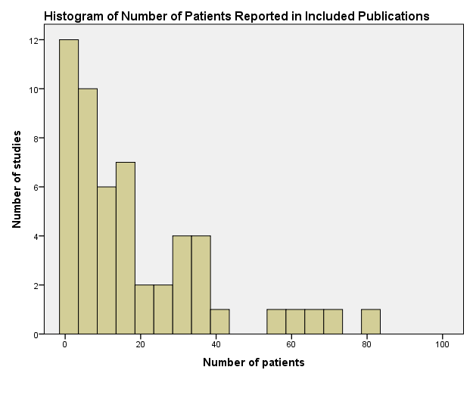
Figure 6. Number of patients reported in included publications

Online supplemental information. Additional Description of Identified Studies
Thirty four publications (64%) did not report their approach to data collection. Eight (15%) studies also reported outcomes for other heart pumps, whilst remaining 45 (85%) publications reported only CentriMag experience.
One study reported international (UK and Germany) experience (20). The location was not reported in 2 publications^{33, 51}.
Four (8%) publications^{7, 8, 20, 29} presented multi-centre experience, whilst the remaining 49 (92%) studies were conducted in a single centre.
Mean age of patients in 31 studies, which report these data, was 43.8 years. Average age of patients in paediatric studies was 9.3 years, in studies, which involved adult patients, - 48.9 years, and in studies in mixed population – 43.4 years.
Details of clinical indications are provided for 552 patients (55%).
Two studies reported the preventive usage of CentriMag VAD in high risk patients, either during cardiac surgery⁵⁴ or LVAD implantation³⁶. Two studies reported a novel approach to percutaneous CentriMag RVAD placement^{49, 53}.
Thirty-nine (73%) publications were presented in full-text format, whilst the remaining 14 (27%) publications were only available as conference proceedings’ abstracts (with no full text available).
No statistical analysis was performed in the majority of studies due to the nature of case-series studies. However, descriptive statistics were used to describe patient characteristics and resource utilisation. Subgroup analysis was not performed in the majority of studies. Survival at different time periods was reported in 92% (n=49) studies, weaning from support – in 70% (n=70%), bridging patients to long-term VAD or heart transplant – in 58% (n=31) of the studies. The most prevalent survival data reported were survival on support (reported in 30 studies, 57%), survival at discharge from hospital (reported in 29 studies, 55%) and 30-day survival (reported in 17 studies (32%). Safety outcomes were reported in 41 (77%) studies. Thirteen (32%) of the studies report number of adverse events, while remaining 28 (68%) of the studies report number of patients, who experienced adverse events, although majority of the studies, reporting number of events rather state that no adverse events were observed, except two studies, which provide detailed information about number of events experienced and number of events per patient^{8, 30}. The most commonly reported safety outcomes were: bleeding (reported in 22 studies, 42%), device performance (reported in 22 studies, 42%), thrombosis (reported in 18 studies, 34%) and neurologic complications (reported in 15 studies, 28%).

Effectiveness outcomes in the included studies (mixed indication)

Table 6. Effectiveness outcomes in the included studies
Study | Sample size | Patient group. % of patients |  |  |  |  | Duration of support |  | Survival. % of patients |  |  |  |  |  |  | Clinical outcomes. % of patients
 |  | Pre-cardiotomy | Post-Cardiac Surgery | Post- HTx | Post-LVAD | Respiratory failure | Mean (SD) | Range | On support | At discharge | 30-day | 90-day | 6-month | 1-year | After 1-year | Weaned | Bridged HTx | Bridged VAD
VAD support for mixed group of patients
Bindoff ¹⁵ | 29 | - | - | - | - | - | NR | - | - | - | - | - | - | - | - | - | - | -
Cassidy¹⁸ | 3 | - | - | - | - | - | 10 | 5-16 | - | 100 | - | - | - | - | - | - | 100 | -
Chen¹⁹ (BiVAD) | 11 | - | - | - | - | - | 12.1 (8.4)** | - | 64 | - | - | - | - | - | - | - | 64 | -
Chen¹⁹ (CentriMag/  Impella) | 3 | - | - | - | - | - | 5 (2) | - | 100 | - | - | - | - | - | - | 100 | - | -
den Uil²² | 2 | - | - | - | - | - | 7 | 6-7 | 100 | - | - | - | - | - | - | 100 | - | -
Loforte³³ | 36 | - | - | - | - | - | 9.9 (6.6) | 3-20 | - | - | 53 | - | - | - | - | 39 | 6 | 0
Takayama⁵² | 63 | - | - | - | - | - | NR | - | - | - | - | - | - | - | - | - | - | -
Worku⁵⁵ | 56 | - | - | - | - | - | 16**** | - | - | - | - | - | - | - | - | - | - | -
De Robertis¹⁰ | 12 | 0 | 58 | 17 | 25 | 0 | 14.2 (15.2)*** | 1-64 | 67 | 42 | 50 | - | - | - | - | - | 17 | 8
Horváth²⁸ | 20 | 65 | 15 | 15 | 5 | 0 | 25.3 (16.5) | 5-71 | 65 | - | 70 | - | - | - | - | 25 | 35 | 5
Favaloro²⁴ | 4 | 25 | 75 | 0 | 0 | 0 | 8.25 | 4-18 | 25 | 25 | - | - | - | - | 25 | - | 50 | -
Kouretas³² | 2 | 0 | 50 | 50 | 0 | 0 | 4.5 | 3-6 | 100 | 100 | - | - | - | - | - | 50 | - | 50
Pawlak⁴⁴ | 2 | 50 | 0 | 50 | 0 | 0 | NR | 13-21 | 50 | - | - | - | - | - | - | 50 | - | -
Takayama⁵³ | 8 | 38 | 25 | 25 | 13 | 0 | NR | - | 88 | 88 | - | - | - | - | - | 38 | - | 38
ECMO support for mixed group of patients
Aziz¹³ | 10 | 60 | 20 | 20 | 0 | 0 | 5.8 (4) | 1-14 | 60 | 60 |  |  |  |  |  |  |  | 10
Bruschi¹⁶ | 14 | 64 | 21 | 14 | 0 | 0 | 12 | 3-30 |  |  |  |  |  |  |  | 29 | 21 | 7
Byrnes¹⁷ | 7 | - | - | - | - | - | 9.5 | - | - | 43 | - | - | - | - | - | - | - | -
DiBella²³ | 6 | - | - | - | - | - | NR | 6-20 | - | - | - | - | - | - | - | 33 | - | 17
Khan³¹ | 3 | 0 | 0 | 67 | 0 | 33 | 3.7 | 2-6 | - | 67 | - | - | - | - | - | 67 | - | -
Reckers⁴⁵ | 33 | - | - | - | - | - | 9.3 | 2-24 | 57 | - | - | - | - | - | - |  | - | -
Soleimani⁵⁰ | 34 | - | - | - | - | - | 6* | 1-40 | - | 55 | - | - | - | - | - | 47 | 3 | 6
Meyer⁴⁰ | 18 | 6 | 67 | 28 | 0 | 0 | 4.3 | 1-14 | - | 39 | 44 | - | - | - | - | 67 | - | -
UK ECMO Service Evaluation⁷ | 67 | 31 | 25 | 7 | 0 | 36 | 6.9 (5.78) | 1-31 | - | 67 | 76 | 64 | - | - | - | - | - | -
Chung²⁰ | 70 | - | - | - | - | - | 8.2 (8.1) | - | 53 | 25 | - | - | - | - | - | 28 | 1 | 23
*Median duration of support.
**Chen 2012: mean duration of support 12.1 days is from CentriMag BiVAD group (n=10), while duration of support for one patient on PediVAS BiVAD was 17 days.
***Duration of support for the whole group (n=18) irrespective of indication.
****Duration of support for the whole group (n=56) irrespective of indication.

Meta-analysis of effectiveness and safety outcomes

Table 7. Meta-analysis of effectiveness outcomes, survival (random-effect model)
Indication | Survival, percentage (95% confidence interval), I²
 | N studies (n pts) | On support | N studies (n pts) | At discharge | N studies (n pts) | 30-day | N studies (n pts) | 90-day | N studies (n pts) | 6-month | N studies (n pts) | 1-year
VAD support in pre-cardiotomy cardiogenic shock indication | 5 (45) | 78%  (48-97%), I²=75.4% | 3 (23) | 75%  (32-99%), I²=74.2% | 6 (69) | 67%  (45-86%), I²=71.7% | 3 (29) | 78%  (45-98%), I²=67.3% | 4 (46) | 73%  (47-93%), I²=69.2% | 3 (32) | 78%  (47-97%), I²=67%
VAD support in post-cardiac surgery cardiogenic shock indication | 4 (32) | 79%  (43-99%),  I²=62.3% | 6 (32) | 61%  (29-88%),  I²= 65% | 5 (65) | 41%  (30-54%), I²= 0% | - | - | 2 (20) | 37%  (3-82%),  I²= 78.4% | - | -
VAD support in post-transplant graft rejection or failure indication | 3 (40) | 91%  (35-100%), I²= 84.1% | 2 (12) | 84%  (23-100%), I²= 68% | 3 (45) | 54%  (39-68%), I²= 0% | - | - | - | - | - | -
VAD support in post-LVAD placement right ventricular failure indication | 6 (58) | 87%  (70-97%), I²= 57% | 4 (54) | 67%  (38-91%), I²=77.5% | 3 (41) | 40%  (2-88%), I²=90% | - | - | - | - | - | -
Pts – patients; VAD, ventricular assist device.

Table 8. Meta-analysis of effectiveness outcomes, weaning from support or bridging to repeat heart transplant or VAD (random-effect model)
Indication | Survival, percentage (95% confidence interval), I²
 | N studies (n pts) | Proportion of patients weaned from support or bridged to heart transplant or bridged to VAD (95% CI) | N studies  (n pts) | Proportion of patients weaned from support or bridged to heart transplant (95% CI)
VAD support in post-transplant graft rejection or failure indication | - | - | 5 (55) | 81%  (54-98%), I²=70.3%
VAD support in post-LVAD placement right ventricular failure indication | 8 (82) | 80%  (64-92%), I²=58.6% | - | -
Pts – patients; VAD, ventricular assist device.

Table 9. Meta-analysis of effectiveness outcomes in the included studies, weaning from support or bridging to repeat heart transplant or VAD (fixed-effect model)
Indication | Survival, percentage (95% confidence interval)
 | N studies  (n pts) | Proportion of patients weaned from support or bridged to heart transplant or bridged to VAD (95% CI) | N studies  (n pts) | Proportion of patients weaned from support or bridged to heart transplant (95% CI)
VAD support in post-transplant graft rejection or failure indication | - | - | 5 (55) | 65%  (52-77%)
VAD support in post-LVAD placement right ventricular failure indication | 8 (82) | 77%  (67-85%) | - | -
Pts – patients; VAD, ventricular assist device.

Table 10. Meta-analysis of effectiveness outcomes with exclusion of studies, which contribute to heterogeneity (random-effect model)
Indication | Survival, percentage (95% confidence interval), I²
 | N studies (n pts) | On support | N studies (n pts) | At discharge | N studies (n pts) | 30-day
VAD support in pre-cardiotomy cardiogenic shock indication | 4 (40) | 88%  (70-99%), I²=50.9% | - | - | 5 (60) | 74%  (56-87%), I²=56%
VAD support in post-LVAD placement right ventricular failure indication | - | - | 3 (48) | 54%  (40-68%), I²= 0% | 2 (36) | 71%  (50-88%), I²= 39.7%
Pts – patients; VAD, ventricular assist device.

Table 11. Meta-analysis of effectiveness outcomes with exclusion of studies, which contribute to heterogeneity (fixed-effect model)
Indication | Survival, percentage (95% confidence interval)
 | N studies (n pts) | On support | N studies (n pts) | At discharge | N studies (n pts) | 30-day
VAD support in pre-cardiotomy cardiogenic shock indication | 4 (40) | 88%  (76-96%) | - | - | 5 (60) | 72%  (60-83%)
VAD support in post-LVAD placement right ventricular failure indication | - | - | 3 (48) | 54%  (40-68%) | 2 (36) | 73%  (57-86%)
Pts – patients; VAD, ventricular assist device.

Table 12. Meta-analysis of adverse events (proportion of patients experienced adverse event) (random-effect model)
Adverse event | N studies (n pts) | Adverse event, percentage (95% confidence interval), I²
Bleeding | 21 (398) | 26% (18-35%), I²=70.7%
Thrombosis and thromboembolism | 16 (245) | 5% (1-12%), I²= 64.5%
Haemolysis | 6 (164) | 2% (0-6%), I²=34.2%
Neurologic complications | 13 (266) | 5% (2-11%), I²=52.5%
Infection | 10 (251) | 22% (10-35%), I²=82.4%
Renal complications | 7 (164) | 30% (7-59%), I²=92.4%
Device failure | 21 (512) | 0% (0-0.01%), I²=0%
Device failure (with exclusion of studies with sample size less than 10) | 14 (480) | 0% (0-0.0%), I²=0%
Pts – patients.

Table 13. Meta-analysis of adverse events (proportion of patients experienced adverse event) (fixed-effect model)
Adverse event | N studies (n pts) | Adverse event, percentage (95% confidence interval)
Bleeding | 21 (398) | 28% (23-32%)
Thrombosis and thromboembolism | 16 (245) | 7% (5-11%)
Haemolysis | 6 (164) | 3% (1-6%)
Neurologic complications | 13 (266) | 7% (4-11%)
Infection | 10 (251) | 24% (19-30%)
Renal complications | 7 (164) | 28% (22-36%)
Device failure | 21 (512) | 0% (0-0.01%)
Device failure (with exclusion of studies with sample size less than 10) | 14 (480) | 0% (0-0.0%)
Pts – patients.

Effectiveness Outcomes of Studies, Which Had Comparative Design or Statistical Analysis
Six original studies had comparative design or provided statistical analysis of outcomes (Thomas et al., 2011 (8); Worku et al., 2011⁵⁵; Akay et al., 2011 (12); Byrnes et al., 2011¹⁷; Cassidy et al., 2009¹⁸ and ECMO Service Evaluation⁷). The remaining 45 studies, which reported effectiveness outcomes, were designed as case-series studies and did not employ statistical analysis.
The UK Cardiothoracic Transplant Audit analyzed all adult cases of CentriMag support after early cardiac allograft failure⁸. CentriMag was used in majority of cases, where mechanical support was required. Survival analysis was performed with 30-day survival estimated at 50%.
Worku et al. 2011 presented analysis of short-term VAD support of 93 patients at Columbia University Medical Center (New York, USA)⁵⁵. Two devices were used (CentriMag and Abiomed BVS5000 (Abiomed Inc., Danvers, MA)). The Abiomed device was found to be independent predictor of hospital mortality in univariate (p=0.009), but not in multivariate (odds ratio 2.12, p=0.325) analysis.
Study from Texas Heart Institute analyzed 30-day survival in patients, supported with CentriMag immediately after failing attempt to wean patients from cardiopulmonary bypass or with delay after transfer to ICU¹². Group of immediate support (in which CentriMag was placed in the operating room) had statistically significantly higher survival (70%) in comparison with the group of delayed (in which CentriMag was placed after transfer to ICU) support (17%), p=0.027.
Study of Cassidy et al. 2009 presented experience of Freeman Hospital, UK with bridging pediatric patients to heart transplant¹⁸. Small number of patients (n=3) were supported with CentriMag and all of them survival to transplant. Survival-to-transplant was 67% in ECMO support group, 77% in Berlin Heart group, and 57% in Medos device group. Statistical analysis was not employed for comparative analysis of survival on different devices.
Retrospective matched cohort study of Byrnes et al. 2011 compared hemolysis and circuit failure rates in patients, supported with centrifugal (CentriMag) and roller (Stockert-Shiley SIII) ECMO systems¹⁷. Patients in the roller pump group had significantly higher risk of hemolysis (odds ratio 1.96, p<0.014) and higher risk of circuit change (7 changes in 14 patients compared with 1 change in 7 patients supported with CentriMag, p=0.174).
Unpublished ECMO Service Evaluation in the UK provided analysis on outcomes in patients, supported with centrifugal (CentriMag) and roller ECMO systems⁷. In total 134 patients were retrospectively matched in 1:1 manner. While no significant differences were found in patient baseline characteristics or ECMO support mode, centrifugal pumps showed much better safety (0 vs. 8 device malfunctions, p=0.008), improved median survival ((128 days, 95% CI 81-174 days on centrifugal vs. 35 days, 95% CI 14-55 days on roller pump, (log rank test, p=0.028)), and reduced resource utilization (volume of red blood cells transfused, p=007; volume of thrombocytes transfused, p=0.02).

Technical data. VAD support in pre-cardiotomy cardiogenic shock indication

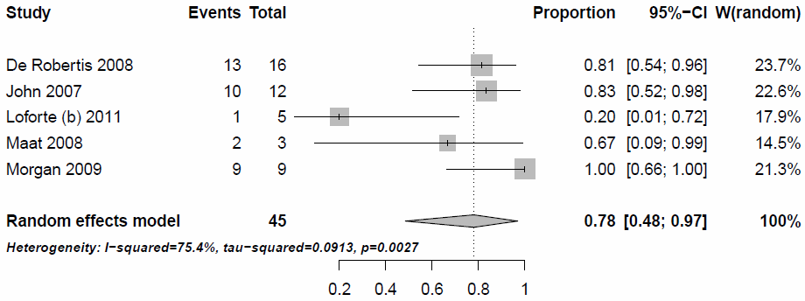
Figure 7. Survival on support (R-E model)
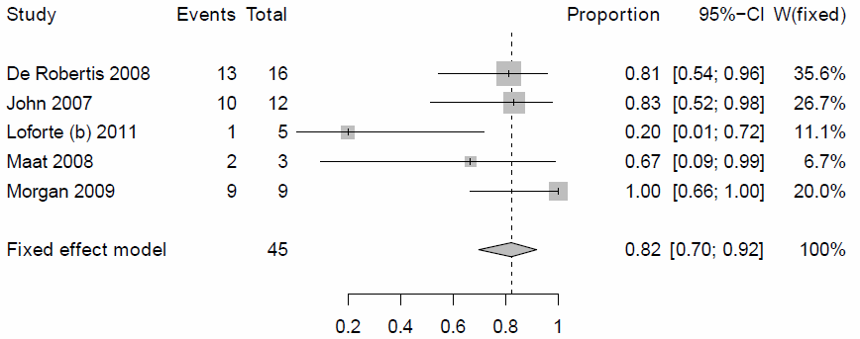
Figure 8. Survival on support (F-E model)

Analysis with exclusion of study of Loforte 2011, which contribute the most to heterogeneity of results
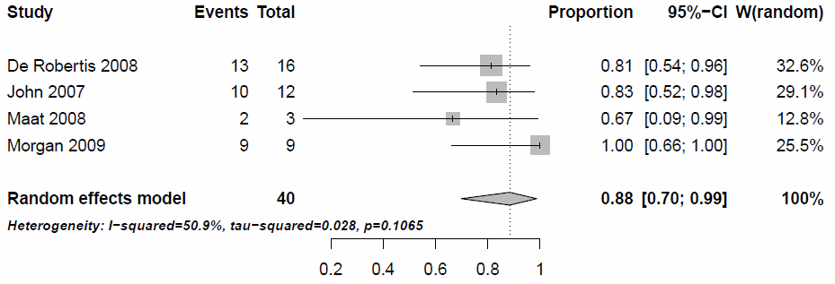
Figure 9. Survival on support (R-E model) (Loforte 2011 excluded)
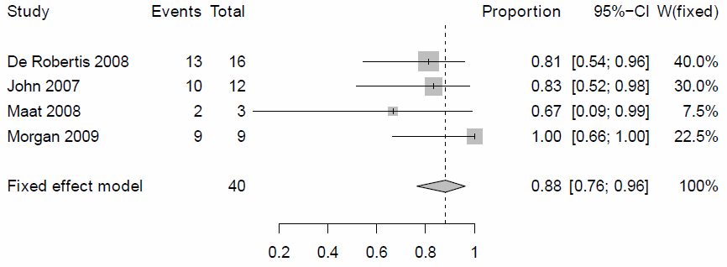
Figure 10. Survival on support (F-E model) (Loforte 2011 excluded)

Survival at discharge
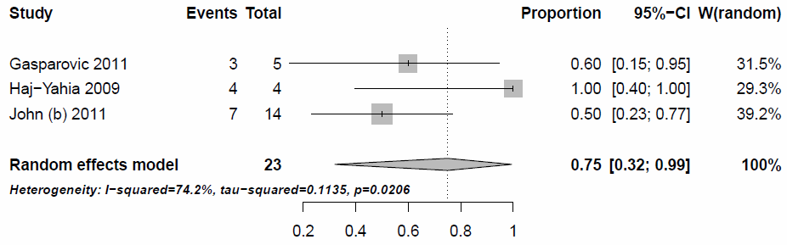
Figure 11. Survival at discharge (R-E model)
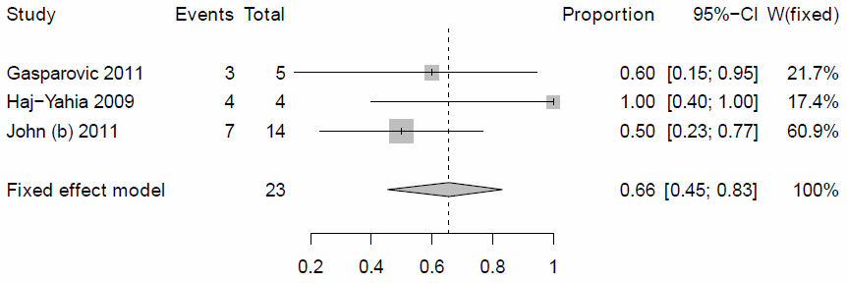
Figure 12. Survival at discharge (F-E model)

30-day survival
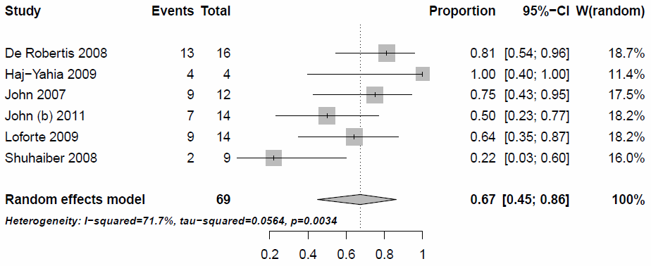
Figure 13. 30-day survival (R-E model)
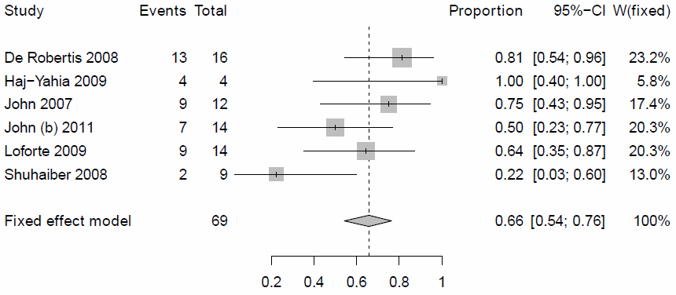
Figure 14. 30-day survival (F-E model)

Analysis with exclusion of study of Shuhaiber 2008, which contribute the most to heterogeneity of results
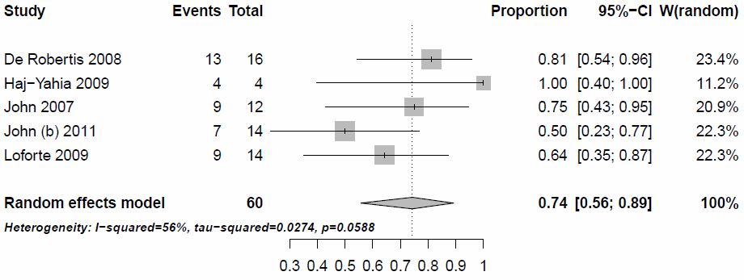
Figure 15. 30-day survival (R-E model), Shuhaiber 2008 excluded
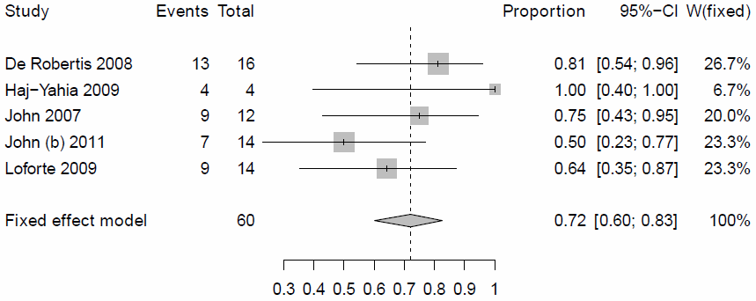
Figure 16. 30-day survival (F-E model), Shuhaiber 2008 excluded

90-day survival
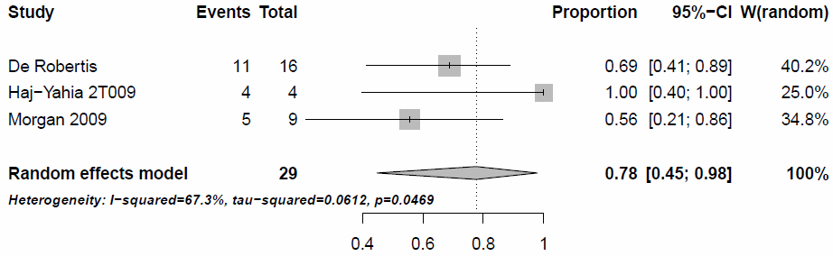
Figure 17. 90-day survival (R-E model)
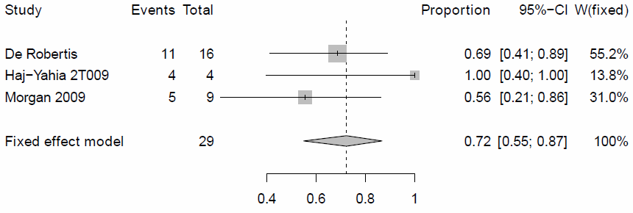
Figure 18. 90-day survival (F-E model)

6-month survival
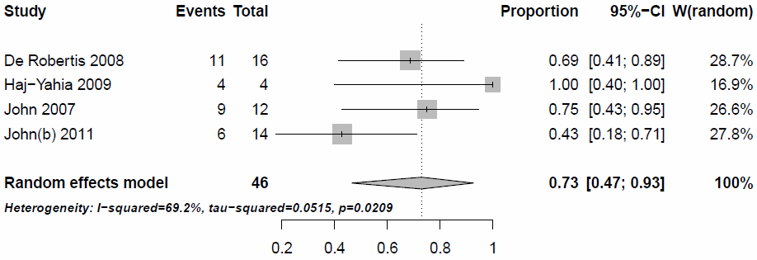
Figure 19. 6-month survival (R-E model)
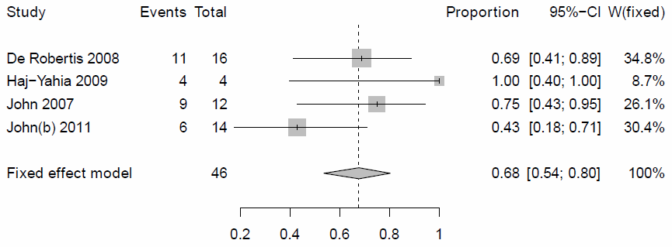
Figure 20. 6-month survival (F-E model)
1-year survival
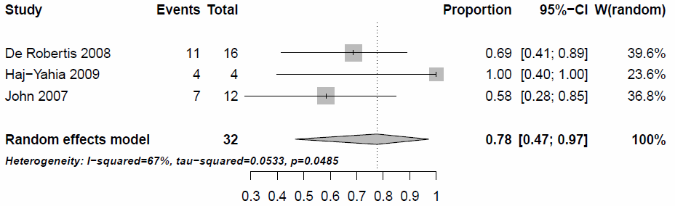
Figure 21. 1-year survival (R-E model)
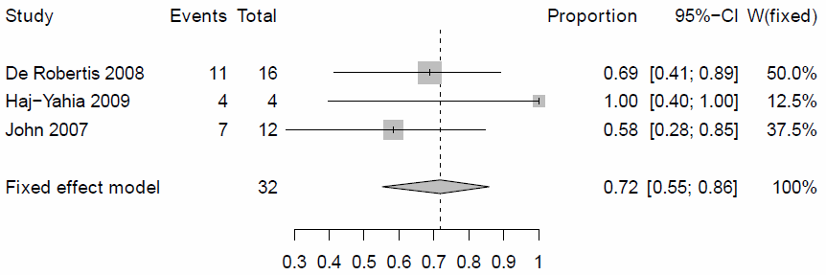
Figure 22. 1-year survival (F-E model)

Post-1-year survival
Not applicable

Technical data. VAD support in post-cardiac surgery cardiogenic shock indication

Survival on support
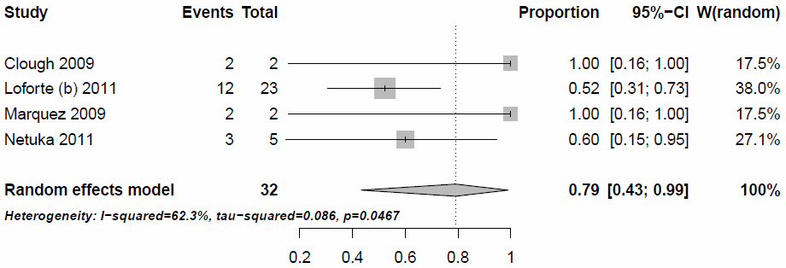
Figure 23. Survival on support (R-E model)
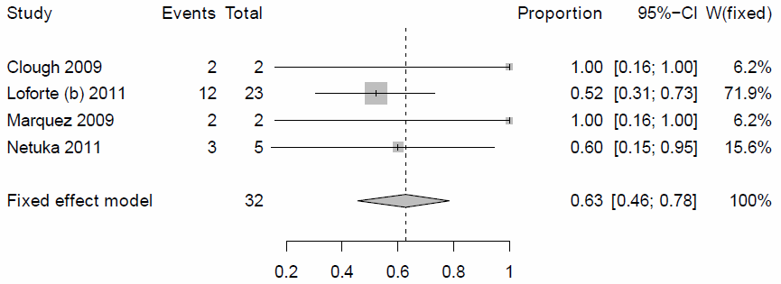
Figure 24. Survival on support (F-E model)
Survival at discharge
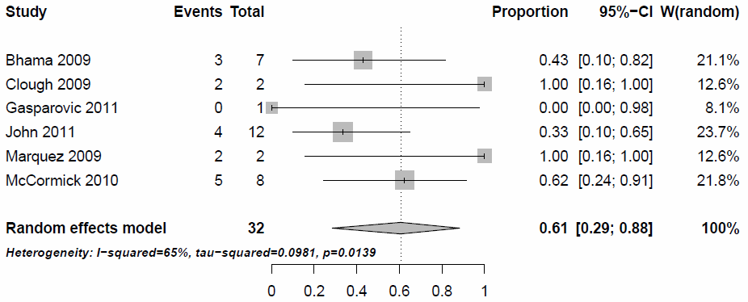
Figure 25. Survival at discharge (R-E model)
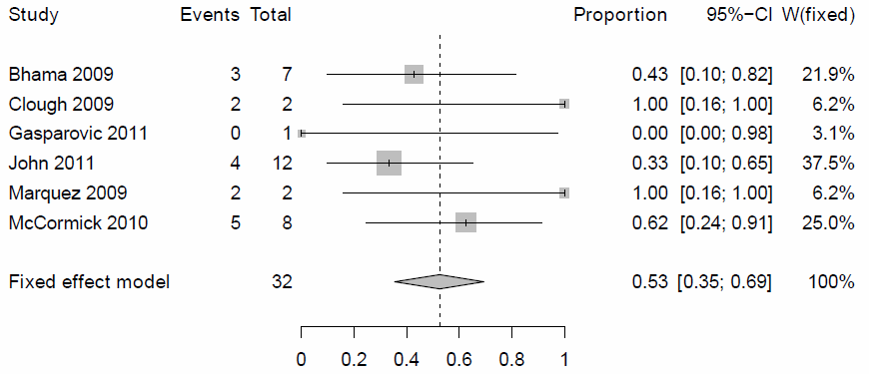
Figure 26. Survival at discharge (F-E model)

30-day survival
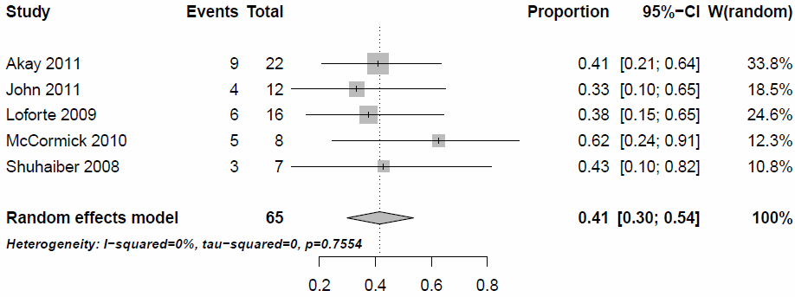
Figure 27. 30-day survival (R-E model)
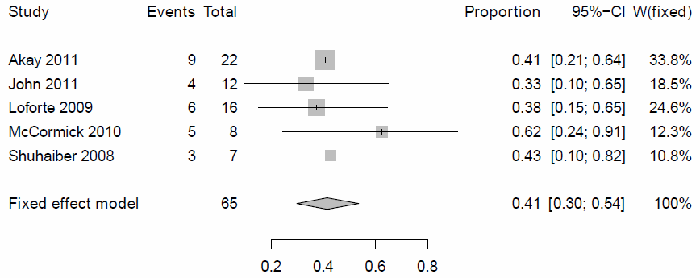
Figure 28. 30-day survival (F-E model)

90-day survival
Not applicable

6-month survival
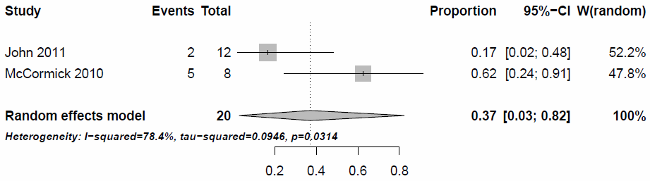
Figure 29. 6-month survival (R-E model)
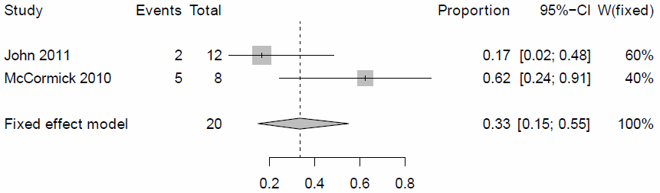
Figure 30. 6-month survival (F-E model)

1-year survival
Not applicable

Post-1-year survival
Not applicable

Technical data. VAD support in post-transplant graft rejection or failure indication

Survival on support
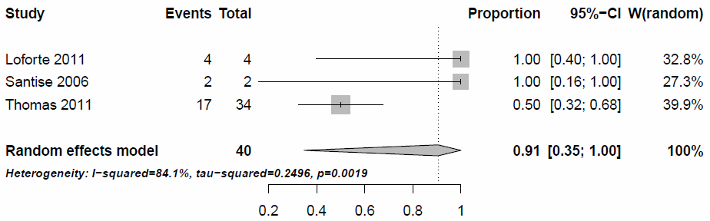
Figure 31. Survival on support (R-E model)

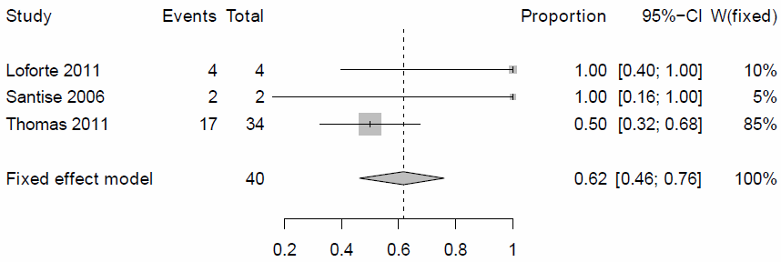
Figure 32. Survival on support (F-E model)
Survival at discharge
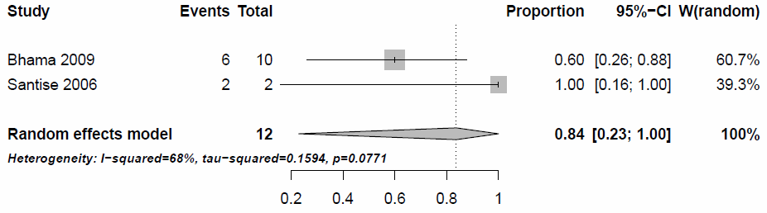
Figure 33. Survival at discharge (R-E model)
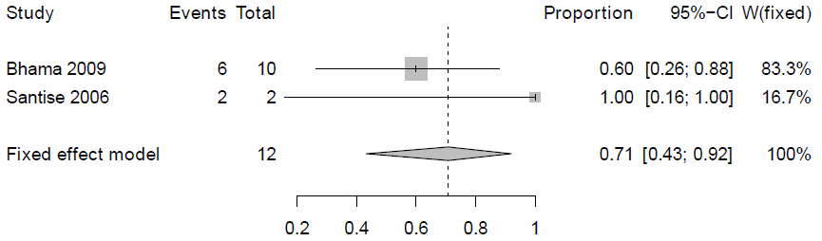
Figure 34. Survival at discharge (F-E model)

30-day survival
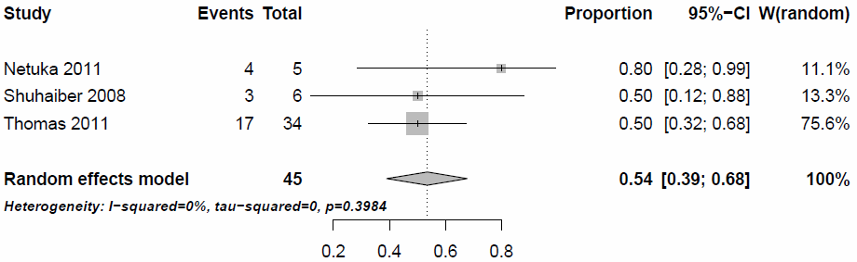
Figure 35. 30-day survival (R-E model)
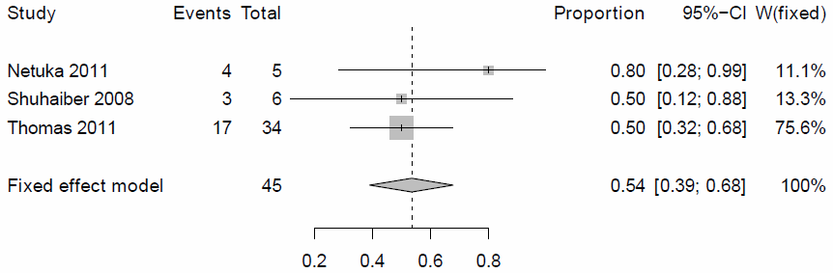
Figure 36. 30-day survival (F-E model)

Weaned from support or bridged to repeat heart transplant
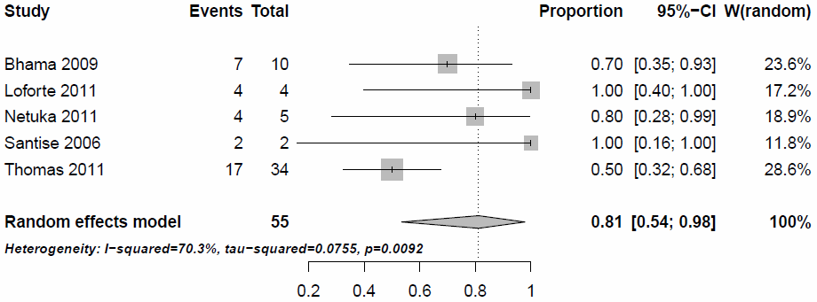
Figure 37. Weaned from support or bridged to repeat heart transplant (R-E model)
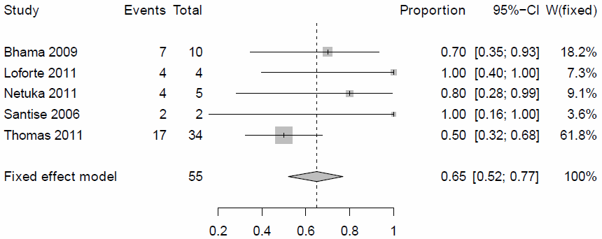
Figure 38. Weaned from support or bridged to repeat heart transplant (F-E model)

6-month survival
Not applicable
1-year survival
Not applicable
Post-1-year survival
Not applicable

Technical data. Post-LVAD placement right ventricular failure indication

Survival on support
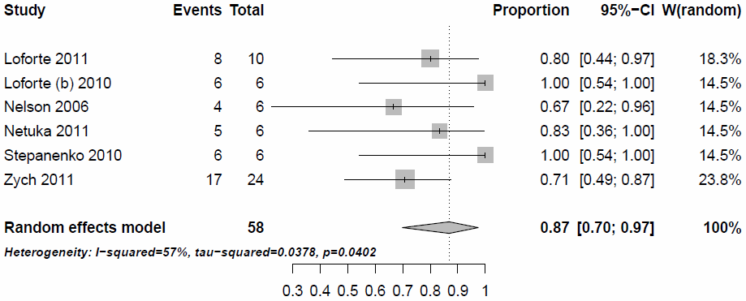
Figure 39. Survival on support (R-E model)
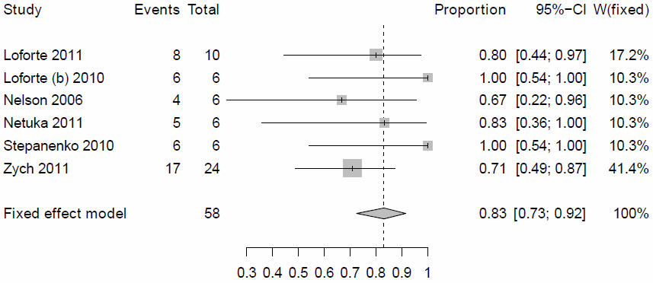
Figure 40. Survival on support (F-E model)

Survival at discharge
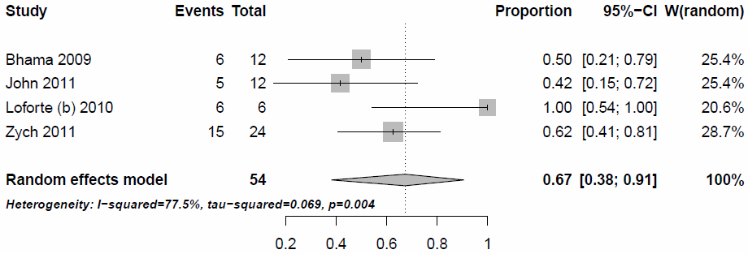
Figure 41. Survival at discharge (R-E model)
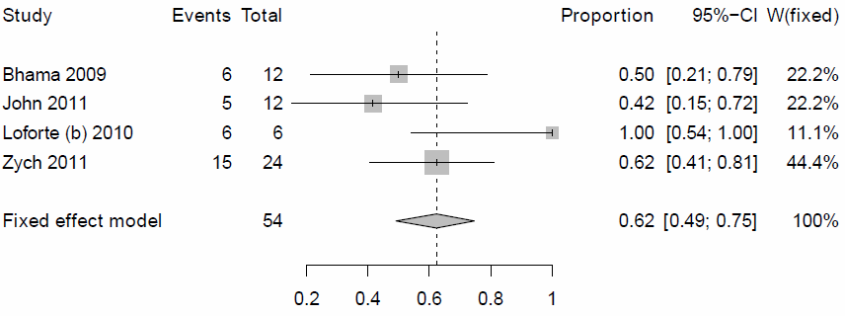
Figure 42. Survival at discharge (F-E model)

Analysis with exclusion of study of Loforte 2010, which contribute the most to heterogeneity of results
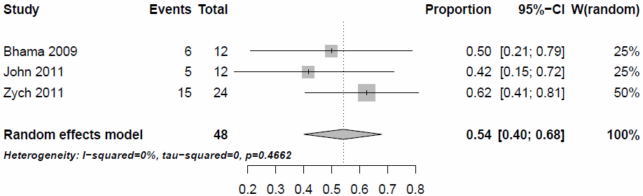
Figure 43. Survival at discharge (R-E model), Loforte 2010 excluded
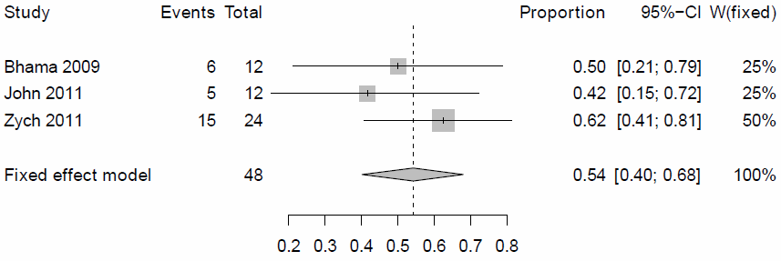
Figure 44. Survival at discharge (F-E model), Loforte 2010 excluded
30-day survival
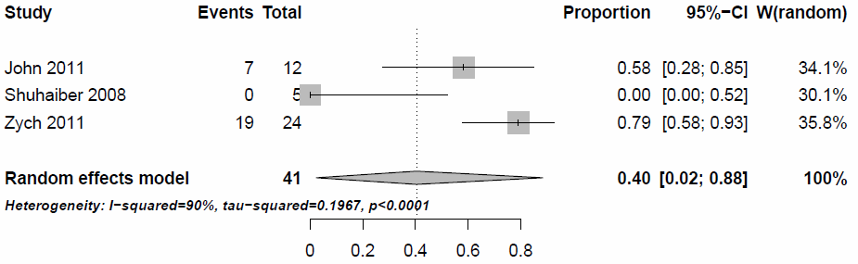
Figure 45. 30-day survival (R-E model)
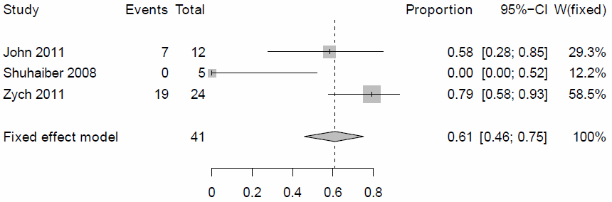
Figure 46. 30-day survival (F-E model)

Analysis with exclusion of study of Shuhaiber 2008, which contribute the most to heterogeneity of results
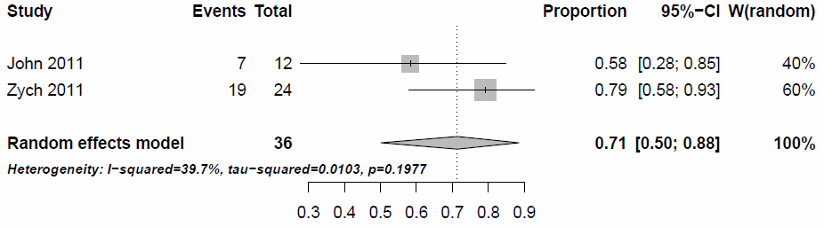
Figure 47. 30-day survival (R-E model)
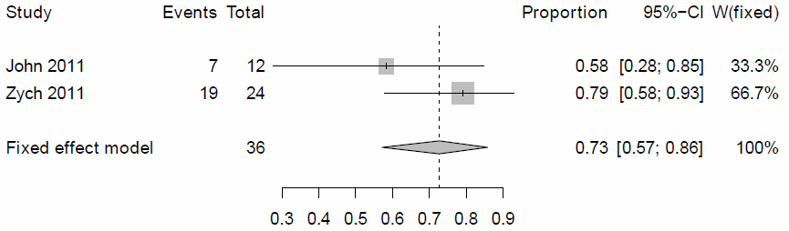
Figure 48. 30-day survival (F-E model)

Weaned from support or bridged to heart transplant or long-term VAD
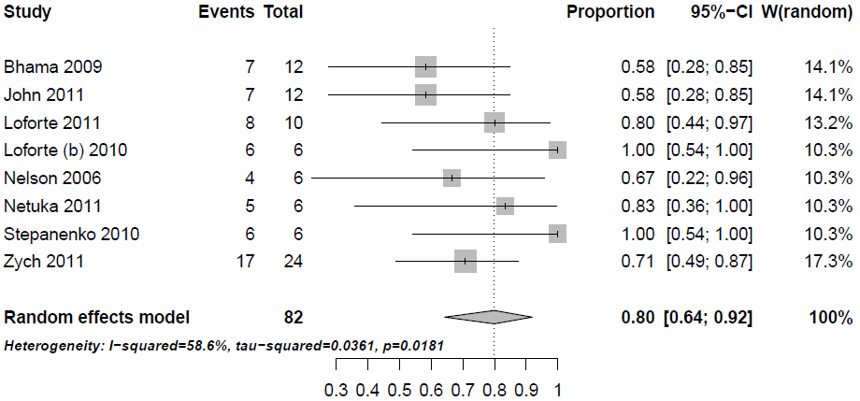
Figure 49. Weaned from support or bridged to heart transplant or long-term VAD (R-E model)
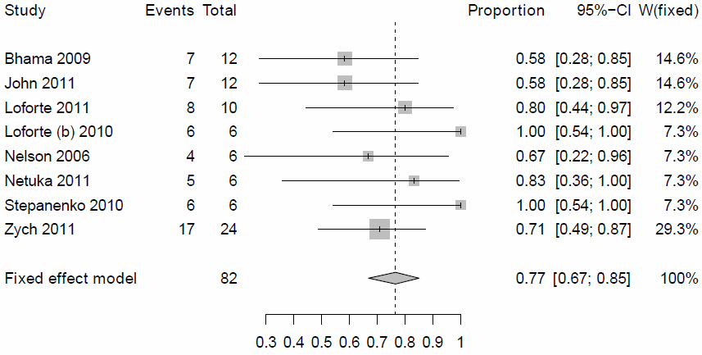
Figure 50. Weaned from support or bridged to heart transplant or long-term VAD (F-E model)

Technical data. Adverse events

Bleeding
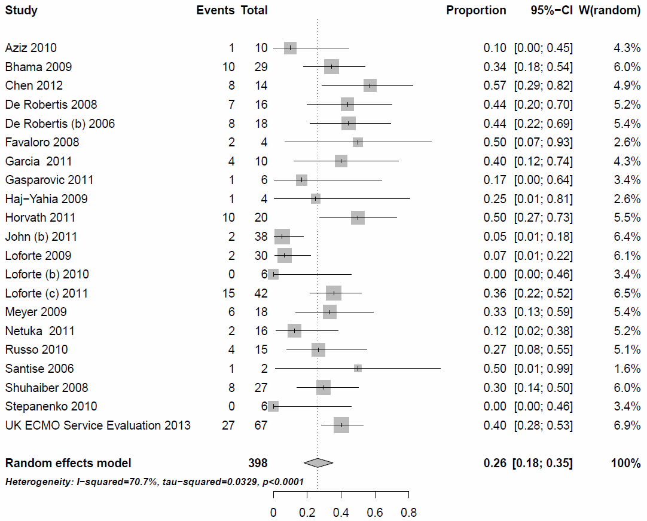
Figure 51. Proportion of patients, who experienced bleeding (R-E model)
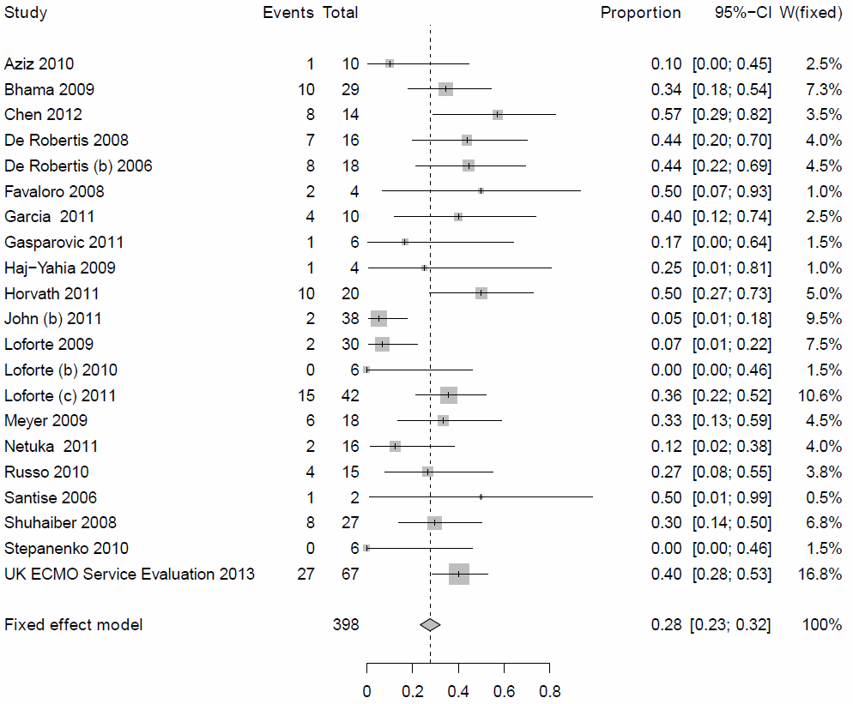
Figure 52. Proportion of patients, who experienced bleeding (F-E model)

Thrombosis and thromboembolism
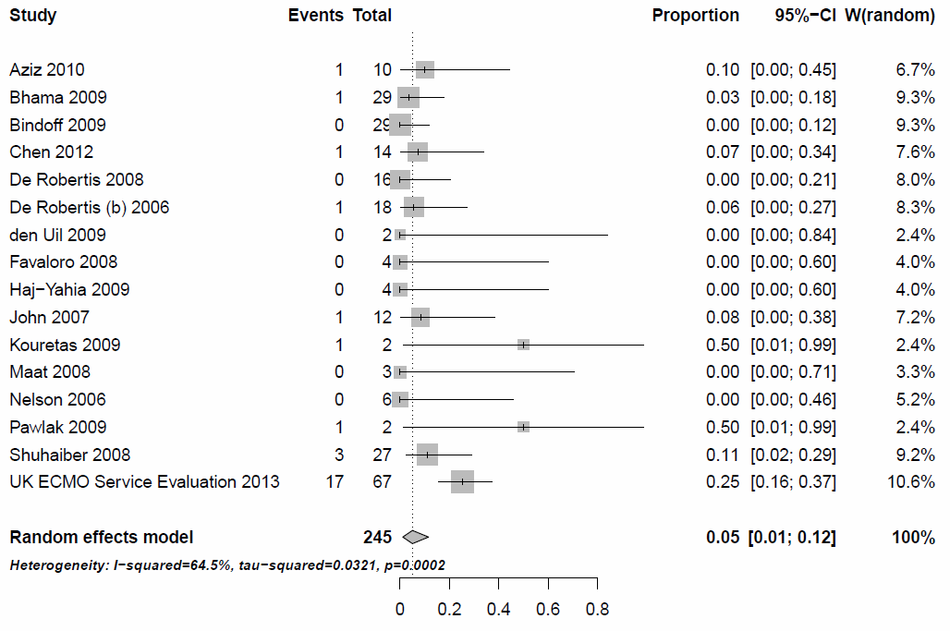
Figure 53. Proportion of patients, who experienced thrombosis and thromboembolism (R-E model)
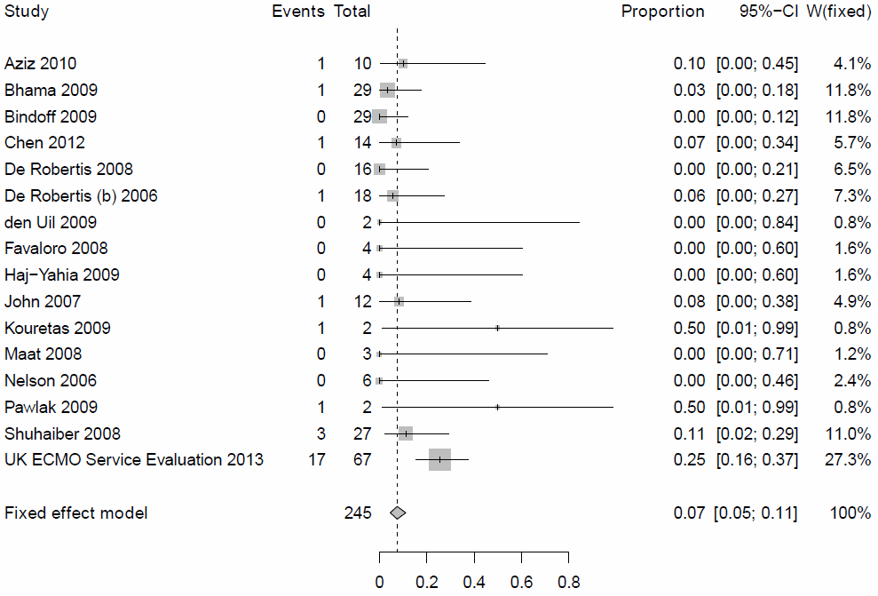
Figure 54. Proportion of patients, who experienced thrombosis and thromboembolism (F-E model)

Hemolysis
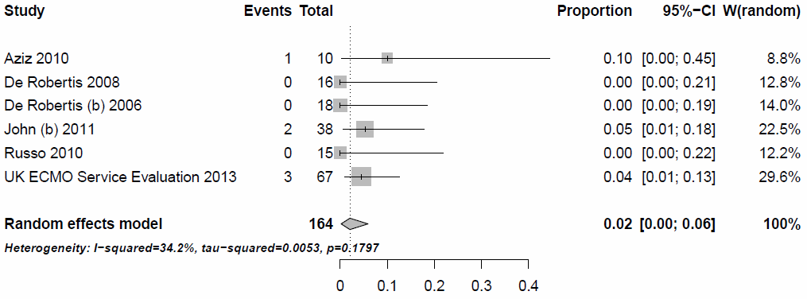
Figure 55. Proportion of patients, who experienced hemolysis (R-E model)
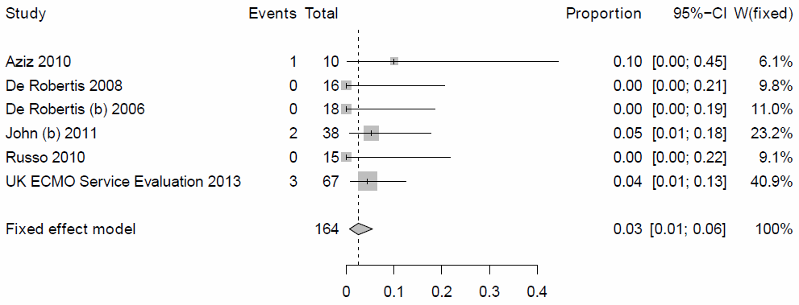
Figure 56. Proportion of patients, who experienced hemolysis (F-E model)

Neurologic complications
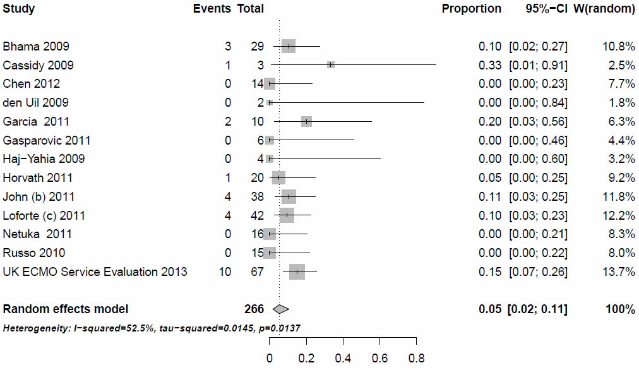
Figure 57. Proportion of patients, who experienced neurologic complications (R-E model)
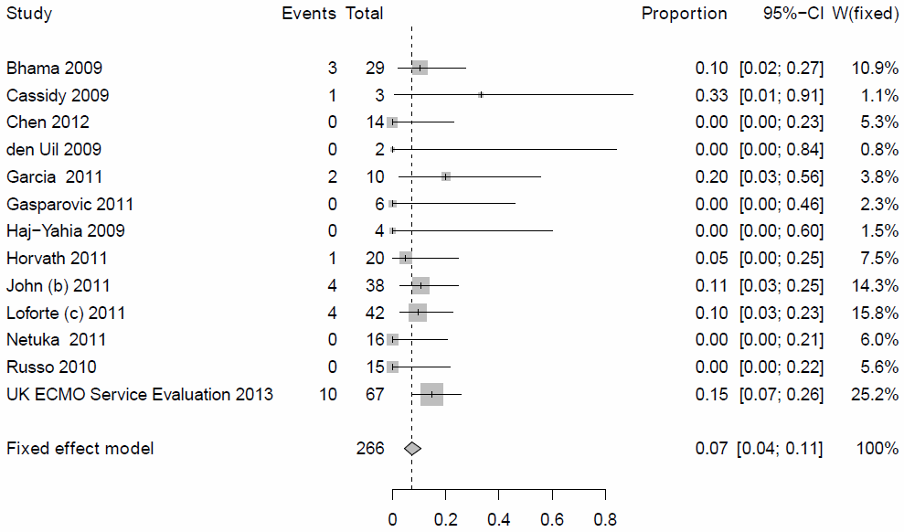
Figure 58. Proportion of patients, who experienced neurologic complications (F-E model)

Infection
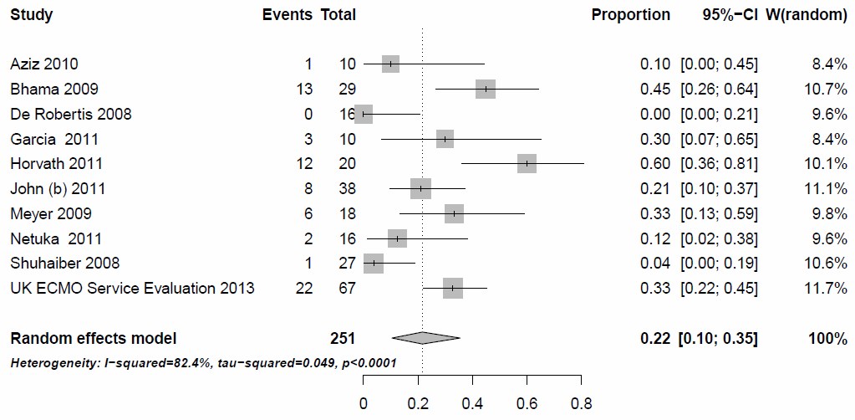
Figure 59. Proportion of patients, who experienced infection (R-E model)
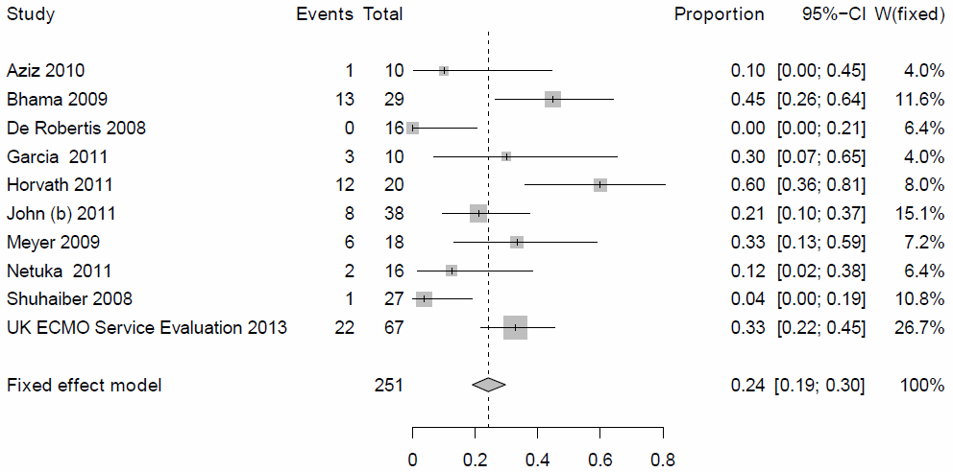
Figure 60. Proportion of patients, who experienced infection (F-E model)

Renal complications
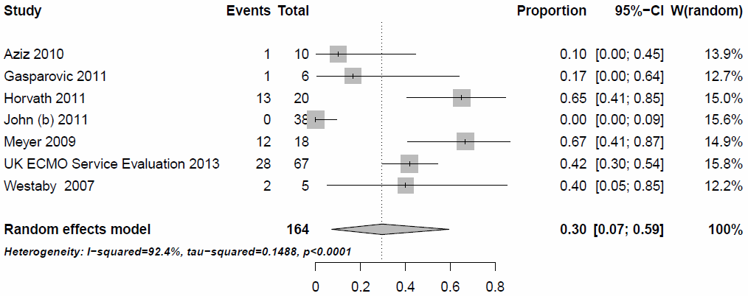
Figure 61. Proportion of patients, who experienced renal complications (R-E model)
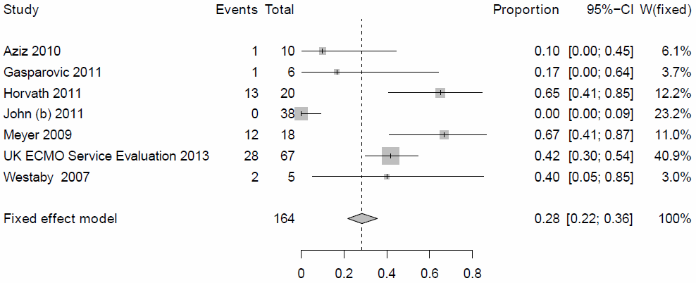
Figure 62. Proportion of patients, who experienced renal complications (F-E model)

Device failure
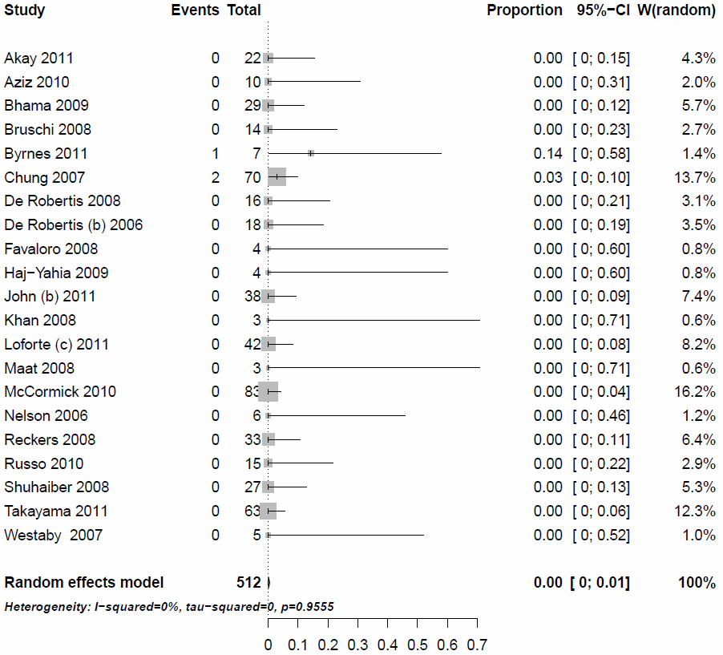
Figure 63. Proportion of patients, who experienced device failure (R-E model)
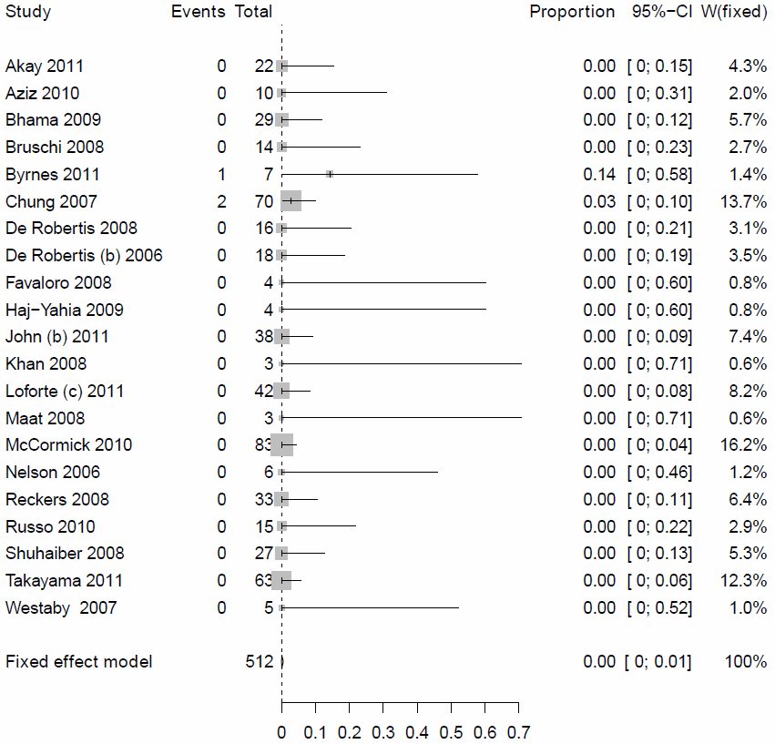
Figure 64. Proportion of patients, who experienced device failure (F-E model)

Analysis of the rate of device failure with exclusion of studies with less than 10 patients included
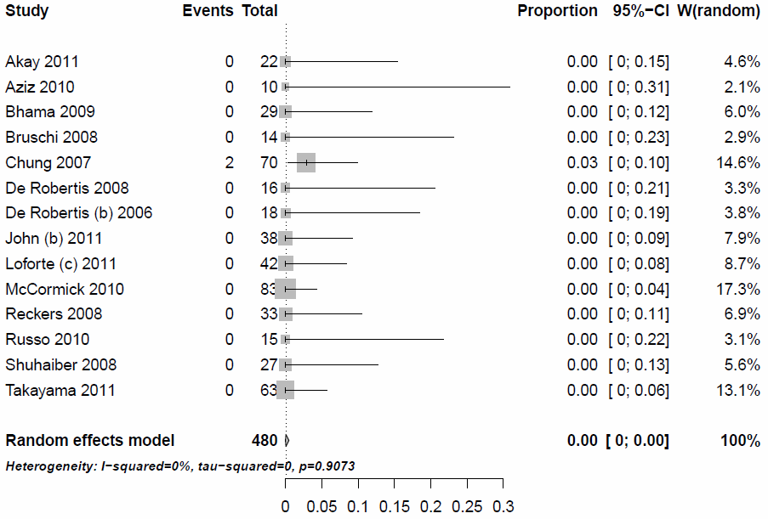
Figure 65. Proportion of patients, who experienced device failure (R-E model)
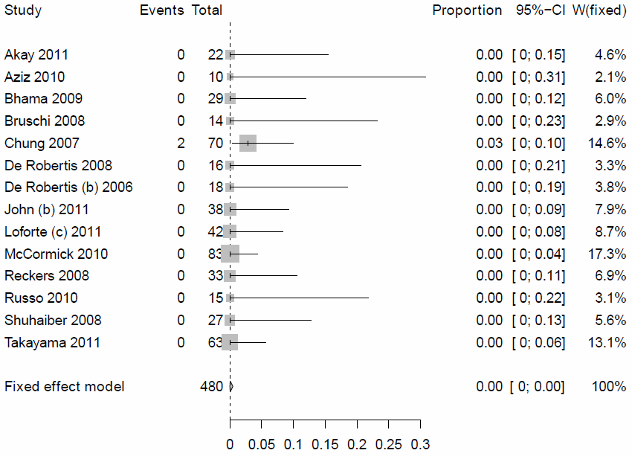
Figure 66. Proportion of patients, who experienced device failure (F-E model)

Technical data. Analysis of adverse events in adult and paediatric populations

Bleeding
Adult population
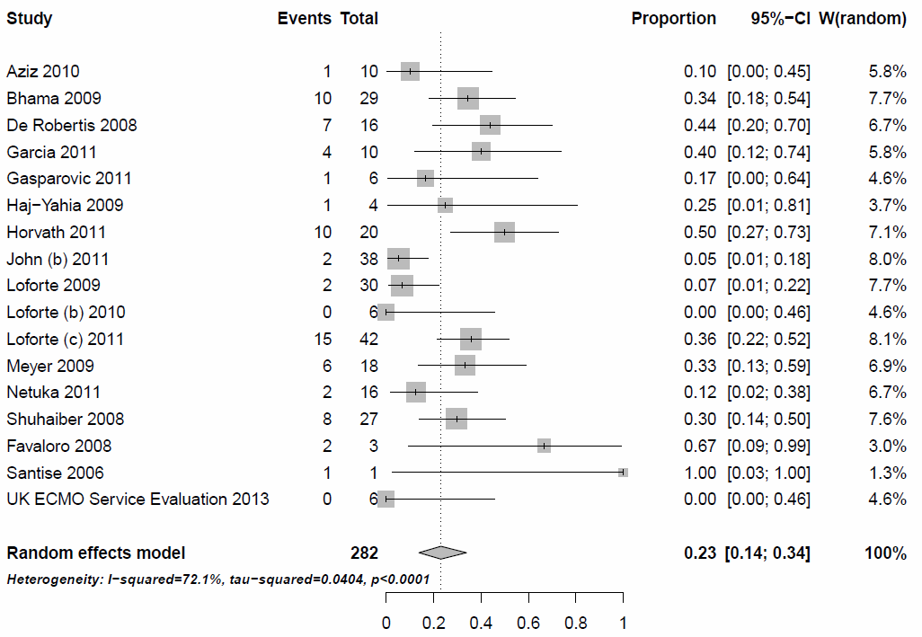
Figure 67: Proportion of patients, who experienced bleeding (R-E model)

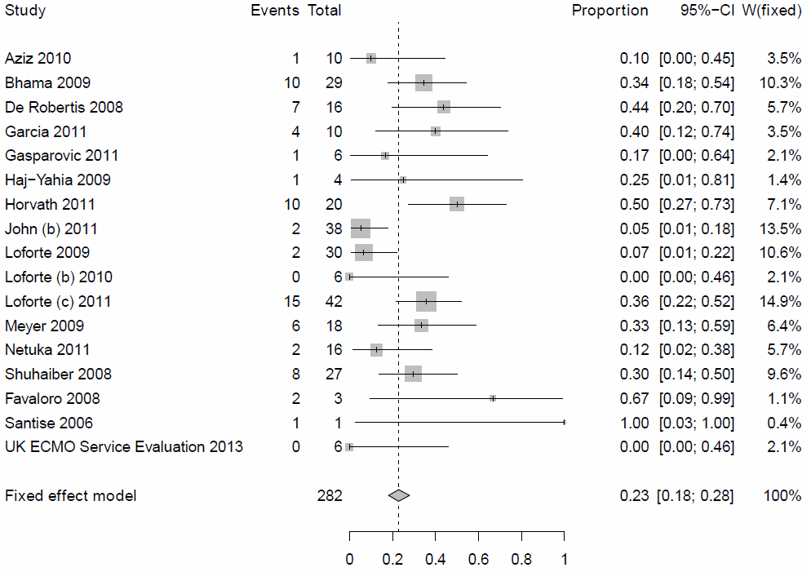
Figure 68. Proportion of patients, who experienced bleeding (F-E model)
Paediatric population
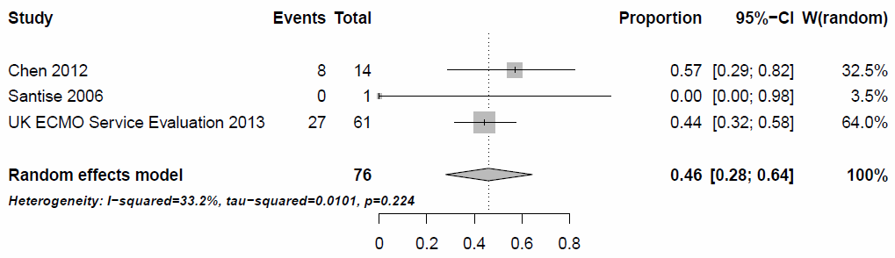
Figure 69. Proportion of patients, who experienced bleeding (R-E model)

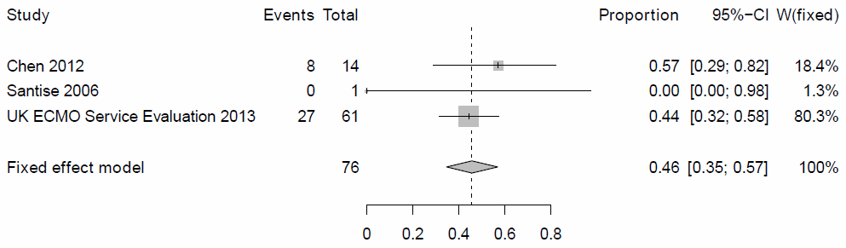
Figure 70. Proportion of patients, who experienced bleeding (F-E model)

Thrombosis and thromboembolism
Adult population
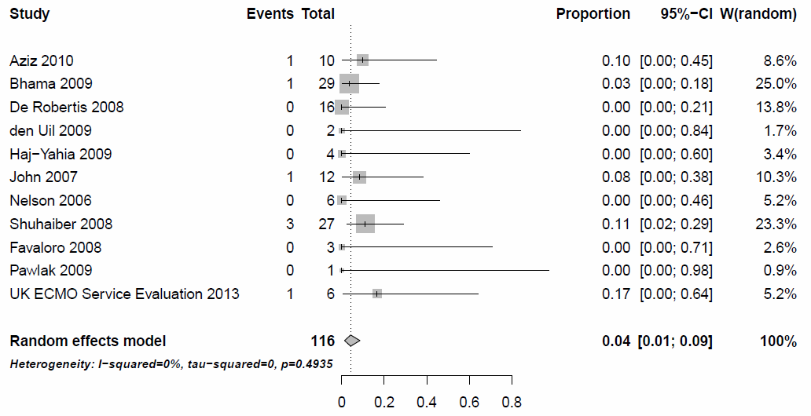
Figure 71. Proportion of patients, who experienced thrombosis and thromboembolism (R-E model)
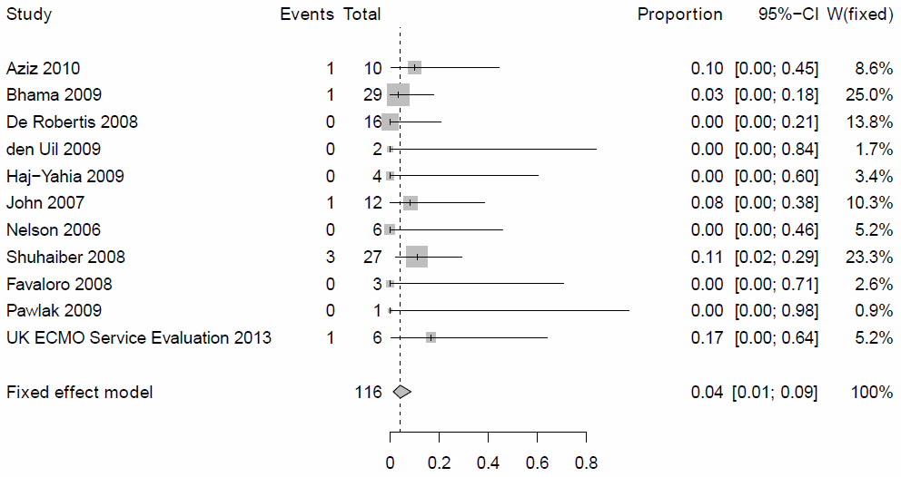
Figure 72. Proportion of patients, who experienced thrombosis and thromboembolism (F-E model)

Paediatric population
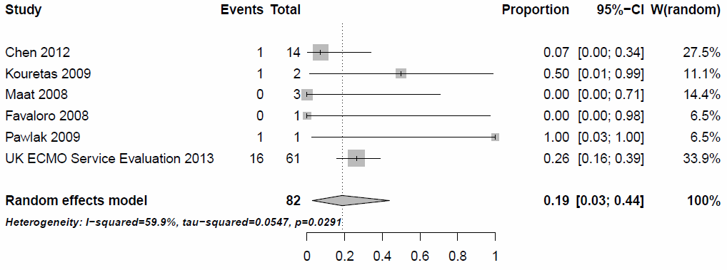
Figure 73. Proportion of patients, who experienced thrombosis and thromboembolism (R-E model)

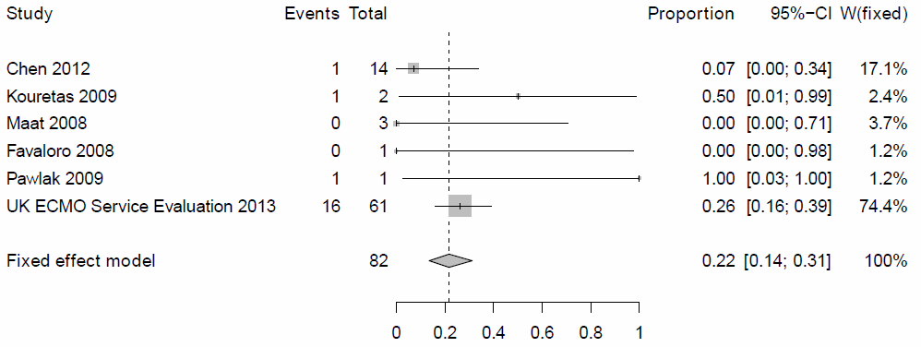
Figure 74. Proportion of patients, who experienced thrombosis and thromboembolism (F-E model)

Hemolysis
Adult population
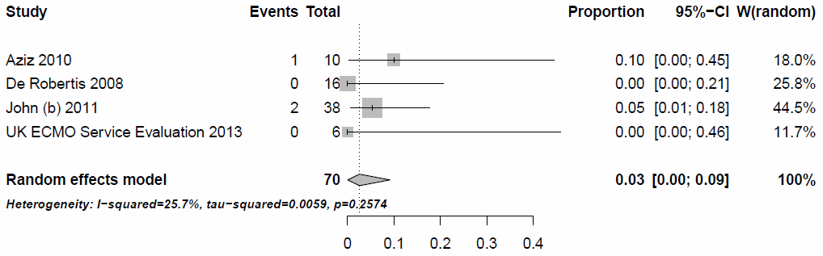
Figure 75. Proportion of patients, who experienced hemolysis (R-E model)
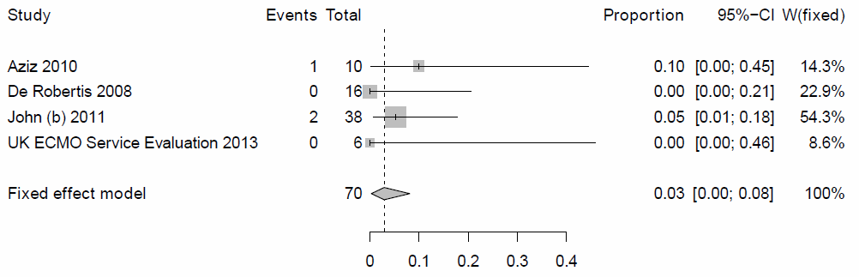
Figure 76. Proportion of patients, who experienced hemolysis (F-E model)

Paediatric population
Study | N studies (n) | Adverse event rate (95% confidence interval)
UK ECMO Service Evaluation 2013 | 61(3) | 0.05 (0.01- 0.14)

Neurologic complications
Adult population
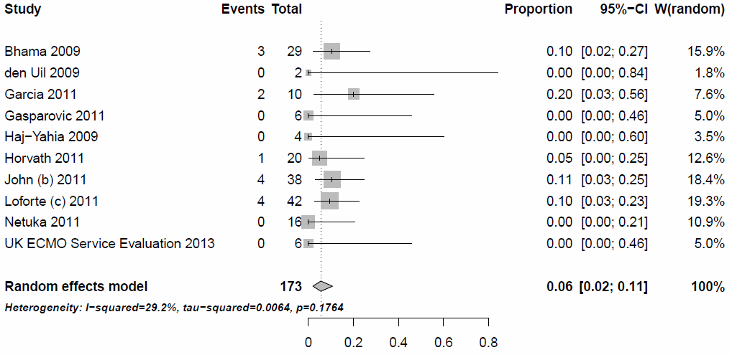
Figure 77. Proportion of patients, who experienced neurologic complications (R-E model)
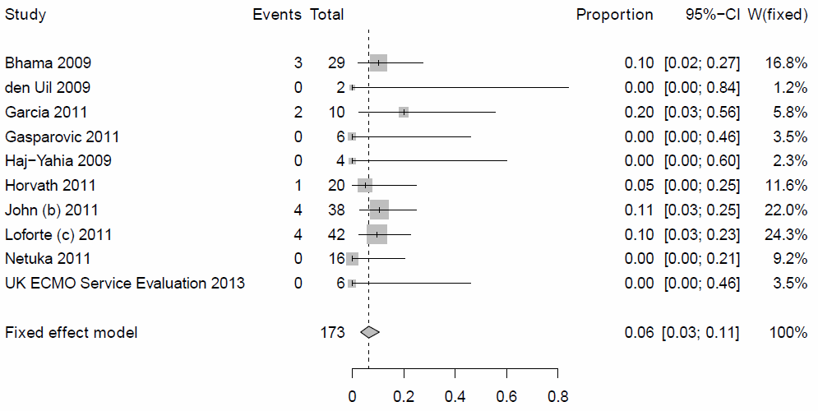
Figure 78. Proportion of patients, who experienced neurologic complications (F-E model)
Paediatric population
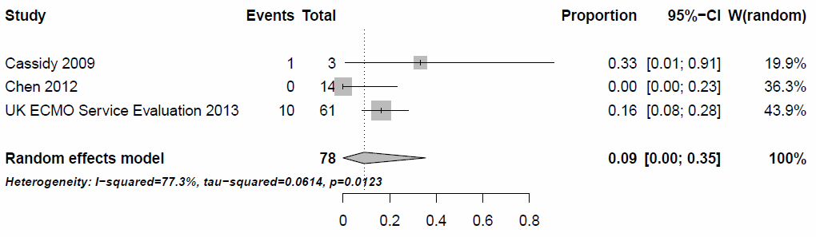
Figure 79. Proportion of patients, who experienced neurologic complications (R-E model)

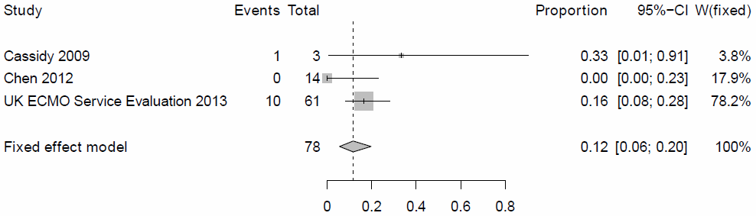
Figure 80. Proportion of patients, who experienced neurologic complications (F-E model)
Infection
Adult population
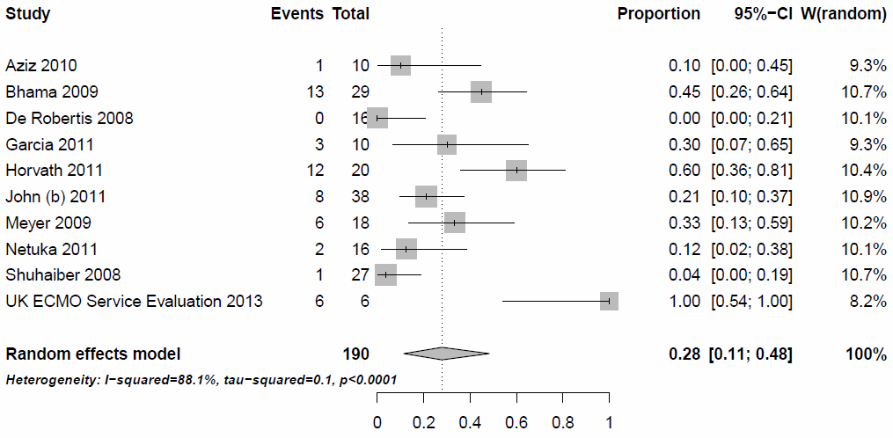
Figure 81. Proportion of patients, who experienced infection (R-E model)

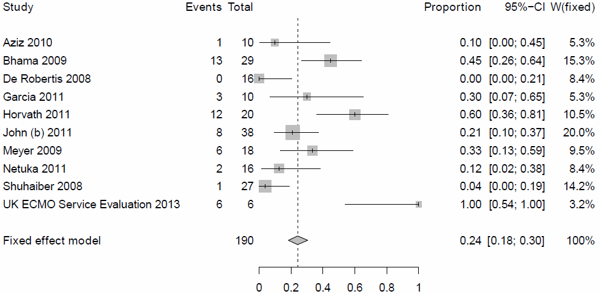
Figure 82. Proportion of patients, who experienced infection (F-E model)
Paediatric population
Study | N studies (n) | Adverse event rate (95% confidence interval)
UK ECMO Service Evaluation 2013 | 61(16) | 0.26 (0.16- 0.39)

Renal complications
Adult population
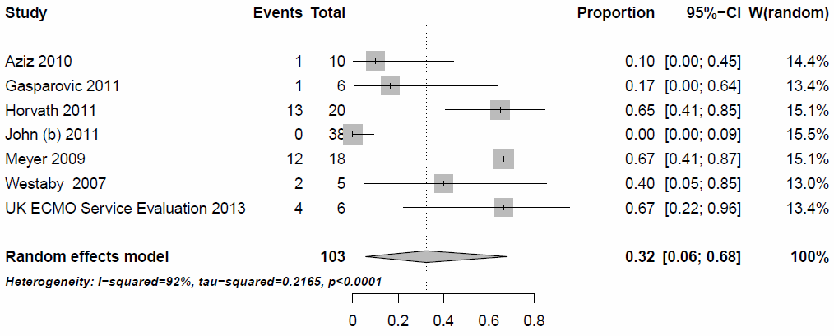
Figure 83. Proportion of patients, who experienced renal complications (R-E model)
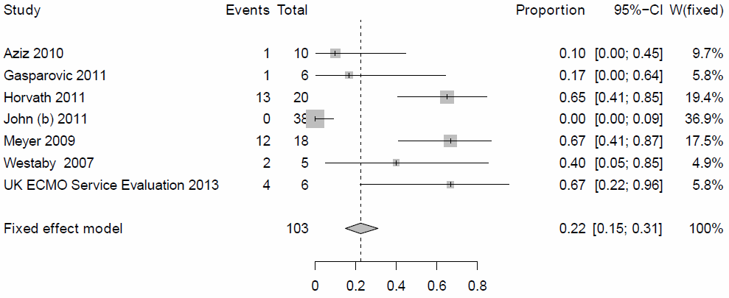
Figure 84. Proportion of patients, who experienced renal complications (F-E model)
Paediatric population
Study | N studies (n) | Adverse event rate (95% confidence interval)
UK ECMO Service Evaluation 2013 | 61(24) | 0.39 (0.27- 0.53)

Device failure
Adult population
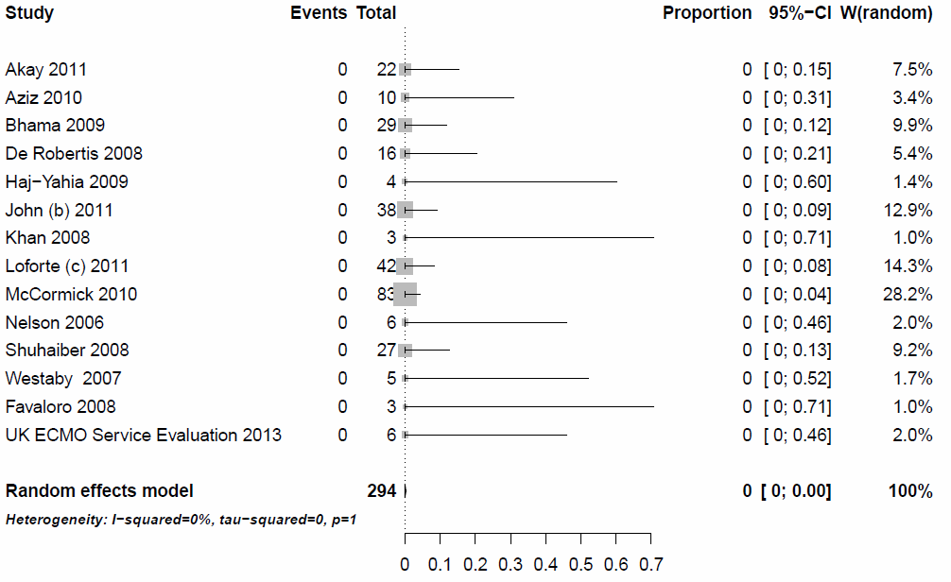
Figure 85. Proportion of patients, who experienced device failure (R-E model)
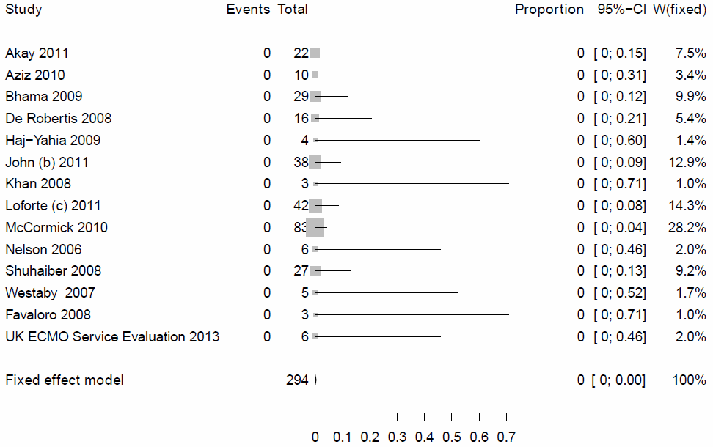
Figure 86. Proportion of patients, who experienced device failure (F-E model)

Paediatric population
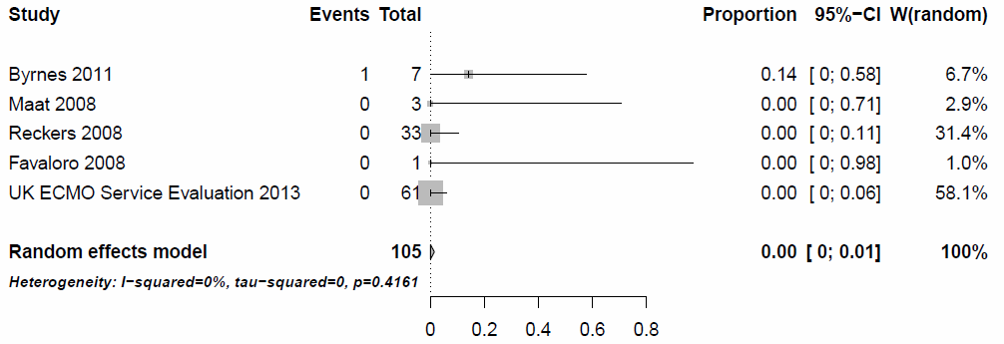
Figure 87. Proportion of patients, who experienced device failure (R-E model)
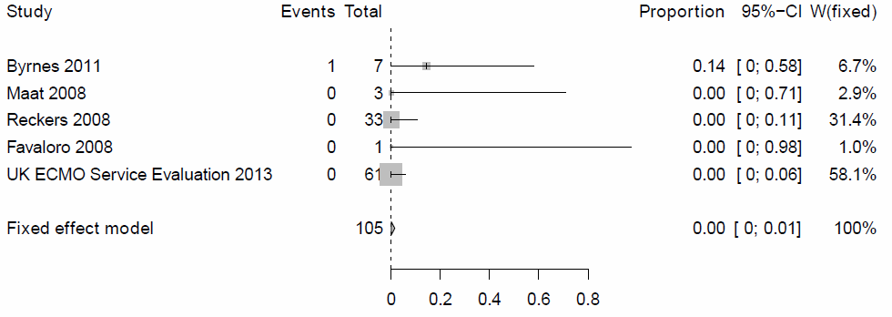
Figure 88. Proportion of patients, who experienced device failure (F-E model)

Additional references

- Centre for Reviews and Dissemination. Systematic reviews: CRD's guidance for undertaking reviews in health care. University of York & NHS Centre for Reviews & Dissemination. January 2009.
- The InterTASC Information Specialists' Sub-Group Search Filter Resource.
- “Glossary.” National Institute for Health and Clinical Excellence (NICE). 15 Apr. 2011. Available from: < http://www.nice.org.uk/website/glossary/glossary.jsp>. [26 November 2013].
- El Banayosy A: Preliminary Clinical Experience with the CentriMag Pump as ECMO in cardiogenic Shock Patients. Artificial Organs 30:A 23, 2006.
- De Robertis F, Birks EJ BP, Banner NR, et al.: End-Stage Cardiac Failure Managed with Levitronix CentriMag Short-Term Ventricular Assist Device (VAD). J Heart Lung Transplant 24:S59, 2005.
- Firouzi A, George RS, Absalom K, et al.: A safe and a cost-effective approach for managing patients with levitronix centrimag short term devices. J Heart Lung Transplant 29:S180, 2010.
- Reckers J, Haun C, Asfour B, Hraska V, Urban A, Fink C: Neonatal ECMO with Levitronix CentriMag: A Centrifugal Pump without Significant Hemolysis. In: Ündar A, editor.Second International Conference on Pediatric Mechanical Circulatory Support Systems and Pediatric Cardiopulmonary Perfusion. Toronto,Canada: Penn State college of medicine, 2006, pp. 45.
- John R, Lietz K, Liao K, Miller LW, Joyce LD: Short-Term Circulatory Support for Cardiogenic Shock With Levitronix Centrimag Ventricular Assist Device. ASAIO J 52:61A, 2006.
- Ziemba EA, John R: Mechanical circulatory support for bridge to decision: which device and when to decide. J Card Surg 25:425-33, 2010.
- Loforte A, Ranocchi F, Montalto A, et al.: Levitronix centrimag as temporary mechanical support in postcardiotomy cardiogenic shock. Interact Cardiovasc Thorac Surg 8:S87, 2009.
- Stepanenko A, Loforte A, Dranishnikov N, et al.: Temporary right ventricular support in left ventricular assist device recipients. J Heart Lung Transplant 30:S159-S60, 2011.
- Melnitchouk S, Naka Y, Jorde U, et al.: Outcome of patients with postcardiotomy shock requiring ventricular assist device support remains poor. J Heart Lung Transplant 30:S218, 2011.
- Hirata Y, Charette K, Mosca RS, Quaegebeur JM, Chen JM: Pediatric application of the Thoratec CentriMag BiVAD as a bridge to heart transplantation. J Thorac Cardiovasc Surg 136:1386-7, 2008.
- Smerling A, Addonizio L, M W, et al.: Outcome of children supported with the centrimag ventricular assist device (VAD). Critical Care Medicine 37:A103, 2009.
- John R, Liao K, Lietz K, et al.: Use of the Levitronix CentriMag Ventricular Assist Device (VAD) for the Treatment of Refactory cardiogenic Shock in Patients with End-Stage Heart Failure. J Heart Lung Transplant 25:S149, 2006.
- Worku B, Takayama H, Van Patten D, Pak P, Naka Y: The Columbia Experience with the Levitronix CentriMag as a Rescue Device in High Risk Patients. J Heart Lung Transplant 29:S9, 2010.

R-code for meta-analysis of effectiveness and safety outcomes

install.packages("meta")
library(meta)
#metaprop #function details
#VAD Precardiotomy
surv_support1<-metaprop(c(13,10,1,2,9),c(16,12,5,3,9),c("De Robertis 2008","John 2007","Loforte (b) 2011","Maat 2008","Morgan 2009"), sm="PAS", comb.fixed=F, comb.random=T
print(surv_support1)
forest(surv_support1)
surv_support1_NEW<-metaprop(c(13,10,2,9),c(16,12,3,9),c("De Robertis 2008","John 2007","Maat 2008","Morgan 2009"), sm="PAS", comb.fixed=F, comb.random=T)
print(surv_support1_NEW)
forest(surv_support1_NEW)

surv_discharge1<-metaprop(c(3,4,7),c(5,4,14),c("Gasparovic 2011","Haj-Yahia 2009","John (b) 2011"), sm="PAS", comb.fixed=F, comb.random=T) #comb.fixed=FALSE, comb.random=TRUE
print(surv_discharge1)
forest(surv_discharge1)
surv30_days1<-metaprop(c(13,4,9,7,9,2),c(16,4,12,14,14,9),c("De Robertis 2008","Haj-Yahia 2009","John 2007","John (b) 2011","Loforte 2009","Shuhaiber 2008"), sm="PAS", comb.fixed=F, comb.random=T)
print(surv30_days1)
forest(surv30_days1)
surv30_days1_NEW<-metaprop(c(13,4,9,7,9),c(16,4,12,14,14),c("De Robertis 2008","Haj-Yahia 2009","John 2007","John (b) 2011","Loforte 2009"), sm="PAS", comb.fixed=T, comb.random=F)
print(surv30_days1_NEW)
forest(surv30_days1_NEW)

surv90_days1<-metaprop(c(11,4,5),c(16,4,9),c("De Robertis ","Haj-Yahia 2T009","Morgan 2009"), sm="PAS",comb.fixed=T, comb.random=F)
print(surv90_days1)
forest(surv90_days1)
surv6_months1<-metaprop(c(11,4,9,6),c(16,4,12,14),c("De Robertis 2008","Haj-Yahia 2009","John 2007","John(b) 2011"), sm="PAS",comb.fixed=F, comb.random=T)
print(surv6_months1)
forest(surv6_months1)
surv1_year1<-metaprop(c(11,4,7),c(16,4,12),c("De Robertis 2008","Haj-Yahia 2009","John 2007"), sm="PAS",comb.fixed=T, comb.random=F)
print(surv1_year1)
forest(surv1_year1)
#survPost1_year1<-metaprop(c(4),c(4),c("Haj-Yahia"), sm="PAS")
weaned1<-metaprop(c(2,2,7),c(16,12,9),c("De Robertis","John","Morgan"), sm="PAS")
Bridged_HTx1<-metaprop(c(3,3,4,1),c(16,5,4,5),c("De Robertis","Gasparovic","Haj-Yahia","Loforte (b)"), sm="PAS")
Bridged_VAD1<-metaprop(c(6,8,2,2),c(16,12,3,9),c("De Robertis","Gasparovic","Haj-Yahia","Loforte (b)"), sm="PAS")

#VAD Post_CSCS
surv_support2<-metaprop(c(2,12,2,3,4),c(2,23,2,5,5),c("Clough 2009","Loforte (b) 2011","Marquez 2009","Netuka 2011","Westaby 2007"), sm="PAS",comb.fixed=T, comb.random=F)
print(surv_support2)
forest(surv_support2)
surv_discharge2<-metaprop(c(3,2,0,4,2,5,4),c(7,2,1,12,2,8,5),c("Bhama 2009","Clough 2009","Gasparovic 2011","John 2011","Marquez 2009","McCormick 2010","Westaby 2007"), sm="PAS",comb.fixed=F, comb.random=T)
print(surv_discharge2)
forest(surv_discharge2)
surv30_days2<-metaprop(c(9,4,6,5,3),c(22,12,16,8,7),c("Akay 2011","John 2011","Loforte 2009","McCormick 2010","Shuhaiber 2008"), sm="PAS",comb.fixed=F, comb.random=T)
print(surv30_days2)
forest(surv30_days2)
surv90_days2 #no data
surv6_months2<-metaprop(c(2,5),c(12,8),c("John 2011","McCormick 2010"), sm="PAS",comb.fixed=F, comb.random=T)
print(surv6_months2)
forest(surv6_months2)
surv1_year2<-metaprop(c(5),c(8),c("McCormick 2010"), sm="PAS")
survPost1_year2 #no data
weaned2<-metaprop(c(9,3,2,11,1,3,4),c(22,7,2,23,2,5,5),c("Akay 2011","Bhama 2009","Clough 2009","Loforte (b) 2011","Marquez 2009","Netuka 2011","Westaby 2007"), sm="PAS")
Bridged_HTx2<-metaprop(c(1),c(23),c("Loforte (b)"), sm="PAS")
Bridged_VAD2<-metaprop(c(1),c(2),c("Marquez"), sm="PAS")

#VAD Post_transplant
surv_support3<-metaprop(c(4,2,17),c(4,2,34),c("Loforte 2011","Santise 2006","Thomas 2011"), sm="PAS",comb.fixed=F, comb.random=T)
print(surv_support3)
forest(surv_support3)
surv_discharge3<-metaprop(c(6,2),c(10,2),c("Bhama 2009","Santise 2006"), sm="PAS",comb.fixed=T, comb.random=F)
print(surv_discharge3)
forest(surv_discharge3)
surv30_days3<-metaprop(c(4,3,17),c(5,6,34),c("Netuka 2011","Shuhaiber 2008","Thomas 2011"), sm="PAS",comb.fixed=T, comb.random=F)
print(surv30_days3)
forest(surv30_days3)
surv90_days3 #no data
surv6_months3 #no data
surv1_year3<-metaprop(c(11),c(34),c("Thomas"), sm="PAS",comb.fixed=F, comb.random=T)
survPost1_year3 #no data
#weaned3<-metaprop(c(7,4,4,1,12),c(10,4,5,2,34),c("Bhama","Loforte","Netuka","Santise","Thomas"), sm="PAS")
#Bridged_HTx3<-metaprop(c(1,5),c(2,34),c("Santise","Thomas"), sm="PAS")
#Bridged_VAD3 #no data
Weaned_bridged<-metaprop(c(7,4,4,2,17),c(10,4,5,2,34),c("Bhama 2009","Loforte 2011","Netuka 2011","Santise 2006","Thomas 2011"), sm="PAS",comb.fixed=T, comb.random=F)
print(Weaned_bridged)
forest(Weaned_bridged)

#VAD Post_LVAD
surv_support3<-metaprop(c(8,6,4,5,6,17),c(10,6,6,6,6,24),c("Loforte 2011","Loforte (b) 2010","Nelson 2006","Netuka 2011","Stepanenko 2010","Zych 2011"), sm="PAS",comb.fixed=T, comb.random=F)
print(surv_support3)
forest(surv_support3)
surv_discharge3<-metaprop(c(6,5,6,15),c(12,12,6,24),c("Bhama 2009","John 2011","Loforte (b) 2010","Zych 2011"), sm="PAS",comb.fixed=F, comb.random=T)
print(surv_discharge3)
forest(surv_discharge3)
surv_discharge3_NEW<-metaprop(c(6,5,15),c(12,12,24),c("Bhama 2009","John 2011","Zych 2011"), sm="PAS",comb.fixed=T, comb.random=F)
print(surv_discharge3_NEW)
forest(surv_discharge3_NEW)

surv30_days3<-metaprop(c(7,0,19),c(12,5,24),c("John 2011","Shuhaiber 2008","Zych 2011"), sm="PAS",comb.fixed=F, comb.random=T)
print(surv30_days3)
forest(surv30_days3)
surv30_days3_NEW<-metaprop(c(7,19),c(12,24),c("John 2011","Zych 2011"), sm="PAS",comb.fixed=T, comb.random=F)
print(surv30_days3_NEW)
forest(surv30_days3_NEW)

surv90_days3 <-metaprop(c(17),c(24),c("Zych"), sm="PAS",comb.fixed=F, comb.random=T)
surv6_months3 <-metaprop(c(4),c(12),c("John"), sm="PAS",comb.fixed=F, comb.random=T)
surv1_year3<-metaprop(c(14),c(24),c("Zych"), sm="PAS",comb.fixed=F, comb.random=T)
survPost1_year3 #no data
#weaned3<-metaprop(c(7,6,8,6,3,5,6,14),c(12,12,10,6,6,6,6,24),c("Bhama","John","Loforte","Loforte (b)","Nelson","Netuka","Stepanenko","Zych"), sm="PAS")
#Bridged_HTx3<-metaprop(c(3),c(24),c("Zych"), sm="PAS")
#Bridged_VAD3<-metaprop(c(1,1),c(12,6),c("John","Nelson"), sm="PAS")
Weaned_bridged<-metaprop(c(7,7,8,6,4,5,6,17),c(12,12,10,6,6,6,6,24),c("Bhama 2009","John 2011","Loforte 2011","Loforte (b) 2010","Nelson 2006","Netuka 2011","Stepanenko 2010","Zych 2011"), sm="PAS")
print(Weaned_bridged)
forest(Weaned_bridged)

#aDVERSE EVENT
Adverse.events <- read.csv("C:/Users/ana.turk/Desktop/Adverse events.csv", sep=";")
head(Adverse.events)
Bleeding<-na.omit(data.frame(Author=Adverse.events$A.Y,Total=Adverse.events$No.Centrimag,Event=Adverse.events$Bleeding.events))
meta_Bleeding<-metaprop(Bleeding$Event,Bleeding$Total,Bleeding$Author, sm="PAS",comb.fixed=T, comb.random=F)
print(meta_Bleeding)
forest(meta_Bleeding)

Thrombosis<-na.omit(data.frame(Author=Adverse.events$A.Y,Total=Adverse.events$No.Centrimag,Event=Adverse.events$Thrombosis.events))
meta_Thrombosis<-metaprop(Thrombosis$Event,Thrombosis$Total,Thrombosis$Author, sm="PAS",comb.fixed=T, comb.random=F)
print(meta_Thrombosis)
forest(meta_Thrombosis)

Hemolysis<-na.omit(data.frame(Author=Adverse.events$A.Y,Total=Adverse.events$No.Centrimag,Event=Adverse.events$Hemolysis.events))
meta_Hemolysis<-metaprop(Hemolysis$Event,Hemolysis$Total,Hemolysis$Author, sm="PAS",comb.fixed=T, comb.random=F)
print(meta_Hemolysis)
forest(meta_Hemolysis)

Neurologic<-na.omit(data.frame(Author=Adverse.events$A.Y,Total=Adverse.events$No.Centrimag,Event=Adverse.events$Neurologic.events))
meta_Neurologic<-metaprop(Neurologic$Event,Neurologic$Total,Neurologic$Author, sm="PAS",comb.fixed=T, comb.random=F)
print(meta_Neurologic)
forest(meta_Neurologic)

Infection<-na.omit(data.frame(Author=Adverse.events$A.Y,Total=Adverse.events$No.Centrimag,Event=Adverse.events$Infection.events))
meta_Infection<-metaprop(Infection$Event,Infection$Total,Infection$Author, sm="PAS",comb.fixed=T, comb.random=F)
print(meta_Infection)
forest(meta_Infection)

Renal<-na.omit(data.frame(Author=Adverse.events$A.Y,Total=Adverse.events$No.Centrimag,Event=Adverse.events$Renal.events))
meta_Renal<-metaprop(Renal$Event,Renal$Total,Renal$Author, sm="PAS",comb.fixed=T, comb.random=F)
print(meta_Renal)
forest(meta_Renal)

Device<-na.omit(data.frame(Author=Adverse.events$A.Y,Total=Adverse.events$No.Centrimag,Event=Adverse.events$Device.events))
meta_Device<-metaprop(Device$Event,Device$Total,Device$Author, sm="PAS",comb.fixed=T, comb.random=F)
print(meta_Device)
forest(meta_Device)

device10 <- read.csv("C:/Users/ana.turk/Desktop/device10.csv", sep=";")
Device2<-metaprop(device10$Device.events,device10$No.Centrimag,device10$A.Y, sm="PAS",comb.fixed=T, comb.random=F)
print(Device2)
forest(Device2)

