**Digital Content Supplement**

**An Exploratory Study of Long-term Outcome Measures in Critical Illness Survivors: Construct Validity of Physical Activity, Frailty and Health-Related Quality of Life Measures**

Angela S McNelly, Jai Rawal, Dinesh Shrikrishna, Nicholas S Hopkinson, John Moxham, and Stephen D Harridge, Nicholas Hart, Hugh E Montgomery, and Zudin A Puthucheary

**METHODS**

1. **Study design**

*1.1 STROBE Flowchart*

**STUDY RECRUITMENT**

363 Patients screened

213 Did not meet criteria

150 Met entry and exclusion criteria

59 Refused

91 Gave assent

4 Withdrew

2 Transfer to another hospital

12 Died

10 ICU stay less than 7 days

63 Patients studied

7 Died in hospital

56 Discharged

8 died in community; 5 LTF; 2 significant morbidity

41 Patients received invitation letter

**STUDY FOLLOW-UP**

2 W/D; 1 LTF

38 Patients contacted re visit

4 W/D; 2 NR; 1 LTF; 1 significant morbidity

30 Patients provided data:

**Full-data** (QOL, CFS, PA) = 27;

**Partial data** = 3 (PA n/a - 1 non-compliant; 2 bed-bound)

**Figure S1: STROBE Flowchart for Patients in Musculoskeletal Ultrasound Study in Critical Care: Longitudinal Evaluation Study [1]Follow-Up**

QOL: Quality of life; CFS: Clinical Frailty Scale; PA: Physical Activity; LTF: Lost to follow-up

up (no current address); NR: Non-responder (correct address; no response); W/D: Withdrawn; n/a: Not available.

**2. Assessment of Health-Related Quality of Life**

**2. Assessment of Health-Related Quality of Life**

*2.1 Application of Health-Related Quality of Life Questionnaire (Medical Outcomes Study Short Form 36 Health Survey, SF-36)*

This consists of eight domain scales (Physical Function; Role - Physical; Bodily Pain; General Health; Vitality; Social Function; Role - Emotional; Mental Health), and two component summary scores (Physical Component Summary Score [PCS] and Mental Component Summary Score [MCS]) [2], and has been validated in UK populations [3].Median, mean and standard deviations were compared with SF-36 scores reported from a large UK control population [3].

**3. Assessment of Daily Activity**

*3.1 Use of Activity Monitors*

Monitors were worn on the upper arm; a demonstration of monitor use was provided to the patient and carer or family member during the home visit, and an information sheet with the researcher’s contact details provided lest further clarification was required. Monitors were either collected in person or returned by mail.

**4. Assessment of Clinical Frailty Score**

*4.1 Details of Clinical Frailty Scale Scoring*

Scores were judged according to the criteria in Table S1 from observation during the home visit.



**Table S1. Description of Clinical Frailty Scale Scores [4].**

**5. Effect/Sample Size Calculations**

*5.1 Projected parameters for statistical calculations for future trial design*

|  |  |  |  |  |
| --- | --- | --- | --- | --- |
|  | CFS*a* | Daily Step Counts *b* | | PCS *c* |
| Healthy controls | 2 | | 10,000 | 50 |
| ICU survivors | 2 | | 8750 | 50 |
| ICU survivors without chronic disease | 2 | | 10,000 | 50 |
| ICU survivors with chronic disease | 3 | | 6250 | 42 |

*a* As per Table S1. From reference [4].

*b* From reference [5].

*c* From reference [6]: Mean±SD ≡ 50±10 [2].



**RESULTS**

1. **Patient Characteristics**

*1.1 Enrolled versus non-followed up patients from full cohort of intensive care unit survivors (n=30)*

|  |  |  |  |
| --- | --- | --- | --- |
| Characteristic | Followed-up | Not Followed-up | P value |
| n | 30 | 11 |  |
| Age (years) | 55.3 (48.3-62.3) | 40.8 (31.9-49.7) | **0.024*c*** |
| Male sex n (%)*a* | 14(46.7) | 8 (72.7) | **<0.001 *c*** |
| Pre-ICU LOS (days)*b* | 1 (1-4) | 1 (1-2) | 0.192 |
| Ventilator days *b* | 8 (2-44) | 8 (4-14) | 0.936 |
| ICU LOS (days) *b* | 15 (7-73) | 13 (9-27) | 0.960 |
| Hospital LOS (days) *b* | 29 (15-141) | 33 (16-54) | 0.902 |
| APACHE II | 23.5 (21.6-25.3) | 20.0 (16.4-23.6) | 0.061 |
| SAPS II | 44.1 (39.3-49.0) | 51.6 (34.3-49.0) | 0.637 |
| Admission SOFA | 8.9 (7.6-10.1) | 9.5 (7.9-11.1) | 0.600 |
| CCI *b* | 0 (0-5) | 0 (0-2) | 0.095 |
| Admission diagnosis, n (%)  Sepsis  Trauma  Intracranial Bleed  Acute liver failure  Cardiogenic shock | 13 (43.3)  7 (23.3)  3 (10.0)  0 (0.0)  7 (23.3) | 3 (27.2)  5 (45.4)  2 (18.2)  1 (9.1)  0 (0.0) |  |
| Comorbidities, n (%)  COPD  Ischaemic heart disease  Hypertension  Diabetes Mellitus  Liver cirrhosis  Haematological disease  Obesity  Previous CVA  Chronic pancreatitis  Renal impairment  Crohn’s disease  Thyroid disease | 6 (20.0)  6 (20.0)  9 (30.0)  4 (13.3)*d*  1 (3.3)  1 (3.3)  3 (10.0)  1 (3.3)  1 (3.3)  2 (6.6)  1 (3.3)  3 (10.0) | 0 (0.0)  0 (0.0)  2 (18.2)  0 (0.0)  1 (9.1)  1 (9.1)  0 (0.0)  0 (0.0)  0 (0.0)  0 (0.0)  0 (0.0) *e*  0 (0.0) |  |

Table S3. Patient Characteristics: Followed up versus Non-followed up Patients From Full Cohort of Intensive Care Unit Survivors (n=30).

ICU: intensive care unit; LOS: Length of stay; APACHE II: Acute Physiology and Chronic Health Evaluation score; SAPS II: Simplified Acute Physiology Score; SOFA: Sequential Organ Failure Assessment Score; CCI: Charlson Co Morbidity Index; RFCSA: Rectus Femoris Cross Sectional Area; ΔRFCSAd10%: Change in RFCSA over 10 days expressed as a percentage; COPD: Chronic Obstructive Pulmonary Disease; CVA: Cerebro-vascular accident. Values are mean with (95% Confidence Intervals), except for *b* indicating median with range. Student’s T-test was used except for *a*(Chi-squared) and *b*(Mann Whitney U test); *c* indicates p<0.05. *d*Including one patient with Non-Insulin Dependent Diabetes Mellitus taking metformin. *e*Including one patient with severe Crohn’s disease (not scored by Charlson Co Morbidity Index [7]), hypothyroidism and hypertension.

1. **SF-36**



1. **Construct Validity**

**i) CFS;** TPDA CFS **ii) Steps/d;** AA steps/d; **TPDA steps/d;** Variation Steps/d**; AA Variation/d;** TPDA Variation/d

|  |  |  |  |  |  |  |  |  |  |  |  |  |  |  |  |  |  |  |  |  |  |  |  |  |  |
| --- | --- | --- | --- | --- | --- | --- | --- | --- | --- | --- | --- | --- | --- | --- | --- | --- | --- | --- | --- | --- | --- | --- | --- | --- | --- |
| **Comparator** | | **r²** | **p-value** | | r² | | p-value | | **r²** | **p-value** | | r² | p-value | | **r²** | **p-value** | | r² | p-value | | **r²** | **p-value** | | r² | p-value |
| **SF-36 PCS** | | 0.56 | | <0.01 | | 0.43 | | <0.01 | 0.25 | <0.01 | | 0.28 | <0.01 | | 0.20 | <0.05 | | 0.09 | NS | | 0.12 | NS | | 0.11 | NS |
| **SF-36 MCS** | | 0.21 | | <0.05 | | 0.11 | | NS | 0.03 | NS | | 0.01 | NS | | 0.03 | NS | | 0.03 | NS | | 0.03 | NS | | 0.02 | NS |
| **SF-36 PF** | | 0.67 | | <0.01 | | 0.5 | | <0.01 | 0.51 | <0.01 | | 0.56 | <0.01 | | 0.47 | <0.01 | | 0.24 | <0.01 | | 0.28 | <0.01 | | 0.27 | <0.01 |
| **Steps/d** | | 0.55 | | <0.01 | | 0.47 | | <0.01 | - | - | | 0.91 | <0.01 | | 0.88 | <0.01 | | 0.67 | <0.01 | | 0.57 | <0.01 | | 0.69 | <0.01 |
| **AA steps/d** | | 0.49 | | <0.01 | | 0.38 | | <0.01 | 0.91 | <0.01 | | - | - | | 0.87 | <0.01 | | 0.68 | <0.01 | | 0.77 | <0.01 | | 0.74 | <0.01 |
| **APACHE II** | | 0.04 | | NS | | 0.03 | | NS | 0.06 | NS | | 0.07 | NS | | 0.05 | NS | | 0.07 | NS | | 0.08 | NS | | 0.07 | NS |
| **SAPS II** | 0.002 | | | NS | | 0.02 | | NS | 0.02 | NS | | 0.02 | NS | | 0.06 | NS | | 0.01 | NS | | 0.02 | NS | | 0.02 | NS |
| **SOFA** | | 0.06 | | NS | | 0.09 | | NS | 0.01 | NS | 0.001 | | NS | 0.001 | | NS | 0.001 | | NS | 0.001 | | NS | 0.001 | | NS |

**Table S5. Adjusted and Unadjusted Values of Clinical Frailty Scale Scores and Parameters of Daily Step Count versus Measures of Physical Activity and Bedside Physiology from Intensive Care Unit Survivors Undergoing Activity Monitoring (n=27): Full Construct Validity Analysis.**

CSF: Clinical Frailty Scale score; PCS: SF-36 Physical Component Summary score; MCS: SF-36 Mental Component Summary score; PF: SF-36 Physical Function score (norm-based); AA: Age Adjusted; TPDA: Time Post-Discharge Adjusted; d: day; APACHE II: Acute Physiology and Chronic Health Evaluation II score; SAPS II: Simplified Acute Physiology Score II; SOFA: Sequential Organ Failure Assessment Score; r²: Coefficient of determination. NS indicates p>0.05.

|  |  |
| --- | --- |
|  |  |

**Figure S2: Relationships Between Daily Step Count Parameters and Health-Related Quality of Life (from Medical Outcomes Study Short Form 36 Questionnaire Domain Scores) in Intensive Care Unit Survivors (n=27).** 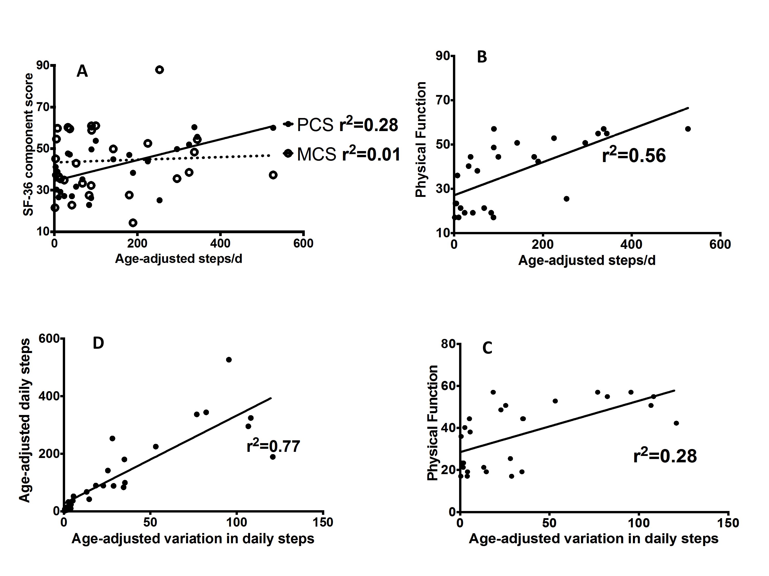

A: SF-36 Component Summary scores versus age-adjusted daily step count

B: SF-36 Physical Function domain score versus age-adjusted daily step count

C: SF-36 Physical Function domain score versus age-adjusted variation in daily step count

D: Age-adjusted daily step count versus age-adjusted variation in daily step count

Construct validity was assessed by determining values of r-squared between parameters of step count (derived from accelerometry), and norm-based scores from the SF-36 survey. SF-36: Medical Outcomes Study Short Form 36 questionnaire; PCS: SF-36 Physical Component Summary score; MCS: SF-36 Mental Component Summary score; Physical Function: SF-36 Physical Function domain score; steps/d: daily step count; r2: Coefficient of determination.

**Figure S3: Relationships Between Clinical Frailty Scale Score and Medical Outcomes Study Short Form 36 Questionnaire Physical Function Domain Score or Time Post-Discharge-Adjusted Daily Step Count in Intensive Care Unit Survivors (n=27).**

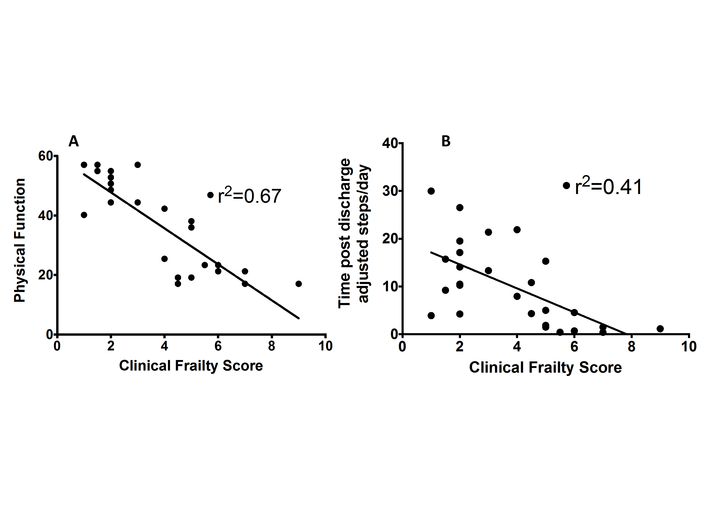

A: SF-36 Physical Function domain score versus Clinical Frailty Scale score

B: Time post-discharge-adjusted daily step count versus Clinical Frailty Scale score

Construct validity was assessed by determining values of r-squared between time post-discharge-adjusted daily step count (derived from accelerometry), and Physical Function scores (from the SF-36 survey), versus Clinical Frailty Scale Score (without adjustment for age and time post-discharge). SF-36: Medical Outcomes Study Short Form 36 questionnaire; Physical Function: SF-36 Physical Function domain score; r2: Coefficient of determination.

**DISCUSSION**

1. **Sufficiency of Sample Size**

A post-hoc power calculation indicates that sufficient numbers of ICU survivors with varying degrees of comorbidity were studied to detect a between-groups difference using physical activity monitoring or the PCS of the SF-36 questionnaire.

|  |  |  |  |  |  |
| --- | --- | --- | --- | --- | --- |
| Outcome measure | With Chronic Disease, mean (SD) | | Without Chronic Disease, mean (SD) | Total number needed | |
| Age-adjusted steps | 53.0 (73.2) | 186.3 (145.8) | | | 26 |
| SF-36 PCS | 34.0 (8.9) | 46.0 (11.4) | | | 26 |
| Clinical Frailty Score*a* | 3 (1.6) | 5 (2.3) | | | 36 |

Table S6: Post-hoc Power Calculations for Different Outcome Measures Studied to Detect a Difference Between Patients With and Without Chronic Disease States.

All power calculations were performed for alpha=0.05 beta=0.80 and two-tailed Students’ T-test except for *a*=Mann-Whitney U test; SD: Standard Deviation; SF-36: Medical Outcomes Study Short Form 36 questionnaire; PCS: SF-36 Physical Component Summary score.

References

1. Puthucheary ZA, Rawal J, McPhail M, et al. Acute skeletal muscle wasting in critical illness. JAMA 2013; 310: 1591-1600.
2. Ware JE, Sherbourne CD. The MOS 36-item short-form health survey (SF-36). I. Conceptual framework and item selection. Med Care 1992; 30: 473-83.
3. Jenkinson C, Stewart-Brown S, Petersen S, Paice C. Assessment of the SF-36 version 2 in the United Kingdom. J Epidemiol Community Health 1999; 53: 46-50.
4. McDermid RC, Stelfox HT, Bagshaw SM. Frailty in the critically ill: a novel concept. Crit Care 2011; 15: 301.
5. Tudor-Locke C and Bassett DR. How many steps/day are enough? Preliminary pedometer indices for public health. Sports Med 2004; 34: 1-8.
6. Stahl E, Lindberg A, Jansson SA, et al. Health-related quality of life is related to COPD disease severity. Health and Quality of Life Outcomes 2005; 34: 56.
7. Charlson M, Pompei, P, Ales KL, MacKenzie CR. A new method of classifying prognostic comorbidity in longitudinal studies: Development and validation. J Chronic Dis 1987; 40: 373-383.