**Evaluating the Sum of Eye and Motor Components of the Glasgow Coma Score as a Predictor of Extubation Failure in Patients with Acute Brain Injury**

*Supplemental Digital Content*

Shaurya Taran, Bastien Perrot, Federico Angriman, Raphael Cinotti

1. **eAppendix 1:** STROBE checklist and Additional Methods
2. **eAppendix 2**: Ethics statement
3. **eFigure 1:** Patient recruitment flowchart
4. **eFigure 2:** GCS-EM in the cohort
5. **eFigure 3:** GCS-EM as a categorical variable and spline
6. **eFigure 4:** Subgroup analyses

|  |  |  |  |
| --- | --- | --- | --- |
|  | Item No | Recommendation | Page No* |
| **Title and abstract** | 1 | (*a*) Indicate the study’s design with a commonly used term in the title or the abstract | 2 |
| (*b*) Provide in the abstract an informative and balanced summary of what was done and what was found |  |
| Introduction | | | |
| Background/rationale | 2 | Explain the scientific background and rationale for the investigation being reported | 5 |
| Objectives | 3 | State specific objectives, including any prespecified hypotheses | 5 |
| Methods | | | |
| Study design | 4 | Present key elements of study design early in the paper | 5-6 |
| Setting | 5 | Describe the setting, locations, and relevant dates, including periods of recruitment, exposure, follow-up, and data collection | 2 |
| Participants | 6 | (*a*) Give the eligibility criteria, and the sources and methods of selection of participants. Describe methods of follow-up | eAppendix1 |
| (*b*)For matched studies, give matching criteria and number of exposed and unexposed |  |
| Variables | 7 | Clearly define all outcomes, exposures, predictors, potential confounders, and effect modifiers. Give diagnostic criteria, if applicable | eAppendix1 |
| Data sources/ measurement | 8 | For each variable of interest, give sources of data and details of methods of assessment (measurement). Describe comparability of assessment methods if there is more than one group | eAppendix1 |
| Bias | 9 | Describe any efforts to address potential sources of bias | 6 |
| Study size | 10 | Explain how the study size was arrived at | N/A |
| Quantitative variables | 11 | Explain how quantitative variables were handled in the analyses. If applicable, describe which groupings were chosen and why | eAppendix1 |
| Statistical methods | 12 | (*a*) Describe all statistical methods, including those used to control for confounding |  |
| (*b*) Describe any methods used to examine subgroups and interactions | 6-7 |
| (*c*) Explain how missing data were addressed |  |
| (*d*) If applicable, explain how loss to follow-up was addressed |  |
| (*e*) Describe any sensitivity analyses |  |
| Results | | |  |
| Participants | 13* | (a) Report numbers of individuals at each stage of study—eg numbers potentially eligible, examined for eligibility, confirmed eligible, included in the study, completing follow-up, and analysed | eAppendix1 |
| (b) Give reasons for non-participation at each stage |  |
| (c) Consider use of a flow diagram |  |
| Descriptive data | 14* | (a) Give characteristics of study participants (eg demographic, clinical, social) and information on exposures and potential confounders | eAppendix1 |
| (b) Indicate number of participants with missing data for each variable of interest |  |
| (c) Summarise follow-up time (eg, average and total amount) |  |
| Outcome data | 15* | Report numbers of outcome events or summary measures over time | N/A |

**eAppendix1: STROBE checklist**

|  |  |  |  |
| --- | --- | --- | --- |
| Main results | 16 | (*a*) Give unadjusted estimates and, if applicable, confounder-adjusted estimates and their precision (eg, 95% confidence interval). Make clear which confounders were adjusted for and why they were included | Figure1 |
| (*b*) Report category boundaries when continuous variables were categorized |  |
| (*c*) If relevant, consider translating estimates of relative risk into absolute risk for a meaningful time period |  |
| Other analyses | 17 | Report other analyses done—eg analyses of subgroups and interactions, and sensitivity analyses | eFigure4 |
| Discussion | | | |
| Key results | 18 | Summarise key results with reference to study objectives | 8-9 |
| Limitations | 19 | Discuss limitations of the study, taking into account sources of potential bias or imprecision. Discuss both direction and magnitude of any potential bias | 9 |
| Interpretation | 20 | Give a cautious overall interpretation of results considering objectives, limitations, multiplicity of analyses, results from similar studies, and other relevant evidence | 10 |
| Generalisability | 21 | Discuss the generalisability (external validity) of the study results | 9 |
| Other information | | | |
| Funding | 22 | Give the source of funding and the role of the funders for the present study and, if applicable, for the original study on which the present article is based | 1 |

*Page numbers correspond to the document at time of submission

This checklist was adapted from the following source: <https://www.equator-network.org/reporting-guidelines/strobe/>

**eAppendix 1 (*cont*.): Additional methods**

*Cohort*

The ENIO study included consecutive patients aged ≥ 18 years with a diagnosis of traumatic brain injury (TBI), subarachnoid aneurysmal haemorrhage (SAH), intracranial haemorrhage (ICH), acute ischemic stroke (AIS), central nervous system infection (brain abscess, empyema, meningitis, encephalitis), or brain tumour. All patients received invasive ventilation for ≥ 24 hours in an intensive care unit (ICU), had a Glasgow Coma Score (GCS) ≤ 12 before intubation, and underwent an extubation trial or primary tracheostomy. Patients were excluded for pregnancy, spinal cord injury above T4, cardiac arrest, Guillain–Barré syndrome, motor neuron disease, muscular dystrophy, myasthenia gravis, death before extubation, end-of-life extubation, withdrawal of life-sustaining treatment in the first 24 h after ICU admission, chronic home oxygen use, chronic obstructive pulmonary disease grade III or IV per the GOLD classification, major chest trauma (Abbreviated Injury Score ≥ 3), or a tracheostomy before ICU admission (1).

For the present analysis, we further excluded patients with a primary tracheostomy (since they were ineligible to experience extubation failure), patients with missing information on GCS eye and motor scores before extubation (required to derive the main exposure), and patients with missing extubation outcome.

*Outcome*

The primary outcome was extubation failure, defined as unplanned reintubation within 5 days of extubation among patients with at least 1 extubation attempt. There is currently no consensus on the time interval to define extubation failure, and prior studies have used intervals between 48 hours from extubation to any point during ICU admission (2-5). For the present analysis, we chose a 5-day time window to maintain consistency with the ENIO study (1). For patients extubated more than once, only the outcome of the first extubation was considered.

*Main exposure*

We defined the main exposure as the sum of the eye and motor components of the GCS (GCS-EM), as measured on the day of extubation while the patient was still intubated. Values of the main exposure ranged from 2 (minimum) to 10 (maximum), reflecting values of 1- 4 for the eye component and 1- 6 for the motor component. For the main analysis, we excluded the verbal component of the GCS as it is not reliably evaluated in intubated patients. This approach is in line with a common clinical practice, standard recommendations, and earlier studies (6-9).

*Additional covariates*

Adjustment covariates were selected for their clinical relevance to extubation outcome. Baseline characteristics included age, sex, heart failure history, and pulmonary disease history. Admission diagnosis included traumatic brain injury, aneurysmal subarachnoid hemorrhage, primary intracranial hemorrhage, acute ischemic stroke, or ‘others’ (defined as brain abscess, meningitis, empyema, encephalitis, or brain tumor). We included markers of illness severity as indicated by the total GCS before intubation (retained as an ordinal variable in all analyses), presence of an intracranial probe (parenchymal probe or external ventricular drain), decompressive craniectomy, development of acute respiratory distress syndrome (defined using the Berlin definition) (10), ventilator-associated pneumonia, and days from intubation to the first extubation attempt. Extubation day factors included respiratory rate, oxygen saturation, presence of cuff leak (evaluated qualitatively by auscultation or quantitatively by air leak volume), cough reflex (reported as none, weak, moderate, or vigorous), gag reflex (defined as pharyngo-laryngeal efforts along with thyroid cartilage movements compatible with swallowing attempts), visual pursuit (defined as the patient’s ability to follow a staff member in the room or a moving item in front of the patient’s face), and type of extubation (planned or accidental). In a separate model, we adjusted for alternate markers of illness severity (use of therapeutic hypothermia or barbiturate coma at any point during ICU admission) and a composite of 3 airway protective reflexes (cough, swallow, or gag), denoted by their presence or absence, similar to a prior study (9). We also included posterior fossa injury (present/absent) in the model given its potential to affect bulbar function and airway protection. Covariate information was collected for the index ICU admission.

*Main Analysis*

For the main analysis, we fitted a multilevel logistic regression model with patient-level covariates and a random intercept for hospital site. GCS-EM was entered into the primary analysis model as an ordinal variable. To account for a possible non-linear effect of GCS-EM on extubation failure, we fitted separate models using restricted cubic splines and categorical transformations of the main exposure. For the latter analysis, we fitted the model using the following GCS-EM categories: 2-5, 6-7, 8, 9, and 10; the reference category was set to 10.

To prevent overfitting, models included no more than 1 covariate per 10 observations in the smallest outcome category. Some continuous variables were standardized to improve model fit. Multi-collinearity was evaluated using the variance inflation factor (VIF). Influential outliers were checked using Cook’s distances. The final model indicated no significant multicollinearity (all VIF values were < 4) and no influential outliers. Significance of the random intercept in the multilevel model was verified by comparison with a simple logistic regression model (i.e., no random intercept) using the likelihood ratio test.

*Subgroup analysis*

We examined the association between GCS-EM and extubation failure in subgroups according to admission diagnosis (traumatic brain injury vs. all other etiologies) and age (≤ 60 vs > 60 years). Subgroup models included fewer patient covariates to prevent overfitting within the smaller samples.

*Sensitivity analysis*

Several sensitivity analyses were performed to verify robustness of our findings to modeling choices. **1)** To evaluate the impact of our choice of adjustment covariates, we refitted the model using covariates from a separate plausible causal pathway for extubation failure. **2)** We refitted a model using the total estimated GCS before extubation, composed of all 3 of the motor, eye, and verbal scores. Phonation and airway protection are mediated by several overlapping brainstem regions; inclusion of the verbal score could therefore, potentially, provide additional prognostic information for extubation readiness. To estimate the verbal score in intubated patients, we used a validated linear regression model reported by Rutledge et al (11):

Verbal GCS = (2.3976) + GCS Motor*(-0.9253) + GCS Eye*(-0.9214) + (GCS Motor)2 * (0.2208) + (GCS Eye)2 *(0.2318)

We derived the total estimated GCS by adding the imputed verbal score to the available motor and eye scores. This variable ranged from 3 to 15 and was entered as a continuous linear predictor into the model. We also tested restricted cubic splines and categorical transformations of the total estimated GCS, as previously described, and selected the model which optimized overall fit without loss of discrimination (using the AIC and c-statistic, respectively). **3)** We evaluated the impact of missing data using multiple imputation with chained equations. The imputation procedure retained all of the primary variables from the main analysis and also included relevant auxiliary variables in order to improve the quality of the imputation (12). We created 5 imputed datasets and reported model outputs from the averaged data. **4)** To evaluate our choice of time interval to define extubation failure, we refitted the model using an interval of 2 days from extubation. **5)** To account for competing risks precluding reintubation, we removed patients who died or had withdrawal of life-sustaining therapies within the first 5 days of extubation (the same time interval used to define extubation failure in the main analysis).

Finally, we used inverse probability of treatment weighting (IPTW) to evaluate the association between GCS-EM and extubation failure. We split the cohort into patients with GCS-EM ≤ 8 vs >8, selecting this threshold for equipoise with respect to the decision to extubate. IPTW was used to achieve conditional exchangeability on measured covariates between lower and higher GCS-EM groups. We fit the model using baseline characteristics (age, sex, history of heart failure, history of pulmonary disease), injury characteristics (brain injury diagnosis, presence of posterior fossa injury), and extubation-day factors (cuff leak test, pre-extubation respiratory rate, pre-extubation oxygen saturation, cough, gag, and visual pursuit). The IPTW model included a random intercept for hospital site. Patients with potential competing risks from death or withdrawal of life sustaining therapies post-extubation were removed. Covariate balance was checked using standardized differences, cumulative distribution functions, and side-by-side box plots of continuous covariates in the weighted and unweighted samples (13). The analysis model for extubation failure included a random intercept for hospital site. This overall analytic approach attempts to replicates the clinical conundrum of extubating patients with lower values of GCS-EM—a subset in whom extubation is often withheld due to potential concern for higher risk of extubation failure (14).

Unless otherwise specified, all additional analyses used the same multilevel structure (patient-level fixed effects and a random intercept for hospital) as in the main analysis. A two-sided alpha threshold of 0.05 was considered significant. Analyses were performed using STATA 18 and R v.4.3.1 (*lme4*, *WeightIt,* *mice*, and *survey* packages).

**eAppendix 2: Ethics statement**

**IRB**

**Groupe Nantais d’Ethique dans le Domaine de la Santé (GNEDS)**

|  |  |
| --- | --- |
| Name of the protocol  Code and version | **Extubation strategies in Neuro-Intensive care unit patients and associations with Outcomes ENIO study – a multicentre international observational study** |

|  |  |
| --- | --- |
| Primary Investigator | Pr ASEHNOUNE Karim |
| Location of the study | Multicentre, international |
| Type of study | Clinical study, observational, multicentre, international, prospective,  Non-controlled, collecting routine clinical data |
| Patients | Adult patients (>18 years old) with brain injury, and a mechanical ventilation duration > 24 hours |
| Expected number of patients | 1500 patients |
| Main objective | Evaluate the incidence of extubation failure in patients with brain-injury, defined as need of re-intubation in the 48 hours following extubation. |
| Secondary objective | Evaluate the incidence of delayed extubation  Evaluate the causes and timing of extubation failure  Prediction score of extubation failure  Evaluate the incidence of tracheostomy  Evaluate management of tracheostomy  Evaluate the morbidity linked with the weaning of mechanical ventilation |

**Documents provided**

|  |  |
| --- | --- |
| Justification of the study | **YES** |
| Methodology | **YES** |
| Information letter | **YES** |
| Consent letter | **NO** |

**Global remark**

The GNEDS (Groupe Nantais d’Ethique dans le Domaine de la Santé – local IRB of the University Hospital of Nantes, France) expresses that its mission is not to provide scientific advice about the protocol, in particular regarding the pertinence of the protocol’s methodology and the objectives. The potential advice about scientific data and methodology would only occur in light of medical ethic matters. In the specific case, the IRB will verify that the objectives and methodology of this study are performed according the ethics principles of medicine.

**Confidentiality**

|  |  |
| --- | --- |
| Confidentiality | **OK** |
| Anonymity | **OK** |
| CNIL | **NO** |

Comments from the translator:

The CNIL (Commission Nationale Informatique et Liberté) is a French official organism that verifies, if needed, the legislation of electronic databases in which people (or patients if adequate) are included: types of data collected, anonymity, purpose of the database, on-line security…

***This study does not require to be declared to the CNIL***

*“Data collected in this study will be kept in an electronic database which fulfils the law “Informatic and Freedom” of January the 6th 1978 and modified in 2000”*

**Information and consent**

*Consent*:

|  |  |
| --- | --- |
| Consent | **YES** |
| Information written down in the medical file | **Information not provided** |

Comments:

1. **Information form delivered to next-of-kin or patient if appropriate**
2. **Oral consent only**
3. **Possibility for the patient to withdraw**

*Information sheet form*which specifies:

|  |  |
| --- | --- |
| Title of the study | **YES** |
| Goals of the study | **YES** |
| Proceedings of the study | **YES** |
| Unmodified practice | **YES** |
| Possibility for the patients not to provide data to the investigator | **YES** |
| Possibility for the patient to receive results of the study | **NO** |
| Information provided to the adequate persons written down in the medical file | **Information not provided** |

Comments:

*“The investigator will write down in the medical file that the patient or next-of-kin was orally informed, was provided the information sheet and that the patient or next-of-kin gave oral consent for participation in the study. The investigator will provide the date in the medical file when this information was given”.*

**Conclusion**

|  |  |
| --- | --- |
| Favourable IRB | **YES** |
| Modification of the protocol |  |
| Unfavourable IRB |  |

Members present: F Ballereau, M Lebrun,P Hamonic, P Taconnet-Henry, JF Huon, R Clement, M Hamidou, P Barriere

**Pr Paul BARRIERE Date: 07 November 2017**



**eFigure 1:** Participant recruitment flowchart

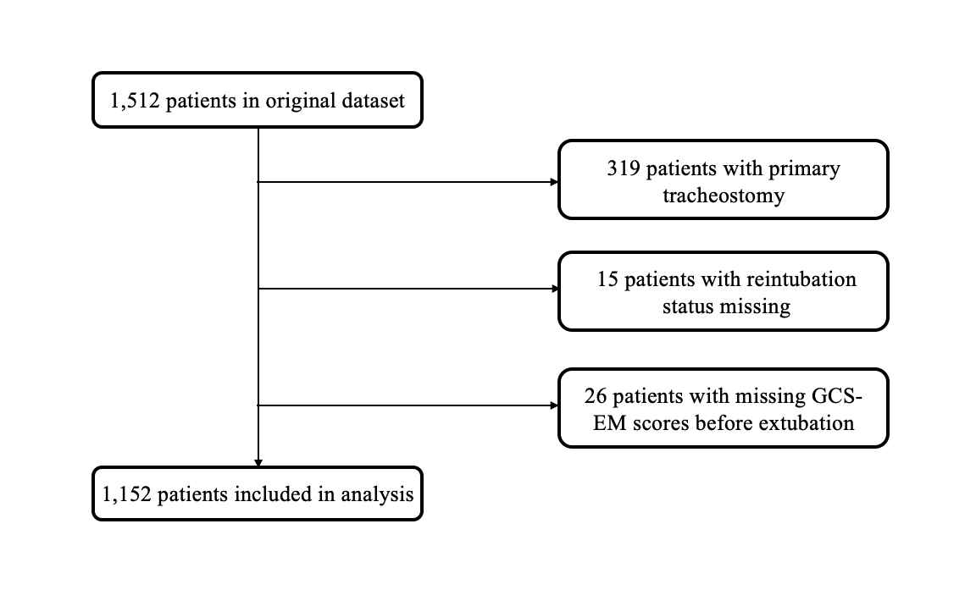

Glasgow Coma Score (Eye + Motor component)

The most common reasons for primary tracheostomy were severe neurologic impairment in 237 patients (74.3%), airway impairment in 51 patients (16.0%), and severe face/neck trauma in 14 (14.4%). GCS-EM values for these patients were not available.

**eFigure 2:** GCS-EM scores in the cohort

**A**

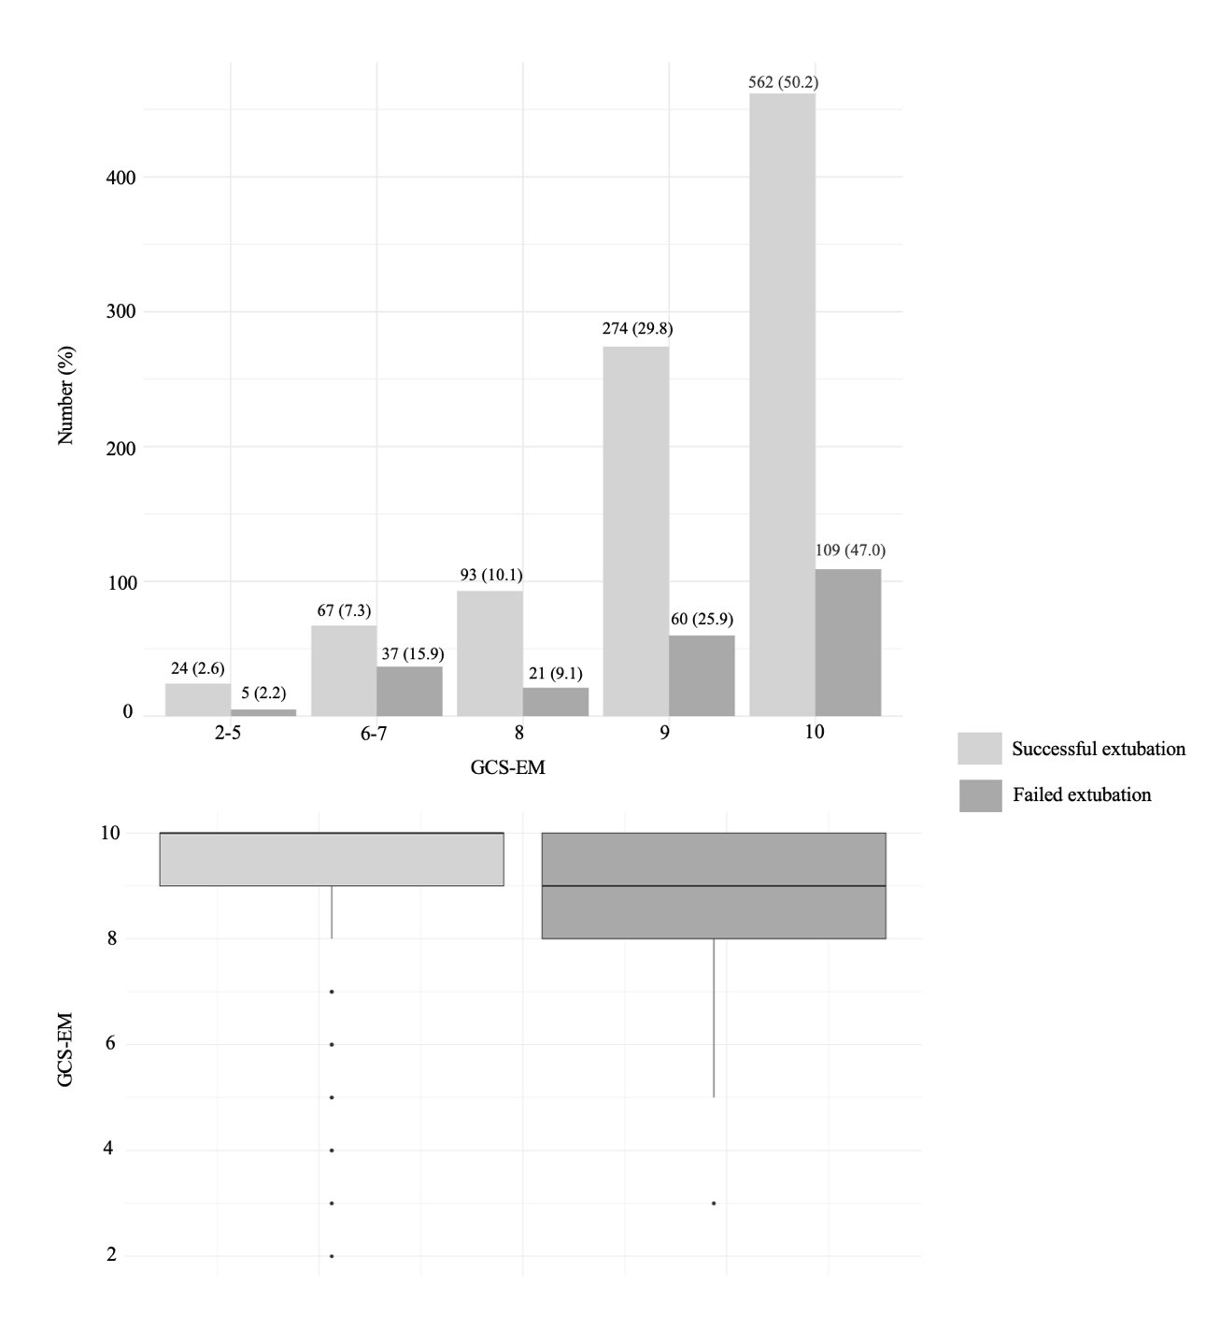

**B**

GCS-EM = Glasgow Coma Score (Eye + Motor component)

In *Panel A*, GCS-EM and extubation outcome are shown according to GCS-EM subgroup, using the same ranges as for the categorical variable analysis. Compared to patients with GCS-EM 10 (maximum possible score), there was no difference in the proportion of patients who failed extubation with a GCS-EM of 9 (*p=*0.273), 8 (*p*=0.720), or 2-5 (*p*=0.873). Patients with GCS-EM 6-7 experienced more extubation failure compared to those with GCS-EM 10 (*p*<0.001), but this association was not significant when adjusted for confounders (*see* eFigure 3).

In *Panel B*, GCS-EM scores are shown stratified by extubation outcome for the overall cohort. There was no difference in GCS-EM between successful vs. failed extubation groups (*p*=0.079).

**eFigure 3:** GCS-EM as a categorical variable (panel A) and spline (panel B)

A

|  |  |  |  |
| --- | --- | --- | --- |
| **GCS -EM score** | **Odds Ratio** | **95%CI** | **P-value** |
|  |  |
| 10 (ref.) | - | - | **-** |
| 9 | 0.67 | 0.38-1.16 | 0.15 |
| 8 | 0.52 | 0.23-1.20 | 0.13 |
| 6-7 | 1.21 | 0.52-2.80 | 0.66 |
| 2-5 | 0.60 | 0.12-3.01 | 0.53 |

B

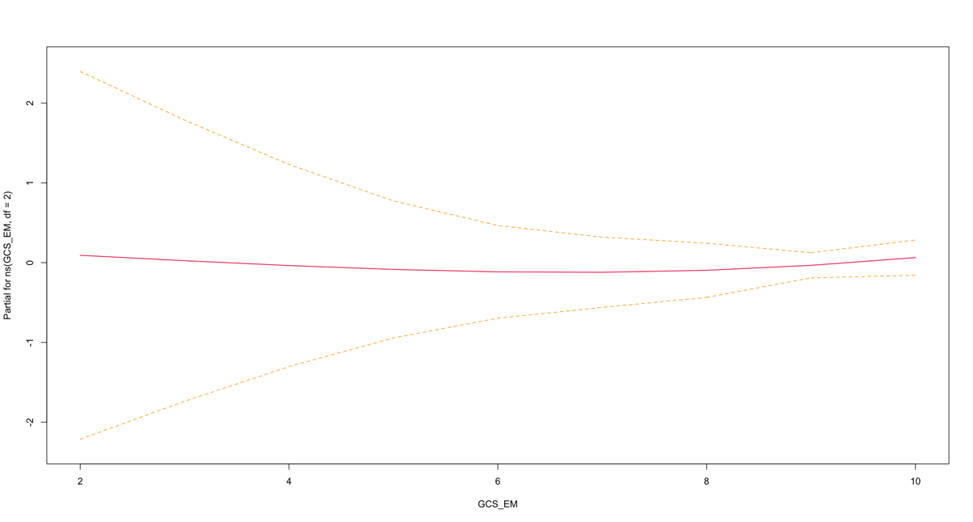

2

4

6

8

10

-2

-1

0

1

2

GCS-EM

Partial

95%CI = 95% confidence interval; GCS-EM = Glasgow Coma Score (Eye + Motor component)

In *Panel A*, odds ratios and 95% confidence intervals are shown for the association between GCS-EM categories and extubation failure, adjusting for the same confounders as in the main model. The reference category was set to 10 (maximum possible score). There was no association between any of the GCS categories and extubation outcome, although wide confidence intervals reflect imprecision in the effect estimate related to the small number of patients per GCS-EM category.

In *Panel B,* GCS-EM is represented as a spline and the association with extubation failure is shown across the full range of values. Results demonstrate no association between GCS-EM and extubation failure (the standard error as shown by the dotted yellow lines include the partial value of 0 for all values of the exposure).

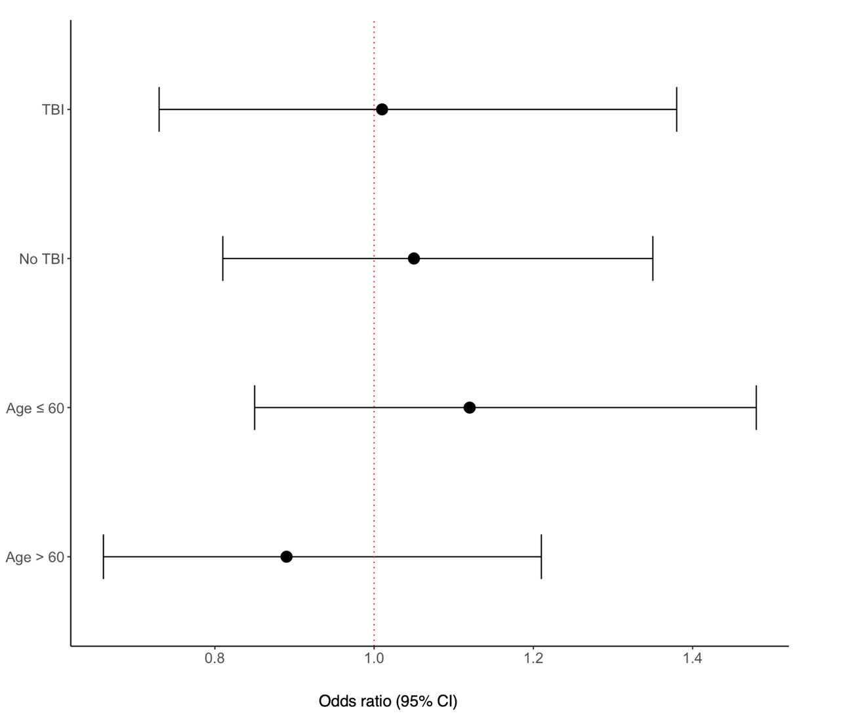**eFigure 4:** Subgroup analyses

95%CI= 95% confidence interval, TBI = traumatic brain injury

Odds ratios and 95% confidence intervals are shown for subgroup analyses. Associations are reported for each 1-point increase in GCS-EM. Models were adjusted for fewer covariates to prevent overfitting within smaller subgroup samples. Odds ratios > 1 indicate that higher levels of GCS-EM are associated with higher odds of extubation failure. Odds ratios < 1 indicate that higher levels of GCS-EM are associated with lower odds of extubation failure.

**References**

1. Cinotti R, Mijangos JC, Pelosi P, et al: Extubation in neurocritical care patients: the ENIO international prospective study. *Intensive Care Med* 2022; 48(11):1539-1550

2. Esteban A, Alía I, Gordo F, et al: Extubation outcome after spontaneous breathing trials with T-tube or pressure support ventilation. The Spanish Lung Failure Collaborative Group. *Am J Respir Crit Care Med* 1997; 156(2 Pt 1):459-465

3. Epstein SK, Ciubotaru RL, Wong JB: Effect of failed extubation on the outcome of mechanical ventilation. *Chest* 1997; 112(1):186-192

4. Pham T, Heunks L, Bellani G, et al: Weaning from mechanical ventilation in intensive care units across 50 countries (WEAN SAFE): a multicentre, prospective, observational cohort study. *Lancet Respir Med* 2023

5. Taran S, Diaz-Cruz C, Perrot B, et al: Association of Noninvasive Respiratory Support with Extubation Outcomes in Brain-injured Patients Receiving Mechanical Ventilation: A Secondary Analysis of the ENIO Prospective Observational Study. *Am J Respir Crit Care Med* 2023; 208(3):270-279

6. McCredie VA, Ferguson ND, Pinto RL, et al: Airway Management Strategies for Brain-injured Patients Meeting Standard Criteria to Consider Extubation. A Prospective Cohort Study. *Ann Am Thorac Soc* 2017; 14(1):85-93

7. Wendell LC, Raser J, Kasner S, et al: Predictors of extubation success in patients with middle cerebral artery acute ischemic stroke. *Stroke Res Treat* 2011; 2011:248789

8. Teasdale G, Maas A, Lecky F, et al: The Glasgow Coma Scale at 40 years: standing the test of time. *Lancet Neurol* 2014; 13(8):844-854

9. Godet T, Chabanne R, Marin J, et al: Extubation Failure in Brain-injured Patients: Risk Factors and Development of a Prediction Score in a Preliminary Prospective Cohort Study. *Anesthesiology* 2017; 126(1):104-114

10. Ranieri VM, Rubenfeld GD, Thompson BT, et al: Acute respiratory distress syndrome: the Berlin Definition. *Jama* 2012; 307(23):2526-2533

11. Rutledge R, Lentz CW, Fakhry S, et al: Appropriate use of the Glasgow Coma Scale in intubated patients: a linear regression prediction of the Glasgow verbal score from the Glasgow eye and motor scores. *J Trauma* 1996; 41(3):514-522

12. Rubin DB, Schenker N: Multiple imputation in health-are databases: An overview and some applications. *Statistics in Medicine* 1991; 10(4):585-598

13. Austin PC: Assessing balance in measured baseline covariates when using many-to-one matching on the propensity-score. *Pharmacoepidemiol Drug Saf* 2008; 17(12):1218-1225

14. Coplin WM, Pierson DJ, Cooley KD, et al: Implications of extubation delay in brain-injured patients meeting standard weaning criteria. *Am J Respir Crit Care Med* 2000; 161(5):1530-1536