**Supplemental Method**

***Study design and patient population***

This was a retrospective cohort study. The tumor immune dysfunction and exclusion (TIDE) score was calculated from the website by using RNA sequencing (RNA-seq) data (http://tide.dfci.harvard.edu). Hematoxylin and eosin-stained histopathological images (20× or 40× magnification) were downloaded from The Cancer Imaging Archive (TCIA). A total of 45 patients from Shanghai Chest Hospital with pathological slides were enrolled in the analysis set. Clinical characteristics were extracted including age, gender, Eastern Cooperative Oncology Group performance‑status score, smoking status, pathologic stage, PD-L1 expression, and history of radiotherapy. This study was approved by the Ethics Committee of Shanghai Chest Hospital (Institutional Review Board No. KS24007). Written informed consent was obtained from patients or their guardians.

***Outcomes***

Overall survival (OS) was defined as the time between the date of treatment start until death due to any cause. Progression-free survival (PFS) was assessed from the date the patient began treatment to the date of progression or death from any cause. Response Evaluation Criteria in Solid Tumors (RECIST) version 1.1 was used to assess efficacy.

***Preprocessing of whole slide images (WSIs)***

The OTSU algorithm, a conventional technique for image thresholding, was utilized to eliminate extraneous background while preserving tissue regions. As depicted in Supplementary Figure 2, the 40× WSIs were partitioned into non-overlapping patches measuring 1024 × 1024 pixels. The 20× WSIs were initially subdivided into sub-images of 512 × 512 pixels and subsequently resized to 1024 × 1024 pixels. The pathologist (Haohua Teng) assessed and excluded sub-images with inadequate image quality (e.g., contamination, blurriness, or blank areas exceeding 50%). To streamline computational processes, 20 sub-images from each image series were randomly chosen.

***Histopathological image features extraction and selection***

The image features were extracted using PyRadiomics, resulting in a total of 1488 features derived from the sub-images. These features encompassed first- and second-order statistical features, as well as higher-order features such as Wavelet, LoG (kernel size: 1, 2, 3, 4, 5), Square, SquareRoot, Logarithm, Exponential, Gradient, and LBP2D. The image features were computed for each sub-image, and the average values of these features across 20 sub-images were calculated.

In the process of feature selection, the mRMR method was initially employed to eliminate redundant and irrelevant features, followed by the recursive feature elimination (RFE) technique to identify the most predictive features associated with the TIDE status within the training dataset.

***Pathomic model development and validation***

The Gradient Boosting Machine (GBM) algorithm was utilized to develop a pathomic model for predicting TIDE status in the training set, based on selected histopathological image features. The robustness of the model was subsequently evaluated in the validation set. Performance assessment of the model was conducted using receiver operating characteristic (ROC) curve analysis, calibration curve analysis, and decision curve analysis.

***Biological basis of pathomic model***

To investigate the biological underpinnings of the model, gene set enrichment analysis (GSEA) was conducted. Subsequently, transcriptome and genetic data were extracted to assess the immune phenotype (including immune cell infiltration, tumor mutational burden [TMB], neoantigen load, cytolytic activity, and immunophenoscore) of patients with LUAD based on existing The Cancer Genome Atlas (TCGA) research.

***Statistical analysis***

The Mann–Whitney *U* test was employed to assess disparities between the two groups, while categorical data were evaluated utilizing the χ2-test or Fisher’s exact test as deemed suitable. The X-tile software version 3.6.1 (Yale University School of Medicine in New Haven, CT, USA) was utilized to ascertain the optimal cutoff point for the TIDE score. Survival analysis was conducted through the Kaplan–Meier method, and both univariate and multivariate Cox proportional-hazards models were utilized to calculate the hazard ratio (HR) and 95% confidence interval (CI) for the outcome. A clinicopathological and pathomic nomogram was constructed to visualize predictions for OS. Model performance was evaluated using time-dependent ROC curves. Statistical significance was defined as a *P*-value of less than 0.05 for all analyses. The statistical analyses were conducted using R version 4.2.2 (R Project for Statistical Computing) and SPSS version 27.0 (IBM, Armonk, NY, USA).

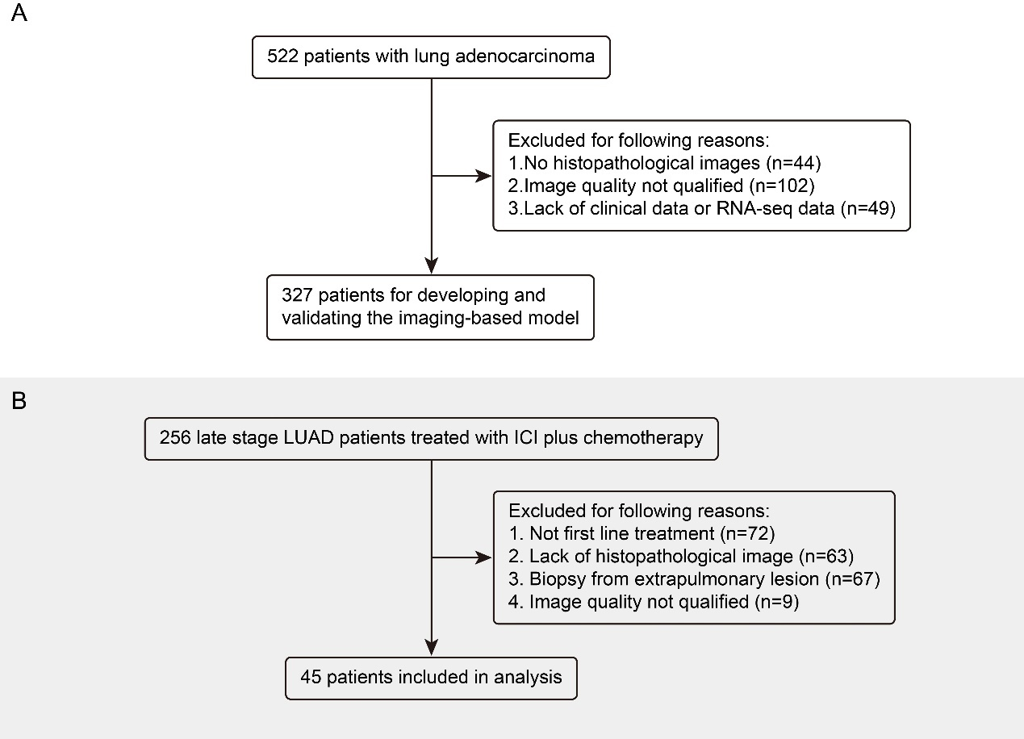

**Supplementary Figure 1:** The process of patient selection in the TCGA training and validation cohorts (A), and Shanghai Chest Hospital (B). ICI: Immune checkpoint inhibitor; LUAD: Lung adenocarcinoma; TCGA: The Cancer Genome Atlas.

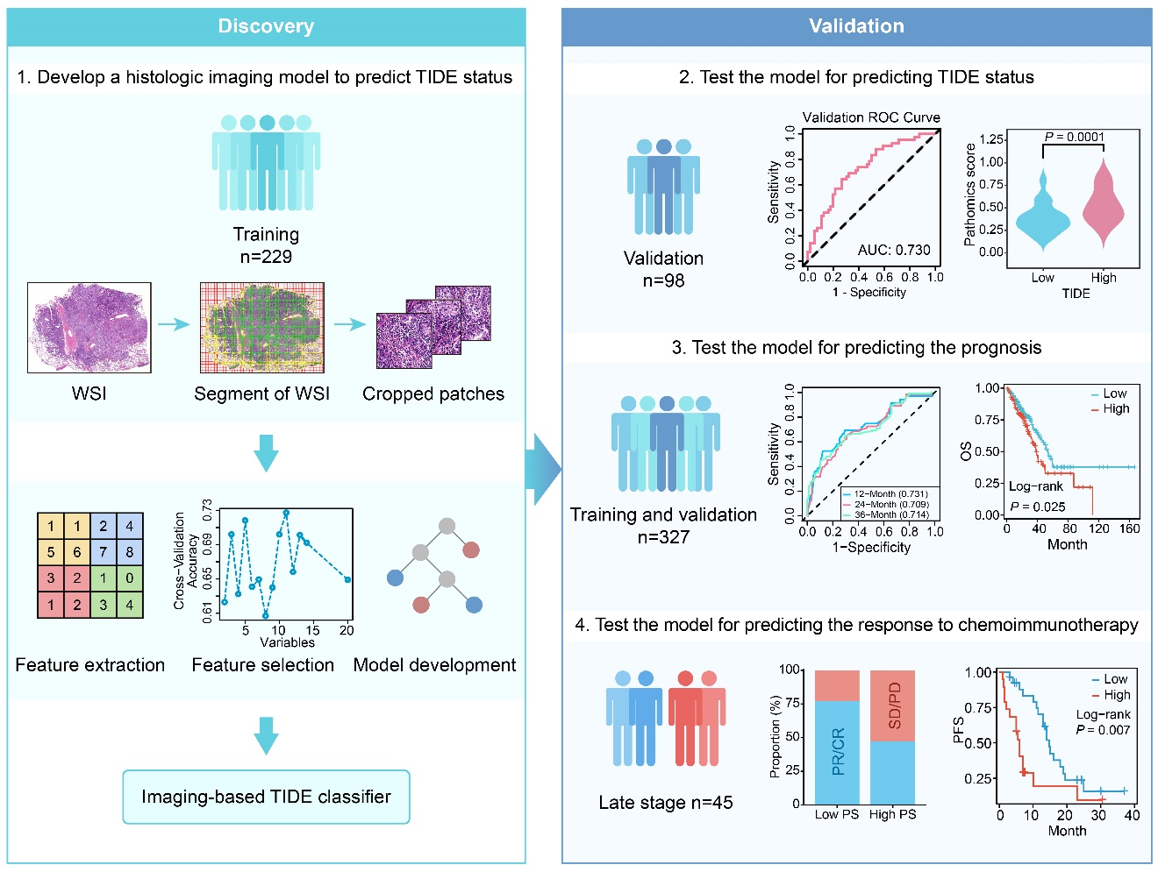

**Supplementary Figure 2:** Study design for the discovery and validation of a pathomic model based on histopathological images to assess TIDE and treatment outcomes in LUAD. LUAD: Lung adenocarcinoma; TIDE: Tumor immune dysfunction and exclusion.

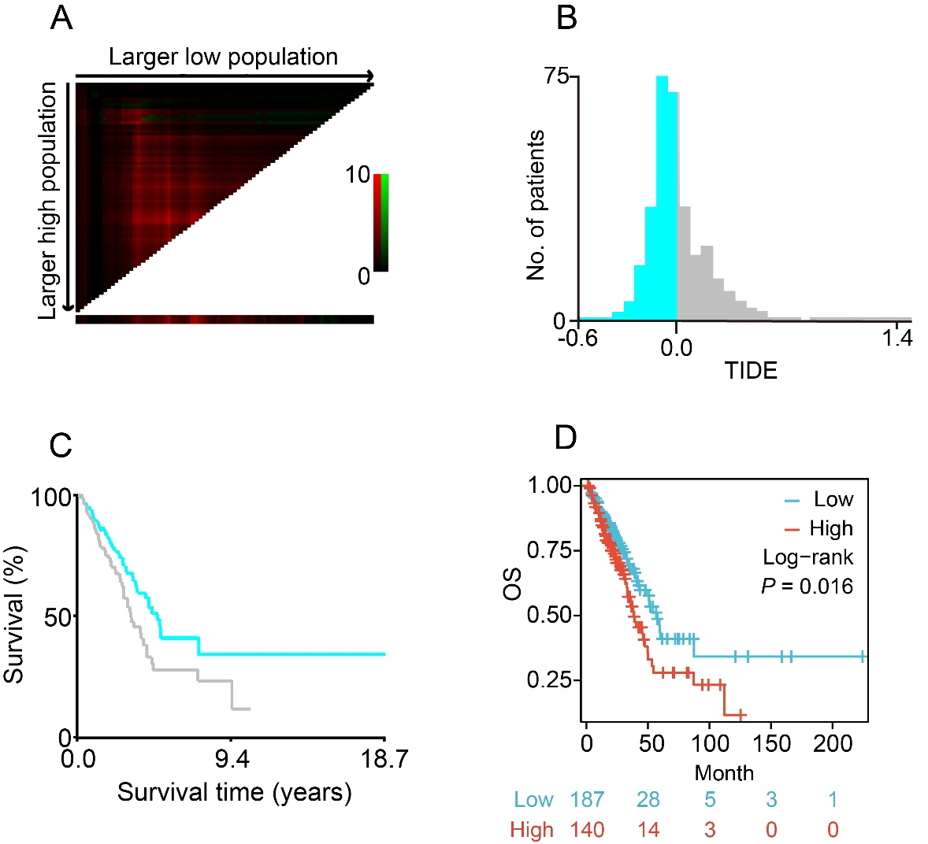

**Supplementary Figure 3:** TIDE score is associated with prognosis in the TCGA LUAD cohort. (A–C) X-tile plots of TIDE score automatically selecting the optimum cut point for OS. (D) OS in patients of low and high TIDE scores. LUAD: Lung adenocarcinoma; OS: Overall survival; TCGA: The Cancer Genome Atlas; TIDE: Tumor immune dysfunction and exclusion.

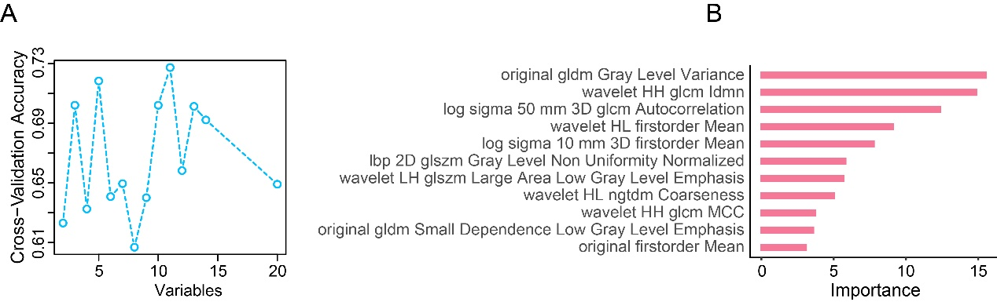

**Supplementary Figure 4:** Selection of histopathological image features. (A) The RFE selected 11 features. (B) The importance of the selected 11 features. RFE: Recursive feature elimination.

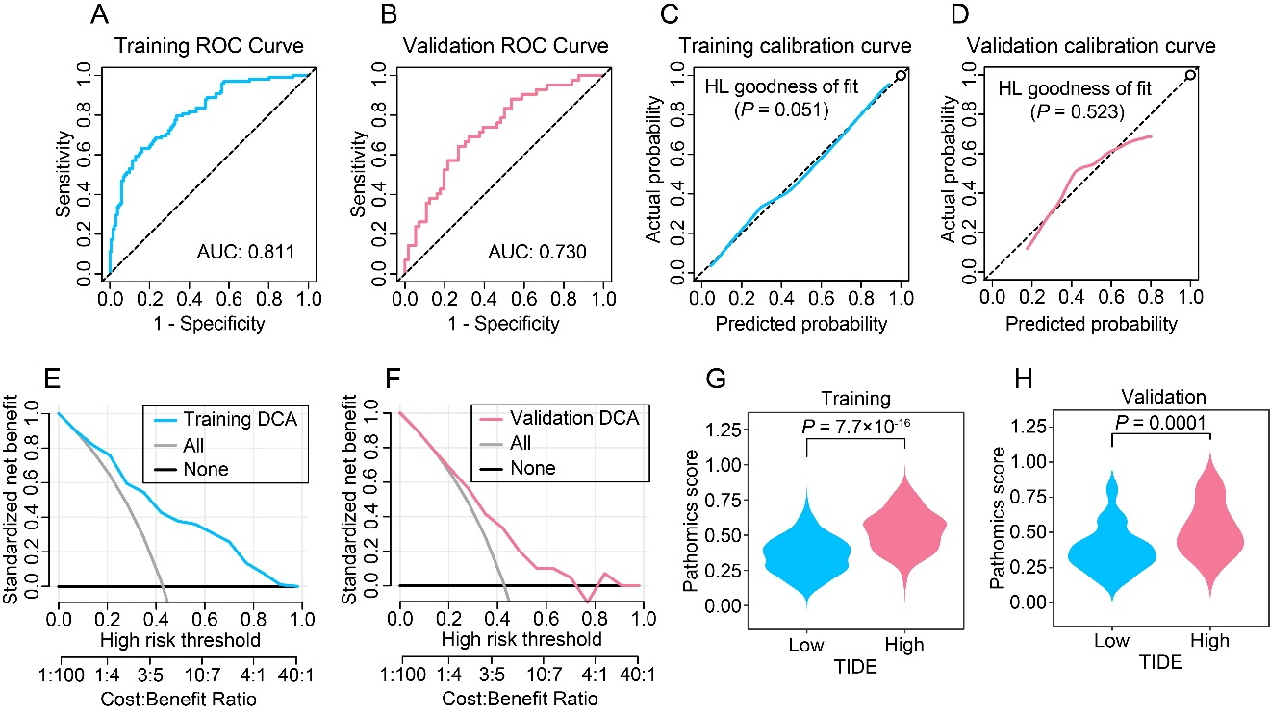

**Supplementary Figure 5:** Performance of the pathomic model to assess TIDE in the training and validation cohorts. The receiver operator characteristic curves according to the pathomic model in the training (A) and validation (B) cohorts. The calibration curves for the pathomic model in the training (C) and validation (D) cohorts. The decision curves in the training (E) and validation (F) cohorts. Distributions of PS in the training (G) and validation (H) cohorts. PS: Pathomic score; TIDE: Tumor immune dysfunction and exclusion.

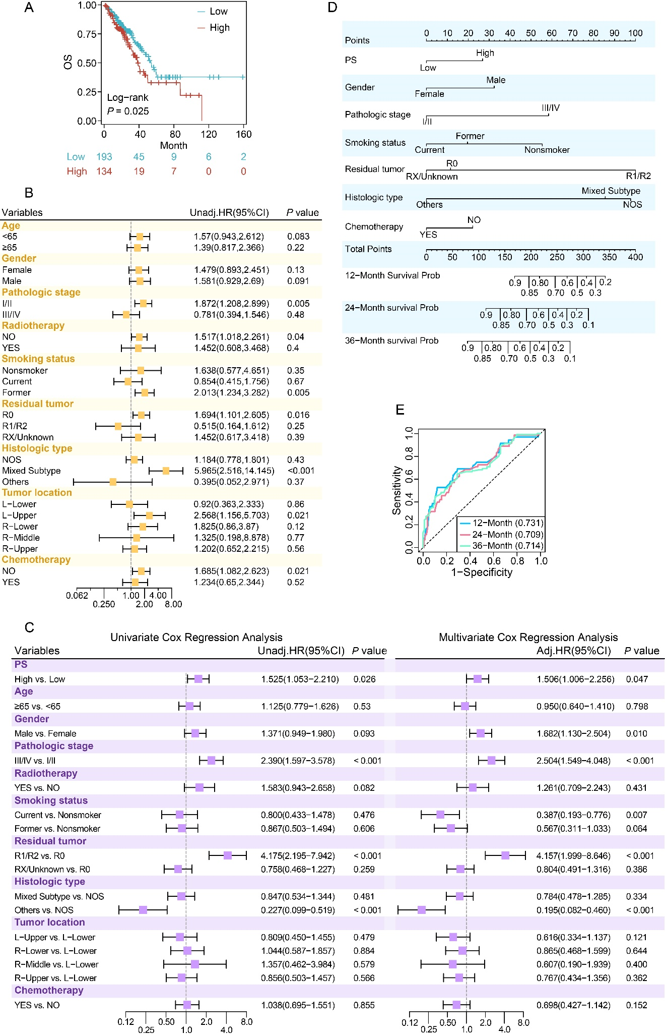

**Supplementary Figure 6:** Relationship between PS and OS in the training and validation cohorts. (A) Kaplan–Meier estimates of OS in low and high PS groups in the training and validation cohorts. (B) Subgroup analysis of OS. (C) Univariate and multivariate Cox regression analyses. (D) The pathomic nomogram for estimating OS. (E) Time-dependent ROC curve. OS: Overall survival; PS: Pathomic score; ROC: Receiver operating characteristic.



**Supplementary Figure 7:** (A) The calibration curves for the pathomic nomogram at 1 year, 2 years, and 3 years between prediction and observation. The decision curves for 1 year (B), 2 years (C), and 3 years (D).

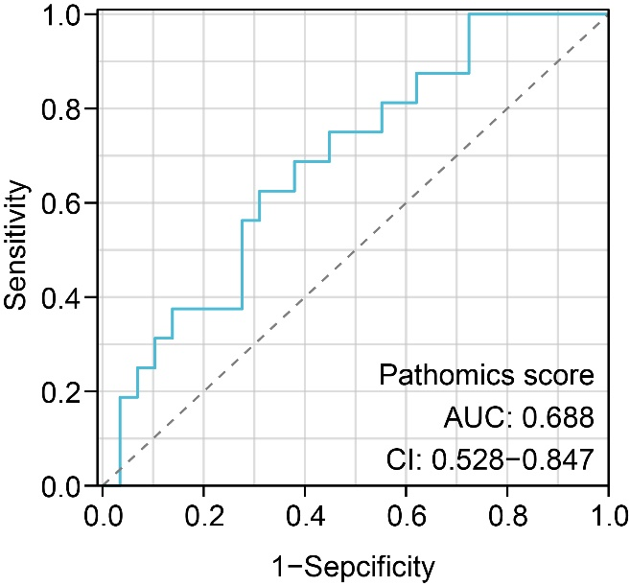

**Supplementary Figure 8:** The performance of PS to predict ORR measured by receiver operator characteristic curve. AUC: Area under the curve; CI: Confidence interval; ORR: Objective response rate; PS: Pathomic score.

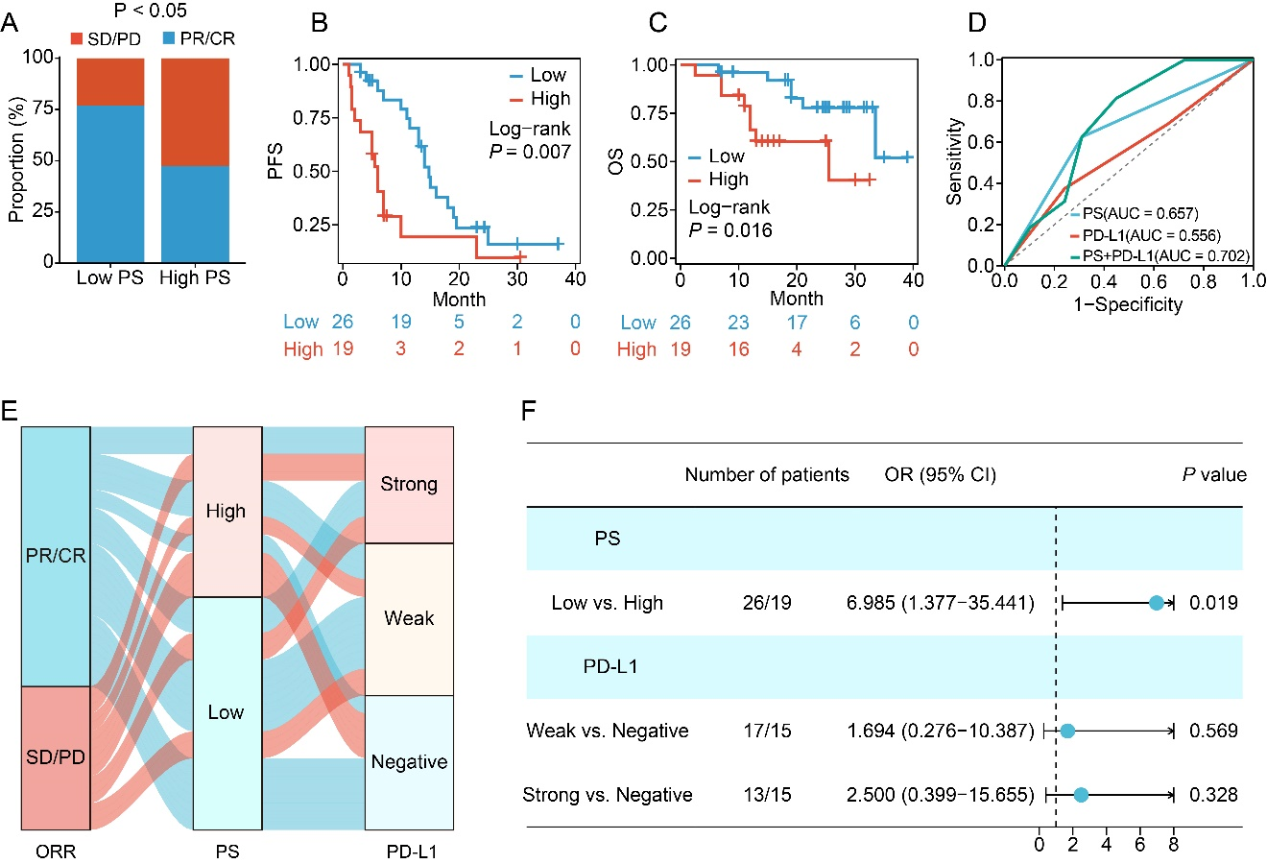

**Supplementary Figure 9:** Relationship between PS and clinical response and outcomes in LUAD patients treated with chemoimmunotherapy. (A) ORRs in patients of low and high PS. PFS (B) and OS (C) in patients of low and high PS. (D) ROC curves comparing the predictive accuracy of PS, PD-L1 expression, and combination. (E) Alluvial diagram of the correspondence among patients classified according to the response, PS, and PD-L1 expression. (F) Forest plot for the multivariate logistic regression analysis for objective response. LUAD: Lung adenocarcinoma; ORR: Objective response rate; OS: Overall survival; PD-L1: Programmed death-ligand 1; PFS: Progression-free survival; PS: Pathomic score; ROC: Receiver operating characteristic.

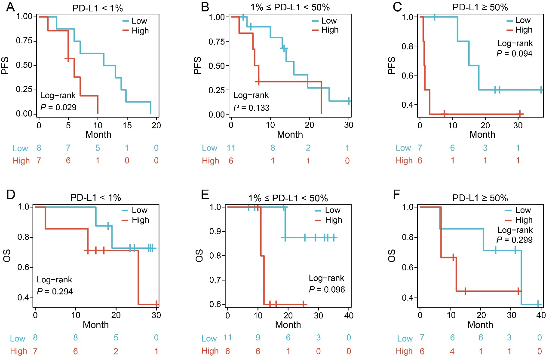

**Supplementary Figure 10:** PFS and OS by PD-L1 expression in LUAD patients treated with chemoimmunotherapy. PFS in the patients with (A) PD-L1 <1%, (B) 1% ≦ PD-L1 <50%, (C) PD-L1 ≧ 50%. OS in the patients with (D) PD-L1 <1%, (E) 1% ≦ PD-L1 <50%, (F) PD-L1 ≧ 50%. LUAD: Lung adenocarcinoma; OS: Overall survival; PD-L1: Programmed death-ligand 1; PFS: Progression-free survival.

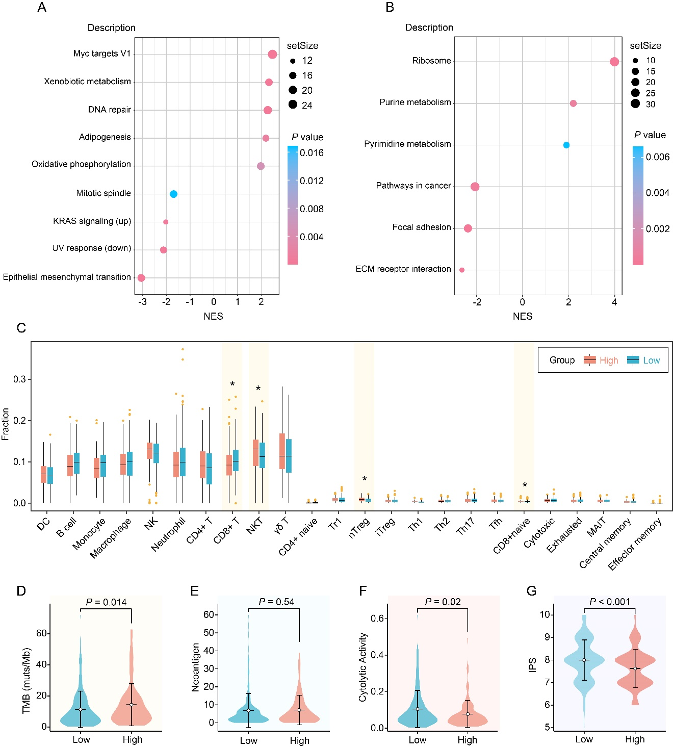

**Supplementary Figure 11:** Molecular correlates of the PS in LUAD. The HALLMARK GSEA (A) and the Kyoto Encyclopedia of Genes and Genomes (KEGG) pathway enrichment analysis (B). (C) The fraction of tumor microenvironment immune cells in low and high PSs groups. Distributions of TMB (D), neoantigen (E), cytolytic activity (F), and immunophenoscore (G) in low and high PS groups. GSEA: Gene set enrichment analysis; LUAD: Lung adenocarcinoma; PS: Pathomic score; TMB: Tumor mutational burden.

**Supplementary Table 1: The characteristics of TCGA LUAD patients with low and high TIDE scores.**

|  |  |  |  |  |
| --- | --- | --- | --- | --- |
| **Variables** | **Total (*n* = 327)** | **Low (*n* = 187)** | **High (*n* = 140)** | ***P-*value** |
| Age (years), *n* (%) |  |  |  | 0.861 |
| <65 | 164 (50) | 93 (50) | 71 (51) |  |
| ≥65 | 163 (50) | 94 (50) | 69 (49) |  |
| Gender, *n* (%) |  |  |  | 0.328 |
| Female | 183 (56) | 109 (58) | 74 (53) |  |
| Male | 144 (44) | 78 (42) | 66 (47) |  |
| Pathologic stage, *n* (%) |  |  |  | 0.678 |
| I/II | 265 (81) | 153 (82) | 112 (80) |  |
| III/IV | 62 (19) | 34 (18) | 28 (20) |  |
| Radiotherapy, *n* (%) |  |  |  | 0.569 |
| No | 293 (90) | 166 (89) | 127 (91) |  |
| Yes | 34 (10) | 21 (11) | 13 (9) |  |
| Smoking status, *n* (%) |  |  |  | 0.309 |
| Current | 82 (25) | 41 (22) | 41 (29) |  |
| Former | 204 (62) | 121 (65) | 83 (60) |  |
| Non-smoker | 41 (13) | 25 (13) | 16 (11) |  |
| Residual tumor, *n* (%) |  |  |  | 0.637 |
| R0 | 220 (67) | 129 (69) | 91 (65) |  |
| R1/R2 | 13 (4) | 8 (4) | 5 (4) |  |
| Rx/unknown | 94 (29) | 50 (27) | 44 (31) |  |
| Histologic type, *n* (%) |  |  |  | 0.005 |
| Mixed subtype | 67 (21) | 48 (26) | 19 (14) |  |
| NOS | 204 (62) | 103 (55) | 101 (72) |  |
| Others | 56 (17) | 36 (19) | 20 (14) |  |
| Tumor location, *n* (%) |  |  |  | 0.191 |
| L-lower | 56 (17) | 30 (16) | 26 (19) |  |
| L-upper | 76 (23) | 43 (23) | 33 (23) |  |
| R-lower | 63 (20) | 37 (20) | 26 (19) |  |
| R-middle | 14 (4) | 4 (2) | 10 (7) |  |
| R-upper | 118 (36) | 73 (39) | 45 (32) |  |
| Chemotherapy, *n* (%) |  |  |  | 0.258 |
| No | 219 (67) | 130 (70) | 89 (64) |  |
| Yes | 108 (33) | 57 (30) | 51 (36) |  |

LUAD: Lung adenocarcinoma; NOS: Not otherwise specified; TCGA: The Cancer Genome Atlas; TIDE: Tumor immune dysfunction and exclusion.

**Supplementary Table 2: The characteristics of TCGA LUAD patients in training and validation cohorts.**

|  |  |  |  |  |
| --- | --- | --- | --- | --- |
| **Variables** | **Total (*n* = 327)** | **Train (*n* = 229)** | **Validation (*n* = 98)** | ***P*-value** |
| TIDE, *n* (%) |  |  |  | 1.000 |
| Low | 187 (57) | 131 (57) | 56 (57) |  |
| High | 140 (43) | 98 (43) | 42 (43) |  |
| Age (years), *n* (%) |  |  |  | 0.262 |
| <65 | 164 (50) | 120 (52) | 44 (45) |  |
| ≥65 | 163 (50) | 109 (48) | 54 (55) |  |
| Gender, *n* (%) |  |  |  | 0.291 |
| Female | 183 (56) | 133 (58) | 50 (51) |  |
| Male | 144 (44) | 96 (42) | 48 (49) |  |
| Pathologic stage, *n* (%) |  |  |  | 0.130 |
| I/II | 265 (81) | 191 (83) | 74 (76) |  |
| III/IV | 62 (19) | 38 (17) | 24 (24) |  |
| Radiotherapy, *n* (%) |  |  |  | 0.190 |
| No | 293 (90) | 209 (91) | 84 (86) |  |
| Yes | 34 (10) | 20 (9) | 14 (14) |  |
| Smoking status, *n* (%) |  |  |  | 0.212 |
| Non-smoker | 41 (13) | 32 (14) | 9 (9) |  |
| Current | 82 (25) | 61 (27) | 21 (21) |  |
| Former | 204 (62) | 136 (59) | 68 (69) |  |
| Residual tumor, *n* (%) |  |  |  | 0.314 |
| R0 | 220 (67) | 150 (66) | 70 (71) |  |
| R1/R2 | 13 (4) | 8 (3) | 5 (5) |  |
| Rx/unknown | 94 (29) | 71 (31) | 23 (23) |  |
| Histologic type, *n* (%) |  |  |  | 0.335 |
| NOS | 204 (62) | 148 (65) | 56 (57) |  |
| Mixed subtype | 67 (20) | 46 (20) | 21 (21) |  |
| Others | 56 (17) | 35 (15) | 21 (21) |  |
| Tumor location, *n* (%) |  |  |  | 0.775 |
| L-lower | 56 (17) | 39 (17) | 17 (17) |  |
| L-upper | 76 (23) | 49 (21) | 27 (28) |  |
| R-lower | 63 (19) | 46 (20) | 17 (17) |  |
| R-middle | 14 (4) | 11 (5) | 3 (3) |  |
| R-upper | 118 (36) | 84 (37) | 34 (35) |  |
| Chemotherapy, *n* (%) |  |  |  | 0.067 |
| No | 219 (67) | 161 (70) | 58 (59) |  |
| Yes | 108 (33) | 68 (30) | 40 (41) |  |

LUAD: Lung adenocarcinoma; NOS: Not otherwise specified; TCGA: The Cancer Genome Atlas; TIDE: Tumor immune dysfunction and exclusion.

**Supplementary Table 3: Performance of pathomic signature in the training and validation cohorts.**

|  |  |  |  |  |  |  |  |
| --- | --- | --- | --- | --- | --- | --- | --- |
| **Items** | **AUC (95% CI)** | **Accuracy** | **Sensitivity** | **Specificity** | **PPV** | **NPV** | **Brier score** |
| Training | 0.811 (0.756–0.867) | 0.751 | 0.633 | 0.840 | 0.747 | 0.753 | 0.185 |
| Validation | 0.730 (0.630–0.830) | 0.694 | 0.643 | 0.732 | 0.643 | 0.732 | 0.210 |

AUC: Area under the curve; CI: Confidence interval; NPV: Negative predictive value; PPV: Positive predictive value.

**Supplementary Table 4: The characteristics of TCGA LUAD patients with low and high PSs.**

|  |  |  |  |  |
| --- | --- | --- | --- | --- |
| **Variables** | **Total (*n* = 327)** | **Low (*n* = 193)** | **High (*n* = 134)** | ***P*-value** |
| Age (years), *n* (%) |  |  |  | 0.701 |
| <65 | 164 (50) | 99 (51) | 65 (49) |  |
| ≥65 | 163 (50) | 94 (49) | 69 (51) |  |
| Gender, *n* (%) |  |  |  | 0.309 |
| Female | 183 (56) | 113 (59) | 70 (52) |  |
| Male | 144 (44) | 80 (41) | 64 (48) |  |
| Pathologic stage, *n* (%) |  |  |  | 0.754 |
| I/II | 265 (81) | 158 (82) | 107 (80) |  |
| III/IV | 62 (19) | 35 (18) | 27 (20) |  |
| Radiotherapy, *n* (%) |  |  |  | 0.370 |
| No | 293 (90) | 170 (88) | 123 (92) |  |
| Yes | 34 (10) | 23 (12) | 11 (8) |  |
| Smoking status, *n* (%) |  |  |  | 0.069 |
| Non-smoker | 41 (13) | 31 (16) | 10 (7) |  |
| Current | 82 (25) | 46 (24) | 36 (27) |  |
| Former | 204 (62) | 116 (60) | 88 (66) |  |
| Residual tumor, *n* (%) |  |  |  | 0.606 |
| R0 | 220 (67) | 134 (69) | 86 (64) |  |
| R1/R2 | 13 (4) | 7 (4) | 6 (4) |  |
| Rx/unknown | 94 (29) | 52 (27) | 42 (31) |  |
| Histologic type, *n* (%) |  |  |  | 0.002 |
| NOS | 204 (62) | 105 (54) | 99 (74) |  |
| Mixed subtype | 67 (20) | 49 (25) | 18 (13) |  |
| Others | 56 (17) | 39 (20) | 17 (13) |  |
| Tumor location, *n* (%) |  |  |  | 0.065 |
| L-lower | 56 (17) | 35 (18) | 21 (16) |  |
| L-upper | 76 (23) | 45 (23) | 31 (23) |  |
| R-lower | 63 (19) | 37 (19) | 26 (19) |  |
| R-middle | 14 (4) | 3 (2) | 11 (8) |  |
| R-upper | 118 (36) | 73 (38) | 45 (34) |  |
| Chemotherapy, *n* (%) |  |  |  | 0.592 |
| No | 219 (67) | 132 (68) | 87 (65) |  |
| Yes | 108 (33) | 61 (32) | 47 (35) |  |

LUAD: Lung adenocarcinoma; NOS: Not otherwise specified; PS: Pathomic score; TCGA: The Cancer Genome Atlas.

**Supplementary Table 5: The characteristics of LUAD patients from Shanghai Chest Hospital.**

|  |  |  |  |  |
| --- | --- | --- | --- | --- |
| **Variables** | **Total (*n* = 45)** | **Low PS (*n* = 26)** | **High PS (*n* = 19)** | ***P*-value** |
| Age (years), *n* (%) |  |  |  | 0.433 |
| <65 | 16 (46) | 8 (31) | 8 (42) |  |
| ≥65 | 29 (64) | 18 (69) | 11 (58) |  |
| Gender, *n* (%) |  |  |  | 0.485 |
| Female | 11 (24) | 5 (19) | 6 (32) |  |
| Male | 34 (76) | 21 (81) | 13 (68) |  |
| ECOG PS, *n* (%) |  |  |  | 0.165 |
| 0 | 15 (33) | 6 (23) | 9 (47) |  |
| 1 | 30 (67) | 20 (77) | 10 (53) |  |
| Smoking status, *n* (%) |  |  |  | 1.000 |
| Non-smoker | 10 (22) | 6 (23) | 4 (21) |  |
| Current | 35 (78) | 20 (77) | 15 (79) |  |
| Pathologic stage, *n* (%) |  |  |  | 0.712 |
| IIIb | 9 (20) | 6 (23) | 3 (16) |  |
| IV | 36 (80) | 20 (77) | 16 (84) |  |
| PD-L1 expression, *n* (%) |  |  |  | 0.764 |
| <1% | 15 (33) | 8 (31) | 7 (36) |  |
| 1%≤ PD-L1 <50% | 17 (38) | 11 (42) | 6 (32) |  |
| ≥50% | 13 (29) | 7 (27) | 6 (32) |  |
| Previous radiotherapy, *n* (%) | 3 (7) | 2 (8) | 1 (5) | 0.778 |

ECOG PS: Eastern Cooperative Oncology Group performance‑status score; LUAD: Lung adenocarcinoma; PD-L1: Programmed death-ligand 1; PS: Pathomic score.