Supplemental Material
Adjustment for urinary creatinine or serum lipids
with analytes assayed in pooled specimens

Clarice R. Weinberg, Min Shi, Katie M. O’Brien, David M. Umbach

Table of Contents
eAppendix 1: Model selection for scenarios B’, C’, E’, and F’.
eTable 1: Model comparison for individual-specimen analyses of a biomarker measured in urine under causal scenarios B’ and C’.
eTable 2: Model comparison for individual-specimen analyses of a lipophilic biomarker measured in serum under causal scenarios E’ and F’.
eFigure 1: Bias in estimation of the exposure regression coefficient $β$ when using traditional standardization of a biomarker measured in urine in causal scenarios B’ and C’.
eAppendix 2: Bias and power results for pooled-specimen analysis of a lipophilic biomarker measured is serum.
eTable 3: Results with the Firth correction applied. Simulations of scenarios in Figures 1 and
2, with 500 cases and 500 controls.
eTable 4: Comparison of 95% confidence interval coverage and bias between study sample sizes n=1000 and n=3000 for naïve standardization after equal volume pooling for causal scenarios D, E, and E’.
eFigure 2: Power for testing ${\text{H}}_{0}: β=0$ at $α=0.05$ using pooled analyses under causal scenarios appropriate for lipophilic biomarkers in serum.

eAppendix 1: Model selection for scenarios B’, C’, E’, and F’
Methods
The preliminary simulations that we used to select the more appropriate model for our new scenarios (B’ and C’ for biomarkers in urine; E’ and F’ for biomarkers in serum) closely mimicked those in O’Brien et al. (2016) in all respects; they involved individual specimens (no pooling). We first standardized the exposure measure (either using $\frac{Z_{j}}{C_{j}}$ – traditional standardization - or $\frac{Z_{j}}{R_{j}}$ – covariate-adjusted standardization). Then we normalized each standardized exposure by subtracting its respective mean and dividing by its standard deviation. As described in O’Brien et al. (2016), this approach ensures that the effect of exposure at the target tissue (the odds ratio specified in the simulation) is comparable to the effect of exposure at the proxy tissue (the odds ratio estimated by model fitting).
Results
To select a model for scenarios B’ and C’ with urine-based biomarkers or for scenarios E’ and F’ with serum-based biomarkers, our preliminary simulations compared traditional standardization to covariate-adjusted standardization while also including X as an additional covariate, even though X is neither a confounder nor a cause of the outcome in these scenarios. For both scenarios B’ and C’, results revealed substantial bias toward the null for traditional standardization, but not for covariate-adjusted standardization, under either scenario (Table S1, Figure S1). Coverage of 95% confidence intervals was less than the nominal 95% for traditional standardization but consistent with nominal for covariate-adjusted standardization. For scenarios E’ and F’, covariate-adjusted standardization performed relatively poorly, exhibiting substantial bias and below nominal coverage, whereas traditional standardization exhibited little bias and nominal coverage (Table S2).
Based on these findings, in all subsequent pool-based simulations, we carried out covariate-adjusted standardization for scenarios B’ and C’ and traditional standardization for scenarios E’ and F’.
eTable 1. Model comparison for individual-specimen analyses of a biomarker measured in urine under causal scenarios B’ and C’. Bias and confidence interval (CI) coverage were calculated as in O’Brien et al. (2016).

 | Traditional Standardization |  |  |  |  | Covariate-adjusted Standardization
 | B’ |  | C’ |  |  | B’ |  | C’
beta | 95% CI coverage | Bias | 95% CI coverage | Bias |  | 95% CI coverage | Bias | 95% CI coverage | Bias
0.69 | 0.77 | -0.083 (0.002) | 0.87 | -0.048 (0.003) |  | 0.94 | -0.005 (0.003) | 0.94 | 0.002 (0.003)
0.26 | 0.92 | -0.029 (0.002) | 0.93 | -0.019 (0.002) |  | 0.95 | -0.003 (0.002) | 0.94 | -0.001 (0.002)
0 | 0.94 | 0.001 (0.002) | 0.95 | -0.001 (0.002) |  | 0.95 | 0.001 (0.002) | 0.95 | -0.001 (0.002)
-0.26 | 0.93 | 0.026 (0.002) | 0.95 | 0.017 (0.002) |  | 0.95 | -0.003 (0.002) | 0.96 | -0.002 (0.002)
-0.69 | 0.77 | 0.077 (0.002) | 0.87 | 0.050 (0.003) |  | 0.95 | 0.000 (0.002) | 0.93 | -0.001 (0.003)

eTable 2. Model comparison for individual-specimen analyses of a lipophilic biomarker in serum under causal scenarios E’ and F’. Bias and confidence interval (CI) coverage were calculated as in O’Brien et al. (2016).

 | Traditional Standardization |  |  |  |  | Covariate-adjusted Standardization
 | E’ |  | F’ |  |  | E’ |  | F’
beta | 95% CI coverage | Bias | 95% CI coverage | Bias |  | 95% CI coverage | Bias | 95% CI coverage | Bias
0.69 | 0.94 | 0.003 (0.002) | 0.94 | 0.002 (0.003) |  | 0.82 | 0.096 (0.003) | 0.54 | 0.257 (0.005)
0.26 | 0.96 | 0.001 (0.002) | 0.95 | 0.000 (0.003) |  | 0.93 | 0.034 (0.002) | 0.89 | 0.078 (0.003)
0 | 0.95 | -0.001 (0.002) | 0.95 | 0.000 (0.002) |  | 0.95 | -0.001 (0.002) | 0.95 | 0.000 (0.003)
-0.26 | 0.95 | -0.001 (0.002) | 0.95 | -0.001 (0.003) |  | 0.92 | -0.035 (0.002) | 0.90 | -0.079 (0.003)
-0.69 | 0.96 | -0.003 (0.002) | 0.94 | 0.002 (0.003) |  | 0.81 | -0.095 (0.003) | 0.55 | -0.247 (0.004)

eFigure 1. Bias in estimation of regression coefficient $β$ when using traditional standardization in causal scenarios B’ and C’. With covariate-adjusted standardization, no bias was evident.
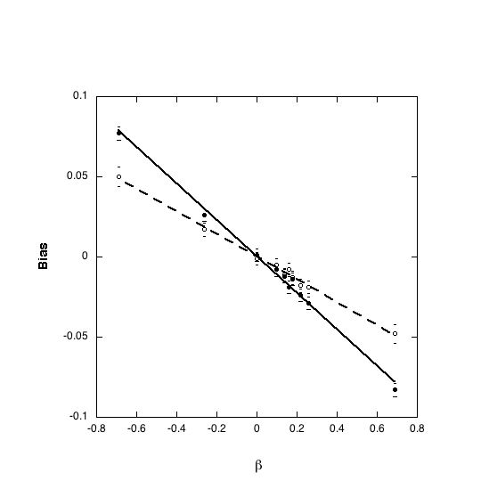
● Scenario B’ (solid line)
○ Scenario C’ (dashed line)
95% Confidence Limits
eTable 3a. Performance comparisons after applying the Firth correction for each causal scenario A, B, B’, C and C’ appropriate for biomarkers in urine: Covariate-adjusted standardization using our pooling protocols vs. naïve standardization after equal-volume pooling. Results summarize 1000 simulated case–control studies of 500 cases and 500 controls each.

Beta | Pool Sizeª | Naïve Standardization |  |  |  | Covariate-adjusted standardization using our pooling protocols
Beta | Pool Sizeª | Coverage | Power | Bias (SE) |  | Coverage | Power | Bias (SE)
 |  |  |  | Scenario A
0 | 1 | 0.949 | 0.048 | 0.007 (0.003) |  | 0.949 | 0.048 | 0.007 (0.003)
0 | 5 | 0.959 | 0.042 | 0.003 (0.003) |  | 0.946 | 0.054 | 0.004 (0.003)
0 | 10 | 0.942 | 0.058 | 0.000 (0.003) |  | 0.951 | 0.051 | 0.003 (0.003)
0.26 | 1 | 0.95 | 0.972 | 0.003 (0.004) |  | 0.95 | 0.972 | 0.003 (0.004)
0.26 | 5 | 0.924 | 0.958 | -0.043 (0.003) |  | 0.943 | 0.967 | 0.009 (0.004)
0.26 | 10 | 0.937 | 0.965 | -0.04 (0.003) |  | 0.946 | 0.961 | 0.002 (0.004)
0.69 | 1 | 0.957 | 1 | 0.006 (0.004) |  | 0.957 | 1 | 0.006 (0.004)
0.69 | 5 | 0.85 | 1 | -0.123 (0.005) |  | 0.954 | 1 | -0.004 (0.005)
0.69 | 10 | 0.864 | 1 | -0.125 (0.006) |  | 0.961 | 1 | 0.015 (0.007)
 |  |  |  | Scenario B
0 | 1 | 0.941 | 0.059 | 0.001 (0.004) |  | 0.941 | 0.059 | 0.001 (0.004)
0 | 5 | 0.949 | 0.048 | 0.002 (0.004) |  | 0.945 | 0.056 | 0.003 (0.004)
0 | 10 | 0.944 | 0.054 | -0.001 (0.004) |  | 0.94 | 0.058 | 0.002 (0.005)
0.26 | 1 | 0.954 | 0.959 | 0.003 (0.004) |  | 0.954 | 0.959 | 0.003 (0.004)
0.26 | 5 | 0.933 | 0.891 | -0.041 (0.004) |  | 0.955 | 0.91 | 0.001 (0.004)
0.26 | 10 | 0.937 | 0.8 | -0.041 (0.005) |  | 0.956 | 0.825 | 0.000 (0.005)
0.69 | 1 | 0.951 | 1 | -0.006 (0.004) |  | 0.951 | 1 | -0.006 (0.004)
0.69 | 5 | 0.878 | 1 | -0.122 (0.005) |  | 0.934 | 1 | 0.004 (0.006)
0.69 | 10 | 0.881 | 1 | -0.122 (0.008) |  | 0.941 | 1 | 0.004 (0.009)
 |  |  |  | Scenario B’
0 | 1 | 0.955 | 0.045 | -0.007 (0.003) |  | 0.955 | 0.045 | -0.007 (0.003)
0 | 5 | 0.943 | 0.058 | -0.004 (0.003) |  | 0.952 | 0.047 | -0.001 (0.003)
0 | 10 | 0.958 | 0.043 | 0.004 (0.003) |  | 0.956 | 0.045 | -0.002 (0.003)
0.26 | 1 | 0.944 | 0.965 | 0.006 (0.004) |  | 0.944 | 0.965 | 0.006 (0.004)
0.26 | 5 | 0.811 | 0.921 | -0.103 (0.003) |  | 0.937 | 0.958 | 0.008 (0.004)
0.26 | 10 | 0.813 | 0.905 | -0.103 (0.003) |  | 0.944 | 0.958 | -0.003 (0.004)
0.69 | 1 | 0.952 | 1 | -0.004 (0.004) |  | 0.952 | 1 | -0.004 (0.004)
0.69 | 5 | 0.378 | 1 | -0.304 (0.004) |  | 0.962 | 1 | -0.002 (0.005)
0.69 | 10 | 0.563 | 1 | -0.295 (0.005) |  | 0.93 | 1 | 0.007 (0.007)
 |  |  |  | Scenario C
0 | 1 | 0.948 | 0.051 | 0.005 (0.003) |  | 0.948 | 0.051 | 0.005 (0.003)
0 | 5 | 0.962 | 0.037 | 0.001 (0.003) |  | 0.957 | 0.043 | -0.003 (0.004)
0 | 10 | 0.949 | 0.05 | -0.004 (0.004) |  | 0.951 | 0.05 | 0.007 (0.005)
0.26 | 1 | 0.937 | 0.941 | -0.003 (0.004) |  | 0.937 | 0.941 | -0.003 (0.004)
0.26 | 5 | 0.944 | 0.871 | -0.045 (0.004) |  | 0.954 | 0.9 | 0.004 (0.004)
0.26 | 10 | 0.918 | 0.737 | -0.05 (0.005) |  | 0.95 | 0.771 | 0.015 (0.006)
0.69 | 1 | 0.959 | 1 | -0.001 (0.004) |  | 0.959 | 1 | -0.001 (0.004)
0.69 | 5 | 0.859 | 1 | -0.115 (0.006) |  | 0.955 | 1 | 0.009 (0.006)
0.69 | 10 | 0.899 | 1 | -0.121 (0.009) |  | 0.955 | 0.999 | 0.016 (0.01)
 |  |  |  | Scenario C’
0 | 1 | 0.954 | 0.046 | -0.002 (0.003) |  | 0.954 | 0.046 | -0.002 (0.003)
0 | 5 | 0.953 | 0.048 | 0.000 (0.003) |  | 0.959 | 0.041 | -0.003 (0.003)
0 | 10 | 0.959 | 0.041 | 0.001 (0.003) |  | 0.951 | 0.049 | 0.000 (0.003)
0.26 | 1 | 0.951 | 0.966 | 0.004 (0.004) |  | 0.951 | 0.966 | 0.004 (0.004)
0.26 | 5 | 0.805 | 0.911 | -0.109 (0.003) |  | 0.945 | 0.96 | -0.007 (0.004)
0.26 | 10 | 0.823 | 0.924 | -0.106 (0.003) |  | 0.961 | 0.975 | 0.001 (0.004)
0.69 | 1 | 0.953 | 1 | 0.008 (0.004) |  | 0.953 | 1 | 0.008 (0.004)
0.69 | 5 | 0.382 | 1 | -0.307 (0.004) |  | 0.962 | 1 | -0.002 (0.005)
0.69 | 10 | 0.559 | 1 | -0.295 (0.005) |  | 0.948 | 1 | -0.008 (0.007)
ª Pool size of 1 means no pooling; analysis used individual observations. In each “pool size 1” row, entries are the same for both naïve standardization and for our proposed methods and are repeated only for convenience.

eTable 3b. Performance comparisons after applying the Firth correction for each causal scenario D, E, E’, F, and F’ appropriate for lipophilic biomarkers: Traditional standardization using our pooling protocols vs. naïve standardization after equal-volume pooling. Results summarize 1000 simulated case–control studies of 500 cases and 500 controls each.

Beta | Pool Sizeª | Naïve Standardization |  |  |  | Traditional standardization using our pooling protocols
Beta | Pool Sizeª | Coverage | Power | Bias (SE) |  | Coverage | Power | Bias (SE)
 |  |  |  | Scenario D
0 | 1 | 0.931 | 0.069 | 0.003 (0.003) |  | 0.931 | 0.069 | 0.003 (0.003)
0 | 5 | 0.954 | 0.046 | 0.009 (0.003) |  | 0.956 | 0.044 | -0.002 (0.003)
0 | 10 | 0.951 | 0.048 | -0.001 (0.003) |  | 0.957 | 0.043 | 0.004 (0.003)
0.26 | 1 | 0.955 | 0.976 | -0.002 (0.003) |  | 0.955 | 0.976 | -0.002 (0.003)
0.26 | 5 | 0.944 | 0.962 | -0.018 (0.004) |  | 0.961 | 0.98 | 0.006 (0.004)
0.26 | 10 | 0.942 | 0.957 | -0.022 (0.004) |  | 0.958 | 0.969 | 0.005 (0.004)
0.69 | 1 | 0.928 | 1 | -0.009 (0.004) |  | 0.928 | 1 | -0.009 (0.004)
0.69 | 5 | 0.931 | 1 | -0.046 (0.005) |  | 0.94 | 1 | -0.009 (0.005)
0.69 | 10 | 0.929 | 1 | -0.057 (0.007) |  | 0.956 | 1 | -0.004 (0.007)
 |  |  |  | Scenario E
0 | 1 | 0.96 | 0.039 | -0.003 (0.003) |  | 0.96 | 0.039 | -0.003 (0.003)
0 | 5 | 0.962 | 0.038 | 0.000 (0.004) |  | 0.963 | 0.036 | 0.001 (0.004)
0 | 10 | 0.951 | 0.05 | 0.007 (0.004) |  | 0.957 | 0.043 | 0.002 (0.004)
0.26 | 1 | 0.949 | 0.966 | -0.005 (0.004) |  | 0.949 | 0.966 | -0.005 (0.004)
0.26 | 5 | 0.945 | 0.913 | -0.021 (0.004) |  | 0.957 | 0.935 | -0.005 (0.004)
0.26 | 10 | 0.959 | 0.851 | -0.018 (0.005) |  | 0.953 | 0.848 | -0.01 (0.005)
0.69 | 1 | 0.948 | 1 | -0.002 (0.004) |  | 0.948 | 1 | -0.002 (0.004)
0.69 | 5 | 0.926 | 1 | -0.044 (0.006) |  | 0.937 | 1 | 0.004 (0.006)
0.69 | 10 | 0.928 | 1 | -0.059 (0.008) |  | 0.951 | 1 | 0.004 (0.008)
 |  |  |  | Scenario E’
0 | 1 | 0.955 | 0.045 | 0.005 (0.004) |  | 0.955 | 0.045 | 0.005 (0.004)
0 | 5 | 0.958 | 0.042 | -0.003 (0.003) |  | 0.954 | 0.046 | 0.002 (0.003)
0 | 10 | 0.947 | 0.053 | -0.002 (0.003) |  | 0.948 | 0.052 | 0.001 (0.004)
0.26 | 1 | 0.946 | 0.955 | -0.011 (0.004) |  | 0.946 | 0.955 | -0.011 (0.004)
0.26 | 5 | 0.947 | 0.961 | -0.024 (0.004) |  | 0.957 | 0.966 | 0.001 (0.004)
0.26 | 10 | 0.957 | 0.968 | -0.025 (0.004) |  | 0.94 | 0.966 | -0.002 (0.004)
0.69 | 1 | 0.955 | 1 | 0.009 (0.004) |  | 0.955 | 1 | 0.009 (0.004)
0.69 | 5 | 0.943 | 1 | -0.049 (0.005) |  | 0.954 | 1 | -0.002 (0.005)
0.69 | 10 | 0.918 | 1 | -0.063 (0.007) |  | 0.959 | 1 | -0.006 (0.006)
 |  |  |  | Scenario F
0 | 1 | 0.949 | 0.052 | -0.003 (0.003) |  | 0.949 | 0.052 | -0.003 (0.003)
0 | 5 | 0.94 | 0.063 | -0.004 (0.003) |  | 0.945 | 0.054 | 0.000 (0.004)
0 | 10 | 0.957 | 0.042 | 0.000 (0.004) |  | 0.952 | 0.049 | -0.002 (0.004)
0.26 | 1 | 0.953 | 0.967 | -0.002 (0.003) |  | 0.953 | 0.967 | -0.002 (0.003)
0.26 | 5 | 0.914 | 0.868 | -0.051 (0.004) |  | 0.949 | 0.898 | -0.006 (0.004)
0.26 | 10 | 0.92 | 0.737 | -0.051 (0.005) |  | 0.945 | 0.748 | 0.007 (0.006)
0.69 | 1 | 0.961 | 1 | -0.003 (0.004) |  | 0.961 | 1 | -0.003 (0.004)
0.69 | 5 | 0.882 | 1 | -0.122 (0.006) |  | 0.955 | 1 | -0.002 (0.007)
0.69 | 10 | 0.904 | 0.995 | -0.119 (0.012) |  | 0.959 | 0.993 | -0.004 (0.013)
 |  |  |  | Scenario F’
0 | 1 | 0.955 | 0.045 | 0.000 (0.003) |  | 0.955 | 0.045 | 0.000 (0.003)
0 | 5 | 0.946 | 0.054 | 0.001 (0.002) |  | 0.95 | 0.05 | -0.001 (0.003)
0 | 10 | 0.947 | 0.052 | 0.000 (0.002) |  | 0.941 | 0.058 | 0.001 (0.003)
0.26 | 1 | 0.947 | 1 | 0.001 (0.003) |  | 0.947 | 1 | 0.001 (0.003)
0.26 | 5 | 0.916 | 0.997 | -0.04 (0.003) |  | 0.954 | 0.999 | 0.004 (0.003)
0.26 | 10 | 0.897 | 0.996 | -0.047 (0.003) |  | 0.949 | 0.999 | 0.001 (0.003)
0.69 | 1 | 0.954 | 1 | -0.006 (0.003) |  | 0.954 | 1 | -0.006 (0.003)
0.69 | 5 | 0.856 | 1 | -0.09 (0.005) |  | 0.968 | 1 | -0.001 (0.005)
0.69 | 10 | 0.889 | 1 | -0.108 (0.007) |  | 0.934 | 1 | -0.022 (0.007)
ª Pool size of 1 means no pooling; analysis used individual observations. In each “pool size 1” row, entries are the same for both naïve standardization and for our proposed methods and are repeated only for convenience.

eAppendix 2: Bias and power results for pooled-specimen analyses of a lipophilic biomarker measured is serum under causal scenarios D, E, E’, F, and F’.

eTable 4(a-c). Comparison of 95% confidence interval coverage and bias between study sample sizes n=1000 and n=3000 for naïve standardization after equal volume pooling for causal scenarios D, E, and E’.

eTable 4(a). Scenario D. Shaded columns duplicate results in Table 3(a).

Beta | Pool size | n=1000 |  |  | n=3000
Beta | Pool size | 95% CI Coverage | Bias (SE) |  | 95% CI Coverage | Bias (SE)
-0.69 | 2 | 0.94 | 0.030 (0.004) |  | 0.93 | 0.031 (0.002)
-0.69 | 5 | 0.94 | 0.029 (0.005) |  | 0.91 | 0.046 (0.003)
-0.69 | 10 | 0.93 | -0.004 (0.008) |  | 0.92 | 0.042 (0.004)
-0.26 | 2 | 0.96 | 0.011 (0.004) |  | 0.94 | 0.013 (0.002)
-0.26 | 5 | 0.96 | 0.009 (0.004) |  | 0.93 | 0.019 (0.002)
-0.26 | 10 | 0.94 | 0.011 (0.004) |  | 0.93 | 0.017 (0.002)
0 | 2 | 0.95 | 0.000 (0.003) |  | 0.96 | 0.002 (0.002)
0 | 5 | 0.95 | -0.001 (0.003) |  | 0.95 | -0.001 (0.002)
0 | 10 | 0.96 | 0.000 (0.003) |  | 0.96 | 0.000 (0.002)
0.26 | 2 | 0.95 | -0.012 (0.003) |  | 0.95 | -0.010 (0.002)
0.26 | 5 | 0.94 | -0.012 (0.004) |  | 0.94 | -0.018 (0.002)
0.26 | 10 | 0.94 | -0.003 (0.004) |  | 0.95 | -0.014 (0.002)
0.69 | 2 | 0.95 | -0.020 (0.004) |  | 0.91 | -0.032 (0.003)
0.69 | 5 | 0.94 | -0.024 (0.005) |  | 0.90 | -0.047 (0.003)
0.69 | 10 | 0.94 | 0.002 (0.008) |  | 0.92 | -0.029 (0.004)

eTable 4(b). Scenario E. Shaded columns duplicate results in Table 3(b).

Beta | Pool size | n=1000 |  |  | n=3000
Beta | Pool size | 95% CI Coverage | Bias (SE) |  |  | 95% CI Coverage | Bias (SE)
-0.69 | 2 | 0.93 | 0.029 (0.004) |  |  | 0.92 | 0.033 (0.003)
-0.69 | 5 | 0.93 | 0.016 (0.006) |  |  | 0.91 | 0.044 (0.003)
-0.69 | 10 | 0.95 | -0.052 (0.009) |  |  | 0.92 | 0.029 (0.005)
-0.26 | 2 | 0.94 | 0.012 (0.004) |  |  | 0.93 | 0.017 (0.002)
-0.26 | 5 | 0.95 | 0.016 (0.004) |  |  | 0.94 | 0.016 (0.002)
-0.26 | 10 | 0.95 | -0.004 (0.005) |  |  | 0.94 | 0.018 (0.003)
0 | 2 | 0.95 | -0.002 (0.004) |  |  | 0.96 | 0.001 (0.002)
0 | 5 | 0.95 | 0.000 (0.004) |  |  | 0.96 | -0.003 (0.002)
0 | 10 | 0.96 | -0.011 (0.004) |  |  | 0.96 | -0.002 (0.002)
0.26 | 2 | 0.96 | -0.006 (0.004) |  |  | 0.95 | -0.013 (0.002)
0.26 | 5 | 0.94 | -0.009 (0.004) |  |  | 0.95 | -0.019 (0.002)
0.26 | 10 | 0.95 | 0.002 (0.005) |  |  | 0.94 | -0.012 (0.003)
0.69 | 2 | 0.95 | -0.023 (0.004) |  |  | 0.93 | -0.030 (0.002)
0.69 | 5 | 0.95 | -0.005 (0.006) |  |  | 0.92 | -0.041 (0.003)
0.69 | 10 | 0.94 | 0.073 (0.011) |  |  | 0.93 | -0.023 (0.004)

eTable 4(c). Scenario E’. Shaded columns duplicate results in Table 3(c).

Beta | Pool size | n=1000 |  |  |  | n=3000
Beta | Pool size | 95% CI Coverage | Bias (SE) |  |  | 95% CI Coverage | Bias (SE)
-0.69 | 2 | 0.94 | 0.030 (0.004) |  |  | 0.75 | 0.092 (0.002)
-0.69 | 5 | 0.94 | 0.027 (0.005) |  |  | 0.61 | 0.133 (0.003)
-0.69 | 10 | 0.92 | 0.020 (0.007) |  |  | 0.69 | 0.138 (0.004)
-0.26 | 2 | 0.94 | 0.009 (0.004) |  |  | 0.90 | 0.038 (0.002)
-0.26 | 5 | 0.95 | 0.009 (0.004) |  |  | 0.83 | 0.054 (0.002)
-0.26 | 10 | 0.94 | 0.009 (0.004) |  |  | 0.82 | 0.058 (0.002)
0 | 2 | 0.95 | -0.003 (0.003) |  |  | 0.96 | 0.000 (0.002)
0 | 5 | 0.95 | -0.001 (0.004) |  |  | 0.95 | 0.001 (0.002)
0 | 10 | 0.96 | 0.001 (0.003) |  |  | 0.95 | -0.001 (0.002)
0.26 | 2 | 0.95 | -0.008 (0.004) |  |  | 0.92 | -0.034 (0.002)
0.26 | 5 | 0.95 | -0.018 (0.004) |  |  | 0.87 | -0.049 (0.002)
0.26 | 10 | 0.95 | -0.004 (0.004) |  |  | 0.89 | -0.047 (0.003)
0.69 | 2 | 0.94 | -0.020 (0.004) |  |  | 0.84 | -0.077 (0.003)
0.69 | 5 | 0.94 | -0.039 (0.005) |  |  | 0.80 | -0.109 (0.004)
0.69 | 10 | 0.93 | -0.005 (0.007) |  |  | 0.88 | -0.074 (0.007)

eFigure 2(a-f). Power for testing ${\text{H}}_{0}: β=0$ at $α=0.05$ using pooled analyses under causal scenarios appropriate for lipophilic biomarkers in serum: Traditional standardization using our pooling protocols is compared with naïve standardization after equal-volume pooling. Results summarize 1000 simulated case-control studies of 500 cases and 500 controls each. Fitted curves are cubic polynomials.

eFigure 2(a). Scenario D, pool size of 5
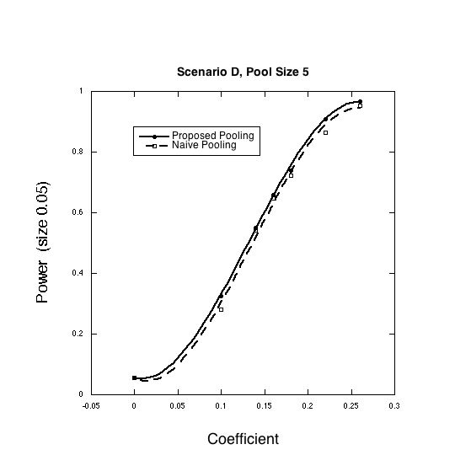

eFigure 2(b). Scenario E, pool size of 5

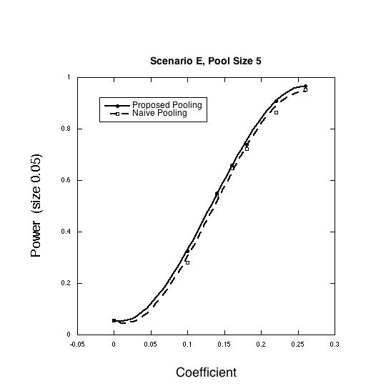

eFigure 2(c). Scenario F, pool size of 5

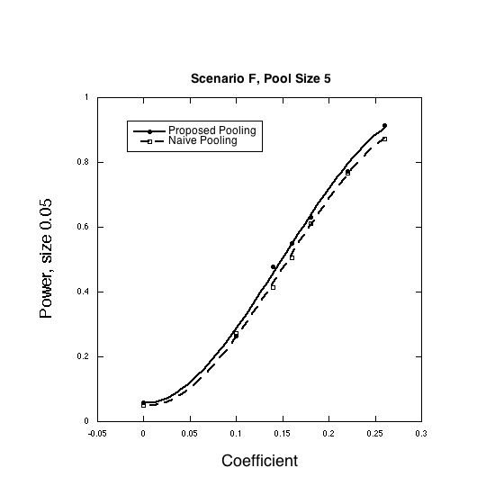

eFigure 2(e). Scenario D, pool size of 10
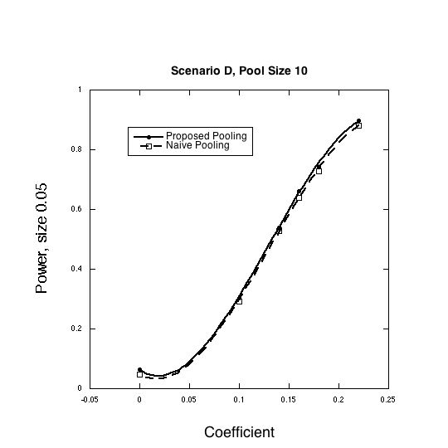

eFigure 2(f). Scenario E, pool size 10

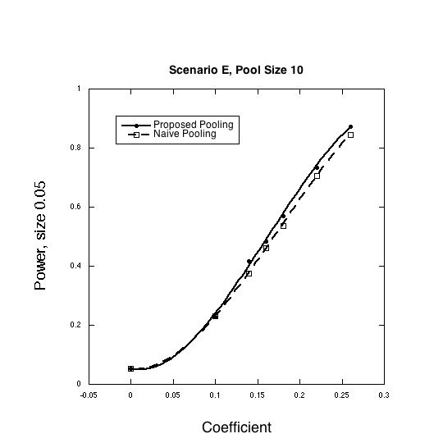

eFigure 2(g). Scenario F, pool size of 10

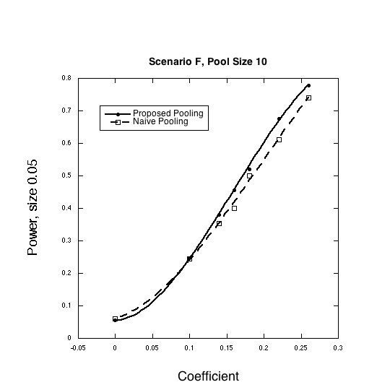

Reference:

O’Brien KM, Upson K, Cook NR, Weinberg CR. 2016. Environmental chemicals in urine and blood: improving methods for creatinine and lipid adjustment. Environmental Health Perspectives 124:220-227.

