Supplementary material to “Early-access programme in emergency care: idarucizumab use for rapid dabigatran reversal in critical care patients”.
Ismail Elalamy, Oliviu Crisan, Fredrik Gruenenfelder, Gaêlle Benarousse and Karim Tazarourte

Supplementary data: French Temporary Authorization for Use (ATU)
For promising new medicines that have not yet gained marketing approval for use in patients, the Temporary Authorizations for Use (ATU) designation can be granted by health authorities such as the Agence Nationale de Sécurité du Médicament et des Produits de Santé (ANSM; the French national agency of medicine and health product safety), which allows the compassionate use of such medicines.
The ANSM granted a cohort ATU to Boehringer Ingelheim, France, in November 2015 for the intravenous administration of idarucizumab (2x2.5 g/50-ml solution for injection/infusion). According to ATU guidelines, a protocol for the therapeutic use and collection of information about idarucizumab was established by the ANSM in co-operation with Boehringer Ingelheim. The ATU programme of idarucizumab in France ended on 21 February 2016 and the product has been marketed in France since 22 February 2016.
This compassionate-use programme was available to physicians working in hospital centres. Only prescribers and pharmacists who practiced in public or private health establishments, having set a co-ordinated organization between the hospital pharmacy and the emergency/re-animation, neurovascular and surgery services to ensure the proper use of idarucizumab and its traceability, were allowed to use the product.

Supplementary Figure 1: Patient disposition

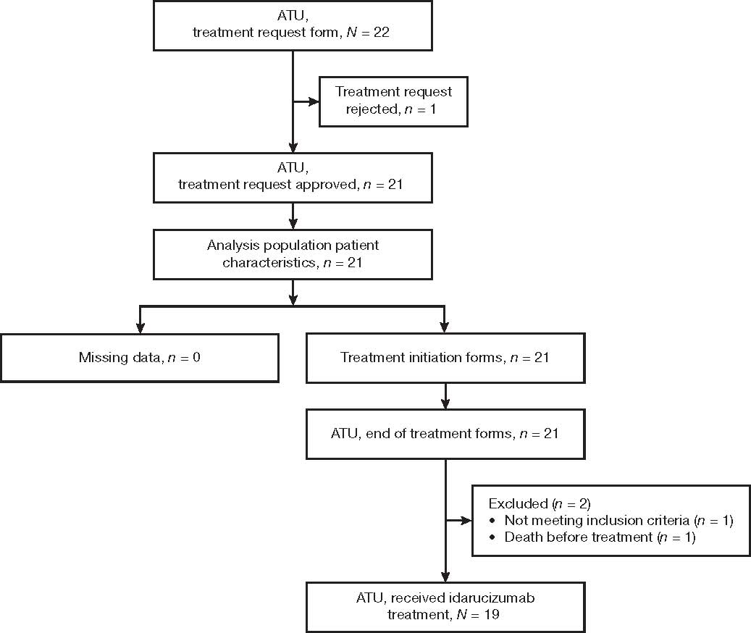

Supplementary Table 1: Patient baseline demographics and medical history data
Parameter | All patients (N = 21)
Age, median (range), y (n = 20) | 79.0 (71.5–85.5)
Body weight, median (range), kg | 75.0 (65.0–80.0)
Sex, male, n | 14
Dabigatran treatment, n
DE 75 mg | 1
DE 110 mg | 13
DE 150 mg | 4
Unknown | 3
Concomitant medication,ª n, yes | 15
Hypolipidemics | 8
Antihypertensives | 5
β-blocker | 5
Antiarrhythmic | 4
Calcium channel blockers | 4
Others, n | 36
Clinical situations^{b}, n
With one clinical situation | 15
With two clinical situations | 6
Included for surgery | 7
Included for bleeding | 8
Included for both surgery and bleeding indications | 6
ªA patient may be counted in more than one category. ^{b}Clinical situations can be either surgery and bleeding or both.
DE, dabigatran etexilate.
Supplementary Table 2: Emergency surgery and bleeding conditions at study inclusion for patients who received idarucizumab
Parameter | Patients (N = 21)
Patients included for emergency surgery/urgent procedures
Total | 7
Cardiac surgery | 1
Cholecystectomy with context of sepsis | 1
Explorative laparotomy for bowel perforation | 1
Laparotomy for sigmoid haematoma | 1
Lavage of knee prosthesis for septic arthritis | 1
Open ankle fracture | 1
Pleural cavity drainage | 1
Patients included for life-threatening or uncontrolled bleeding
Total | 8
Gastrointestinal haemorrhage | 3
Subarachnoid haemorrhageª | 2
Intracerebral haemorrhage | 1
Intracranial haemorrhage | 1
Urinary haemorrhage | 1
Patients included for both conditions
Total | 6
Endoscopy for gastrointestinal haemorrhage | 1
Endoscopy for left haemothorax | 1
Neurosurgery for chronic subdural haematoma | 1
Neurosurgery for intracranial haematoma^{b} | 1
Cardiac tamponade with pericardial drainage | 1
Surgery of epigastric artery for intra-abdominal haemorrhage | 1
ªOne patient did not receive idarucizumab based on the physician’s decision. ^{b}The patient died before initiation of the treatment.

