Online Methods

Lipidomics and Redox Lipidomics Indicate Early-Stage Alcohol-Induced Liver Damage

Authors:

Jeremy P. Koelmel^{1,2¥}, Wan Y. Tan^{1¥}, Yang Li², John A. Bowden^{3,4}, Atiye Ahmadireskety³, Andrew C. Patt⁵, David J. Orlicky⁶, Ewy Mathé⁵, Nicholas M Kroeger⁷, David C Thompson⁸, Jason A. Cochran^{2,7}, Jaya Prakash Golla¹, Aikaterini Kandyliari^{1,9}, Ying Chen¹, Georgia Charkoftaki¹, Krystal J. Godri Pollitt¹, Joy G. Cagmat², Hiroshi Tsugawa^{10,11}, Anmol Arora^{1,12}, Kirill Veselkov¹³, Shunji Kato¹⁴, Yurika Otoki¹⁴, Kiyotaka Nakagawa¹⁴, Richard A. Yost^{2,3}, Timothy J Garrett^{2,3*}, Vasilis Vasilou^{1*}

¹ Department of Environmental Health Sciences, Yale School of Public Health, New Haven, CT
² Department of Pathology, Immunology and Laboratory Medicine, University of Florida, Gainesville, FL
³ Department of Chemistry, University of Florida, Gainesville, FL
⁴ Center for Environmental and Human Toxicology & Department of Physiological Sciences, University of Florida, Gainesville, FL
⁵ Department of Biomedical Informatics, College of Medicine, Ohio State University, Columbus, OH
⁶ Department of Pathology, University of Colorado School of Medicine, Denver, Colorado
⁷ Computer & Information Science & Engineering, University of Florida, Gainesville, FL
⁸ Department of Clinical Pharmacy, University of Colorado Skaggs School of Pharmacy and Pharmaceutical Sciences, University of Colorado, Aurora, CO
⁹ Unit of Human Nutrition, Department of Food Science and Human Nutrition, Agricultural University of Athens, Athens, Greece
¹⁰ RIKEN Center for Sustainable Resource Science, Kanagawa, Japan
¹¹ RIKEN Center for Integrative Medical Sciences, Kanagawa, Japan
¹² School of Clinical Medicine, University of Cambridge, Cambridge, United Kingdom
¹³ Department of Metabolism, Digestion and Reproduction, Imperial College London, London, United Kingdom
¹⁴ Food and Biodynamic Chemistry Laboratory, Graduate School of Agricultural Science, Tohoku University, Sendai, Japan, 980-8577

Contact Information:
Co-corresponding authors
Vasilis Vasiliou
vasilis.vasiliou@yale.edu
Timothy Garrett
tgarrett@ufl.edu

LipidMatch Flow – Comprehensive Data-Processing Workflow

A diverse array of lipidomics software have recently been developed to meet the rising demand for lipidomics in clinical and pharmaceutical research, among other fields In the present study, we utilize LipidMatch Flow, which is a unique system in that it covers the entire data-processing workflow and emphasizes user-friendliness: rather than a command-line interface, users need only drag correctly-named files onto the interface. This significantly reduces the time needed for data-processing. Centroiding, chromatographic peak picking, filtering and alignment, blank filtering, lipid annotation, and assimilation of negative and positive polarity data, as well as redundant adducts, are all performed in LipidMatch Flow, with parameters being automatically set dependent on vendor (Figure S5).
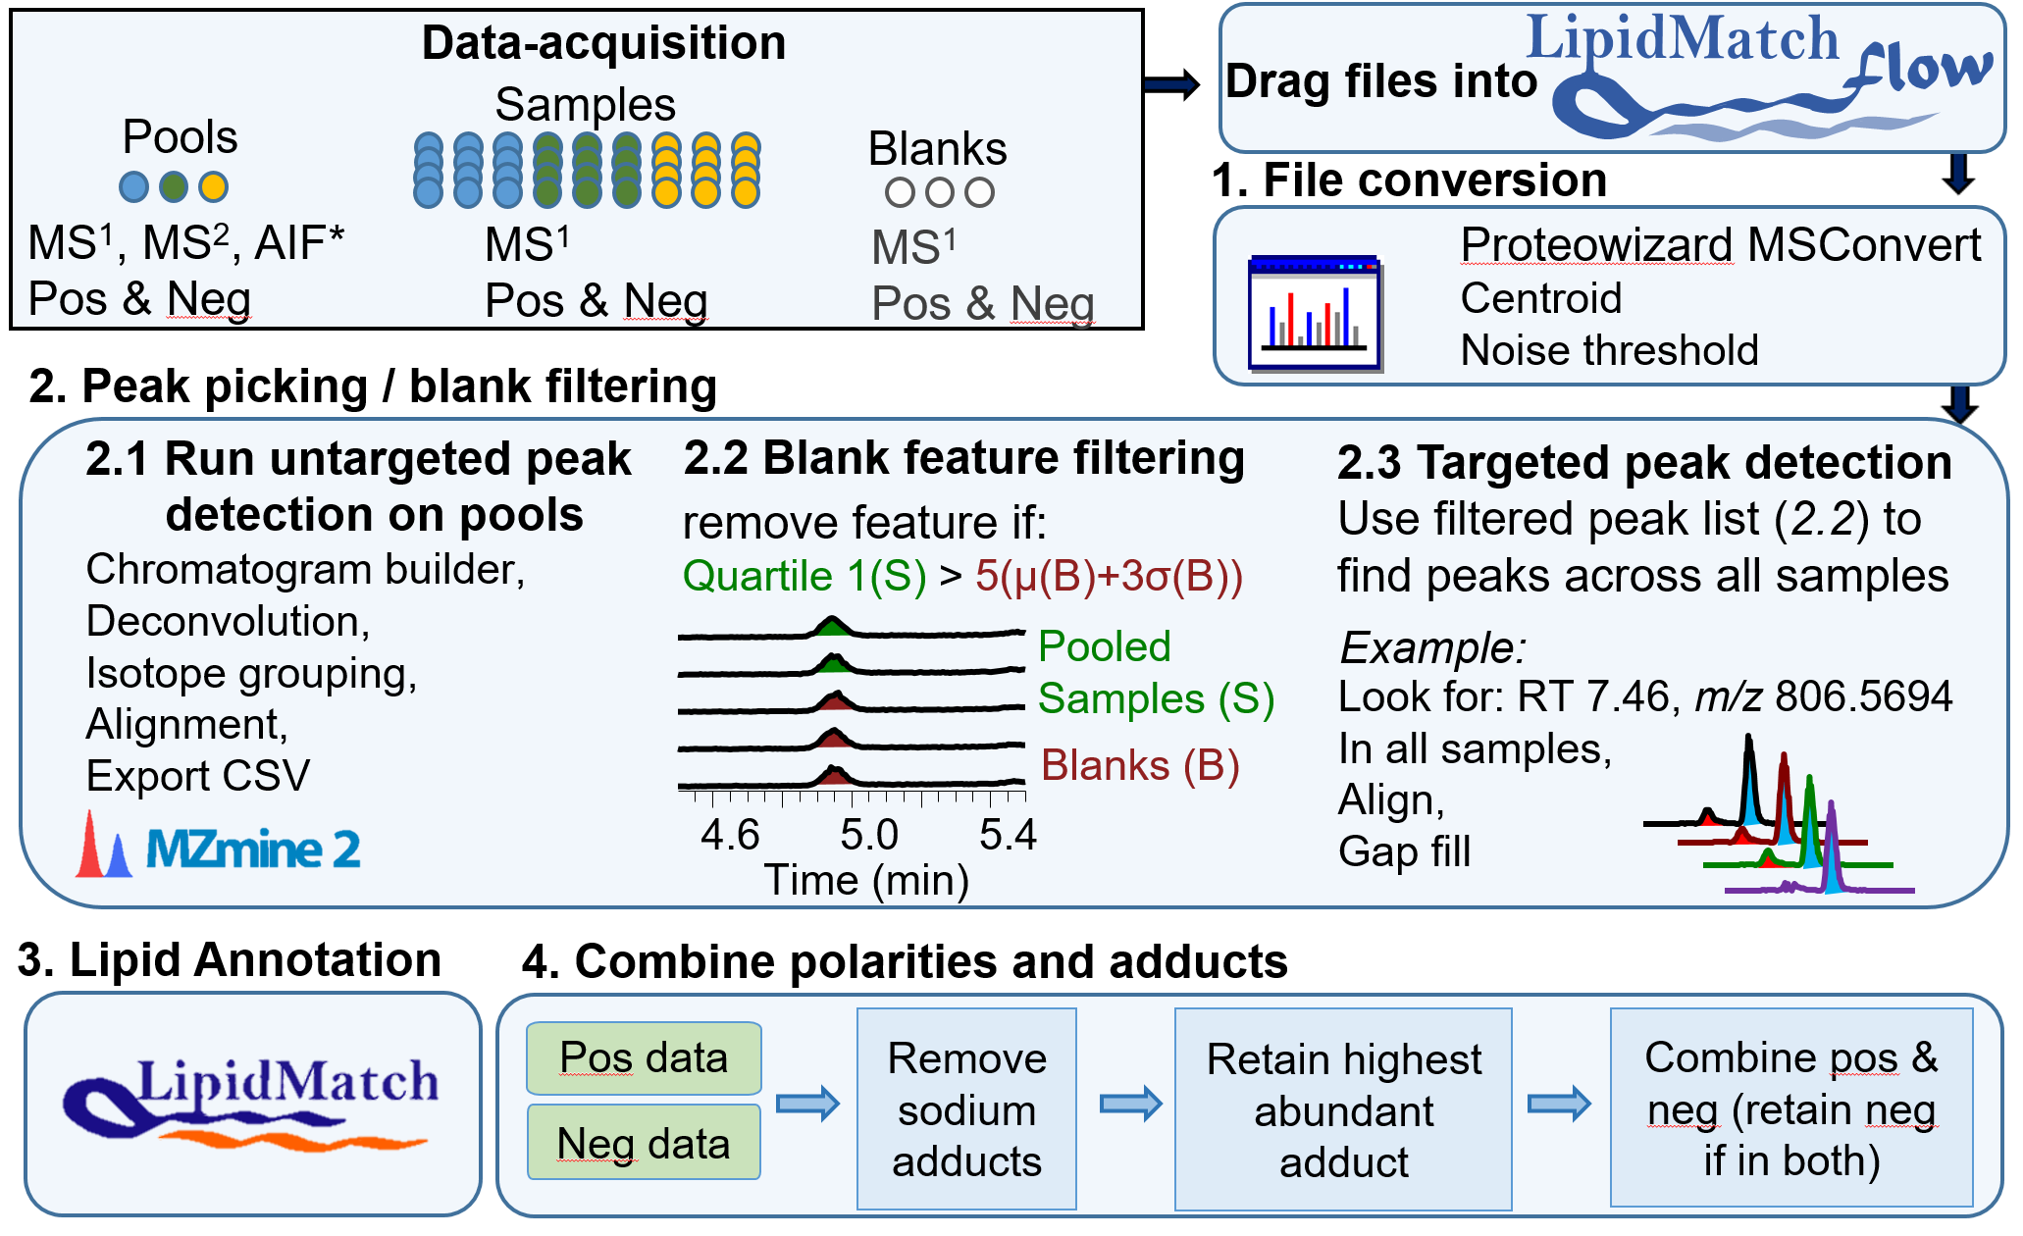
Figure S5: Data-acquisition workflow and LipidMatch Flow data-processing workflow. After dragging files into LipidMatch Flow, all further steps are automated.
Acronyms are defined as follows - RT: retention time, MS²: tandem mass spectrometry, MS¹: full-scan data, Pos: positive ion mode, Neg: negative ion mode, m/z: mass to charge ratio, µ: average, and σ: standard deviation.
* Data-independent analysis is only supported for Thermo’s all-ion fragmentation (AIF). Otherwise, the software currently supports Agilent, Sciex, and Thermo targeted, data-dependent and full scan file formats.

LipidMatch Flow is the only open-source software that automates a wide variety of data-processing steps. Parameters are automatically selected based on the vendor, allowing for a rapid, user-friendly experience. LipidMatch Flow uses rule-based lipid annotation (as described previously) and names lipids according to the structural information derived from tandem mass spectrometry evidence. The software contains one of the largest in silico lipid MS/MS libraries to date, with unique libraries developed from standards, literature, and curated from MS-DIAL, LipidBlast, and LIPID MAPS. LipidMatch Flow is one of only a few software to have fully editable libraries and annotation rules, covering data-dependent and data-independent data, and providing correct structural resolution in the provided annotation. A video tutorial showing the user workflow for LipidMatch Flow and library development can be found at: https://www.youtube.com/playlist?list=PLZtU6nmcTb5kAOHAPjtpWXwyjfpDnaB2M
Details about the unique algorithms and user workflow can also be found below.

LipidMatch Flow Data-Processing Workflow and Algorithms

The LipidMatch Flow algorithm consists of four major steps (outlined in Figure S5) consisting of data conversion into open source formats implementing MSConvert[1], peak picking and filtering (implementing MZMine 2.26[2]) and C# code/lipid annotation (implementing LipidMatch[3]), and combining negative and positive polarities and redundant adducts written in R.

Step 1. Data import

Users simply drag files onto the interface and files are converted with implementation of MSConvert[1]. The algorithm recognizes the extension of the file being imported and then choses parameters appropriate for each vendor. Currently, the LipidMatch Flow software supports SCIEX, Agilent, and Thermo file extensions. MS/MS files are converted to .ms2 (and .ms1 in the case of Thermo all-ion fragmentation data) for LipidMatch[3] annotation, whereas full-scan data files are converted to .mzXML for peak picking. MSConvert parameters were as follows:
Thermo: Vendor Peak Picking, Absolute Threshold – 0.001, Default array length > 2 (only for .ms2), Agilent: Vendor Peak Picking, Default array length > 2 (only for .ms2), and SCIEX (.wiff and .wiff2): CWT peak picking (not vendor) with a minimum signal to noise and minimum peak spacing of 0.1, Default array length > 2 (only for .ms2).

The algorithm also checks that all files needed (minimum of one blank, one pooled or reference sample, and one MS/MS file (all ion fragmentation, data-dependent or targeted MS/MS acquisition)) are provided and named correctly to prevent errors later on. A separate GUI is available in LipidMatch Flow to automatically generate new file names with the correct naming conventions for ease of use. All steps for data to acquire, naming conventions, and use of the renaming tool can be found in the user manual and in the YouTube tutorial videos: https://www.youtube.com/playlist?list=PLZtU6nmcTb5kAOHAPjtpWXwyjfpDnaB2M

Step 2. Peak picking and filtering

The feature detection algorithm consists of three major steps: non-targeted peak picking on reference files, blank filtering, and targeted peak picking across all full-scan files (all samples).

2.1. Non-targeted peak picking on reference files

The non-targeted peak picking step is the most RAM and CPU intensive step, and hence is the bottleneck for data-processing in most experiments. Therefore, by only performing non-targeted peak picking on pooled or reference samples and then only targeting selected peaks across all samples, the LipidMatch Flow implementation of MZMine increases throughput.

Separate MZMine batch files were created for each vendor, to optimize parameters based on intensity scales and mass accuracy of instruments. MZMine batch files contain all parameters and data-processing steps to run in MZMine. The algorithm uploads an MZMine batch file from the LipidMatch Flow directory into MZMine 2.26 and applies it to files containing "targeted" somewhere in the file name (pools or representative samples). The steps performed in non-targeted peak detection are centroiding (select m/z peaks above an intensity threshold), chromatogram builder (creates EIC traces based on exact mass), deconvolution using local minimums (resolves peaks, including closely eluting peaks, in the EIC traces), isotope grouping (keeps the predominant isotope only), alignment (combines peaks across samples into a single table with each row representing a feature (retention time and m/z), and exporting of the peak height to a .csv file.

2.2. Blank feature filtering (BFF)

Blank feature filtering (BFF) was implemented to remove detected ions which are introduced during sample preparation, or are background signals from solvents, instrument carryover, or other sources of non-sample origin. BFF has been shown to work better than a number of other filtering methods in terms of reducing the number of background peaks (reducing false positives) while simultaneously retaining the most peaks of sample origin (reducing false negatives).[4] By removing background, there is a higher chance of finding statistically significant features, and the probability of a significant feature being due to non-biological origin is drastically reduced.

The version of blank feature filtering implemented in LipidMatch Flow takes the first quartile of the pooled/reference samples and determines if they are greater than 5 times the "limit of detection" (the average of the blanks + 3 x the standard deviation of the blanks). Those features below this threshold are removed for further data-processing, not only improving the quality of data but also improving throughput by limiting the number of features of non-biological origin processed. After blank filtering, the feature list is formatted as a targeted .csv file for import into MZMine's "targeted peak detection" module.

2.3. Targeted peak detection

Targeted peak detection is much more rapid and improves consistency of peak picking as compared to non-targeted peak detection.

Targeted peak detection is performed across all samples and quality controls using a targeted peak list generated from steps 2.1 and 2.2 using a batch file specific to each vendor. The processing steps are as follows: centroiding and threshold mass spectra, targeted peak detection, deconvolution using local minimum, alignment using join aligner, row filtering and duplicate filtering, gap filling (using both the same range and peak finder module), duplicate filtering, and exporting. The final MZMine project is also saved so the user can go back and manually verify peak integration.

Step 3. Annotation of lipids

Features determined in Step 2 are annotated using the MS/MS files imported into the LipidMatch Flow software and LipidMatch. LipidMatch algorithms and coverage versus other software is compared in Table 1b. Briefly, rule-based annotation is implemented, where depending on the fragments observed, the lipid is named accordingly. Annotation conforms to rules being developed by the community in order to only provide information known about the molecular structure based on mass spectrometry data, limiting over annotation which can lead to false interpretations of the data.[5] For example, if only a class-based fragment is observed for a phosphatidylethanolamine (neutral loss of m/z 141.0191) containing 16:0 and 22:6 fatty acids than the lipid is annotated as PE(38:6), whereas if fatty acyl chain fragments (neutral loss of RCO, where R is the remaining fatty acyl chain) are observed, then the species is annotated as PE(16:0_22:6) where the underscore denotes that the fatty acyl position on the backbone is unknown. If more than one lipid is annotated for a feature, then annotations are ranked by summed fragments intensities. In-depth descriptions of annotation algorithms and validation have been provided previously.[3]

Step 4. Combining redundant features

Nearly all lipidomics software provide annotations where the same lipid can exist in the final data table(s) as different adducts and across different mass spectrometry polarities. These redundant and highly correlated features cause problems in multivariate analysis and false positive rate calculations, and therefore should be removed or combined. LipidMatch Flow integrates a novel algorithm for combining redundant features across different adducts and polarities (Figure S5).

First positive and negative data are filtered individually. For positive polarity, sodium adducts are removed due to the lack of correlation of sodium adducts with analyte concentration when only background sodium exists for ionization.[6] For both polarities, if a lipid exists as multiple adducts or across different retention times, the highest intensity lipid ion is chosen. Note that for lipid isomers, which can be separated chromatographically and by MS/MS (for example LPC positional isomers), separate names are provided, and hence both isomers are retained. If a lipid is confirmed in both negative and positive polarity, the positive ion is removed and negative ion retained. The negative ion is prioritized because there is less influence from noise (lower background) on the final peak areas and higher confidence in annotation and spectral deconvolution of co-eluting isomers (more intense fatty acyl fragments).

If a number of co-eluting adducts of the same lipid species are observed and annotated by MS/MS, then the confidence in annotation is significantly higher. Therefore, in the case of co-eluting identifications of different adducts for one lipid species, all adducts annotated are included in the final csv file in a separate column for the user.

LipidMatch Flow Library Development

A workflow for user to generate in-silico libraries for LipidMatch Flow is presented in the following youtube tutorial:
https://www.youtube.com/watch?v=I6_hUy3o5Yo
Briefly, users begin with an input of possible fatty acids and an R script provided can be used to generate all combinations of fatty acids for lipid species containing two or three fatty acyl chains. Then excel formulas are used to generate the fixed neutral losses, fragment ions, and fatty acid dependent fragmentation for each lipid class. Rules for which fragments must be observed for confirmation are place into a table (.csv) which is imported by LipidMatch Flow along with the new libraries during use of the software.

One unique set of libraries are the oxidized lipid libraries and their fragmentation. Ketones, epoxy, hydroxyl, and hydroperoxyl additions (including combinations thereof) were added to unsaturated fatty acids at common places along the fatty acid chain. Short chain oxidation products were also generated through cleavage at likely points along the chain with termini ending in aldehyde or carboxylic acids. Only the most common unsaturated fatty acids, and fatty acids were included, and all combinations of fatty acids for one, two, and three fatty acid containing species were generated using the R script described in the youtube tutorial. It is important to note that for oxidized lipids numerous isomers cannot be distinguished through MS/MS alone, and therefore all possibilities are included when annotating features. In addition, for oxidized triglycerides, for which this is the first software to include, triglycerides containing fatty acid esters of hydroxy fatty acids (FAHFA) may lead to similar spectra.[7]

Mouse Models and Experimental Design

Animals
Male C57BL/6J mice (10–12 wk old) were purchased from Jackson Laboratory (Bar Harbor, ME). Mice were maintained in a temperature-controlled room (21–22°C) on a 12 hr light/dark cycle. Food and water were supplied ad libitum. All animal procedures were approved by and conducted in compliance with Institutional Animal Care and Use Committee (IACUC) of the Yale University.

Chronic ethanol feeding.
Mice were randomly divided into seven groups (Figure S5). The chow group (N = 6) was fed standard rodent chow. Ethanol (EtOH) groups (GE1-3; N = 7-10/group) and pair-fed control groups (GC1-3; N = 5-7/group) were fed a modified Lieber-DeCarli (LD) diet (F4473SP and F4474SP; Bio-Serv, Frenchtown, NJ) for up to five weeks. The LD liquid diet is composed of 45% fat-derived calories, 15% protein-derived calories and with the remaining 40% calories comprised varying concentrations of EtOH-derived and carbohydrate-derived calories. GE groups started with a LD diet containing 2% EtOH (v/v) with a weekly increase of 1% EtOH (v/v) until it reached 5% (v/v). GC groups received a LD diet (CON) in which the ethanol content was substituted by carbohydrates. Fresh LD Diets were prepared daily. Mice fed the same diet were housed in pairs and had LD diet as the sole source of food and water. Diet intake was recorded daily and body weights were measured twice each week. On the 6th-7th day (3pm - 9am) of week 2 (GE1 and GC1), week 4 (GE2 and GC2) and week 5 (GE3 and GC3), mice were placed singly in a metabolic cage (Tecniplast S.p.A., Italy) (with free access to the corresponding LD diet) for 18 hr to collect urine and feces, followed by 4hr fasting in regular housing cages. Mice were then euthanized by isoflurane overdose. Blood was collected from the inferior vena cava, followed by cardiac perfusion with phosphate buffered saline (pH 7.4). The liver was then quickly removed and weighed. One piece of liver was fixed in 10% formalin for histology and the remainder was flash frozen in liquid nitrogen. Plasma was extracted from whole blood by centrifugation at 15,000 rpm for 10 min at 4°C and immediately frozen at -80°C. Five µm sections of paraffin-embedded liver were prepared and stained with hematoxylin and eosin (H&E) by the Department of Pathology at the Yale University using standard procedures. Liver histopathology was examined by a blinded pathologist (DJO).

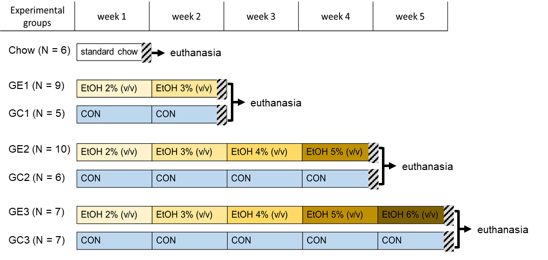
Figure S5: Scheme of treatment regime. Male C57BL/6J mice (10–12 week old) were randomly divided into seven groups. The chow group was fed standard rodent chow. Ethanol- (EtOH) groups (GE1, GE2, GE3) and pair-fed control groups (GC1, GC2, GC3) were fed a modified Lieber-DeCarli (LD) diet for up to five weeks. GE groups started with a LD diet containing 2% EtOH (v/v) with a weekly increase of 1% EtOH (v/v) until it reached 5% (v/v). GC groups received a LD diet (CON) in which the EtOH content was substituted by carbohydrates. On the 6th-7th day (3pm - 9am) of week 2 (GE1 and GC1), week 4 (GE2 and GC2) or week 5 (GE3 and GC3), mice were placed singly in a metabolic cage (Strips, LOCATION) with free access to the corresponding LD diet for 18 hr, and then subjected to 4hr fasting in regular housing cages prior to being euthanized.

Sample Processing and Data-Acquisition

Liver and plasma samples were extracted using the Bligh-Dyer extraction method[8]. More specifically, 20 μL of plasma was extracted for each mouse and frozen liver sample (50.0 ± 2.5 mg for each sample) was placed in a tube with 500 μL H₂O containing ceramic beads (Precellys Lysing Kit, tissue homogenizing CKMix, Bertin Technologies SAS, France). The tissue was homogenized (Precellys Evolution homogenizer, Bertin Technologies SAS, France) at 6,000 rpm for 20 s three times with a 5 s interval between homogenization periods. Dry ice was used to keep the temperature of the homogenate low. Aliquots of 100 µL tissue homogenate were placed into five individual tubes (Protein LoBind, Eppendorf, Germany), four of which were stored at -80°C for future use and the remaining 100 µL aliquot was immediately utilized, using the Bligh-Dyer extraction method [8]. Fifteen µL of internal standard mixture (20 µg/mL stock solution of EquiSPLASH™ LIPIDOMIX® Quantitative Mass Spec Internal Standard mixture) was added to each sample and to blanks (for neat quality controls). Sample processing was performed identically on extraction blanks (without internal standards) for blank feature filtering. All standards and samples were gravimetrically weighed and exact values were recorded for normalization of the data. Final extracts were dried under nitrogen and reconstituted in 100 µL of isopropanol (optima grade). Aliquots of reconstituted samples were combined for pools by group.

Liquid chromatography was performed on a UHPLC system (Vanquish, Thermo Scientific, San Jose, CA). Lipids in each sample were separated using a C₃₀ column (2.1 × 150 mm, 2.6 μm particle size, (Accucore, Thermo Scientific, San Jose, CA) and a gradient program consisting of mobile phase A (60:40 acetonitrile/water) and mobile phase B (90:10 isopropanol/acetonitrile), each containing 5 mmol/L ammonium formate and 0.1% (v/v) formic acid. Two µL samples were injected for both mass spectrometer ion polarities. The flow rate was set to 0.4 ml/min with the following gradient:
Time (min) | 0 | 7 | 8 | 12 | 20 | 22 | 27 | 27.1 | 32
% B | 40 | 55 | 65 | 65 | 95 | 100 | 100 | 40 | 40

The UHPLC system was coupled to a mass spectrometer (Q-Exactive Orbitrap, Thermo Scientific, San Jose, CA) for chromatographic separation and mass spectral measurement of lipids in positive and negative ion mode, respectively. The scanning modes (in both polarities) employed were full scan for all samples, blanks, and QCs, and iterative-exclusion data-dependent acquisition (IE-DDA) and all-ion fragmentation (AIF) for pooled samples and representative samples. IE-DDA has been shown to improve coverage of lipids nearly two-fold,[9,10] and we employed the software IE-Omics[9] to automate the process. Full scan data was acquired in profile mode at 70,000 mass resolution, 200 – 1500 m/z range, with an automatic gain control (AGC) target of 5 x 10⁶, and maximum injection time of 256 ms. For DDA, the same full-scan parameters were used except the AGC was set to 3 x 10⁶. The DDA parameters were as follows: mass resolution – 35,000, AGC – 5 x 10⁶, maximum injection time – 150 ms, loop count and topN – 10, isolation window – 1 m/z, stepped normalized collision energy (NCE) – 20, 25, 30 eV, minimum AGC target – 8 x 10³, intensity threshold 5.3 x 10⁴ and dynamic exclusion – 6 s. All-ion fragmentation data was acquired with the same setting as full-scan data and with a stepped NCE of 20, 25, 30 eV.

All samples were acquired in negative and positive polarity in full-scan mode using liquid chromatography high resolution mass spectrometry.

Lipidomics Data-Processing Workflow and Statistics

Representative samples (pooled samples for ethanol-fed and pair-fed control mice and randomly selected mice from both pair-fed control and ethanol-fed mice in GE3 and GC3 (5th week)) were provided as "targeted" files for non-targeted peak detection in LipidMatch Flow and all remaining full-scan data-files were uploaded for non-targeted peak detection. Selected all-ion fragmentation (AIF) and all iterative-exclusion data-dependent acquisition (IE-DDA) files were imported for annotation. After generation of annotated feature tables with redundant ions combined via LipidMatch Flow, the data was normalized to internal standards (EquiSPLASH™ LIPIDOMIX® Quantitative Mass Spec Internal Standard mixture) using LipidMatch Normalizer[6]. The mixture covered the 13 most prominent lipid classes, where standards were selected which best represented lipid class chemistry for those lipid classes not covered. After normalization, feature tables were formatted for import into Metaboanalyst 4.0[11] for data-transformation and statistics.

Missing values were replaced by half of the minimum value, and features with 70% or more missing values were removed. Resulting data was log transformed and mean centered. Univariate and multivariate analysis of the resulting data was performed. ANOVA analysis with false discovery rate (FDR) correction using the Benjamini and Hochberg method[12] with a Tukey HSD performed to determine significantly changed lipids. Furthermore, significantly changed lipids were determined as upregulated or downregulated if the average lipid levels changes by over 25% in either direction with percent change being calculated as the maximum difference of the average of two groups being compared divided by the minimum average. In order to determine lipid class based trends, the percent of significantly upregulated or downregulated lipids across each comparison (ethanol-fed versus control mice for the three respective time-points, and ethanol fed-mice across time points) was calculated and summarized in Figure 2 and Table S1. For pattern analysis, correlation plots were performed and lipids were colored by class. For multivariate analysis, principle components analysis was performed.

References

1. Kessner D, Chambers M, Burke R, Agus D, Mallick P. ProteoWizard: open source software for rapid proteomics tools development. Bioinformatics. 2008;24: 2534–2536. doi:10.1093/bioinformatics/btn323
2. Pluskal T, Castillo S, Villar-Briones A, Orešič M. MZmine 2: Modular framework for processing, visualizing, and analyzing mass spectrometry-based molecular profile data. BMC Bioinformatics. 2010;11: 395. doi:10.1186/1471-2105-11-395
3. Koelmel JP, Kroeger NM, Ulmer CZ, Bowden JA, Patterson RE, Cochran JA, et al. LipidMatch: an automated workflow for rule-based lipid identification using untargeted high-resolution tandem mass spectrometry data. BMC Bioinformatics. 2017;18: 331. doi:10.1186/s12859-017-1744-3
4. Patterson RE, Kirpich AS, Koelmel JP, Kalavalapalli S, Morse AM, Cusi K, et al. Improved experimental data processing for UHPLC–HRMS/MS lipidomics applied to nonalcoholic fatty liver disease. Metabolomics. 2017;13: 142. doi:10.1007/s11306-017-1280-1
5. Koelmel JP, Ulmer CZ, Jones CM, Yost RA, Bowden JA. Common cases of improper lipid annotation using high-resolution tandem mass spectrometry data and corresponding limitations in biological interpretation. Biochimica et Biophysica Acta (BBA) - Molecular and Cell Biology of Lipids. 2017;1862: 766–770. doi:10.1016/j.bbalip.2017.02.016
6. Koelmel JP, Cochran JA, Ulmer CZ, Levy AJ, Patterson RE, Olsen BC, et al. Software tool for internal standard based normalization of lipids, and effect of data-processing strategies on resulting values. BMC Bioinformatics. 2019;20: 217. doi:10.1186/s12859-019-2803-8
7. Tan D, Ertunc ME, Konduri S, Zhang J, Pinto AM, Chu Q, et al. Discovery of FAHFA-Containing Triacylglycerols and Their Metabolic Regulation. J Am Chem Soc. 2019;141: 8798–8806. doi:10.1021/jacs.9b00045
8. Bligh EG, Dyer WJ. A Rapid Method of Total Lipid Extraction and Purification. Can J Biochem Physiol. 1959;37: 911–917. doi:10.1139/o59-099
9. Koelmel JP, Kroeger NM, Gill EL, Ulmer CZ, Bowden JA, Patterson RE, et al. Expanding Lipidome Coverage Using LC-MS/MS Data-Dependent Acquisition with Automated Exclusion List Generation. J Am Soc Mass Spectrom. 2017;28: 908–917. doi:10.1007/s13361-017-1608-0
10. Sartain M, Salcedo J, Murali A, Li X, Stow S, Koelmel J. Improving Coverage of the Plasma Lipidome Using Iterative MS/MS Data Acquisition Combined with Lipid Annotator Software and 6546 LC/Q‑TOF. Agilent Application Note. 2019;5994–0775en. Available: https://www.agilent.com/cs/library/applications/application-6546-q-tof-lipidome-5994-0775en-agilent.pdf
11. Chong J, Soufan O, Li C, Caraus I, Li S, Bourque G, et al. MetaboAnalyst 4.0: towards more transparent and integrative metabolomics analysis. Nucleic Acids Res. 2018;46: W486–W494. doi:10.1093/nar/gky310
12. Benjamini Y, Hochberg Y. Controlling the False Discovery Rate: A Practical and Powerful Approach to Multiple Testing. Journal of the Royal Statistical Society Series B (Methodological). 1995;57: 289–300.

