Supplementary Materials
Single cell RNA-Seq analysis of macrophages and hepatocytes
Macrophage-specific expressed genes were identified by analyzing single cell RNA sequencing GSE129516 database (1).
Establishment of stable cell lines
ApoB100 coding region or mouse miR-206 precursor was cloned into PB-CuO-CMV-MCS-EF1α-CymR-Puro vector (System Bioscience), referred as to pB-CuO-miR-206 or pB-CuO-ApoB100. Transfection and puromycin selection were performed based on the manufacturer’s manual.
Triton WR1339 treatment of mice
Eight-week-old male C57BL/6J mice were treated with the HFHC for eight weeks. Mice were then injected with AAV8-SCR (n=6), AAV8-miR-206 (n=6), or a combination of AAV8-miR-206 and AAV8-Cas9-sgLxrα (n=6). Eight weeks after injection, mice were fasted for 5 hours to minimize the contribution of postprandial lipid to the plasma triglycerides concentrations. After fasting, HFHC-treated mice were injected intraperitoneally with Triton WR1339 (500 mg/kg) and 500 µCi of ³⁵S-methionine/cysteine in saline to inhibit lipolysis and to label newly synthesized proteins. VLDL clearance is completely inhibited under these conditions,(2) allowing us to determine hepatic production rate of VLDL. Therefore, blood was taken before injection (50 μL) and at 1 hour after Triton WR1339 injection. Serum triglycerides levels were measured using an enzyme method (Wako, Osta, Japan). The VLDL-triglycerides production rate was calculated by the increase in serum triglycerides level from baseline to 1 hour after WR1339 injection. We used a 1-hour time point to estimate the rate of VLDL-triglycerides production, assuming a linear increase of serum triglycerides concentration during this period. The data were expressed as micromoles of triglycerides produced per hour per kilogram of body weight, assuming a serum volume of 3.5% (liters per kilogram). VLDL was isolated by ultracentrifugation, run on an SDS-PAGE gel and ApoB100 bands cut and counted for quantitation of VLDL secretion.
Metabolic labeling experiments
The proteasomal inhibitor MG132 and MTP inhibitor CP-10447 were obtained from Sigma (St. Louis, MO). The ³⁵S-methionine/cysteine protein labeling mixture was obtained from Perkin- Elmer Life Sciences (Waltham, MA). HepG2 cells were plated in the high glucose DMEM containing 10% FBS and 0.5 mM oleate. 24 hours later, HepG2 cells were transfected with scramble (control) or miR-206 mimic. 48 hours after transfection, HepG2 cells were then rinsed twice with warm PBS, and preincubated for 60 min in experimental medium (DMEM without methionine/cysteine, supplemented with 1% FBS, 0.5 mM oleate, 1% L-glutamine and penicillin/streptomycin). Cells were metabolically labeled with 120 μCi/mL of [³⁵S]-methionine/cysteine for 3 hours at 37ºC in the presence of 25 μM MG132 (Sigma) or CP-10447 (Santa Cruz Biotechnology). Media were collected and cell extract was obtained after incubation of cells in lysis buffer (50 mM Tris, pH 8.0, 150 mM NaC1, 0.02% sodium azide, 1 pg/mL aprotinin, and 1% NP-40) for 20 min. Cell extract and media were spun to remove cellular debris, and ApoB was immune-precipitated. Immunoprecipitated samples were either directly counted in Ready SafeTM scintillation cocktail or run on a 3-13% SDS-PAGE gradient gel, dried, and exposed using autoradiography.
Macrophage isolation
For peritoneal macrophages isolation, eight-week old male C57BL/6J mice (n=3) were injected intraperitoneally with 3 mL of 3% thioglycollate broth (Thermo Fisher). Four days later, mice were lightly anesthetized and injected intraperitoneally with 5 mL of sterilized PBS. The peritoneal fluid was carefully aspirated to avoid hemorrhage. After centrifugation at 200 g for 10 min, the cell pellet was washed twice with the maintenance medium (RPMI 1640 with 10% FBS and 50 U/mL recombinant mouse M-CSF). Cells were seeded in the maintenance medium for 2 h at 37 ℃, non-adherent cells were removed by extensive washing with the maintenance medium. Isolated macrophages were transfected with scramble or miR-206 mimic using Lipofectamine™ LTX (Invitrogen, MA). 48 hours after transfection, macrophages were collected for total RNA preparation (QIAGEN RNeasy Micro Kit).
Ultra-low input RNA sequencing of hepatocytes and macrophages
Eight-week-old male C57BL/6J mice (Jackson Laboratory, n=3) were hydrodynamically injected with 20 μg pT3-TTR-miR-206-IRES-GFP (TTR promoter drive miR-206 and GFP transcription) and 0.8 μg pCMV/Sleeping Beauty Transposon (SB). Four weeks post injection, primary hepatocytes were isolated via perfusion as previously described.(3) Isolated hepatocytes were subjected to flow cytometry sorting, both of GFP negative (control) and positive hepatocytes (miR-206 overexpressed) were collected for total RNA extraction (Qiagen RNeasy Micro Kit). The library was prepared and sequenced via ultra-low input RNA sequencing in GENEWIZ (New Jersey). Raw data is available in GSE228412 (https://www.ncbi.nlm.nih.gov/geo/query/acc.cgi?acc=GSE228412).
GW3965 treatment of hepatocytes
Mouse hepatocytes were plated in 4-well chamber slides with DMEM medium supplemented with 10% FBS (Invitrogen). 24 hours later, cells were transfected with pT3-EF1α or pT3-AP-1 and cells were maintained in control medium (DMEM supplemented with 2% DMSO), or DMEM containing GW3965 (2 μM) for 48 hours.
Identification of miR-206 targets
MiR-206 reprogrammed the transcriptome of hepatocytes towards inhibition of genes involved in DNL, cholesterol synthesis, and assembly and secretion of VLDL. To identify genes that could be directly targeted by miR-206, we used Targetscan software to scan 3’UTR of mRNAs of 24 genes involved in DNL, cholesterol synthesis and assembly and secretion of VLDL (4). This analysis identified two miR-206 binding sites within the 3’UTR of Hmgcr mRNA and one miR-206 binding site within the 3’UTR of Lxrα mRNA.
FPLC analysis
After five-hour fasting, blood of mice was collected for serum isolation. After serum isolation by centrifugation, the distribution of lipids within the serum lipoprotein fractions was assessed by FPLC. Pooled serum from mice was used for FPLC analysis. Cholesterol levels of FPLC fractions were measured using Wako enzymatic kits (Cholesterol E).
Analysis of the Lxrα promoter
PROMO was used to identify transcription factor binding sites within the promoters of miR-206 and Lxrα (5).
3’UTR reporter vector construction and luciferase assay
To generate the luciferase reporter vectors, 3' UTR of Lxrα, Hmgcr, Trps1 or Srebf2 was amplified from mouse cDNA by PCR, and inserted into the pMiR-Reporter vector (Ambion), referred as pMiR- Lxrα, pMiR-Hmgcr, pMiR-Trps1 or pMiR-Srebf2. Two bases of the binding sites for miR-206 within the 3’UTR of Lxrα, Hmgcr or Trps1 were mutated using QuikChange II Site-Directed Mutagenesis Kit (Agilent Technologies) per the manufacture’s instruction, and referred as pMiR-Mu-Lxrα, pMiR-Mu-Hmgcr, pMiR-Mu-Trps1 or pMiR-Mu-Srebf2. 24 hours before transfection, 5×10⁴ Hepa1-6 cells were plated per well in a 24-well plate. Then, 200 ng of the luciferase reporter vector and miR-206 mimic (20 nM) as well as 30 ng of pSV-β-Galactosidase Vector (Promega) were transfected into Hepa1-6 cells using Lipofectamine 2000 (Invitrogen). Scramble was used as the control of miR-206 mimic. 48 hours after transfection, luciferase and β-galactosidase assays were performed using the Luciferase Assay System and Beta-Glo® Assay System (Promega). Luciferase activities were normalized to galactosidase activities; wells were transfected in triplicate; and each well was assayed in triplicate.
Chromatin immunoprecipitation (ChIP) Assay
Approximately 1×10⁶ macrophages was used for ChIP assay. ChIP assay was performed using the ChIP Assay Kit (Abcam, ab500) based on the manufacture’s protocol. TRPS1 antibody was purchased from Abcam (ab125197). The binding region was detected in PCR reactions. A 10 kb region upstream from the binding site was used as a negative control and chromatin solution was reserved for input control. Primers flanking the binding sites of TRPS1 (-305 - -297, and -509 -500) within the murine Lxrα promoter were: forward, 5′- CTAAAGAGAAATGATTGTGG -3′ and reverse, 5′- AGTGAGAGAAGCAGACATTAGCA -3′. The negative control primers were: forward, 5′- ACTTACCCATTATCTTCCTGGT -3′ and reverse, 5′- AGTAGATGGTATAGAGTTCCA -3′. Primers flanking the binding site of TRPS1 (-627 - -620) within the miR-206 promoter were: forward, 5′- CACATAGATATGAGGATTCA -3′ and reverse, 5′- TTGGCATAGAATTCTCTGTCA -3′. The negative control primers were: forward, 5′- AGTTGAAATAACTCCTGTAGTCT -3′ and reverse, 5′- GTCTAGCCATGCATAGGAGAAATG -3′.
miRNA transfection and gene expression
5×10⁴ of Hepa1-6, RAW264.7 or THP-1 cells were seeded in a 24-well plate and allowed to adhere overnight. To determine the effects of miR-206 overexpression on gene expression, cells cultured in the DMEM with 10% FBS were transfected with miR-206 mimic (20 nM) using Lipofectamine 3000. Cells transfected with scramble served as the control. 48 hours after transfection, cells were washed using cold PBS and the total RNA were isolated for gene expression analysis.
Histological analysis
Liver samples were embedded in Tissue-Tek OCT embedding compound, and frozen on dry ice. 8 µm-thick sections were cut with a Leica CM3050 S cryostat, air-dried, and fixed in 10% formalin. After washing, sections were stained with an Oil-Red-O (Sigma-Aldrich)/60% isopropanol solution (Fisher Scientific). Briefly, sections were rinsed with 60% isopropanol and stained for 20 min with prepared Oil Red O solution (0.5% in isopropanol followed by dilution to 60% with distilled water and filtered).
RNA isolation and quantitative reverse transcription-PCR (qRT-PCR)
Total RNA was isolated with miRNeasy Mini Kit (Qiagen). To assess gene expression, 1 μg RNA was used for cDNA synthesis with Superscript III reverse transcription reagent (Invitrogen). PCR amplification was performed at 50°C for 2 minutes and 95°C for 10 minutes, followed by 40 cycles at 95°C for 15 seconds and 60°C for 1 minute in a 7900 real time-PCR system with SYBR green (Applied Biosystems). For each sample, we analyzed β-actin, GAPDH or 18S rRNA expression to normalize target gene expression. Primers for qRT-PCR were designed with Primer Express software (Applied Biosystems).
To determine levels of miRNA expression, 10 ng RNA were used for miRNA-specific cDNA synthesis with the TaqMan MicroRNA Reverse Transcription Kit and Taqman MicroRNA Assays (all Applied Biosystems). PCR amplification was performed at 95°C for 10 minutes, followed by 40 cycles at 95°C for 15 seconds and 60°C for 1 minute in a 7900 real time-PCR system (Applied Biosystems). The small RNA Sno202 and RNU6 were used to normalize target miRNA expression. Relative changes in gene and miRNA expression were determined using the 2^{-ΔΔCt} method (6).
Cholesterol Efflux of THP-1 Cells
THP-1 cells were purchased from ATCC (TIB-202) and cultured in RPMI-1640 (Gibco) supplemented with 50 µM 2-mercaptoethanol, 20 ng/ml PMA (Phorbol 12-myristate 13-acetate, Sigma) and 10% FBS. Differentiated THP-1 cells were plated in 12-well plates (1×10⁶ cells/well) and transfected with either miR-206 mimic or scramble (Dharmacon). 24 hours later, cells were labeled with 0.5 μCi/mL [³H]-cholesterol (PerkinElmer) for 24 hours. Following labelling, cells were then washed with PBS and cultured with serum-free RPMI 1640 medium including 50 mg/mL human ApoA1. Supernatants were collected after 6 h, and radioactivity was counted and expressed as a percentage of total cell [³H]-cholesterol content (total effluxed [³H]-cholesterol + cell-associated [³H]-cholesterol).

Measurement of OCR
Primary mouse hepatocytes were seeded into collagen-coated XF24 plates (Seahorse Bioscience, Billerica, MA) at 4×10⁴ cells/well in DMEM with 10% FBS. After 2 hours of adherence, OCR of hepatocytes was measured using the XF24 extracellular flux analyzer from Seahorse Bioscience. Detailed methods and reagent are available at our previous publication (7).
Hepatic lipid analysis
Mouse liver (100 mg) was placed in 1 mL chloroform/methanol (2:1) mixture and incubated on mice for 10 minutes before homogenization. Lipids were extracted from liver homogenates through room temperature orbital shaking (2 hours) followed by centrifugation (5000 RPM for 5 minutes). Supernatants were collected and washed with 0.4 mL chloroform/methanol (2:1) mixture by centrifugation at 5000 RPM for 20 minutes (room temperature). New supernatants were washed with 0.2 volume of 0.9% NaCl. After centrifuging for 5 minutes at 5000 RPM, supernatants were removed and lower-phase was dried at 42°C. Dried lipids were re-suspended in 2% Triton X-100. Liver triglycerides were quantified via a colorimetric assay using a triglyceride assay kit from Roche Diagnostics according to the manufacturer’s protocols.
Blood lipid analysis
Blood was collected into tubes from cardiac puncture of mice. Serum was separated by centrifugation (3000 x RPM for 20 min at 4 °C). Serum chemistry was carried out by the Pathology Laboratory of the University of Minnesota.
Analysis of fecal bile acids excretion
Feces from mice were collected during a 72 hours period prior to termination. 5 mg of dried feces was used for extraction of bile acids as described previously.(8) Bile acids were quantified as previously described.(8)
Western blot and IP analysis
Western blot was performed following standard procedures and analyzed by LICOR-Odyssey infra-red scanner. Primary antibodies of hemagglutinin tag (HA) (ThermoFisher, Cat. No.: MA5-27915 for IP), FLAG (ThermoFisher, Cat. No.: MA1-91878 for IP), LXRα (Novus Biologicals, Cat. No.: NBP1-77106), TRPS1 (Proteintech, Cat. No.: 20003-1-AP), ApoB100 (Calbiochem, Catalog No. 178467), c-Jun (BD Biosciences, Cat. No.: 610327l), c-fos (Abcam, Cat. No.: ab222699), Srebp1c (Abcam, Cat. No.: ab28481), FASN (Abcam, Cat. No.: ab128856), SCD1 (SCBT, Cat. No.: sc-515875), GPAT4 (ThermoFisher, Cat. No.: BS-15587R), MTTP (Abcam, Cat. No.: ab75316), ApoCII (ThermoFisher, Cat. No.: PA5-102480), HMGCR (ThermoFisher, Cat. No.: MA5-32521), SQLE (ThermoFisher, Cat. No.: PA5-76523), HMGCS1 (ThermoFisher, Cat. No.: A304-590A), ABCA1 (ThermoFisher, Cat. No.: MA1-91401), and SREBP2 (SCBT, Cat. No.: sc-13552) were purchased.

Supplementary Figures
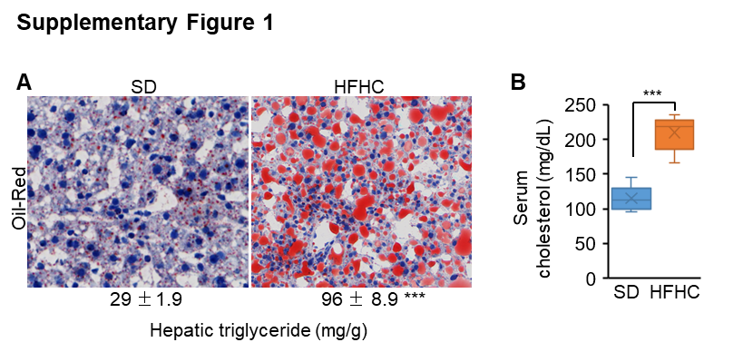

Supplementary Figure 1 HFHC treatment induced hepatosteatosis. (A) Oil-Red staining of livers from mice treated with either the standard diet (SD) (n=6) or the HFHC (n=6) for 8 weeks. (B) Levels of serum cholesterol in two groups of mice. Data represent mean ± SEM. ***p < 0.001 (Fig. 1A-B: two-way student’s t test).

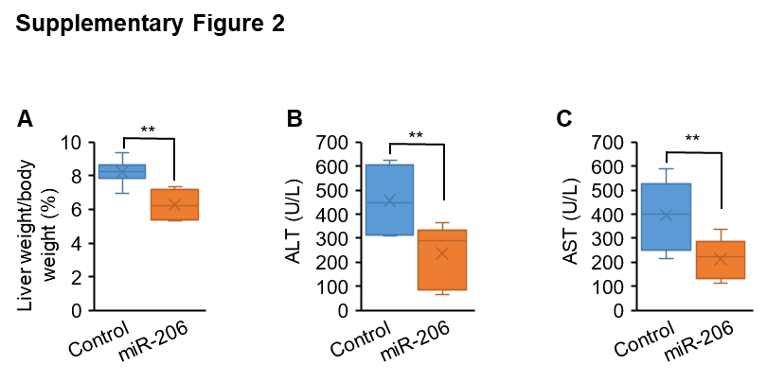

Supplementary Figure 2 The ratios of liver weight/body weight and levels of AST and ALT in mice treated with scramble or miR-206 mimic. Eight-week-old male C57BL/6J mice were maintined on the HFHC for eight weeks. At 16 weeks of age, mice were injected with either miR-206 mimic (n=6) or scramble (control, n=6) twice weekly for eight weeks. (A) The ratios of liver weight/body weight in two groups of mice. (B-C) Levels of AST and ALT in two groups of mice. Data represent mean ± SEM. **p < 0.01 (Fig. 2A-C: two-tailed student’s t test)

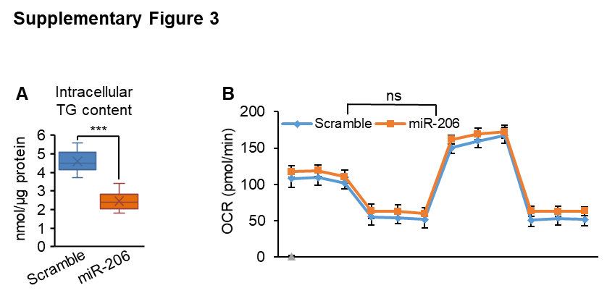

Supplementary Figure 3 miR-206 exhibted no effect on FAO. (A) Levels of intracellular lipid content in human hepatocytes transfected with AAV8-SCR (control) or AAV8-miR-206. Human hepatocytes were maintained in DMEM medium containing 0.5 mM oleate. Twenty-four hours after oleate treatment, primary hepatocytes were transfected with AAV8-SCR (control) or AAV8-miR-206 vector. (B) Levels of OCR (oxygen consumption rate) in hepatocytes of mice treated with AAV-SCR or AAV8-miR-206. Eight-week-old male C57BL/6J mice were maintined on the HFHC for eight weeks. At 16 weeks of age, mice were injected with either miR-206 mimic (n=6) or scramble (control, n=6) twice weekly for eight weeks. Hepatocytes were isolated via perfusion. Data represent mean ± SEM. ns: no significance (Fig. 3A-B: two-tailed student’s t test)

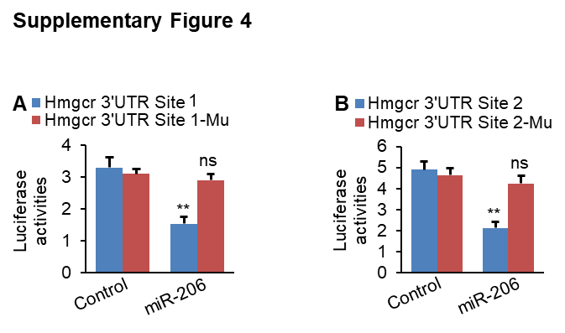

Supplementary Figure 4 Each of the miR-206 binding sites is required for miR-206 to repress Hmgcr. (A-B) Luciferase activity of the reporter construct containing the 3’UTR of Hmgcr with either wild-type or mutated miR-206 binding site 1 or 2 after treatment with miR-206 or scramble (control). Data represent mean ± SEM. **p < 0.01 and ns: no significance (Fig. 4A-B: two-tailed student’s t test)

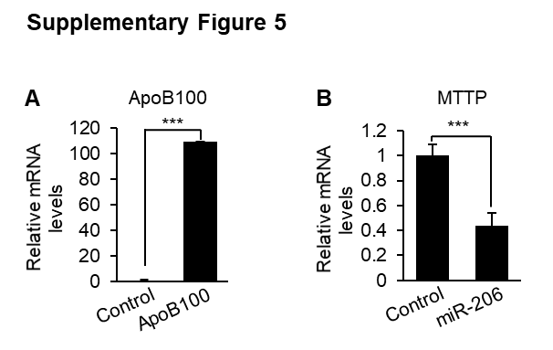

Supplementary Figure 5 (A) mRNA levels of ApoB100 in wild-type HepG2 cells (control) and HepG2-ApoB100 cells (ApoB100). (B) mRNA levels of MTTP in HepG2-ApoB100 cells transfected with scramble (control) or miR-206 mimic. Data represent mean ± SEM. ***p < 0.001 (Fig. 5A-B: two-tailed student’s t test)

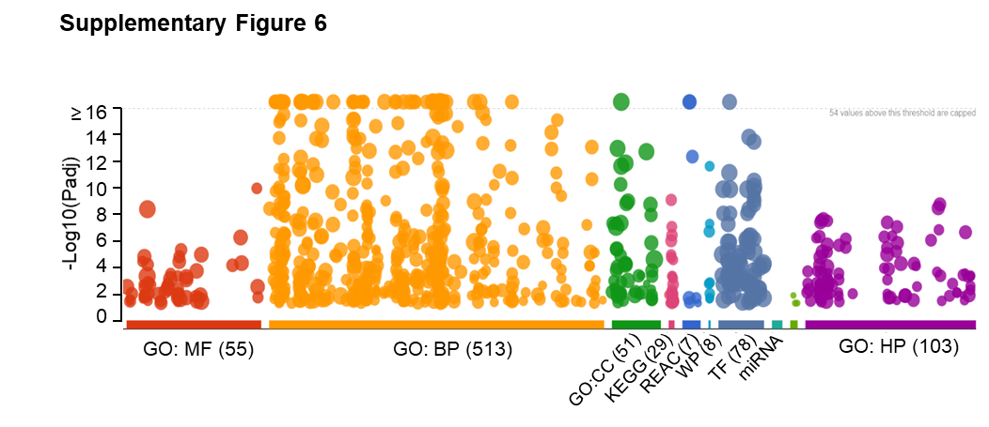
Supplementary Figure 6 Gene ontology (GO) analysis of 951 genes that are specifically expressed in macrophages. GO (gene oncology) analysis was performed using g-Profiler software. Of them, 78 genes encode transcription factors (TF).

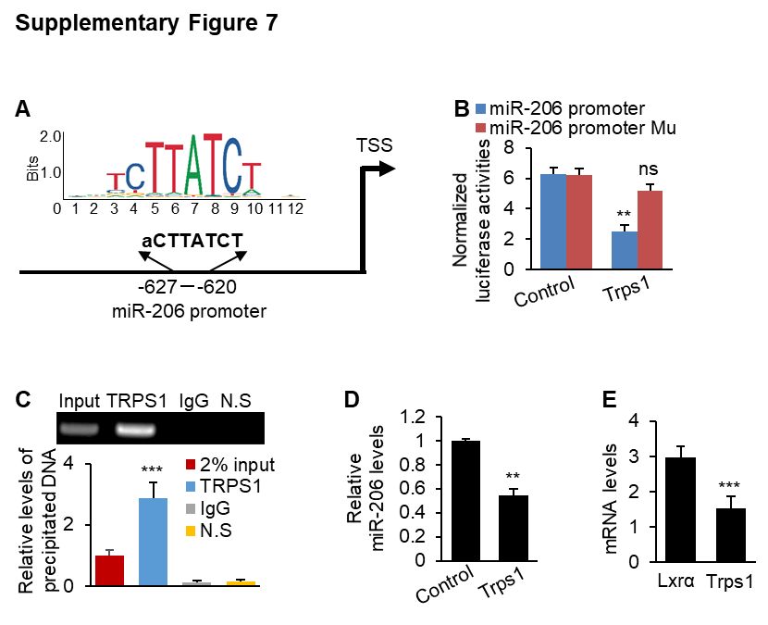
Supplementary Figure 7 TRPS1 repressed transcription of miR-206 by physically binding to miR-206 promoter. (A) A TRPS1 binding site within the promoter of miR-206. (B) Luciferase activity of the reporter construct containing miR-206 promoter with either wild-type or mutated TRPS1 binding site after pT3-EF1α (control) or pT3-Trps1 transfection. (C) ChIP assays were performed using genomic DNA isolated from macrophages; and the binding of TRPS1 to the endogenous promoter of miR-206 was detected using a specific TRPS1 antibody; N.S.: non-specific control, which is located 10 kb upstream of the predicted TRPS1 binding site. qPCR was used to quantify ChIP DNA. (D) Levels of miR-206 in macrophages treated with pT3-EF1α (control) or pT3-Trps1. (E) mRNA levels of Trps1 and Lxrα in macrophages, as revealed by single cell sequencing. Data represent mean ± SEM. **p < 0.01, **p < 0.001 and no: no significance (Fig. 7B-E: two-tailed student’s t test).
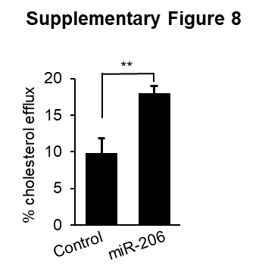

Supplementary Figure 8 miR-206 drove cholesterol efflux in human THP-1 macrophages. THP-1 macrophages were transfected with scramble or miR-206 mimic. 24 hours transfection, THP-1 cells were labelled with [³H]-cholesterol. Cholesterol efflux was calculated as a percent of media [³H]-cholesterol per total cell and media [³H]-cholesterol. Data represent mean ± SEM. **p < 0.01 (Fig. 8: two-tailed student’s t test).

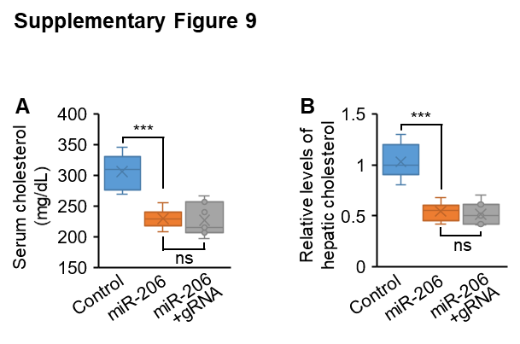

Supplementary Figure 9 Levels of hepatic and serum cholesterol in three groups of mice injected with AAV8-SCR (control, n=6), AAV8-miR-206 (n=6), or a combination of AAV8-miR-206 and AAV8-Cas9-sgLxrα (n=6). Data represent mean ± SEM. ***p < 0.001 (Fig. 9A-B: one-way ANOVA test).

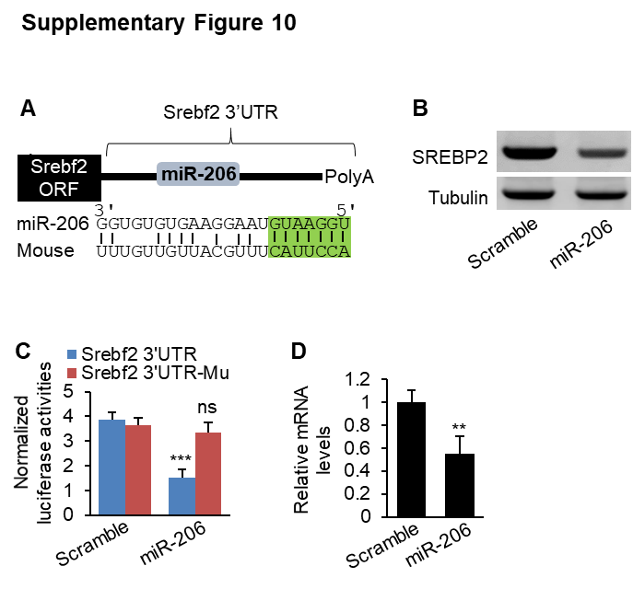

Supplementary Figure 10 Srebf2 is a direct target of miR-206. (A) Graphic representation of the conserved miR-206 binding site within the 3’UTR of Srebf2. Complementary sequence to the seed region of miR-206 within the 3’UTR of Srebf2 is highlighted in green. (B-C) mRNA levels of Srebf2 and protein levels of SREBP2 in murine primary hepatocytes transfected with AAV8-miR-206 or AAV8-SCR vector (control). (D) Luciferase activity of the reporter construct containing the 3’UTR of Srebf2 with either wild-type or mutated miR-206 binding site after treatment with AAV8-miR-206 or AAV8-SCR vector (control). Data represent mean ± SEM. **p < 0.01, ***p < 0.001 and ns: no significance (Fig. 10B-D: two-tailed student’s t test).

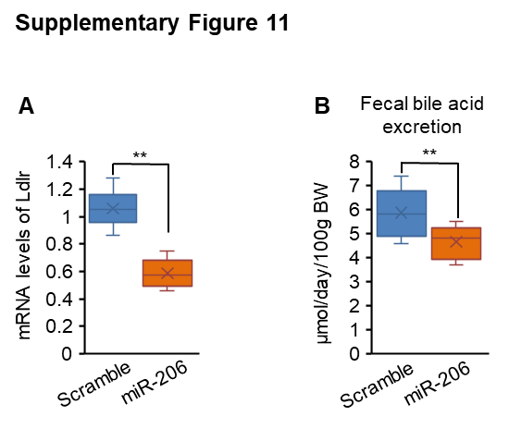

Supplementary Figure 11 Liver-specific expression of miR-206 reduced hepatic Ldlr and fecal bile acids excretion. (A) mRNA levels of Ldlr in livers of mice injected with AAV8-miR-206 or AAV8-SCR (control). (B) Levels of fecal bile acids excretion in two groups of mice. Data represent mean ± SEM. **p < 0.01 (Fig. 11A-B: two-tailed student’s t test).

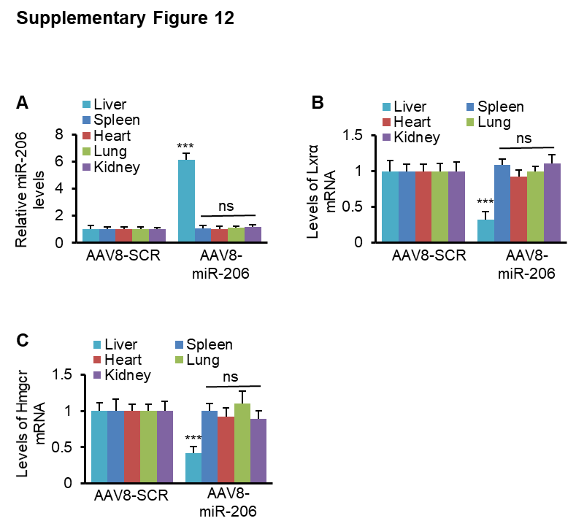

Supplementary Figure 12 Levels of miR-206 and mRNA levels of Hmgcr and Lxrα in different organs. (A-C) miR-206 levels and mRNA levels of Hmgcr and Lxrα in the liver, spleen, heart, lung and kidney of mice injected with AAV8-SCR (n=6) or AAV8-miR-206 (n=6). Eight-week-old male C57BL/6 mice maintained on the HFHC diet were injected with AAV8 virus at a dose of 5x10¹¹ genome copies/mice via tail vein. Eight weeks post injection, liver, spleen, heart, lung and kidney were collected for miRNA and gene expression analysis. Data represent mean ± SEM. ***p < 0.001 and ns: no significance (Fig. 12A-C: two-tailed student’s t test).

References
1. Xiong X, Kuang H, Ansari S, Liu T, Gong J, Wang S, Zhao X-Y, Ji Y, Li C, Guo L. Landscape of intercellular crosstalk in healthy and NASH liver revealed by single-cell secretome gene analysis. Molecular cell. 2019;75(3):644-60. e5.
2. Aalto-Setälä K, Fisher E, Chen X, Chajek-Shaul T, Hayek T, Zechner R, Walsh A, Ramakrishnan R, Ginsberg H, Breslow J. Mechanism of hypertriglyceridemia in human apolipoprotein (apo) CIII transgenic mice. Diminished very low density lipoprotein fractional catabolic rate associated with increased apo CIII and reduced apo E on the particles. J Clin Invest. 1992;90(5):1889-900.
3. Liu N, Chang CW, Steer CJ, Wang XW, Song G. MicroRNA-15a/16-1 prevents hepatocellular carcinoma by disrupting the communication between Kupffer cells and regulatory T cells. Gastroenterology. 2022;162(2):575-89.
4. Lewis BP, Burge CB, Bartel DP. Conserved seed pairing, often flanked by adenosines, indicates that thousands of human genes are microRNA targets. cell. 2005;120(1):15-20.
5. Farré D, Roset R, Huerta M, Adsuara JE, Roselló L, Albà MM, Messeguer X. Identification of patterns in biological sequences at the ALGGEN server: PROMO and MALGEN. Nucleic Acids Research. 2003;31(13):3651-3.
6. Schmittgen TD, Livak KJ. Analyzing real-time PCR data by the comparative C(T) method. Nature Protocol. 2008;3(6):1101-8. PubMed PMID: 18546601.
7. Zhang T, Duan J, Zhang L, Li Z, Steer CJ, Yan G, Song G. LXRα promotes hepatosteatosis in part through activation of microRNA‐378 transcription and inhibition of Ppargc1β expression. Hepatology. 2019;69(4):1488-503.
8. Post SM, de Crom R, van Haperen R, van Tol A, Princen HM. Increased fecal bile acid excretion in transgenic mice with elevated expression of human phospholipid transfer protein. Arteriosclerosis, Thrombosis, and Vascular Biology. 2003;23(5):892-7.

