Supporting Methods and Materials
Multiomics combined with machine learning defines unique molecular subtypes of cholangiocarcinoma and identifies TNK1 as a therapeutic target
Dong-Gi Mun^{1†}, Erik Jessen^{2†}, Jennifer L. Tomlinson³, Danielle Carlson³, Rohit Budhraja¹, Roberto Alva-Ruiz³, Amro Abdelrahman³, Ryan Watkins³, Lindsey Gregory³, Chantal McCabe², Chen Wang², Rondell P. Graham¹, Kathryn Woods^{4,5}, Martin Golkowski^{4,5}, Marshall Baker^{5,6}, Gregory J. Gores⁷, Sumera I. Ilyas^{7,8}, Caitlin Conboy⁹, Ellen L. Larson³, Jack W Sample³, Enis H. Ozmert³, Richard K. Kandasamy^{1,2,8}, Mitesh J. Borad¹⁰, Lewis Roberts⁷, Joshua Andersen⁵, Akhilesh Pandey^{1,11,12}*, Rory L. Smoot^{3,13}*

¹Department of Laboratory Medicine and Pathology, Mayo Clinic, Rochester, MN, USA
²Department of Quantitative Health Sciences, Mayo Clinic, Rochester, MN, USA
³Department of Surgery, Mayo Clinic, Rochester, MN, USA
⁴Department of Pharmacology and Toxicology, University of Utah, Salt Lake City, UT, USA
⁵Huntsman Cancer Institute, University of Utah, Salt Lake City, UT, USA
⁶Department of Surgery, University of Utah Health, UT, USA
⁷Division of Gastroenterology and Hepatology, Mayo Clinic, Rochester, MN, USA
⁸Department of Immunology, Mayo Clinic, Rochester, MN, USA
⁹Division of Hematology and Oncology, Mayo Clinic, Rochester, MN, USA
¹⁰Division of Hematology and Oncology, Mayo Clinic, Scottsdale, AZ, USA
¹¹Center for Individualized Medicine, Mayo Clinic, Rochester, MN, USA
¹²Manipal Academy of Higher Education, Manipal, 576104, Karnataka, India
¹³Department of Biochemistry and Molecular Biology, Mayo Clinic, Rochester, MN, USA
†These authors contributed equally to this work.
Address for Correspondence: Rory L. Smoot, M.D.
Associate Professor of Surgery, Biochemistry and Molecular Biology
Mayo Clinic
200 First Street SW, Rochester, MN 55905
Tel: 507 284 1529; Fax: 507 284 5196
Email: smoot.rory@mayo.edu
Akhilesh Pandey, M.D., Ph.D.
Professor, Department of Laboratory Medicine and Pathology
Mayo Clinic
200 First Street SW, Rochester, MN 55905
Tel: 507 293 9564
Email: pandey.akhilesh@mayo.edu

Supplementary Methods
All research was conducted in accordance with both the Declaration of Helsinki and Istanbul and was reviewed by the Mayo Clinic Institutional Review Board (approval numbers 20-001603 and 707-03). All subjects provided written consent for broad research participation including clinical data. Tissue collection was done prospectively and all participants provided written consent to IRB protocol 707-03.

Whole exome sequencing
Whole exome sequencing and transcriptome sequencing were performed at Mayo Clinic Genome Analysis Core. Paired-end libraries were prepared using 200 ng of genomic DNA following the manufacturer’s protocol using the Agilent Bravo liquid handler (Agilent Technologies, Santa Clara, CA). The concentration and size distribution of the completed libraries was determined using an Agilent Bioanalyzer DNA 1000 chip and Qubit fluorometry (Thermo Fisher Scientific, Waltham, MA). Whole exome capture was carried out using 750 ng of the prepped library following the protocol for Agilent’s SureSelect Human All Exon v5 + UTRs. The purified capture products are then amplified using the SureSelect Post-Capture Indexing forward and Index PCR reverse primers (Agilent) for 12 cycles. The concentration and size distribution of the completed captured libraries was determined on Qubit (Thermo Fisher Scientific) and Agilent Bioanalyzer DNA 1000 chip. Libraries were sequenced at an average coverage of ~80X following Illumina’s standard protocol following Illumina’s standard protocol on a S4 flow cell (Illumina, San Diego, CA). S4 flow cells are sequenced at 150 x 2 paired end reads using NovaSeq S4 sequencing kit, NovaSeq Control Software v1.8.0 and base-calling is analyzed using Illumina’s RTA version 3.4.4. For the purpose of analyzing exome sequencing data, we utilized Mayomics, a state-of-the art DNA sequencing secondary analysis pipeline based on the Cromwell workflow engine. The workflow includes steps for: alignment with accelerated bwa aligner, germline variant calling (Haplotyper/HaplotypeCaller), somatic variant calling (TNScope/mutect2 and strelka), Structural Variant calling (SV, manta), and copy number calling for exome (PatternCNV). The workflow supports somatic variant calling in paired mode and single-tumor mode. Unique Molecular Indexes (UMI) are also supported. QC metrics tools are run on both bam files and VCF. Variants are annotated using CAVA for transcript/protein level annotation as linked to a number of public databases (clinvar/hgmd/dbNSFP/dbSNP) using the bioR toolkit.

mRNA sequencing
TruSeq RNA Exome (Illumina, San Diego, CA) was used to generate sequencing libraries from RNA extracted from frozen tissue samples following the instructions of manufactures. Quality of extracted RNA was assessed using an RNA Integrity Number (RIN) and a DV200 value generated by the Agilent Fragment Analyzer (Agilent Technologies, Santa Clara, CA). Concentration was determined using a Qubit Fluorometer (Thermo Fisher Scientific, Waltham, MA). RNA Exome libraries are prepared per manufacturer’s instructions to generate cDNA libraries with an input of 50 ng. These cDNA libraries are then pooled 4-plex and normalized to 200 ng/sample and the transcriptome coding regions are captured. The final pools are assessed for quality using both Agilent Bioanalyzer (Agilent Technologies) and Qubit (Thermo Fisher Scientific). Libraries were sequenced at ~75 million fragment reads per sample (8 samples/lane) following Illumina’s standard protocol using the Illumina cBot and HiSeq 3000/4000 PE Cluster Kit (Illumina). The flow cells were sequenced as 100 x 2 paired end reads on an Illumina HiSeq 4000 using HiSeq 3000/4000 sequencing kit HD v3.4.0.38 collection software. Base-calling is performed using Illumina’s RTA version 2.7.7. For the purpose of analyzing RNA Sequencing samples, we utilized the comprehensive pipeline MAPRSeq for the alignment and analysis of RNA sequencing data. The pipeline is based on the GATK best practices workflow defined by the Broad Institute and is able to process frozen or FFPE technologies through alignment (Star), variant calling, quality control, feature assignment/counts, and fusion modules. MAPRSeq requires the RNA fasta files, a flag denoting the strandedness of the chemistry, and a technology specific tasks file maintained by Mayo Clinic.

Sample preparation for proteomics
Frozen tissues were pulverized using a cryoPREP device (CP02, Covaris) in TT05 tissue bag (520140, Covaris). The powder was lysed in lysis buffer (8 M urea in 20 mM HEPES, 1 mM sodium orthovanadate, 2.5 mM sodium pyrophosphate, 1 mM β-glycerophosphate) and sonicated using a tip sonicator (SFX550, Branson). Lysates were cleared by centrifugation at 20,000 xg for 10 min at 4 °C. Protein samples were reduced and alkylated using dithiothreitol (D9163, Sigma) and iodoacetamide (I1149, Sigma), respectively. Extracted proteins were diluted using 20 mM HEPES to a final concentration of 1 M urea and TPCK-treated trypsin (LS003744, Worthington) was added with 1:50 enzyme to protein ratio and kept for incubation at 37 °C for overnight. Digests were acidified and subjected to desalt using Sep-Pak C₁₈ cartridge (Waters, Milford, MA). Eluted peptides were lyophilized and subjected to tandem mass tag (A44520, Thermo Fisher Scientific) labeling following the manufacturer’s instruction. TMT-labeled peptides were fractionated using high pH reversed phase liquid chromatography on Dionex Ultimate 3000 liquid chromatography system (Thermo Scientific). Mobile phase A was composed of 20 mM ammonium formate in water and mobile phase A was composed of 20 mM ammonium formate in 80% ACN. Peptides were separated on a Xbridge column (50 cm x 4.6 mm, 3.5 µm, Waters) with a 2 hr gradient from 2 to 40% mobile phase B. A total of 96 fractions were collected and concatenated into 24 fractions. Around 5 µg equivalent of each fraction was set aside for global proteome analysis and the rest of each sample was concentrated into 12 fractions and dried prior to phosphopeptide enrichment. Each fraction was reconstituted in 100 µl of 80% ACN in 0.1% TFA and transferred to 96 well plate. IMAC-based phosphopeptide enrichment was performed using Fe(III)-NTA resin (G5496-60082, Agilent) on an AssayMap Bravo (Agilent Technologies, CA) platform following the manufacture instruction. For enrichment of phosphotyrosine peptides, immunoaffinity purification was performed. Lyophilized peptides were reconstituted in IAP buffer (50 mM MOPS, 10 mM sodium phosphate, 50 mM NaCl) followed by incubation with anti-phosphotyrosine antibody beads (pY1000, Cell Signaling Technology) at 4 °C for 1 hr. After incubation, phosphotyrosine peptides and the pY1000 antibody complex were washed three times with IAP buffer and then twice with water. Elution of phosphopeptides was performed with 0.15% TFA. Eluents were desalted with C₁₈ StageTips followed by vacuum drying for LC-MS/MS analysis.
For label-free kinome profiling, we used our in-house developed kinobead platform as described previously (1-3). Briefly, frozen human and PDX tissue samples were suspended in modified RIPA buffer (50 mM Tris-HCl, 150 mM NaCl, 1% NP-40 (v/v), 0.25% Na-deoxycholate (w/v), 1 mM EDTA, 10 mM NaF, 5% glycerol (v/v), pH 7.8) containing HALT protease and phosphatase inhibitor cocktail (100x, Thermo Fisher Scientific, Waltham, MA), as well as 1 mM phenylmethylsulfonyl fluoride (Sigma). Tissues were homogenized on ice using a hand-held homogenizer and clarified by centrifugation at 4°C and 21,000 x g for 20 min. 40 µl of a 50% slurry of kinobead mixture in 20% aq. ethanol were prepared for each kinase enrichment experiment. The beads were washed twice with 400 µl modified RIPA buffer and 600 µg of protein in lysate was added. The mixture was incubated on a tube rotator for 3 hr at 4°C and then the beads were pelleted rapidly at 2000 xg on a benchtop centrifuge. After removal of the supernatant, the beads were rapidly washed twice with 400 µl of ice-cold mod. RIPA buffer and three times with 400 µl ice-cold tris-buffered saline (TBS, 50 mM tris, 150 mM NaCl, pH 7.8) to remove detergents. 100 µl of freshly prepared denaturing buffer (8M urea, 100 mM Tris, pH 8.5) containing 5 mM tris(2-carboxyethyl)phosphine hydrochloride and 10 mM chloroacetamide were added and the slurry agitated on a thermomixer at 37 °C and 1400 rpm for 30 min. The mixture was diluted 2-fold with 100 mM triethylamine bicarbonate, the pH adjusted to 8-9 by addition 1 N aq. NaOH. After that, 2 µg LysC were added, and the mixture incubated on a thermomixer at 1400 rpm at 37°C for 2 hr. Then, the mixture was diluted another 2-fold with 100 mM TEAB, 2 µg MS-grade trypsin (Thermo Fisher Scientific,) were added, and the mixture incubated on a thermomixer at 1400 rpm at 37°C overnight. After that, formic acid were added (1.5% final) and peptides were desalted using C₁₈ StageTips according to the published protocol (4).

Mass spectrometry data acquisition
LC-MS/MS data of TMT-labeled peptides were acquired on Orbitrap Fusion Eclipse mass spectrometer (Thermo Scientific, San Jose, CA) coupled to Ultimate 3000 liquid chromatography system (Thermo Scientific, San Jose, CA). The peptides were loaded onto a trap column (PepMap C₁₈, 2cm x 100µm, 100 Å) at a flow rate of 20 µl/min and separated on EASY-Spray column (PepMap RSCL C₁₈, 50 cm x 75 µm, 100 Å) at a flow rate of 300 nL/min. Solvent A (0.1% formic acid in water) and solvent B (0.1% formic acid in acetonitrile) were used for generating gradient (3-40%) over 135 min. Mass spectrometry data were acquired in data-dependent acquisition mode with cycle time of 2 sec. MS scan and MS/MS scan were acquired with resolution of 120,000 and 30,000, respectively. Precursor ions were isolated under 0.7 m/z isolation width and fragmented with normalized collision energy of 35. For label-free protein quantification for kinome profling, peptide samples (200 ng) were analyzed on a timsTOF Pro 2 mass spectrometer connected to nanoElute 2 liquid chromatography system (Bruker, Billerica, MA). Peptides were separated in on an analytical column (PepSep column, 15 cm x 150 µm) packed with 1.5 µm diameter C₁₈ beads. Solvent A (0.1% formic acid in water) and solvent B (0.1% formic acid in acetonitrile) were used for generating gradient (5-30%) over 45 min at flow rates of 0.5 µL/min. MS data were acquired in data-independent acquisition mode using the diaPASEF method with ion mobility range at 0.6-1.4 Vscm⁻² (5).

Mass spectrometric data analysis
The raw mass spectrometry data from TMT experiments were searched using Andromeda in MaxQuant software suite (version 1.6.17.0) against the human UniProt protein database. TMT on lysine and peptide n-terminal and cysteine carbamidomethylation were set as fixed modifications and N-terminal acetylation and methionine oxidation were set as variable modifications. For processing data of phosphorylated peptides, phosphorylation on serine, threonine and tyrosine were additionally considered as set as variable modifications. Search was performed with a false discovery rate of 1% for both peptides and proteins using a target-decoy approach. Peptide length was to at least 7 amino acids long and MS2 match tolerance was set to 0.02 Da. Enzyme specificity was set to trypsin and a maximum of two missed cleavages were allowed. For label-free experiments, MS raw files were analyzed using DIA-NN (v.1.9.1) in a library-free mode (6). Both the human and mouse protein database downloaded from UniProt (UP000005640 and UP000000589) were used for DIA-NN analysis. Briefly, DIA-NN search parameters were as follows. Reannotate: enabled; FASTA digest for library-free search/library generation: enabled; deep learning-based spectra, RTs, and IMs prediction: enabled; protease: Trypsin/P; missed cleavages: 1; number of variable modifications: 0; N-term M excision: enabled; Cys carbamidomethylation: enabled; peptide length range: 7-30; precursor charge range: 1-4; precursor m/z range: 300 - 1800; fragment ion m/z range: 200-1800; generate spectral library: enabled; quantities matrices: enabled; precursor FDR: 1 %; use isotopologues: enabled; MBR: enabled; no shared spectra: enabled; protein inference: Genes; neural network classifier: Single pass mode; quantification strategy: Robust LC (high precision); cross-run normalization: RT-dependent. DIA-NN raw output files were loaded into Perseus (v2.0.10.0), log2 transformed, median-normalized, and missing values were imputed (width: 0.2; downshift 1.8) (7). Protein could be classified as both human and mouse were removed from downstream analyses, and proteins unique to human proteins retained. Differential expression analysis of proteomics data between human NTL tissues, human tumor tissues, and PDX tumor tissues was performed using two-tailed two sample Student’s t-tests with Benjamini-Hochberg correction for multiple hypothesis testing (FDR = 0.05, N = 5).

Comparison, human CCA and PDX tumor
To determine if proteome and kinome expression were conserved between human and PDX tumors, we performed Pearson correlation of the log2 MS intensity fold-changes between human NTL and human tumors, and human NTL and PDX of proteins (global proteome profiling) and kinases (kinome profiling). Only the proteins and kinases that were significantly differentially expressed between both human and PDX samples were used. To determine if molecular pathways were conserved between human and PDX tumors, we applied GSEA with GOBP pathways, as previously described, and performed Pearson correlation of normalized enrichment score (NES) values as described above (8, 9).

Multiomics data integration
Preprocessing
The main goals of data preprocessing were to reduce variation contributed by technical aspects and batch effects; and facilitate equal contribution of each data modality. Joint dimension reduction was performed to parse dimensions of variation in the data. Thus, normalization is necessary to reduce non-biological sources of variation. Normalization methods are modality specific. Copy number variation was normalized by identifying batches of samples within the cohort with similar exon coverage behavior. Batches likely represent the combined effects of similar batch and technical processing. The corresponding CNV-normal samples for each batch were then used to create the exon cover behavior distributions used to identify outlier CNV events, resulting in increased signal-to-noise over distributions generated using all samples. RNA-sequencing was normalized by calculating gene counts as FPKM to account for differences in total sequencing depth. Batch effect subtraction was performed using ComBat. The distributions of FPKM values were then normalized using quantile normalization. After normalization, each modality was transformed and filtered to facilitate equal contribution when input into the joint dimension reduction model. The jDR methods work best with Gaussian distributions, so transformation of normalized-FPKM RNA-seq counts to log₁₀+1e⁻⁴ was performed to shift the distribution from right-skewed to Gaussian. Additionally, the number of features for each modality are ideally within an order of magnitude else there are disproportionate contributions of modalities to the variance. Variance filtering is performed to remove features of low variance from modalities with features numbering greater than an order of magnitude from the modality with the lowest number of features.
Modeling
Joint dimension reduction was performed using the MOFA methodology. MOFA integrates the different data modalities and parses out dimensions of variability in the data, called factors. The contribution of each data modality to the variance explained by a factor is quantified as weights from a loading analysis. To determine the number of viable factors within the dataset, a randomized dataset was run as a unique data modality. Once the randomized dataset contributed the most variation to a factor, that factor and all subsequent factors were disregarded. Default settings were used in model creation except to remove scaling between data modalities of the weights resulting from the feature loading analyses, and to pre-scale the value ranges of the data modalities. The modified settings were introduced to allow for more accurate comparison of feature loading weights between data modalities since the minimum and maximum values, which are dependent on a modalities’ value range, are no longer set to the same range.
Analysis
Analyzing the factors, dimensions of variation in the integrated data, requires correlation of factor values to clinical metadata to make biological inferences. Hierarchical all-against-all (HAllA) clustering of both quantitative and categorical clinical variables to the factor values allows biological questions to be connected to features driving factor-sample distributions. The advantage of using HAllA is the ability to take in different data types, and form clusters of similarly behaving clinical and factor variables. Once a clinical variable of interest has an associated factor, the contributing data modalities and features can be further analyzed using joint pathway analysis or kinase enrichment inference.

PDX generation and treatment
In patients with informed consent, resected tumor tissue was processed and implanted into the flanks of NOD/SCID mice as previously described and animal studies conducted and reported in accordance with ARRIVE guidelines (10, 11). Patient inclusion criteria included a histologic diagnosis of cholangiocarcinoma, age above 18, and included both male and female patients. Once tumors reached approximately 125mm³ treatment was initiated with vehicle or the TNK1 inhibitor TP-5801 (MedChemExpress) at 20mg/kg daily via gavage. In separate preclinical PDX trials, we also randomized into two treatment groups of either vehicle or combination of Gemcitabine (at 4mg/kg via intraperitoneal injection) and Cisplatin (at 1mg/kg via intraperitoneal injection). Tumors were measured using calipers every third day and tumor volume calculated. For the PDX in vivo testing, which involved repeated measurement experiments, a two-way ANOVA model or mixed-effects model, in cases of missing values, were employed as appropriate. The adjusted P-values were corrected for multiple comparisons using Bonferroni hypothesis testing.
We calculated the Median Inhibitory Index (MEI) to evaluate the effects of Gemcitabine and Cisplatin. This index reflects how much the median of the delta in tumor volume changed with the combination treatment of Gemcitabine and Cisplatin compared to the vehicle treatment on the last day of the preclinical PDX trials. A MEI of 0 indicates that the median of the delta in tumor volume for the treatment group is similar to that of the vehicle group, suggesting no inhibitory effect. A MEI greater than 0 indicates that the median of the delta in tumor volume for the treatment group is larger than that of the vehicle group, suggesting a tumor growth effect and indicating a resistant model. A MEI lower than 0 but greater than -0.4 (the sensitivity threshold) suggests a minimal change in the median of the delta in tumor volume for the treatment group compared to the vehicle group. This indicates a minimal inhibitory effect, and the PDX model is considered resistant to the treatment. A MEI less than or equal to -0.4 but greater than -1 indicates a considerable decrease in the median of the delta in tumor volume in the treatment group compared to the vehicle group, demonstrating an inhibitory effect and a sensitive PDX model. Lastly, a MEI less than or equal to -1.0 signifies that the median of the delta in tumor volume in the treatment group has decreased below the starting points of the vehicle group, indicating a tumor shrinkage effect and confirming that the PDX model is sensitive to the treatment.

Mouse serum analysis
Around 500 µL of whole blood was collected at time of euthanasia. Blood was centrifuged at 13,000 g for 15 minutes in a refrigerated centrifuge. 100 µL of the resulting supernatant, the serum, was placed in the Vetscan Mammalian liver profile rotor for analyzation in the Abaxis Vetscan Vs2 Chemistry Blood Analyzer. The values analyzed included: Alanine Aminotransferase (ALT), Albumin (ALB), Alkaline Phosphatase (ALP), Bile Acids (BA), Total Bilirubin (TBIL), Total Cholesterol (CHOL), Gamma Glutamyl Transferase (GGT), and Blood Urea Nitrogen (BUN).

Dose response (IC₅₀) curves
CCA cells were seeded at equal densities in 96-well plates. At optimal density, cells were treated at fixed series of decreasing drug concentrations in triplicates for 48 hours. Cell viability was measured using the CellTiter-Glo Luminescent Cell Viability Assay (Promega) according to the manufacturer’s instructions. ATP chemiluminescence was measured using a plate reader, and cell viability was normalized to vehicle controls. IC₅₀ values were calculated using nonlinear regression and a four-parameter logistic curve fit in GraphPad Prism (GraphPad Software, San Diego, CA).

Cell viability, migration and colony formation assays
The human CCA cell lines (HuCCT-1 and RBE) were cultured in DMEM supplemented with 10% fetal bovine serum with penicillin/streptomycin. All cultures were maintained in a 5% CO₂ air-humidified atmosphere at 37 °C. Cell death was assessed using Hoechst 33342 (Invitrogen) and propidium iodide (PI) (Sigma) staining. Cells were seeded at equal density in 48-well plates and treated as indicated. After the desired time points. Hoechst (5 µg/mL) and PI (1 µg/mL) were added directly to the culture medium and incubated at 37°C for 30 minutes. Cells were imaged using a Nexcelom Celigo Imaging Cytometer, and cell death was quantified as the percentage of PI positive cells relative to Hoechst positive cells.
Cell migration was assessed using a standard scratch (wound healing) assay. Cells were seeded in 6-well plates and grown to near confluence. A linear scratch was made using a sterile 200 µL pipette tip, and the wells were washed twice with PBS to remove debris. Fresh medium containing the drug or vehicle was added and brightfield images were acquired at 0, 24, and 48 hours. Scratch area was measured using ImageJ, and migration was quantified as the percentage of wound closure relative to time 0. Each condition was performed in triplicate.
For the colony formation assay, 500 cells/well were seeded in 6-well plates and allowed to adhere overnight. Cells were then treated with TP-5801 or vehicle and incubated under standard conditions for 7 days. Wells were washed with PBS, fixed in 4% paraformaldehyde for 30 minutes, and stained with 0.05% crystal violet for 15 minutes. Colonies were quantified using ImageJ and normalized to vehicle control.

Immunoblot Analysis
HuCCT-1 cells were transfected with siTNK1 or control siRNA using Lipofectamine RNAiMAX Transfection Reagent (Thermo Fisher Scientific, 13778075) according to the manufacturer's protocol. After 72 hours post-transfection, cells were lysed in ice-cold RIPA buffer supplemented with protease inhibitor cocktail (Roche). Proteins were resolved by SDS-PAGE using 10% polyacrylamide gels and transferred onto polyvinylidene difluoride (PVDF) membranes (Millipore). The membranes were incubated with the following primary antibodies and imaged using ECL Prime Western Blotting Reagent (Cytivia, RPN2236): anti-TNK1 (Cell Signaling Technology, Clone C44F9, 4570T) and anti-β-actin (Santa Cruz Biotechnology, sc-47778).

Cell proliferation
HuCCT-1 and RBE cells were seeded in 96-well plates at a density of 3000 cells/well. Cells were transfected with either control siRNA or siTNK1 as mentioned above. Cell proliferation was assessed at 0, 24, 48, 72 and 96 hours post-transfection using the CellTiter-Glo Luminescent Cell Viability Assay (Promega, G7570). Luminescence was measured using a Biotek Synergy H1 microplate reader. Relative proliferation rates were calculated by normalizing luminescence values to the 0 hour time point for each treatment group.
Figure S1. Generation of proteomics data. (A) Venn diagrams comparing quantified proteins and phosphorylated peptides. (B) A PCA plot of global proteomics data. (C) A heatmap of global proteomics data. (D) A PCA plot of phosphoproteomics data. (E) A heatmap of phosphoproteomics data.
Figure S2. Representative enriched pathways. (A) ECM receptor (B) Platelet activation pathway.

Figure S3. Multiomics factor analysis. (A) Proportion of variance for individual factors explained by each omics data (view1 somatic mutations, view2 RNA expression, view3 Total Protein, view4 Phosphoprotein). (B) A cumulative proportion of total variance for each omics data. (C) Top 10 RNA, Protein, and Phosphoprotein features by absolute loading weights for factors 1, 2, and 3. Directionally of feature value and factor value correlation denoted by + or – symbols.
Figure S4. Molecular landscape of clinically relevant alterations. Heatmap of Z-scores (red increased) of features (row annotation; RNA: green, Protein: blue, Phosphoprotein: red) significantly associated with the presence of a (A) TP53 mutation, (B) FGFR2 fusion, (C) ARID1A mutation, and (D) BAP1 mutation (column annotation; Mutation/Fusion: red, No mutation/No fusion: blue).

Figure S5. Schematic for generating SVM classification model. (A) A radial SVM model was trained using the cohort-relative Z-score derived from multiomics featured in the Mayo Clinic cohort of 43 patients. (B) Mapping of the four subtypes from Chinese cohort onto three clusters of our cohort.

Figure S6. Cellular proliferation and apoptosis assays of PDX model. (A) The immunohistochemistry staining results (2.5X and 20X) indicate that the mice treated with the TNK1 inhibitor (TP-5801) exhibited lower levels of tumor cell proliferation, as evidenced by KI-67 staining, increase in apoptotic activity, as shown by Cleaved Caspase-3 staining, in comparison to the vehicle group. (B) Quantitative analysis showed that the average number of KI-67 positive cells was significantly higher in the vehicle group compared to the TP-5801 treated group in PDX115. (C) The average number of cleaved Caspase-3 positive cells was significantly greater in the TP-5801 group than in the vehicle group within the same cluster. (D) Evaluation of liver and kidney function of PDX115 under TP-5801 treatment. (E) Measured delta in mice weights of PDX115 during the TP-5801 study. *, p-value ≤ 0.05; **, p-value ≤ 0.01

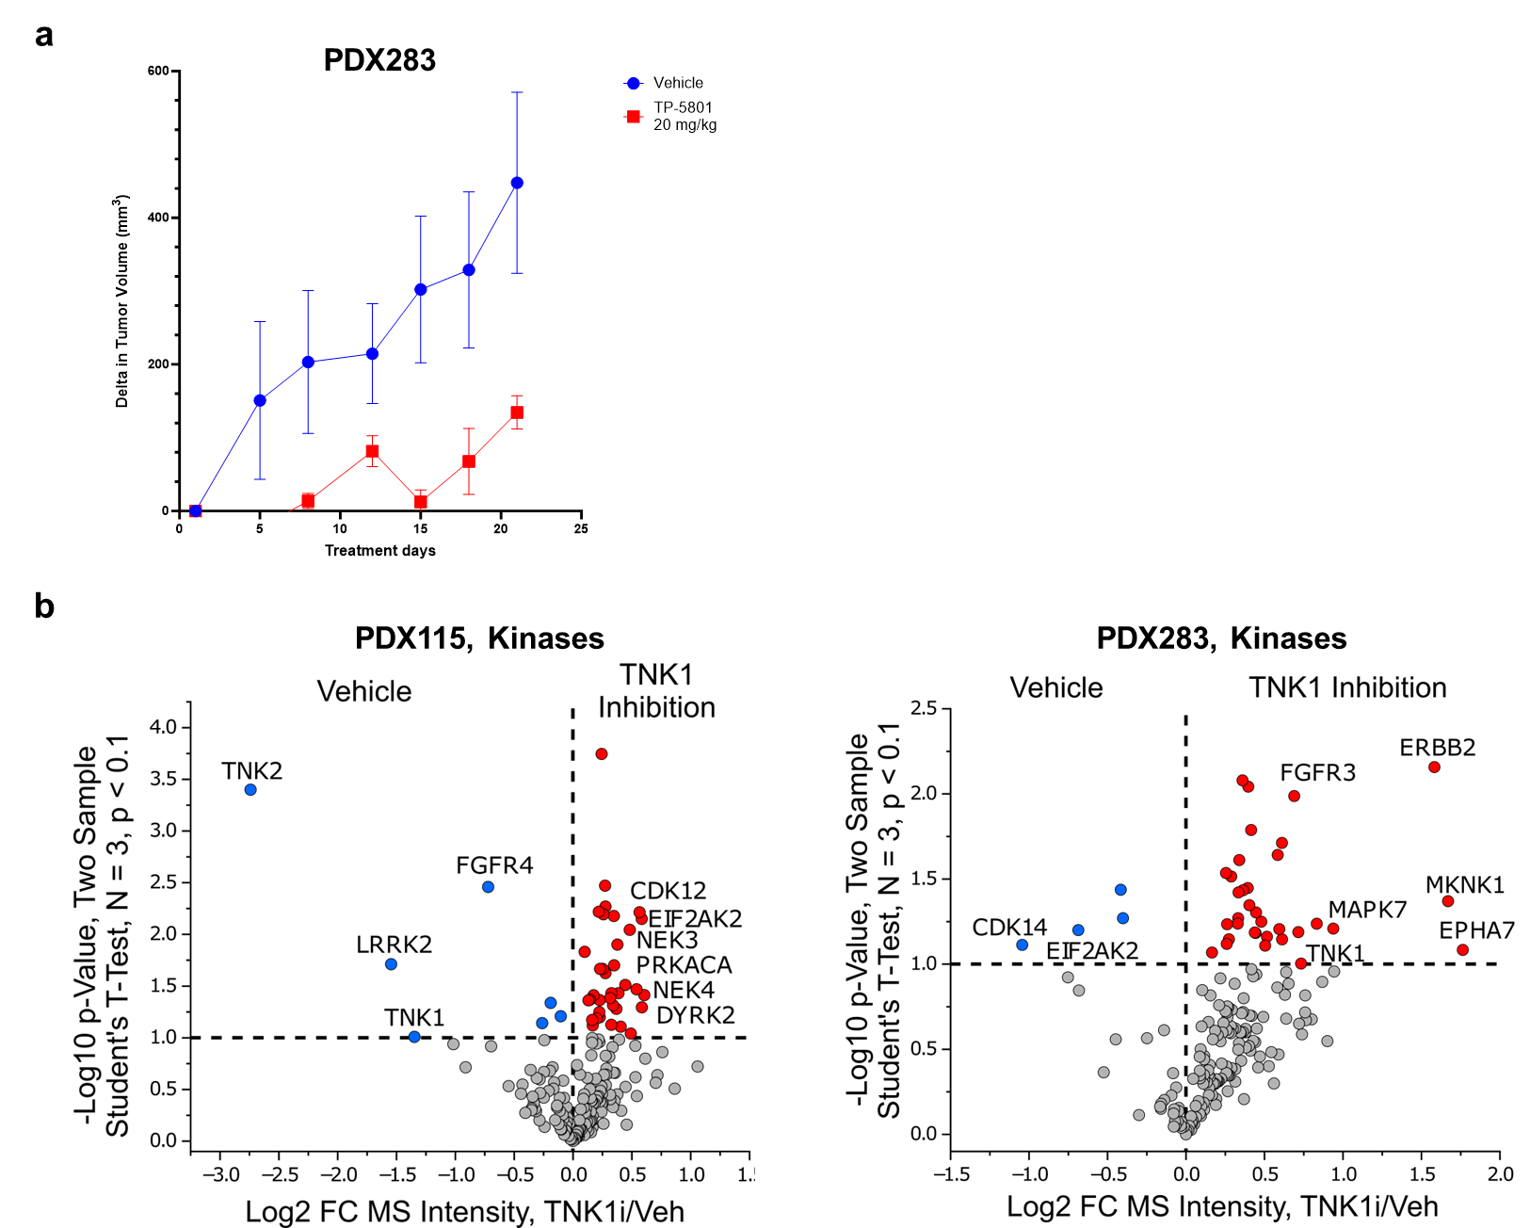
Figure S7. Effect of TNK1 inhibitor treatment on PDX models. (A) TNK1 inhibitor treatment in an additional PDX model. Delta tumor size plot for the TNK1 inhibitor (TP-5801) for PDX283 mapped to Cluster 2. (B) Kinome profiling reveals changes of kinases upon TNK1 inhibition.

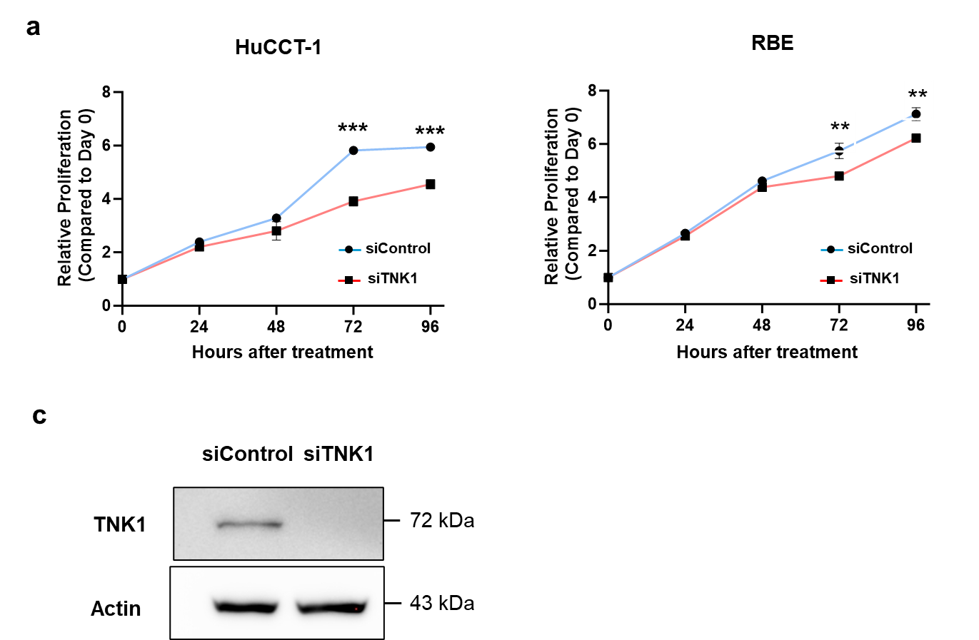
Figure S8. Evaluation of effect of TNK1 knockdown in CCA cells. (A) Proliferation assay of siControl and siTNK1 transfected HuCCT-1 and RBE cells over 96 hours. Relative proliferation rates were calculated by normalizing luminescence values to the 0 hour time point for each treatment group. **, p-value ≤ 0.01; ***, p-value ≤ 0.001. (B) Immunoblot analysis of TNK1 in HuCCT-1 cells under siControl and siTNK1 conditions.

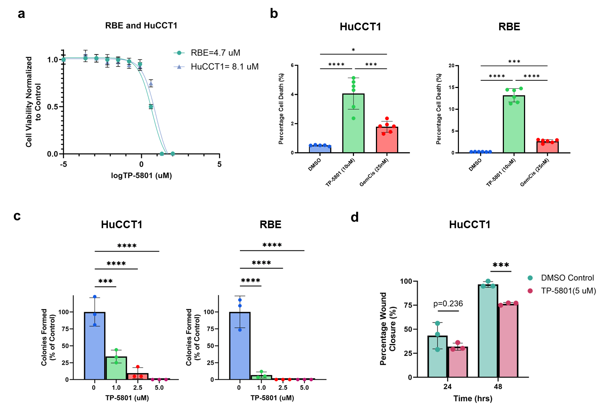
Figure S9. Evaluation of TNK1 inhibition by TP-5801 treatment on cellular functions. (A) Viability dose-response curve and calculated IC₅₀ of HuCCT-1 and RBE cells treated with TP-5801. (B) Percentage of cell death in HuCCT-1 and RBE cells following treatment with vehicle, TP-5801 or gemcitabine/cisplatin. (C) Colony formation of HuCCT-1 and RBE cells upon TP-5801 treatment. (D) Percentage of wound closure measured by wound healing assay of HuCCT-1 cells. *, p-value ≤ 0.05; **, p-value ≤ 0.01; ***, p-value ≤ 0.001; ****, p-value ≤ 0.0001

List of Supplementary Tables
Table S1. Patient cohort demographics and baseline characteristics
Table S2. Clinical information of each patient used for the genomics and proteomics study
Table S3. List of identified somatic mutations from CCA patients
Table S4. List of identified fusion genes from CCA patients
Table S5. List of proteins identified from global proteomics along with their relative abundances in each sample
Table S6. List of phosphorylation sites identified from phosphoproteomics along with their relative abundances in each sample
Table S7. List of kinases with upregulated phosphorylation in CCA patients
Table S8. Pathway analysis of the molecular features associated with each cluster
Table S9. Somatic mutations involved in each cluster
Table S10. Molecules significantly associated with overall survival identified using HAllA
Table S11. Pathway analysis of the molecules associated with overall survival
Table S12. Enriched kinases of molecules significantly associated with overall survival
Table S13. Molecules significantly associated with lymph node positivity identified using HAllA
Table S14. Pathway analysis of the molecules associated with lymph node positivity
Table S15. Pathways significantly associated with mutations using HAllA
Table S16. Classification of PDX models using SVM model

REFERENCES
1. Golkowski M, Vidadala VN, Lau HT, Shoemaker A, Shimizu-Albergine M, Beavo J, Maly DJ, et al. Kinobead/LC-MS Phosphokinome Profiling Enables Rapid Analyses of Kinase-Dependent Cell Signaling Networks. J Proteome Res 2020;19:1235-1247.
2. Golkowski M, Lau HT, Chan M, Kenerson H, Vidadala VN, Shoemaker A, Maly DJ, et al. Pharmacoproteomics Identifies Kinase Pathways that Drive the Epithelial-Mesenchymal Transition and Drug Resistance in Hepatocellular Carcinoma. Cell Syst 2020;11:196-207 e197.
3. Golkowski M, Lius A, Sapre T, Lau HT, Moreno T, Maly DJ, Ong SE. Multiplexed kinase interactome profiling quantifies cellular network activity and plasticity. Mol Cell 2023;83:803-818 e808.
4. Rappsilber J, Mann M, Ishihama Y. Protocol for micro-purification, enrichment, pre-fractionation and storage of peptides for proteomics using StageTips. Nat Protoc 2007;2:1896-1906.
5. Meier F, Brunner AD, Frank M, Ha A, Bludau I, Voytik E, Kaspar-Schoenefeld S, et al. diaPASEF: parallel accumulation-serial fragmentation combined with data-independent acquisition. Nat Methods 2020;17:1229-1236.
6. Demichev V, Messner CB, Vernardis SI, Lilley KS, Ralser M. DIA-NN: neural networks and interference correction enable deep proteome coverage in high throughput. Nat Methods 2020;17:41-44.
7. Tyanova S, Temu T, Sinitcyn P, Carlson A, Hein MY, Geiger T, Mann M, et al. The Perseus computational platform for comprehensive analysis of (prote)omics data. Nat Methods 2016;13:731-740.
8. Krug K, Mertins P, Zhang B, Hornbeck P, Raju R, Ahmad R, Szucs M, et al. A Curated Resource for Phosphosite-specific Signature Analysis. Mol Cell Proteomics 2019;18:576-593.
9. Subramanian A, Tamayo P, Mootha VK, Mukherjee S, Ebert BL, Gillette MA, Paulovich A, et al. Gene set enrichment analysis: a knowledge-based approach for interpreting genome-wide expression profiles. Proc Natl Acad Sci U S A 2005;102:15545-15550.
10. Leiting JL, Murphy SJ, Bergquist JR, Hernandez MC, Ivanics T, Abdelrahman AM, Yang L, et al. Biliary tract cancer patient-derived xenografts: Surgeon impact on individualized medicine. JHEP Rep 2020;2:100068.
11. Percie du Sert N, Hurst V, Ahluwalia A, Alam S, Avey MT, Baker M, Browne WJ, et al. The ARRIVE guidelines 2.0: Updated guidelines for reporting animal research. PLoS Biol 2020;18:e3000410.

