Supplemental Material

Table of Contents

Table S1. Demographic and Clinical Characteristics of the Entire Cohort and Stratified by Quartiles of Angiopoietin-1 Delta

Table S2. Demographic and Clinical Characteristics of the Entire Cohort and Stratified by Quartiles of Angiopoietin-2 Delta

Table S3. Angiopoietin Concentrations in Participants

Table S4. Associations Between Angiopoietin Quartiles and All-Cause Mortality

Table S5. Associations Between Angiopoietin Quartiles and CKD Progression (Death as Competing Event）

Table S6. Associations Between Angiopoietin Quartiles and Heart Failure (Death as Competing Event)

Table S7. Mediation Analysis to Assess the Effect of Angpt-1 and Angpt-2 on the Relationship Between AKI and Outcomes

Table S8: Summary of Human Clinical Trials Intervening on the Angiopoietin Pathway
Figure S1. Study Flow Diagram
Figure S2. Spline Plots Between Angiopoietins and Outcomes
Figure S3. One Single Nucleotide Polymorphism Was Associated with Angiopoietin-2 Concentrations
Figure S4. Distribution of Angiopoietin-2 Concentrations in Plasma and Allele Count of TMPRSS4 Variant rs611475
Figure S5. Conceptual Diagram of Mediation Analysis
Figure S6: Regional Association Plot

References
1. Campochiaro PA, Sophie R, Tolentino M, et al. Treatment of diabetic macular edema with an inhibitor of vascular endothelial-protein tyrosine phosphatase that activates Tie2. Ophthalmology. 2015;122(3):545-554.
2. Campochiaro PA, Khanani A, Singer M, et al. Enhanced Benefit in Diabetic Macular Edema from AKB-9778 Tie2 Activation Combined with Vascular Endothelial Growth Factor Suppression. Ophthalmology. 2016;123(8):1722-1730.
3. Pharmaceuticals R. Anti-vasculaR Endothelial Growth Factor plUs Anti-angiopoietin 2 in Fixed comBination therapY: Evaluation for the Treatment of Diabetic Macular Edema (RUBY). https://clinicaltrials.gov/ct2/show/study/NCT02712008. Published 2018. Accessed November 11, 2020.
4. pharmaceuticals P. Safety And PK Study Of CVX-060 In Patients With Advanced Solid Tumors. https://clinicaltrials.gov/ct2/show/NCT00879684. Published 2015. Accessed November 11, 2020.
5. Hyman DM, Rizvi N, Natale R, et al. Phase I Study of MEDI3617, a Selective Angiopoietin-2 Inhibitor Alone and Combined with Carboplatin/Paclitaxel, Paclitaxel, or Bevacizumab for Advanced Solid Tumors. Clinical cancer research : an official journal of the American Association for Cancer Research. 2018;24(12):2749-2757.

Table S1. Demographic and Clinical Characteristics of the Entire Cohort and Stratified by Quartiles of Angiopoietin-1 Delta
Participant Characteristics | All  (N = 1503) | Quartiles of Angpt-1 Delta |  |  |  | P value
Participant Characteristics | All  (N = 1503) | Quartile 1  Range (pg/mL): -37437 to -1245  (n = 375) | Quartile 2  -1238 to 692  (n = 376) | Quartile 3  694 to 3319 (n = 376) | Quartile 4  3322 to 26795  (n = 376) | P value
Age | 65.8 (56.6, 73.9) | 65.5 (56.8, 74.2) | 65.3 (55.9, 74.5) | 66.75 (57.25, 74.1) | 65.8 (56.55, 73.3) | 0.884
Female sex | 555 (37%) | 143 (38%) | 131 (35%) | 131 (35%) | 150 (40%) | 0.382
Black race | 196 (13%) | 49 (13%) | 41 (11%) | 52 (14%) | 54 (14%) | 0.513
Hispanic/Latino ethnicity | 37 (2%) | 7 (2%) | 13 (3%) | 7 (2%) | 10 (3%) | 0.435
Current or former smoker | 872 (58%) | 210 (56%) | 233 (62%) | 230 (62%) | 199 (53%) | 0.025
Pre-admission COPD | 329 (22%) | 76 (20%) | 85 (23%) | 81 (22%) | 87 (23%) | 0.809
Pre-admission CVD | 680 (45%) | 170 (45%) | 185 (49%) | 165 (44%) | 160 (43%) | 0.258
Pre-admission CKD | 594 (40%) | 149 (40%) | 146 (39%) | 166 (44%) | 133 (35%) | 0.104
Pre-admission Diabetes | 642 (43%) | 174 (46%) | 161 (43%) | 158 (42%) | 149 (40%) | 0.305
Pre-admission Hypertension | 1118 (74%) | 282 (75%) | 274 (73%) | 281 (75%) | 281 (75%) | 0.841
Pre-admission Heart Failure | 319 (21%) | 79 (21%) | 73 (19%) | 83 (22%) | 84 (22%) | 0.648
Variables at index hospitalization
Sepsis | 143 (10%) | 27 (7%) | 40 (11%) | 41 (11%) | 35 (9%) | 0.290
UACR , mg/g | 31.96 (12.5, 88.35) | 30.47 (11.46, 85.85) | 32.78 (13.33, 85.55) | 40.28 (14.39, 103.04) | 28.24 (12.04, 80.8) | 0.108
AKI | 746 (50%) | 192 (51%) | 196 (52%) | 180 (48%) | 178 (47%) | 0.464
AKI stage No AKI | 757 (50%) | 183 (49%) | 180 (48%) | 196 (52%) | 198 (53%) | 0.691
Stage 1 | 539 (36%) | 142 (38%) | 145 (39%) | 131 (35%) | 121 (32%) | 0.691
Stage 2 | 114 (8%) | 31 (8%) | 29 (8%) | 25 (7%) | 29 (8%) | 0.691
Stage 3 | 93 (6%) | 19 (5%) | 22 (6%) | 24 (6%) | 28 (7%) | 0.691
Creatinine, mg/dL | 1.4 (1.02, 1.95) | 1.41 (1, 1.94) | 1.4 (1.03, 1.89) | 1.45 (1.06, 2.11) | 1.3 (1, 1.9) | 0.161
CRP, mg/L | 99.96 (30.17, 197.55) | 72.63 (18.31, 177.47) | 110.54 (32.94, 200.3) | 112.94 (36.82, 200.96) | 104.55 (27.8, 201.6) | 0.027
NT-proBNP, pg/mL | 1191 (351, 3157) | 944 (297, 2890) | 1371.5 (404, 3444.5) | 1358 (398, 3569) | 1101 (342, 2976) | 0.014
Troponin, ng/mL | 31.6 (13.6, 203.6) | 28.7 (13.2, 137.3) | 40.1 (14.8, 252.3) | 37.15 (13.6, 222.25) | 28.75 (13.5, 208.6) | 0.188
Variables at 3-month visit after hospitalization
BMI, kg/m² | 29.7 (25.8, 35) | 30.3 (26.1, 35.5) | 29.8 (25.95, 34.9) | 29.2 (25.8, 35) | 29.1 (25.3, 34.2) | 0.184
UACR, mg/g | 14.43 (6.67, 59.29) | 14.83 (6.67, 78.75) | 15.75 (7.07, 68.99) | 14.35 (6.85, 69.28) | 13.19 (6.33, 40.67) | 0.311
Creatinine, mg/dL | 1.03 (0.84, 1.33) | 1.07 (0.85, 1.36) | 1.03 (0.86, 1.37) | 1.07 (0.87, 1.35) | 0.98 (0.8, 1.22) | 0.002
eGFR, mL/min/m² | 3.56 (1.51, 7.63) | 3.62 (1.6, 7.82) | 3.16 (1.69, 7.53) | 3.36 (1.3, 8.07) | 3.85 (1.81, 7.45) | 0.473
CRP, mg/L | 68.2 (50.2, 89.1) | 66.8 (48.4, 89.1) | 66.35 (47.9, 89) | 67.25 (49.45, 86.25) | 74.25 (55.3, 90.7) | 0.012
NT-proBNP, pg/mL | 290 (88, 902) | 273 (84, 847) | 344 (98, 911) | 295 (95.5, 966) | 259 (74, 729) | 0.113
Troponin, ng/mL | 16.9 (10.4, 28.7) | 18.2 (10.4, 29.25) | 17.7 (9.8, 28.3) | 17.4 (10.8, 29.9) | 14.9 (10, 26.4) | 0.266
At baseline, there were 12 participants with missing smoking status, 4 with missing COPD status, 3 with missing CVD status, 2 with missing hypertension status, 1 with missing heart failure status, 10 with missing UACR values, 59 with missing CRP values, 18 with missing NT-proBNP values, and 61 with missing troponin values. At 3-months, there were 2 patients with missing BMI values, 2 with missing UACR values, 22 with missing CRP values, 65 with missing NT-proBNP values and 70 with missing troponin values. AKI = acute kidney injury; Angpt-1 = angiopoietin-1; Angpt-2 = angiopoietin-2; BMI = body mass index; CKD = chronic kidney disease; COPD = chronic obstructive pulmonary disease; CVD = cardiovascular disease; eGFR = estimated glomerular filtration rate; NT-proBNP = N-terminal pro-B-type natriuretic peptide; UACR = urine albumin-to-creatinine ratio.
Table S2. Demographic and Clinical Characteristics of the Entire Cohort and Stratified by Quartiles of Angiopoietin-2 Delta
Participant Characteristics | All  (N = 1503) | Quartiles of Angpt-2 Delta |  |  |  | P value
Participant Characteristics | All  (N = 1503) | Quartile 1  Range (pg/mL): -83580 to -3166  (n = 375) | Quartile 2  -3111 to -845  (n = 376) | Quartile 3  -840 to 75  (n = 376) | Quartile 4 79to 16182  (n = 376) | P value
Age | 65.8 (56.6, 73.9) | 68.5 (58.2, 74.7) | 66 (57.4, 73.6) | 64.25 (54.4, 72.8) | 65.3 (56.8, 74.1) | 0.011
Female sex | 555 (37%) | 126 (34%) | 125 (33%) | 148 (39%) | 156 (41%) | 0.040
Black race | 196 (13%) | 28 (7%) | 40 (11%) | 51 (14%) | 77 (20%) | <.001
Hispanic/Latino ethnicity | 37 (2%) | 7 (2%) | 12 (3%) | 8 (2%) | 10 (3%) | 0.654
Current or former smoker | 872 (58%) | 223 (59%) | 224 (60%) | 195 (52%) | 230 (62%) | 0.035
Pre-admission COPD | 329 (22%) | 65 (17%) | 81 (22%) | 80 (21%) | 103 (27%) | 0.037
Pre-admission CVD | 680 (45%) | 199 (53%) | 168 (45%) | 139 (37%) | 174 (46%) | 0.002
Pre-admission CKD | 594 (40%) | 138 (37%) | 146 (39%) | 135 (36%) | 175 (47%) | 0.011
Pre-admission Diabetes | 642 (43%) | 169 (45%) | 152 (40%) | 141 (38%) | 180 (48%) | 0.019
Pre-admission Hypertension | 1118 (74%) | 280 (75%) | 275 (73%) | 258 (69%) | 305 (81%) | 0.005
Pre-admission Heart Failure | 319 (21%) | 97 (26%) | 66 (18%) | 57 (15%) | 99 (26%) | <.001
Variables at index hospitalization
Sepsis | 143 (10%) | 71 (19%) | 32 (9%) | 20 (5%) | 20 (5%) | <.001
UACR , mg/g | 31.96 (12.5, 88.35) | 54.17 (25.69, 117.89) | 35.92 (14.67, 88.35) | 19.64 (8.39, 52.2) | 24.59 (8.77, 97.14) | <.001
AKI | 746 (50%) | 266 (71%) | 180 (48%) | 145 (39%) | 155 (41%) | <.001
AKI stage No AKI | 757 (50%) | 109 (29%) | 196 (52%) | 231 (61%) | 221 (59%) | <.001
Stage 1 | 539 (36%) | 190 (51%) | 134 (36%) | 108 (29%) | 107 (28%) | <.001
Stage 2 | 114 (8%) | 37 (10%) | 23 (6%) | 26 (7%) | 28 (7%) | <.001
Stage 3 | 93 (6%) | 39 (10%) | 23 (6%) | 11 (3%) | 20 (5%) | <.001
Creatinine, mg/dL | 1.4 (1.02, 1.95) | 1.59 (1.23, 2.18) | 1.39 (1, 1.83) | 1.22 (0.88, 1.69) | 1.37 (1.01, 2.05) | <.001
CRP, mg/L | 99.96 (30.17, 197.55) | 203.56 (125.53, 268.31) | 137.35 (73.69, 215.41) | 63.53 (10.72, 141.6) | 28.07 (5.56, 72.26) | <.001
NT-proBNP, pg/mL | 1191 (351, 3157) | 3134 (1699, 5406) | 1318 (491, 3183) | 530 (175, 1218) | 628.5 (215, 2028) | <.001
Troponin, ng/mL | 31.6 (13.6, 203.6) | 192.1 (40.3, 547) | 38.3 (14.2, 209.6) | 17.9 (9.65, 42.2) | 22 (12.3, 54.2) | <.001
Variables at 3-month visit after hospitalization
BMI, kg/m² | 29.7 (25.8, 35) | 29.7 (26.4, 35.2) | 29.7 (25.9, 34.1) | 29.3 (25.5, 34.2) | 30.4 (25.75, 36.3) | 0.483
UACR, mg/g | 14.43 (6.67, 59.29) | 16.75 (7.69, 62.7) | 12.5 (6, 47.99) | 12.03 (6.15, 37.18) | 18.62 (7.19, 107.59) | 0.001
Creatinine, mg/dL | 1.03 (0.84, 1.33) | 1.04 (0.86, 1.33) | 1.01 (0.84, 1.27) | 0.97 (0.8, 1.24) | 1.11 (0.88, 1.47) | <.001
eGFR, mL/min/m² | 3.56 (1.51, 7.63) | 3.84 (1.87, 8.81) | 3.34 (1.48, 6.94) | 3.08 (1.19, 6.5) | 3.8 (1.69, 9.55) | 0.004
CRP, mg/L | 68.2 (50.2, 89.1) | 67.3 (50.7, 87.2) | 70.1 (53.6, 88.9) | 73.8 (55.2, 93.75) | 61.4 (43.8, 83.4) | <.001
NT-proBNP, pg/mL | 290 (88, 902) | 503 (212, 1288) | 242.5 (83, 803) | 133.5 (54.5, 442) | 327 (104, 1395) | <.001
Troponin, ng/mL | 16.9 (10.4, 28.7) | 20.9 (12.9, 30.8) | 15.8 (9.6, 25.6) | 13.5 (7.85, 23.15) | 18.9 (10.9, 32.9) | <.001
At baseline, there were 12 participants with missing smoking status, 4 with missing COPD status, 3 with missing CVD status, 2 with missing hypertension status, 1 with missing heart failure status, 10 with missing UACR values, 59 with missing CRP values, 18 with missing NT-proBNP values, and 61 with missing troponin values. At 3-months, there were 2 patients with missing BMI values, 2 with missing UACR values, 22 with missing CRP values, 65 with missing NT-proBNP values and 70 with missing troponin values. AKI = acute kidney injury; Angpt-1 = angiopoietin-1; Angpt-2 = angiopoietin-2; BMI = body mass index; CKD = chronic kidney disease; COPD = chronic obstructive pulmonary disease; CVD = cardiovascular disease; eGFR = estimated glomerular filtration rate; NT-proBNP = N-terminal pro-B-type natriuretic peptide; UACR = urine albumin-to-creatinine ratio.

Table S3. Angiopoietin Concentrations in Participants

Angiopoietins | AKI (n=757 ) | Non-AKI (n=746) | P value
Angpt-1 (pg/mL) | 4705.9 (2183.3-8352.6) | 5147.4 (2222.5-9612.8) | 0.152
Angpt-2 (pg/mL) | 2444.6 (1749.4-3854.6) | 2007.4 (1504-2900.5) | <.001
Angpt-1:Angpt-2 ratio | 1.68 (0.66-3.7) | 2.23 (0.92-4.73) | <.001
 | CKD Progression (n=293) | Non-CKD Progression (n=1210)
Angpt-1 (pg/mL) | 4487.9 (2183.3-8157.3) | 4975 (2207.3-9086.5) | 0.222
Angpt-2 (pg/mL) | 2760.3 (1849.2-4214.1) | 2106.75 (1564.7-3161.7) | <.001
Angpt-1:Angpt-2 ratio | 1.46 (0.59-3.23) | 2.03 (0.85-4.37) | <.001
 | HF (n=211) | Non-HF (n=1292)
Angpt-1 (pg/mL) | 3927.4 (2002.6-7500.3) | 5096.9 (2233.25-9177.45) | 0.004
Angpt-2 (pg/mL) | 3467.8 (2282-6618.6) | 2081.8 (1553.15-3070.25) | <.001
Angpt-1:Angpt-2 ratio | 1.05 (0.36-2.13) | 2.17 (0.9-4.54) | <.001
 | Died (n=314) | Survived (n=1189)
Angpt-1 (pg/mL) | 3944.5 (1947.6-7115.8) | 5183.4 (2251.9-9268.7) | 0.001
Angpt-2 (pg/mL) | 3216.5 (2226.4-5751.9) | 2031.3 (1531.2-2973.9) | <.001
Angpt-1:Angpt-2 ratio | 1.18 (0.4-2.44) | 2.24 (0.92-4.67) | <.001
The p-value above is comparing the concentrations of angiopoietins between those with and without AKI, with and without CKD progression, with and without HF and those who died and survived.

Table S4. Associations between Angiopoietin Quartiles and All-Cause Mortality
Angiopoietins | Number of Events (%) | Mean (95% CI) Event Rate per 1000 PY | Unadjusted  HR (95% CI) | Adjusted 1  HR (95% CI) | Adjusted 2  HR (95% CI) | Adjusted 3  HR (95% CI)
Participants with AKI
Angpt-1
Log₂-transformed | 203/746 (27%) | 62 (54-71.1) | 0.9 (0.82-0.98) | 0.8 (0.7, 0.92) | 0.82 (0.71, 0.93) | 0.84 (0.73, 0.97)
1st quartile | 66/189 (35%) | 79.4 (62.4-101) | 1 (ref) | 1 (ref) | 1 (ref) | 1 (ref)
2nd quartile | 55/197 (28%) | 63.4 (48.7-82.6) | 0.81 (0.56-1.17) | 0.8 (0.5, 1.27) | 0.82 (0.51, 1.29) | 0.85 (0.53, 1.37)
3rd quartile | 48/195 (25%) | 55.9 (42.2-74.2) | 0.71 (0.49-1.04) | 0.62 (0.36, 1.05) | 0.59 (0.35, 1.01) | 0.69 (0.4, 1.2)
4th quartile | 34/165 (21%) | 47.3 (33.8-66.2) | 0.6 (0.4-0.92) | 0.39 (0.21, 0.71) | 0.4 (0.22, 0.74) | 0.49 (0.26, 0.91)
Angpt-2
Log₂-transformed | 203/746 (27%) | 62 (54-71.1) | 2.05 (1.78-2.35) | 1.85 (1.57, 2.19) | 1.84 (1.56, 2.18) | 2.17 (1.74, 2.72)
1st quartile | 18/146 (12%) | 25.9 (16.3-41.1) | 1 (ref) | 1 (ref) | 1 (ref) | 1 (ref)
2nd quartile | 25/171 (15%) | 30.6 (20.7-45.3) | 1.19 (0.63-2.21) | 0.92 (0.47, 1.79) | 0.89 (0.46, 1.76) | 0.94 (0.47, 1.84)
3rd quartile | 50/195 (26%) | 57.2 (43.3-75.4) | 2.28 (1.31-4) | 1.59 (0.86, 2.94) | 1.51 (0.81, 2.81) | 1.65 (0.87, 3.12)
4th quartile | 110/234 (47%) | 123.8 (102.7-149.2) | 5.46 (3.24-9.19) | 3.43 (1.91, 6.18) | 3.39 (1.87, 6.13) | 3.69 (1.9, 7.16)
Angpt-1:Angpt-2 ratio
Log₂-transformed | 203/746 (27%) | 62 (54-71.1) | 0.75 (0.7-0.81) | 0.69 (0.63-0.77) |  | 0.71 (0.63, 0.8)
1st quartile | 90/213 (42%) | 103.7 (84.3-127.5) | 1 (ref) | 1 (ref) |  | 1 (ref)
2nd quartile | 59/199 (30%) | 65.7 (50.9-84.7) | 0.62 (0.44-0.87) | 0.49 (0.32-0.76) |  | 0.54 (0.34, 0.84)
3rd quartile | 35/174 (20%) | 44.6 (32.1-62.2) | 0.41 (0.28-0.62) | 0.33 (0.19-0.55) |  | 0.38 (0.22, 0.66)
4th quartile | 19/160 (12%) | 26.2 (16.7-41.1) | 0.24 (0.15-0.4) | 0.18 (0.09-0.35) |  | 0.24 (0.12, 0.48)
Participants without AKI
Angpt-1
Log₂-transformed | 111/757 (15%) | 30.8 (25.6-37.1) | 1 (0.89-1.13) | 0.95 (0.8-1.11) | 0.95 (0.81, 1.13) | 0.95 (0.8, 1.14)
1st quartile | 22/186 (12%) | 24 (15.8-36.4) | 1 (ref) | 1 (ref) | 1 (ref) | 1 (ref)
2nd quartile | 38/179 (21%) | 44.8 (32.6-61.6) | 1.95 (1.15-3.31) | 1.97 (1.08-3.6) | 1.87 (1.01, 3.44) | 1.94 (1.05, 3.58)
3rd quartile | 24/181 (13%) | 28.6 (19.2-42.7) | 1.26 (0.7-2.25) | 0.89 (0.43-1.83) | 0.86 (0.42, 1.76) | 0.87 (0.42, 1.81)
4th quartile | 27/211 (13%) | 26.9 (18.5-39.3) | 1.18 (0.67-2.08) | 1.03 (0.49-2.17) | 1.03 (0.49, 2.17) | 0.99 (0.45, 2.19)
Angpt-2
Log₂-transformed | 111/757 (15%) | 30.8 (25.6-37.1) | 1.95 (1.58-2.41) | 1.78 (1.39-2.29) | 1.78 (1.39, 2.29) | 2.12 (1.49, 3)
1st quartile | 14/229 (6%) | 12.4 (7.3-20.9) | 1 (ref) | 1 (ref) | 1 (ref) | 1 (ref)
2nd quartile | 18/205 (9%) | 17.4 (10.9-27.6) | 1.38 (0.68-2.79) | 1.33 (0.63-2.82) | 1.31 (0.61, 2.78) | 1.45 (0.68, 3.11)
3rd quartile | 40/181 (22%) | 49.9 (36.6-68.1) | 4.17 (2.25-7.73) | 3.6 (1.81-7.18) | 3.63 (1.82, 7.23) | 4.28 (2.06, 8.9)
4th quartile | 39/142 (27%) | 61.2 (44.7-83.8) | 5.09 (2.74-9.45) | 4.67 (2.31-9.41) | 4.64 (2.3, 9.38) | 6.25 (2.77, 14.1)
Angpt-1:Angpt-2 ratio
Log₂-transformed | 111/757 (15%) | 30.8 (25.6-37.1) | 0.86 (0.78-0.96) | 0.82 (0.71-0.93) |  | 0.82 (0.71, 0.96)
1st quartile | 30/162 (19%) | 40 (27.9-57.2) | 1 (ref) | 1 (ref) |  | 1 (ref)
2nd quartile | 34/177 (19%) | 39.1 (27.9-54.7) | 0.98 (0.59-1.62) | 0.97 (0.55-1.69) |  | 0.99 (0.56, 1.76)
3rd quartile | 28/202 (14%) | 29.1 (20.1-42.2) | 0.74 (0.43-1.26) | 0.55 (0.29-1.02) |  | 0.56 (0.29, 1.1)
4th quartile | 19/216 (9%) | 18.5 (11.8-29.1) | 0.47 (0.26-0.84) | 0.32 (0.15-0.68) |  | 0.34 (0.15, 0.76)
Model 1: adjusted for race, sex, age, BMI, smoking status, history of COPD, diabetes, CVD, CKD, sepsis during hospitalization, 3-month eGFR, 3-month UACR, 3-month CRP, and clinical site. Model 2: Model 1 + Angpt-2 (for the exposure variable Angpt-1) and Angpt-1 (for the exposure variable Angpt-2). Model 3: Model 1 + baseline Angiopoietin levels. Angpt-1 = Angiopoietin-1; Angpt-2: Angiopoietin-2; CI = confidence interval; HR = hazard ratio

Table S5 Associations Between Angiopoietin Quartiles and CKD Progression (Death as Competing Event）

Angiopoietins | Number of Events (%) | Mean (95% CI) Event Rate per 1 000 PY | Unadjusted  HR (95% CI) | Adjusted *  HR (95% CI)
Participants with AKI
Angpt-1
Log₂-transformed | 201/746 (27%) | 73 (63.6-83.8) | 0.96 (0.88-1.06) | 0.88 (0.79-0.99)
1st quartile | 58/189 (31%) | 83.9 (64.9-108.5) | 1 (ref) | 1 (ref)
2nd quartile | 49/197 (25%) | 68.3 (51.6-90.4) | 0.83 (0.56-1.21) | 0.7 (0.45-1.09)
3rd quartile | 52/195 (27%) | 71.2 (54.2-93.4) | 0.89 (0.61-1.29) | 0.77 (0.48-1.23)
4th quartile | 42/165 (25%) | 68.3 (50.5-92.4) | 0.86 (0.58-1.27) | 0.63 (0.38-1.04)
Angpt-2
Log₂-transformed | 201/746 (27%) | 73 (63.6-83.8) | 1.3 (1.15-1.47) | 1.23 (1.04-1.45)
1st quartile | 26/146 (18%) | 42.4 (28.9-62.3) | 1 (ref) | 1 (ref)
2nd quartile | 35/171 (20%) | 48.2 (34.6-67.1) | 1.12 (0.68-1.86) | 1.3 (0.78-2.17)
3rd quartile | 55/195 (28%) | 73.9 (56.8-96.3) | 1.66 (1.04-2.65) | 1.3 (0.78-2.17)
4th quartile | 85/234 (36%) | 126.7 (102.4-156.7) | 2.29 (1.47-3.55) | 1.83 (1.08-3.1)
Angpt-1:
Angpt-2 ratio
Log₂-transformed | 201/746 (27%) | 73 (63.6-83.8) | 0.9 (0.84-0.97) | 0.88 (0.8-0.96)
1st quartile | 70/213 (33%) | 102.8 (81.4-130) | 1 (ref) | 1 (ref)
2nd quartile | 58/199 (29%) | 76.1 (58.9-98.5) | 0.85 (0.6-1.2) | 0.73 (0.5-1.09)
3rd quartile | 38/174 (22%) | 56.5 (41.1-77.6) | 0.64 (0.43-0.96) | 0.77 (0.49-1.2)
4th quartile | 35/160 (22%) | 54.8 (39.3-76.3) | 0.65 (0.43-0.97) | 0.51 (0.3-0.85)
Participants without AKI
Angpt-1
Log₂-transformed | 92/757 (12%) | 26.8 (21.9-32.9) | 1.03 (0.91-1.17) | 0.99 (0.85-1.17)
1st quartile | 17/186 (9%) | 19.4 (12.1-31.3) | 1 (ref) | 1 (ref)
2nd quartile | 35/179 (20%) | 44.7 (32.1-62.2) | 2.28 (1.27-4.08) | 1.43 (0.78-2.61)
3rd quartile | 19/181 (10%) | 23.5 (15-36.9) | 1.31 (0.67-2.54) | 0.77 (0.34-1.75)
4th quartile | 21/211 (10%) | 21.8 (14.2-33.5) | 1.22 (0.64-2.33) | 0.75 (0.33-1.68)
Angpt-2
Log₂-transformed | 92/757 (12%) | 26.8 (21.9-32.9) | 1.27 (1.01-1.61) | 1.07 (0.77-1.49)
1st quartile | 19/229 (8%) | 17.4 (11.1-27.2) | 1 (ref) | 1 (ref)
2nd quartile | 29/205 (14%) | 29.7 (20.6-42.7) | 1.63 (0.91-2.89) | 1.22 (0.64-2.33)
3rd quartile | 21/181 (12%) | 27.5 (17.9-42.2) | 1.45 (0.78-2.68) | 1.07 (0.51-2.23)
4th quartile | 23/142 (16%) | 38.7 (25.7-58.3) | 1.92 (1.05-3.54) | 1.01 (0.47-2.15)
Angpt-1:
Angpt-2 ratio
Log₂-transformed | 92/757 (12%) | 26.8 (21.9-32.9) | 0.97 (0.86-1.09) | 0.98 (0.84-1.14)
1st quartile | 17/162 (10%) | 23.8 (14.8-38.4) | 1 (ref) | 1 (ref)
2nd quartile | 28/177 (16%) | 34.3 (23.7-49.7) | 1.46 (0.79-2.67) | 1.15 (0.61-2.17)
3rd quartile | 25/202 (12%) | 27.4 (18.5-40.6) | 1.24 (0.66-2.31) | 0.95 (0.46-1.95)
4th quartile | 22/216 (10%) | 22.3 (14.7-33.9) | 1.07 (0.56-2.05) | 1.23 (0.6-2.49)

CKD progression is the composite outcome of incident CKD, progression of pre-existing CKD, and end-stage renal disease.
*Adjusted for race, sex, age, body mass index, smoking status, history of chronic obstructive pulmonary disease, diabetes, cardiovascular disease, chronic kidney disease, acute kidney injury during hospitalization, sepsis during hospitalization, 3-month estimated glomerular filtration rate, 3-month urine albumin creatinine ratio, 3-month c-reactive protein, and clinical site.
CKD = chronic kidney disease. Other abbreviations as in Table S1.

Table S6. Associations Between Angiopoietin Quartiles and Heart Failure (Death as Competing Event)

Angiopoietins | Number of Events (%) | Mean (95% CI) Event Rate per 1 000 PY | Unadjusted  HR (95% CI) | Adjusted 1  HR (95% CI) | Adjusted 2  HR (95% CI)
Participants with AKI
Angpt-1
Log₂-transformed | 134/746 (18%) | 44.6 (37.7-52.9) | 0.84 (0.76-0.93) | 0.77 (0.67, 0.88) | 0.8 (0.7, 0.92)
1st Quartile | 46/189 (24%) | 61.4 (46-82) | 1 (ref) | 1 (ref) | 1 (ref)
2nd Quartile | 40/197 (20%) | 51.7 (37.9-70.5) | 0.85 (0.56-1.31) | 0.8 (0.5, 1.26) | 0.81 (0.5, 1.31)
3rd Quartile | 27/195 (14%) | 33.5 (23-48.8) | 0.55 (0.34-0.88) | 0.46 (0.26, 0.8) | 0.47 (0.26, 0.84)
4th Quartile | 21/165 (13%) | 31.2 (20.3-47.8) | 0.51 (0.31-0.86) | 0.39 (0.21, 0.75) | 0.5 (0.26, 0.94)
Angpt-2
Log₂-transformed | 134/746 (18%) | 44.6 (37.7-52.9) | 1.89 (1.63-2.19) | 1.99 (1.66, 2.38) | 1.87 (1.5, 2.32)
1st Quartile | 6/146 (4%) | 8.8 (3.9-19.5) | 1 (ref) | 1 (ref) | 1 (ref)
2nd Quartile | 18/171 (11%) | 22.9 (14.4-36.3) | 2.61 (1.05-6.5) | 2.5 (0.99, 6.3) | 2.78 (1.01, 7.62)
3rd Quartile | 30/195 (15%) | 37.3 (26.1-53.4) | 4.02 (1.69-9.58) | 3.39 (1.39, 8.26) | 3.69 (1.41, 9.66)
4th Quartile | 80/234 (34%) | 109.9 (88.2-136.8) | 10.21 (4.5-23.16) | 8.16 (3.49, 19.07) | 8.1 (3.17, 20.72)
Angpt-1:Angpt-2 ratio
Log₂-transformed | 134/746 (18%) | 44.6 (37.7-52.9) | 0.72 (0.67-0.78) | 0.68 (0.61, 0.76) | 0.72 (0.64, 0.8)
1st Quartile | 65/213 (31%) | 88 (69-112.3) | 1 (ref) | 1 (ref) | 1 (ref)
2nd Quartile | 38/199 (19%) | 46.4 (33.8-63.7) | 0.57 (0.38-0.86) | 0.53 (0.34, 0.83) | 0.64 (0.41, 1.01)
3rd Quartile | 24/174 (14%) | 32.7 (21.9-48.8) | 0.41 (0.26-0.65) | 0.36 (0.21, 0.63) | 0.5 (0.28, 0.91)
4th Quartile | 7/160 (4%) | 9.8 (4.7-20.6) | 0.13 (0.06-0.27) | 0.1 (0.04, 0.25) | 0.15 (0.06, 0.39)
Participants without AKI
Angpt-1
Log₂-transformed | 77/757 (10%) | 22.3 (17.9-27.9) | 1.03 (0.9-1.17) | 0.95 (0.81, 1.13) | 0.99 (0.82, 1.18)
1st Quartile | 14/186 (8%) | 15.7 (9.3-26.5) | 1 (ref) | 1 (ref) | 1 (ref)
2nd Quartile | 27/179 (15%) | 34 (23.3-49.6) | 2.08 (1.08-3.99) | 1.76 (0.89, 3.51) | 2.56 (1.23, 5.34)
3rd Quartile | 18/181 (10%) | 22.5 (14.2-35.8) | 1.4 (0.69-2.84) | 0.88 (0.39, 2.03) | 1.18 (0.46, 3.01)
4th Quartile | 18/211 (9%) | 18.7 (11.8-29.6) | 1.18 (0.58-2.38) | 0.84 (0.39, 1.82) | 1.12 (0.48, 2.59)
Angpt-2
Log₂-transformed | 77/757 (10%) | 22.3 (17.9-27.9) | 2.31 (1.85-2.9) | 2.19 (1.66, 2.89) | 1.41 (0.93, 2.12)
1st Quartile | 9/229 (4%) | 8.1 (4.2-15.5) | 1 (ref) | 1 (ref) | 1 (ref)
2nd Quartile | 15/205 (7%) | 14.9 (9-24.7) | 1.83 (0.81-4.13) | 1.25 (0.53, 2.94) | 1.18 (0.51, 2.75)
3rd Quartile | 22/181 (12%) | 28.5 (18.7-43.2) | 3.32 (1.54-7.18) | 1.89 (0.83, 4.33) | 1.66 (0.73, 3.8)
4th Quartile | 31/142 (22%) | 56.1 (39.5-79.8) | 6.25 (2.98-13.11) | 4.18 (1.87, 9.32) | 2 (0.81, 4.9)
Angpt-1:Angpt-2 ratio
Log₂-transformed | 77/757 (10%) | 22.3 (17.9-27.9) | 0.84 (0.75-0.95) | 0.78 (0.67, 0.91) | 0.92 (0.78, 1.08)
1st Quartile | 24/162 (15%) | 34.5 (23.1-51.5) | 1 (ref) | 1 (ref) | 1 (ref)
2nd Quartile | 23/177 (13%) | 27.9 (18.6-42) | 0.8 (0.45-1.43) | 0.71 (0.39, 1.3) | 1.04 (0.51, 2.14)
3rd Quartile | 15/202 (7%) | 16.1 (9.7-26.6) | 0.47 (0.25-0.91) | 0.31 (0.15, 0.65) | 0.45 (0.2, 1)
4th Quartile | 15/216 (7%) | 15 (9.1-24.9) | 0.45 (0.23-0.86) | 0.36 (0.17-0.75) | 0.62 (0.26, 1.47)

Angpt-1: Angiopoietin-1; Angpt-2: Angiopoietin-2
Adjusted 1: for race, sex, age, body mass index, smoking status, history of chronic obstructive pulmonary disease, diabetes, cardiovascular disease, chronic kidney disease, acute kidney injury during hospitalization, sepsis during hospitalization, 3-month eGFR, 3-month urine albumin creatinine ratio, 3-month c-reactive protein and clinical site.
Adjusted 2: Adjusted 1 + NT-pro-BNP and troponin. Abbreviations as in Table S1.
Table S7: Mediation Analysis to Assess the Effect of Angpt-1 and Angpt-2 on the Relationship Between AKI and Outcomes.
Outcome | Log₂ transformed biomarkers | Analysis | HR (95% CI) | Proportion mediated by biomarker
CKD Progression | Angpt-1 | Total Effect | 2.83 (2.22, 3.61) | <1%
CKD Progression | Angpt-1 | Direct effect | 2.83 (2.22, 3.61) | <1%
CKD Progression | Angpt-2 | Total Effect | 2.83 (2.22, 3.61) | 9.2% (5.2%, 15.8%)  P<.0001
CKD Progression | Angpt-2 | Direct effect | 2.57 (2.01, 3.29) | 9.2% (5.2%, 15.8%)  P<.0001
CKD Progression | Angpt-2 | Direct effect | 1.66 (1.31, 2.10) | 9.2% (5.2%, 15.8%)  P<.0001
Heart Failure | Angpt-1 | Total Effect | 1.97 (1.49, 2.60) | <1%
Heart Failure | Angpt-1 | Direct effect | 1.96 (1.48, 2.59) | <1%
Heart Failure | Angpt-2 | Total Effect | 1.97 (1.49, 2.60) | 42.2% (22.7%, 64.5%)  P<.0001
Heart Failure | Angpt-2 | Direct effect | 1.48 (1.10, 1.98) | 42.2% (22.7%, 64.5%)  P<.0001
All cause mortality | Angpt-1 | Total Effect | 2.06 (1.63, 2.60) | <1%
All cause mortality | Angpt-1 | Direct effect | 2.05 (1.63, 2.59 | <1%
All cause mortality | Angpt-2 | Total Effect | 2.06 (1.63, 2.60) | 30.1% (17.9%, 45.9%)  P<.0001

S8. Summary of Human Clinical Trials Intervening on the Angiopoietin Pathway

Authors | Clinical Trial Phase/Sample Size | Disease | Intervention | Safety/Tolerability
Campochiaro et al.¹ | Phase I/n=6 | Diabetic macular edema | Subcutaneous AKB-9778 | -Eye disorders (12%)  -Diabetic retinal edema (8%)  -Gastrointestinal disorders (8%)  - Nausea (8%)  -Injection site erythema (4%)  -Injection site hematoma (4%)  -Dizziness (15%)  -Somnolence (4%)  -Syncope (4%)
Campochiaro et al.² | Phase II/n=144 | Diabetic macular edema | Subcutaneous AKB-9778 | -Dizziness (17%)  -Nausea (8%)  -Fatigue (10%)  -Vomiting (6%)  -Cough (2%)
NCT02712008³ | Phase II/n=302 | Diabetic macular edema | Intravitreal REGN910-3 | Not reported
NCT00879684⁴ | Phase I/n=34 | Advanced solid tumors | Intravenous CVX-060 | -Small intestinal obstruction (3%)  -Vomiting (3%)  -Dehydration (6%)
Hyman et al.⁵ | Phase 1/n=116 | Advanced solid tumors | Intravenous MEDI3617 | -Grade 3 edema
AKB-9778: also known as Razuprotafib, inhibits VE-PTP, which is a negative regulator of Tie2 receptor; CVX-060: humanized monoclonal antibody; MEDI3617: selective Angpt-2 monoclonal antibody; REGN910-3: anti-angiopoietin-2 Angpt-2 antibody

Figure S1. Study Flow Diagram
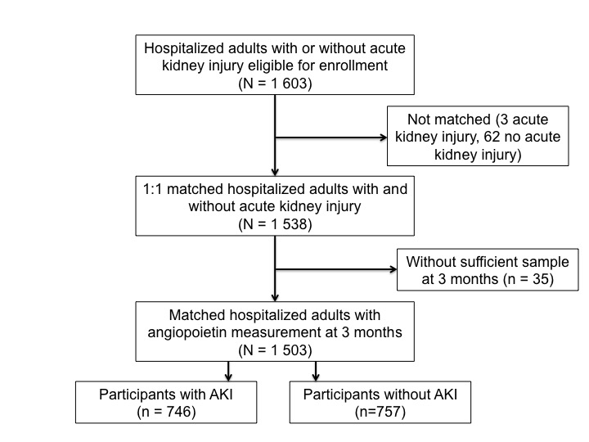

.
Mortality
CKD progression
Heart failure
Figure S2 Legend:
The above spline plots reveal non-linear relationships between angiopoietins and outcomes. The solid line represents the multivariable adjusted hazard ratio and the dashed lines represent the 95% confidence intervals.
Figure S2. Spline Plots Between Angiopoietins and Outcomes
Figure S3. One Single Nucleotide Polymorphism Was Associated with Angiopoietin-2 Concentrations.
A) Manhattan Plot

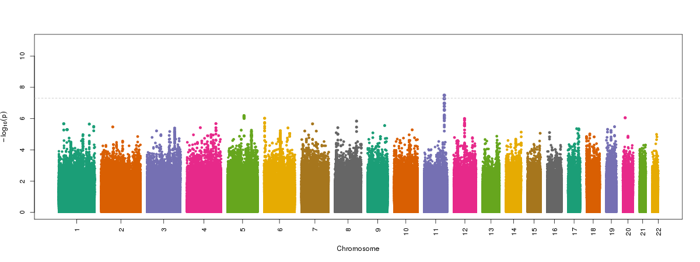
B) Quantile-Quantile Plot
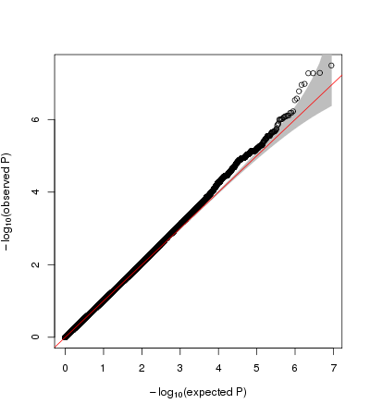

Figure S3 Legend:
- Manhattan plot of a genome-wide association study in 1290 individuals in ASSESS-AKI. The genome-wide significance level is set at 5 × 10⁻⁸ and plotted as the dotted line. One Genome Wide Significant single nucleotide variant was identified (rs611475 in the TMPRSS4 gene, p~ 3,23X10⁻⁸).
- Quantile-quantile (QQ) plot of the data shown in the Manhattan plot in A.

Figure S4. Distribution of Angiopoietin-2 Concentrations in Plasma and Allele Count of TMPRSS4 Variant rs611475

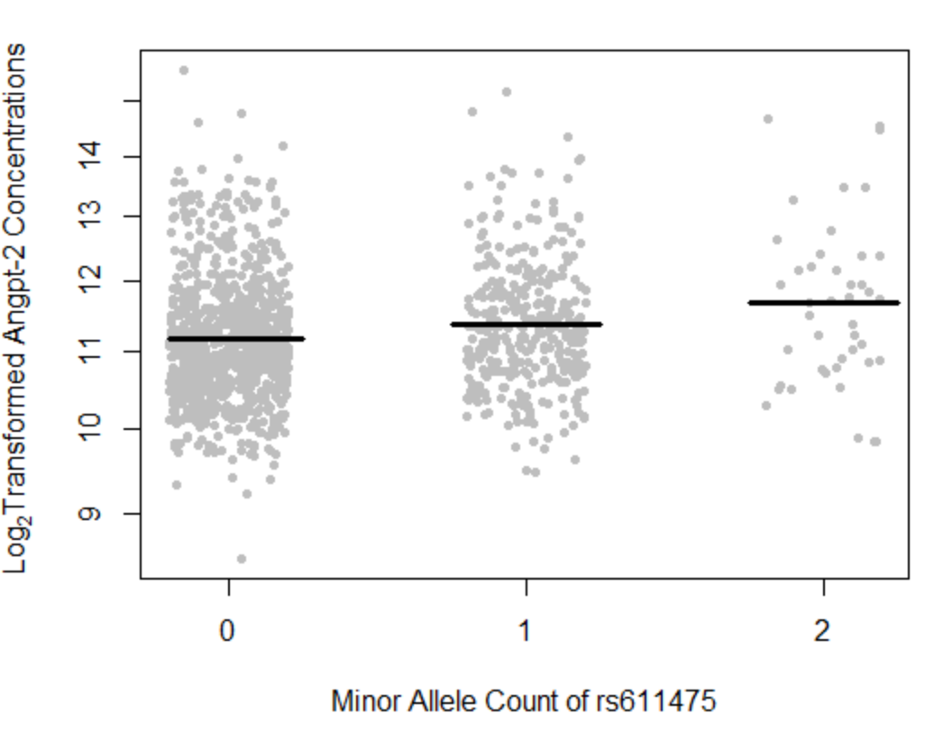
SNV is here
Figure S4 Legend: Each dot represents one patient. The horizontal line represents the average Angpt-2 concentration within each minor allele count of rs611475

Figure S5. Conceptual Diagram of Mediation Analysis

Mediator

Direct effect
rs611475
Kidney Disease Progression
Angpt2
Outcome
Independent

Total effect
Kidney Disease Progression
rs611475

SNP | Analysis | HR for Kidney Disease Progression (95% CI) | P Value | Proportion Mediated by Angpt-2
rs611475 | Total Effect | 1.30 (1.04-1.62) | .0179 | 26.9 % (8.2%-60.5%)  P =.006
rs611475 | Direct effect | 1.21 (0.96-1.51) | .1024 | 26.9 % (8.2%-60.5%)  P =.006

Figure S5 Legend: Mediation analysis estimated that 27% of the association between rs611475 and kidney disease progression was mediated through Angpt-2 concentration.

Figure S6. Regional Association Plot

Figure S6 legend: The above regional association plot identified multiple SNPs in linkage disequilibrium suggesting a single signal at this locus.

