Appendix: Methods
State Hospital Workforce Deficit Estimator
Workforce Supply
We used a number of publicly available datasets to identify the available hospital workforce. For intensivist and hospitalist physicians, we use the January 2020 Provider Enrollment, Chain and Ownership System (PECOS) file, March 2020 National Plan and Provider Enumeration System (NPPES) registry, and the 2017 Medicare Part B public use file (PUF). The PECOS file and NPPES registry, which includes provider taxonomy codes, allow identification of self-reported intensivists. We further cross referenced self-identified intensivists with billing activity for ICU services using the Medicare Part B PUF to identify intensivists active in the ICU setting. Hospitalist physicians were identified based on their self-reported taxonomy codes and further limited to physicians with the specialties of internal medicine, family medicine, and OB/GYN in the PECOS data. These physicians were further cross referenced to the Medicare PUF and limited to those physician who billed Medicare for inpatient services for more than 90% of their E&M services in 2017.
For critical care nurses, we used the 2019 Bureau of Labor Statistics Occupational Employment Statistics (OES) and 2018 National Sample Survey of Registered Nurses (NSSRN). From the NSSRN, we calculated the ratio of hospital-based RNs and hospital-based Clinical Nurse Specialists (CNS), and then identified the proportion of hospital-based RNs who provide critical care services (Critical Care RNs) for every state. In the NSSRN, eight states are reported in two state regions. We applied the same proportion for each state in the state regions. We calculated the number of RNs and CNSs employed by hospitals in every state from the OES, which reports this workforce as a combined workforce. We then applied the proportion of RNs to CNSs to the total BLS OES hospital nurse workforce, and the proportion of Critical Care Nurses to the hospital RN workforce in each state (Figure 1).

Figure 1. Calculation for the State Critical Care Nursing (CCRN) Workforce
$${CCRN}_{State} = \left[{\left(\frac{RN}{RN+CNS}\right)}_{State(NSSRN)}×{\left(HospRN\&CNS\right)}_{State(OES)}\right] ×{\left(\frac{CCRN}{CCRN+RN}\right)}_{State(NSSRN)}$$

Hospital pharmacist supply was determined directly from the 2019 BLS OES hospital employed pharmacists data for every state. The respiratory therapist workforce used the FY 2018 American Hospital Association (AHA) Annual Hospital Survey data. This dataset is available to researchers from the AHA. The Annual Hospital Survey reports the number of respiratory therapist in every hospital, which we aggregated to the state level.
COVID-19 Hospital Workforce Demand
We calculated hospital workforce demand for each state based on projected COVID-19 hospitalizations and ICU cases from the Institute for Health Metrics and Evaluation (IHME) COVID-19 Health Care Utilization Projections and historical hospital inpatient days from the CMS Medicare Hospital Cost Reports. For IHME projections, we used the maximum number of projected acute hospitalizations and ICU beds for COVID. For baseline hospital occupancy, we calculated the total number of inpatient days for acute hospital and ICU patient days (annualized to Calendar Year 2018) and divided by 365 to determine an average daily non-COVID-19 occupancy of general acute hospital and ICU beds. For acute care beds, we applied a 25% reduction in occupancy to reflect cancellation in elective procedures. We did not apply a reduction to ICU occupancy and ICU demand is less flexible.
We multiplied the IHME COVID cases by 3.5 to account for work shifts (i.e. four 12-hour shifts per week) and divided by each professions’ case load (i.e. patients per healthcare worker) to calculate the number of FTEs needed for every profession (Figure 2). We assumed all professions satisfied COVID-19 demands before serving non-COVID-19 patients – determining the shortage for adequate COVID-19 response and/or the available number of health workers for non COVID-19 patients. We compared the demand data against the supply data for the various health care worker and categorized states by whether they had sufficient supply to meet COVID demands for each profession under the 3 different IHME COVID-19 demand scenarios (low, mean, high).
The Estimator tool also supported real-time calculations applying different worker attrition rates to account for sickness, fatigue, and/or other reasons, as well as adjusting health worker case loads using baseline or surge staffing models (Table 1). These staffing models were based on early surge capacity staffing recommendations from the University of California, San Francisco Healthforce Center. All data for each type of healthcare worker was made available in a downloadable excel spreadsheet that also allowed users to override staffing assumptions, including shifts per week, hours per shift, provider to patient ratios, number of available intensivists, and number of COVID patients. Figure 3 provides screenshot of the calculator for Intensivists.
Appendix Figure 2. COVID-19 Critical Care Nurse (CCRN) Demand
$$CCRN Demand= \frac{{ICU Beds}_{IHME}×{3.5 }_{Work Shifts}}{Case Load}$$

Appendix Table 1. Profession Case Loads for Baseline and Surge Staffing Models
 | Critical Care Nurses (CCRN) | Hospitalists | Intensivists | Pharmacists | Respiratory Therapists
ICU Beds
Patients Per FTE – Baseline | 1 | N/A | 7 | 8 | 4
Patients Per FTE – Surge | 3 | N/A | 10 | 30 | 6
Acute Hospital Beds
Patients Per FTE – Baseline | N/A | 10 | N/A | 8 | 8
Patients Per FTE – Surge | N/A | 18 | N/A | 30 | 12

Appendix Figure 3. Health Workforce Deficit Estimator – Intensivists Calculator
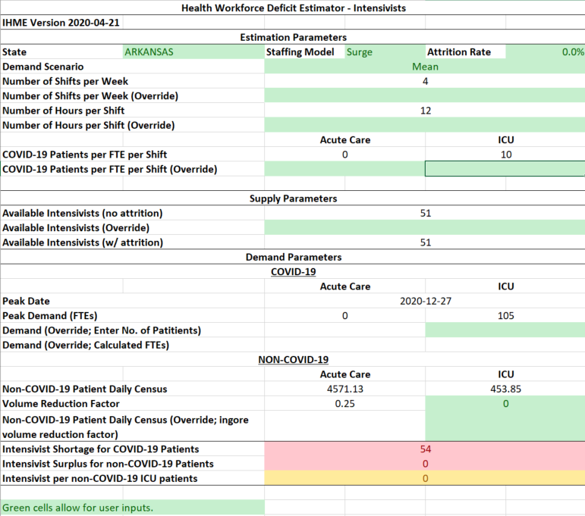

Kuo Y, Goodwin JS. Association of Hospitalist Care With Medical Utilization After Discharge: Evidence of Cost Shift From a Cohort Study. Ann Internal Med. 2011;155:152-9.
Institute for Health Metrics and Evaluation. COVID-19 Projections. Institute for Health Metrics and Evaluation [IHME web site]. March 25, 2021. Available at: https://covid19.healthdata.org/united-states-of-america?view=total-deaths&tab=trend. Accessed March 25, 2021.
University of California San Francisco Healthforce Center. Staffing Plans for Surge Hospitals [University of California, San Francisco web site]. 2020. Available at: https://healthforce.ucsf.edu/file/staffing-plans-surge-hospitals-public-apr-7-updatexlsx. Accessed August 9, 2020.

