15 Minute Violin Warm-Up routine

It is possible to change the order of these exercises.

1. Right Arm Exercise (1 minute)
Play the note ‘D’ on A-string using whole bows. Play 4 whole bows at 5 different sound points on the string: (near the fingerboard->between middle and fingerboard-> at the middle-> between middle and bridge-> next to the bridge). Focus on having free, smooth motion of the right arm, lots of echo in the tone, and a wide oscillation of the string.

2. Left Hand Exercise (1 minute)
Set all the fingers in 1st position on A-string to the notes B-C#-D-E, Metronome Speed: Crotchet=80. Lift each finger starting with 4th finger (i.e. E-D, then D-C#, then C#-B, then B-A) Repeat each combination two times playing crotchets and four times in quavers. Focus on having a quick lift of fingers and a loose feel of the hand when the fingers are in the air.

After reaching open A-string, work dropping the fingers down (i.e. A-B, then B-C#, then C#-D, then D-E). Repeat each combination two times playing crotchets and four times playing quavers. Focus on having a quick drop of fingers on the string and a loose feel of the hand when the fingers are on the string.

3. Right Arm Exercise 2 – Weight Exercise (30 Seconds)

Using whole bows alternate between heavy and light bow feel (i.e. on a down bow stroke play bottom half of the bow heavy and forte, and the top half light and piano; on an up bow again start heavy and forte, and in the lower half play light and piano). Then do two heavy-light cycles per bow stroke on a down-bow and on an up-bow (i.e. heavy-light-heavy-light), then 3, 4, 6 and 8 heavy-light cycles in a bow stroke.

4. Left Arm Exercise 2 – Henry Schradieck Op. 1 Part 1. (1 minute)

Using Metronome Speed Crotchet =80 play through Part A Exercises 1-8.

5. Right Arm Exercise 3 – Speed Exercise (30 Seconds)
This exercise is identical to the Weight Exercise with the difference that instead of heavy-light pattern the fast-slow pattern will be used.

Using whole bows alternate between fast and slow bow speed (i.e. on a down bow stroke play bottom half of the bow fast and forte, and the top half slow and piano; on an up bow again start fast and forte, and in the lower half play slow and piano). Then do two fast-slow cycles per bow stroke on a down-bow and on an up-bow (i.e. fast-slow-fast-slow), then 3, 4, 6 and 8 fast-slow cycles in a bow stroke.

6. Left Arm Exercise 3 – Vibrato (2 minutes)

Place your hand in 3rd or 4th position in such a way that your wrist is touching lightly the side of the violin. Place the fingers down on the string (one at a time) and move the hand from the wrist in such a way that the nail joint of each finger opens and closes and the finger on the string rolls from the tip to the pad and back to the tip. Start slow and build up the speed to full vibrato.

7. Right Arm Exercise 4 – String Crossings Rodolphe Kreutzer Etude No. 7 Excerpt (1 minute)

Start slowly focusing on the precise movement of the upper arm and elbow moving to the correct string. Then increase the speed.

8 Right Arm Exercise 5 – String Crossings Rodolphe Kreutzer Etude No. 13 Excerpt (1 minute)

Play in the top half of the bow focusing on the coordination and smooth movement of the elbow, wrist and fingers for string crossings.

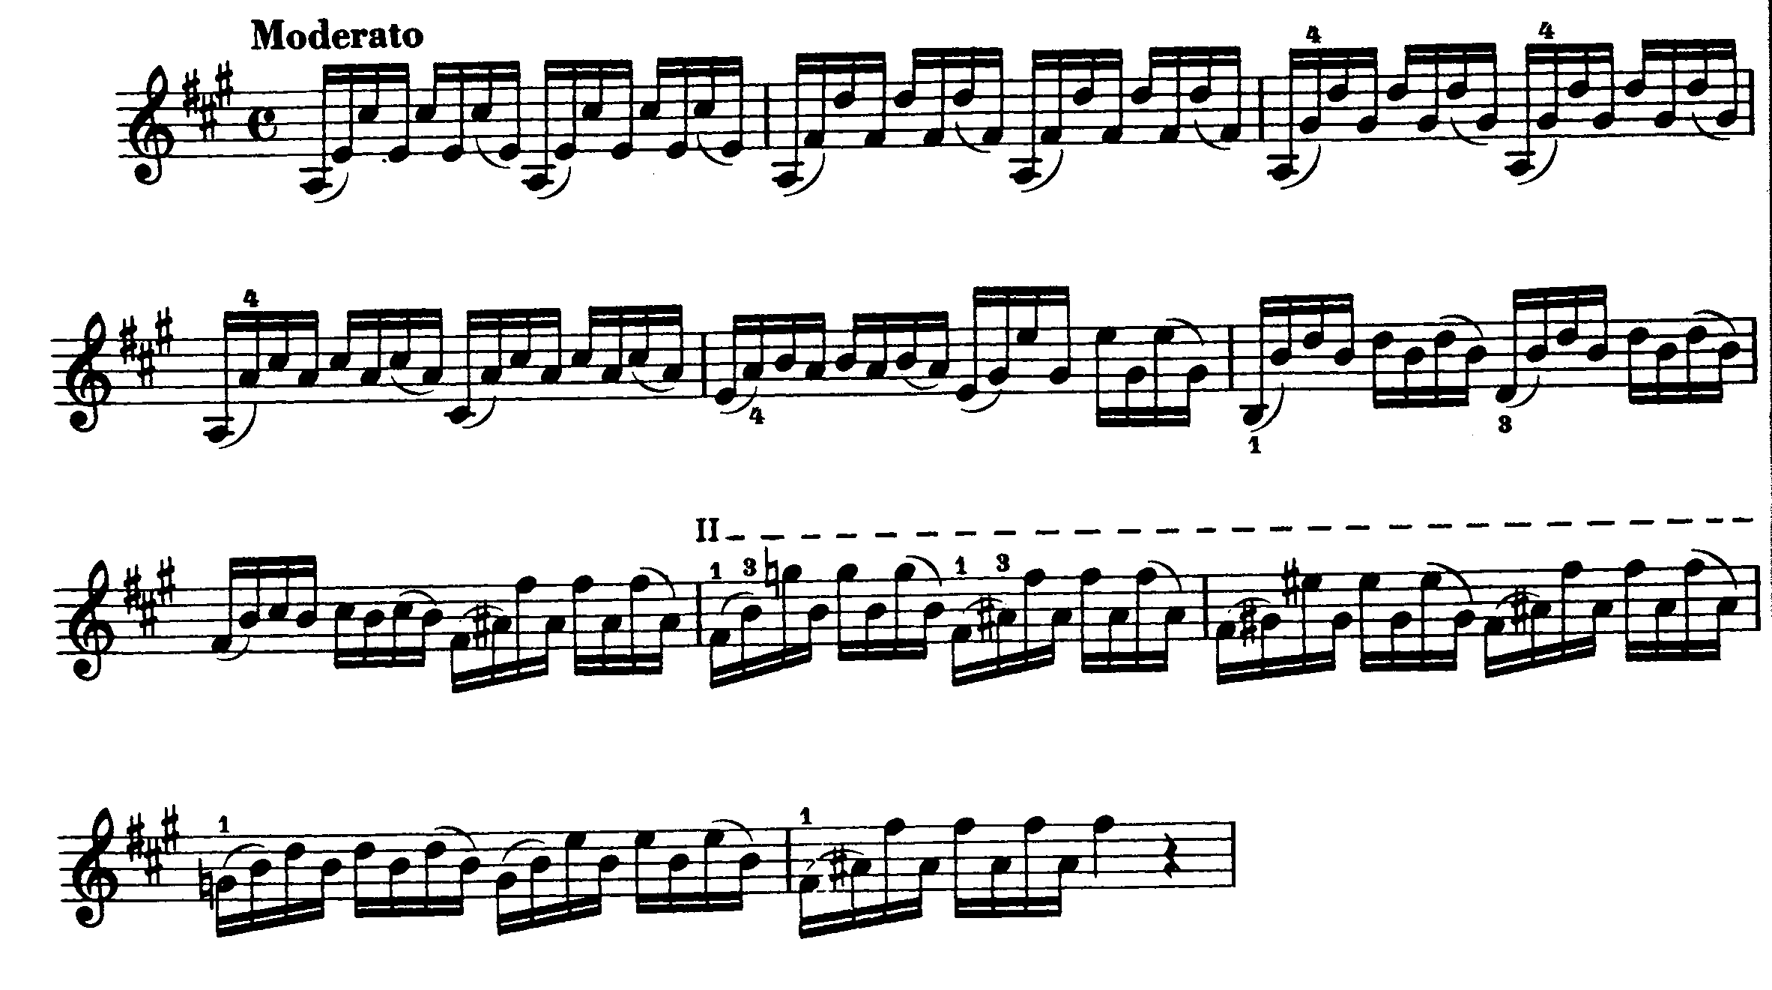

9. Left Arm Exercise 4 – Shifting (1 minute)

10 Scale (5 minutes)

Play 3 octave G major scale at a speed M=50 in Slurs of 3 at three notes to a beat; then in slurs of 8 at eight notes to a beat; and then sautille at the same speed (optionally it is possible to play each note repeated twice in sautille stroke).

11 Arpeggios (1 minute)

Play 3 octave G major and minor triads in slurs of 3 and 6

