Table 1. Search strategy used for search of databases.
Pubmed
1 | (("Arteriovenous Malformations") OR (Arteriovenous Malformation[Title/Abstract])) OR (AVM[Title/Abstract])
2 | (((((((brain*[Title/Abstract]) OR (cerebral[Title/Abstract])) OR (intracerebral[Title/Abstract])) OR (central nervous system[Title/Abstract])) OR (intracranial[Title/Abstract])) OR (cerebellar[Title/Abstract])) OR (intraventricular[Title/Abstract])) OR (supratentorial[Title/Abstract])
3 | ((((((("Radiosurgery") OR (stereotactic radiosurgery[Title/Abstract])) OR (Gamma Knife[Title/Abstract])) OR (Linear Accelerator[Title/Abstract])) OR (LINAC[Title/Abstract])) OR (CyberKnife[Title/Abstract])) OR (Radiotherapy[Title/Abstract])) OR (Stereotactic Radiation[Title/Abstract])
4 | (("Embolization, Therapeutic") OR (Embolization[Title/Abstract])) OR (Embolotherapy[Title/Abstract])
 | #1 AND #2 AND #3 AND #4
Embase
1 | ('arteriovenous malformation')/exp OR (('Arteriovenous Malformation'):ti,ab,kw) OR ((AVM):ti,ab,kw)
2 | (brain*):ti,ab,kw OR ((cerebral):ti,ab,kw) OR ((intracerebral):ti,ab,kw) OR (('central nervous system'):ti,ab,kw) OR ((intracranial):ti,ab,kw) OR ((cerebellar):ti,ab,kw) AND ((intraventricular):ti,ab,kw) AND ((supratentorial):ti,ab,kw)
3 | (radiosurgery)/exp OR (('stereotactic radiosurgery'):ti,ab,kw) OR (('Gamma Knife'):ti,ab,kw) OR (('Linear Accelerator'):ti,ab,kw) OR ((LINAC):ti,ab,kw) OR ((CyberKnife):ti,ab,kw) OR ((Radiotherapy):ti,ab,kw) OR (('Stereotactic Radiation'):ti,ab,kw)
4 | (Embolization):ti,ab,kw OR (('Therapeutic embolization'):ti,ab,kw) OR ((Embolotherapy):ti,ab,kw)
#1 AND #2 AND #3 AND #4

Table 2. Risk of bias in the observational cohort studies using the Newcastle-Ottawa Scale.
Authors (Year) | Selection scores |  |  |  | Comparability score | Outcome score |  |  | Total score
 | Representation of exposed cohort | Selection of nonexposed cohort | Ascertainment of exposure | Demonstration that outcome of interest not present at start of study | Control for important or additional factor | Assessment of outcome | FU long enough for outcomes to occur | Adequacy of FU of cohorts
Abecassis (2017) ¹ | 1 | 1 | 1 | 0 | 2 | 1 | 1 | 1 | 8
Achrol (2007) ² | 1 | 1 | 1 | 0 | 1 | 1 | 1 | 1 | 7
Al Saiegh (2022) ³ | 1 | 1 | 1 | 0 | 0 | 1 | 1 | 1 | 6
Andrade-Souza (2007) ⁴ | 1 | 1 | 1 | 0 | 2 | 1 | 1 | 1 | 8
Arai (2006) ⁵ | 1 | 1 | 1 | 0 | 0 | 1 | 1 | 1 | 6
Back (2008) ⁶ | 1 | 1 | 1 | 0 | 1 | 1 | 1 | 0 | 6
Bethanabatla (2022) ⁷ | 1 | 1 | 1 | 0 | 2 | 1 | 1 | 1 | 8
Bowden (2014) ⁸ | 1 | 1 | 1 | 0 | 2 | 1 | 1 | 1 | 8
Brunozzi (2022) ⁹ | 1 | 1 | 1 | 0 | 1 | 1 | 1 | 1 | 7
Burke (2021) ¹⁰ | 1 | 1 | 1 | 0 | 2 | 1 | 1 | 1 | 8
Chen (2021) ¹¹ | 1 | 1 | 1 | 0 | 1 | 1 | 1 | 1 | 7
Chen (2021) ¹² | 1 | 1 | 1 | 0 | 2 | 1 | 1 | 1 | 8
Chen (2020) ¹³ | 1 | 1 | 1 | 0 | 2 | 1 | 1 | 1 | 8
Chen (2019) ¹⁴ | 1 | 1 | 1 | 0 | 2 | 1 | 1 | 1 | 8
Darsaut (2011) ¹⁵ | 1 | 1 | 1 | 0 | 0 | 1 | 1 | 1 | 7
Deruty (1998) ¹⁶ | 1 | 1 | 1 | 0 | 0 | 1 | 1 | 1 | 6
Ding (2014) ¹⁷ | 1 | 1 | 1 | 0 | 2 | 1 | 1 | 1 | 8
Ding (2014) ¹⁸ | 1 | 1 | 1 | 0 | 2 | 1 | 1 | 1 | 8
Dumot (2022) ¹⁹ | 1 | 1 | 1 | 0 | 1 | 1 | 1 | 1 | 7
Erickson (2022) ²⁰ | 1 | 1 | 1 | 0 | 0 | 1 | 1 | 1 | 6
Faye (2020) ²¹ | 1 | 1 | 1 | 0 | 0 | 1 | 1 | 1 | 6
Hadjipanayis (2001) ²² | 1 | 1 | 1 | 0 | 0 | 1 | 1 | 1 | 6
Hasegawa (2022) ²³ | 1 | 1 | 1 | 0 | 2 | 1 | 1 | 1 | 8
Hasegawa (2019) ²⁴ | 1 | 1 | 1 | 0 | 1 | 1 | 1 | 1 | 7
Hirschmann (2020) ²⁵ | 1 | 1 | 1 | 0 | 2 | 1 | 1 | 1 | 8
Hoh (2000) ²⁶ | 1 | 1 | 1 | 0 | 0 | 1 | 1 | 1 | 6
Hung (2019) ²⁷ | 1 | 1 | 1 | 1 | 1 | 1 | 1 | 1 | 8
Izawa (2009) ²⁸ | 1 | 1 | 1 | 0 | 0 | 1 | 1 | 1 | 6
Kano (2012) ²⁹ | 1 | 1 | 1 | 0 | 2 | 1 | 1 | 1 | 8
Kawashima (2020) ³⁰ | 1 | 1 | 1 | 0 | 2 | 1 | 1 | 1 | 8
Kim (2022) ³¹ | 1 | 1 | 1 | 0 | 2 | 1 | 1 | 1 | 8
Lecavalier-Barsoum (2013) ³² | 1 | 1 | 1 | 0 | 0 | 1 | 1 | 1 | 6
Lee (2015) ³³ | 1 | 1 | 1 | 0 | 2 | 1 | 1 | 1 | 8
Lindvall (2015) ³⁴ | 1 | 1 | 1 | 0 | 0 | 1 | 1 | 1 | 6
Link (2018) ³⁵ | 1 | 1 | 1 | 0 | 1 | 1 | 1 | 1 | 7
Loebl (2022) ³⁶ | 1 | 1 | 1 | 0 | 1 | 1 | 1 | 1 | 7
Marciscano (2017) ³⁷ | 1 | 1 | 1 | 0 | 0 | 1 | 1 | 1 | 6
Mariachev (2015) ³⁸ | 1 | 1 | 1 | 0 | 0 | 1 | 1 | 1 | 6
Meng (2021) ³⁹ | 1 | 1 | 1 | 0 | 2 | 1 | 1 | 1 | 8
Milker-Zabel (2012) ⁴⁰ | 1 | 1 | 1 | 0 | 0 | 1 | 1 | 1 | 6
Miyawaki (1999) ⁴¹ | 1 | 1 | 1 | 0 | 1 | 1 | 1 | 1 | 7
Mohr (2020) ⁴² | 1 | 1 | 1 | 1 | 2 | 1 | 1 | 1 | 9
Murray (2011) ⁴³ | 1 | 1 | 1 | 0 | 0 | 1 | 1 | 1 | 6
Nagaraja (2006) ⁴⁴ | 1 | 1 | 1 | 0 | 0 | 1 | 1 | 1 | 6
Nagy (2017) ⁴⁵ | 1 | 1 | 1 | 1 | 0 | 1 | 1 | 1 | 7
Nagy (2012) ⁴⁶ | 1 | 1 | 1 | 0 | 0 | 1 | 1 | 1 | 6
Naoi (2000) ⁴⁷ | 1 | 1 | 1 | 0 | 1 | 1 | 1 | 1 | 7
Nataraj (2014) ⁴⁸ | 1 | 1 | 1 | 1 | 1 | 1 | 1 | 1 | 8
Nerva (2018) ⁴⁹ | 1 | 1 | 1 | 0 | 2 | 1 | 1 | 1 | 8
Oermann (2015) ⁵⁰ | 1 | 1 | 1 | 0 | 2 | 1 | 1 | 1 | 8
Paul (2014) ⁵¹ | 1 | 1 | 1 | 0 | 2 | 1 | 1 | 1 | 8
Pedroso (2004) ⁵² | 1 | 1 | 1 | 0 | 0 | 1 | 1 | 1 | 6
Pelissou-Guyotat (1997) ⁵³ | 1 | 1 | 1 | 0 | 0 | 1 | 1 | 1 | 6
Peres (2017) ⁵⁴ | 1 | 1 | 1 | 1 | 1 | 1 | 1 | 1 | 8
Pulli (2019) ⁵⁵ | 1 | 1 | 1 | 0 | 2 | 1 | 1 | 1 | 8
Punyawai (2021) ⁵⁶ | 1 | 1 | 1 | 0 | 0 | 1 | 1 | 1 | 6
Rajshekhar (2016) ⁵⁷ | 1 | 1 | 1 | 0 | 1 | 1 | 1 | 1 | 7
Sai Kiran (2007) ⁵⁸ | 1 | 1 | 1 | 0 | 1 | 1 | 1 | 1 | 7
Schlienger (2000) ⁵⁹ | 1 | 1 | 1 | 1 | 0 | 1 | 1 | 1 | 7
Schwyzer (2012) ⁶⁰ | 1 | 1 | 1 | 0 | 1 | 1 | 1 | 1 | 7
Smith (1997) ⁶¹ | 1 | 1 | 1 | 0 | 0 | 1 | 1 | 1 | 6
Soize (2014) ⁶² | 1 | 1 | 1 | 0 | 1 | 1 | 1 | 0 | 6
Sun (2011) ⁶³ | 1 | 1 | 1 | 1 | 1 | 1 | 1 | 1 | 8
Thenier-Villa (2017) ⁶⁴ | 1 | 1 | 1 | 0 | 2 | 1 | 1 | 1 | 8
Wang (2014) ⁶⁵ | 1 | 1 | 1 | 0 | 2 | 1 | 1 | 1 | 8
Winkler (2021) ⁶⁶ | 1 | 1 | 1 | 0 | 1 | 1 | 1 | 1 | 7
Xiao (2010) ⁶⁷ | 1 | 1 | 1 | 0 | 1 | 1 | 1 | 1 | 7
Yan (2021) ⁶⁸ | 1 | 1 | 1 | 0 | 2 | 1 | 1 | 1 | 8
Yang (2009) ⁶⁹ | 1 | 1 | 1 | 0 | 0 | 1 | 1 | 1 | 6
Young (1997) ⁷⁰ | 1 | 1 | 1 | 0 | 0 | 1 | 1 | 1 | 6
FU: Follow-up

Figure 1. Funnel plots to assess publication bias for each outcome (Eager’s regression could not be performed for outcomes with limited studies).
a) Obliteration, Eager’s P=0.07
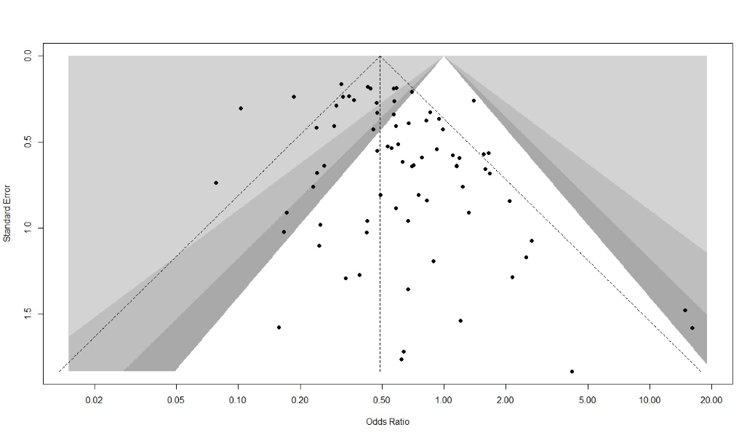
b) Radiation induced changes, Eager’s P=0.25
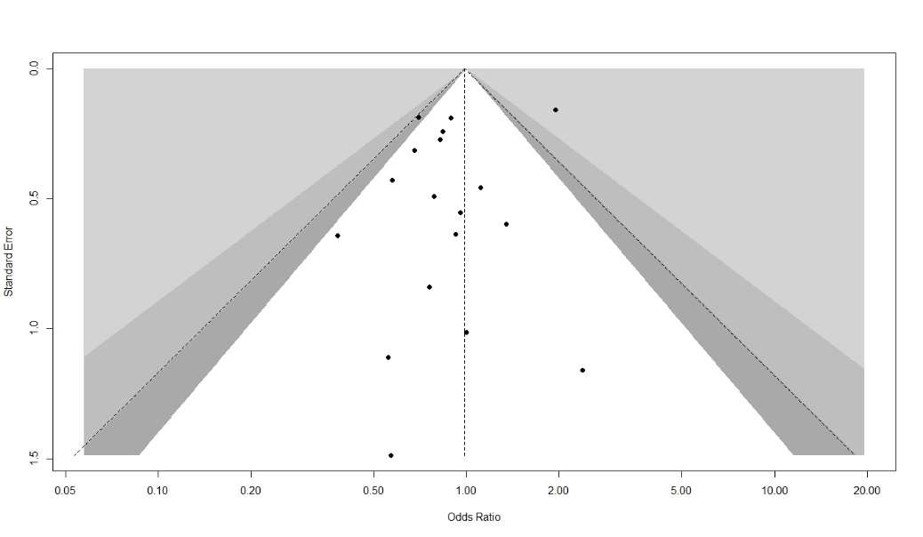
c) Post-treatment hemorrhage, Eager’s P=0.13
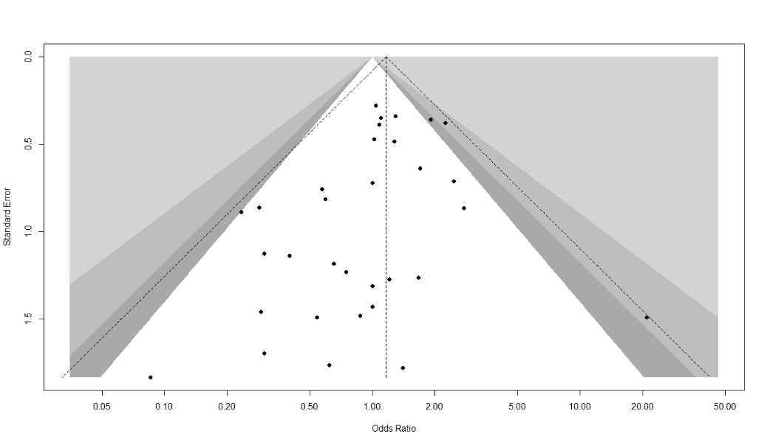
d) Cyst formation, Eager’s P=NA
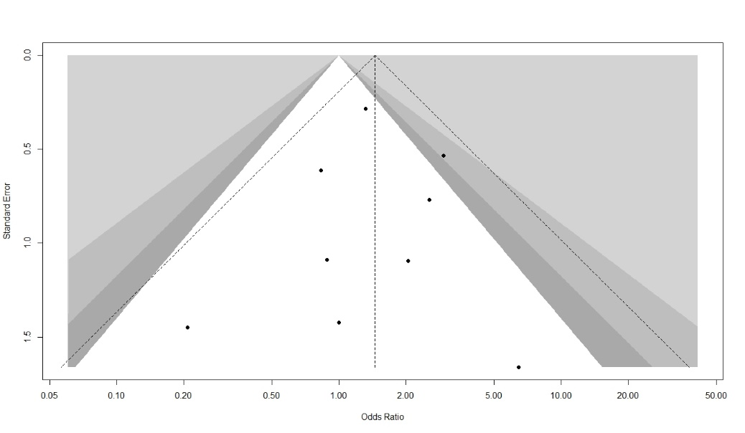

e) Mortality, Eager’s P=NA
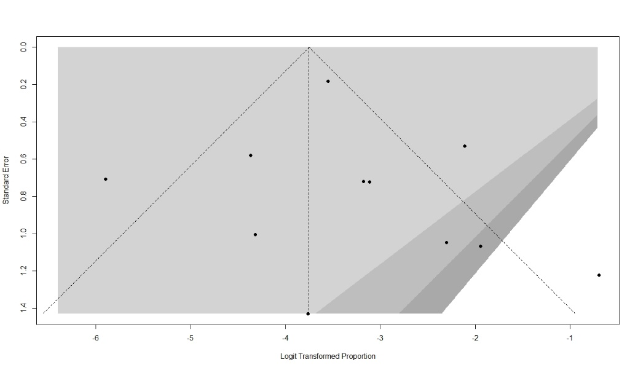

References
1. Abecassis IJ, Nerva JD, Feroze A, et al. Multimodality Management of Spetzler-Martin Grade 3 Brain Arteriovenous Malformations with Subgroup Analysis. World Neurosurg. Jun 2017;102:263-274. doi:10.1016/j.wneu.2017.03.046
2. Achrol AS, Kim H, Pawlikowska L, et al. Association of tumor necrosis factor-alpha-238G>A and apolipoprotein E2 polymorphisms with intracranial hemorrhage after brain arteriovenous malformation treatment. Neurosurgery. Oct 2007;61(4):731-9; discussion 740. doi:10.1227/01.Neu.0000298901.61849.A4
3. Al Saiegh F, Liu H, El Naamani K, et al. Frameless Angiography-Based Gamma Knife Stereotactic Radiosurgery for Cerebral Arteriovenous Malformations: A Proof-of-Concept Study. World Neurosurg. Aug 2022;164:e808-e813. doi:10.1016/j.wneu.2022.05.046
4. Andrade-Souza YM, Ramani M, Scora D, Tsao MN, terBrugge K, Schwartz ML. Embolization before radiosurgery reduces the obliteration rate of arteriovenous malformations. Neurosurgery. Mar 2007;60(3):443-51; discussion 451-2. doi:10.1227/01.Neu.0000255347.25959.D0
5. Arai Y, Handa Y, Ishii H, et al. Endovascular therapy followed by stereotactic radiosurgery for cerebral arteriovenous malformations. Interv Neuroradiol. Jan 20 2006;12(Suppl 1):163-6. doi:10.1177/15910199060120s128
6. Back AG, Vollmer D, Zeck O, Shkedy C, Shedden PM. Retrospective analysis of unstaged and staged Gamma Knife surgery with and without preceding embolization for the treatment of arteriovenous malformations. J Neurosurg. Dec 2008;109 Suppl:57-64. doi:10.3171/jns/2008/109/12/s10
7. Bethanabatla R, Spencer T, Kelly L, Gan P, Taha A. Stereotactic Radio Surgery, Embolization and Conservative Management for Cerebral Arteriovenous Malformation: A New Zealand Experience of Long-Term Outcomes. World Neurosurg. Aug 2022;164:e992-e1000. doi:10.1016/j.wneu.2022.05.088
8. Bowden G, Kano H, Tonetti D, Niranjan A, Flickinger J, Lunsford LD. Stereotactic radiosurgery for arteriovenous malformations of the cerebellum. J Neurosurg. Mar 2014;120(3):583-90. doi:10.3171/2013.9.Jns131022
9. Brunozzi D, McGuire LS, Turchan WT, et al. Brain arteriovenous malformation flow after stereotactic radiosurgery: Role of quantitative MRA. Interv Neuroradiol. Oct 19 2022:15910199221133174. doi:10.1177/15910199221133174
10. Burke RM, Chen CJ, Ding D, et al. Effect of Prior Embolization on Outcomes After Stereotactic Radiosurgery for Pediatric Brain Arteriovenous Malformations: An International Multicenter Study. Neurosurgery. Sep 15 2021;89(4):672-679. doi:10.1093/neuros/nyab245
11. Chen Y, Li R, Ma L, et al. Long-term outcomes of brainstem arteriovenous malformations after different management modalities: a single-centre experience. Stroke Vasc Neurol. Mar 2021;6(1):65-73. doi:10.1136/svn-2020-000407
12. Chen CJ, Ding D, Lee CC, et al. Stereotactic Radiosurgery With Versus Without Embolization for Brain Arteriovenous Malformations. Neurosurgery. Jan 13 2021;88(2):313-321. doi:10.1093/neuros/nyaa418
13. Chen CJ, Ding D, Lee CC, et al. Stereotactic radiosurgery with versus without prior Onyx embolization for brain arteriovenous malformations. J Neurosurg. Dec 11 2020:1-9. doi:10.3171/2020.7.Jns201731
14. Chen CJ, Kearns KN, Ding D, et al. Stereotactic radiosurgery for arteriovenous malformations of the basal ganglia and thalamus: an international multicenter study. J Neurosurg. Jan 11 2019;132(1):122-131. doi:10.3171/2018.8.Jns182106
15. Darsaut TE, Guzman R, Marcellus ML, et al. Management of pediatric intracranial arteriovenous malformations: experience with multimodality therapy. Neurosurgery. Sep 2011;69(3):540-56; discussion 556. doi:10.1227/NEU.0b013e3182181c00
16. Deruty R, Pelissou-Guyotat I, Morel C, Bascoulergue Y, Turjman F. Reflections on the management of cerebral arteriovenous malformations. Surg Neurol. Sep 1998;50(3):245-55; discussion 255-6. doi:10.1016/s0090-3019(98)00082-2
17. Ding D, Yen CP, Starke RM, Xu Z, Sheehan JP. Radiosurgery for ruptured intracranial arteriovenous malformations. J Neurosurg. Aug 2014;121(2):470-81. doi:10.3171/2014.2.Jns131605
18. Ding D, Yen CP, Xu Z, Starke RM, Sheehan JP. Radiosurgery for low-grade intracranial arteriovenous malformations. J Neurosurg. Aug 2014;121(2):457-67. doi:10.3171/2014.1.Jns131713
19. Dumot C, Picart T, Eker O, Guyotat J, Berhouma M, Pelissou-Guyotat I. Outcomes of Unruptured Low-Grade Brain Arteriovenous Malformations Using TOBAS (Treatment of Brain Arteriovenous Malformations Study) Criteria. World Neurosurg. Nov 2022;167:e1050-e1061. doi:10.1016/j.wneu.2022.08.152
20. Erickson N, Mooney J, Salehani A, et al. Predictive Factors for Arteriovenous Malformation Obliteration After Stereotactic Radiosurgery: A Single-Center Study. World Neurosurg. Apr 2022;160:e529-e536. doi:10.1016/j.wneu.2022.01.060
21. Faye M, Diallo M, Sghiouar M, Ndiaye Sy EC, Borius PY, Régis JM. Stereotactic radiosurgery for thalamus arteriovenous malformations. J Radiosurg SBRT. 2020;6(4):269-275.
22. Hadjipanayis CG, Levy EI, Niranjan A, et al. Stereotactic radiosurgery for motor cortex region arteriovenous malformations. Neurosurgery. Jan 2001;48(1):70-6; discussion 76-7. doi:10.1097/00006123-200101000-00013
23. Hasegawa T, Kato T, Naito T, et al. Effect of embolization before stereotactic radiosurgery for brain arteriovenous malformations: a case-control study with propensity score matching. J Neurosurg. Sep 9 2022:1-7. doi:10.3171/2022.7.Jns221343
24. Hasegawa T, Kato T, Naito T, et al. Long-Term Outcomes for Pediatric Patients with Brain Arteriovenous Malformations Treated with Gamma Knife Radiosurgery, Part 1: Analysis of Nidus Obliteration Rates and Related Factors. World Neurosurg. Jun 2019;126:e1518-e1525. doi:10.1016/j.wneu.2019.03.176
25. Hirschmann D, Goebl P, Witte FH, et al. Evaluation of the radiosurgical treatment of cerebral arteriovenous malformations: a retrospective single-center analysis of three decades. J Neurointerv Surg. Apr 2020;12(4):401-406. doi:10.1136/neurintsurg-2019-015332
26. Hoh BL, Ogilvy CS, Butler WE, Loeffler JS, Putman CM, Chapman PH. Multimodality treatment of nongalenic arteriovenous malformations in pediatric patients. Neurosurgery. Aug 2000;47(2):346-57; discussion 357-8. doi:10.1097/00006123-200008000-00015
27. Hung YC, Mohammed N, Eluvathingal Muttikkal TJ, et al. The impact of preradiosurgery embolization on intracranial arteriovenous malformations: a matched cohort analysis based on de novo lesion volume. J Neurosurg. Aug 30 2019:1-12. doi:10.3171/2019.5.Jns19722
28. Izawa M, Chernov M, Hayashi M, Iseki H, Hori T, Takakura K. Combined management of intracranial arteriovenous malformations with embolization and gamma knife radiosurgery: comparative evaluation of the long-term results. Surg Neurol. Jan 2009;71(1):43-52; discussion 52-3. doi:10.1016/j.surneu.2007.11.016
29. Kano H, Kondziolka D, Flickinger JC, et al. Stereotactic radiosurgery for arteriovenous malformations after embolization: a case-control study. J Neurosurg. Aug 2012;117(2):265-75. doi:10.3171/2012.4.Jns111935
30. Kawashima M, Hasegawa H, Shin M, et al. Outcomes of stereotactic radiosurgery for hemorrhagic arteriovenous malformations with or without prior resection or embolization. J Neurosurg. Dec 4 2020:1-9. doi:10.3171/2020.7.Jns201502
31. Kim MJ, Jung HH, Kim YB, et al. Comparison of Single-Session, Neoadjuvant, and Adjuvant Embolization Gamma Knife Radiosurgery for Arteriovenous Malformation. Neurosurgery. Dec 29 2022;doi:10.1227/neu.0000000000002308
32. Lecavalier-Barsoum M, Roy D, Doucet R, et al. Long-term results of radiosurgery for cerebral arteriovenous malformations. Can J Neurol Sci. Mar 2013;40(2):182-6. doi:10.1017/s0317167100013706
33. Lee CC, Chen CJ, Ball B, et al. Stereotactic radiosurgery for arteriovenous malformations after Onyx embolization: a case-control study. J Neurosurg. Jul 2015;123(1):126-35. doi:10.3171/2014.12.Jns141437
34. Lindvall P, Grayson D, Bergström P, Bergenheim AT. Hypofractionated stereotactic radiotherapy in medium-sized to large arteriovenous malformations. J Clin Neurosci. Jun 2015;22(6):955-8. doi:10.1016/j.jocn.2014.12.015
35. Link TW, Winston G, Schwarz JT, et al. Treatment of Unruptured Brain Arteriovenous Malformations: A Single-Center Experience of 86 Patients and a Critique of the A Randomized Trial of Unruptured Brain Arteriovenous Malformations (ARUBA) Trial. World Neurosurg. Dec 2018;120:e1156-e1162. doi:10.1016/j.wneu.2018.09.025
36. Loebel F, Pontoriero A, Kluge A, et al. Image-guided robotic radiosurgery for the treatment of arteriovenous malformations. PLoS One. 2022;17(9):e0266744. doi:10.1371/journal.pone.0266744
37. Marciscano AE, Huang J, Tamargo RJ, et al. Long-term Outcomes With Planned Multistage Reduced Dose Repeat Stereotactic Radiosurgery for Treatment of Inoperable High-Grade Arteriovenous Malformations: An Observational Retrospective Cohort Study. Neurosurgery. Jul 1 2017;81(1):136-146. doi:10.1093/neuros/nyw041
38. Maryashev SA, Golanov AV, Konovalov AN, et al. The outcomes of stereotactic radiotherapy in patients with cerebral arteriovenous malformations. Zh Vopr Neirokhir Im N N Burdenko. 2015;79(1):14-32. doi:10.17116/neiro201579114-32
39. Meng X, He H, Liu P, et al. Radiosurgery-Based AVM Scale Is Proposed for Combined Embolization and Gamma Knife Surgery for Brain Arteriovenous Malformations. Front Neurol. 2021;12:647167. doi:10.3389/fneur.2021.647167
40. Milker-Zabel S, Kopp-Schneider A, Wiesbauer H, et al. Proposal for a new prognostic score for linac-based radiosurgery in cerebral arteriovenous malformations. Int J Radiat Oncol Biol Phys. Jun 1 2012;83(2):525-32. doi:10.1016/j.ijrobp.2011.07.008
41. Miyawaki L, Dowd C, Wara W, et al. Five year results of LINAC radiosurgery for arteriovenous malformations: outcome for large AVMS. Int J Radiat Oncol Biol Phys. Jul 15 1999;44(5):1089-106. doi:10.1016/s0360-3016(99)00102-9
42. Mohr JP, Overbey JR, Hartmann A, et al. Medical management with interventional therapy versus medical management alone for unruptured brain arteriovenous malformations (ARUBA): final follow-up of a multicentre, non-blinded, randomised controlled trial. Lancet Neurol. Jul 2020;19(7):573-581. doi:10.1016/s1474-4422(20)30181-2
43. Murray G, Brau RH. A 10-year experience of radiosurgical treatment for cerebral arteriovenous malformations: a perspective from a series with large malformations. Clinical article. J Neurosurg. Aug 2011;115(2):337-46. doi:10.3171/2011.3.Jns10814
44. Nagaraja S, Lee KJ, Coley SC, et al. Stereotactic radiosurgery for brain arteriovenous malformations: quantitative MR assessment of nidal response at 1 year and angiographic factors predicting early obliteration. Neuroradiology. Nov 2006;48(11):821-9. doi:10.1007/s00234-006-0131-y
45. Nagy G, Grainger A, Hodgson TJ, et al. Staged-Volume Radiosurgery of Large Arteriovenous Malformations Improves Outcome by Reducing the Rate of Adverse Radiation Effects. Neurosurgery. Feb 1 2017;80(2):180-192. doi:10.1227/neu.0000000000001212
46. Nagy G, Rowe JG, Radatz MW, Hodgson TJ, Coley SC, Kemeny AA. A historical analysis of single-stage γ knife radiosurgical treatment for large arteriovenous malformations: evolution and outcomes. Acta Neurochir (Wien). Mar 2012;154(3):383-94. doi:10.1007/s00701-011-1245-5
47. Naoi Y, Iizuka Y, Cho N, et al. STEREOTACTIC RADIOSURGERY USING A LINEAR ACCELERATOR FOR THE TREATMENT OF CEREBRAL ARTERIOVENOUS MALFORMATION
A PRELIMINARY REPORT. The Journal of JASTRO. 2000;12(3):221-227. doi:10.11182/jastro1989.12.221
48. Nataraj A, Mohamed MB, Gholkar A, et al. Multimodality treatment of cerebral arteriovenous malformations. World Neurosurg. Jul-Aug 2014;82(1-2):149-59. doi:10.1016/j.wneu.2013.02.064
49. Nerva JD, Barber J, Levitt MR, et al. Onyx embolization prior to stereotactic radiosurgery for brain arteriovenous malformations: a single-center treatment algorithm. J Neurointerv Surg. Mar 2018;10(3):258-267. doi:10.1136/neurintsurg-2017-013084
50. Oermann EK, Ding D, Yen CP, et al. Effect of Prior Embolization on Cerebral Arteriovenous Malformation Radiosurgery Outcomes: A Case-Control Study. Neurosurgery. Sep 2015;77(3):406-17; discussion 417. doi:10.1227/neu.0000000000000772
51. Paúl L, Casasco A, Kusak ME, Martínez N, Rey G, Martínez R. Results for a series of 697 arteriovenous malformations treated by gamma knife: influence of angiographic features on the obliteration rate. Neurosurgery. Nov 2014;75(5):568-83; dicussion 582-3; quiz 583. doi:10.1227/neu.0000000000000506
52. Pedroso AG, De Salles AA, Tajik K, et al. Novalis Shaped Beam Radiosurgery of arteriovenous malformations. J Neurosurg. Nov 2004;101 Suppl 3:425-34.
53. Pelissou-Guyotat I, Deruty R, Morel C. The role of Linac radiosurgery in multidisciplinary management for cerebral arteriovenous malformations: personal experience. Stereotact Funct Neurosurg. 1997;69(1-4 Pt 2):147-51. doi:10.1159/000099867
54. Peres CMA, Souza EC, Teixeira MJ, Figueiredo EG, Caldas J. Impact of Associated Nidal Lesions in Outcome of Brain Arteriovenous Malformations After Radiosurgery with or without Embolization. World Neurosurg. Sep 2017;105:643-650. doi:10.1016/j.wneu.2017.06.044
55. Pulli B, Chapman PH, Ogilvy CS, et al. Multimodal cerebral arteriovenous malformation treatment: a 12-year experience and comparison of key outcomes to ARUBA. J Neurosurg. Nov 1 2019:1-10. doi:10.3171/2019.8.Jns19998
56. Punyawai P, Radomsutthikul N, Dhanachai M, Kobkitsuksakul C, Hansasuta A. Long-term outcomes of 170 brain arteriovenous malformations treated by frameless image-guided robotic stereotactic radiosurgery: Ramathibodi hospital experience. Medicine (Baltimore). May 14 2021;100(19):e25752. doi:10.1097/md.0000000000025752
57. Rajshekhar V, Moorthy RK, Jeyaseelan V, et al. Results of a Conservative Dose Plan Linear Accelerator-Based Stereotactic Radiosurgery for Pediatric Intracranial Arteriovenous Malformations. World Neurosurg. Nov 2016;95:425-433. doi:10.1016/j.wneu.2016.06.007
58. Kiran NA, Kale SS, Vaishya S, et al. Gamma Knife surgery for intracranial arteriovenous malformations in children: a retrospective study in 103 patients. J Neurosurg. Dec 2007;107(6 Suppl):479-84. doi:10.3171/ped-07/12/479
59. Schlienger M, Atlan D, Lefkopoulos D, et al. Linac radiosurgery for cerebral arteriovenous malformations: results in 169 patients. Int J Radiat Oncol Biol Phys. Mar 15 2000;46(5):1135-42. doi:10.1016/s0360-3016(99)00523-4
60. Schwyzer L, Yen CP, Evans A, Zavoian S, Steiner L. Long-term results of gamma knife surgery for partially embolized arteriovenous malformations. Neurosurgery. Dec 2012;71(6):1139-47; discussion 1147-8. doi:10.1227/NEU.0b013e3182720280
61. Smith KA, Shetter A, Speiser B, Spetzler RF. Angiographic follow-up in 37 patients after radiosurgery for cerebral arteriovenous malformations as part of a multimodality treatment approach. Stereotact Funct Neurosurg. 1997;69(1-4 Pt 2):136-42. doi:10.1159/000099865
62. Soize S, Bouquigny F, Kadziolka K, Portefaix C, Pierot L. Value of 4D MR angiography at 3T compared with DSA for the follow-up of treated brain arteriovenous malformation. AJNR Am J Neuroradiol. Oct 2014;35(10):1903-9. doi:10.3174/ajnr.A3982
63. Sun DQ, Carson KA, Raza SM, et al. The radiosurgical treatment of arteriovenous malformations: obliteration, morbidities, and performance status. Int J Radiat Oncol Biol Phys. Jun 1 2011;80(2):354-61. doi:10.1016/j.ijrobp.2010.01.049
64. Thenier-Villa JL, Galárraga-Campoverde RA, Martínez Rolán RM, et al. Linear Accelerator Stereotactic Radiosurgery of Central Nervous System Arteriovenous Malformations: A 15-Year Analysis of Outcome-Related Factors in a Single Tertiary Center. World Neurosurg. Jul 2017;103:291-302. doi:10.1016/j.wneu.2017.04.081
65. Wang YC, Huang YC, Chen HC, et al. Linear accelerator stereotactic radiosurgery in the management of intracranial arteriovenous malformations: long-term outcome. Cerebrovasc Dis. 2014;37(5):342-9. doi:10.1159/000360756
66. Winkler EA, Lu A, Morshed RA, et al. Bringing high-grade arteriovenous malformations under control: clinical outcomes following multimodality treatment in children. J Neurosurg Pediatr. Apr 10 2020;26(1):82-91. doi:10.3171/2020.1.Peds19487
67. Xiao F, Gorgulho AA, Lin CS, et al. Treatment of giant cerebral arteriovenous malformation: hypofractionated stereotactic radiation as the first stage. Neurosurgery. Nov 2010;67(5):1253-9; discussion 1259. doi:10.1227/NEU.0b013e3181efbaef
68. Yan D, Chen Y, Li Z, et al. Stereotactic Radiosurgery With vs. Without Prior Embolization for Brain Arteriovenous Malformations: A Propensity Score Matching Analysis. Front Neurol. 2021;12:752164. doi:10.3389/fneur.2021.752164
69. Yang SY, Kim DG, Chung HT, Paek SH, Park JH, Han DH. Radiosurgery for large cerebral arteriovenous malformations. Acta Neurochir (Wien). Feb 2009;151(2):113-24. doi:10.1007/s00701-008-0173-5
70. Young C, Summerfield R, Schwartz M, O'Brien P, Ramani R. Radiosurgery for arteriovenous malformations: the University of Toronto experience. Can J Neurol Sci. May 1997;24(2):99-105. doi:10.1017/s0317167100021405

