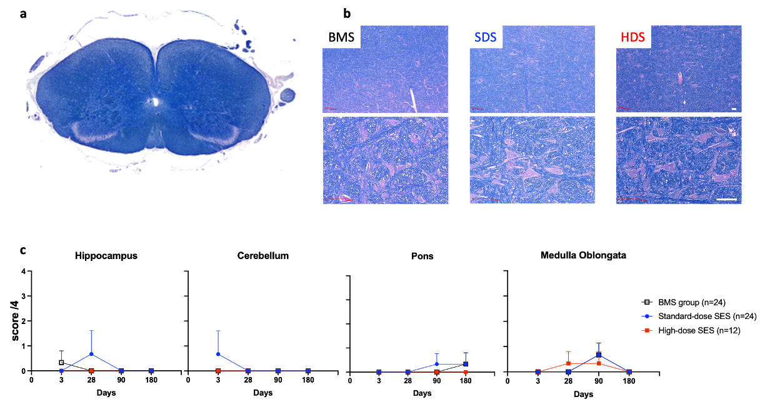
Supplementary Figure 4. Demyelination analysis (Luxol Fast Blue Staining). (a) Representative image of one of the analysed brain areas, the medulla oblongata. (b) Representative higher magnification images of the medulla oblongata at day 90 for the three groups. Scale bar= 100µm. (c) Quantitative analysis performed at day 3, 28, 90, and 180 after stent implantation. The BMS and SDS groups each included twenty-four animals (N=6 at each time point), while the HDS group had 12 animals (N=3 at each time point). Very slight signs of demyelination (appearing as small round vacuoles within the blue matter) were observed in rare animals across all groups. The extent of myelin vacuolization was scored from 1 to 4 (<25%, 25-50%, 50-75%, >75% of the sample). The scores consistently remained low, with no statistical differences observed between the groups.
(Groups: BMS - Black squares, SDS - Blue circles, HDS - Red squares)

