**Supplementary appendix**

Supplementary Table 1. Detailed search strategies used in this review

Supplementary Table 2. Characteristics of the studies included in the systematic review and meta-analysis of prevalence.

Supplementary Table 3. Characteristics of the cohort studies included in the systematic review and meta-analysis of incidence.

Supplementary Figure 1. Funnel plot of stroke prevalence among adults living with HIV

Supplementary Figure 2. Forest plots and funnel plot of ischemic stroke prevalence among adults living with HIV.

Supplementary Figure 3. Forest plots of stroke prevalence among older adults and general population living with HIV.

Supplementary Figure 4. Funnel plots of stroke prevalence among older adults and general population living with HIV.

Supplementary Figure 5. Funnel plots of stroke incidence (per 10,000 person-years) among adults living with HIV.

Supplementary Table 4. Univariable meta-regression of stroke incidence and study characteristics among adults living with HIV.

Supplementary Figure 6. Funnel plots of ischemic stroke and hemorrhagic stroke incidence (per 10,000 person-years) among adults living with HIV.

**Supplementary Table 1. Detailed search strategies used in this review**

|  |  |
| --- | --- |
| Database | Search terms |
| PubMed | ((“HIV”[Title/Abstract]) OR (“AIDS”[Title/Abstract]) OR (“human immunodeficiency virus” [Title/Abstract]) OR (“acquired immunodeficiency syndrome” [Title/Abstract])) and (“stroke”[Title/Abstract]) |
| EMBASE | (((“HIV”) OR (“AIDS”) OR (“human immunodeficiency virus”) OR (“acquired immunodeficiency syndrome”)) and (“stroke”)):ab |
| Web of Science | (AB= “HIV” OR AB= “AIDS” OR AB=“human immunodeficiency virus” OR AB= “acquired immunodeficiency syndrome”) AND (AK=“stroke”) |

**Supplementary Table 2. Characteristics of the studies included in the systematic review and meta-analysis of prevalence.**

|  |  |  |  |  |  |  |  |  |  |  |
| --- | --- | --- | --- | --- | --- | --- | --- | --- | --- | --- |
| First author, year (Country) | Median year of sampling (y) | Study design | Population group | Sample size, n | Age, y | Stroke cases | Proportion of ART, % | Region | World Bank Income level | Risk of bias |
| Tiffany E. Gooden et al, 2022 (UK)[1] | 2010 | Cohort | Adult | 9233 | Mean (SD): 41 (11) | 152 | NA | European Region | High income | Low |
| Fred Stephen Sarfo et al, 2021 (Ghana)[2] | NA | Cohort | Adult | 261 | NA | 5 | 100 | African Region | Lower middle income | Low |
| Amaraporn Rerkasem et al, 2021 (Thailand)[3] | 2016 | Cross-sectional | Adult | 892 | Mean (SD): 43 (10) | 8 (ischemic) | 100 | South-East Asia Region | Upper middle income | Moderate |
| Urvish K. Patel MBBS et al, 2021 (USA)[4] | 2008 | Cross-sectional | Adult | 1559351 | NA | 14895 (ischemic) | NA | Region of the Americas | High income | Low |
| Robert S. Rosenson et al, 2020 (USA)[5] | 2013 | Cohort | Adult | 82426 | NA | 596 | 95.96 | Region of the Americas | High income | Low |
| Alyson Kaplan et al, 2020 (USA)[6] | 2013 | Cohort | Adult | 232 | NA | 8 | NA | Region of the Americas | High income | Moderate |
| Joseph Kamtchum-Tatuene et al, 2019 (Malawi)[7] | NA | Case-control | Adult | 51 | NA | 19 (ischemic) | 50.98 | African Region | Low income | Moderate |
| Lene Ryom et al, 2018 (Australia, Europe, and the USA)[8] | 2007 | Cohort | Adult | 35711 | Median (IQR): 44 (38–51) | 379 | 85.16 | NA | NA | Low |
| Kenneth H. Mayer et al, 2018 (USA)[9] | 2010 | Cross-sectional | Adult | 12837 | Mean (SD): 40 (12) | 184 | NA | Region of the Americas | High income | Low |
| Joseph Kamtchum-Tatuene et al, 2018 (Malawi)[10] | 2011 | Case-control | Adult | 139 | NA | 12 | 45.6 | African Region | Low income | Moderate |
| Yung-Feng Yen et al, 2016 (China)[11] | 2005 | Cohort | Adult | 23507 | NA | 309 | 66.19 | Western Pacific Region | Upper middle income | Low |
| Claire E Kendall et al, 2014 (Canada)[12] | 2005 | Cross-sectional | Adult | 14005 | NA | 173 | NA | Region of the Americas | High income | Low |
| Joshua Okyere et al, 2022 (South Africa)[13] | 2011 | Cross-sectional | Older adults | 516 | NA | 21 | NA | African Region | Upper middle income | Moderate |
| Delphine Sauce et al, 2021 (France)[14] | NA | Cohort | Older adults | 111 | Median (IQR): 81 (78–84) | 4 | NA | European Region | High income | Moderate |
| Bethan I. Jones et al, 2022 (United Kingdom)[15] | 2002 | Cohort | General population | 2945 | Mean (SD): 39 (13) | 33 | NA | European Region | High income | Low |
| Hui-Lin Lin et al, 2019 (China)[16] | 2004 | Cohort | General population | 6078 | Mean (SD): 34 (11) | 609 | NA | Western Pacific Region | Upper middle income | Low |
| Jowi, J. O. et al, 2007 (Kenya)[17] | 2002 | Cross-sectional | General population | 708 | NA | 19 | NA | African Region | Lower middle income | Moderate |

Note: ART=antiretroviral therapy; IQR=interquartile range; NA=not available; SD=standard deviation; UK=United Kingdom; USA=United States of America.

**Supplementary Table 3. Characteristics of the cohort studies included in the systematic review and meta-analysis of incidence.**

|  |  |  |  |  |  |  |  |  |  |  |  |  |  |
| --- | --- | --- | --- | --- | --- | --- | --- | --- | --- | --- | --- | --- | --- |
| First author, year (Country) | Median year of sampling (y) | Sample size, n | Age, y | Follow up duration (years) or incidence rate and its 95%CI | | | Case | | | Proportion of AR, % | Region | World Bank Income level | Risk of bias |
| All | Ischemic stroke | Hemorrhagic stroke | All | Ischemic stroke | Hemorrhagic stroke |
| Bastian Neesgaard et al, 2022 (European and Australian)[18] | 2016 | 29340 | Median (IQR): 44.3 (36.2-51.3). | 160252.00 | NA | NA | 228 | NA | NA | 75.60 | NA | NA | Low |
| Akarin Hiransuthikul et al, 2022 (Thailand)[19] | 2008 | 2020 | Median (IQR): 32.2 (27.3–38) | NA | 23579 | NA | NA | 15 | NA | 100.00 | South-East Asia Region | Upper middle income | Low |
| Tiffany E. Gooden et al, 2022 (UK)[1] | 2010 | 9081 | Mean (SD): 41 (11) | 40205.10 | NA | NA | 72 | NA | NA | NA | European Region | High income | Low |
| Olof Elvstam et al, 2022 (Sweden)[20] | 2006 | 6562 | NA | 44937.00 | NA | NA | 98 | NA | NA | 100.00 | European Region | High income | Low |
| Frédérique Chammartin et al, 2022 (Switzerland)[21] | 2004 | 15303 | NA | 174947.00 | NA | NA | 275 | NA | NA | 95.67 | European Region | High income | Low |
| Jason J. Sico et al, 2021 (USA)[22] | 2006 | 33528 | NA | NA | 180975 | NA | NA | 1396 | NA | 44.88 | Region of the Americas | High income | Low |
| Fred Stephen Sarfo et al, 2021 (Ghana)[2] | NA | 255 | NA | 245.00 | NA | NA | 3 | NA | NA | 100.00 | African Region | Lower middle income | Low |
| Barbara N Harding et al, 2021 (USA)[23] | 2010 | 15974 | Median (IQR): 42 (35-49) | 18.9 (16.0-22.3) | 15.4 (12.8-18.5) | 2.5 (1.5-3.9) | 139 | 113 | 18.00 | 100.00 | Region of the Americas | High income | Low |
| Robert S. Rosenson et al, 2020 (USA)[5] | 2013 | 82426 | NA | 169412.00 | NA | NA | 253 | NA | NA | 95.96 | Region of the Americas | High income | Low |
| Jane A. O’Halloran et al, 2020 (USA)[24] | 2011 | 20242 | NA | 39823.00 | NA | NA | 78 | NA | NA | 100.00 | Region of the Americas | High income | Low |
| Raquel de Vasconcellos Carvalhaes de Oliveira et al, 2018 (Brazil)[25] | 1998 | 1135 | NA | 9011.68 | NA | NA | 23 | NA | NA | NA | Region of the Americas | Upper middle income | Low |
| Giuseppe Vittorio De Socio et al, 2017 (Italy)[26] | 2009 | 369 | Mean (SD): 43 (9) | 3097.00 | NA | NA | 5 | NA | NA | NA | European Region | High income | Low |
| Yung-Feng Yen et al, 2016 (China)[11] | 2005 | 22581 | NA | 109514.00 | 109514 | 109514.00 | 228 | 169 | 59.00 | 66.19 | Western Pacific Region | Upper middle income | Low |
| Eugenia Quiros-Roldan et al, 2016 (Italy)[27] | 2006 | 3766 | NA | 28768.00 | NA | NA | 51 | NA | NA | 60.09 | European Region | High income | Low |
| Michael J. Vinikoor et al, 2013 (USA)[28] | 2004 | 2515 | NA | NA | 13708 | 13708.00 | NA | 31 | 9.00 | 89.03 | Region of the Americas | High income | Low |
| Giustino Parruti et al, 2013 (Italy)[29] | 2012 | 201 | Mean (SD): 45 (10) | 430.50 | NA | NA | 5 | NA | NA | 79.60 | European Region | High income | Low |
| Felicia C. Chow et al, 2012 (USA)[30] | 2006 | 4308 | Mean (SD): 42 (11) | NA | 25100 | NA | NA | 132 | NA | NA | Region of the Americas | High income | Low |

Note: ART=antiretroviral therapy; IQR=interquartile range; NA=not available; SD=standard deviation; UK=United Kingdom; USA=United States of America.



**Supplementary Figure 1. Funnel plot of stroke prevalence among adults living with HIV**

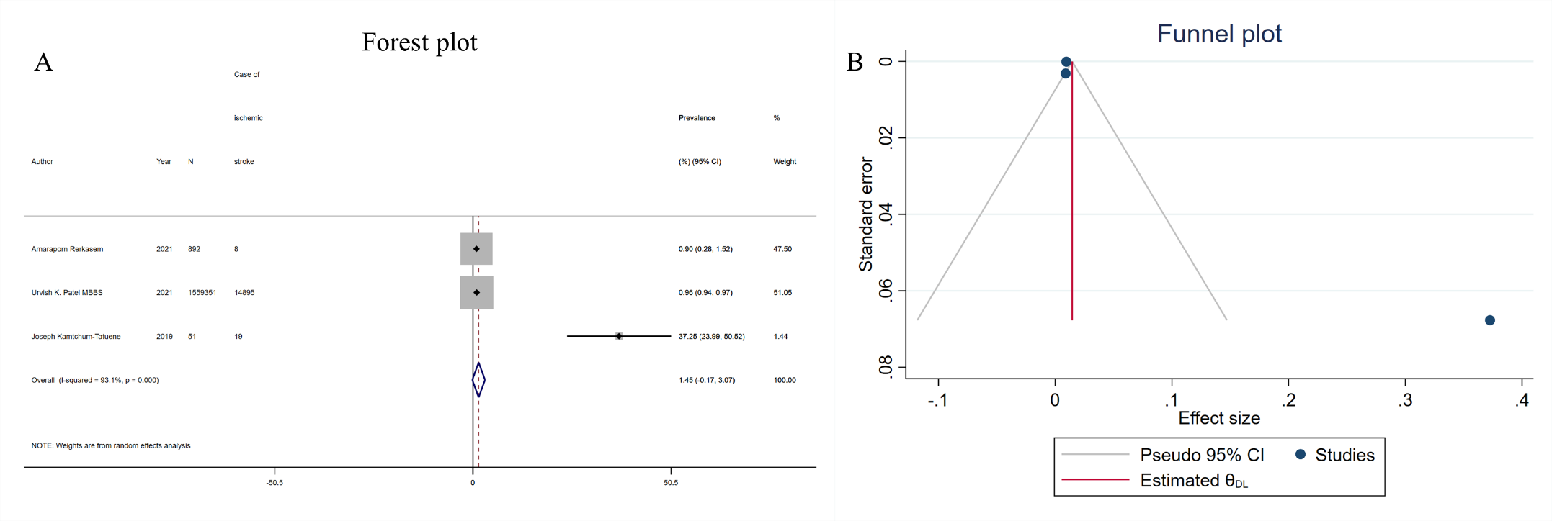

**Supplementary Figure 2. Forest plots and funnel plot of** **ischemic stroke prevalence among adults living with HIV: (A) Forest plots; (B) Funnel plot**

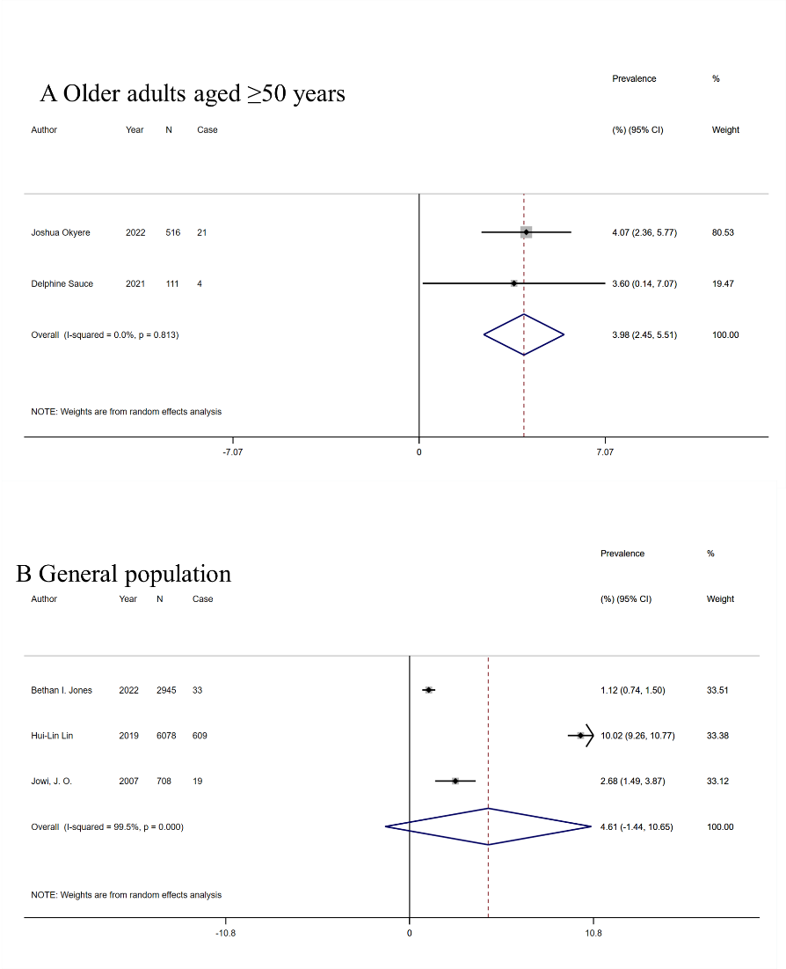

**Supplementary Figure 3. Forest plots of stroke prevalence among older adults and general population living with HIV: (A) Older adults; (B) General population**

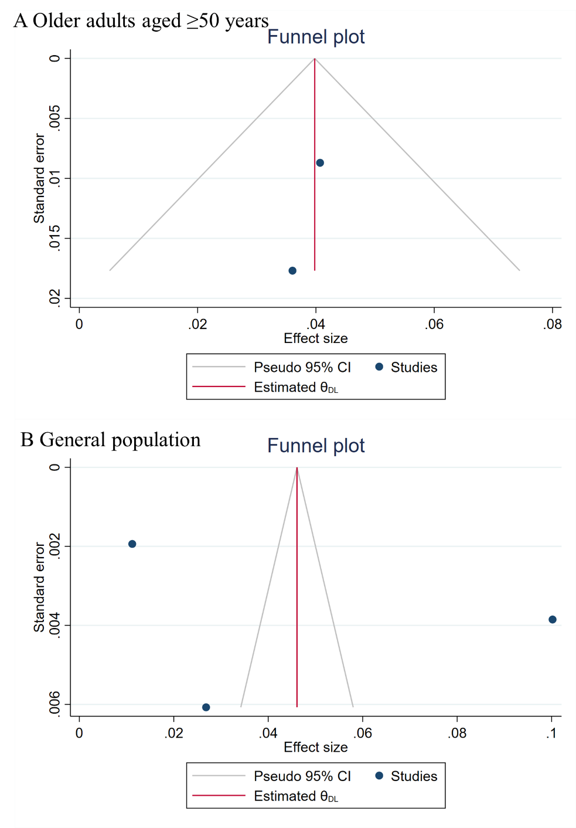

**Supplementary Figure 4. Funnel plots of stroke prevalence among older adults and general population living with HIV: (A) Older adults; (B) General population**



**Supplementary Figure 5. Funnel plots of stroke incidence (per 10,000 person-years) among adults living with HIV.**

Note: CI=confidence interval; HIV=human immunodeficiency virus.

**Supplementary Table 4. Univariable meta-regression of stroke incidence and study characteristics among adults living with HIV.**

|  |  |  |  |  |
| --- | --- | --- | --- | --- |
| Study Characteristic | Number of studies, n | Coefficient (95% CI) | p value | R2 |
| **Geographic region** |  |  |  | -11.23% |
| Africa | 1 | Ref. |  |  |
| Europe | 6 | -0.010 ( -0.029, 0.008) | 0.231 |  |
| America | 4 | -0.010 ( -0.029, 0.008) | 0.23 |  |
| Western Pacific Region | 1 | -0.010 ( -0.029, 0.009) | 0.243 |  |
| **World Bank Income level** |  |  |  | 33.41% |
| Lower-middle-income | 1 | Ref. |  |  |
| Upper-middle-income | 2 | -0.010 ( -0.027, 0.007) | 0.217 |  |
| High-income | 9 | -0.011 ( -0.028, 0.007) | 0.2 |  |
| **Median year of sampling (y)** | 12 | 0.000 ( 0.000, 0.000) | 0.082 | 31.99% |
| **ART proportion,%** | 10 | 0.000 ( 0.000, 0.000) | 0.959 | 78.16% |

Note: ART=antiretroviral therapy; CI=confidence interval.

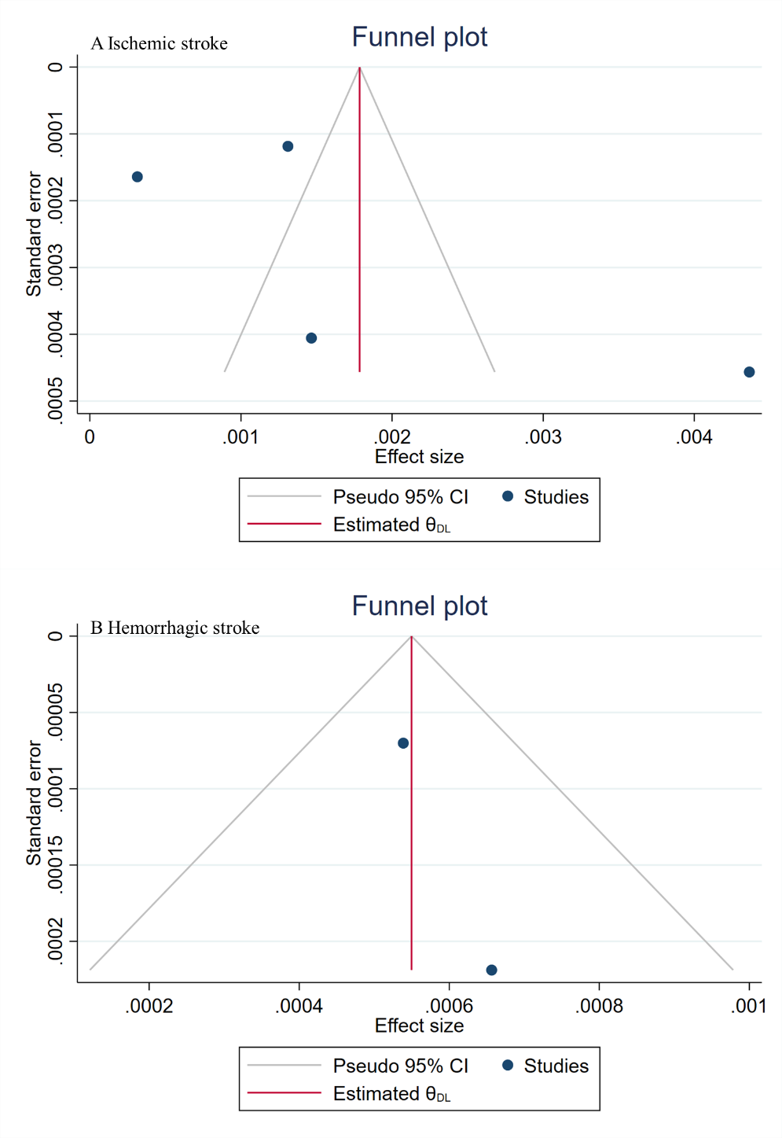

**Supplementary Figure 6. Funnel plots of ischemic stroke and hemorrhagic stroke incidence (per 10,000 person-years) among adults living with HIV.**

Note: CI=confidence interval; HIV=human immunodeficiency virus. A: Ischemic stroke; B: Hemorrhagic stroke.

**Reference**

1. Gooden TE, Gardner M, Wang J, Jolly K, Lane DA, Benjamin LA, et al. **Incidence of Cardiometabolic Diseases in People With and Without Human Immunodeficiency Virus in the United Kingdom: A Population-Based Matched Cohort Study**. *The Journal of infectious diseases* 2022; 225(8):1348-1356.

2. Sarfo FS, Norman B, Appiah L, Ovbiagele B. **Factors associated with incidence of stroke and heart failure among people living with HIV in Ghana: Evaluating Vascular Event Risk while on Long-Term Antiretroviral Suppressive Therapy (EVERLAST) Study**. *Journal of clinical hypertension (Greenwich, Conn)* 2021; 23(6):1252-1259.

3. Rerkasem A, Sripan P, Pongtam S, Ounjaijean S, Kulprachakarn K, Wongthanee A, et al. **The Prevalence and Risk Factors for Peripheral Arterial Disease in Adults Living With Human Immunodeficiency Virus**. *The international journal of lower extremity wounds* 2021:15347346211009404.

4. Patel UK, Malik P, Li Y, Habib A, Shah S, Lunagariya A, et al. **Stroke and HIV-associated neurological complications: A retrospective nationwide study**. *Journal of medical virology* 2021; 93(8):4915-4929.

5. Rosenson RS, Hubbard D, Monda KL, Reading SR, Chen L, Dluzniewski PJ, et al. **Excess Risk for Atherosclerotic Cardiovascular Outcomes Among US Adults With HIV in the Current Era**. *Journal of the American Heart Association* 2020; 9(1):e013744.

6. Kaplan A, Simon TG, Henson JB, Wang T, Zheng H, Osganian SA, et al. **Brief Report: Relationship Between Nonalcoholic Fatty Liver Disease and Cardiovascular Disease in Persons With HIV**. *Journal of acquired immune deficiency syndromes (1999)* 2020; 84(4):400-404.

7. Kamtchum-Tatuene J, Mwandumba H, Al-Bayati Z, Flatley J, Griffiths M, Solomon T, et al. **HIV is associated with endothelial activation despite ART, in a sub-Saharan African setting**. *Neurology(R) neuroimmunology & neuroinflammation* 2019; 6(2):e531.

8. Ryom L, Lundgren JD, El-Sadr W, Reiss P, Kirk O, Law M, et al. **Cardiovascular disease and use of contemporary protease inhibitors: the D:A:D international prospective multicohort study**. *The lancet HIV* 2018; 5(6):e291-e300.

9. Mayer KH, Loo S, Crawford PM, Crane HM, Leo M, DenOuden P, et al. **Excess Clinical Comorbidity Among HIV-Infected Patients Accessing Primary Care in US Community Health Centers**. *Public health reports (Washington, DC : 1974)* 2018; 133(1):109-118.

10. Kamtchum-Tatuene J, Al-Bayati Z, Mwandumba HC, Solomon T, Christmas SE, Benjamin LA. **Serum concentration of anti-Cytomegalovirus IgG and ischaemic stroke in patients with advanced HIV infection in Malawi**. *PloS one* 2018; 13(11):e0208040.

11. Yen YF, Jen I, Chen M, Chuang PH, Liu YL, Sharp GB, et al. **Association of cytomegalovirus end-organ disease with stroke in people living with HIV/AIDS: A nationwide population-based cohort study**. *PloS one* 2016; 11(3).

12. Kendall CE, Wong J, Taljaard M, Glazier RH, Hogg W, Younger J, et al. **A cross-sectional, population-based study measuring comorbidity among people living with HIV in Ontario**. *BMC public health* 2014; 14:161.

13. Okyere J, Ayebeng C, Owusu BA, Dickson KS. **Prevalence and factors associated with hypertension among older people living with HIV in South Africa**. *BMC public health* 2022; 22(1):1684.

14. Sauce D, Pourcher V, Ferry T, Boddaert J, Slama L, Allavena C. **Immune activation and chronic inflammation: Is there an additional effect of HIV in a geriatric population?** *Medicine* 2021; 100(17):e25678.

15. Jones BI, Freedman A, Thomas MJ, Villalba-Mendez C, Sathia L, Flanagan D, et al. **Comorbid diseases and conditions in people with HIV in the UK**. *Current medical research and opinion* 2022; 38(2):277-285.

16. Lin HL, Muo CH, Lin CY, Chen HJ, Chen PC. **Incidence of stroke in patients with HIV infection: A population-based study in Taiwan**. *PloS one* 2019; 14(5):e0217147.

17. Jowi JO, Mativo PM, Musoke SS. **Clinical and laboratory characteristics of hospitalised patients with neurological manifestations of HIV/AIDS at the Nairobi hospital**. *East African medical journal* 2007; 84(2):67-76.

18. Neesgaard B, Greenberg L, Miró JM, Grabmeier-Pfistershammer K, Wandeler G, Smith C, et al. **Associations between integrase strand-transfer inhibitors and cardiovascular disease in people living with HIV: a multicentre prospective study from the RESPOND cohort consortium**. *The lancet HIV* 2022; 9(7):e474-e485.

19. Hiransuthikul A, Chutinet A, Sophonphan J, Ubolyam S, Ruxrungtham K, Avihingsanon A, et al. **Incidence and Risk Factors of Ischemic Stroke and Transient Ischemic Attack Among People Living with HIV: A Longitudinal Cohort Study**. *AIDS research and human retroviruses* 2022; 38(2):131-134.

20. Elvstam O, Marrone G, Engström G, Nilsson PM, Carlander C, Treutiger CJ, et al. **Associations between HIV viremia during antiretroviral therapy and cardiovascular disease**. *AIDS (London, England)* 2022; 36(13):1829-1834.

21. Chammartin F, Darling K, Abela IA, Battegay M, Furrer H, Calmy A, et al. **CD4:CD8 Ratio and CD8 Cell Count and Their Prognostic Relevance for Coronary Heart Disease Events and Stroke in Antiretroviral Treated Individuals: The Swiss HIV Cohort Study**. *Journal of acquired immune deficiency syndromes (1999)* 2022; 91(5):508-515.

22. Sico JJ, Kundu S, So-Armah K, Gupta SK, Chang CH, Butt AA, et al. **Depression as a Risk Factor for Incident Ischemic Stroke Among HIV-Positive Veterans in the Veterans Aging Cohort Study**. *Journal of the American Heart Association* 2021; 10(13):e017637.

23. Harding BN, Avoundjian T, Heckbert SR, Whitney BM, Nance RM, Ruderman SA, et al. **HIV Viremia and Risk of Stroke Among People Living with HIV Who Are Using Antiretroviral Therapy**. *Epidemiology (Cambridge, Mass)* 2021; 32(3):457-464.

24. O'Halloran JA, Sahrmann J, Butler AM, Olsen MA, Powderly WG. **Brief Report: Integrase Strand Transfer Inhibitors Are Associated With Lower Risk of Incident Cardiovascular Disease in People Living With HIV**. *Journal of acquired immune deficiency syndromes (1999)* 2020; 84(4):396-399.

25. Oliveira RVC, Shimakura SE, Campos DP, Hökerberg YHM, Victoriano FP, Ribeiro S, et al. **Effects of antiretroviral treatment and nadir CD4 count in progression to cardiovascular events and related comorbidities in a HIV Brazilian cohort: a multi-stage approach**. *AIDS care* 2018; 30(5):551-559.

26. De Socio GV, Pucci G, Baldelli F, Schillaci G. **Observed versus predicted cardiovascular events and all-cause death in HIV infection: a longitudinal cohort study**. *BMC infectious diseases* 2017; 17(1):414.

27. Quiros-Roldan E, Raffetti E, Focà E, Brianese N, Ferraresi A, Paraninfo G, et al. **Incidence of cardiovascular events in HIV-positive patients compared to general population over the last decade: a population-based study from 2000 to 2012**. *AIDS care* 2016; 28(12):1551-1558.

28. Vinikoor MJ, Napravnik S, Floris-Moore M, Wilson S, Huang DY, Eron JJ. **Incidence and clinical features of cerebrovascular disease among HIV-infected adults in the Southeastern United States**. *AIDS research and human retroviruses* 2013; 29(7):1068-1074.

29. Parruti G, Vadini F, Sozio F, Mazzott E, Ursini T, Polill E, et al. **Psychological factors, including alexithymia, in the prediction of cardiovascular risk in HIV infected patients: results of a cohort study**. *PloS one* 2013; 8(1):e54555.

30. Chow FC, Regan S, Feske S, Meigs JB, Grinspoon SK, Triant VA. **Comparison of ischemic stroke incidence in HIV-infected and non-HIV-infected patients in a US health care system**. *Journal of acquired immune deficiency syndromes (1999)* 2012; 60(4):351-358.