Appendices
Appendix Table 1. Characteristics of patients at baseline, ART initiation, death, non-AIDS death, HIV-CAUSAL Collaboration 2005-2015.

 |  | General HIV population | U.S. Veterans
At baseline | N | 6927 | 2672
 | CD4 count | 354 [203,530] | 284 [128,471]
 | Calendar year | 2008 [2006,2011] | 2008 [2006,2010]
 | Age | 55 [52,59] | 56 [53,60]
 | HIV-RNA | 50946 [11700,207703] | 37859 [9653,112879]
At ART initiation | N | 5160 | 2087
 | CD4 count | 272 [171,375] | 229 [108,356]
 | HIV-RNA | 71559 [17000,220895] | 57600 [14652,161000]
At death | N | 295 | 339
 | CD4 count | 340 [180,498] | 225 [84,441]
 | HIV-RNA | 90 [40,20400] | 2392 [50,60500]
At non-AIDS death | N | 124 | 136
 | CD4 count | 360 [240,497] | 329 [179,520]
 | HIV-RNA | 50 [40,22803] | 344 [48,18323]

Appendix Table 2. Estimated 5-year risks of non-AIDS mortality under three ART initiation strategies assuming that deaths due to an unknown cause were non-AIDS deaths, HIV-CAUSAL Collaboration 2005-2015.

 |  | Non-AIDS mortality (main analysis) |  |  | Non-AIDS mortality (sensitivity analysis)
Population | ART initiation strategy | 5-year Risk, % (95% CI) | Risk difference (95% CI) | Risk ratio (95% CI) | 5-year Risk, % (95% CI) | Risk difference (95% CI) | Risk ratio (95% CI)
General HIV population (N=6927) | Immediate universal | 2.7% (2.1,3.4) | 0 (Ref.) | 1 (Ref.) | 3.8% (3.3,4.6) | 0 (Ref.) | 1 (Ref.)
 | <500 cells/mm³ | 2.8% (2.2,3.5) | 0.07 (-0.03,0.16) | 1.03 (0.99,1.06) | 3.9% (3.4,4.6) | 0.10 (-0.02,0.22) | 1.02 (1.1,1.06)
 | <350 cells/mm³ | 2.9% (2.3,3.7) | 0.17 (-0.07,0.43) | 1.06 (0.97,1.16) | 4.0% (3.7,4.8) | 0.21 (-0.05,0.61) | 1.05 (0.99,1.17)
US Veterans (N=2669) | Immediate universal | 6.6% (5.2,8.9) | 0 (Ref.) | 1 (Ref.) | 9.2% (8.2,11.5) | 0 (Ref.) | 1 (Ref.)
 | <500 cells/mm³ | 7.0% (5.6,9.2) | 0.40 (0.13,0.84) | 1.06 (1.02,1.13) | 9.6% (8.7,11.8) | 0.39 (0.17,0.61) | 1.04 (1.02,1.17)
 | <350 cells/mm³ | 7.6% (6.4,9.9) | 1.00 (0.31,2.00) | 1.15 (1.04,1.30) | 10.2% (9.0,12.3) | 1.03 (0.48,1.58) | 1.11 (1.05,1.18)

Appendix Figure 1. a. Mean of the all-cause mortality outcome and time-varying variables in the general HIV population: observed (solid line) and simulated via the parametric g-formula (dashed line).

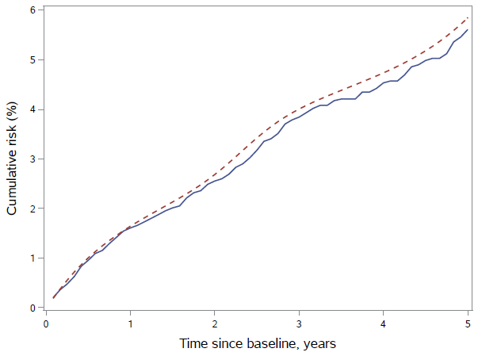 | 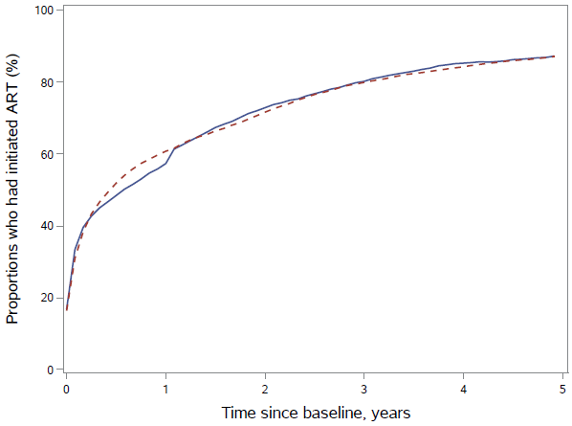
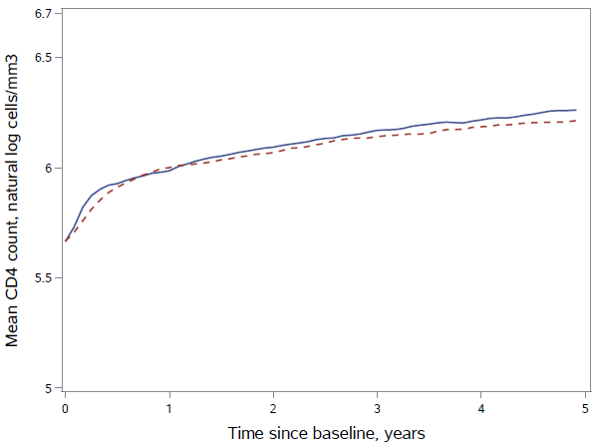 | 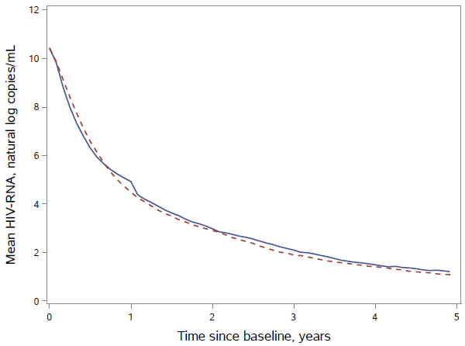
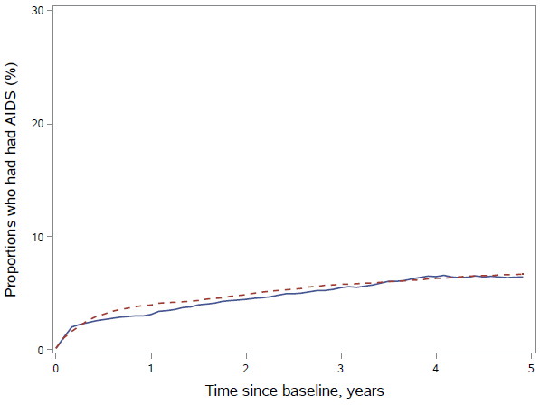 | 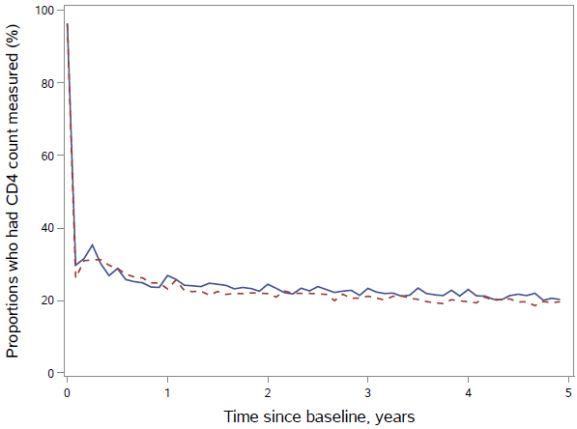

Appendix Figure 1. b. Mean of the all-cause mortality outcome and time-varying variables in the US Veteran population: observed (solid line) and simulated via the parametric g-formula (dashed line).

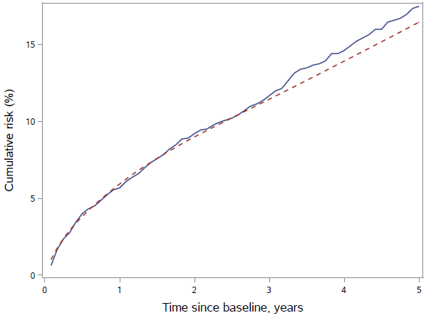 | 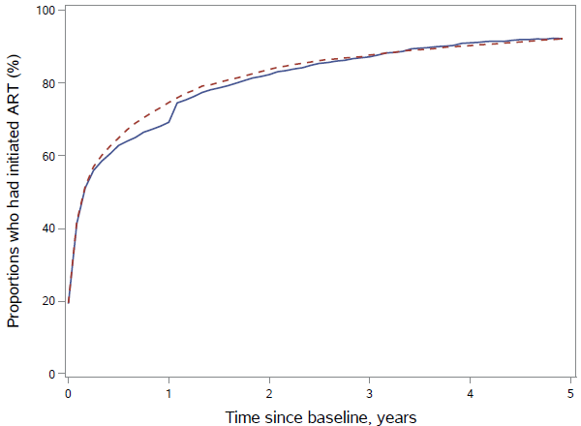
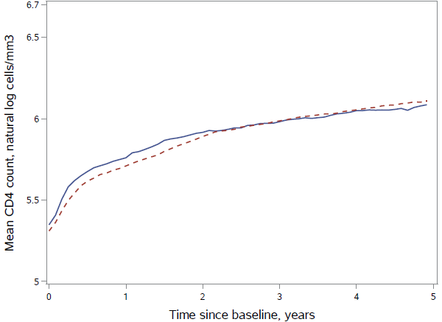 | 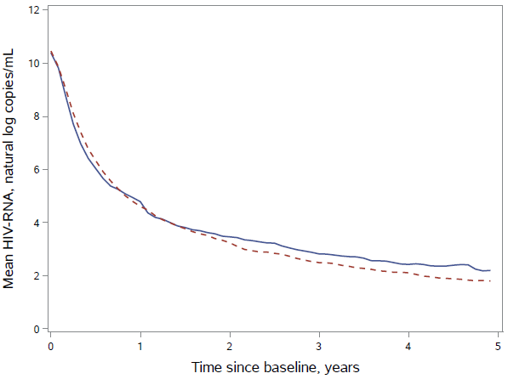
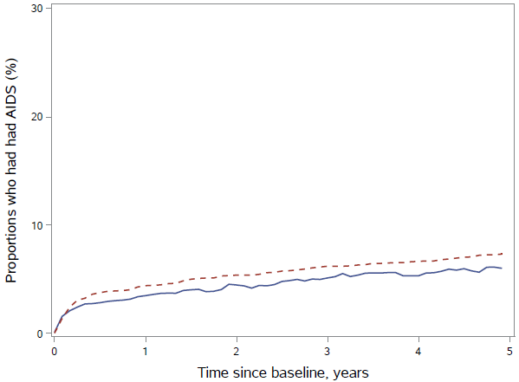 | 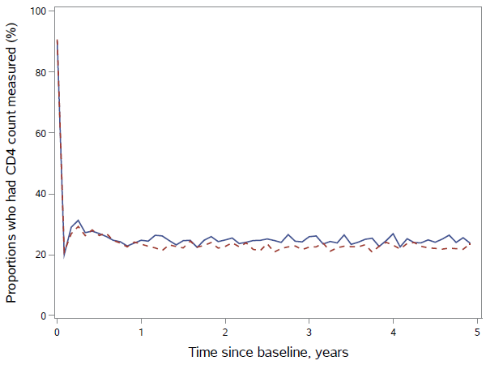

Appendix Figure 2. a. Mean of the non-AIDS mortality outcome and time-varying variables in the general HIV population: observed (solid line) and simulated via the parametric g-formula (dashed line).

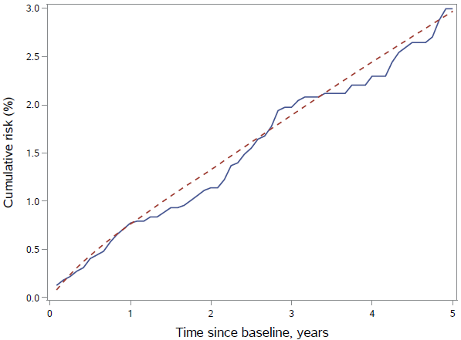 | 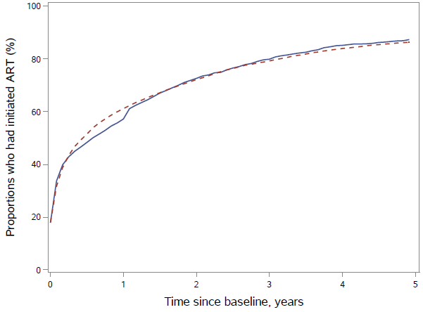
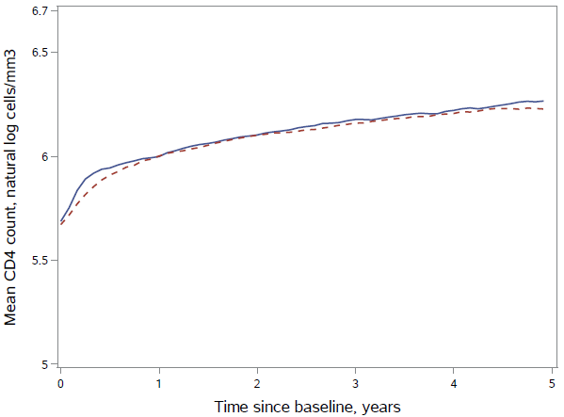 | 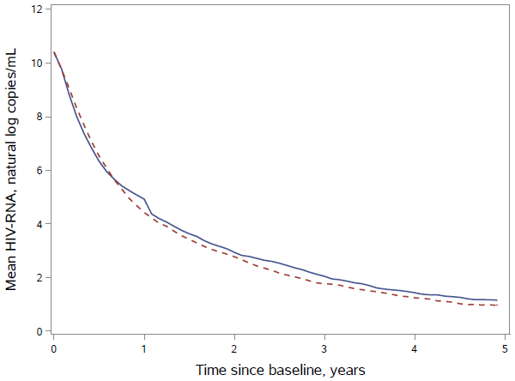
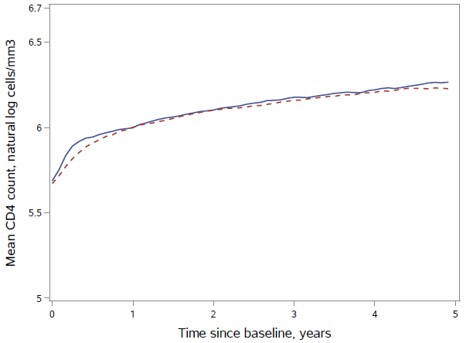 | 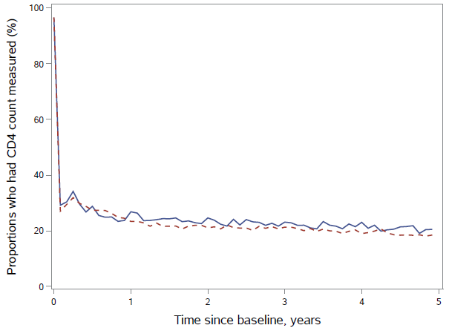

Appendix Figure 2. b. Mean of the non-AIDS mortality outcome and time-varying variables in the US Veteran population: observed (solid line) and simulated via the parametric g-formula (dashed line).

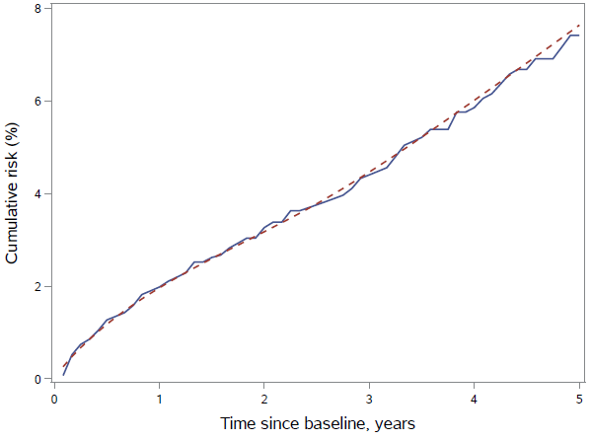 | 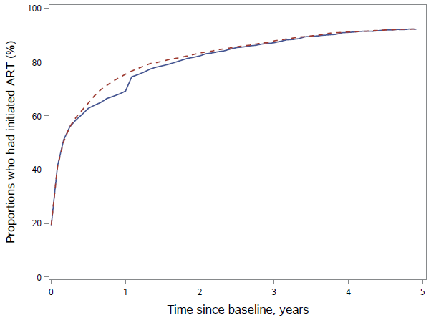
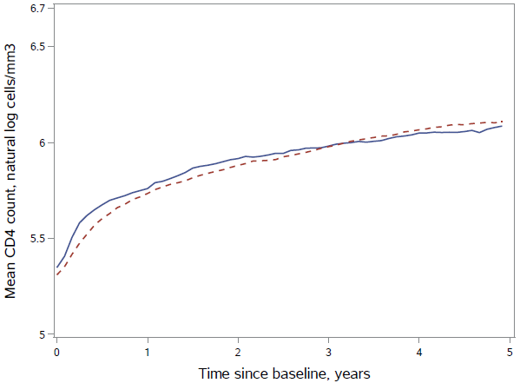 | 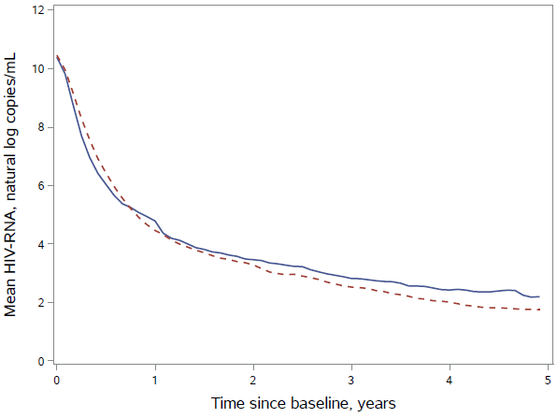
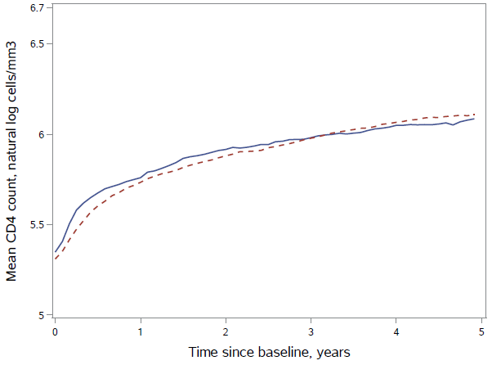 | 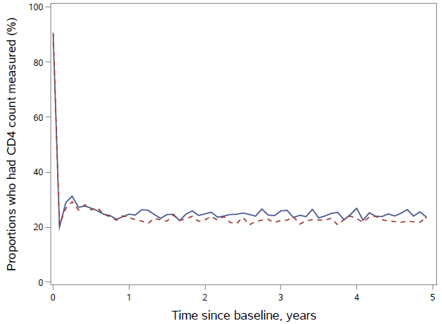

Appendix Figure 3. Mean of the all-cause mortality outcome and time-varying variables in the general HIV population with baseline CD4 cell count≥500 cells/mm³: observed (solid line) and simulated via the parametric g-formula (dashed line).
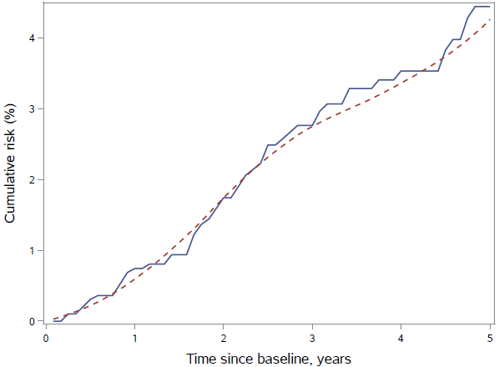 | 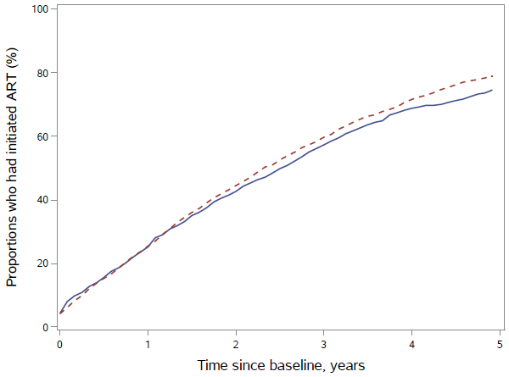
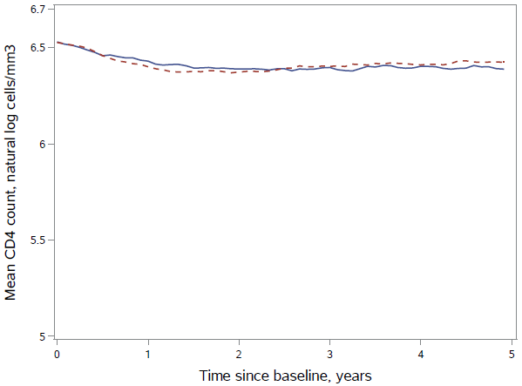 | 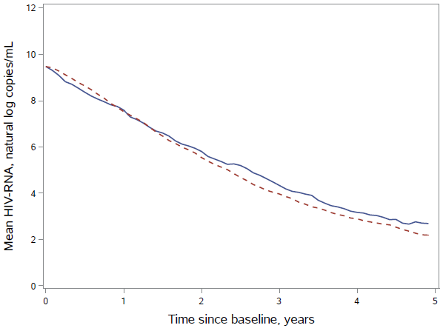
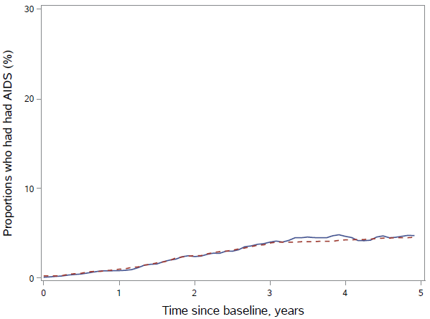 | 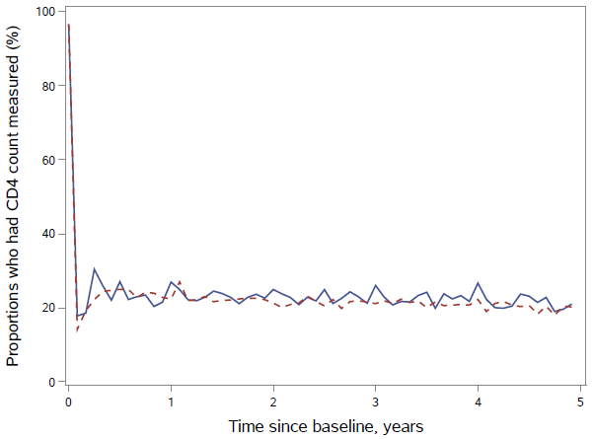

Appendix 5
Contributors to the HIV-CAUSAL Collaboration

AMACS
Steering Committee: Antoniadou A., Chrysos G., Daikos G., Gargalianos-Kakolyris P., Gogos HA., Katsarou O., Kordossis T., Lazanas M., Nikolaidis P., Panos G., Paparizos V., Paraskevis D., Sambatakou H., Skoutelis A., Touloumi G. (Chair). Coordinating Center: Department of Hygiene, Epidemiology and Medical Statistics, Athens University Medical School, Greece (Touloumi G., Pantazis N., Vourli G., Gountas I., Gioukari V.)
Participating Centers: 4th Dept of Internal Medicine, Athens Medical School, Attikon University Hospital (Antoniadou A, Papadopoulos A, Petrikkos G); Infectious Disease Unit, “Tzaneio” General Hospital of Pireaus (Chrysos G, Paraskeva D, Hatziastros P); 1st Dept of Propedeutic Medicine, Athens University, Medical School “Laikon” General Hopsital (Daikos G, Psichogiou M); 1st Dept of Medicine, Infectious Diseases Unit, "G. Gennimatas" Athens General Hospital (Gargalianos-Kakolyris P, Xylomenos G); 1st Dept of Internal Medicine, Infectious Diseases Section, Patras University Hospital (Gogos HA, Marangos MN, Panos G); Haemophilia Centre, 2nd Blood Transfusion Centre, “Laikon” Athens General Hospital (Katsarou O, Kouramba A, Ioannidou P); AIDS Unit, Dept of Pathophysiology, “Laikon” Athens General Hospital and Athens University, Medical School (Kordossis T, Kontos A); Infectious Diseases Unit, Red Cross General Hospital of Athens (Lazanas M, Chini M, Tsogas N); 1st Dept of Internal Medicine, Infectious Diseases Devision, AHEPA University Hospital, Aristotle University HIV Unit (Nikolaidis P, Kolaras P, Metallidis S); 2nd Internal Medicine Clinic, 1st IKA (Panos G, Haratsis G); AIDS Unit, Clinic of Venereologic & Dermatologic Diseases, Athens University, Medical School, Syngros Hospital (Paparizos V, Leuow K, Kourkounti S); HIV Unit, 2nd Dpt. of Internal Medicine, Athens University, Medical School, Hippokration General Hospital (Sambatakou H, Mariolis I); Infectious Diseases & HIV Division, Dept of Internal Medicine, Evaggelismos Athens General Hospital (Skoutelis A, Papastamopoulos V, Baraboutis I).

AQUITAINE
Principal investigator: Pr F. Dabis. Scientific committee: Prs F. Bonnet, D. Breilh, F. Dabis, M. Dupon, G. Chêne, H. Fleury, D. Malvy, P. Mercié, I. Pellegrin, P. Morlat, D. Neau, JL. Pellegrin, R. Thiébaut; Drs S. Bouchet, V. Gaborieau, D. Lacoste, S. Tchamgoué. Epidemiology and biostatistics: Prs G. Chêne, F. Dabis, R. Thiébaut, Drs M. Bruyand, S. Lawson-Ayayi, L. Wittkop. Clinical and biological hospital units: Bordeaux University Hospital: Pr P. Morlat (Pr F. Bonnet, Drs N. Bernard, M. Hessamfar, D. Lacoste, MA. Vandenhende); Pr M. Dupon (Drs FA. Dauchy, H. Dutronc), Pr M. Longy-Boursier (Pr P. Mercié, Drs P. Duffau, J. Roger Schmeltz), Pr D. Malvy (Drs T. Pistone, MC Receveur), Pr D. Neau (Drs C. Cazanave, A. Ochoa, MO. Vareil), Pr JL. Pellegrin (Pr JF. Viallard, Drs C. Greib, E. Lazaro); Pr H. Fleury (Pr ME. Lafon, Drs S. Reigadas, P. Trimoulet); Pr D. Breilh; Pr M. Molimard (Drs S. Bouchet, K. Titier); Pr JF. Moreau (Dr I. Pellegrin); Drs F. Haramburu, G. Miremont-Salamé. Arcachon Hospital: Dr A. Dupont. Dax Hospital: Dr Y. Gerard (Drs L. Caunègre, K. André). Bayonne Hospital: Dr F. Bonnal (Drs S. Farbos, MC. Gemain). Libourne Hospital: Dr J. Ceccaldi (Dr S. Tchamgoué). Mont-de-Marsan Hospital: Dr S. De Witte (Dr C. Courtault). Pau Hospital: Drs E. Monlun (Dr V. Gaborieau). Périgueux Hospital: Dr P. Lataste (Dr JP. Meraud). Villeneuve-sur-Lot Hospital: Dr I. Chossat. Permanent team: MJ. Blaizeau, M. Bruyand, V. Conte, M. Decoin, J. Delaune, S. Delveaux, F. Diarra, C. D’Ivernois, A. Frosch, S. Geffard, C. Hannapier, S. Lawson-Ayayi, E. Lenaud, O. Leleux, F. Le Marec, J. Leray, I. Louis, G. Palmer, A. Pougetoux, X. Sicard, D. Touchard B. Uwamaliya-Nziyumvira.

ATHENA
The ATHENA database is maintained by Stichting HIV Monitoring and supported by a grant from the Dutch Ministry of Health, Welfare and Sport through the Centre for Infectious Disease Control of the National Institute for Public Health and the Environment. CLINICAL CENTRES (* denotes site coordinating physician). Academic Medical Centre of the University of Amsterdam: HIV treating physicians: J.M. Prins*, T.W. Kuijpers, H.J. Scherpbier, J.T.M. van der Meer, F.W.M.N. Wit, M.H. Godfried, P. Reiss, T. van der Poll, F.J.B. Nellen, S.E. Geerlings, M. van Vugt, D. Pajkrt, W.J. Wiersinga, M. van der Valk, A. Goorhuis, J.W. Hovius. HIV nurse consultants: M.A.H. Bijsterveld, J. van Eden, A.M.H. van Hes, M. Mutschelknauss, H.E. Nobel, F.J.J. Pijnappel, A.M. Weijsenfeld. HIV clinical virologists/chemists: S. Jurriaans, N.K.T. Back, H.L. Zaaijer, B. Berkhout, M.T.E. Cornelissen, C.J. Schinkel, X.V. Thomas. Admiraal De Ruyter Ziekenhuis, Goes: HIV treating physicians: M. van den Berge, A. Stegeman. HIV nurse consultants: S. Baas, L. Hage de Looff. HIV clinical virologists/chemists: B Wintermans, J Veenemans. Catharina Ziekenhuis, Eindhoven: HIV treating physicians: M.J.H. Pronk*, H.S.M. Ammerlaan. HIV nurse consultants: E.S. de Munnik, E. van Beek. HIV clinical virologists/chemists: A.R. Jansz, J. Tjhie, M.C.A. Wegdam, B. Deiman, V. Scharnhorst. Elisabeth-TweeSteden Ziekenhuis, Tilburg: HIV treating physicians: M.E.E. van Kasteren*, A.E. Brouwer. HIV nurse consultants: R. van Erve, B.A.F.M. de Kruijf-van de Wiel, S.Keelan-Pfaf, B. van der Ven. Data collection: B.A.F.M. de Kruijf-van de Wiel, B. van der Ven. HIV clinical virologists/chemists: A.G.M. Buiting, P.J. Kabel, D.Versteeg. Emma Kinderziekenhuis: HIV nurse consultants: A. van der Plas, A.M. Weijsenfeld. Erasmus MC, Rotterdam: HIV treating physicians: M.E. van der Ende*, H.I. Bax, E.C.M. van Gorp, J.L. Nouwen, B.J.A. Rijnders, C.A.M. Schurink, A. Verbon, T.E.M.S. de Vries-Sluijs. HIV nurse consultants: N. Bassant, J.E.A. van Beek, M. Vriesde, L.M. van Zonneveld. Data collection: H.J. van den Berg-Cameron, F.B. Bruinsma-Broekman, J. de Groot, M. de Zeeuw-de Man. HIV clinical virologists/chemists: C.A.B. Boucher, M.P.G Koopmans, J.J.A van Kampen, S.D. Pas. Erasmus MC–Sophia, Rotterdam: HIV treating physicians: G.J.A. Driessen, A.M.C. van Rossum. HIV nurse consultants: L.C. van der Knaap, E. Visser. Flevoziekenhuis, Almere: HIV treating physicians: J. Branger*, A. Rijkeboer-Mes. HIV nurse consultant and data collection: C.J.H.M. Duijf-van de Ven. HagaZiekenhuis, Den Haag: HIV treating physicians: E.F. Schippers*, C. van Nieuwkoop. HIV nurse consultants: J.M. van IJperen, J. Geilings. Data collection: G. van der Hut. HIV clinical virologist/chemist: P.F.H. Franck. HIV Focus Centrum (DC Klinieken): HIV treating physicians: A. van Eeden*. HIV nurse consultants: W. Brokking, M. Groot, L.J.M. Elsenburg. HIV clinical virologists/chemists: M. Damen, I.S. Kwa. Isala, Zwolle: HIV treating physicians: P.H.P. Groeneveld*, J.W. Bouwhuis. HIV nurse consultants: J.F. van den Berg, A.G.W. van Hulzen. Data collection: G.L. van der Bliek, P.C.J. Bor. HIV clinical virologists/chemists: P. Bloembergen, M.J.H.M. Wolfhagen, G.J.H.M. Ruijs. Leids Universitair Medisch Centrum, Leiden: HIV treating physicians: F.P. Kroon*, M.G.J. de Boer, H. Jolink, A.M. Vollaard. HIV nurse consultants: W. Dorama, N. van Holten. HIV clinical virologists/chemists: E.C.J. Claas, E. Wessels. Maasstad Ziekenhuis, Rotterdam: HIV treating physicians: J.G. den Hollander*, K. Pogany, A. Roukens. HIV nurse consultants: M. Kastelijns, J.V. Smit, E. Smit, D. Struik-Kalkman, C. Tearno. Data collection: M. Bezemer, T. van Niekerk. HIV clinical virologists/chemists: O. Pontesilli. Maastricht UMC+, Maastricht: HIV treating physicians: S.H. Lowe*, A.M.L. Oude Lashof, D. Posthouwer. HIV nurse consultants: R.P. Ackens, J. Schippers, R. Vergoossen. Data collection: B. Weijenberg-Maes. HIV clinical virologists/chemists: I.H.M. van Loo, T.R.A. Havenith. MCH-Bronovo, Den Haag: HIV treating physicians: E.M.S. Leyten*, L.B.S. Gelinck. HIV nurse consultants: A.Y. van Hartingsveld, C. Meerkerk, G.S. Wildenbeest. HIV clinical virologists/chemists: J.A.E.M. Mutsaers, S.Q. van Veen. MC Slotervaart, Amsterdam: HIV treating physicians: J.W. Mulder*, S.M.E. Vrouenraets, F.N. Lauw. HIV nurse consultants: M.C. van Broekhuizen, H. Paap, D.J. Vlasblom. HIV clinical virologists/chemists: P.H.M. Smits. MC Zuiderzee, Lelystad: HIV treating physicians: S. Weijer*, R. El Moussaoui. HIV nurse consultant: A.S. Bosma. Medisch Centrum Leeuwarden, Leeuwarden: HIV treating physicians: M.G.A.van Vonderen*, D.P.F. van Houte, L.M. Kampschreur. HIV nurse consultants: K. Dijkstra, S. Faber. HIV clinical virologists/chemists: J Weel. Medisch Spectrum Twente, Enschede: HIV treating physicians: G.J. Kootstra*, C.E. Delsing. HIV nurse consultants: M. van der Burg-van de Plas, H. Heins. Data collection: E. Lucas. Noordwest Ziekenhuisgroep, Alkmaar: HIV treating physicians: W. Kortmann*, G. van Twillert*, J.W.T. Cohen Stuart, B.M.W. Diederen, R. Renckens. HIV nurse consultant and data collection: D. Ruiter-Pronk, F.A. van Truijen-Oud. HIV clinical virologists/chemists: W. A. van der Reijden, R. Jansen. OLVG, Amsterdam: HIV treating physicians: K. Brinkman*, G.E.L. van den Berk, W.L. Blok, P.H.J. Frissen, K.D. Lettinga W.E.M. Schouten, J. Veenstra. HIV nurse consultants: C.J. Brouwer, G.F. Geerders, K. Hoeksema, M.J. Kleene, I.B. van der Meché, M. Spelbrink, H. Sulman, A.J.M. Toonen, S. Wijnands. HIV clinical virologists: M. Damen, D. Kwa. Data collection: E. Witte. Radboudumc, Nijmegen: HIV treating physicians: R. van Crevel*, M. Keuter, A.J.A.M. van der Ven, H.J.M. ter Hofstede, A.S.M. Dofferhoff. HIV nurse consultants: M. Albers, K.J.T. Grintjes-Huisman, M. Marneef, A. Hairwassers. HIV clinical virologists/chemists: J. Rahamat-Langendoen. HIV clinical pharmacology consultant: D. Burger. Rijnstate, Arnhem: HIV treating physicians: E.H. Gisolf*, R.J. Hassing, M. Claassen. HIV nurse consultants: G. ter Beest, P.H.M. van Bentum, N. Langebeek. HIV clinical virologists/chemists: R. Tiemessen, C.M.A. Swanink. Spaarne Gasthuis, Haarlem: HIV treating physicians: S.F.L. van Lelyveld*, R. Soetekouw. HIV nurse consultants: L.M.M. van der Prijt, J. van der Swaluw. Data collection: N. Bermon. HIV clinical virologists/chemists: W.A. van der Reijden, R. Jansen, B.L. Herpers, D.Veenendaal. Medisch Centrum Jan van Goyen, Amsterdam: HIV treating physicians: D.W.M. Verhagen. HIV nurse consultants: M. van Wijk. Universitair Medisch Centrum Groningen, Groningen: HIV treating physicians: W.F.W. Bierman*, M. Bakker, J. Kleinnijenhuis, E. Kloeze, H. Scholvinck, Y. Stienstra, C.L. Vermont, K.R. Wilting. HIV nurse consultants: A. Boonstra, H. de Groot-de Jonge, P.A. van der Meulen, D.A. de Weerd. HIV clinical virologists/chemists: H.G.M. Niesters, C.C. van Leer-Buter, M. Knoester. Universitair Medisch Centrum Utrecht, Utrecht: HIV treating physicians: A.I.M. Hoepelman*, J.E. Arends, R.E. Barth, A.H.W. Bruns, P.M. Ellerbroek, T. Mudrikova, J.J. Oosterheert, E.M. Schadd, M.W.M. Wassenberg, M.A.D. van Zoelen. HIV nurse consultants: K. Aarsman, D.H.M. van Elst-Laurijssen, E.E.B. van Oers-Hazelzet. Data collection: M. van Berkel. HIV clinical virologists/chemists: R. Schuurman, F. Verduyn-Lunel, A.M.J. Wensing. VUmc, Amsterdam: HIV treating physicians: E.J.G. Peters*, M.A. van Agtmael, M. Bomers, J. de Vocht. HIV nurse consultants: M. Heitmuller, L.M. Laan. HIV clinical virologists/chemists: C.W. Ang, R. van Houdt, A.M. Pettersson, C.M.J.E. Vandenbroucke-Grauls. Wilhelmina Kinderziekenhuis, UMCU, Utrecht: HIV treating physicians: S.P.M. Geelen, T.F.W. Wolfs, L.J. Bont. HIV nurse consultants: N. Nauta. COORDINATING CENTRE. Director: P. Reiss. Data analysis: D.O. Bezemer, A.I. van Sighem, C. Smit, F.W.M.N. Wit, T.S. Boender. Data management and quality control: S. Zaheri, M. Hillebregt, A. de Jong. Data monitoring: D. Bergsma, A. de Lang, S. Grivell, A. Jansen, M.J. Rademaker, M. Raethke, R. Meijering, S. Schnörr. Data collection: L. de Groot, M. van den Akker, Y. Bakker, E. Claessen, A. El Berkaoui, J. Koops, E. Kruijne, C. Lodewijk, L. Munjishvili, B. Peeck, C. Ree, R. Regtop, Y. Ruijs, T. Rutkens, L. van de Sande, M. Schoorl, A. Timmerman, E. Tuijn, L. Veenenberg, S. van der Vliet, A. Wisse, T. Woudstra. Patient registration: B. Tuk.

CoRIS/CoRIS-MD
Steering committee: S Moreno, J del Amo, D Dalmau, ML Navarro, MI González, JL Blanco, F Garcia, R Rubio, JA Iribarren, F Gutiérrez, F Vidal, J Berenguer, J González. Field work, data management, and statistical analyses: P Sobrino, I Jarrín, B Alejos, V Hernando, D Alvarez, C Moreno. Participating centres: Hospital General Universitario de Alicante, Alicante (J Portilla, E Merino, S Reus, V Boix, L Giner, C Gadea, I Portilla, M Pampliega, M Díez, JC Rodríguez, J Sánchez-Payá) ; Hospital Universitari de Bellvitge, Badalona (D Podzamczer, E Ferrer, A Imaz, E Van Den Eyncle, S Di Yacovo, M Sumoy); Hospital Universitario de Canarias, Santa Cruz de Tenerife (JL Gómez, J Hernández, MR Alemán, MM Alonso, MI Hernández, F Díaz-Flores, D García, R Pelazas) ; Hospital Universitario Central de Asturias, Oviedo (V Asensi, E Valle, JA Cartón); Hospital Clínico San Carlos, Madrid (V Estrada, MJ Téllez, J Vergas, E Pérez-Cecila); Hospital Doce de Octubre, Madrid (R Rubio, F Pulido, O Bisbal, M Matarranz, M Lagarde, R Rubio-Martín, A Hernando, L Bermejo, L Dominguez); Hospital Universitario Donostia, San Sebastián (JA Iribarren, J Arrizabalaga, MJ Aramburu, X Camino, F Rodríguez-Arrondo, MÁ von Wichmann, L Pascual, MÁ Goenaga, MJ Bustinduy, H Azkune, M Ibarguren, M Aguado, M Umerez); Hospital General Universitario de Elche, Elche (F Gutiérrez, M Masiá, C López, S Padilla, A Navarro, F Montolio, C Robledano, JG Colomé, A Adsuar, R Pascual, F Carlos, M Martinez, J Llenas, M Fernández, E García); Hospital Germans Trías i Pujol, Badalona (R Muga, J Tor, A Sanvisens); Hospital General Universitario Gregorio Marañón, Madrid (J Berenguer, JC López Bernaldo de Quirós, P Miralles, I Gutiérrez, M Ramírez, B Padilla, P Gijón, A Carrero, T Aldamiz-Echevarría, F Tejerina, FJ Parras, P Balsalobre, C Diez; Hospital Universitari de Tarragona Joan XXIII, IISPV, Universitat Rovira i Virgili, Tarragona (F Vidal, J Peraire, C Viladés, S Veloso, M Vargas, M López-Dupla, M Olona, A Aguilar, JJ Sirvent, V Alba, O Calavia; Hospital Universitario La Fe, Valencia (M Montero, J Lacruz, M Blanes, E Calabuig, S Cuellar, J López, M Salavert) ; Hospital Universitario La Paz/IdiPaz, Madrid (J González, I Bernardino, JR Arribas, ML Montes, JM Peña, B Arribas, JM Castro, FJ Zamora, I Pérez, M Estébanez, S García, M Díaz, NS Alcáriz, J Mingorance, D Montero, A González, MI de José); Hospital de la Princesa, Madrid (I de los Santos, J Sanz, A Salas, C Sarriá, A Gómez-Berrocal, L Garcia-Fraile; Hospital San Pedro-CIBIR, Logroño (JA Oteo, JR Blanco, V Ibarra, L Metola, M Sanz, L Pérez-Martínez) ; Hospital Universitario Miguel Servet, Zaragoza (A Pascual, C Ramos, P Arazo, D Gil); Hospital Universitari Mutua de Terrassa, Terrassa (D Dalmau, A Jaén, M Cairó, D Irigoyen, Q Jordano, M Xercavins, J Martinez-Lacasa, P Velli, R Font, M Sanmartí, L Ibáñez; Complejo Hospitalario de Navarra, Pamplona (M Rivero, MI Casado, JA Díaz, J Uriz, J Repáraz, C Irigoyen, MJ Arraiza); Hospital Parc Taulí, Sabadell (F Segura, MJ Amengual, G Navarro, M Sala, M Cervantes, V Pineda, V Segura, M Navarro, E Antón, MM Nogueras); Hospital Ramón y Cajal, Madrid (S Moreno, JL Casado, F Dronda, A Moreno, MJ Pérez Elías, D López, C Gutiérrez, N Madrid, A Lamas, P Martí, A de Diaz, S Serrrano, L Donat); Hospital Reina Sofía, Murcia (A Cano, E Bernal, Á Muñoz); Hospital San Cecilio, Granada (F García, J Hernández, A Peña, L Muñoz, J Parra, M Alvarez, N Chueca, V Guillot, D Vinuesa, JA Fernández); Centro Sanitario Sandoval, Madrid (J Del Romero, C Rodríguez, T Puerta, JC Carrió, M Vera, J Ballesteros); Hospital de la Santa Creu i Sant Pau, Barcelona (P Domingo, MA Sambeat, K Lamarca, G Mateo, M Gutiérrez, I Fernández); Hospital Universitario Santiago de Compostela, Santiago de Compostela (A Antela, E Losada); Hospital Son Espases, Palma de Mallorca (M Riera, M Peñaranda, M Leyes, MA Ribas, AA Campins, C Vidal, L Gil, F Fanjul, C Marinescu); Hospital Universitari Vall d´Hebron, Barcelona (E Ribera); Hospital Virgen de la Victoria, Málaga (J Santos, M Márquez, I Viciana, R Palacios, I Pérez, CM González); Hospital Universitario Virgen del Rocío, Sevilla (P Viciana, M Leal, LF López-Cortés, N Espinosa); Hospital Universitario de Basurto, Bilbao (J Muñoz, M Zuriñe Zubero, J Mirena, S Ibarra, O Ferrero, J López de Munain, MM Cámara, I López, M de la Peña); Hospital Universitario Infanta Sofía, San Sebastián de los Reyes (I Suárez-García, E Malmierca); Hospital Universitario Costa del Sol, Marbella (J Olalla, A del Arco, J de la Torre, JL Prada, Z Caracuel); Hospital del Poniente, El Ejido (AM Lopez-Lirola, AB Lozano, E Fernández, I Pérez, JM Fernández); Hospital Universitario Santa Lucia, Cartagena (OJ Martínez, FJ Vera, L Martínez, J García, B Alcaraz, A Jimeno); INIBIC-Complejo Hospitalario Universitario de A Coruña, A Coruña (E Poveda, B Pernas, A Mena, M Grandal, A Castro, JD Pedreira); Hospital Clínico Universitario Virgen de la Arrixaca, Murcia (C Galera, H Albendin, A Iborra, A Moreno, MA Campillo, A Vidal); Hospital Marina Baixa, Villajoyosa (C Amador, F Pasquau, J Ena, C Benito, V Fenoll); Complejo Hospitalario de Jaén, Jaén (MO Mohamed-Balghata, MA Gómez); Hospital San Agustín de Avilés, Avilés (MA de Zarraga, ME Rivas); Fundación Jiménez Diaz,Madrid (M Górgolas).

FHDH-ANRS CO4
Scientific committee: S Abgrall, F Barin, M Bentata, E Billaud, F Boué, C Burty, A Cabié, D Costagliola, L Cotte, P De Truchis, X Duval, C Duvivier, P Enel, L Fredouille-Heripret, J Gasnault, C Gaud, J Gilquin, S Grabar, C. Katlama, MA Khuong, JM Lang, AS Lascaux, O Launay, A Mahamat, M Mary-Krause, S Matheron, JL Meynard, J Pavie, G Pialoux, F Pilorgé, I Poizot-Martin, C Pradier, J Reynes, E Rouveix, A Simon, P Tattevin, H Tissot-Dupont, JP Viard, N Viget. DMI2 coordinating center: French Ministry of Health (Valérie Salomon), Technical Hospitalization Information Agency, ATIH (N Jacquemet). Statistical analysis center: U943 INSERM et UPMC (S Abgrall, D Costagliola, S Grabar, M Guiguet, E Lanoy, L Lièvre, M Mary-Krause, H Selinger-Leneman), INSERM Transfert (JM Lacombe, V Potard). COREVIH: Paris area: Corevih Ile de France Centre (GH Pitié-Salpétrière: F Bricaire, S Herson, C Katlama, A Simon; Hôpital Saint-Antoine: N Desplanque, PM Girard, JL Meynard, MC Meyohas, O Picard; Hôpital Tenon: J Cadranel, C Mayaud, G Pialoux), Corevih Ile de France Est (Hôpital Saint-Louis: JP Clauvel, JM Decazes, L Gerard, JM Molina; GH Lariboisière-Fernand Widal: M Diemer, P Sellier; Hôpital Avicenne: M Bentata, P Honoré; Hôpital Jean Verdier: V Jeantils, S Tassi; Hôpital Delafontaine: D Mechali, B Taverne), Corevih Ile de France Nord (Hôpital Bichat-Claude Bernard: E Bouvet, B Crickx, JL Ecobichon, S Matheron, C Picard-Dahan, P Yeni), Corevih Ile de France Ouest (Hôpital Ambroise Paré: H Berthé, C Dupont; Hôpital Louis Mourier: C Chandemerle, E Mortier; Hôpital Raymond Poincaré: P de Truchis), Corevih Ile de France Sud (Hôpital Européen Georges Pompidou: D Tisne-Dessus, L Weiss; GH Tarnier-Cochin: D Salmon; Hôpital Saint-Joseph: I Auperin, J Gilquin; Hôpital Necker adultes: L Roudière, JP Viard; Hôpital Antoine Béclère: F Boué, R Fior; Hôpital de Bicêtre: JF Delfraissy, C Goujard; Hôpital Henri Mondor: C Jung, Ph Lesprit; Hôpital Paul Brousse: D Vittecoq). Outside Paris area: Corevih Alsace (CHRU de Strasbourg: P Fraisse, JM Lang, D Rey; CH de Mulhouse: G Beck-Wirth), Corevih de l’Arc Alpin (CHU de Grenoble: JP Stahl, P Lecercq), Corevih Auvergne-Loire (CHU de Clermont-Ferrand: F Gourdon, H Laurichesse; CHRU de Saint-Etienne: A Fresard, F Lucht); Corevih Basse-Normandie (CHRU de Caen: C Bazin, R Verdon), Corevih Bourgogne (CHRU de Dijon: P Chavanet), Corevih Bretagne (CHU de Rennes: C Arvieux, C Michelet), Corevih Centre (CHRU de Tours: P Choutet, A Goudeau, MF Maître), Corevih Franche-Comté (CHRU de Besançon: B Hoen; CH de Belfort: P Eglinger, JP Faller); Corevih Haute-Normandie (CHRU de Rouen: F Borsa-Lebas, F Caron), Corevih Languedoc-Roussillon (CHU de Montpellier: J Reynes; CHG de Nîmes: JP Daures), Corevih Lorraine (Nancy Hôpital de Brabois: T May, C Rabaud; CHRU de Reims: JL Berger, G Rémy), Corevih de Midi-Pyrénées (Toulouse CHU Purpan: E Arlet-Suau, L Cuzin, P Massip, MF Thiercelin Legrand; Toulouse Hôpital la Grave: G Pontonnier; Toulouse CHU Rangueil), Corevih Nord-Pas de Calais (CH de Tourcoing: N Viget, Y Yasdanpanah), Corevih PACA Est (Nice Hôpital Archet 1: P Dellamonica, C Pradier, P Pugliese; CHG Antibes-Juan les Pins: K Aleksandrowicz, D Quinsat), Corevih PACA Ouest (Marseille Hôpital de la Conception: I Ravaux, H Tissot-Dupont; Marseille Hôpital Nord: JP Delmont, J Moreau; Marseille Institut Paoli Calmettes: JA Gastaut; Marseille Hôpital Sainte-Marguerite: I Poizot-Martin, F Retornaz, J Soubeyrand; Marseille Centre pénitentiaire des Baumettes: A Galinier, JM Ruiz; CHG d’Aix-En-Provence: T Allegre, PA Blanc; CH d’Arles: D Bonnet-Montchardon; CH d’Avignon: G Lepeu; CH de Digne Les Bains: P Granet-Brunello; CH de Gap: JP Esterni, L Pelissier; CH de Martigues: R Cohen-Valensi, M Nezri; CHI de Toulon: S Chadapaud, A Laffeuillade), Corevih Pays de la Loire (CHRU de Nantes: E Billaud, F Raffi), Corevih de la Vallée du Rhône (Lyon Hôpital de la Croix-Rousse: A Boibieux, D Peyramond; Lyon Hôpital Edouard Herriot: JM Livrozet, JL Touraine; Lyon Hôtel-Dieu: L Cotte, C Trepo). Overseas: Corevih Guadeloupe (CHRU de Pointe-à-Pitre: M Strobel; CH Saint-Martin: F Bissuel), Corevih Guyane (CHG de Cayenne: R Pradinaud, M Sobesky), Corevih Martinique (CHRU de Fort-de-France: A Cabié), Corevih de La Réunion (CHD Félix Guyon: C Gaud, M Contant).
Swiss HIV Cohort Study (SHCS): Aubert V, Barth J, Battegay M, Bernasconi E, Böni J, Bucher HC, Burton-Jeangros C, Calmy A, Cavassini M, Egger M, Elzi L, Fehr J, Fellay J, Furrer H (Chairman of the Clinical and Laboratory Committee), Fux CA, Gorgievski M, Günthard H (President of the SHCS), Haerry D (deputy of "Positive Council"), Hasse B, Hirsch HH, Hösli I, Kahlert C, Kaiser L, Keiser O, Klimkait T, Kovari H, Kouyos R, Ledergerber B, Martinetti G, Martinez de Tejada B, Metzner K, Müller N, Nadal D, Pantaleo G, Rauch A (Chairman of the Scientific Board), Regenass S, Rickenbach M (Head of Data Center), Rudin C (Chairman of the Mother & Child Substudy), Schmid P, Schultze D, Schöni-Affolter F, Schüpbach J, Speck R, Staehelin C, Tarr P, Telenti A, Trkola A, Vernazza P, Weber R, Yerly S.

GEMES
Principal Investigator: R Muga/S Pérez-Hoyos. Data analysis center: S Pérez-Hoyos, A Schiaffino Centro Nacional de Epidemiología: J del Amo, D Alvarez, S Monge. Participating centres: Cohorte del Hospital Germans Trias I Pujol, Badalona (R Muga, A Sanvisens, B Clotet, J Tor, F Bolao, I Rivas, D Fuster ), Cohorte de Madrid-Sandoval (J del Romero, P Raposo, C Rodríguez, M Vera), Cohorte de los CIPS de la Comunidad Valenciana (I Hurtado, J Belda, E Fernandez, I Alastrue, C Santos, T Tasa, A Juan, J Trullen), Cohortes de los CAS, de las Prisiones de Cataluña y de hemofílicos del Hospital Vall d´Hebron, Barcelona (P Garcia de Olalla, J Cayla, E Masdeu, H Knobel, JM Mirò, MA Sambeat, R Guerrero, E Rivera), Cohorte de hemofílicos del Hospital La Paz, Madrid (M Quintana, C Gonzalez), Cohorte de Navarra (J Castilla, M Guevara). Laboratory: C de Mendoza, N Zahonero, M Ortíz.

IPEC
Principal investigators: Beatriz Grinsztejn and Valdiléa G Veloso. Collaborators: Lara Coelho, Raquel De Boni, Dayse P Campos, Antonio G Pacheco, Paula M Luz, Rodrigo de C. Moreira, Ronaldo I Moreira, Ruth K Friedman, Marilia Santini-Oliveira, Sandra W Cardoso, Monica Derrico, Sayonara R Ribeiro, Leonardo Eksterman, Hugo Perazzo, Estevão P. Nunes, Maria R. Guimarães, Rodolfo Castro, Marcelo Ribeiro-Alves, Katia Lemos, Jose Roberto Grangeiro, Mario Sergio Pereira, Luciane Velasque, Jose Ricardo Coutinho, Angela Cristina Andrade, Juliana Netto, Rodrigo Otavio Escada, Desiree Gomes Santos, Flaviana Pavan.

PISCIS
Coordinators: J. Casabona, Centre d'Estudis Epidemiològics les Infeccions de Transmissió Sexual i Sida de Catalunya (CEEISCAT), Jose M. Miró (Hospital Clínic de Barcelona-Idibaps, Universitat de Barcelona, Barcelona, Spain). Field coordinator: A. Gallois (CEEISCAT). Steering committee: J. Casabona, A. Gallois, A. Esteve (CEEISCAT), Jose M. Miró (Hospital Clínic de Barcelona-Idibaps, Universitat de Barcelona), D. Podzamczer (Hospital de Bellvitge de Barcelona), J. Murillas (Hospital Son Espases). Scientific committee: JM Gatell, C. Manzardo (Hospital Clínic-Idibaps, Universitat de Barcelona), C. Tural, B. Clotet (Hospital Universitari Germans Trias i Pujol, Universitat Autónoma de Barcelona), E. Ferrer (Hospital de Bellvitge), M. Riera (Hospital Son Espases), F. Segura, G. Navarro (Corporación Sanitaria Universitaria Parc Taulí, Universitad Autónoma de Barcelona), L. Force (Hospital de Mataró), J. Vilaró (Hospital General de Vic), A. Masabeu (Hospital de Palamós), I. García (Hospital General d’Hospitalet), M.Guadarrama (Hospital Alt Penedès de Vilafranca), C. Cifuentes (Hospital Son Llàtzer), D. Dalmau, À. Jaen (Hospital Universitari Mútua de Terrassa), C. Agustí (CEEISCAT). Data Management and statistical analysis: A. Esteve, A. Montoliu (CEEISCAT), I. Pérez (Hospital Clínic- Idibaps, Universitat de Barcelona). Technical support: I. Pérez (Hospital Clínic de Barcelona- Idibaps, Universitat de Barcelona), Freyra Gargoulas (Hospital Son Espases and Hospital Son Llàtzer). Clinicians involved: JL Blanco, F. Garcia-Alcaide, E. Martínez, J. Mallolas, M. López-Dieguez, JF García-Goez, (Hospital Clínic- Idibaps, Universitat de Barcelona), G. Sirera, J. Romeu, A. Jou. E. Negredo, C. Miranda, MC Capitan (Hospital Universitari Germans Trias i Pujol, Universitat Autónoma de Barcelona), M. Saumoy, A. Imaz, JM Tiraboschi, O. Murillo, F. Bolao, C. Peña, C. Cabellos, M Masó, A. Vila (Hospital Universitari de Bellvitge), M. Sala, M. Cervantes, Mª Jose Amengual, M. Navarro, E Penelo (Corporación Sanitaria Universitaria Parc Taulí, Universitad Autónoma de Barcelona), P. Barrufet, G. Bejarano ( Hospital de Mataró, Barcelona ), J. Molina, M. Guadarrama, M. Alvaro, J. Mercadal (Hospital Alt Penedès de Vilafranca). Civil society representatives: Juanse Fernández (Comitè 1er de Desembre), Jesús E. Ospina (RedVIH).

PRIMO
JM Molina, B Loze (St Louis - Paris), P Morlat, M Bonarek, F Bonnet, C Nouts, I Louis (St André - Bordeaux), F Raffi, V Reliquet, F Sauser, C Biron, O Mounoury, H Hue, D Brosseau (Hotel Dieu - Nantes), JF Delfraissy, C Goujard, J Ghosn, MT Rannou (Bicêtre – Le Kremlin Bicêtre), JF Bergmann, E Badsi, A Rami, M Diemer, MParrinello (Lariboisière - Paris), PM Girard, D Samanon-Bollens, P Campa, M Tourneur, N Desplanques (St Antoine - Paris), JM Livrozet, F Jeanblanc, P Chiarello, D Makhloufi (E Herriot - Lyon), AP Blanc, T Allègre (CHG - Aix en Provence), J Reynes, V Baillat, V Lemoing, C Merle de Boever, C Tramoni (Gui de Chauliac - Montpellier), A Cabié , G Sobesky, S Abel, V Beaujolais (CHU - Fort de France), G Pialoux, L Slama, C Chakvetadze, V Berrebi (Tenon - Paris), P Yeni, E Bouvet, I Fournier, J Gerbe (Bichat - Paris), C Trepo, K Koffi, C Augustin-Normand, P Miailhes, V Thoirain, C Brochier (Hotel Dieu - Lyon), R Thomas, F Souala, M Ratajczak (Pontchaillou - Rennes), J Beytoux, C Jacomet, F Gourdon (G Montpied - Clermont-Ferrand), E Rouveix, S Morelon, C Dupont, C Olivier (A Paré - Boulogne), O Lortholary, B Dupont, JP Viard, A Maignan (Necker - Paris), JM Ragnaud, I Raymond (Pellegrin - Bordeaux), C Leport, C Jadand, C Jestin, P Longuet, S Boucherit (Bichat - Paris), D Sereni, C Lascoux, F Prevoteau (St Louis - Paris), A Sobel, Y Levy, JD Lelièvre, AS Lascaux, S Dominguez, C Dumont (H Mondor - Créteil), H Aumaître, B Delmas, M Saada, M Medus (St Jean - Perpignan), L Guillevin, D Salmon, T Tahi (Cochin - Paris), Y Yazdanpanah, S Pavel, MC Marien (CH Dron - Tourcoing), B Drenou, G Beck-Wirth, C Beck, M Benomar (E Muller - Mulhouse), C Katlama, R Tubiana, H Ait Mohand, A Chermak, S Ben Abdallah (Pitié-Salpétrière - Paris), M Bentata, F Touam, (Avicenne - Bobigny), B Hoen, C Drobacheff, A Folzer (St Jacques - Besançon), P Massip, M Obadia, L Prudhomme, E Bonnet, F Balzarin (Purpan - Toulouse), E Pichard, JM Chennebault, P Fialaire, J Loison (CHR - Angers), P Galanaud, F Boué, D Bornarel (Béclère - Clamart), R Verdon, C Bazin, M Six, P Ferret (CHR Côte de Nacre - Caen), L Weiss, D Batisse, G Gonzales-Canali, D Tisne-Dessus (HEGP - Paris), A Devidas, P Chevojon, I Turpault (Corbeil Essonnes), A Lafeuillade, A Cheret, G Philip (Chalucet - Toulon), P Morel, J Timsit (St Louis - Paris), S Herson, N Amirat, A Simon, C Brancion (Pitié-Salpétrière - Paris), J Cabane, O Picard, J Tredup, N Desplanques (St Antoine - Paris), A Stein, I Ravault (La Conception - Marseille), C Chavanet, M Buisson, S Treuvetot (Bocage - Dijon), P Choutet, P Nau, F Bastides (Bretonneau - Tours), T May, L Boyer, S Wassoumbou (CHU - Nancy), E Oksenhendeler, L Gérard (St Louis - Paris), L Bernard, P De Truchis, H Berthé (R Poincaré - Garches), Y Domart, D Merrien (CH - Compiègne), A Greder Belan, (A Mignot - Le Chesnay), M Gayraud, L Bodard, A Meudec (IMM Jourdan - Paris), C Beuscart, C Daniel, E Pape (La Beauchée - St Brieuc), P Vinceneux, AM Simonpoli, A Zeng (L Mourier - Colombes), L Fournier (M Jacquet - Melun), JG Fuzibet, C Sohn, E Rosenthal, M Quaranta (L’Archet - Nice), P Dellamonica, S Chaillou, M Sabah (L’Archet - Nice), B Audhuy, A Schieber (L Pasteur - Colmar), P Moreau, M Niault, O Vaillant (Bretagne Sud - Lorient), G Huchon, A Compagnucci (Hotel-Dieu - Paris), I De Lacroix Szmania, L Richier (Intercommunal - Créteil), I Lamaury (Abymes - Pointe à Pitre), F Saint-Dizier, D Garipuy (Ducuing – Toulouse), JA Gastaut, MP Drogoul, I Poizot Martin, G Fabre (St Marguerite – Marseille), G Lambert de Cursay, B Abraham, C Perino (CH - Brives), P Lagarde, F David (CH - Lagny), J Roche-Sicot, JL Saraux, A Leprêtre (S Veil - Eaubonne), B Fampin, A Uludag, AS Morin (Beaujon – Clichy), O Bletry, D Zucman (Foch - Suresnes), A Regnier (CH - Vichy), JJ Girard (CH - Loches), DT Quinsat, L Heripret (CH - Antibes), F Grihon (Haute Vallée de l’Oise - Noyon), D Houlbert (CH - Alençon), M Ruel, K Chemlal (CH - Nanterre), F Caron, Y Debab (C Nicolle - Rouen), F Tremollieres, V Perronne (F Quesnay - Mantes La Jolie), G Lepeu, B Slama (H Duffaut - Avignon), P Perré (Les Oudairies - La Roche sur Yon), C Miodovski (Paris), G Guermonprez, A Dulioust (CMC Bligny - Briis s/Forges), P Boudon, D Malbec (R Ballanger - Aulnay s/bois), O Patey, C Semaille (CH - Villeneuve St Georges), J Deville, G Remy, I Béguinot (CH - Reims).

SEROCO
Hopital Antoine Beclere, Clamart (P Galanaud, F Boue, V Chambrin, C Pignon, GA Estocq, A Levy), Hopital de Bicetre, Le Kremlin Bicetre (JF Delfraissy, C Goujard, M Duracinsky, P Le Bras, MS Ngussan, D Peretti, N Medintzeff, T Lambert, O Segeral, P Lezeau, Y Laurian), Hopital Europeen Georges Pompidou, Paris (L Weiss, M Buisson, C Piketty, M Karmochkine, D Batisse, M Eliaszewitch, D Jayle, D Tisne- Dessus, M Kazatchkine), Hopital Bichat Claude Bernard, Paris (C Leport, U Colasante, C Jadand, C Jestin, X Duval, W Nouaouia, S Boucherit, JL Vilde), Hopital Saint Antoine, Paris (PM Girard, D Bollens, D Binet, B Diallo, MC Meyohas, L Fonquernie, JL Lagneau), Hopital Cochin, Paris (D Salmon, LGuillevin, T Tahi, O Launay, MP Pietrie, D Sicard, N Stieltjes, J Michot), Hopital Henri Mondor, Creteil (A Sobel, Y Levy, F Bourdillon, AS Lascaux, JD Lelievre, C Dumont), Hopital Necker, Paris (B Dupont, G Obenga, JP Viard, A Maignan), Hopital Paul Brousse, Villjuif (D Vittecoq, L Escaut, C Bolliot), Hopital Pitie Salpetriere, Paris (F Bricaire, C Katlama, L Schneider, S Herson, A Simon, M Iguertsira), Hopital de la Conception, Marseille (A Stein, C Tomei, I Ravaux, C Dhiver, H Tissot Dupont, A Vallon, J Gallais, H Gallais), Hopital Sainte Marguerite, Marseille (JA Gastaut, MP Drogoul, G Fabre), Hopital de L’Archet, Nice (P Dellamonica, J Durant, V Mondain, I Perbost, JP Cassuto, JM Karsenti, H Venti, JG Fuzibet, E Rosenthal, C Ceppi, M Quaranta), Hopital Avicenne, Bobigny (JA Krivitsky, M Bentata, O Bouchaud, P Honore), Hopital Saint Louis, Paris (D Sereni, C Lascoux, J Delgado), ACCTES / Hopital Necker, Paris (C Rouzioux, M Burgard, L Boufassa), Hopital Mignot, Le Chesnay (J Peynet).

SOUTHERN ALBERTA CLINIC COHORT
John Gill, Hartmut Krentz and Ron Read (Southern Alberta Clinic, Calgary, Canada).

SWISS HIV COHORT STUDY
Aubert V, Battegay M, Bernasconi E, Böni J, Braun DL, Bucher HC, Calmy A, Cavassini M, Ciuffi A, Dollenmaier G, Egger M, Elzi L, Fehr J, Fellay J, Furrer H (Chairman of the Clinical and Laboratory Committee), Fux CA, Günthard HF (President of the SHCS), Haerry D (deputy of "Positive Council"), Hasse B, Hirsch HH, Hoffmann M, Hösli I, Kahlert C, Kaiser L, Keiser O, Klimkait T, Kouyos RD, Kovari H, Ledergerber B, Martinetti G, Martinez de Tejada B, Marzolini C, Metzner KJ, Müller N, Nicca D, Pantaleo G, Paioni P, Rauch A (Chairman of the Scientific Board), Rudin C (Chairman of the Mother & Child Substudy), Scherrer AU (Head of Data Centre), Schmid P, Speck R, Stöckle M, Tarr P, Trkola A, Vernazza P, Wandeler G, Weber R, Yerly S.

UK CHIC
Steering Committee: Jonathan Ainsworth, Sris Allan, Jane Anderson, Abdel Babiker, David Chadwick, Valerie Delpech, David Dunn, Martin Fisher, Brian Gazzard, Richard Gilson, Mark Gompels, Phillip Hay, Teresa Hill, Margaret Johnson, Sophie Jose, Stephen Kegg, Clifford Leen, Fabiola Martin, Mark Nelson, Chloe Orkin, Adrian Palfreeman, Andrew Phillips, Deenan Pillay, Frank Post, Jillian Pritchard, Caroline Sabin, Achim Schwenk, Anjum Tariq, Roy Trevelion, John Walsh. Central Co-ordination: University College London (Teresa Hill, Sophie Jose, Andrew Phillips, Caroline Sabin); Medical Research Council Clinical Trials Unit at UCL (MRC CTU at UCL), London (David Dunn, Adam Glabay). Participating Centres: Brighton and Sussex University Hospitals NHS Trust (M Fisher, N Perry, S Tilbury, E Youssef, D Churchill); Chelsea and Westminster Hospital NHS Foundation Trust, London (B Gazzard, M Nelson, R Everett, D Asboe, S Mandalia); King’s College Hospital NHS Foundation Trust, London (F Post, H Korat, C Taylor, Z Gleisner, F Ibrahim, L Campbell); Mortimer Market Centre, University College London (R Gilson, N Brima, I Williams); Royal Free NHS Foundation Trust/University College London (M Johnson, M Youle, F Lampe, C Smith, R Tsintas, C Chaloner, S Hutchinson, C Sabin, A Phillips T Hill, S Jose); Imperial College Healthcare NHS Trust, London (J Walsh, N Mackie, A Winston, J Weber, F Ramzan, M Carder); Barts and The London NHS Trust, London (C Orkin, J Lynch, J Hand, C de Souza); Homerton University Hospital NHS Trust, London (J Anderson, S Munshi); North Middlesex University Hospital NHS Trust, London (J Ainsworth, A Schwenk, S Miller, C Wood); The Lothian University Hospitals NHS Trust, Edinburgh (C Leen, A Wilson, S Morris); North Bristol NHS Trust (M Gompels, S Allan); Leicester, University Hospitals of Leicester NHS Trust (A Palfreeman, K Memon, A Lewszuk); Middlesbrough, South Tees Hospitals NHS Foundation Trust, (D Chadwick, E Cope, J Gibson); Woolwich, Lewisham and Greenwich NHS Trust (S Kegg, P Main, Dr Mitchell, Dr Hunter), St. George’s Healthcare NHS Trust (P Hay, M Dhillon); York Teaching Hospital NHS Foundation Trust (F Martin, S Russell-Sharpe); Coventry, University Hospitals Coventry and Warwickshire NHS Trust (S Allan, A Harte, S Clay); Wolverhampton, The Royal Wolverhampton Hospitals NHS Trust (A Tariq, H Spencer, R Jones); Chertsey, Ashford and St.Peter’s Hospitals NHS Foundation Trust (J Pritchard, S Cumming, C Atkinson); Public Health England, London (V Delpech); HIV i-base (R Trevelion).

UK Register of HIV Seroconverters
Steering Committee: Andrew Phillips (Chair), University College London (UCL), London; Abdel Babiker, MRC CTU, London; Valerie Delpech, Public Health England, London; Sarah Fidler, St. Mary’s Hospital, London; Martin Fisher, Brighton & Sussex University Hospitals NHS Trust, Brighton; Julie Fox, Guys and St Thomas' NHS Trust/ Kings College, London; Richard Gilson, West London Centre for Sexual Health, London; David Goldberg, Health Protection Scotland, Glasgow; David Hawkins, Chelsea & Westminster NHS Trust, London; Anne Johnson, UCL, London; Margaret Johnson, UCL and Royal Free NHS Trust, London; Ken McLean, West London Centre for Sexual Health, London; Deenan Pillay, UCL, London; Frank Post, Kings College, London. Collaborating clinical centres: N Kennedy, Monklands Hospital, Airdrie; J Pritchard , Ashford Hospital, Ashford; U Andrady, Ysbyty Gwynedd, Bangor; N Rajda, North Hampshire Hospital, Basingstoke; C Donnelly, S McKernan, Royal Victoria Hospital, Belfast; S Drake, G Gilleran, D White, Birmingham Heartlands Hospital, Birmingham; J Ross, J Harding, R Faville, Whittall Street Clinic, Birmingham; J Sweeney, P Flegg, S Toomer, Blackpool Victoria Hospital, Blackpool; H Wilding, R Woodward, Royal Bournemouth Hospital, Bournemouth; G Dean, C Richardson, N Perry, Royal Sussex County Hospital, Brighton; M Gompels, L Jennings, Southmead Hospital, Bristol; D Bansaal, Queens Hospital, Burton-upon-Trent; M Browing, L Connolly, Cardiff Royal Infirmary, Cardiff; B Stanley, North Cumbria Acute Hospitals NHS Trust, Carlisle; S Estreich, A Magdy, St. Helier Hospital, Carshalton; C O’Mahony, Countess of Chester Hospital, Chester; P Fraser, Chesterfield & North Derbyshire Royal Hospital, Chesterfield; SPR Jebakumar, Essex County Hospital, Colchester; L David, Coventry & Warwickshire Hospital, Coventry; R Mette, Mayday University Hospital, Croydon; H Summerfield, Weymouth Community Hospital, Dorset; M Evans, Ninewells Hospital, Dundee; C White, University Hospital of North Durham, Durham; R Robertson, Muirhouse Medical Group, Edinburgh; C Lean, S Morris, Western General Hospital, Edinburgh; A Winter, Gartnavel General Hospital & Glasgow Royal Infirmary, Glasgow; S Faulkner, Gloucestershire Royal Hospital, Gloucester; B Goorney, Salford Hope Hospital, Greater Manchester; L Howard, Farnham Road Hospital, Guildford; I Fairley, C Stemp, Harrogate Hospital, Harrogate; L Short, Huddersfield Royal Infirmary, Huddersfield; M gomez, F young, St Mary’s Hospital Isle of Wight; M Roberts, S Green, Kidderminster General Hospital, Kidderminster; K Sivakumar, The Queen Elizabeth Hospital, King's Lynn; J Minton, A Siminoni, Leeds General Infirmary, Leeds; J Calderwood, D Greenhough, J Minton, St. James Hospital, Leeds; C DeSouza, Lisa Muthern, C Orkin, Barts & The London NHS Trust, London; S Murphy, M Truvedi, Central Middlesex Hospital, London; K McLean, Charing Cross Hospital, London; D Hawkins, C Higgs, A Moyes, Chelsea & Westminster Hospital, London; S Antonucci, S McCormack, Dean Street Clinic, London; W Lynn, Ealing Hospital, London; M Bevan, J Fox, A Teague, Guy's & St. Thomas NHS Trust, London; J Anderson, S Mguni, Homerton Hospital, London; F Post, L Campbell, E Wandolo King's College Hospital, London; C Mazhude, H Russell, Lewisham University Hospital, London; R Gilson, G Carrick, C Young Mortimer Market Centre, London; J Ainsworth, A Waters, North Middlesex Hospital, London; P Byrne, M Johnson, Royal Free Hospital, London; London; S Fidler, K Kuldanek, S Mullaney, St. Mary's Hospital, London; V Lawlor, R Melville, Whipps Cross Hospital, London; A Sukthankar, S Thorpe, Manchester Royal Infirmary, Manchester; C Murphy, E Wilkins, North Manchester General Hospital, Manchester; S Ahmad, P Green, Withington Hospital, Manchester; S Tayal, James Cook Hospital, Middlesbrough; E Ong, Newcastle General Hospital, Newcastle; J Meaden, Norfolk & Norwich University Hospital, Norwich; L Riddell, City Hospital, Nottingham; D Loay, K Peacock, George Eliot Hospital, Nunneaton; H Blackman, V Harindra, St. Mary's Hospital, Portsmouth; AM Saeed, Royal Preston Hospital, Preston; S Allen, U Natarajan, East Surrey Hospital, Redhill; O Williams, Glan Clwyd District General, Rhyl; H Lacey, Baillie Street Health Centre, Rochdale; C Care, C Bowman, S Herman, Royal Hallamshire Hospital, Sheffield; S V Devendra, J Wither, Royal Shrewsbury Hospital, Shrewsbury; A Bridgwood, G Singh, North Staffordshire Hospital, Stoke-on-Trent; S Bushby, Sunderland Royal Hospital, Sunderland; D Kellock, S Young, King's Mill Centre, Sutton-in-Ashfield; G Rooney, B Snart, The Great Western Hospital, Swindon; J Currie, M. Fitzgerald, Taunton & Somerset Hospital, Taunton; J Arumainayyagam, S Chandramani, Manor Hospital, Walsall; S Rajamanoharan, T Robinson, Watford General Hospital, Watford; M Roberts, Worcester Royal Infirmary, Worcester; O Williams, Maelor Hospital, Wrexham; B Taylor, Wycombe General Hospital, Wycombe; C Brewer, I Fairley, Monkgate Health Centre, York Hospital NHS Trust, York.

Veterans Aging Cohort Study-Virtual Cohort
Principal investigator and co-principal investigator: AC Justice, DA Fiellin. Participating VA centers: Atlanta, GA (D. Rimland, C Jones-Taylor), Baltimore, MD (KA Oursler, R Titanji), Bronx, NY (S Brown, S Garrison), Houston, TX (M Rodriguez-Barradas, N Masozera), Los Angeles, CA (M Goetz, D Leaf), Manhattan-Brooklyn, NY (M Simberkoff, D Blumenthal, J Leung), Pittsburgh, PA (A Butt, E Hoffman), and Washington, DC (C Gibert, R Peck). Core Faculty: K Mattocks (Deputy Director), S Braithwaite, C Brandt, K Bryant, R Cook, J Conigliaro, K Crothers, J Chang, S Crystal, N Day, J Erdos, M Freiberg, M Kozal, N Gandhi, M Gaziano, M Gerschenson, B Good, A Gordon, JL Goulet, MA Hernán, K Kraemer, J Lim, S Maisto, P Miller, L Mole, P O’Connor, R Papas, JM Robins, C Rinaldo, M Roberts, J Samet, B Tierney, J Whittle.

