Supplemental Digital Content

Endovascular vs. Open Revascularization for Peripheral Arterial Disease

Table of Contents | Page
Table 1S: Diagnosis and procedural codes for inclusion into cohort | 2
Table 2S: Subsequent intervention procedural codes | 5
Table 3S: Subsequent interventions after endovascular and open lower extremity revascularization for matched groups | 8
Table 4S: Adjusted hazard ratios and 95% confidence intervals for overall 4-year amputation or death, endovascular vs. open revascularization, controlling for patient demographics, preoperative characteristics, and perioperative factors | 9
Table 5S: Adjusted hazard ratios and 95% confidence intervals for overall 4-year amputation or death, endovascular vs. open revascularization, by controlling for patient demographics, preoperative characteristics, and perioperative factors, stratified by propensity score quintiles | 10
Figure 1S. Overall 4-year amputation free survival by endovascular vs. open revascularization and comorbidity in propensity score matched cohorts | 11
References | 12

List of Investigators:
Jason T. Wiseman MD MSPH; Sara Fernandes-Taylor PhD; Sandeep Saha MS; Jeffrey Havlena MS; Paul J. Rathouz PhD; Maureen A. Smith MD PhD; and K. Craig Kent MD

Table 1S: Diagnosis and procedural codes for inclusion into cohort
Diagnosis codes | Claudication* | ICD-9 codes^{1,2}:  440.21 Atherosclerosis of native arteries of the extremities with intermittent claudication
 | Critical limb ischemia | ICD-9 codes^{1,2}:  440.20 Atherosclerosis of native arteries of the extremities, unspecified  440.22 Atherosclerosis of native arteries of the extremities with rest pain  440.23 Atherosclerosis of native arteries of the extremities with ulceration  440.24 Atherosclerosis of native arteries of the extremities with gangrene  785.4 Gangrene  440.29 Other atherosclerosis of native arteries of the extremities  440.4 Chronic total occlusion of artery of the extremities  443.9 Unspecified peripheral vascular disease  707.10 Ulcer unspecified  707.11 Ulcer of thigh  707.12 Ulcer of calf  707.13 Ulcer of the ankle  707.14 Ulcer of heel/foot  707.15 Ulcer of foot/toes  707.19 Ulcer of other part of lower limb  730.06 Acute osteomyelitis, lower leg  730.07 Acute osteomyelitis, ankle and foot  730.16 Chronic osteomyelitis, lower leg  730.17 Chronic osteomyelitis, ankle and foot  730.26 Unspecified osteomyelitis, lower leg  730.27 Unspecified osteomyelitis, ankle and foot  730.36 Periostitis, without mention of osteomyelitis, lower leg  730.37 Periostitis, without mention of osteomyelitis, ankle and foot  730.86 Other infections involving bone in diseases classified elsewhere, lower leg  730.87 Other infections involving bone in diseases classified elsewhere, ankle and foot  730.96 Unspecified infection of bone, lower leg  730.97 Unspecified infection of bone, ankle and foot
Procedural codes | Endovascular | ICD-9 codes^{1,2}:  39.50 Angioplasty of other noncoronary vessel(s)  39.79 Other endo procedures of other vessels  39.90 Insertion of nondrug-eluting peripheral vessel stents(s)  00.55 Insertion of drug-eluting non-coronary stent
CPT codes^{3,4}:
35454 Transluminal balloon angioplasty, open; iliac
35473 Transluminal balloon angioplasty, percutaneous; iliac
35456 Transluminal balloon angioplasty, open; femoral-popliteal
35459 Transluminal balloon angioplasty, open; tibioperoneal trunk and branches
35470 Transluminal balloon angioplasty, percutaneous; tibioperoneal trunk or branches, each vessel
35474 Transluminal balloon angioplasty, percutaneous; femoral-popliteal
37205 Transcatheter placement of an intravascular stent(s), (except coronary, carotid, and vertebral vessel), percutaneous; initial vessel
37206 Transcatheter placement of an intravascular stent(s), (except coronary, carotid, and vertebral vessel), percutaneous; each additional vessel
37207 Transcatheter placement of an intravascular stent(s), (noncoronary vessel), open; initial vessel
37208 Transcatheter placement of an intravascular stent(s), (noncoronary vessel), open; each additional vessel
35482 Transluminal peripheral atherectomy, open; iliac
35492 Transluminal peripheral atherectomy, percutaneous; iliac
35483 Transluminal peripheral atherectomy, open; femoral-popliteal
35485 Transluminal peripheral atherectomy, open; tibioperoneal trunk and branches
35493 Transluminal peripheral atherectomy, percutaneous; femoral-popliteal
35495 Transluminal peripheral atherectomy, percutaneous; tibioperoneal trunk and branches
 | Open | ICD-9 codes^{2,5}:  38.08 Incision of lower limb arteries  38.18 Endarterectomy of lower limb arteries  38.38 Resection of lower limb arteries with anastomosis  38.48 Resection of lower limb arteries with replacement  39.29 Other (peripheral) vascular shunt or bypass  39.56 Repair of blood vessel with tissue patch graft  39.57 Repair of blood vessel with synthetic patch graft  39.58 Repair of blood vessel with unspecified type of patch graft  39.59 Other repair of vessel
CPT codes⁴:
35563 Bypass graft, with vein; ilioiliac
35565 Bypass graft, with vein; iliofemoral
35661 Bypass graft, with other than vein; femoral-femoral
35663 Bypass graft, with other than vein; ilioiliac
35665 Bypass graft, with other than vein; iliofemoral
35556 Bypass graft, with vein; femoral-popliteal
35558 Bypass graft, with vein; femoral-femoral
35566 Bypass graft, with vein; femoral-anterior tibial, posterior tibial, peroneal artery
35571 Bypass graft, with vein; popliteal-tibial, -peroneal artery or other distal vessels
35583 In-situ vein bypass; femoral-popliteal
35585 In-situ vein bypass; femoral-anterior tibial, posterior tibial, or peroneal artery
35587 In-situ vein bypass; popliteal-tibial, peroneal
35656 Bypass graft, with other than vein; femoral-popliteal
35666 Bypass graft, with other than vein; femoral-anterior tibial, posterior tibial, or peroneal artery
35671 Bypass graft, with other than vein; popliteal-tibial or -peroneal artery
35879 Revision, lower extremity arterial bypass, without thrombectomy, open; with vein patch angioplasty
35881 Revision, lower extremity arterial bypass, without thrombectomy, open; with segmental vein interposition
35883 Revision, femoral anastomosis of synthetic arterial bypass graft in groin, open; with nonautogenous patch graft
35884 Revision, femoral anastomosis of synthetic arterial bypass graft in groin, open; with autogenous vein patch graft
35541 Bypass graft, with vein
35681 Bypass graft; composite, prosthetic and vein
35682 Bypass graft; autogenous composite, two segments of veins from two locations
35683 Bypass graft; autogenous composite, three or more segments of vein
35351 Thromboendarterectomy, including patch graft, if performed; iliac
35355 Thromboendarterectomy, including patch graft, if performed; iliofemoral
35302 Thromboendarterectomy, including patch graft, if performed; superficial femoral artery
35303 Thromboendarterectomy, including patch graft, if performed; popliteal artery
35304 Thromboendarterectomy, including patch graft, if performed; tibioperoneal trunk artery
35305 Thromboendarterectomy, including patch graft, if performed; tibial or peroneal artery
35306 Thromboendarterectomy, including patch graft, if performed; each additional tibial
35371 Thromboendarterectomy, including patch graft, if performed; common femoral
35372 Thromboendarterectomy, including patch graft, if performed; deep (profunda) femoral
*Patients were classified as having claudication, and not critical limb ischemia, if they had a ICD-9 diagnosis code of 440.21 without co-diagnosis of rest pain, osteomyelitis, ulceration, and/or gangrene.

Table 2S: Subsequent intervention procedural codes
All additional interventions | Endovascular reinterventions | Angioplasty | ICD-9 codes¹:  39.50 Angioplasty of other noncoronary vessel(s)
CPT codes³:
35454 Transluminal balloon angioplasty, open; iliac
35473 Transluminal balloon angioplasty, percutaneous; iliac
35456 Transluminal balloon angioplasty, open; femoral-popliteal
35459 Transluminal balloon angioplasty, open; tibioperoneal trunk and branches
35470 Transluminal balloon angioplasty, percutaneous; tibioperoneal trunk or branches, each vessel
35474 Transluminal balloon angioplasty, percutaneous; femoral-popliteal
 |  | Thrombolysis | CPT codes⁶:  37201 Cardiovascular Transcatheter therapy, infusion for thrombolysis other than coronary.  37202 Cardiovascular Transcatheter therapy, infusion other than for thrombolysis, any type (eg, spasmolytic, vasoconstrictive).
 |  | Intravascular Stent | ICD-9 codes^{1,2}  39.90 Insertion of nondrug-eluting peripheral vessel stents(s)  00.55 Insertion of drug-eluting non-coronary stent
CPT codes⁴:
37205 Transcatheter placement of an intravascular stent(s), (except coronary, carotid, and vertebral vessel), percutaneous; initial vessel
37206 Transcatheter placement of an intravascular stent(s), (except coronary, carotid, and vertebral vessel), percutaneous; each additional vessel
37207 Transcatheter placement of an intravascular stent(s), (noncoronary vessel), open; initial vessel
37208 Transcatheter placement of an intravascular stent(s), (noncoronary vessel), open; each additional vessel
 |  | Arthrectomy | CPT codes⁴:  35482 Transluminal peripheral atherectomy, open; iliac  35492 Transluminal peripheral atherectomy, percutaneous; iliac  35483 Transluminal peripheral atherectomy, open; femoral-popliteal  35485 Transluminal peripheral atherectomy, open; tibioperoneal trunk and branches  35493 Transluminal peripheral atherectomy, percutaneous; femoral-popliteal  35495 Transluminal peripheral atherectomy, percutaneous; tibioperoneal trunk and branches
 |  | Angiogram | CPT codes⁶:  36140 Cardiovascular Introduction of needle or intracatheter; extremity artery.  36200 Cardiovascular Introduction of catheter, aorta  36245 Cardiovascular Selective catheter placement, arterial system; each first order abdominal, pelvic, or lower extremity artery branch, within a vascular family.  36246 Cardiovascular Selective catheter placement, arterial system; initial second order abdominal, pelvic, or lower extremity artery branch, within a vascular family.  36247 Cardiovascular Selective catheter placement, arterial system; initial third order or more selective abdominal, pelvic, or lower extremity artery branch, within a vascular family.  36248 Cardiovascular Selective catheter placement, arterial system; additional second order, third order, and beyond, abdominal, pelvic, or lower extremity artery branch, within a vascular family.  75626 Angiogram  75630 Aortography, abdominal plus bilateral iliofemoral lower extremity, catheter, by serialography, radiological supervision and interpretation.
 | Open reinterventions | Thrombectomy/ Embolectomy | CPT codes⁴:  37184 Thrombectomy - Prim art mech thrombectomy  37185 Thrombectomy - Prim art mech thrombectomy add on  34203 Embolectomy – removal of leg artery clot  35351 Thromboendarterectomy, including patch graft, if performed; iliac  35355 Thromboendarterectomy, including patch graft, if performed; iliofemoral  35302 Thromboendarterectomy, including patch graft, if performed; superficial femoral artery  35303 Thromboendarterectomy, including patch graft, if performed; popliteal artery  35304 Thromboendarterectomy, including patch graft, if performed; tibioperoneal trunk artery  35305 Thromboendarterectomy, including patch graft, if performed; tibial or peroneal artery  35306 Thromboendarterectomy, including patch graft, if performed; each additional tibial  35371 Thromboendarterectomy, including patch graft, if performed; common femoral  35372 Thromboendarterectomy, including patch graft, if performed; deep (profunda) femoral
 |  | Open bypass graft or repair | ICD-9 codes^{2,5}:  38.08 Incision of lower limb arteries  38.18 Endarterectomy of lower limb arteries  38.38 Resection of lower limb arteries with anastomosis  38.48 Resection of lower limb arteries with replacement  39.29 Other (peripheral) vascular shunt or bypass  39.56 Repair of blood vessel with tissue patch graft  39.57 Repair of blood vessel with synthetic patch graft  39.58 Repair of blood vessel with unspecified type of patch graft  39.59 Other repair of vessel
CPT codes⁴:
35563 Bypass graft, with vein; ilioiliac
35565 Bypass graft, with vein; iliofemoral
35661 Bypass graft, with other than vein; femoral-femoral
35663 Bypass graft, with other than vein; ilioiliac
35665 Bypass graft, with other than vein; iliofemoral
35556 Bypass graft, with vein; femoral-popliteal
35558 Bypass graft, with vein; femoral-femoral
35566 Bypass graft, with vein; femoral-anterior tibial, posterior tibial, peroneal artery
35571 Bypass graft, with vein; popliteal-tibial, -peroneal artery or other distal vessels
35583 In-situ vein bypass; femoral-popliteal
35585 In-situ vein bypass; femoral-anterior tibial, posterior tibial, or peroneal artery
35587 In-situ vein bypass; popliteal-tibial, peroneal
35656 Bypass graft, with other than vein; femoral-popliteal
35666 Bypass graft, with other than vein; femoral-anterior tibial, posterior tibial, or peroneal artery
35671 Bypass graft, with other than vein; popliteal-tibial or -peroneal artery
35879 Revision, lower extremity arterial bypass, without thrombectomy, open; with vein patch angioplasty
35881 Revision, lower extremity arterial bypass, without thrombectomy, open; with segmental vein interposition
35883 Revision, femoral anastomosis of synthetic arterial bypass graft in groin, open; with nonautogenous patch graft
35884 Revision, femoral anastomosis of synthetic arterial bypass graft in groin, open; with autogenous vein patch graft
35541 Bypass graft, with vein
35681 Bypass graft; composite, prosthetic and vein
35682 Bypass graft; autogenous composite, two segments of veins from two locations

Table 3S: Subsequent interventions after endovascular and open lower extremity revascularization for matched groups*
 |  | Subsequent Interventions, % (95% Confidence Interval)
Time | Index Procedure | Any | Endovascular | Open
30-days | Endovascular | 14.6 | 13.5 | 2.1
 | Open | 7.2 | 4.1 | 4.4
 | Difference | +7.4 (6.3,8.5) | +9.4 (8.4,10.4) | -2.3 (-2.9,1.7)
Year 1 | Endovascular | 38.3 | 35.8 | 7.3
 | Open | 30.7 | 24.1 | 14.8
 | Difference | +7.6 (5.7,9.5) | +11.7 (9.9,13.5) | -7.5 (-8.8,-6.2)
Year 2 | Endovascular | 45.3 | 42.9 | 9.2
 | Open | 38.3 | 31.8 | 18.1
 | Difference | +7.0 (4.9,9.1) | +11.1 (9.0,13.2) | -8.9 (-10.3,-7.4)
Year 3 | Endovascular | 50.0 | 47.9 | 10.4
 | Open | 43.7 | 37.4 | 20.9
 | Difference | +6.3 (3.9,8.7) | +10.5 (8.0,13.0) | -10.5 (-12.2,-8.8)
Year 4 | Endovascular | 54.0 | 51.8 | 10.8
 | Open | 45.4 | 39.1 | 21.7
 | Difference | +8.6 (5.5,11.7) | +12.7 (9.6,15.8) | -10.9 (-12.8,-9.0)
P-value |  | <0.001 | <0.001 | <0.001
*Data are hierarchical (e.g., a given patient may have undergone and been counted for both a subsequent endovascular intervention and a subsequent open intervention but would have been counted only once for any subsequent intervention); P-values were obtained with the use of log-rank analysis of Kaplan-Meier curves testing the overall difference in event rates between index procedure groups. Rates are cumulative over time.
Difference, relative rate difference of endovascular vs. open

Table 4S: Adjusted hazard ratios and 95% confidence intervals for overall 4-year amputation or death, endovascular vs. open revascularization, controlling for patient demographics, preoperative characteristics, and perioperative factors
 | Hazard Ratio | 95% CI | P-value
Unadjusted | 0.87 | 0.82-0.91 | <0.001
Adjusted for covariates* | 0.84 | 0.79-0.88 | <0.001
Adjusted for covariates* with SMR weighting estimation | 0.84 | 0.80-0.88 | <0.001
Adjusted for covariates* with propensity score matching (1 to 1, nearest neighbor, caliper = 0.02) | 0.84 | 0.79-0.89 | <0.001
Adjusted for covariates* with propensity score stratification by quintiles | 0.83 | 0.73-0.94 | 0.044
*Cox regression model controlling for age, gender, extent of disease, diabetes, renal failure, congestive heart failure/ ischemic heart disease, myocardial infarction, stroke, electrolyte disorder, deficiency anemia, coagulopathy, chronic pulmonary disorder, neurological disorder, dementia, pulmonary circulation disorder, weight loss, cancer, race, eye disease, chronic blood loss anemia, rheumatoid arthritis or collagen vascular disease, complicated hypertension, obesity, benign tumor, Medicaid eligibility ever, hospital and patient rural urban commuting area, hospital type, origin of admission and year of procedure.
CI, confidence interval; SMR, standardized mortality ratio

Table 5S: Adjusted hazard ratios and 95% confidence intervals for overall 4-year amputation or death, endovascular vs. open revascularization, by controlling for patient demographics, preoperative characteristics, and perioperative factors, stratified by propensity score quintiles
Quintile | Hazard Ratio | 95% CI | P-value
1 | 0.85 | 0.73-0.99 | 0.044
2 | 0.87 | 0.76-0.99 | 0.033
3 | 0.86 | 0.77-0.98 | 0.018
4 | 0.81 | 0.72-0.91 | <0.001
5 | 0.79 | 0.70-0.88 | <0.001
Each respective Cox regression model controlling for age, gender, extent of disease, diabetes, renal failure, congestive heart failure/ ischemic heart disease, myocardial infarction, stroke, electrolyte disorder, deficiency anemia, coagulopathy, chronic pulmonary disorder, neurological disorder, dementia, pulmonary circulation disorder, weight loss, cancer, race, eye disease, chronic blood loss anemia, rheumatoid arthritis or collagen vascular disease, complicated hypertension, obesity, benign tumor, Medicaid eligibility ever, hospital and patient rural urban commuting area, hospital type, origin of admission and year of procedure.
CI, confidence interval

A. AFS by procedure type and presence of DM B. AFS by procedure type and presence of RF
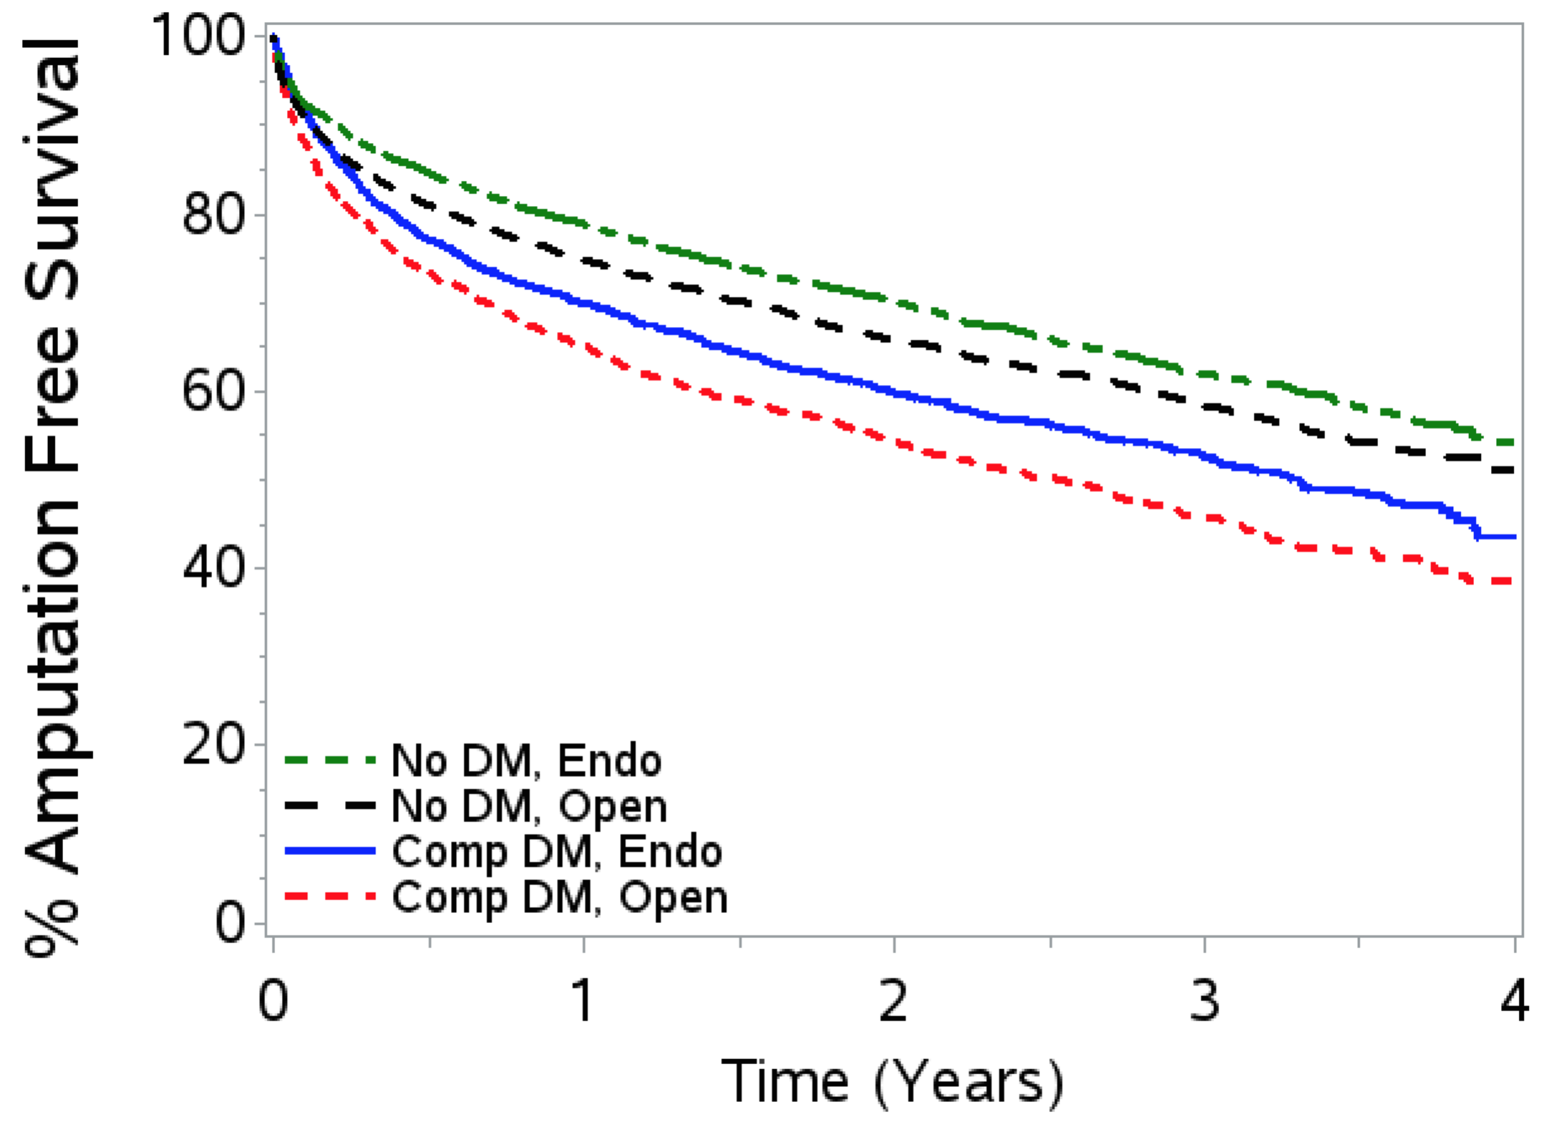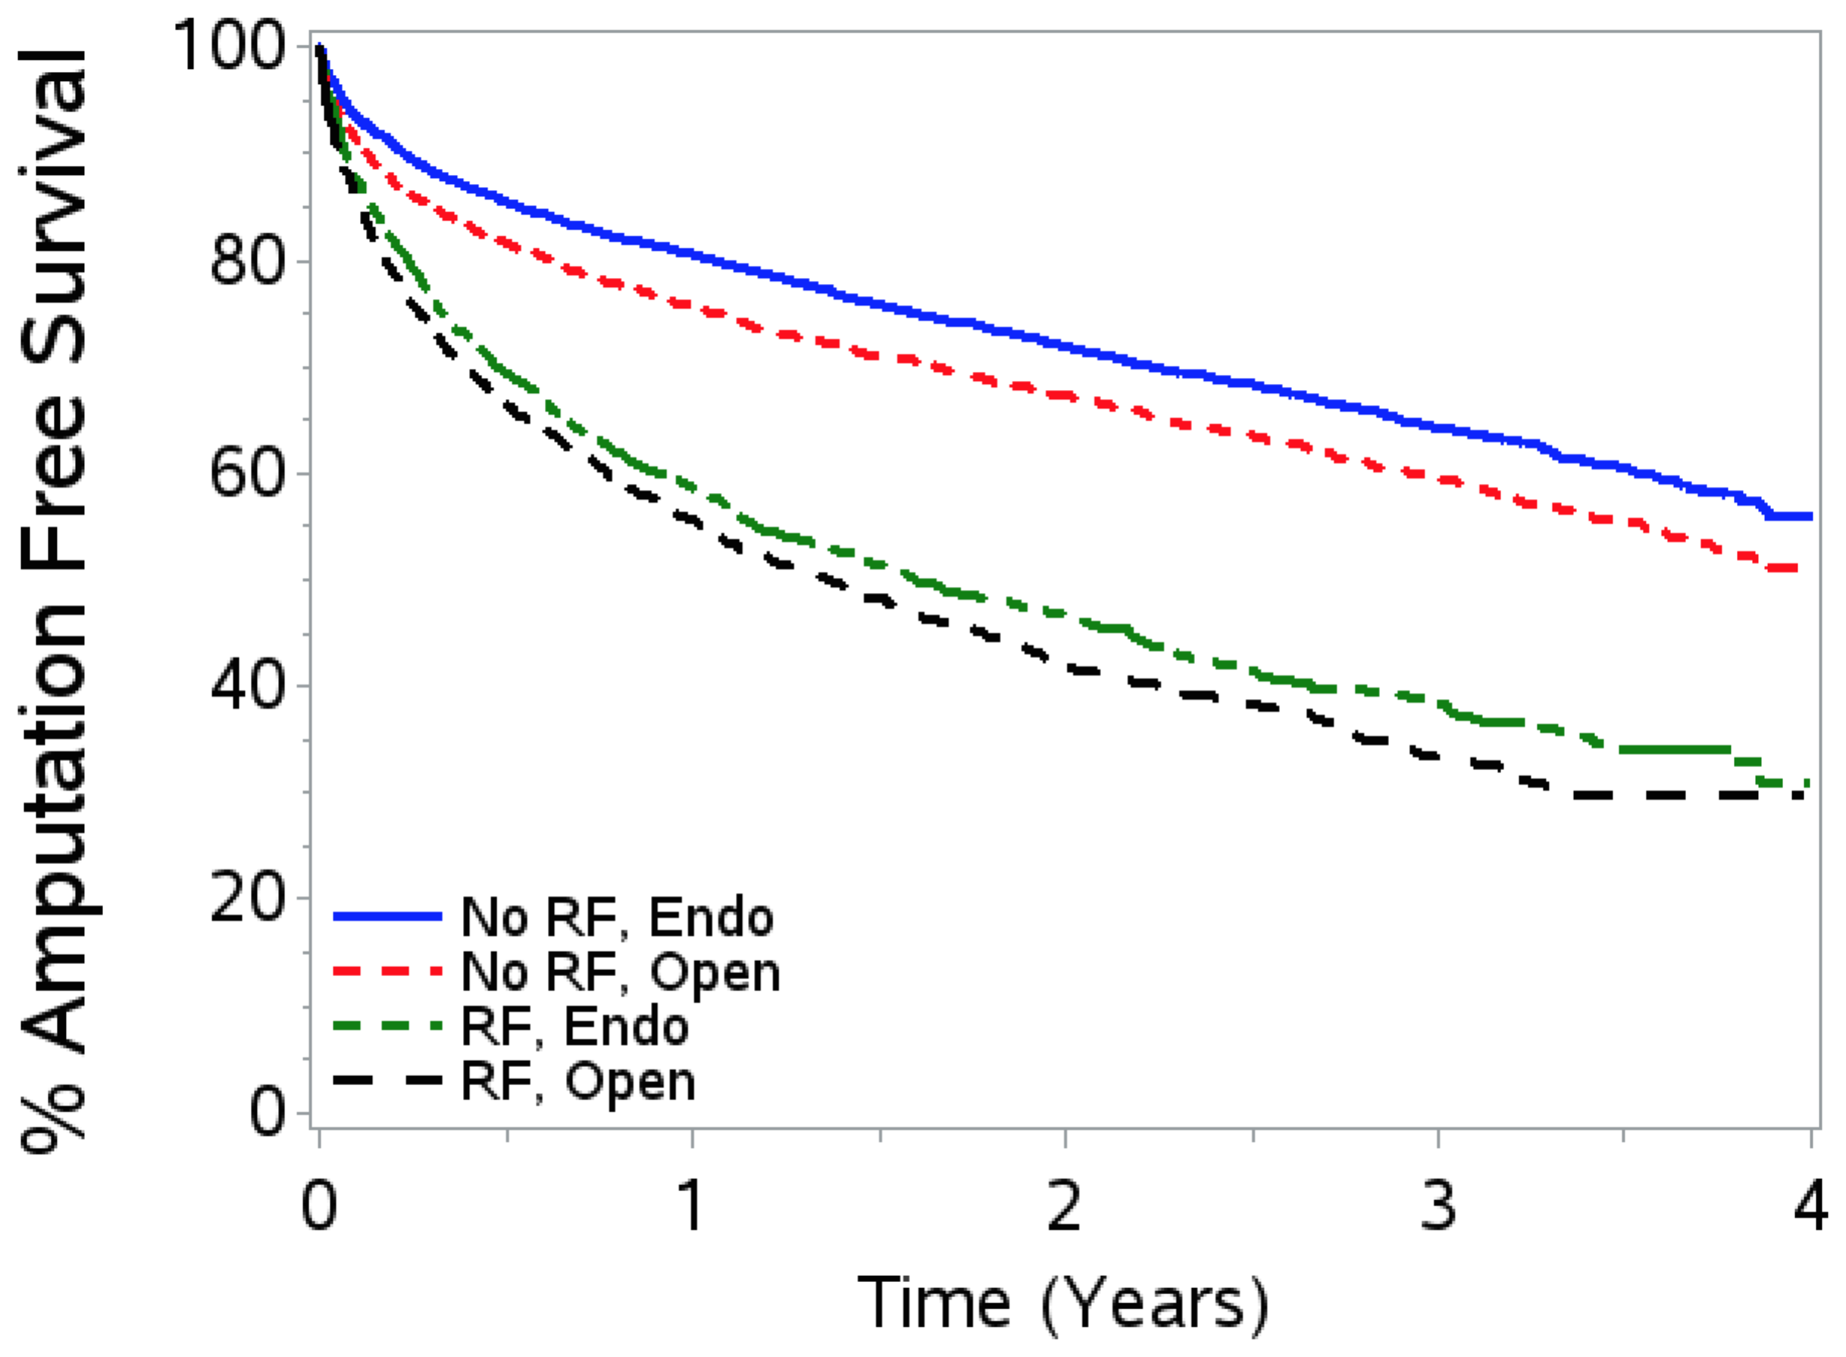
C. AFS by procedure type and presence of CHF/IHD D. AFS by procedure type and presence of CLI
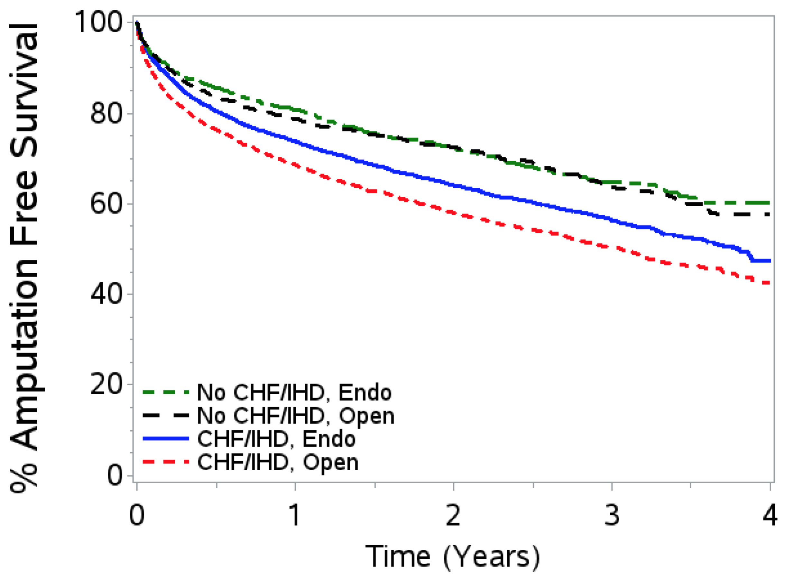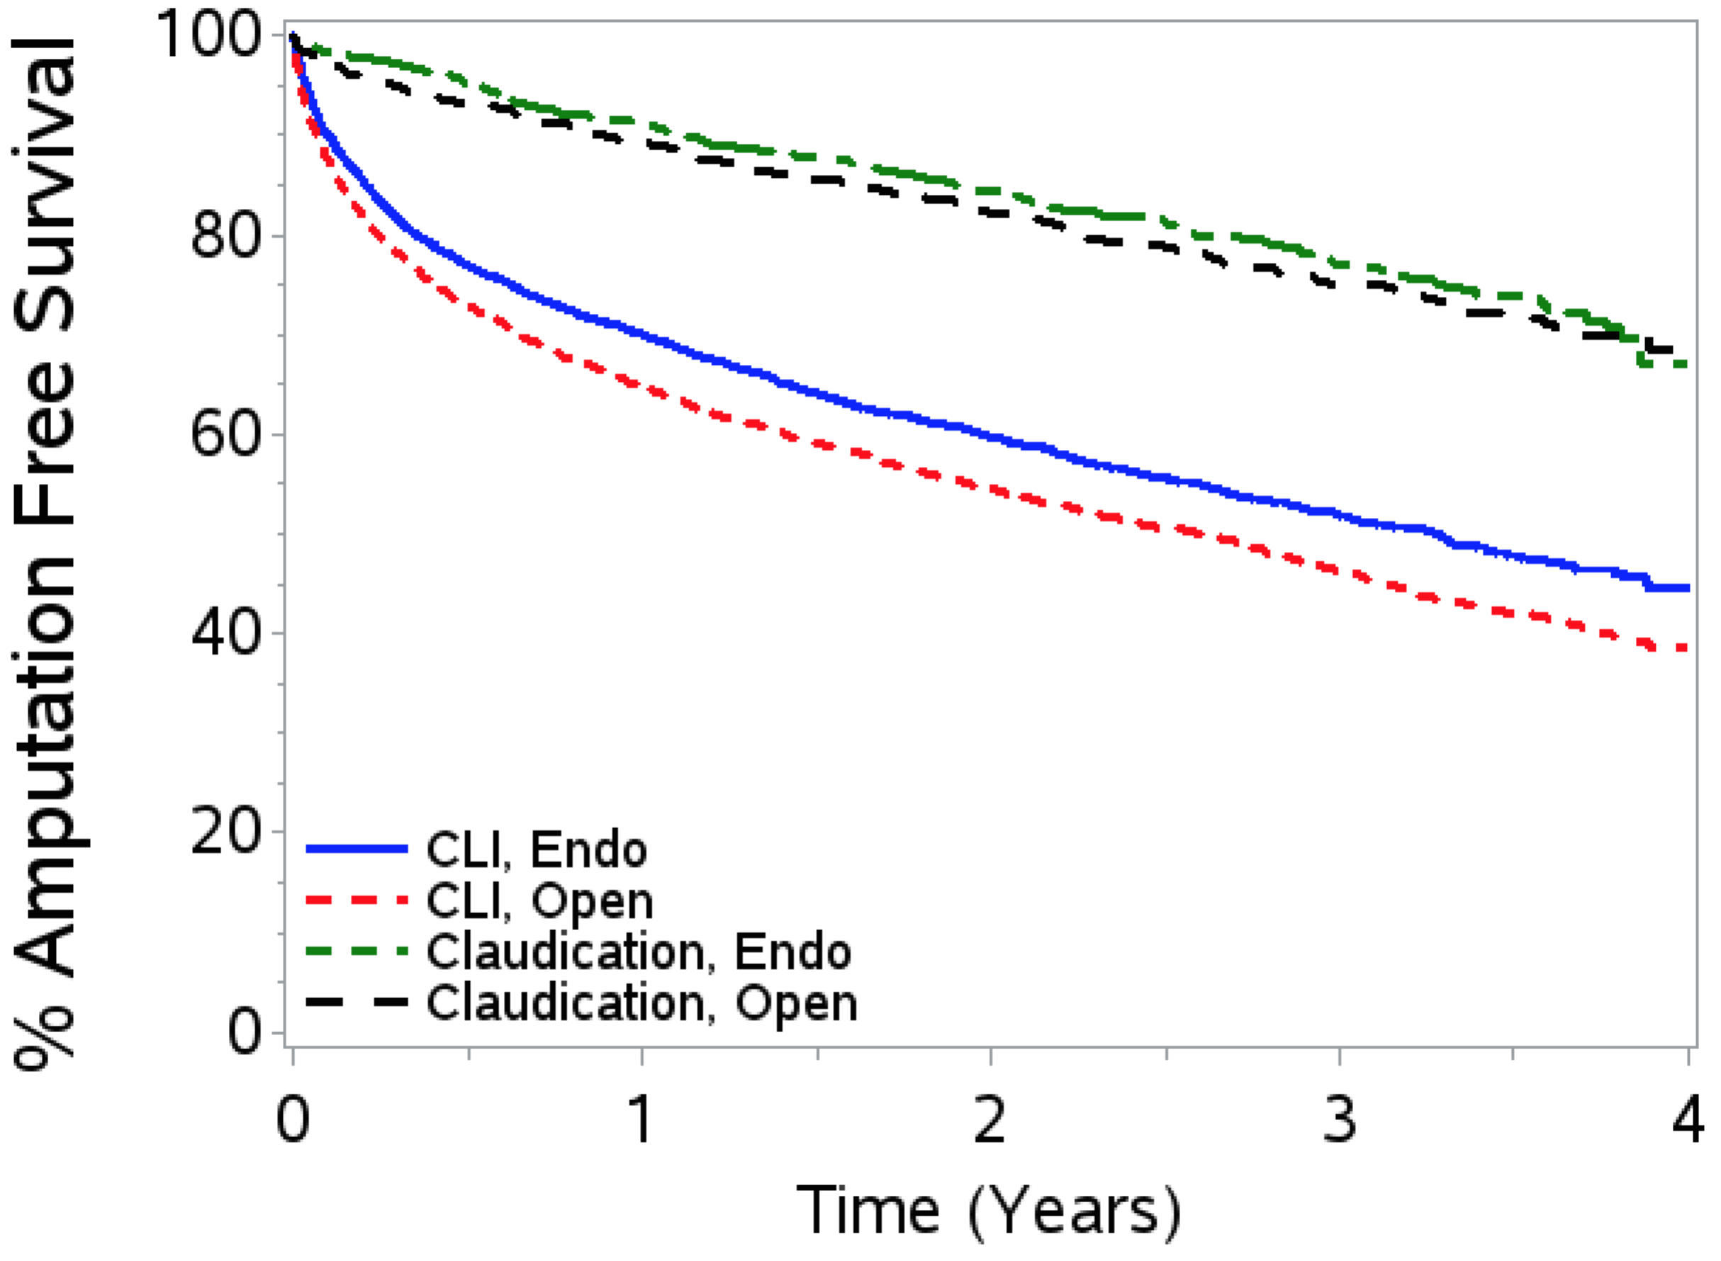
Figure 1S. Overall 4-year amputation free survival by endovascular vs. open revascularization and comorbidity in propensity score matched cohorts. A, 4-year amputation free survival by procedure type and presence of diabetes mellitus; B, 4-year amputation free survival by procedure type and presence of renal failure; C, 4-year amputation free survival by procedure type and presence of congestive heart failure/ischemic heart disease; D, 4-year amputation free survival by procedure type and extent of disease.
AFS, amputation free survival; RF, renal failure; DM, diabetes mellitus; CLI, critical limb ischemia, CHF/IHD, congestive heart failure / ischemic heart disease, Endo, endovascular.

REFERENCES

1. Vogel TR, Kruse RL. Risk factors for readmission after lower extremity procedures for peripheral artery disease. J Vasc Surg 2013; 58: 90–97.

2. Holman KH, Henke PK, Dimick JB, et al. Racial disparities in the use of revascularization before leg amputation in Medicare patients. J Vasc Surg 2011; 54: 420–426.

3. Goodney PP, Beck AW, Nagle J, et al. National trends in lower extremity bypass surgery, endovascular interventions, and major amputations. J Vasc Surg 2009; 50: 54–60.

4. Goodney PP, Holman K, Henke PK, et al. Regional intensity of vascular care and lower extremity amputation rates. J Vasc Surg 2013; 57: 1471–1480.

5. Vogel TR, Kruse RL. Risk Factors for Readmission after Lower Extremity Procedures for Peripheral Artery Disease. J Vasc Surg 2013; 58: 90–97.

6. Vogel TR, Dombrovskiy VY, Carson JL, et al. In-hospital and 30-day outcomes after tibioperoneal interventions in the US Medicare population with critical limb ischemia. J Vasc Surg 2011; 54: 109–115.

